**THE RESURRECTION OF OUR LORD**

**April 20, 2025**

Finally, the faith and witness of the women consisted of three elements: the discovery of the empty tomb, the word of the two messengers, and their remembrance of the words of Jesus. Often the third factor is overlooked, but it is very important in the Gospel and is confirmed in our experience.

After the resurrection, disciples remembered and understood. The two at Emmaus experienced Christ in the breaking of the bread and then remembered what Jesus had said on the road. Faith does not usually move from promise to fulfillment but from fulfillment to promise. Remembering is often the activating of the power of recognition.

For this reason alone it is important that the preacher and teacher share with the listeners the story of Jesus and of the church. Such recitals may not strike fire at the time or be heard as matters of burning relevance; however, the time will come when the congregation will remember and it will make all the difference.

**Fred Craddock**

The women receive a word that runs counter to what they know to be true. "Why do you look for the living among the dead? He is not here, but has risen" (24: 5). One might be tempted to linger over the description of these angelic messengers, but they are not the point. The focus in this section is on the message, not the messengers (24: 4-7). What is most striking is that the women encounter the resurrection through this message. They are *told* that Jesus has risen, but they do not see the risen Jesus himself. What they have is a word, a message.

This brings the Easter experience uncomfortably close, because this is precisely what we have--the word of resurrection. One would think God would work differently. It would seem so much easier to have the women come to the tomb and watch Jesus walk out into the light of a new day. And it would seem much easier for Jesus simply to appear in dazzling glory to us, who gather on an Easter morning generations later. And this is precisely where our situation is like that of the women on the first Easter: we are all given a message of resurrection, which flies in the face of what we know to be true.

The only logical response to such a message is unbelief. Experience teaches that death wins. The Easter message says that Jesus lives. When such contradictory claims collide, it only makes sense to continue affirming what we already know. This is what Luke reports in the next section (24: 8-11). The women bring the message of resurrection to the others, and they respond as thinking people regularly respond: they thought that the message was "an idle tale, and they did not believe them" (24: 11).

Unbelief does not mean that people believe nothing. Rather, it means that they believe something else. People say "I don't believe it" because there is something else that they believe more strongly. Yet here is where the Easter message begins its work, by challenging our certainties. Experience teaches that death wins and that even the strongest succumb to it. Experience teaches that life is what you make it, so get what you can while you can because it will be over soon enough. And the Easter message says, "Really? How can you be so sure?" Death is real, but it is not final. In Jesus, life gets the last word.

**Craig Koester**

**✠*****In the Name of Jesus* ✠**

**INTRODUCTION**

"This is the day that the LORD has made; let us rejoice and be glad in it." God has indeed raised from the dead the one who was put to death "by hanging him on a tree." Alleluia! God allows Jesus to appear "to us who were chosen by God as witnesses" in holy baptism and invites us to eat and drink at the table of the risen Christ. Alleluia!

**✠ GATHERING ✠**

**PRESERVICE MUSIC *The Easter Song*  New Song Praise Band** (Annie Herring)

**Piano and Trumpet** ***Blessed Assurance (With Amazing Grace)***

P. Knapp and S. DeCesare

Performed by Maggie Martin and Nate Miller

**THE EASTER ACCLAMATION**

P: Christ is risen! Alleluia!

**C: (Shouted) Christ is risen indeed! Alleluia!**

**ANNOUNCEMENTS**

*As you are able please rise*

**AN EASTER LITANY**

P: Rejoice, heavenly choirs of angels.

**C: Rejoice, all creation around God’s throne.**

P: Jesus Christ, our King, is risen!

**C: Sound the trumpet of salvation.**

P: Rejoice, O earth, in shining splendor,

**C: Radiant in the brightness of Your King.**

P: Christ has conquered! Glory fills you!

**C: Darkness vanishes forever.**

P: On this Day the Lord has acted.

**C: We will rejoice and be glad in it. (Psalm 118:24)**

**THE PROCESSIONAL HYMN 365 *Jesus Christ is Risen Today***

The congregation faces the cross as it enters the assembly

**THE GREETING**

P: Christ is risen! Alleluia!

**C: He is risen indeed! Alleluia!**

P: The grace of our Lord Jesus Christ, the love of God, and the communion of the Holy

Spirit be with you all.

**C: And also with you.**

**THE KYRIE (see p. 4)**

**T**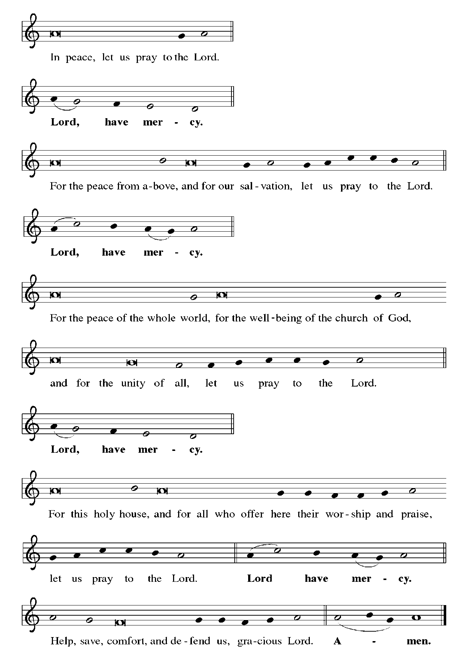

**THE HYMN OF PRAISE (see p. 6)**

**C—All**

**1—Women/children**

**2—Men**

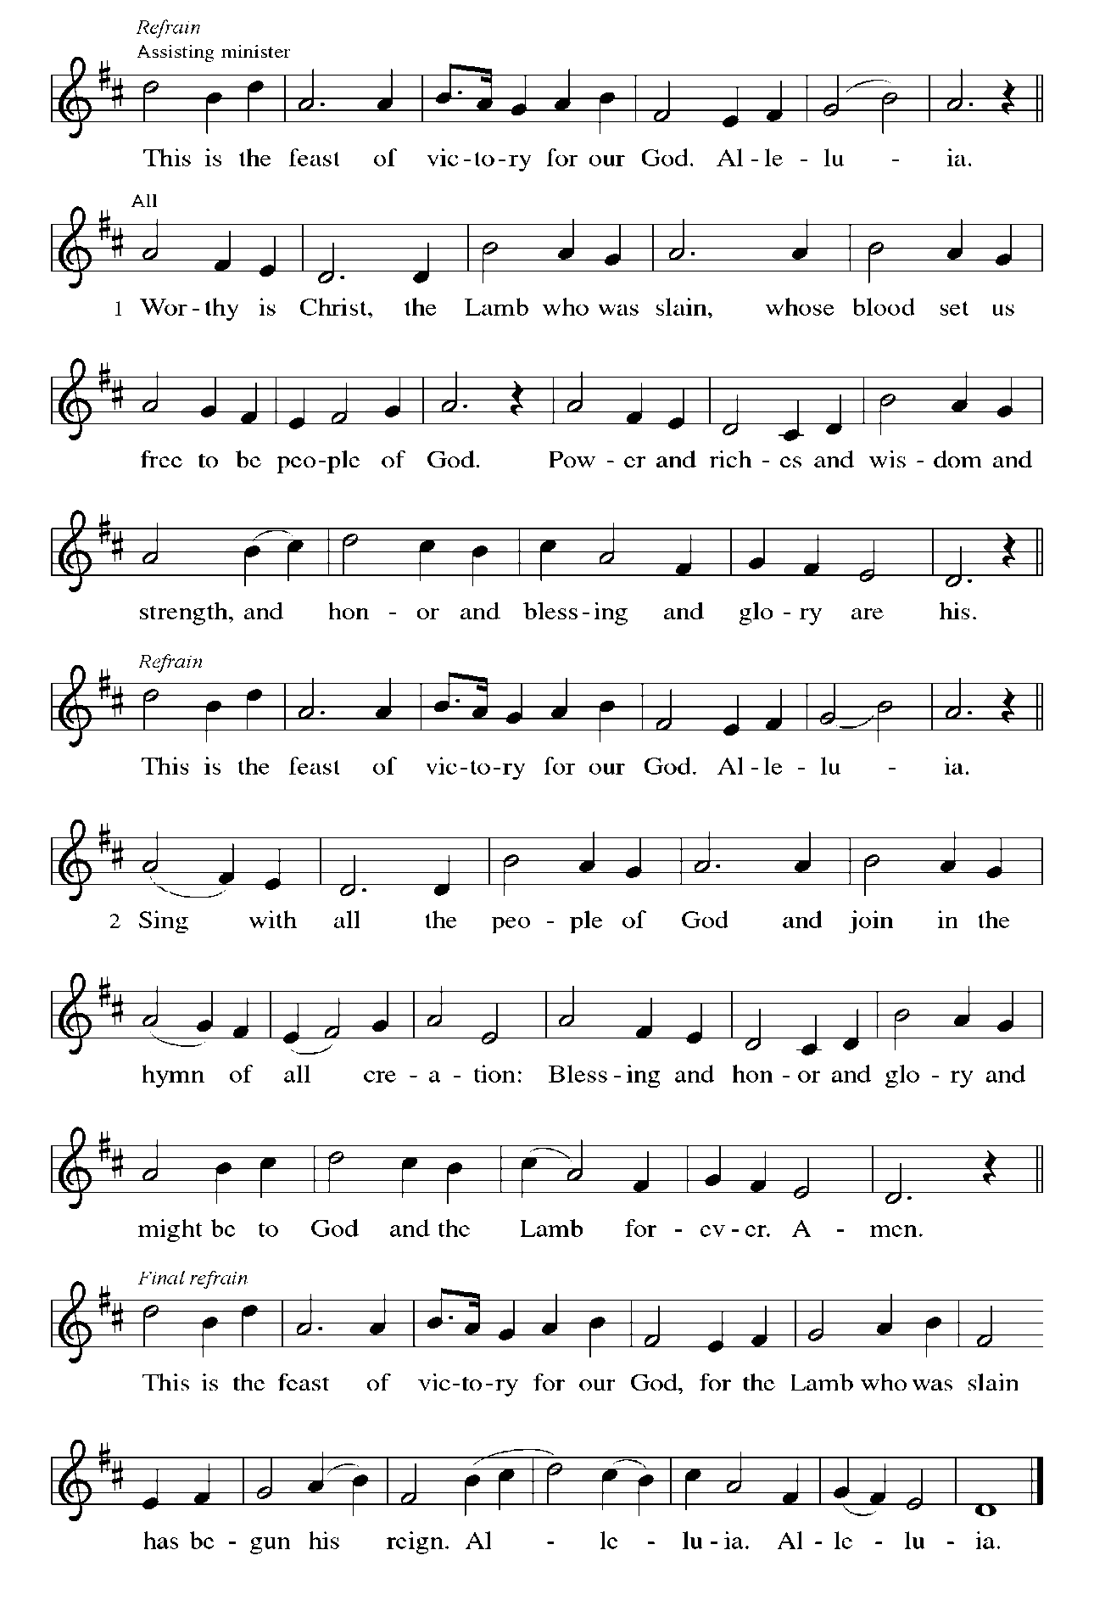

**THE PRAYER OF THE DAY**

P: The Lord be with you.

**C: And also with you.**

P: Let us pray. God of mercy, we no longer look for Jesus among the dead, for He is alive

and has become the Lord of life. Increase in our minds and hearts the risen life we

share with Christ, and help us to grow as Your people toward the fullness of eternal life

with You, through Jesus Christ, our Savior and Lord, Who lives and reigns with You

and the Holy Spirit, one God, now and forever.

**C: Amen.**

*The assembly is seated*

**✠ WORD ✠**

**THE FIRST READING Acts 10: 38-43**

*Peter's sermon, delivered at the home of Cornelius, a Roman army officer, is a summary of the essential message of Christianity: Everyone who believes in Jesus, whose life, death, and resurrection fulfilled the words of the prophets, receives forgiveness of sins through his name.*

34Then Peter began to speak to them: "I truly understand that God shows no partiality, 35but in every nation anyone who fears Him and does what is right is acceptable to Him.

36"You know the message He sent to the people of Israel, preaching peace by Jesus Christ--He is Lord of all. 37That message spread throughout Judea, beginning in Galilee after the baptism that John announced: 38how God anointed Jesus of Nazareth with the Holy Spirit and with power; how He went about doing good and healing all who were oppressed by the devil, for God was with Him.

39We are witnesses to all that He did both in Judea and in Jerusalem. They put Him to death by hanging Him on a tree; 40but God raised Him on the third day and allowed Him to appear, 41not to all the people but to us who were chosen by God as witnesses, and who ate and drank with Him after He rose from the dead.

42"He commanded us to preach to the people and to testify that He is the one ordained by God as judge of the living and the dead. 43All the prophets testify about Him that everyone who believes in Him receives forgiveness of sins through His name."

The Word of the Lord.

**Thanks be to God.**

**THE PSALM: Psalm 118: 1-2, 14-24** Antiphon by Bradley Ellingboe

Choir sings refrain first, followed immediately by the congregation

and as indicated

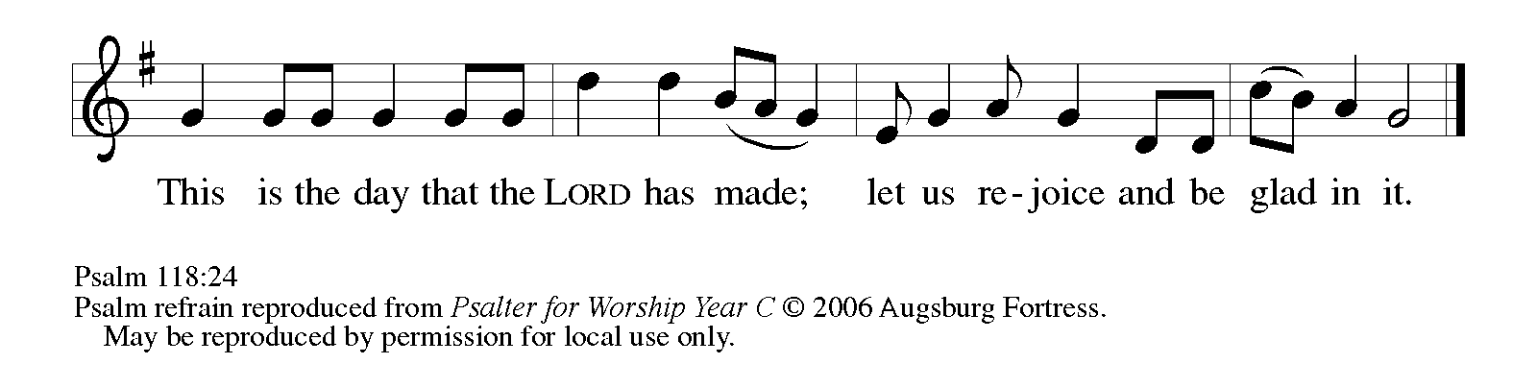

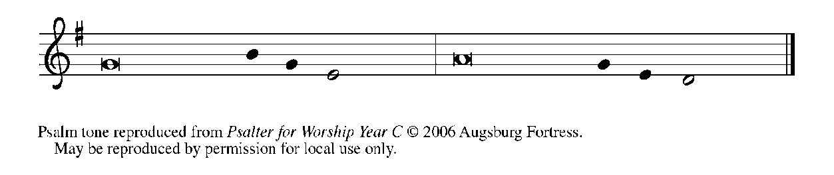

1Give thanks to the LORD, for the | LORD is good;

     God's mercy en- | dures forever.

**2Let Israel | now declare,**

**"God's mercy en- | dures forever."**

14The LORD is my strength | and my song,

     and has become | my salvation.

**15Shouts of rejoicing and salvation echo in the tents | of the righteous:**

**"The right hand of the | LORD acts valiantly!**

16The right hand of the LORD | is exalted!

     The right hand of the | LORD acts valiantly!"

**17I shall not | die, but live,**

**and declare the works | of the LORD.   REFRAIN**

18The LORD indeed pun- | ished me sorely,

     but did not hand me o- | ver to death.

**19Open for me the | gates of righteousness;**

**I will enter them and give thanks | to the LORD.**

20"This is the gate | of the LORD;

     here the righ- | teous may enter."

**21I give thanks to You, for You have | answered me**

**and You have become | my salvation.   REFRAIN**

22The stone that the build- | ers rejected

     has become the chief | cornerstone.

**23By the LORD has | this been done;**

**it is marvelous | in our eyes.**

24This is the day that the | LORD has made;

     let us rejoice and be | glad in it.   **REFRAIN**

**SECOND READING 1 Corinthians 15: 19-26**

*Paul describes the consequences of the resurrection, including the promise of new life in Christ in a world that has known only death since Adam, the destruction of the forces of evil, and the establishment of God's victorious rule over all.*

19If for this life only we have hoped in Christ, we are of all people most to be pitied. 20But in fact Christ has been raised from the dead, the first fruits of those who have died. 21For since death came through a human being, the resurrection of the dead has also come through a human being; 22for as all die in Adam, so all will be made alive in Christ.

23But each in his own order: Christ the first fruits, then at His coming those who belong to Christ. 24Then comes the end, when He hands over the kingdom to God the Father, after He has destroyed every ruler and every authority and power. 25For He must reign until He has put all His enemies under His feet. 26The last enemy to be destroyed is death.

The Word of the Lord.

**Thanks be to God.**

*As you are able please rise*

**THE VERSE (see p. 10)**

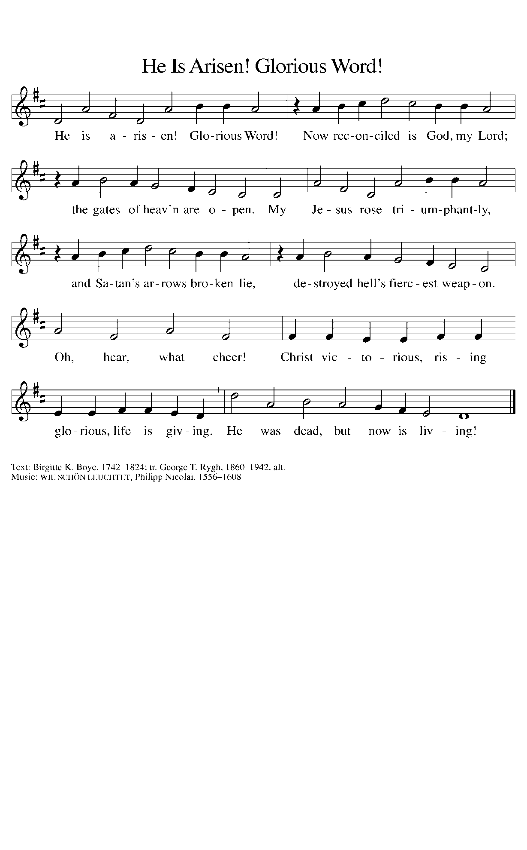

**THE HOLY GOSPEL Luke 24: 1-12**

*The women who followed Jesus take the lead in proclaiming the resurrection.*

P: The Holy Gospel according to St. Luke, the twenty-fourth chapter.

**C: Glory to You, O Lord!**

1At the first of the sabbaths, at deep dawn, (the women) came to the place of remembering

taking the spices they had prepared.

2And they found the stone rolled away from the place of remembering.

3And when they went in they did not find the body of the Lord Jesus.

4And when they became at their wits’ end, not knowing which way to turn they saw two

men standing in flashing clothes.

5And when they became terrified and bowed their faces to the ground the men said to

them, “Why do you seek the Living One among the dead?

6He is not here but has been raised. Remember how He said to you while still in the Galilee,

7that it was necessary for the Son of Man to be handed over into the hands of sinful

men and be crucified and on the third day be raised up.”

8And they remembered the words spoken to them

9and they returned from the place of remembering and they reported all these things to the

eleven and all the rest.

10It was Mary Magdalene and Joanna and Mary the mother of James and the rest of the women

who said these things to the apostles.

11But these words seemed to them to be garbage, and they did not believe them.

12But Peter rose up and ran to the place of remembering, and saw the linen cloths by themselves,

and he was amazed and went away by himself.

P: The Gospel of the Lord.

**C: Praise to You, O Christ!**

*The assembly is seated*

**THE SERMON**

*Silence for reflection follows the sermon*

*As you are able please rise*

**THE HYMN OF THE DAY NSB 10 *Beautiful Savior***

*The assembly is seated*

**MILESTONE OF FIRST COMMUNION**

P: This morning we celebrate an important milestone of faith for our students. Will the

parents of those who participated in our First Communion instruction please stand.

In Christian love you presented ***Carson and Stella; Cameron and Richer’ea; Ben and***

***Molly*** for Holy Baptism. In Baptism sacred promises are made. As their parents, it is

your calling to faithfully bring them to the services of God’s house and the Holy

Supper, to teach them the Lord’s Prayer, the Creed and the Ten Commandments, to

place in their hands the holy Scriptures, and to provide for their instruction in the

Christian faith.

Do you renew your commitment to these Baptismal promises? If so, please answer, “I

do, and I ask God to help and guide me.”

*Parents:*

*I do, and I ask God to help and guide me.*

A: People of God, do you promise to support and encourage these parents in the keeping

of these sacred promises? If so, please answer, “We will, and we ask God to help and

guide us.”

**C: We will, and we ask God to help and guide us.**

P: One of the ways we help you keep these promises and “provide for their instruction in

the Christian faith” is to prepare them for their participation in the Lord’s Supper. This

is an important step in the life of the Christian because it is here that we receive

assurance of God’s forgiveness and are strengthened for service by God’s abiding love.

This sacrament is a gift of God’s love to you and your child. This morning we celebrate

this milestone of faith with you.

**PRAYER WITH BLESSING**

A: Let us pray. Gracious God, we come before You confident of Your love and grace. Be

with ***Carson and Stella; Camren and Richer’ea; Ben and Molly*** as they come for the

first time and with each of us as we come to Your Table. Fill them with Your Holy

Spirit and draw them into a closer walk with You each day. Give their parents the

wisdom and courage to raise them in Your ways and according to Your will. We ask

this in the name of Christ our Lord.

**C: Amen.**

A: We now ask ***Carson and Stella; Camren and Richer’ea; Ben and Molly*** who have

completed the instruction for First Communion to come forward with their parents for

the laying on of hands to receive God’s blessing.

P: **(*Carson and Stella; Cameron and Richer’ea; Ben and Molly*)** I bless you in the name

of Jesus Christ, our Lord and welcome you to the Lord’s Table.

*As you are able please rise*

**THE PRAYER OF THE CHURCH**

A: In the light of Christ’s resurrection, let us pray for the Church, the world, and all who

long for the grace of new life, that the whole creation may know the benefits of Christ’s

Easter victory.

A: That the Church may faithfully and fearlessly bear witness to Christ as the Lord of the

living and the dead, for Christ is risen:

**C: He is risen indeed!**

A: That Christ’s victory over death would vanquish all powers of evil and oppression and

bring peace and reconciliation to our troubled and broken world, especially in Ukraine

and Haiti; Darfur and Sudan; the Democratic Republic of Congo; Israel and Gaza, for

Christ is risen:

**C: He is risen indeed!**

A: That in the power of the Holy Spirit this congregation may discover new ways to do

good and bring Christ’s healing to the hurting and the lost, for Christ is risen:

**C: He is risen indeed!**

A: That ***Carson and Stella; Camren and Richer’ea; Ben and Molly***may through their

participation in the Lord’s Supper may grow ever more fully into the new life in Christ

promised in their Baptism, for Christ is risen:

**C: He is risen indeed!**

A: That those who have trouble believing the Good News may be granted faith and hope

by the Spirit of the living Christ, for Christ is risen:

**C: He is risen indeed!**

A: That the sick, especially **Kevin Thiede; Bill Noble; Carol Radke; Russ Fischer;**

**Martha Schroeder; Kathy Stein; Debbie Martin; Christine Kiser; Ken Mulder;**

**Joyce Stark; and Fred Weiss** might know the strength and compassion of the Lord,

for Christ is risen:

**C: He is risen indeed!**

A: That those celebrating birthdays, especially **Diane Sunde;** **and Jean Kleinschmidt;**

and anniversaries, especially **Tim and Stacie Crozier** might know Your love this Day

and every day and be filled with Your love and grace in all the days ahead, for Christ

is risen:

**C: He is risen indeed!**

A: That with Mary Magdalene, Joanna, Mary the mother of James, the disciples, and all

the saints we may come at last to see and worship You in glory: Lord, in Your mercy,

**C: Hear our prayer.**

P: Hear our prayers, O God, on behalf of those for whom we pray, and give us peace and

joy in this time of resurrection and new life, for the sake of Your Son, Jesus Christ, our

risen and living Lord.

**C: Amen.**

**✠ MEAL ✠**

**THE OFFERING**

**THE VOLUNTARY *Rejoice, He Is Alive*** **St. Paul Senior Choir**

**(J. Shafferman; Arr. P. Drennan; Orch. L. Shackley)**

*As you are able please rise*

**THE OFFERTORY**

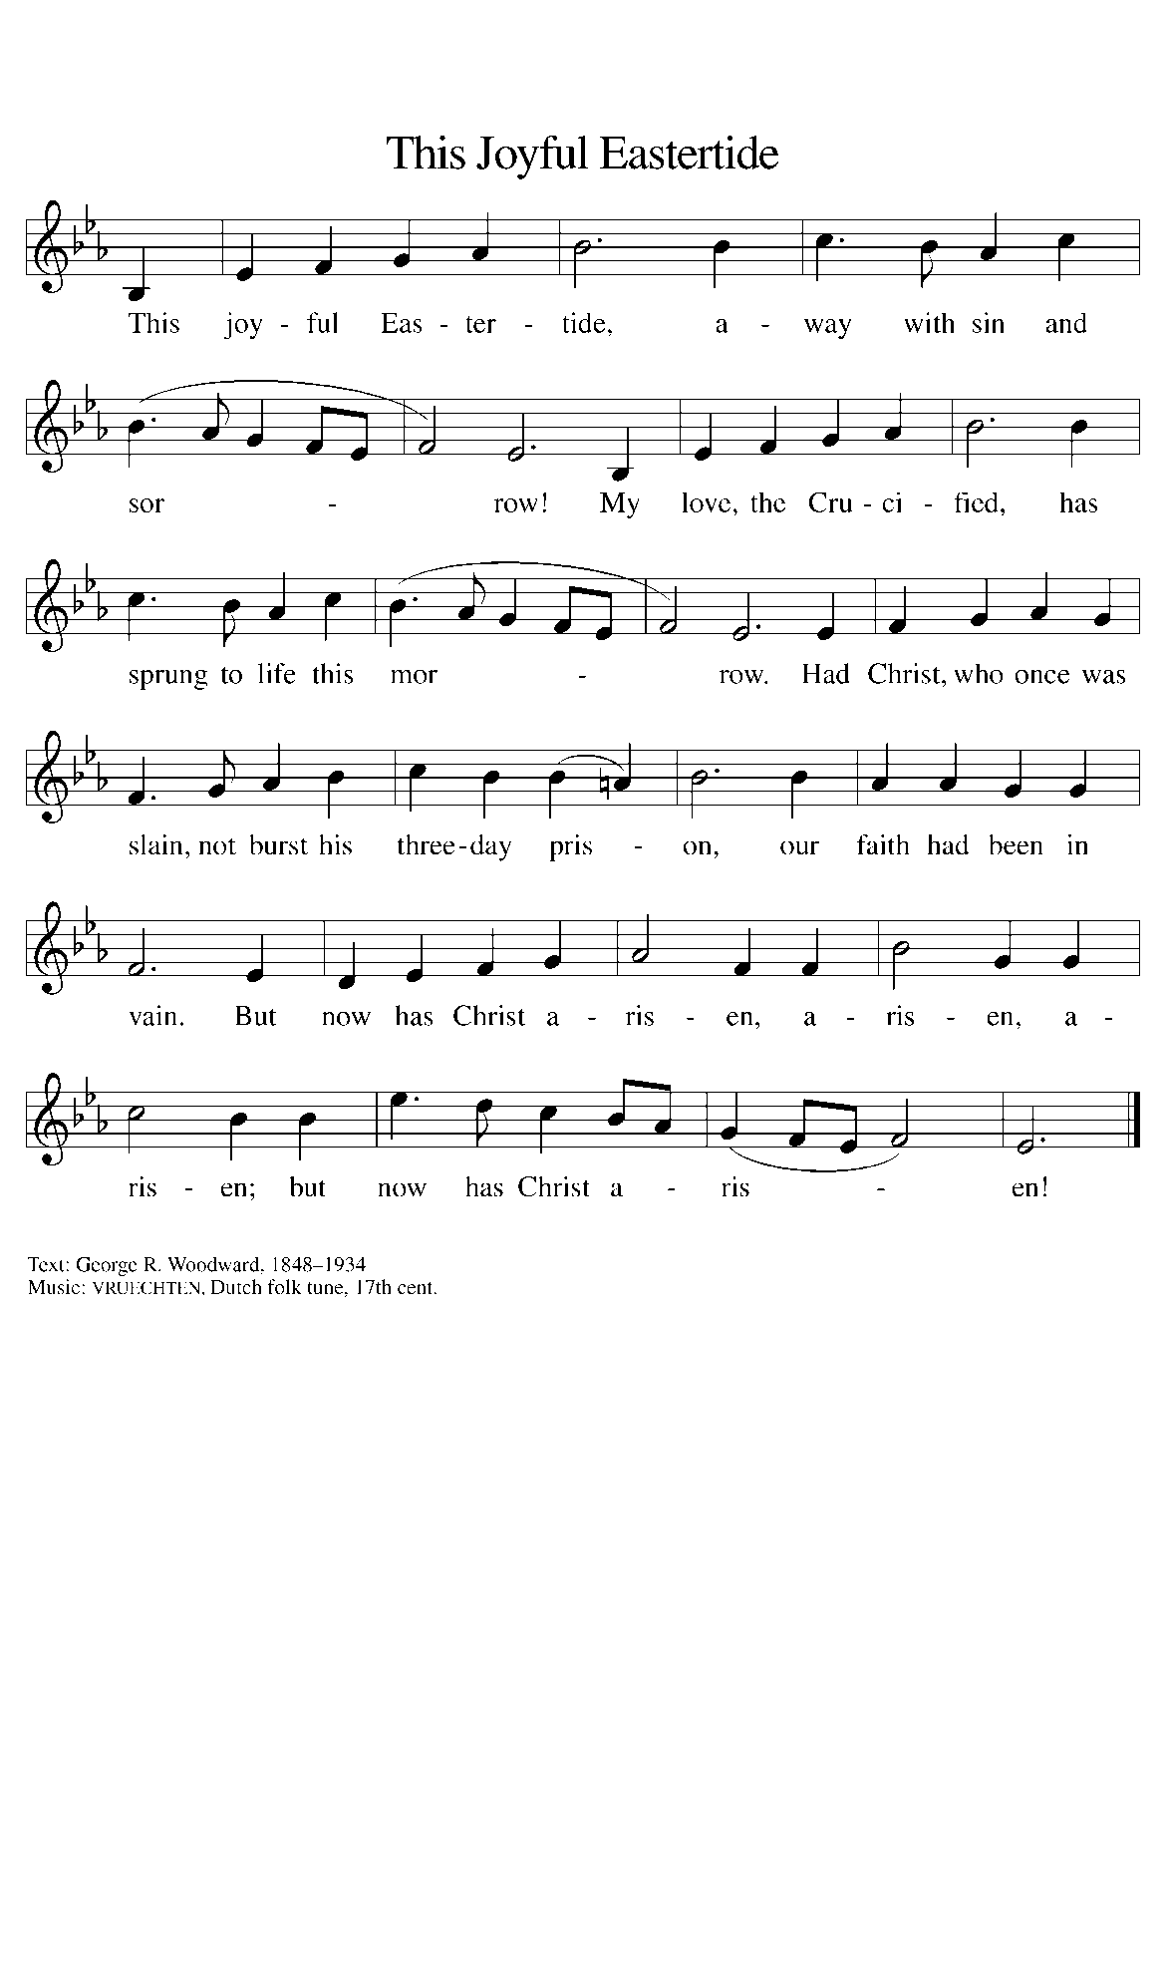

**THE OFFERTORY PRAYER**

A: Let us pray. Living Lord Jesus Christ,

**C: On this Day of resurrection we offer You these simple gifts, signs of Your grace**

**and love. Be known to us in the breaking of the bread, and nourish us with the**

**cup of salvation, for You are Lord, now and forever. Amen.**

**THE GREAT THANKSGIVING**

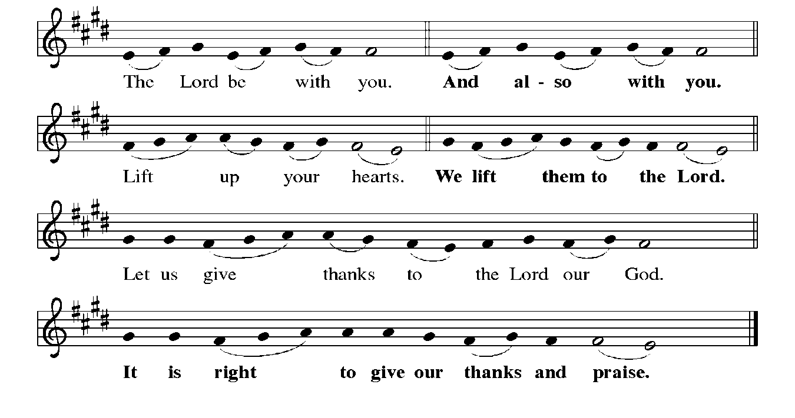

P: It is indeed right, our duty, and our joy … join their unending hymn:

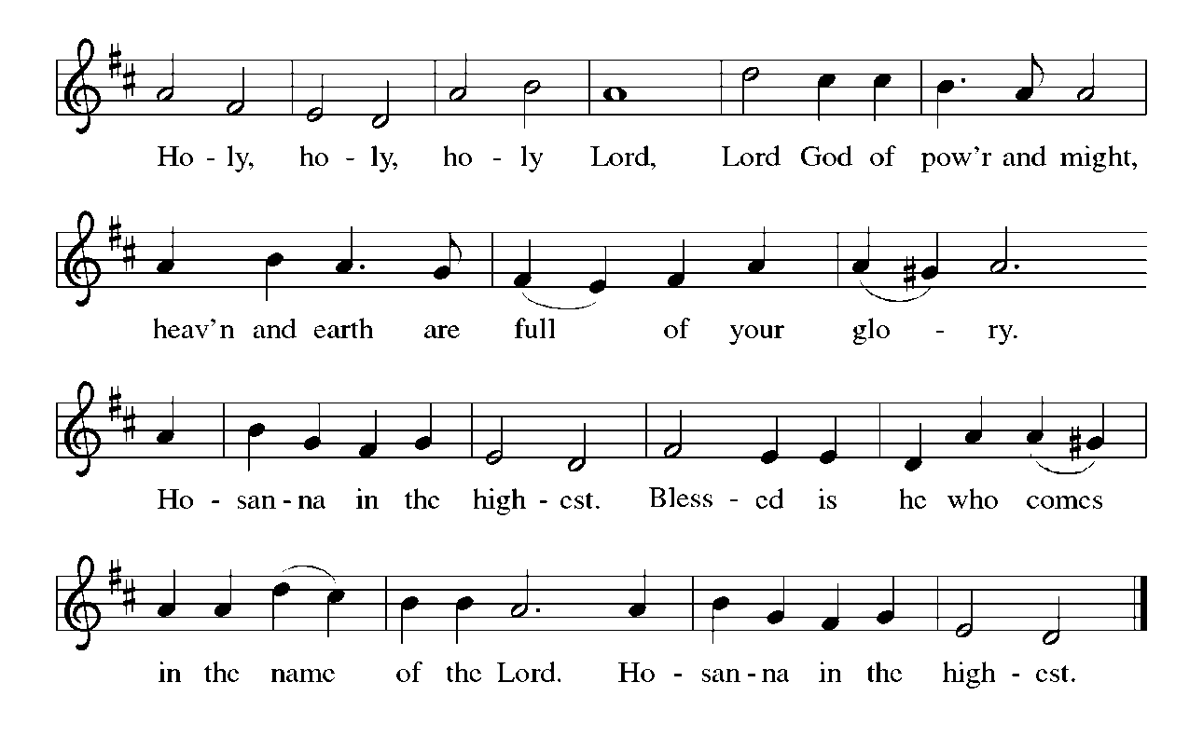

P: Holy God, our strength, our song, and our salvation, we bless and praise You.

On this Day You have acted; we will rejoice and be glad in it.

You are holy, O God, in Your irresistible will for life: in creation, in all its

intricate beauty; in Israel’s rescue from bondage, exile, and faithlessness;

and in her prophets’ promise of the death of death and a new creation.

In fulfillment of those promises, You sent Your Son, Jesus Christ.

He is the first fruits of resurrection, in Whom all will be made alive.

In the night ... “Do this for the remembrance of Me.”

As often as we eat ... we proclaim the Lord’s death until He comes.

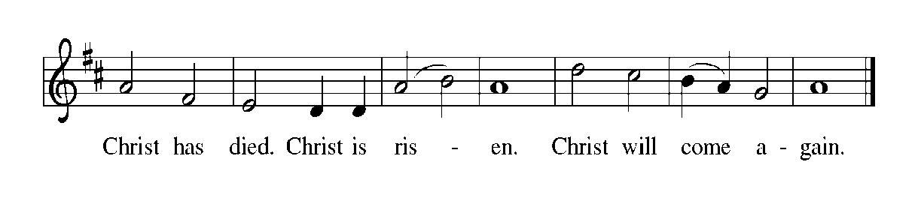

P: With this bread and cup we remember the life our Lord offered for us.

Anointed with Your Spirit, He did good, fed the hungry, and healed the sick.

Put to death on the cross, You raised Him to defeat the last enemy of death.

Now He reigns until He returns to share with us Your final Feast of victory.

Send now Your Holy Spirit on us and these gifts of bread and wine, that we

and all who share the Lord’s Body and Blood

May, with the women, bear faithful witness to His rising, until the hope of memory

becomes the joy of reality, and we, and all for whom He rose share in Your

everlasting glory.

To You, O God: Father, Son, and Holy Spirit, be all honor and glory, in Your holy

Church, in heaven and on earth, now and forever.

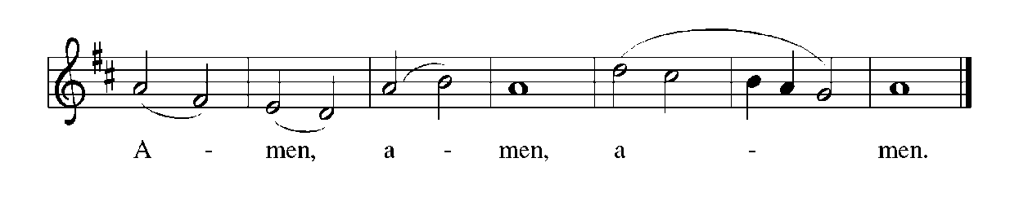

**THE LORD’S PRAYER**

P: Risen from the dead, Jesus lives to intercede for us and join us as He taught us to

pray:

**C: Our Father, Who art in heaven, hallowed be Thy Name. Thy Kingdom come, Thy**

**will be done on earth as it is in heaven. Give us this day our daily bread, and**

**forgive us our trespasses as we forgive those who trespass against us. And lead us**

**not into temptation, but deliver us from evil. For Thine is the Kingdom, and the**

**power, and the glory, forever and ever. Amen.**

**INVITATION TO THE MEAL**

P: Alleluia! Christ the Lamb of God has been sacrificed. Therefore, let us celebrate His

Feast with joy. Blessed are those who are called to the Supper of the Lamb. God’s

holy gifts for God’s holy people. Come, for all is now ready.

*The assembly is seated*

**THE DISTRIBUTION**

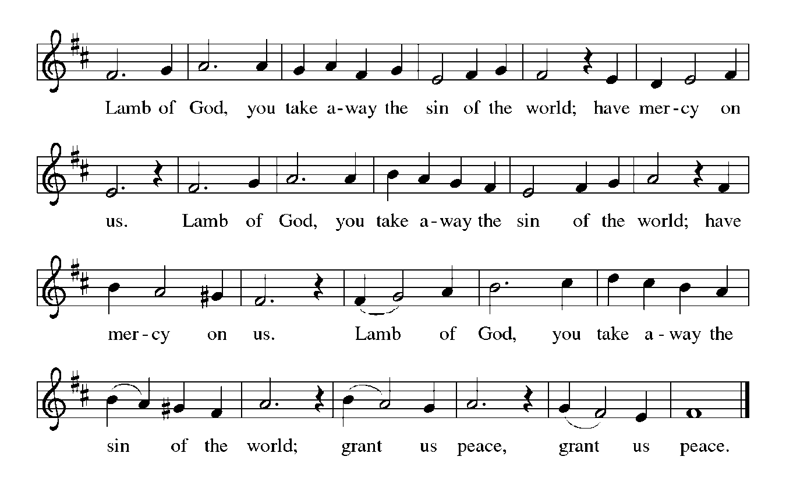

**HYMN DURING DISTRIBUTION 367 *Now All the Vault of Heaven Resounds***

**ELW 369 *Jesus Christ is Ris’n Today***

**ELW 389 *Christ is Alive, Let Christians Sing***

**ELW 392 *Alleluia! Sing to Jesus***

**NSB 50 *I Exalt Thee***

*As you are able please rise*

**THE POST COMMUNION BLESSING**

P: The Body and Blood of our Lord Jesus Christ strengthen you and keep you in His

grace.

**C: Amen.**

**THE POST-COMMUNION PRAYER**

A: Let us pray. Glorious Lord of life, at this Table we have tasted Your promised future

in which there will be no more death or pain. Strengthen us to be Your risen Body in

the world, that Your praise and glory may resound in all creation; through Jesus Christ

our Lord.

**C: Amen.**

**✠ SENDING ✠**

**THE BENEDICTION**

P: May God the Father Who raised Christ from the dead open to you the gate of everlasting

life.

**C: Amen.**

P: May God the Son Who burst from the grave give you joy as you celebrate His

resurrection.

**C: Amen.**

P: May God the Holy Spirit Who brought you to birth in Baptism fill you with strength

and peace.

**C: Amen.**

P: Almighty God: Father, Son **✠** and Holy Spirit bless you now and forever.

**C: Amen.**

**RECESSIONAL HYMN see p. *Day of Delight and Beauty Unbounded***

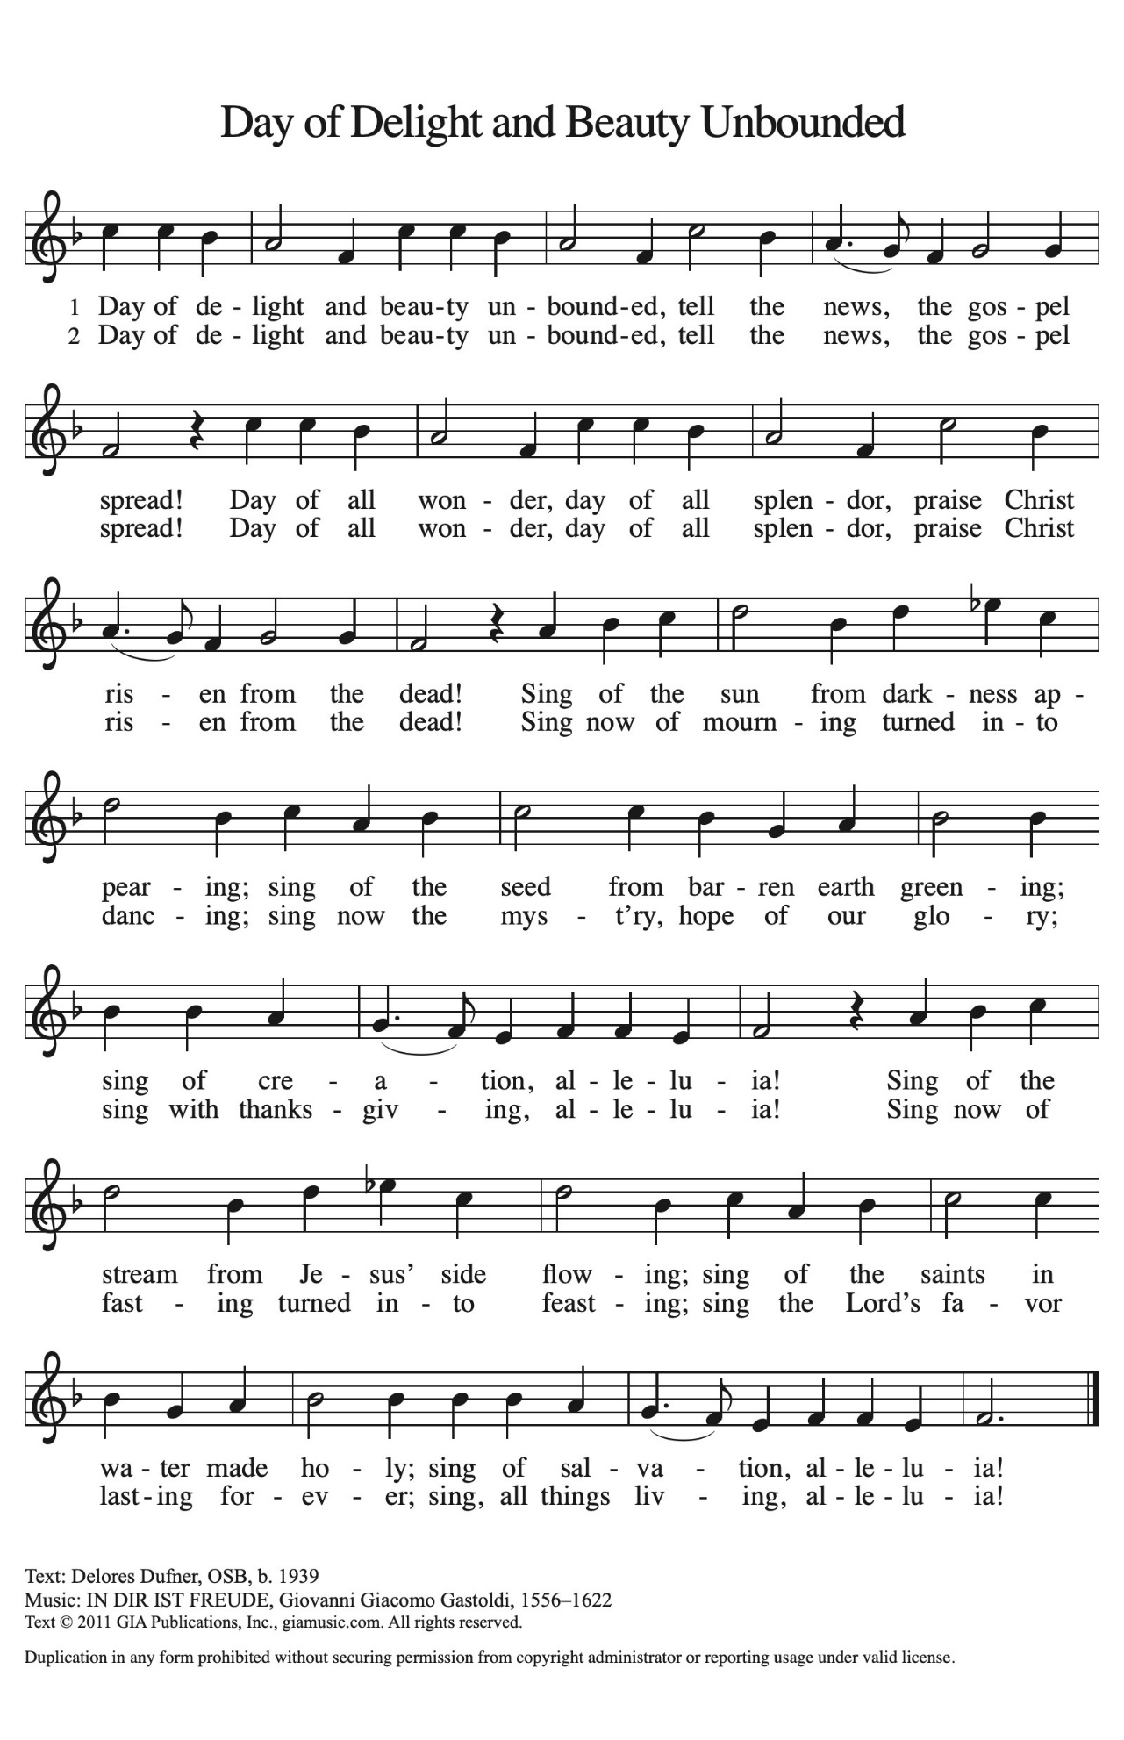

The congregation faces the cross as it leaves the assembly

**THE DISMISSAL**

A: Alleluia! Christ is risen!

**C: He is risen indeed! Alleluia!**

A: Go in the peace of Christ, alleluia!

**C: Thanks be to God! Alleluia!**

**POSTLUDE**

**✠ *To God Alone Be Glory* ✠**

The Meditations are from *Interpretation.* *A Bible Commentary for Teaching and*

*Preaching.* Fred Craddock. (Louisville: John Knox Press, 1990) 282-83; and

*Working Preaching Online.* Copyright 2022 Luther Seminary.

The Greeting, Peace, Prayers, and Dismissal are adapted from *Sundays and Seasons.*

Copyright 2000 Augsburg Fortress.

**ANNOUNCEMENTS**

**Please remember to mail your offering to the Church Office** at 818 Franklin Street, Michigan City, IN 46360**.** Another alternative is to give on-line through Tithe.ly. Please see your closure letter for information on how to set up a Tithe.ly account.

**St. Paul Members are reminded to have** a loved one contact the office if you are hospitalized. Many times, the Pastor doesn’t know someone is in the hospital. If you call and leave a message, please tell us which hospital the patient is at.

**Birthdays: Diane Sunde (4/19); Jean Kleinschmidt (4/23)**

**Anniversaries: Tim & Stacie Crozier (4/22)**

**PRAYER CONCERNS:** Pope Francis, Larry Litchford, Sarah McNabb, Carol Radke, Jeanie Boatman Shepple, Nolan Wilson, Debbie Martin, Mark Tannehill, Brian Wiseman, Kathy Stein, Danielle Schnell, Jan Paholski, Laura Dovey, and Grace Romine.

**OFFICE HOURS:** Libby will be in the office on Mondays, Wednesdays, and Fridays; volunteers will cover Tuesdays and Thursdays.

Monday & Wednesday 8:00 a.m. – 5 p.m.

Tuesday & Thursday 9:00 a.m. – 12:00 p.m.

Friday 8:00 a.m. – 12:00 p.m.

**If you are listening to the worship broadcast on the radio and would like to watch the Sunday morning service live stream follow these steps:**

(1) If you have You Tube available on your TV, search for

**St. Paul Lutheran Church Michigan City, IN.**

(2) The direct link on the computer is

https://www.youtube.com/channel/UC5AIPNaKr3QN50984jGOa1g.

   (3) This link is also on the main page of the church’s website in

the church section and will continue to be posted weekly on the St.

Paul Facebook page.

And it will always be available on the radio broadcast Sunday mornings at 11:00 a.m.

on WEFM (95.9), and on the local cable access station #99 for the previous week’s

service on Sundays at 4:00 p.m. and the current service on Wednesdays at 7:00 p.m.

and Fridays at 8:30 p.m.

**Next Sunday’s lessons are Acts 5: 27-32; Psalm 118: 14-29 or Psalm 150; Revelations 1: 4-8; John 20: 19-31** for those of you who like to study them in advance.

**To send e-mail to the church office**, please use the following addresses:

Pastor Mark Reshan: seniorpastor@stpaulmichigancity.com

Church Office Secretary (Libby Pollock): churchsecretary@stpaulmichigancity.com

Church Treasurer (Karen Fleming): finance@stpaulmichigancity.com

**The Good News Newsletter**: If you have an article or anything you want included in **The Good News** please send it to the following e-mail address: splcgoodnews@gmail.com. Pastor Pamela Thiede will be using this e-mail address to assemble **The Good News** each month. The deadline for getting information to Pastor Pamela will be the 20th of each month.

**Worship Attendance:**

**Wednesday, April 9, 2025 @ 6:00 p.m. 27**

**Saturday , April 12, 2025 @ 4:00 p.m. 38**

**Sunday, April 13, 2025 @ 9:00 a.m. 101**

**TOTAL 166**

**Copies of the minutes from the January 23, 2025 and February 27, 2025 Church Council meetings are on the back table in the upper Narthex. They were approved by the council via email.**

**FYI:**

In response to the ever rising costs for postage we will be putting your copy

of the “Good News” in your hanging file folder in the narthex each month

from now on. Those of you who are unable to attend services on a regular

basis may still receive your copies through your email address or in the

U.S. mail. If you normally receive your copy of the newsletter via your

email address anyway, nothing will change for you. Thank you so much for

your understanding and cooperation!

**THANK YOU!**

**Let’s give a huge thank you to Warren Schacht for putting almost all the Archive Room media on easy-to-watch and hear discs for anyone wanting to have a look or a listen to what’s available. A sincere and heartfelt thank you for taking the time and interest to do something that will benefit the record of the past for future generations to come! Your efforts are so appreciated.**

**MISSION OF THE MONTH FOR APRIL 2025**

April Monthly Mission: Michigan City Area Schools. We will be collecting money to support different projects in various elementary schools in Michigan City through Donors Choose. Donors Choose provides a list of teacher-led classroom projects that need funding, Flexible seating, bubbling fish tubes, classroom supplies, Tinker Tar guitars, and a kid wash for field day are some of the options we can provide to our elementary schools. Please consider donating to help fund our local teachers’ classroom projects! Checks can be written to St. Paul and can be marked for MCAS and placed in the offering plate. Noisy coin offering will also support the mission of the month. To see a full list of projects, visit [www.donorschoose.org](http://www.donorschoose.org) and search for Michigan City.

**2025 Financial Stewardship**

Weekly Church Operating Needs (x 2 weeks)

April 5-6, 2025; April 12-13, 2025: $ 12, 271.38

General Fund (including General Memorials): $ 8,055.00

Overage/Shortage: —$ 3,761.00

Restricted Income (not including Memorials)

Supports IK Synod & Church wide Ministries: $ 173.50

Ministries in our Community/Congregation: $ 170.00

Capital Fund: $ 328.00

Memorials

General Fund: $ 320.00

**ACTIVITIES, EVENTS & MEETINGS**

**APRIL 2025**

**Sunday, April 20, 2025 @ 9:00 a.m. Resurrection of Our Lord Easter Service**

(No Coffee Hour After)

**Monday,** April 21, 2025 @ 2:00 p.m. Finance Comm. Mtg./Luther House

**Wednesday,** April 23, 2025 No Bible Study

@ 10:00 a.m. God’s Purls/St. Paul Room

**Saturday,** April 26, 2025 @ 4:00 p.m. 2 Easter Worship Service

**Sunday,** April 27, 2025 @ 9:00 a.m. 2 Easter Worship Service

**Monday,** April 28, 2025 @ 3:00 p.m. Executive Board Mtg./Luther House

**Wednesday,** April 30, 2025 @ 9:5 a.m. Bible Study/Luther House

  @ 10:00 a.m. God’s Purls/St. Paul Room

**Thursday,** May 1, 2025 @ 5:30 p.m. Church Council Mtg./St. Paul Room

**THANK YOU!**

Although there are two less services again this year than in the past, there is still an enormous amount of work that goes into preparing for all those worship services. Like the services around Christmas, we just assume (and expect) that the worship space will be decorated beautifully, the music will be uplifting and inspiring, and that the services will run smoothly and flawlessly.

All of that takes place because of the efforts of our many volunteers who selflessly give of their time, effort, and energy to make our worship special. At the risk of overlooking someone, here is a list of those who participated in preparations and our worship during Holy Week:

Altar Guild

For Palm Sunday: Melinda Nagle; Karen Steinborn; Virginia Murray

For Maundy Thursday/Easter Vigil: Sandy Galinowski; Bernadette Krueger;

Karen Peters

For Easter Sunday: Norma Milzarek; Marsha Logan; Melinda Nagle

Assisting Ministers: Donna Knoll; Sarah Payne; Trish Sprague; Sue Koziel

Bulletins: Pastor Mark Kloess; Libby Pollock

Candles (filling and lighting the candles) Al & Sue Green; Larry & Judy Litchford

Deacons/Ushers: Bob Kiser; Craig Hunt; Rich Fleming; Tim Crozier

Flowers & Decorations: Sue Koziel; Karen and Kerry Steinborn; Terry Wolter

Lectors for Palm Saturday/Sunday: Trish Sprague; Sue Koziel; Sarah Payne; Doug Kienitz; Donna Knoll

Lectors for Maundy Thursday/Good Friday: Donna Knoll

Lectors for the Easter Vigil: Donna Knoll; Trish Sprague; Susan Bagby

Musicians: Dr. George Karst; Maggie Martin; John Carington; The St. Paul Senior

Choir; The New Song Praise Band; Nate Miller

Video: Mike Bockover; Paul Brooks; Pam Soule

As always, we owe them a huge debt of gratitude for all their faithful and hard work. Please make sure you thank these people when you see them for enriching our worship during the most holy time of the year.

**MEMORIALS IN SPRING FLOWERS 2025**

**In memory of loved ones from Virginia Murray**

**In memory of my mother, Audrey Beyer, and my husband, Randy Peters, from Karen Peters**

**In memory of my husband, Lee Timm, from Sally Timm**

**In honor of our family from Tim & Stacie Crozier**

**In memory of my husband, Roger Milzarek, from Norma Milzarek**

**In memory of Fred & Winnie Ziemke, and Eleanore and Robert Anderson, from Terry & Carole Ziemke**

**In memory of Elizabeth Haple, Norma and Lawrence Wolgast, Ceann Smith,**

**Villeta Rashka, Teri Rashka and David Hapke, from Steve & Lauretta Hapke**

**In memory of loved ones from Bob & Karen Kiser**

**In memory of our parents, Steve and Erma, and my brother, Allen Kring from Al & Sue Green**

**In memory of my husband George, and Jack and Pearl Latham, from Donna**

**Ottersen**

**In lovng memory of our parents, Russell and Ruth Squires, from Janet Bakken and Cindy Poland**

**In memory of my husband, Henry (Sonny) Robbins, from Sandra Robbins**

**In loving memory of my husband, Norman Egilske, from Diane Egilske**

**In loving memory of our father, Henry (Sonny) Robbins, from Mike & Amy Maesch**

**In memory of loved ones, from Wayne & Linda Hardesty**

**In memory of loved ones, from Chip & Audrey Claussen**

**In memory of my husband, Joseph Koziel, and my parents, Roger and Lucille Storey, from Sue Koziel**

**In honor of my daughter, Kelly; and my two daughters-in-law, Kristen and Katie, from Sue Koziel**

**In honor of my brother, Ken Mulder; and my friend, Cheryl, from Judy Mutchler**

**In memory of John Foldenauer, from Jason & Carey Howard**

**In loving memory of Otto and Etta Meyer, Allie and Gladys Thomas, Charles Thomas, Sr., Stanley and Gloria Redman, and Josh Jones, from Jana Thomas**

**In memory of Ronald Johnson from Bev Johnson**

**In memory of our father, Ron Johnson**

**In loving memory of my mother, Valerie Waltz, from Richer’ea Garrett**

**In loving memory of many loved ones, from Diane Waltz**

**In memory of loved ones, from Chuck & Sherry Payne**

**In memory of loved ones from David & Nancy Squires**

**In honor of my parents, Jerry and Nancy Stewart, from Melanie Albano**

**In loving memory of my parents, Joyce and William Manning, from Bethany**

**Manning**