THE COMMEMORATION OF ST. MATTHEW
The Seventeenth Sunday after Pentecost
September 20, 2026

Matthew (the son of Alphaeus, according to Mark) was a tax collector for the Roman government in Capernaum. He is called Levi in the accounts of his call to discipleship, although in the lists of the Twelve he is always called Matthew.
It is frequently believed that Levi was his original name and that Matthew (Hebrew, “gift from God”) was given to him after he became a disciple. Since the second century the authorship of the first gospel has been attributed to Matthew. He is usually represented in art by a winged man (suggested by Ezekiel 1: 1-10 and 10: 8-14). His feast day in the Eastern church is November 16.

Philip Pfatteicher and Carlos Messerli
Manual on the Liturgy

This life therefore is not righteousness
but growth in righteousness;
not health but healing
not being but becoming,
not rest but exercise.
We are not yet what we shall be
but we are growing toward it,
the process is not yet finished,
but it is going on.
This is not the end
but it is the road.
All does not yet gleam in glory
But all is being purified.

Martin Luther
In the Name of Jesus

INTRODUCTION

In the time of Jesus, tax collectors were social outcasts. Many were known for being dishonest and brutal in their collection of taxes. Jesus called Matthew to be his disciple and willingly shared a meal with this seemingly unsavory fellow. To his critics, Jesus said, I did not come to call the virtuous, but sinners. Here is the source of our hope: Jesus has no desire to condemn us, but to forgive and heal us.

Matthew, Apostle and Evangelist

Matthew (or Levi) was a tax collector in Capernaum for the Roman government. Tax collectors were frequently despised for dishonesty and for assisting the occupiers. Jesus nevertheless showed love for them, and chose Matthew to be a disciple.

GATHERING

PRE-SERVICE MUSIC The Robe New Song Praise Band
(West King)

ANNOUNCEMENTS

As you are able please rise

THE GATHERING SONG NSB 68 O, the Deep, Deep Love of Jesus

THE GREETING AND PRAYER OF THE DAY

P: The grace of our Lord Jesus Christ, the love of God, and the communion of the Holy Spirit be
with you all.

C: And also with you.

P: Let us pray. Almighty God, Your Son our Savior called a despised collector of taxes to become
one of His apostles. Help us, like Matthew, to respond to the transforming call of Your Son,
Jesus Christ our Lord, Who lives and reigns with You and the Holy Spirit, one God, now and
forever.

C: Amen.

The assembly is seated

WORD

FIRST READING Ezekiel 2: 8--3:11

Following the call of the prophet to speak the Word of God, this passage relates in vivid imagery the need to consume the Word until it is fully assimilated by the prophet.

⁸You, mortal, hear what I say to you; do not be rebellious like that rebellious house; open your mouth and eat what I give you. ⁹I looked, and a hand was stretched out to me, and a written scroll was in it. ¹⁰He spread it before me; it had writing on the front and on the back, and written on it were words of lamentation and mourning and woe.
^{3:1}He said to me, O mortal, eat what is offered to you; eat this scroll, and go, speak to the house of Israel. ²So I opened my mouth, and he gave me the scroll to eat. ³He said to me, Mortal, eat this scroll that I give you and fill your stomach with it. Then I ate it; and in my mouth it was as sweet as honey.
⁴He said to me: Mortal, go to the house of Israel and speak my very words to them. ⁵For you are not sent to a people of obscure speech and difficult language, but to the house of Israel ⁶not to many peoples of obscure speech and difficult language, whose words you cannot understand. Surely, if I sent you to them, they would listen to you.
⁷But the house of Israel will not listen to you, for they are not willing to listen to Me; because all the house of Israel have a hard forehead and a stubborn heart. ⁸See, I have made your face hard against their faces, and your forehead hard against their foreheads. ⁹Like the hardest stone, harder than flint, I have made your forehead; do not fear them or be dismayed at their looks, for they are a rebellious house.
¹⁰He said to me: Mortal, all My words that I shall speak to you receive in your heart and hear with your ears; ¹¹then go to the exiles, to your people, and speak to them. Say to them, "Thus says the Lord God"; whether they hear or refuse to hear.

The Word of the Lord.

Thanks be to God.

THE PSALM: Psalm 119: 33-40 Read responsively

³³Teach me, O LORD, the way of Your statutes,
and I shall keep it to the end.

³⁴Give me understanding, and I shall keep Your teaching;
I shall keep it with all my heart.

³⁵Lead me in the path of Your commandments,
for that is my desire.

³⁶Incline my heart to Your decrees
and not to unjust gain.

³⁷Turn my eyes from beholding falsehood;
give me life in Your way.

³⁸Fulfill Your promise to Your servant,
which is for those who fear You.

³⁹Turn away the reproach that I dread,
because Your judgments are good.

⁴⁰Behold, I long for Your commandments;
by Your righteousness enliven me.

SECOND READING Ephesians 2: 4-10

The author of this letter is eager to show God’s love for sinners. God reaches into the deathly snare of sin and death in order to draw us out into life with Christ. This act is nothing less than the gift of God’s mercy.

¹You were dead through the trespasses and sins ²in which you once lived, following the course of this world, following the ruler of the power of the air, the spirit that is now at work among those who are disobedient. ³All of us once lived among them in the passions of our flesh, following the desires of flesh and senses, and we were by nature children of wrath, like everyone else.
⁴But God, Who is rich in mercy, out of the great love with which He loved us ⁵even when we were dead through our trespasses, made us alive together with Christ--by grace you have been saved--⁶and raised us up with Him and seated us with Him in the heavenly places in Christ Jesus, ⁷so that in the ages to come He might show the immeasurable riches of His grace in kindness toward us in Christ Jesus.
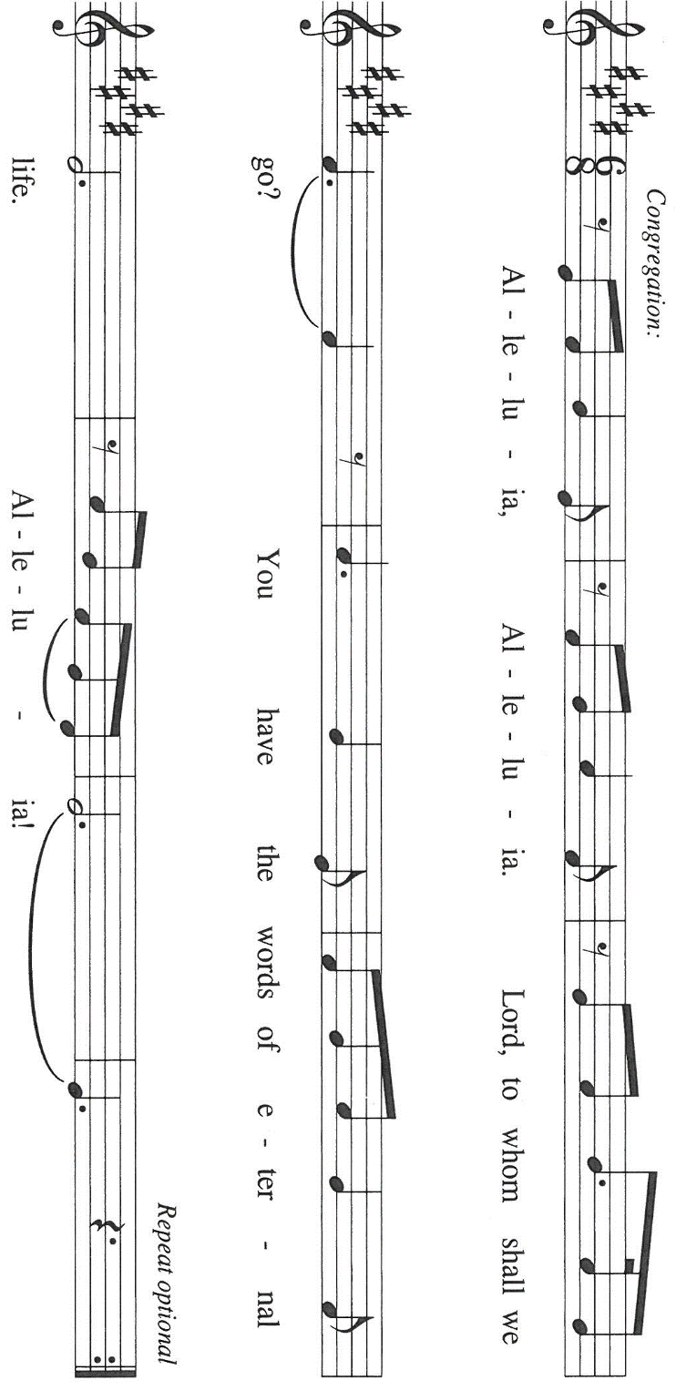
⁸For by grace you have been saved through faith, and this is not your own doing; it is the gift of God--⁹not the result of works, so that no one may boast. ¹⁰For we are what He has made us, created in Christ Jesus for good works, which God prepared beforehand to be our way of life.

The Word of the Lord.

Thanks be to God.

As you are able lease rise

THE VERSE Sung twice

THE HOLY GOSPEL Matthew 9: 9-13

P: The Holy Gospel according to St. Matthew, the ninth chapter.

C: Glory to You, O Lord!

Regarded as a traitor to his people and an oppressor of the poor, this tax collector follows Jesus and then offers him hospitality. In the sharing of a meal Jesus reveals his mission: to serve God's mercy.
⁹As Jesus was walking along, He saw a man called Matthew sitting at the tax booth; and He said to him, "Follow Me." And he got up and followed Him.
¹⁰And as He sat at dinner in the house, many tax collectors and sinners came and were sitting with Him and His disciples. ¹¹When the Pharisees saw this, they said to His disciples, "Why does your teacher eat with tax collectors and sinners?" ¹²But when He heard this, He said, "Those who are well have no need of a physician, but those who are sick. ¹³Go and learn what this means, 'I desire mercy, not sacrifice.' For I have come to call not the righteous but sinners."

P: The Gospel of the Lord.

C: Praise to You, O Christ!

The assembly is seated

THE SERMON

Silence for reflection follows the sermon

As you are able please rise

THE HYMN OF THE DAY (see p. 6) By All Your Saints

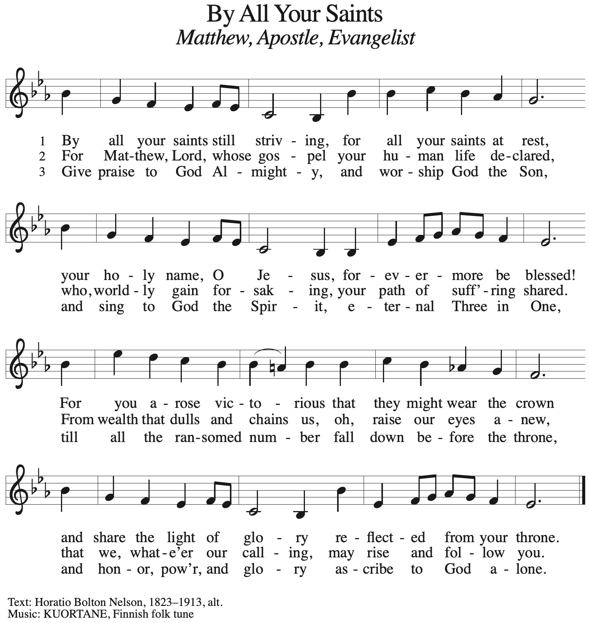
THE NICENE CREED

A: God has made us His people through our Baptism into Christ. Living together in trust and
hope, we confess our faith.

C: We believe in one God,
the Father, the Almighty,
maker of heaven and earth,
of all that is, seen and unseen.

We believe in one Lord, Jesus Christ,
the only Son of God,
eternally begotten of the Father,
God from God, Light from Light,
true God from true God,
begotten, not made,
of one Being with the Father.
Through Him all things were made.
For us and for our salvation
He came down from heaven;
by the power of the Holy Spirit
He became incarnate from the virgin Mary, and was made man.
For our sake He was crucified under Pontius Pilate;
He suffered death and was buried.
On the third day He rose again
in accordance with the Scriptures;
He ascended into heaven
and is seated at the right hand of the Father.
He will come again in glory to judge the living and the dead,
and His kingdom will have no end.

We believe in the Holy Spirit, the Lord, the giver of life,
Who proceeds from the Father and the Son.
With the Father and the Son He is worshiped and glorified.
He has spoken through the prophets.
We believe in one holy catholic and apostolic Church.
We acknowledge one Baptism for the forgiveness of sins.
We look for the resurrection of the dead,
and the life of the world to come. Amen

THE PRAYER OF THE CHURCH

A: As we await the harvest of the Spirit, let us offer our prayers to God Who is abundant in every
good gift.

A: That with compassion and mercy the Church may welcome all sinners, as God’s mercy has
welcomed us, let us pray to the Lord:

C: Lord, hear our prayer.

A: That all leaders and teachers of the Church might be strengthened for courageous speaking and
living of God’s Word in and for the world, let us pray to the Lord:

C: Lord, hear our prayer.

A: That in all places of turmoil and terror, violence and bloodshed there might be a harvest of
reconciliation, justice, and peace, let us pray to the Lord:

C: Lord, hear our prayer.

A: That in this week we may produce an abundance of the good works for which You have created
us, let us pray to the Lord:

C: Lord, hear our prayer.

A: That those who suffer, especially the sick: Martha Schroeder; Mark Tannehill; Jon
Samuelson; Dale Thomas; Angela Cook; Mike Fitzgerald; Jeff Timmrick; Christine
Kiser; and John Ripka might be raised up into God’s healing, let us pray to the Lord:

C: Lord, hear our prayer.

A: That those celebrating birthdays, especially Helen Wiese; may be filled with grace this day
and every day and grow in grace in the days ahead, let us pray to the Lord:

C: Lord, hear our prayer.

A: That with St. Matthew, Evangelist and Apostle, whom we commemorate this Day, we may
faithfully proclaim the generous mercy of God, let us pray to the Lord:

C: Lord, hear our prayer.

P: Teach us to pray, O God, and grant us wisdom in our asking, in the name of Jesus Christ our
Lord.

C: Amen.

MEAL

THE PEACE

P: The peace of the Lord be with you always.

C: And also with you.

The assembly is seated

THE OFFERING

THE VOLUNTARY Be Thou My Vision St. Paul Senior Choir
(C. Young)

As you are able please rise

THE OFFERTORY (see p. 9) As the Grains of Wheat

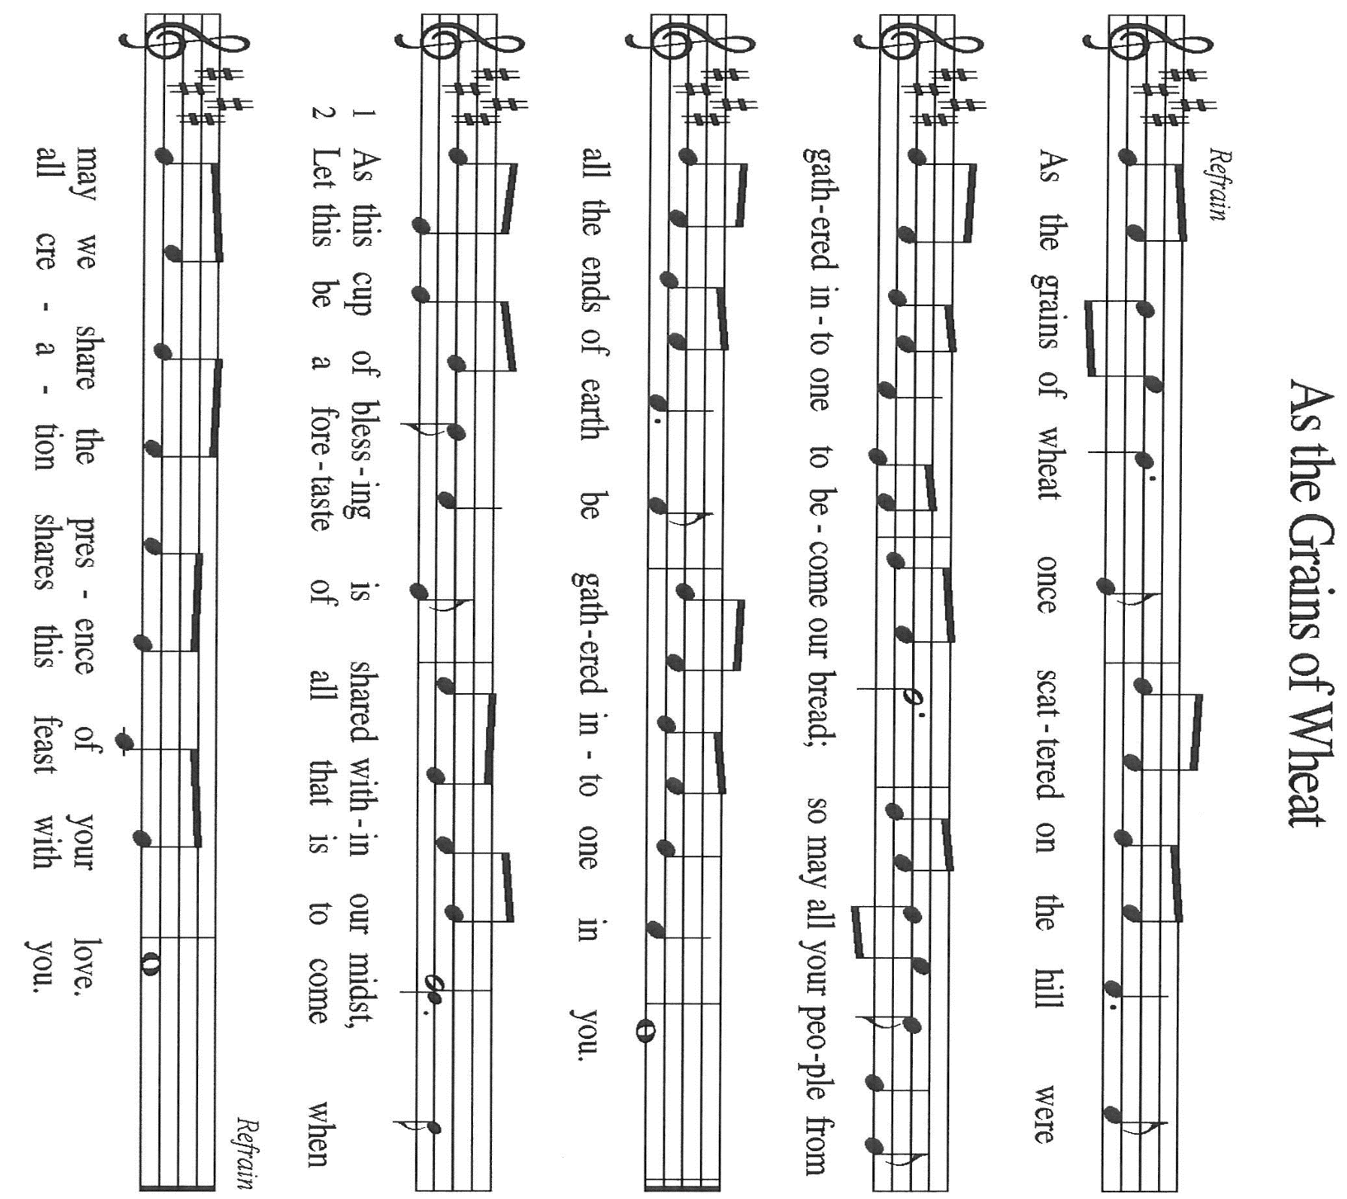

THE OFFERTORY PRAYER

A: Let us pray. Gracious God,

C: You are rich in mercy and have loved us from death to new life in Christ. Receive these
gifts we offer You, and guide us with Your love as You nourish the faith of the Church
by the preaching of Your apostles. We ask this in the name of Jesus the Lord. Amen.
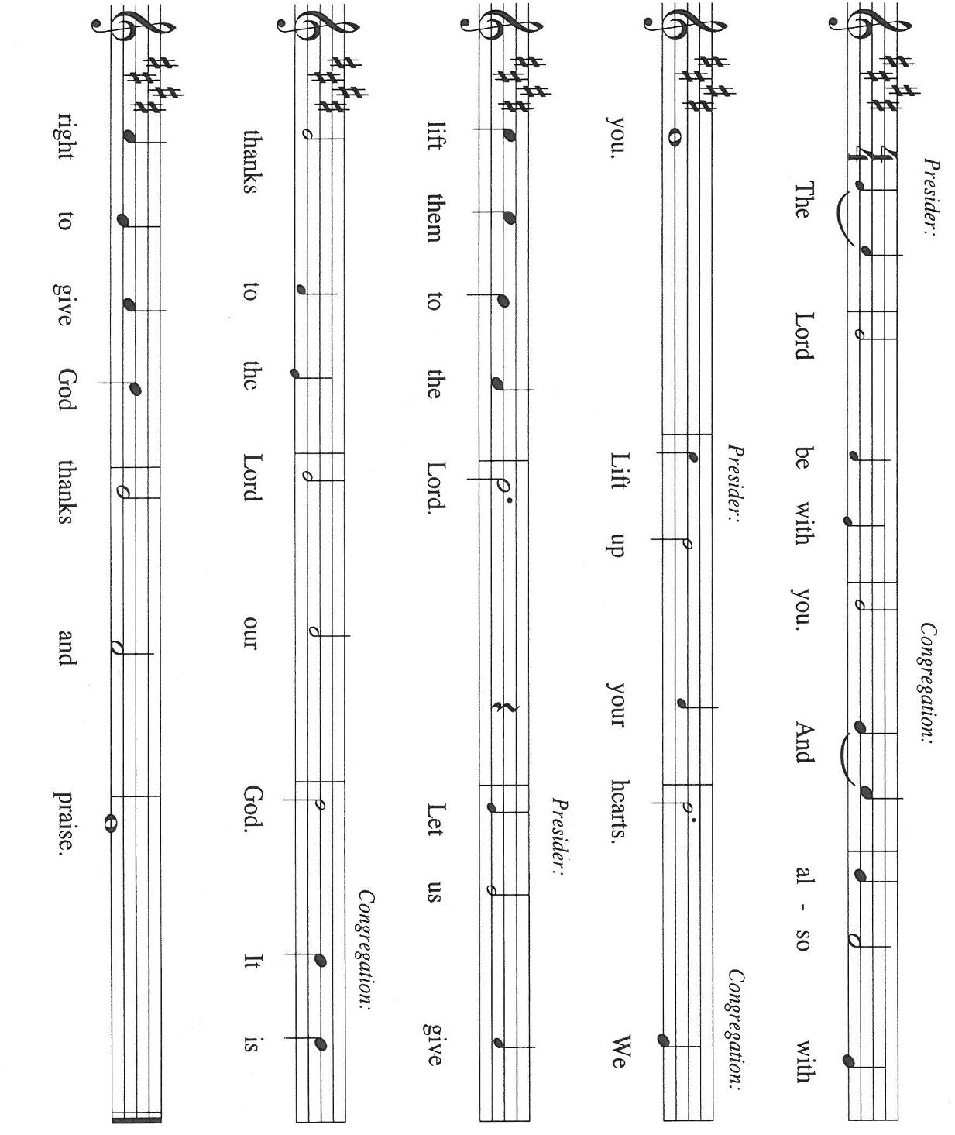
THE GREAT THANKSGIVING

P: It is our duty and delight … join their unending hymn

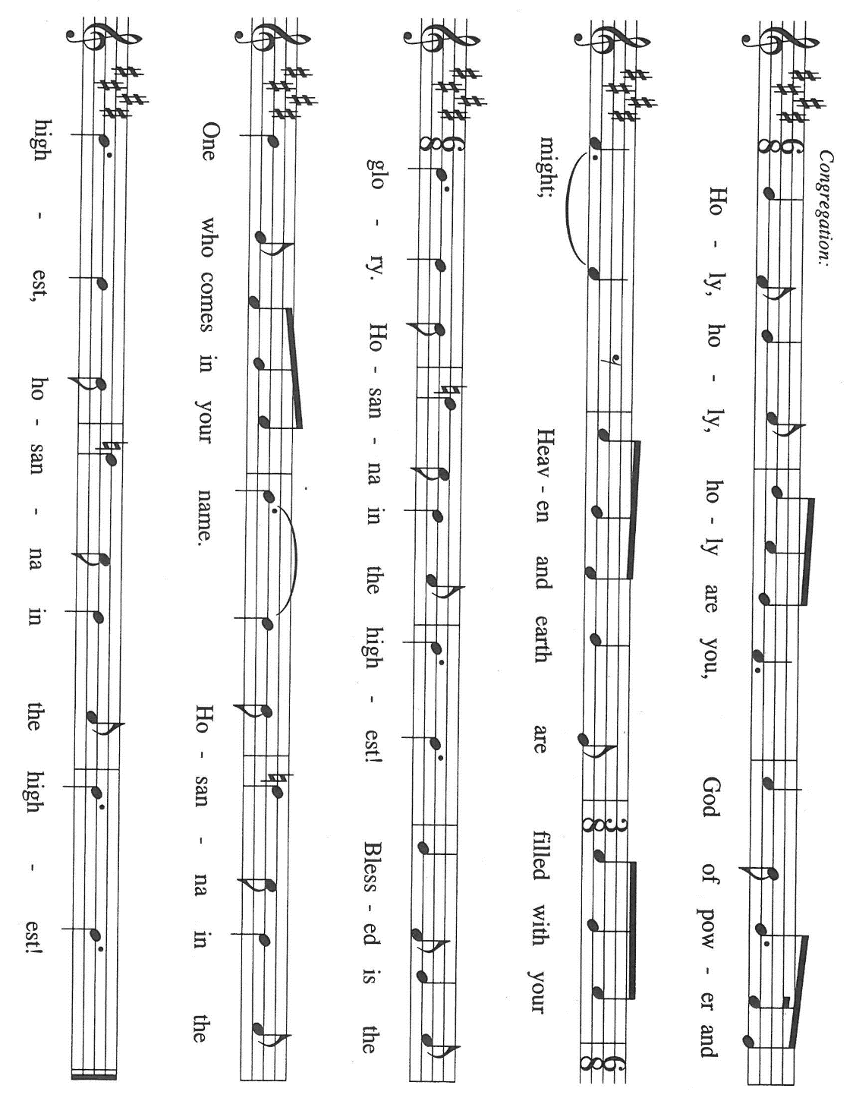

P: Holy God of mercy, we bless and praise You.
For in great love You created us and all creatures.
You chose the house of Israel to bring Your ways to all the world.
When they turned away, You sent judges, kings, and prophets to call them
from sin and death to new life.
At the last, You sent Your only-begotten Son, Jesus Christ.
In Him we are made alive in Your love.

In the night ... “Do this for the remembrance of Me.”
As often as we eat ... we proclaim the Lord’s death until He comes.

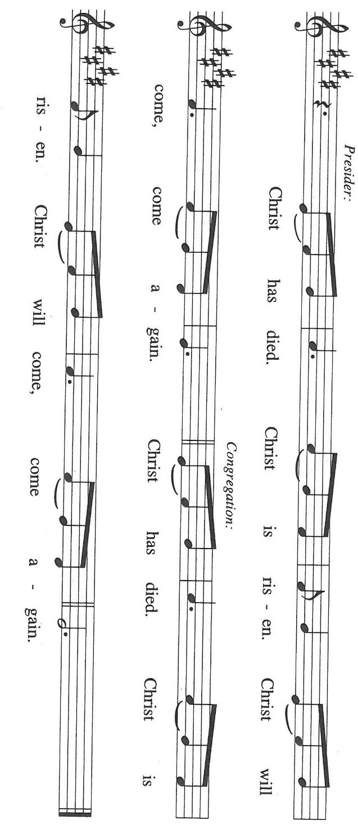

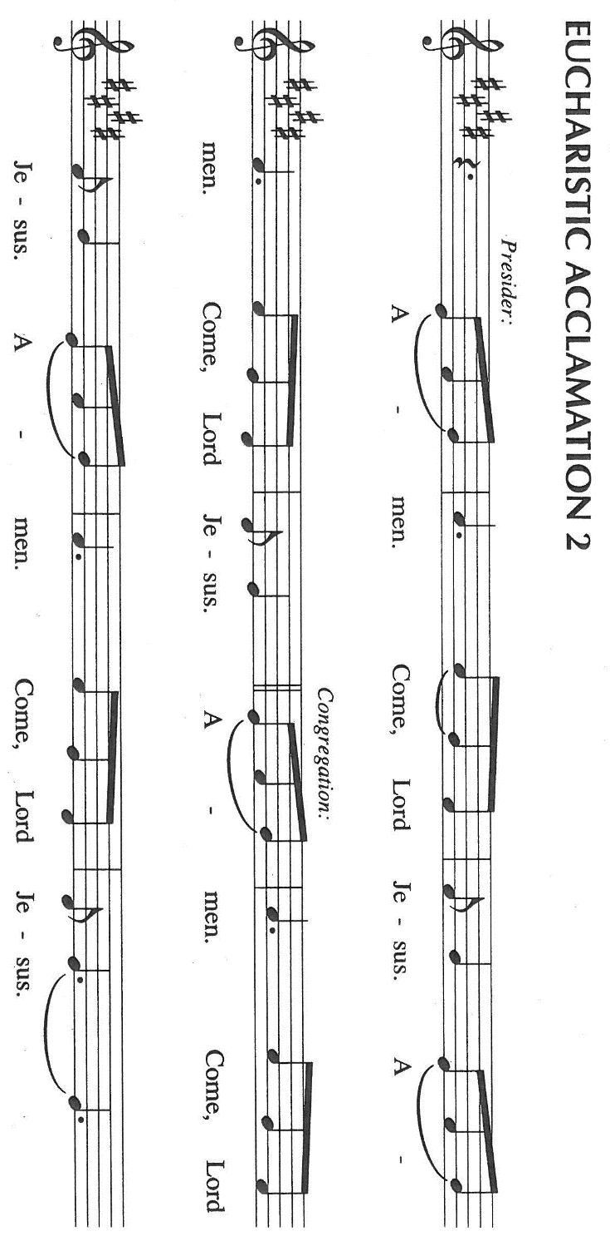

P: With this bread and cup we remember the sacrifice of our Lord’s life.
He fed the hungry, welcomed sinners, and loved us even into death.
Raised from death and seated at Your right hand, He will return in glory to
overcome all Your enemies with the immeasurable riches of His love.

Send Your Spirit on us and these Your gifts of bread and wine.
May this Meal transform us as we respond to His daily call to follow Him
in lives of good works until we receive Your gift of full life in Christ.

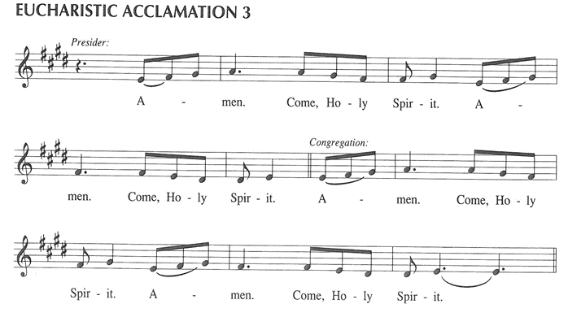

To You, O God: Father, Son, and Holy Spirit, be all honor and glory, in Your holy Church,
in heaven and on earth, now and forever.

C: Amen!

THE LORD’S PRAYER

P: Gathered into one by the Spirit, let us pray as Jesus taught us:

C: Our Father in heaven, hallowed be Your name.
Your Kingdom come, Your will be done on earth as in heaven.
Give us today our daily bread, and forgive us our sins, as we forgive
those who sin against us.
Save us from the time of trial, and deliver us from evil.
For the Kingdom, the power, and the glory are Yours, now and forever.
Amen.

INVITATION TO THE MEAL

P: This is the Lamb of God Who takes away the sin of the world. Blessed are those who are called
to the Supper of the Lamb. God’s holy gifts for God’s holy people. Come, for all is now ready.

The assembly is seated

THE DISTRIBUTION Lamb of God (see p. 14)

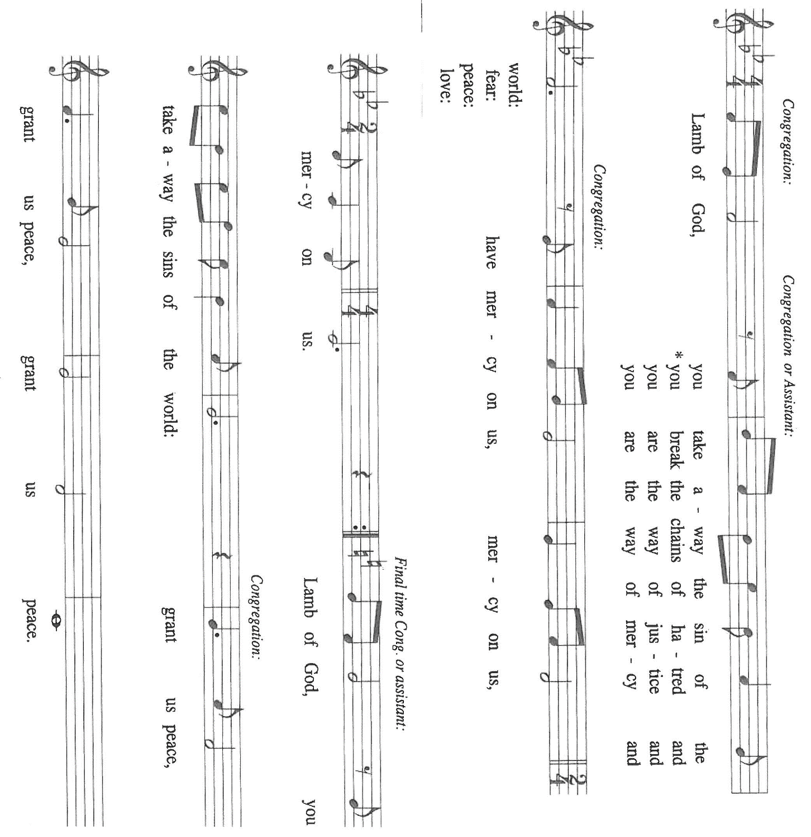

HYMN DURING DISTRIBUTION 428 Give Thanks for Saints

ELW 483 Here is Bread

ELW 496 One Bread, One Body

NSB 48 I Am the Bread of Life (Talbot)

NSB 50 I Exalt Thee

As you are able please rise

THE POST-COMMUNION BLESSING

P: The Body and Blood of our Lord Jesus Christ strengthen you and keep you in His
grace.

C: Amen.

THE POST-COMMUNION PRAYER

A: Let us pray. God of mercy and compassion, we have shared the joy of salvation that Matthew
knew when Jesus called him. May this Food renew our life in Him Who came not to call the
righteous but sinners to new life in His Kingdom, Your Son, Jesus Christ our Lord.

C: Amen.

SENDING

THE BENEDICTION

P: Almighty God: Father, Son, and Holy Spirit bless you now and forever.

C: Amen.

THE RECESSIONAL HYMN 424 Ye Watchers and Ye Holy Ones

THE DISMISSAL

A: Go in peace. Remember the poor.

C: Thanks be to God!

POSTLUDE

To God Alone Be Glory

The Meditation is from Manual on the Liturgy. Philip Pfatteicher and Carlos Messerli.
(Minneapolis: Augsburg Publishing House, 1979) 37.

ANNOUNCEMENTS

Please remember to mail your offering to the Church Office at 818 Franklin Street, Michigan City, IN 46360. Another alternative is to give on-line through Tithe.ly. Please see your closure letter for information on how to set up a Tithe.ly account.

St. Paul Members are reminded to have a loved one contact the office if you are hospitalized. Many times, the Pastor doesn’t know someone is in the hospital. If you call and leave a message, please tell us at which hospital the patient is located.

BIRTHDAYS: Helen Wiese (9/22)

PRAYER CONCERNS: Debbie Martin; Mark Tannehill; Kathy Stein; Jan Paholski; Laura Dovey; Bill Hazelgrove; Al Levenhagen; Carl Wipperman; Major Payne.

OFFICE HOURS: Libby will be in the office on Mondays, Wednesdays, and Fridays; volunteers will cover Tuesdays and Thursdays.

Monday & Wednesday 8:00 a.m. – 5 p.m.
Tuesday & Thursday 9:00 a.m. – 12:00 p.m.
Friday 8:00 a.m. – 12:00 p.m.

If you are listening to the worship broadcast on the radio and would like to watch the Sunday morning service live stream follow these steps:

(1) If you have You Tube available on your TV, search for
St. Paul Lutheran Church Michigan City, IN.

(2) The direct link on the computer is https://
www.youtube.com/channel/UC5AIPNaKr3QN50984jGOa1g

(3) This link is also on the main page of the church’s website in
the church section and will continue to be posted weekly on the
St. Paul Facebook page.

And it will always be available on the radio broadcast Sunday mornings at 11:00
a.m. on WEFM (95.9), and on the local cable access station #99 for the previous
week’s service on Sundays at 4:00 p.m. and the current service on Wednesdays at
7:00 p.m. and Fridays at 8:30 p.m.

To send e-mail to the church office, please use the following addresses:

Pastor Mark Reshan: seniorpastor@stpaulmichigancity.com

Church Office Secretary (Libby Pollock): churchsecretary@stpaulmichigancity.com

Church Treasurer (Karen Fleming): finance@stpaulmichigancity.com

2026 Church Council:

Pastor - Mark Reshan

President - Donna Knoll

Vice President - Jan Bakken

Secretary - Judy Hunt

Treasurer - Karen Fleming

Members: Sue Koziel; Jim Schraidt; Trish Sprague; Bob Kiser; Barry Anderson; and
Pam Soule

Worship Attendance:

Saturday, September 5, 2026 @ 4:00 p.m. 25

Sunday, September 6, 2026 @ 9:00 a.m. 67

TOTAL 92

Copies of the minutes from the June 25, 2026 and July 23, 2026 Church Council meetings are on the back table in the upper Narthex. They were approved by the council via email.

Good News Newsletter: If you have an article or anything you want included in The Good News please send it to the following e-mail address: splcgoodnews@gmail.com. Pastor Pamela Thiede will be using this e-mail address to assemble The Good News each month. The deadline for getting information to Pastor Pamela will be the 20th of each month.

Next week’s lessons are Daniel 10: 10-14, 12: 1-3; Psalm 103: 1-5, 20-22;
Revelation,12: 7-12; Luke 10: 17-20 for those of you who like to study them in advance.

SEPTEMBER 2026 MONTHLY MISSION:
SHRINER’S CHILDREN’S HOSPITAL
We all know Shriner’s from their commercials and their little red hats, but nearly 20,000 children each year get to know Shriner’s Children’s Hospital in Chicago for their incredible pediatric specialty care. The hospital opened in March of 1926 with 60 beds.
60 0% of patients suffered with polio and often lived at the hospital for up to a year. Over the next few decades, an orthopedic residency, bone rodding surgery, halo ring implantation, cleft lip and palate repair, pediatric spinal cord injury surgery, and motion analysis services were added. Our very own little one, Maggie Brooks, has been visiting Shriner’s in Chicago since four weeks old to correct bilateral clubfoot, a condition where she was born with both feet turned inward and upward. Shriner’s offers care to all families no matter their ability to pay or insurance status. They even have financial assistance programs that help reimburse for transportation or lodging if needed.
At Shriner’s Chicago, every child who is inpatient receives a handmade blanket and goody bag upon arrival to the hospital. We will be collecting the following items to help fill their goody bags:
Small cars or toys
Card games
Small activity books
New or gently used children’s books
Please place items in the bin in the outer narthex. If you would like to support Shriner’s financially, please make checks out to St. Paul’s and mark for Shriner’s Children’s Hospital and place in the offering plate. Noisy coin offering will also go towards the mission of the month. Thank you for your generosity!

2026 Financial Stewardship

Weekly Church Operating Needs (x 2 weeks)
September 5-6, 2026 and September 12-13, 2026: $ 10,302.00

General Fund (including General Memorials): $ 7,776.00

Overage/Shortage: — $ 2,526.00

Restricted Income (not including Memorials)
Supports IK Synod & Church wide Ministries: $ 236.00

Ministries in our Community/Congregation: $ 370.00

Capital Fund: $ 327.00

ACTIVITIES, EVENTS & MEETINGS
SEPTEMBER 2026

Sunday, September 13, 2026 @ 9:00 a.m. 16th Pentecost Worship Service /Sanctuary
with coffee after
Monday, September 14, 2026 @ 1:00 p.m. Hope Circle/Green Room
@ 7:00 p.m. Women’s Bible Study/St. Paul Room
Wednesday, September 16, 2026 @ 9:15 a.m. Bible Study/Luther House
@ 10:00a.m. God’s Purls
@ 4:30 p.m. Choir Rehearsal/Sanctuary
Saturday, September 19, 2026 @ 9:00 a.m. – 3:00 p.m. Stained Glass Window Tour
@ 4:00 p.m. 17th Pentecost Worship Service/Sanctuary

Sunday, September 20, 2026 @ 9:00 a.m. 17th Pentecost Worship Service/Sanctuary with coffee after
Monday, September 21, 2026 @ 2:00 p.m. Finance Comm. Meeting/Luther House
@3:00 p.m. Executive Board Meeting/Luther House
@7:00 p.m. Women’s Bible Study/St. Paul Room
Wednesday, September 23, 2026 @ 9:15 a.m. Bible Study/Luther House
@ 10:00 a.m. God’s Purls
@ 4:30 p.m. Choir Rehearsal/Sanctuary
Thursday, September 24, 2026 @ 3:00 p.m. Church Council Mtg./St. Paul Room

Saturday, September 26, 2026 @ 4:00 p.m. 18th Pentecost Worship Service/Sanctuary

Sunday, September 27, 2026 29:00 a.m. 18th Pentecost Worship Service/Sanctuary with coffee after
Monday, September 28, 2026 @ 7:00 p.m. Women’s Bible Study/St. Paul Room
Wednesday, September 30, 2026 @ 9:15 a.m. Bible Study/Luther House
@ 10:00 a.m. God’s Purls

PLEASE NOTE:
God’s Purls are still meeting every week on Wednesdays at 10:00 a.m. but they are no longer meeting in the St. Paul Room at the church. If you have any questions or concerns please contact Judy Mutchler at (219) 229-4764.

Thank$ for $haring
Thank you to all who participate in our Give-Back opportunities each month. We earned $108 from our GIVE BACK at 5 Guys on July 15, 2026. And at our GIVE BACK at Swingbelly’s on Wednesday, September 9, 2026 we earned? Our next GIVE BACK will be at Galveston Steakhouse on Thursday, October 1, 2026 from 4pm—10 pm. Here are two coupons. One for you and one for a friend.

