-
July, 2026
MARK: MY WORDS

It will be a fun change of pace. As you recall, there are three major celebratory events scheduled to commemorate our congregation’s 150th anniversary. The first occasion was on March 15 when we welcomed Bishop Timothy Graham of our Indiana-Kentucky Synod and his wife Meme for a festival service of Holy Communion.
Although it was during Lent, the mood was festive. A special banner was created by Jary Tannehill and processed along with a banner from the 100th anniversary service in 1976. Former pastors, interns, and deaconess Marilyn Chelsvig were present and participated in the service. A brass quintet, along with our Senior Choir, under the direction of Maggie Martin, provided powerful and vibrant arrangements of beloved hymns.
The St. Paul Room was beautifully decorated, and a delicious catered meal was served following the service. There were much laughter and good fellowship. It was a fitting and memorable way to mark the first time the congregation gathered for worship in 1876.
Our third and final celebration will be on Reformation Sunday, October 25, when we will honor the festivals of that time of the church year: Reformation, All Saints, and Christ the King with a hymn festival. Our guest organist will be Dr. Steven Wente, Professor Emeritus of Organ and Church Music at Concordia University, Chicago. Once again, we will have a brass quintet, and a combined choir of members of our Senior Choir and the Harbor Country Singers, all under the direction of Maggie Martin. It will be a powerful evening of song, Scripture readings, and prayer, followed by a light reception in the St. Paul Room.
Squeezed in-between these two major events is a much lower-key gathering on Sunday, July 19. Following the service, there will be an Ice Cream Social in the St. Paul Room. The goodies will be provided by Bubbles Ice Cream Parlor of Michigan City. There will be four flavors of ice cream served: Zanzibar chocolate, vanilla, strawberry, and butter pecan. Nuts, whipped cream, cherries, and sprinkles are included. Chosen toppings will be marshmallow, chocolate syrup, sundae nuts (cashews/almonds), and hot caramel.
Everyone who purchased an anniversary T-shirt is encouraged to wear it to worship that day. We will sing our anniversary hymn and enjoy some wonderful, refreshing ice cream and joyful fellowship. There is no charge for the sundaes so plan to join us for another uplifting anniversary year celebration.



The Fourth of July falls on a Saturday this year, and there was much discussion about whether to hold our usual Saturday afternoon worship service. The belief was that many people might either be out of town or involved in family gatherings or special community observances. We took two informal surveys among the Saturday worshipers; and given the small number of people who said that they would attend and the likelihood that people may attend some of the observances, the Worship Committee decided that there will be NO worship service on Saturday, July 4. Worship on Sunday, July 5, will be held as usual at 9:00 a.m.


I scream, you scream, let's all scream for FREE ice cream on Sunday, July 19! We will be celebrating the church's 150th anniversary with an ice cream social in the St. Paul Room following Sunday morning worship on July 19. Please plan to join us and the Bubble's crew to enjoy an unlimited, no-cost-to-you sundae bar! Come and create your favorite concoction of vanilla, Zanzibar chocolate, strawberry, or butter pecan topped with marshmallow creme, chocolate sauce, hot caramel, whipped topping, sprinkles, or nuts, and of course a cherry on top! Everyone is encouraged to wear their St. Paul 150th anniversary shirts to worship and the ice cream social that day. Bring your friends, bring your family, but most of all, bring your sweet tooth! We can't wait to celebrate 150 years of worship with you and a sweet treat!

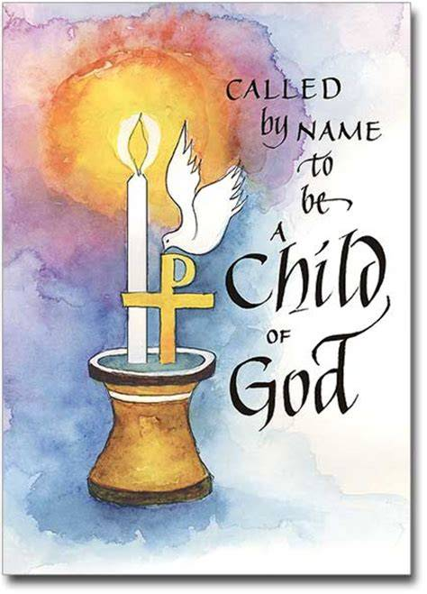

BAPTISM

On Sunday, July 12, we will joyfully celebrate the Baptism of Maggie Louise Brooks, daughter of Paul and Lora. We look forward to welcoming Maggie as the newest member of the Body of Christ.

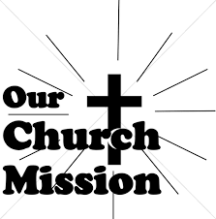
JULY MONTHLY MISSION
LUTHERAN WORLD RELIEF KITS

We will be purchasing supplies to assemble two kinds of Lutheran World Relief kits this fall. Lutheran World Relief kits are sent to people around the world who are experiencing poverty, disaster, conflict, or more. To make it easier, we are offering everyone an opportunity to sponsor kits. Please indicate how many of each kit you would like to sponsor and return this form with payment in the offering plate (or to the church office). We will take care of purchasing all the supplies. We will hold an assembly day before Saturday worship this fall where we will assemble all the kits together. (No purchase necessary to help us assemble. We will assemble as a team; you will not be responsible for assembling all the kits you purchase yourself.)

Orders are due Sunday, August 2, 2026. Please make checks payable to St. Paul Lutheran Church.

______________# of health kits at $10 each
(Health kits contain a towel, bar soap, toothbrush, comb, and nail clippers.)

______________# of school kits at $10 each
(School kits contain a drawstring backpack, notebooks, rulers, pencils and pens, pencil sharpener, scissors, crayons, and an eraser.)

Total $______________


CALL PROCESS

Since it has been over twenty years since the congregation was involved in the Call Process, the Church Council asked me to summarize the steps so that everyone would understand what will occur both before and after I leave my service here. Feel free to ask me or any Council members about any questions or concerns you might have.
- I have notified the Synod office of my intention of retiring. The first step is to schedule a “transition visit” (exit interview) with me and the Council. That has been set for Thursday, August 27, when Bishop Graham will lead those discussions.

- In cooperation with the Council, an Interim Pastor is appointed by the Bishop. This person provides both weekday ministry and weekend worship on a full-time or part-time basis as determined by the Council.

- A workshop, “Exploring God’s Expectations,” is scheduled by the Synod office for the Council to discern its health and mission. The names of those from the Synod who will conduct this workshop will be given to the Council, and the President of the Council will meet with these persons to discuss immediate leadership needs.

- A Call Committee of normally 5 or 7 persons is appointed by the Council. They are to be representative of the congregation’s membership and concerns.

- Once the workshop has been completed. a meeting with the person from the Synod office who oversees the Call Process is scheduled with the Council and the Call Committee to give an overview of the Process.

- A survey is conducted to determine needed leadership skills and interests. These will be included in the Ministry Site Profile, a thorough assessment of the congregation’s history, needs, and mission.

- Pastors who are looking to move to another congregation (or their first congregation after graduating from seminary) also fill out a detailed profile listing their skills, strengths, and interests for ministry.

- The Synod office will work to match the congregation’s needs with the gifts of potential candidates. One to three candidates’ names will be submitted to the Call Committee for consideration. They have the responsibility to interview all candidates to be considered for call.
- The Call Committee conducts an initial interview with the candidate(s) seeking call to determine whether the gifts and ministry style of the candidates match the needs of the congregation. If none of them are deemed suitable, they will be notified by the Committee that they are no longer being considered for the call. Additional names will then be requested by the Call Committee Chair from the Synod office.

- If a primary candidate has been selected by the Committee, their name is referred to the Council, and the other candidates are notified that they are no longer under consideration.

- The Council interviews the candidate and may either accept or decline the candidate. If declined, the process is repeated until the Call Committee and Council agree on a candidate to be recommended to the congregation.

- If the Council accepts the Committee’s recommendation, a congregational meeting is scheduled for consideration of the call. The Synod office is notified of the date and an Official Letter of Call and related materials are given to the Council.

- On that date, the candidate preaches and leads worship, followed by an informal meeting with the congregation. A call meeting is conducted by a representative of the Bishop, at which time the Letter of Call and proposed compensation package is reviewed and acted on by the congregation. A 2/3-majority of a written ballot vote of eligible voting members is required to extend the call. The compensation package requires a simple majority vote.

- The completed Letter of Call and compensation form is signed by Council officers and forwarded to the Synod office. The Bishop then sends the Letter of Call to the candidate. Upon receipt of the Letter of Call, the candidate has 30 days in which to respond.

- With a positive response, a date is set for the start of service to the congregation. The Synod office is notified. and a date for the installation service is scheduled, at which time the candidate is installed by the Bishop or a synod staff member.

- If the call is declined, the process resumes with the Call Committee interviewing further candidates.

As you can see, this is not a quick and easy process. You may recall that Pastor Richard Poole, who served as Interim Pastor after Pastor Matevia left, was here for three years before I arrived. Given how many “Boomer” pastors like me are or will be retiring, the small number of seminary graduates coming out of our ELCA schools, and the number of other congregations in our Synod seeking pastors (as of this writing there are 21 in that position), the Call Process could go on for some time.
The congregation will need great patience, strong prayer for wisdom and guidance for the Call Committee, and above all, trust that God will bring it together with a candidate who will serve St. Paul faithfully and fruitfully.


June 18, 2026

Dear St. Paul Congregation,
You will never know how often I ask myself the question, “How does anyone ever get along with out a church family?” That is because of all of you whom we do, indeed, consider family.
On behalf of Mark and me, we’d like to thank you all for your love and support. It’s been almost four years since this insidious infection began. We still don’t know how it started, but it has resulted in our seeing many doctors at three highly acclaimed medical universities: Indiana University Hospital in Fishers, Mayo in Rochester, and Rush in Chicago. The prognosis was the
same everywhere, “We can save the leg, but you will have to be on heavy-duty antibiotics for the rest of your life.” Neither of us realized the toll that would take on Mark’s system. So, after much prayer and soul-searching, Mark finally decided to have his leg amputated.
That is when the love started pouring in, and we are so greatful! Thank you for the cards and prayers. Thank you for building Mark a ramp. Thank you for the cash and gift cards. Thank
you for the food and for the rides to and from appointments. Thank you for being with me when I was in the waiting room. Thank you for the texts and emails. Thank you for the phone calls; but mostly, thank you all for being there for us.
By the time you are reading this, Mark will likely have his new leg and may well be on his way to a new normal of walking on it. This could not happen without your help! We love you all!
Fondly,

Mark and Jary Tannehill


July Birthdays July Anniversaries
3 Christian Scheuchner 1 Chip & Audrey Claussen
4 Amy Petri 3 Jeffrey & Helena Albertson
6 David Squires David & Nancy Squires
Donna Sutor 17 Allen & JoAnne Sydow
8 Albert Green 18 Mike & Amy Maesch
10 Elizabeth Thompson
Sharon McCay
11 Warren Schacht
12 Norma Milzarek
13 Warren Glanz
14 Craig Hunt
15 Kyle Neulieb
24 Zachary Petri
25 Cheryl Kaluzny
Bernadette Krueger
29 Charles Thomas II



IN MEMORY OF ALLEN KRING
General Fund from JoAnn Kring


Long-Term Prayer List

Lucas Bradshaw Laura Dovey Bethany Manning
Debbie Martin Shirley McCarty Jan Paholski
Martha Schroeder Jeanie Boatman Shepple Kathy Stein
Mark Tannehill Kathy Thielman Delores Williams
Brian Wiseman

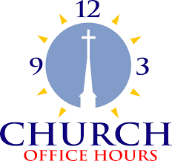

Monday 8:00 a.m. – 5 p.m.
Tuesday 9:00 a.m. – 12:00 noon
Wednesday 8:00 a.m. – 5 p.m.
Thursday 9:00 a.m. – 12 noon
Friday 8:00 a.m. – 12 noon

St. Paul Lutheran Church Staff
Pastor Rev. Mark Reshan
Secretary Libby Pollock
Accompanists Jary Tannehill, Mark Tannehill, Jacob Tannehill
Custodian Mark Kloess

Thank$ for $haring

In May, we raised $220 from the Give Back at Galveston. In June, we raised $273 at Holly’s. Thanks to every who participated.

This month, we are going to Five Guys on Wednesday, July 15. Here are two coupons—one for you and one for a friend.

