-
April, 2026
MARK: MY WORDS

We have noted before the importance of recognizing Easter as a season rather than a one-and-done day at the end of Lent and the Three Days. The enormity of the earth-and-history-shattering announcement that “He is not here; He has been raised, as He said” (Matthew 28:6) made by the “angel who descended from heaven, whose appearance was like lightning and his clothing white as snow” to the women at the tomb requires more than one day to grasp and celebrate its importance. There are seven (the Biblical number for completion or perfection) weeks in which to ponder and honor The Living One.
Although this is the year of St. Matthew’s Gospel, on six of the weeks after Easter Sunday, we hear from John’s Gospel. An essay from our worship resource, Sundays and Seasons, offers a look at the theme of these readings:
We have arrived at the Easter season. Jesus has been resurrected from the dead, and we circle back around to one of Jesus’ most pertinent teachings about himself: “I am the way and the truth and the life” (John 14:6).
While we’d love to start Easter with all the disciples on fire for Jesus, running through the streets and telling everyone what the women disciples have shared with them about Jesus’ resurrection, we do not. Instead, we encounter them locked in a room, terrified of the Judean leadership, likely concerned for their own mortality, and clearly not convinced that the women were telling the truth. Ah, the humanity of it all!
We have likely faced a time when something seemed too good to be true or when we’ve had trouble exercising our faith when we needed it the most. …
… Sometimes, as frail human beings, we need Jesus to meet us just where we are. Whether it is in a locked room with the promise of peace, or on the Emmaus road in the breaking of bread and drinking of wine, sometimes we need Jesus to show up and stay with us a while amid our heartache, pain, and wavering faith. When life seems too much to bear, Jesus says to us, “I come that you may have abundance of life!” (see John 10:10). In a world filled with scarcity-thinking, Jesus promises more than enough…
… This is terribly countercultural. When the “demons” of scarcity are breathing down our necks, telling us that there is not enough—there is never enough—Jesus says, “I am the way and the truth and the life” (John 14:6). In other words, “I am enough!”
The truth is that there is always enough inside the beloved community formed and held together by God. Perhaps that is why Jesus turns our attention to living in love for God and neighbor. “If you love me, you will keep my commandments” (John 14:15).
Such a rich variety of texts contribute to these weeks being the most joyous time of the church year. After the solemnity of Lent, it will feel good to be able to break out our “Alleluias!” and delve into the rich liturgical and hymnic resources of the Church to bear witness to the Resurrection.
As you committed to the forty days of Lenten discipline, so may you also resolve to attend and participate in worship and service beyond Easter Day through the Fifty Days of The Resurrection. You, and we, and those we are called to serve will be blessed in that holy work.



Although only a few days remain of the Lenten/Holy Week liturgies, it is good to be reminded of our scheduled worship services during these most holy Days:

Thursday, April 2 Maundy Thursday Senior Communion/Altar Guild luncheon 10:00 a.m.
(Please note: there will be NO evening service)

Friday, April 3 Good Friday Tenebrae 7:00 p.m.

Saturday, April 4 The Vigil of Easter 7:00 p.m.
Sunday, April 5 The Resurrection of Our Lord 9:00 a.m.


PRAYER LIST

We have gotten away from our practice of including people on our prayer list during worship. We had decided that unless a person was in hospice care or recovering from surgery, we would limit mentioning them to three weeks, after which time they would be moved to the long-term prayer list in the newsletter. They will still receive our prayers, just not publicly during worship. We will return to that arrangement.

THANK YOUS

As this is being written, we are moving toward Palm Saturday/Sunday and the liturgies of Holy Week and Easter morning. Although there are two less services again this year than in the past, there is still an enormous amount of work that goes into preparing for all those worship services. Like the services around Christmas, we just assume (and expect) that the worship space will be decorated beautifully, the music will be uplifting and inspiring, and that the services will run smoothly and flawlessly.
All of that takes place because of the efforts of so many of our volunteers who selflessly give of their time, effort, and energy to make our worship special. At the risk of overlooking someone, here is a list of those who participated in preparations and our worship during Holy Week:

Deacons/Ushers Craig Hunt, Bob Kiser, Rich Fleming,
Tim Crozier, Kelly Neulieb

Assisting Ministers Donna Knoll, Sarah Payne, Trish Sprague,
Sue Koziel

Lectors for the Easter Vigil Donna Knoll, Trish Sprague, Susan Bagby

Lectors for Palm Saturday/Sunday/ Trish Sprague, Sue Koziel, Sarah Payne,
Maundy Thursday/Good Friday Doug Kienitz, Donna Knoll

Altar Guild
Palm Sunday Norma Milzarek, Sue Koziel, Melinda Nagle
Maundy Thursday and Easter Vigil Sandy Galinowski, Bernadette Krueger,
Karen Peters, Karen Steinborn, Virginia Murray

Easter Judy Hunt, Bernadette Krueger

Video Paul Brooks, Mike Bockover, Pam Soule

Musicians Dr. George Karst, Maggie Martin,
The Senior Choir, New Song Praise Band

Flowers and decorations Sue Koziel, Karen Steinborn, Karen Peters

Bulletins Libby Pollock

MORE THANK YOUS

The 150th Anniversary service and dinner was a great success. Attendance was good; the music was powerful and uplifting; the Bishop’s sermon was full of God’s Good News and promises; the dinner was delicious; the fellowship warm and inviting; and a great sense of joy and celebration permeated the entire day.
For those who were not able to attend, here is a list of those who contributed so mightily to that Day, first worship participants and then those who helped with the dinner, decorations, and other work connected to our time together.

Worship Participants
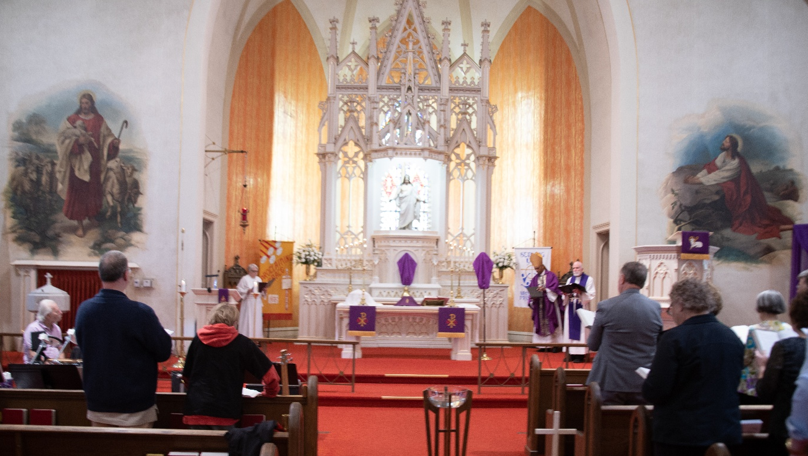
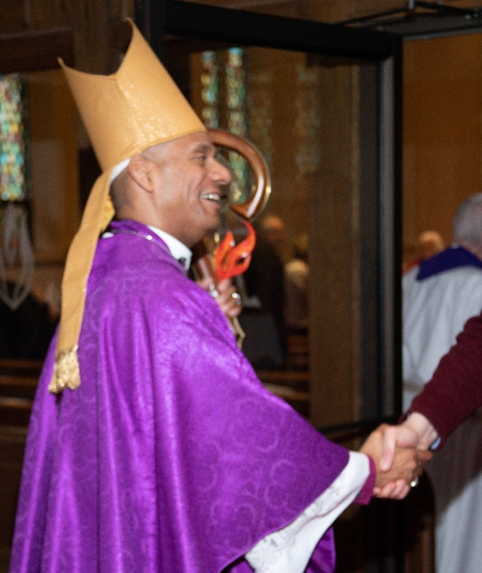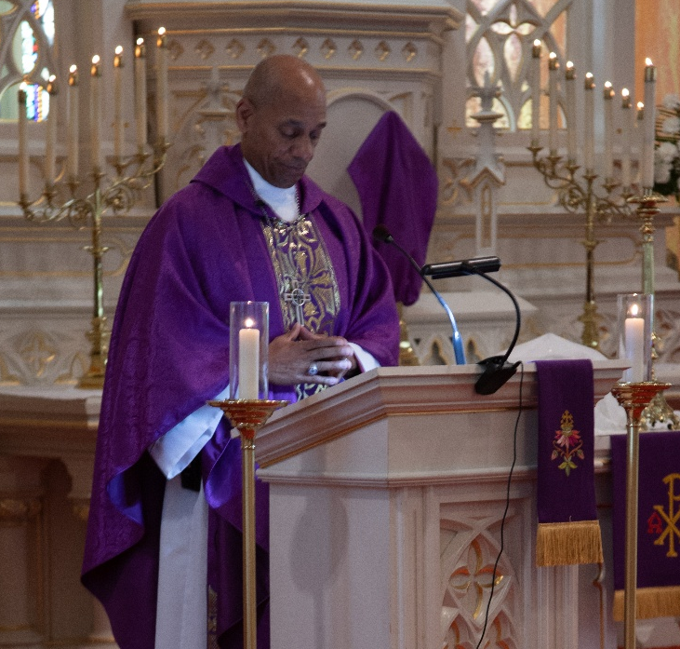
Preacher/Presider Bishop Timothy Graham, Indiana-Kentucky Synod, ELCA


Lectors Bishop Emeritus Jim Stuck (former pastor)
Pastor David Schreiber (former pastor)
Pastor Phil Geleske (son of the congregation)
Pastor Dale Zylstra (adopted son of the congregation)
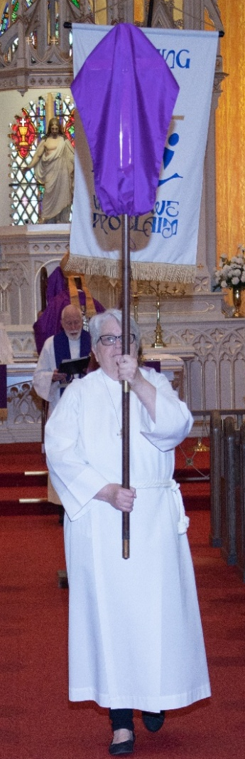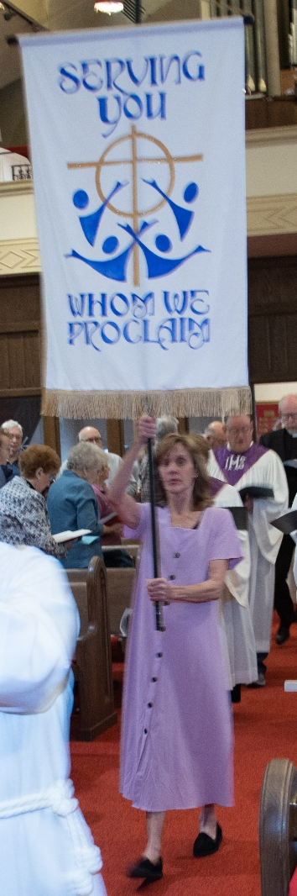

Crucifer/Assisting Minister Donna Knoll, Church Council President

Banner Bearer Peggy Wolf

Anniversary Banner Jary Tannehill

Anniversary Logo Pastor Mark Kloess

Deacons/Ushers Bob Kiser, Tim Crozier, Rich Fleming

Handbell Choir Maggie Martin, Director
Kelly Neulieb, Trish Sprague, Judy Hunt, Karen Fleming,
Judy Mutchler

Organist/Pianist Maggie Martin, Director of Music

The Michiana Brass Charles Steck, Trumpet; Jay Crouch, Trumpet
William Browne, Horn; Gary Cooper, Trombone
Gary Kurtis, Tuba

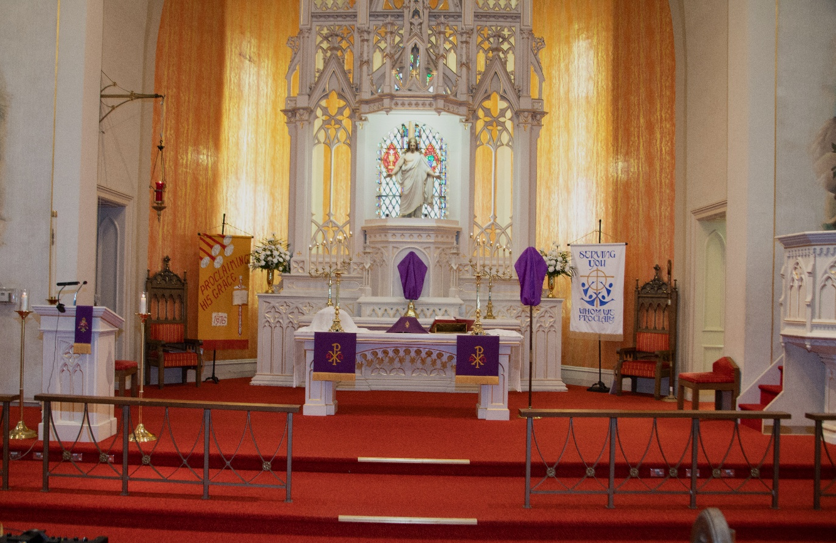
Altar Guild Judy Hunt, Virginia Murray, Melinda Nagle, Marge Bockover

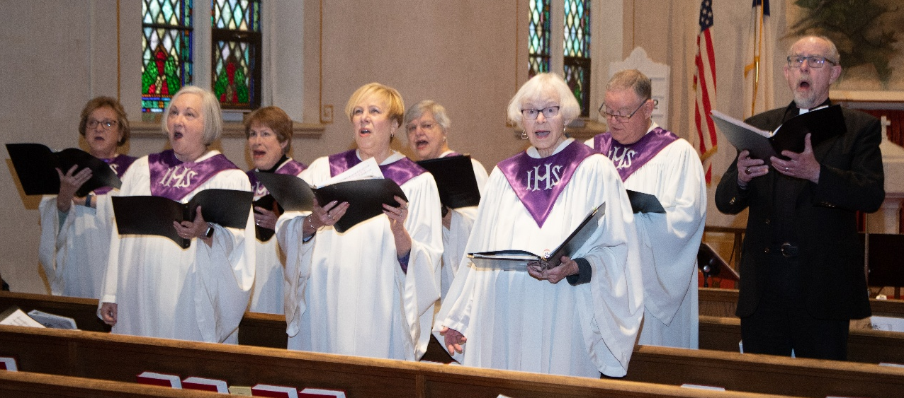
St. Paul Choir Stacie Crozier, Mary Knaup, Virginia Murray, Joan Seifert,
Susan Bagby, Susan Koziel, Doug Kienitz, David Jocelyn

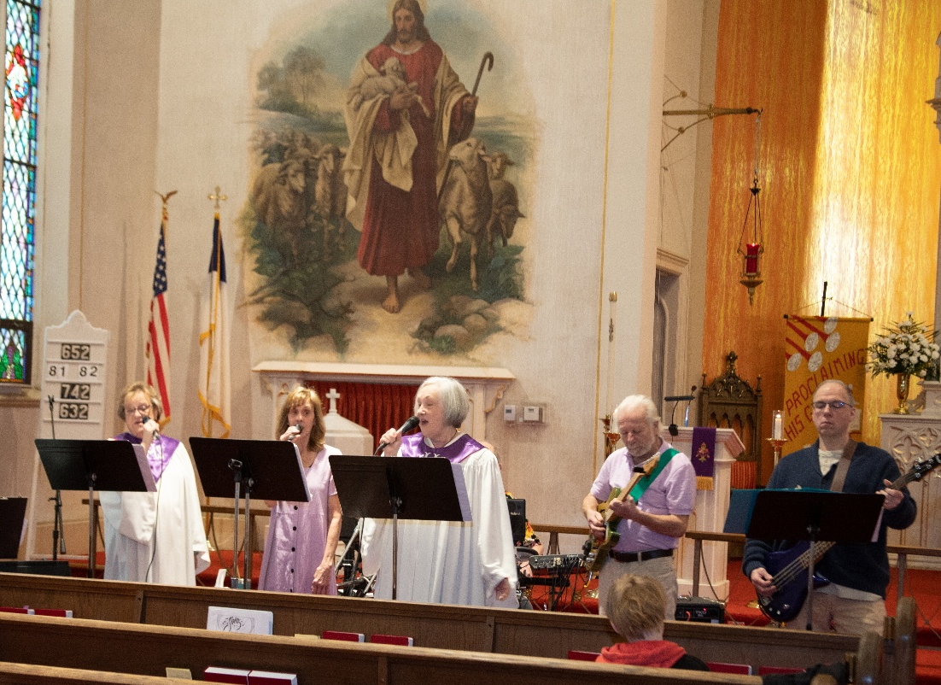

New Song Praise Band Jary Tannehill, Mark Tannehill, Charles Marks, Jacob Tannehill, Peggy Wolf, Stacie Crozier, Susan Koziel
Anniversary Committee Paul and Lora Brooks, Virginia Murray, Sue Koziel,
Janet Bakken

Beacher Article and
Mayoral Proclamation Barry Anderson, Laura Mellen

Archives Laura Mellen

DINNER HELPERS

Decorations Sue Koziel, Karen Steinborn, Virginia Murray, Stacie Crozier, Karen Peters

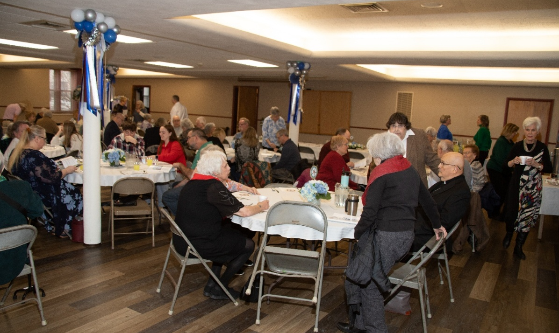
Servers and Clean-Up Crew Susan Murray, David Murray, Kerry Steinborn, Mike VanArken

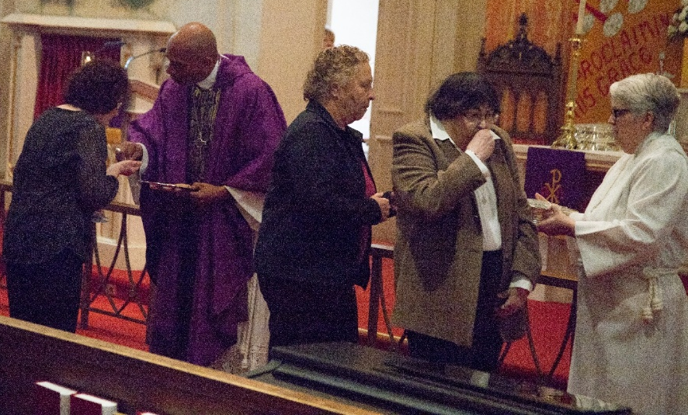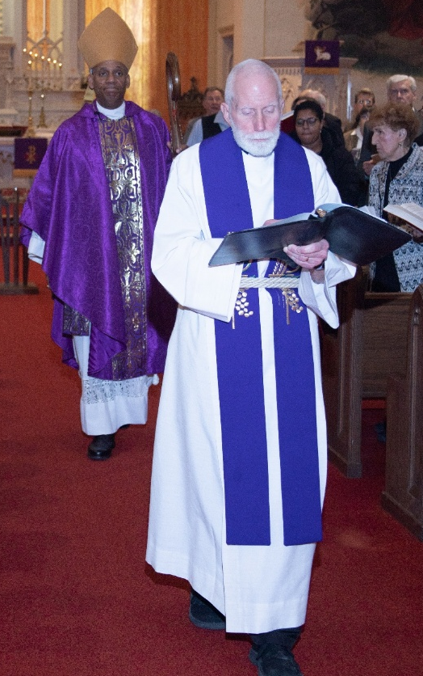


FUNERAL ARRANGEMENTS

I wrote about this several years ago, but a recent situation reminded me that it bears repeating. When a loved one dies the preparations and details for a funeral can be overwhelming, particularly if this is the first time the family has had to deal with a death. For many people, the first step is choosing which funeral home with whom they would like to work.
Usually, within a few days of the death, the funeral director will want to meet with the family to discuss arrangements and their preferences for the service and burial. If the family would like the funeral/memorial service to take place at church, or, if they want me to conduct the service at the funeral home or the cemetery, it is vital that I be consulted about the date and time before arrangements are set with the funeral home.
Not long ago we had a situation where the time and the date of the funeral was determined by the family with the funeral director without contacting me to see if I was available. From a professional standpoint, funerals always take precedence for my schedule. Most of the time, if I already had something scheduled, I can move that around to accommodate the family’s desire to have the funeral when it is best for them.
However, sometimes such juggling is not possible, or there may be a personal commitment that I am unable to change. Out of courtesy and respect for me, I would ask that the family or the funeral director check with me first before a date and time are scheduled for the service.
Thank you for your understanding and cooperation.



TIME AWAY

As always, I plan (hope) to take the week after Easter off to recuperate from the busyness of the end of Lent/Holy Week/the Easter Vigil and the celebration of The Resurrection. In the past I have said that if there is an emergency that I may be contacted on my cell phone (630-450-1894).
But, in the past, people’s understanding of “emergency” has led to phone calls, text messages, and emails that could well have waited until I returned. So, this year I will ask this: unless there is a death, please wait to contact me until worship on Saturday, April 11 or Sunday, April 12. I will be back on those days to preach and preside. If there is a hospitalization in which death does not seem imminent, please rely on the hospital chaplains for pastoral care.
As the only pastor, it can be difficult to truly get away from the office; but such time is vital to my spiritual, emotional, physical, and mental well-being.

MONTHLY MISSION: BOYS & GIRLS CLUB of LaPORTE COUNTY

The Boys and Girls Club provides a safe space for kids to go after school, during the summer, and while school is operating online, to learn and grow beyond the classroom. Members receive access to homework help, mentoring, sports programs, STEAM enrichment, community service opportunities, and much more. Their programs include the following:
- Homework Help/Tutoring/Power Hour – daily homework assistance and educational activities
- Career Explorations – Virtual job shadowing programs for a wide range of careers for post-grads where they can learn about careers plus the education/training necessary to achieve them.
- Ultimate Journey/STEAM – Science, Technology, Engineering, Art, and Math enrichment activities such as making slime, building stomp rockets, Lego challenges, and much more. The Westcott club features a dedicated STEM MakerSpace and teaches problem-solving, critical thinking, and decision-making.
- Volunteering – provides opportunities for writing letters to nursing home residents, cleaning up litter around the Elston school building, and creating safety posters for use at school.
- SMART Moves and SMART Decisions – Skills Mastery and Resilience Training help students develop good decision-making skills and increase their social-emotional skills.
- Game Changers – health and wellness program that allows students to sample different sports, games, and physical activities.
- Food Program – provides free snacks to after-school Club members and free breakfast, lunch, and a snack to Summer Club members.
If you would like to support this mission, we will be collecting both supplies and monetary donations. Please make checks payable to St. Paul; mark them for the Boys and Girls Club and place them in the offering. Noisy coin for the month of April will also go to support the Boys and Girls Club. The following supplies can be placed in the bin in the Narthex:
- Construction paper and card stock of all colors, plain white paper
- Felt
- Glue bottles, sticks, or bulk pourable
- Bulk pourable tempura paint
- Markers and crayons
- Paper towels, Kleenex, disinfectant/cleaning wipes
- Dixie cups
- K-8th grade appropriate board and card games
- Plain block Legos
- Play Doh
- Small “treasure box” type prizes
Thank you for your unwavering support for our community each month!

April Birthdays April Anniversaries
1 Jana Thomas 2 David & Nancy Zummak
Marjory Bockover 8 Gary & Nan Larson
Steve Baker 16 Jacob & Monica Tannehill
3 Sarah McNabb 22 Tim & Stacie Crozier
5 Connie Burgess 24 Stephen & Lauretta Hapke
7 Kathryn Glanz
10 Jeffrey Albertson
13 Drew Robbins
15 Richard T. Cains
Nancy Hawkins
16 Karen Kiser
17 Megan VanGemeren
19 Diane Sunde
20 Jeffrey Furness
Melania Roberson
23 Jean Kleinschmidt
25 Marie Protas
26 Karen Fleming
Tim Crozier
28 Virginia Murray
Ryan Krueger
29 Jason Howard
30 Sharon Hutchcraft
Sheryl Lubke



Long-Term Prayer List

John Bennitt Lucas Bradshaw Laura Dovey
Bethany Manning Debbie Martin Shirley McCarty
Sarah McNabb Jan Paholski Martha Schroeder
Jeanie Boatman Shepple Kathy Stein Mark Tannehill
Kathy Thielman David Weiss Brian Wiseman



IN MEMORY OF FRED WEISS
General Fund from Jim & Bernadette Krueger, Bob & Karen Kiser, Jim & Sandy Galinowski, Wayne & Suzann Dolson, Janet Bakken, Susan Bagby, Richard Thielman

IN MEMORY OF GRACE ROMINE
General Fund from Jim & Bernadette Krueger; Faith Circle (Nancy, Kathy, Lynn, Marge, Sharon); Virginia, David, & Susan Murray; Bob & Karen Kiser; Mark Romine; Janet Bakken; Jim & Sandy Galinowski; Wayne & Suzann Dolson; Susan Bagby; David & Nancy Squires

IN MEMORY OF JOYCE STARK
General Fund from Edward & Wanda Young, Mike & Carolyn Shebel,
Warren & Kathryn Glanz



Monday 8:00 a.m. – 5 p.m.
Tuesday 9:00 a.m. – 12:00 noon
Wednesday 8:00 a.m. – 5 p.m.
Thursday 9:00 a.m. – 12 noon
Friday 8:00 a.m. – 12 noon

St. Paul Lutheran Church Staff
Pastor Rev. Mark Reshan
Secretary Libby Pollock
Accompanists Jary Tannehill, Mark Tannehill, Jacob Tannehill
Custodian Mark Kloess

Thank$ for $haring
Thank you for participating in our St. Paul Givebacks. Our Galveston outing raised $205, and we raised $263 at Holly’s.

This month, we are going to Swingbelly’s on Wednesday, April 8. Here are two coupons—one for you and one for a friend.

