THE EIGHTH SUNDAY AFTER PENTECOST
July 19, 2026

For if we are forbidden to uproot the tares, and if we are to wait in patience until the harvest time, how then are we to cast out certain persons from amongst us? Between the true wheat and the tares, while the latter is still green, and the stalk has not yet come into ear, there is a great similarity, and little or no difference between them, so as to tell one from the other.
The Lord therefore warns us that in the beginning we are not to be too ready to deliver judgment, where anything is uncertain; but that we leave judgment to God, so that when the day of the Judge shall come, he shall exclude the wicked from the company of the blessed, not on the mere suspicion of having committed an offence, but because of manifest guilt.

St. Jerome
Fourth Century

INTRODUCTION

It is an age-old question: why is there evil in the world? In the parable of the wheat and the weeds Jesus suggests that both grow together until the harvest. With Paul, we long for the day that all creation will be set free from bondage and suffering. Having both weeds and wheat within us, we humbly place our hope in the promises of God, and from the Lord's table we go forth to bear the fruit of justice and mercy.

GATHERING

PRELUDE

ANNOUNCEMENTS

As you are able please rise

CONFESSION AND ABSOLUTION

P: In the name of the Father and of the Son and of the Holy Spirit.

C: Amen.

P: “But You, O LORD, are gracious and full of compassion, slow to anger and full of
kindness and truth. Turn to me and have mercy upon me ...” (Psalm 86: 15-16a) In our
confessing, God meets us first with forgiveness and hope. Let us therefore turn to the
Lord, that we may be restored and given “the spirit to think and do what is right.”

Silence for self-examination and reflection is kept

P: Most gracious and merciful God,

C: We confess that we are in bondage to sin, futility, and decay, and we cannot free
ourselves. We despair of hope because of the sufferings of this present time.
(Romans 8: 18) We fall back into fear as we wait for the redemption of our bodies.
(8: 23) Bereft of hope, we are not faithful and fruitful seeds of Your Kingdom.
(Matthew 13: 29) In Your great compassion, set us free from our bondage. Fill us
with hope. Lead us by Your Spirit, that we may live fully and joyfully as Your
children for whom the creation waits.

P: “Do not fear, or be afraid; have I not told you from of old and declared it? You are My
witnesses!” (Isaiah 44: 5) “From of old” God has promised you freedom. Therefore,
in your hearing again this Day, as a called and ordained minister of the Church of
Christ, and by His authority, I declare to you the entire forgiveness of all your sins, in
the name of the Father and of the Son and of the Holy Spirit.

C: Amen.

GATHERING HYMN 399 O Holy Spirit, Root of Life

THE GREETING AND PRAYER OF THE DAY

P: The grace of our Lord Jesus Christ, the love of God, and the communion of the Holy
Spirit be with you all.

C: And also with you.

P: Let us pray. Faithful God, most merciful Judge, You care for Your children with
firmness and compassion. By Your Spirit nurture us who live in Your Kingdom, that
we may be rooted in the way of Your Son, Jesus Christ, our Savior and Lord.

C: Amen.

The assembly is seated

WORD

FIRST READING Isaiah 44: 6-8

Using a dramatic courtroom scene in which God is at once prosecuting attorney, witness, and judge, this prophet of the exile introduces monotheism for the first time: the Lord is not one among many gods; the Lord is the only God.

Thus says the LORD, the King of Israel,
and his Redeemer, the LORD of hosts:
I am the first and I am the last;
besides Me there is no god.
⁷Who is like Me? Let them proclaim it,
let them declare and set it forth before Me.
Who has announced from of old the things to come?
Let them tell us what is yet to be.
⁸Do not fear, or be afraid;
have I not told you from of old and declared it?
You are My witnesses!
Is there any god besides Me?
There is no other rock; I know not one.

The Word of the Lord.

Thanks be to God.

THE PSALM: Psalm 86: 11-17 Read responsively

¹¹Teach me Your way, O LORD, and I will walk in Your truth;
give me an undivided heart to revere Your name.

¹²I will thank You, O Lord my God, with all my heart,
and glorify Your name forevermore.

¹³For great is Your love toward me;
You have delivered me from the pit of death.

¹⁴The arrogant rise up against me, O God,
and a band of violent people seeks my life;
they have not set You before their eyes.

¹⁵But You, O Lord, are gracious and full of compassion,
slow to anger, and full of kindness and truth.

¹⁶Turn to me and have mercy on me;
give Your strength to Your servant,
and save the child of Your handmaid.

¹⁷Show me a sign of Your favor, so that those who hate me
may see it and be put to shame;
because You, Lord, have helped me and comforted me.

SECOND READING Romans 8: 12-25

Paul encourages us to experience life as more than just mortal existence, which he calls "life in the flesh." Those who are led by God's Spirit discover a hope that sustains them even in their suffering.

So then, brothers and sisters, we are debtors, not to the flesh, to live according to the flesh--¹³for if you live according to the flesh, you will die; but if by the Spirit you put to death the deeds of the body, you will live.
¹⁴For all who are led by the Spirit of God are children of God. ¹⁵For you did not receive a spirit of slavery to fall back into fear, but you have received a spirit of adoption. When we cry, "Abba! Father!" ¹⁶it is that very Spirit bearing witness with our spirit that we are children of God, ¹⁷and if children, then heirs, heirs of God and joint heirs with Christ--if, in fact, we suffer with Him so that we may also be glorified with Him.
¹⁸I consider that the sufferings of this present time are not worth comparing with the glory about to be revealed to us. ¹⁹For the creation waits with eager longing for the revealing of the children of God; ²⁰for the creation was subjected to futility, not of its own will but by the will of the one who subjected it, in hope ²¹that the creation itself will be set free from its bondage to decay and will obtain the freedom of the glory of the children of God.
²²We know that the whole creation has been groaning in labor pains until now; ²³and not only the creation, but we ourselves, who have the first fruits of the Spirit, groan inwardly while we wait for adoption, the redemption of our bodies. ²⁴For in hope we were saved. Now hope that is seen is not hope. For who hopes for what is seen? ²⁵But if we hope for what we do not see, we wait for it with patience.

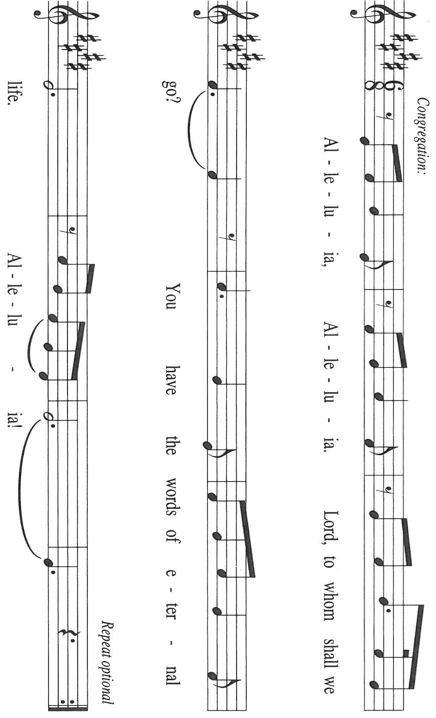
The Word of the Lord.

Thanks be to God.

As you are able please rise

THE VERSE Sung twice

THE HOLY GOSPEL Matthew 13: 24-30, 36-43

Jesus has just told His disciples the famous parable of the sower, which compares different responses to the Word to different kinds of soil in which a seed is planted. Now He tells a second parable about sowing to illustrate the co-existence of good and evil in our world.

P: The Holy Gospel according to St. Matthew, the thirteenth chapter.

C: Glory to You, O Lord!

Jesus put before the crowds another parable: "The kingdom of heaven may be compared to someone who sowed good seed in his field; ²⁵but while everybody was asleep, an enemy came and sowed weeds among the wheat, and then went away. ²⁶So when the plants came up and bore grain, then the weeds appeared as well. ²⁷And the slaves of the householder came and said to him, 'Master, did you not sow good seed in your field? Where, then, did these weeds come from?'
²⁸He answered, 'An enemy has done this.' The slaves said to him, 'Then do you want us to go and gather them?' ²⁹But he replied, 'No; for in gathering the weeds you would uproot the wheat along with them. ³⁰Let both of them grow together until the harvest; and at harvest time I will tell the reapers, Collect the weeds first and bind them in bundles to be burned, but gather the wheat into my barn.' "
³⁶Then He left the crowds and went into the house. And His disciples approached Him, saying, "Explain to us the parable of the weeds of the field." ³⁷He answered, "The one who sows the good seed is the Son of Man; ³⁸the field is the world, and the good seed are the children of the kingdom; the weeds are the children of the evil one, ³⁹and the enemy who sowed them is the devil; the harvest is the end of the age, and the reapers are angels.
⁴⁰Just as the weeds are collected and burned up with fire, so will it be at the end of the age. ⁴¹The Son of Man will send His angels, and they will collect out of His kingdom all causes of sin and all evildoers, ⁴²and they will throw them into the furnace of fire, where there will be weeping and gnashing of teeth. ⁴³Then the righteous will shine like the sun in the kingdom of their Father. Let anyone with ears listen!"

P: The Gospel of the Lord.

C: Praise to You, O Christ!

The assembly is seated

THE SERMON

Silence for reflection follows the sermon

As you are able please rise

THE HYMN OF THE DAY NSB 40 God of the Poor

THE APOSTLES’ CREED

A: God has made us His people through our Baptism into Christ. Living together in trust
and hope, we confess our faith.

C: I believe in God, the Father almighty,
creator of heaven and earth.

I believe in Jesus Christ, his only Son, our Lord.
He was conceived by the power of the Holy Spirit
and born of the virgin Mary.
He suffered under Pontius Pilate,
was crucified, died, and was buried.
He descended into hell.
On the third day he rose again.
He ascended into heaven,
and is seated at the right hand of the Father.
He will come again to judge the living and the dead.

I believe in the Holy Spirit,
the holy catholic Church,
the communion of saints,
the forgiveness of sins,
the resurrection of the body,
and the life everlasting. Amen.

THE PRAYER OF THE CHURCH

A: Thanking God with all our heart, we glorify God’s name by raising our intercessions
for the Church, the world, and all those in need.

A: That like the master of the field the Church may defer judgment and await with patience
God’s promised harvest of life and hope: In the Spirit we plead,

C: Hear us, O God.

A: That the seeds of hatred, destruction, prejudice, and violence sown in the human heart
by the Enemy might be uprooted by the fruits of kindness, gentleness, patience, and
compassion: In the Spirit we plead,

C: Hear us, O God.

A: That our congregation might be to our neighbors a welcome place of joy, help, and
hope: In the Spirit we plead,

C: Hear us, O God.

A: That those in our military, especially Katrine Sommers and Blake Waltz, might be
kept in safety: In the Spirit we plead,

C: Hear us, O God.

A: That those who groan from hunger, disease, addiction, grief, or illness, especially:
Mark Tannehill; Pastor Dale Zylstra; Hazel Miller; Martha Schroeder; Jean
Warner; Jan Paholski; Laura Dovey; Dale Thomas; and Amanda Seedorf might
be sustained in their suffering with patience and hope: In the Spirit we pray,

C: Hear us, O God.

A: That those who mourn, especially the family and friends of Shirley Reshan, aunt of
Pastor Reshan, who died in the Lord this week, may be comforted by the promise of
resurrection to life everlasting and of being reunited with those they love before the
throne of the Lamb: In the Spirit we plead,

C: Hear us, O God.
A: That with all the saints, we too may be glorified with Christ in the Kingdom of heaven:
In the Spirit we plead,

C: Hear us, O God.

P: Hear our prayers, O God of grace and glory, and come to our rescue. We cry to You,
Father, with Your Son, in the power of the Spirit, and bless You forevermore.

C: Amen.

MEAL

THE PEACE

P: The peace of the Lord be with you always.

C: And also with you.

The assembly is seated

THE OFFERING

THE VOLUNTARY The Heart of Worship New Song Praise Band
(Matt Redman)

As you are able please rise

THE PRESENTATION OF GIFTS (see p. 8) As the Grains of Wheat

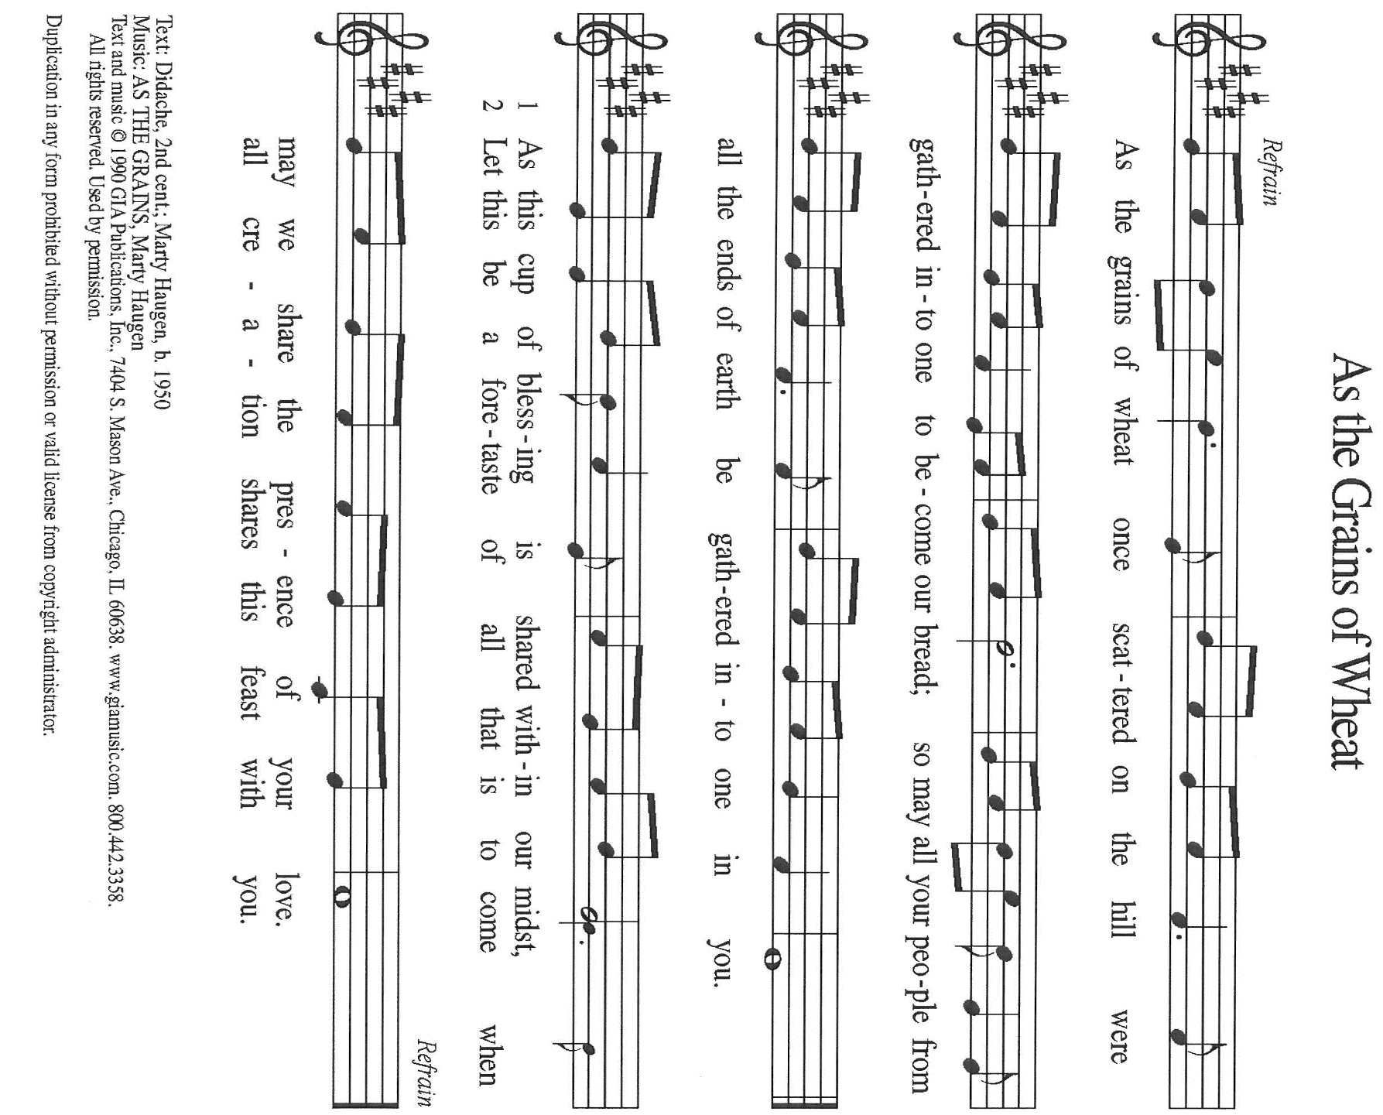

THE OFFERTORY PRAYER

A: Let us pray. Gracious God,

C: By water and the Spirit You have made us Your children. As those joined to
Christ, we share both His sufferings and His glory. With these offerings we bring
You our hurts and our joys, our hopes, and our very lives. Receive them for Jesus’
sake. Through this Meal, grant us the strength to live out Your will of grace and
compassion. We ask this in the name of Jesus the Lord. Amen.
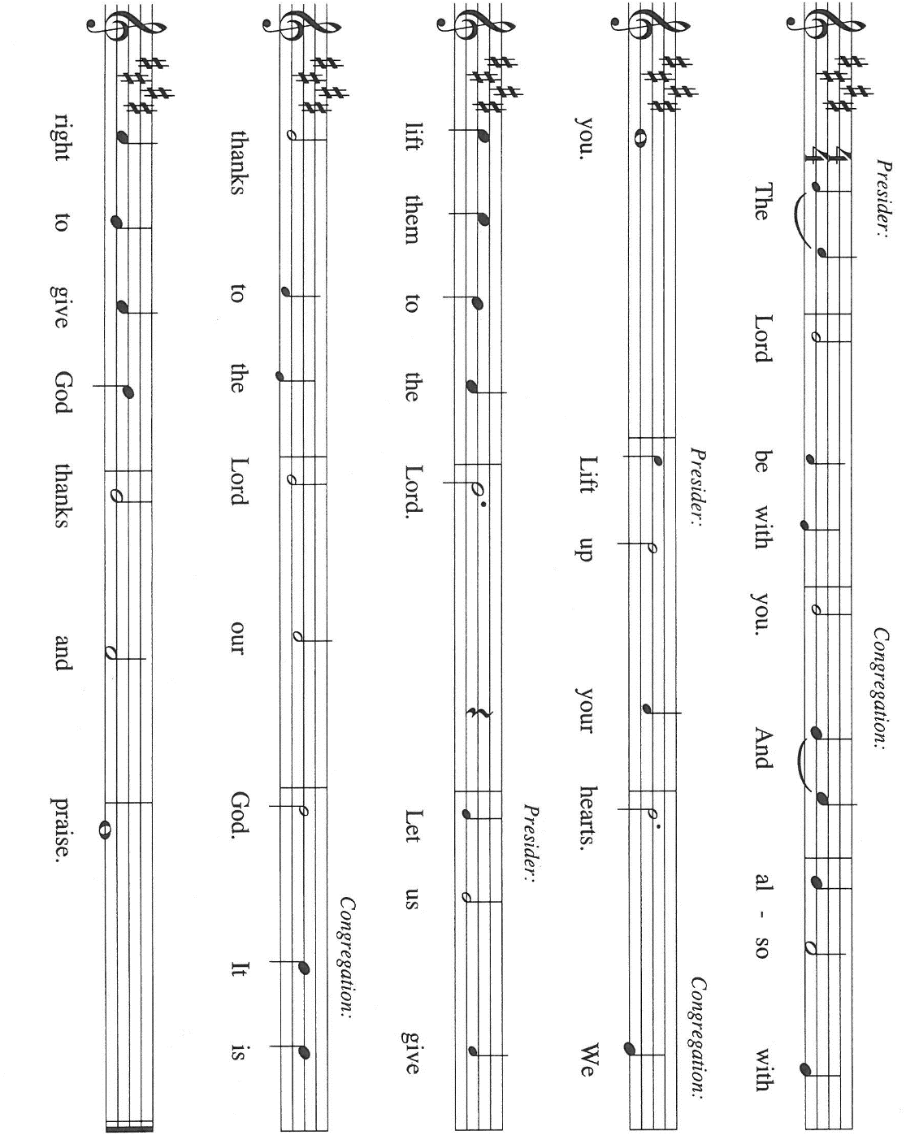
THE GREAT THANKSGIVING

P: It is our duty and delight …join their unending hymn:

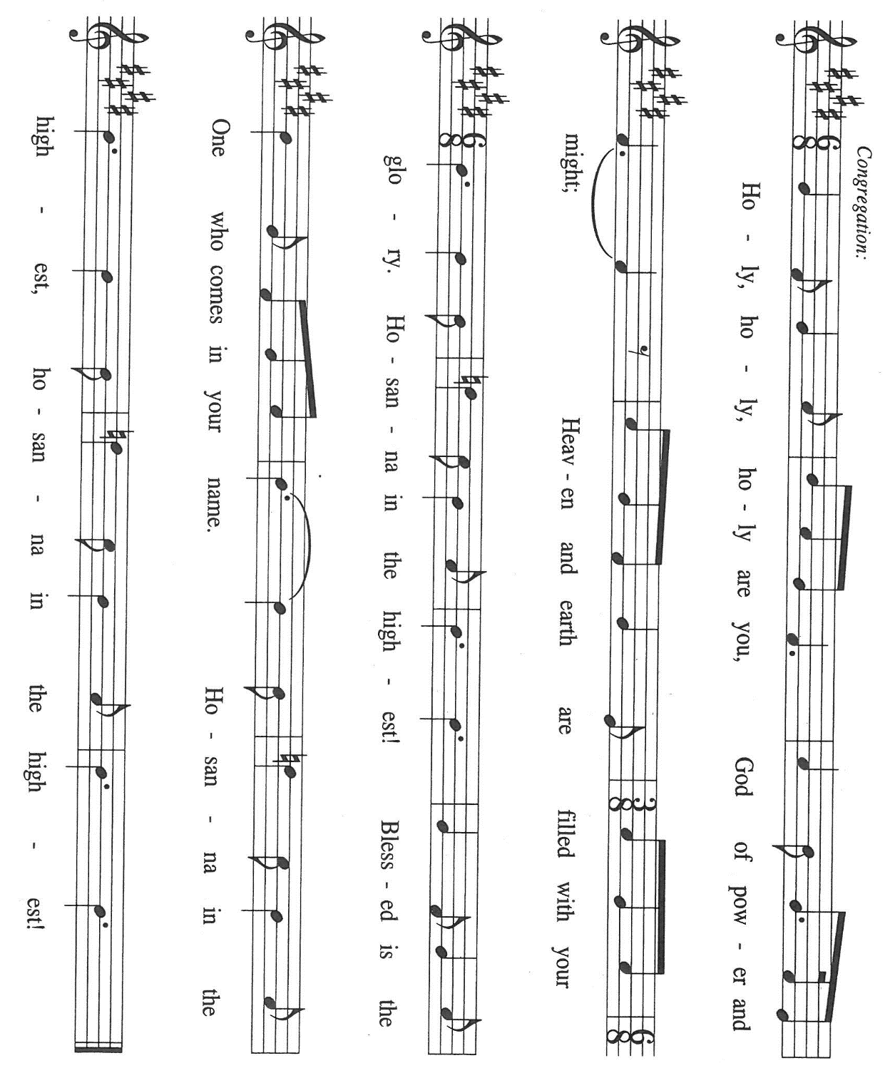

P: Holy God, King of Israel, Lord of Hosts, Creator of heaven and earth,
We bless and praise You for Your abundant mercies.
You are the First and the Last; beside You there is no other.
As Israel’s Redeemer You rescued her from slavery and exile, and made her a witness
to Your promise to bless all nations.

At the last, You fulfilled that promise in Your Son, Jesus Christ.
In Him we are Your children, and joint heirs of Your salvation.
In the night ... “Do this for the remembrance of Me.”
As often as we eat ... we proclaim the Lord’s death until He comes.

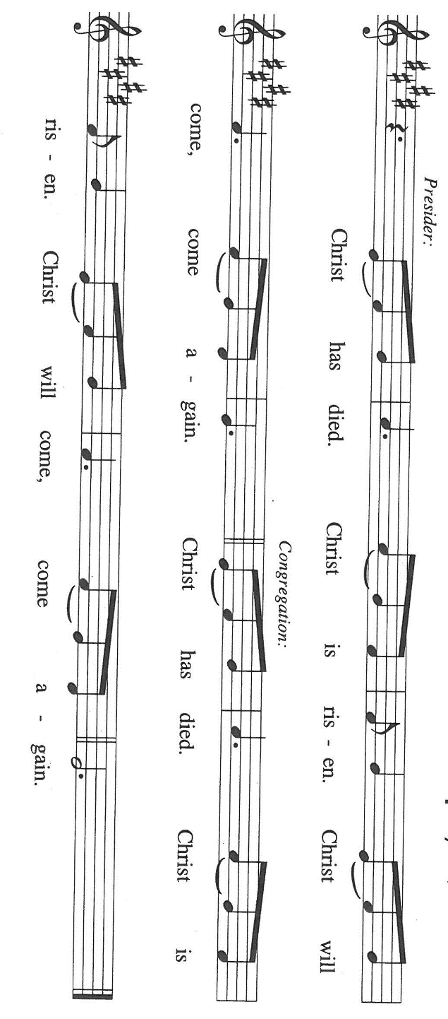

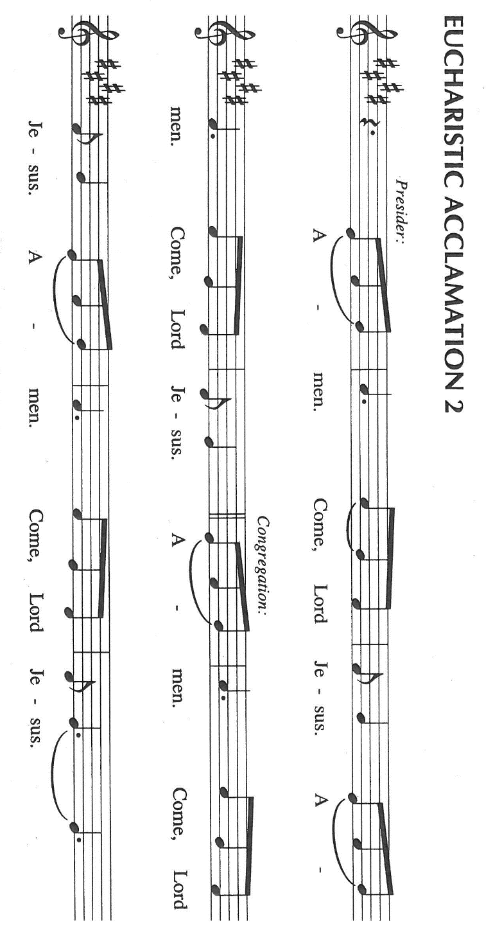

P: Therefore, O God, with this bread and cup we remember the whole sacrifice of our
Lord’s life, death, and resurrection.
When He ascended He promised to return to gather His people to shine like the sun in
the joy and fullness of the Kingdom.

As we watch and wait for His coming, we ask You: send Your Spirit on us and these
Your gifts of bread and wine.
By this Meal grant us strength to live as Your children, revealing Your freedom from
futility and decay until the Spirit gathers all into Your love.

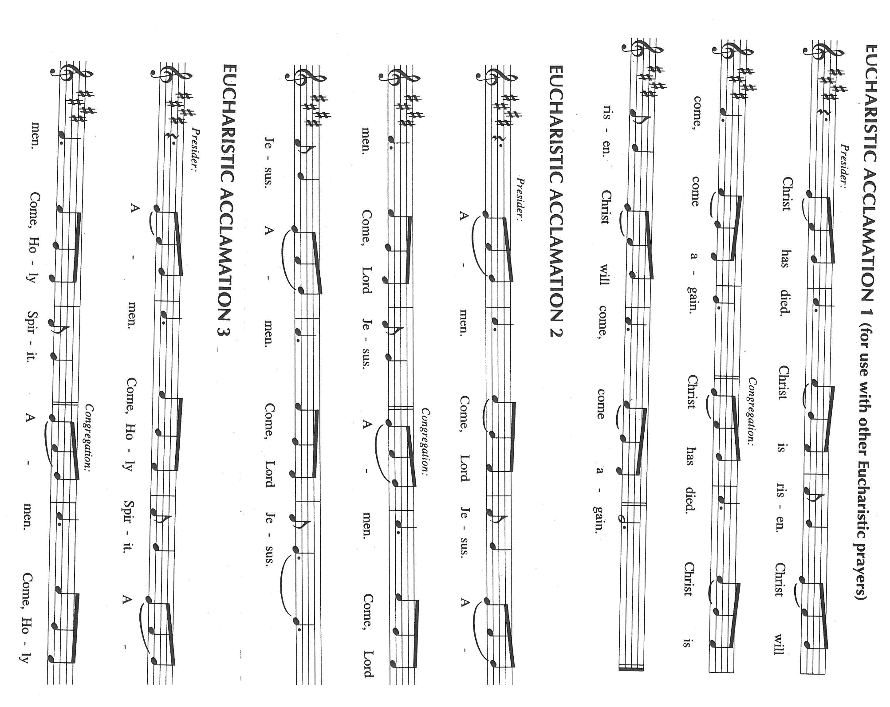

Until that Day, accept our prayers and praises, O God: Father, Son, and Holy Spirit, in
Your holy Church, in heaven and on earth, now and forever.

C: Amen!

THE LORD’S PRAYER

P: Let the good seed of God’s Word bear fruit now as we offer the prayer Jesus taught us
to pray:

C: Our Father in heaven, hallowed be Your name.
Your Kingdom come, Your will be done on earth as in heaven.
Give us today our daily bread, and forgive us our sins, as we forgive
those who sin against us.
Save us from the time of trial, and deliver us from evil.
For the Kingdom, the power, and the glory are Yours, now and forever.
Amen.

INVITATION TO THE MEAL

P: Behold, the Lamb of God Who takes away the sin of the world. Blessed are those who
are called to the Supper of the Lamb. God’s holy gifts for God’s holy people. Come,
for all is now ready.

The assembly is seated

DISTRIBUTION Lamb of God (see p. 13)

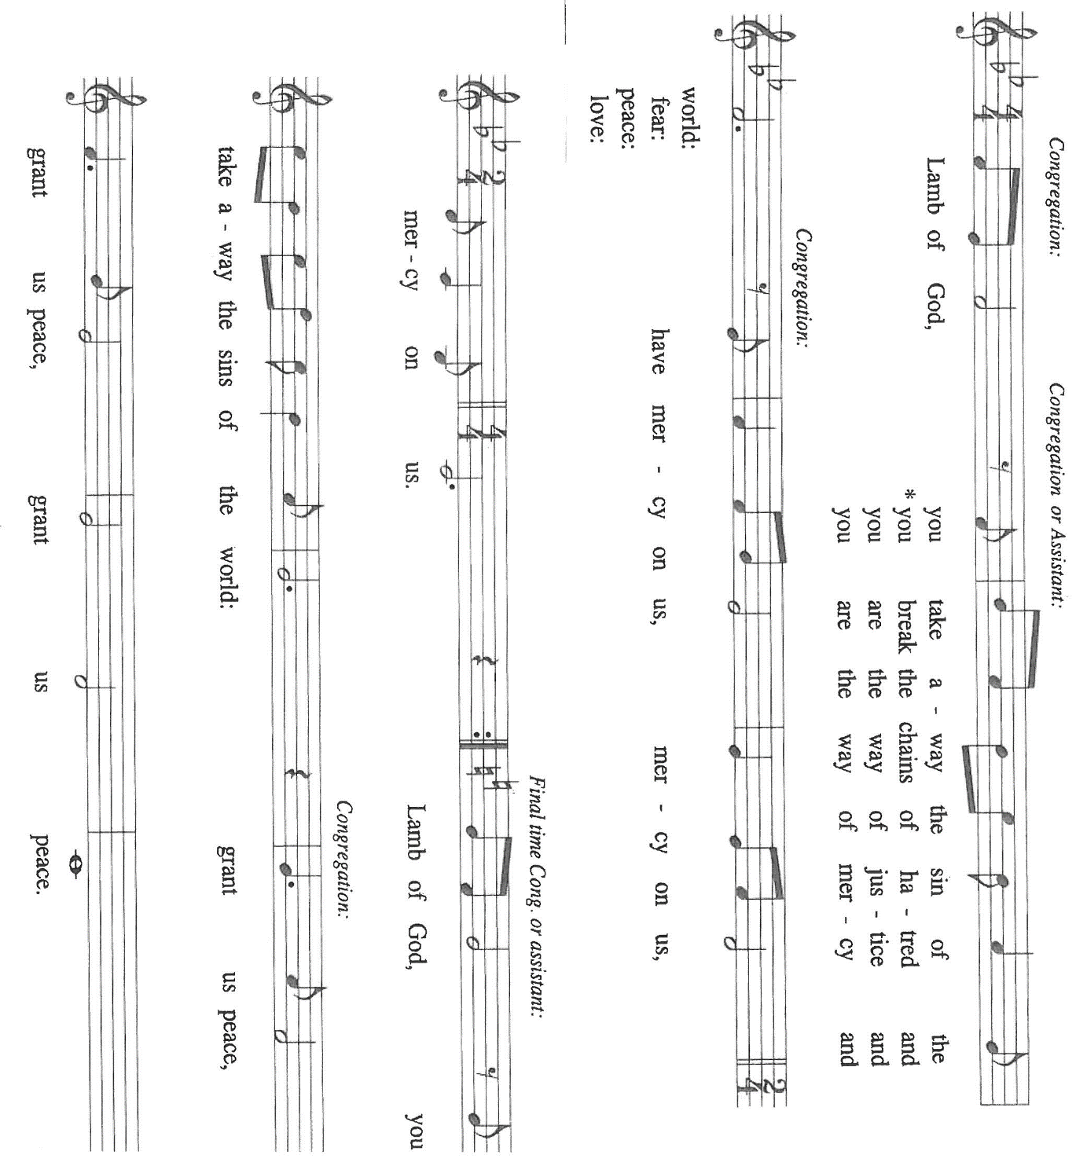

HYMN DURING DISTRIBUTION 693 Come, Ye Thankful People, Come

ELW 485 I Am the Bread of Life

ELW 484 You Satisfy the Hungry Heart

NSB 88 There is a Redeemer

NSB 38 Glorify Thy Name

As you are able please rise

THE POST-COMMUNION BLESSING

P: The Body and Blood of our Lord Jesus Christ strengthen you and keep you in His
grace.

C: Amen.

THE POST-COMMUNION PRAYER

A: Let us pray. Lord of the harvest, You have again given us a foretaste of Your final
Feast of victory. The whole creation awaits with eager longing for the revealing of
Your Kingdom. Send us in the power of the Spirit to bring Your grace to its groaning,
and Your truth to its hoping. Grant this through Christ our Lord.

C: Amen.

SENDING

THE BENEDICTION

P: Almighty God: Father, Son, and Holy Spirit bless you now and forever.

C: Amen.

THE SENDING HYMN God, We Gather to Remember

(Sung to the tune of, Joyful, Joyful, We Adore Thee)

God, we gather to remember all Your blessings in this place.
For the heritage we honor is a heritage of grace.
When our church was given land here, when we laid the cornerstone,
When a Sunday School was planned here, it was by Your grace alone.

By Your grace, You gave a vision to those settlers long ago.
As they served You here in mission soon Your church began to grow.
They promoted education, bought an organ, built new pews.
Year by year this congregation kept on sharing Your good news.

By Your grace we’re still surrounded by those witnesses of old,
For our faith and work are grounded in the good news that they told.
Now they point us toward tomorrow: “We in faith served God’s own Son;
Now it’s your turn to follow, now it is your race to run!”

By Your grace, through prayer and singing, worship fills our church’s days.
Band and choir and hand bells ringing—all are forms of joyful praise.
Love of God and love of neighbor send us out in Jesus’ name.
Worship leads us out to labor serving You Whom we proclaim.

THE DISMISSAL

A: Go forth with God’s blessing to love and serve the Lord.

C: Thanks be to God!

POSTLUDE

To God Alone Be

The Meditation, Greeting, and Prayers are adapted from Sundays and Seasons. Copyright
1996, 1999 Augsburg Fortress.

The Prayers are also adapted from Intercessions for the Christian People. Gail Ramshaw,
ed. (New York: Pueblo Publishing Company, 1988) 47.

The Eucharistic Prayer is from With One Voice. Leader’s Edition. (Minneapolis:
Augsburg Fortress, 1995) 71.

The musical setting of the liturgy, “Now the Feast and Celebration” by Marty Haugen, is
used by permission of GIA Publishers, Inc. OneLicense.net License #A-702836.

DON’T FORGET!

Today is our ICE CREAM SOCIAL, Sunday, July 19, 2026 right after the Sunday morning worship service. Anyone who owns one of our 150th Anniversary t-shirts please wear them today, July 19.

PLEASE NOTE:

From now through Wednesday, August 19, 2026 the front doors of the church (those doors facing Franklin Street) will be open on Wednesdays to invite new visitors in to hear the organ concert. Any Wednesday, at your choosing, at 11:30 a.m. Concerts begin at 12:15 p.m. Please come and help us greet visitors. Your help is appreciated.

ANNOUNCEMENTS

Please remember to mail your offering to the Church Office at 818 Franklin Street, Michigan City, IN 46360. Another alternative is to give on-line through Tithe.ly. Please see your closure letter for information on how to set up a Tithe.ly account.

St. Paul Members are reminded to have a loved one contact the office if you are hospitalized. Many times, the Pastor doesn’t know someone is in the hospital. If you call and leave a message, please tell us at which hospital the patient is located.

BIRTHDAYS: Cheryl Kaluzny (7/25)

PRAYER CONCERNS: Debbie Martin; Mark Tannehill; Kathy Stein; Jan Paholski; Laura Dovey; Bill Hazelgrove; Al Levenhagen; Carl Wipperman; Major Payne.

OFFICE HOURS: Libby will be in the office on Mondays, Wednesdays, and Fridays; volunteers will cover Tuesdays and Thursdays.

Monday & Wednesday 8:00 a.m. – 5 p.m.
Tuesday & Thursday 9:00 a.m. – 12:00 p.m.
Friday 8:00 a.m. – 12:00 p.m.

If you are listening to the worship broadcast on the radio and would like to watch the Sunday morning service live stream follow these steps:

(1) If you have You Tube available on your TV, search for
St. Paul Lutheran Church Michigan City, IN.

(2) The direct link on the computer is https://
www.youtube.com/channel/UC5AIPNaKr3QN50984jGOa1g

(3) This link is also on the main page of the church’s website in
the church section and will continue to be posted weekly on the St.
Paul Facebook page.

And it will always be available on the radio broadcast Sunday mornings at 11:00 a.m.
on WEFM (95.9), and on the local cable access station #99 for the previous week’s
service on Sundays at 4:00 p.m. and the current service on Wednesdays at 7:00 p.m.
and Fridays at 8:30 p.m.

To send e-mail to the church office, please use the following addresses:
Pastor Mark Reshan: seniorpastor@stpaulmichigancity.com
Church Office Secretary (Libby Pollock): churchsecretary@stpaulmichigancity.com
Church Treasurer (Karen Fleming): finance@stpaulmichigancity.com

2026 Church Council:
Pastor - Mark Reshan
President - Donna Knoll
Vice President - Jan Bakken
Secretary - Judy Hunt
Treasurer - Karen Fleming

Members: Sue Koziel; Jim Schraidt; Trish Sprague; Bob Kiser; Barry Anderson; and
Pam Soule

Worship Attendance:

Wednesday, July 8, 2026 Organ Concert @12:15 p.m. 46

Saturday, July 11, 2026 @ 4:00 p.m. 38

Sunday, July 12, 2026 @ 9:00 a.m. 89

TOTAL 173

Copies of the minutes from the May 21, 2026 and June 25, 2026 Church Council meetings are on the back table in the upper Narthex. They were approved by the council via email.

The Good News Newsletter: If you have an article or anything you want included in The Good News please send it to the following e-mail address: splcgoodnews@gmail.com. Pastor Pamela Thiede will be using this e-mail address to assemble The Good News each month. The deadline for getting information to Pastor Pamela will be the 20th of each month.

Next week’s lessons are 1 Kings 3: 5-12; Psalm 119: 129-136; Romans 8: 26-39; Matthew 13: 31-33, 44-52 for those of you who like to study them in advance.

MISSION OF THE MONTH FOR JULY, 2026
July’s mission of the month will be the Lutheran World Relief Kits. Attached is the order form for people to sponsor kits and place this order form with payment in the offering plate or send to the church office.

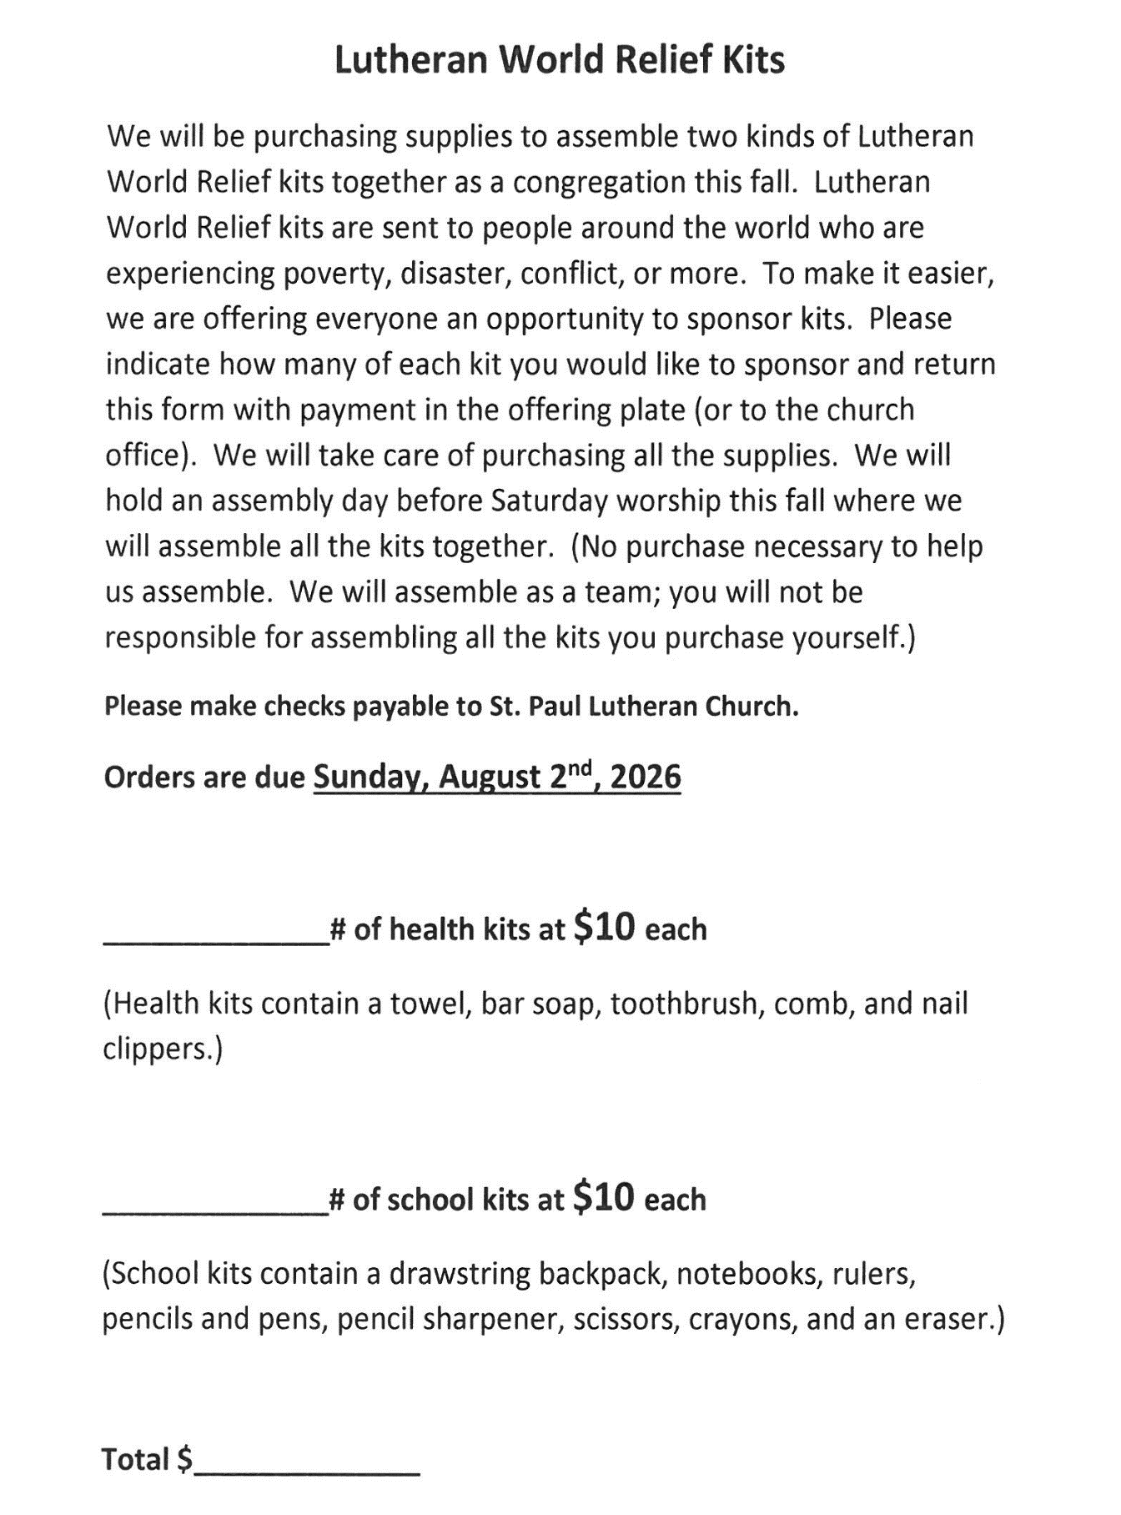

ACTIVITIES, EVENTS & MEMORIALS
JULY 2026

Sunday, July 5, 2026 @ 9:00 a.m. 6 Pentecost Worship Service/Sanctuary; with coffee after

Wednesday, July 8, 2026 @ 10:00 a.m. God’s Purls/St. Paul Room
@12:15 p.m. Organ Concert Summer Series/Sanctuary

Saturday, July 11, 2026 @ 4:00 p.m. 7 Pentecost Worship Service/Sanctuary

Sunday, July 12, 2026 @ 9:00 a.m. 7 Pentecost Worship Service/Sanctuary to include the Baptism of Maggie Louise Brooks; with coffee after

Monday, July 13, 2026 @ 1:00 p.m. Hope Circle

Wednesday, July 15, 2026 @ 10:00 a.m. God’s Purls/St. Paul Room

@ 10:00 a.m. – 9:00 p.m. GIVE BACK @ 5 GUYS
@12:15 p.m. Organ Concert Summer Series/Sanctuary

Saturday, July 18, 2026 @ 4:00 p.m. 8 Pentecost Worship Service/Sanctuary

Sunday, July 19, 2026 @ 9:00 a.m. 8 Pentecost Worship Service/Sanctuary; with
coffee after @ 10:30 a.m. ICE CREAM SOCIAL/St. Paul Room

Wednesday, July 22, 2026 @ 10:00 a.m. God’s Purls/St. Paul Room
@ 12:15 p.m. Organ Concert Summer Series/Sanctuary

Saturday, July 25, 2026 9 Pentecost Worship Service/Sanctuary

Sunday, July 26, 2026 @ 9:00 a.m. 9 Pentecost Worship Service/Sanctuary; with coffee after
Wednesday, July 29, 2026 @ 10:00 a.m. God’s Purls/St. Paul Room
@ 12:15 p.m. Organ Concert Summer Series/Sanctuary

