THE NINTH SUNDAY AFTER PENTECOST
July 26, 2026

“The kingdom of heaven is like yeast that a woman took and hid in three measures of flour until all of it was leavened.” In a single sentence several ancient stories are evoked, and yet, by the introduction of a few new terms the traditional sense of these stories is radically transformed.
Three measures of flour is an ephah, somewhere around a bushel. That is a lot of flour. It is three measures or an ephah that Abraham causes to be prepared for the angels of God at Mamre. In the new temple that is imagined and described by the prophet Ezekiel, the grain offerings will be an ephah of flour baked by the priests apart from the people.
Yet the one who welcomes the outsiders to table says this: the dominion of God is like leavened holy bread baked by a woman. No wonder the leaven is hid. All the meal—enough for Abraham, enough for the new temple, enough for meeting God—is leavened, to be feast for all who long to meet with God in the same way that Jesus’ unclean death is made to be such a feast.
This dominion of God, then, is not what had been expected: it comes with a radical grace to the outsiders and the sinners.

Gordon Lathrop

INTRODUCTION

As Solomon prays for wisdom, we seek to more deeply know the treasures of faith. In today's gospel Jesus offers everyday images that reveal to us the reign of God: a tree that becomes a sheltering home, yeast that penetrates and expands, a treasured pearl, a net that gains a great catch. Even as we seek the riches of God's reign, the great surprise is that God's grace finds us first!

James, Apostle

James and his brother John were the sons of Zebedee, fishermen by trade before their call from Jesus. He was the first of the twelve apostles to be martyred, and his death is the only one recorded in scripture (Acts 12: 1-2).

GATHERING

PRE-SERVICE MUSIC Sing Allelu (Ode 40) New Song Praise Band
(John Andrew Shreiner)

ANNOUNCEMENTS

As you are able please rise

CONFESSION AND ABSOLUTION

P: In the name of the Father and of the Son and of the Holy Spirit.

C: Amen.

P: “Steady my footsteps in Your Word; let no iniquity have dominion over me.” (Psalm
119: 133) On this Day we come with the hope that the “love of God in Christ Jesus our
Lord” (Romans 8: 39) is strong than any “hardship, distress,” (8: 33) or sin. Let us
therefore with confidence confess our “iniquities” before God.

Silence for reflection and self-examination.

P: Most merciful God,

C: We confess that we have sinned against You in thought, word, and deed. We have
not always “discerned between good and evil” (1 Kings 3: 9). Doubtful of Your
good intentions and purposes for us (Romans 8: 28), we fall into fear and despair.
We have not placed seeking the way of Your Kingdom above all else (Matthew 13:
44, 46). In Your great compassion, have mercy on us for the sake of Your Son,
Jesus Christ. Make us “conquerers” over all that would try to separate us from
You (Romans 8: 39), that with a sure and deep trust we may obey You and serve
You.

P: “Turn to me in mercy, as You always do to those who love Your name.” (Psalm 119:
132) God’s mercy is faithful and true, and, most importantly, it is for you this Day. For
as a called and ordained minister of the Church of Christ, and by His authority, I
therefore declare to you the entire forgiveness of all your sins, in the name of the Father
and of the Son and of the Holy Spirit.

C: Amen.

GATHERING SONG 532 Gather Us In

THE GREETING AND PRAYER OF THE DAY

P: The grace of our Lord Jesus Christ, the love of God, and the communion of the Holy
Spirit be with you all.

C: And also with you.

P: Let us pray. Beloved and Sovereign God, through the death and resurrection of Your
Son You bring us into Your Kingdom of justice and mercy. By Your Spirit, give us
Your wisdom, that we may treasure the life that comes from Jesus Christ, our Savior
and Lord.

C: Amen.

The assembly is seated

WORD

FIRST READING 1 Kings 3: 5-12

This passage reflects a concern for leadership that is also present in the larger corpus extending from Joshua through 2 Kings. Leadership in the community that lives under the rule of God has its basis in the covenant, and leaders depend upon God's gifts of wisdom and discernment.

At Gibeon the LORD appeared to Solomon in a dream by night; and God said, "Ask what I should give you." ⁶And Solomon said, "You have shown great and steadfast love to Your servant my father David, because he walked before You in faithfulness, in righteousness, and in uprightness of heart toward You; and You have kept for him this great and steadfast love, and have given him a son to sit on his throne today.
⁷And now, O LORD my God, You have made Your servant king in place of my father David, although I am only a little child; I do not know how to go out or come in. ⁸And Your servant is in the midst of the people whom You have chosen, a great people, so numerous they cannot be numbered or counted. ⁹Give Your servant therefore an understanding mind to govern Your people, able to discern between good and evil; for who can govern this Your great people?"
¹⁰It pleased the LORD that Solomon had asked this. ¹¹God said to him, "Because you have asked this, and have not asked for yourself long life or riches, or for the life of your enemies, but have asked for yourself understanding to discern what is right, ¹²I now do according to your word. Indeed I give you a wise and discerning mind; no one like you has been before you and no one like you shall arise after you."

The Word of the Lord.

Thanks be to God.

THE PSALM: Psalm 119: 129-136 Read responsively

¹²⁹Your decrees are wonderful;
therefore I obey them with all my heart.

¹³⁰When Your Word is opened it gives light;
it gives understanding to the simple.

¹³¹I open my mouth and pant
because I long for Your commandments.

¹³²Turn to me and be gracious to me,
as You always do to those who love Your name.

¹³³Order my footsteps in Your Word;
let no iniquity have dominion over me.

¹³⁴Rescue me from those who oppress me,
and I will keep Your commandments.

¹³⁵Let Your face shine upon Your servant
and teach me Your statutes.
¹³⁶My eyes shed streams of tears,
because people do not keep Your teaching.

SECOND READING Romans 8: 26-39

For several chapters in his letter to the Romans, Paul argues that justification by faith produces a life in the Spirit superior to any legal obedience that might be attained through human effort. Now, in the final words of this chapter, his exuberance for this spiritual life leads to a confident hymn in praise of Christ's love.

The Spirit helps us in our weakness; for we do not know how to pray as we ought, but that very Spirit intercedes with sighs too deep for words. ²⁷And God, Who searches the heart, knows what is the mind of the Spirit, because the Spirit intercedes for the saints according to the will of God.
²⁸We know that all things work together for good for those who love God, who are called according to His purpose. ²⁹For those whom He foreknew He also predestined to be conformed to the image of His Son, in order that He might be the firstborn within a large family. ³⁰And those whom He predestined He also called; and those whom He called He also justified; and those whom He justified He also glorified.
³¹What then are we to say about these things? If God is for us, who is against us? ³²He who did not withhold His own Son, but gave Him up for all of us, will He not with Him also give us everything else? ³³Who will bring any charge against God's elect? It is God Who justifies. ³⁴Who is to condemn? It is Christ Jesus, Who died, yes, Who was raised, Who is at the right hand of God, who indeed intercedes for us. ³⁵Who will separate us from the love of Christ? Will hardship, or distress, or persecution, or famine, or nakedness, or peril, or sword? ³⁶As it is written,
"For Your sake we are being killed all day long;
we are accounted as sheep to be slaughtered."
³⁷No, in all these things we are more than conquerors through Him Who loved us. ³⁸For I am convinced that neither death, nor life, nor angels, nor rulers, nor things present, nor things to come, nor powers, ³⁹nor height, nor depth, nor anything else in all creation, will be able to separate us from the love of God in Christ Jesus our Lord.

The Word of the Lord.

Thanks be to God.

As you are able please rise

THE VERSE Sung twice (see p. 5)

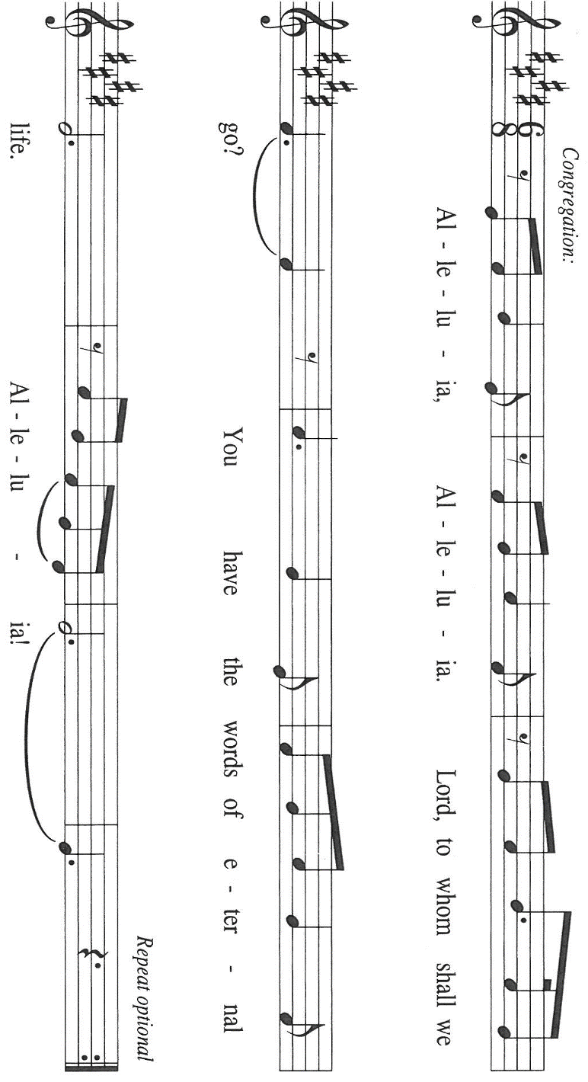

THE HOLY GOSPEL Matthew 13: 31-33, 44-52

Throughout Matthew's gospel, Jesus and his disciples proclaim the good news that "the kingdom of heaven is near!" Here, Jesus offers several brief parables that explore the implications of this announcement for people's lives.

P: The Holy Gospel according to St. Matthew, the thirteenth chapter.

C: Glory to You, O Lord!

[Jesus] put before the crowds another parable: "The kingdom of heaven is like a mustard seed that someone took and sowed in his field; ³²it is the smallest of all the seeds, but when it has grown it is the greatest of shrubs and becomes a tree, so that the birds of the air come and make nests in its branches."
³³He told them another parable: "The kingdom of heaven is like yeast that a woman took and mixed in with three measures of flour until all of it was leavened."
⁴⁴"The kingdom of heaven is like treasure hidden in a field, which someone found and hid; then in his joy he goes and sells all that he has and buys that field.
⁴⁵"Again, the kingdom of heaven is like a merchant in search of fine pearls; ⁴⁶on finding one pearl of great value, he went and sold all that he had and bought it.
⁴⁷"Again, the kingdom of heaven is like a net that was thrown into the sea and caught fish of every kind; ⁴⁸when it was full, they drew it ashore, sat down, and put the good into baskets but threw out the bad. ⁴⁹So it will be at the end of the age. The angels will come out and separate the evil from the righteous ⁵⁰and throw them into the furnace of fire, where there will be weeping and gnashing of teeth.
⁵¹"Have you understood all this?" They answered, "Yes." ⁵²And He said to them, "Therefore every scribe who has been trained for the kingdom of heaven is like the master of a household who brings out of his treasure what is new and what is old."

P: The Gospel of the Lord.

C: Praise to You, O Christ!

The assembly is seated

THE SERMON

Silence for reflection follows the sermon

As you are able please rise

THE HYMN OF THE DAY 745 Lord, Teach Us How to Pray Aright
Stanza 2—Women; Stanza 4--Men

THE APOSTLES’ CREED

A: God has made us His people through our Baptism into Christ. Living together in trust
and hope, we confess our faith.

C: I believe in God, the Father almighty,
creator of heaven and earth.

I believe in Jesus Christ, his only Son, our Lord.
He was conceived by the power of the Holy Spirit
and born of the virgin Mary.
He suffered under Pontius Pilate,
was crucified, died, and was buried.
He descended into hell.
On the third day he rose again.
He ascended into heaven,
and is seated at the right hand of the Father.
He will come again to judge the living and the dead.

I believe in the Holy Spirit,
the holy catholic Church,
the communion of saints,
the forgiveness of sins,
the resurrection of the body,
and the life everlasting. Amen.

THE PRAYER OF THE CHURCH

A: Who can separate us from the love of God? Who can separate us from the love of
Christ? Let our hearts respond to such overwhelming love by joining in prayer for the
Church, the world, and all those in need.

A: That the Church might proclaim and enact the treasure of the Gospel with passion,
integrity, and joy, we pray: O Holy Spirit,

C: Have mercy and hear us.

A: That as a mustard seed is planted and grows into a great shrub, our ministries in this
church might by the Spirit’s power become great ventures of blessing for many people,
we pray: O Holy Spirit,

C: Have mercy and hear us.

A: That birds of the air, fields and their crops, the seas and all creatures that swim in them
might be protected and nurtured by our wise stewardship of Your wondrous creation,
we pray: O Holy Spirit,

C: Have mercy and hear us.

A: That those suffering weakness in any way: the hungry, the homeless, refugees, the
addicted, and the sick, especially: Bev Coburn; Dale Thompson; Debbie
Martin; Martha Schroeder; Major Payne; Jon Samuelson; Mark Tannehill;
Pastor Dale Zylstra; and Jean Warner might know God is for them through His
healing love, we pray: O Holy Spirit,

C: Have mercy and hear us.

A: That with all those trained for the Kingdom of heaven, especially James, Apostle and
martyr, whom we commemorate this Day, we might be united in the love of God in
Christ Jesus our Lord for all eternity, we pray: O Holy Spirit,

C: Have mercy and hear us.

P: Astonish us once again, O God, and bring forth the abundance of Your wisdom and
grace. May all who ask for our prayers know Your love, and may we give testimony
to Your great compassion in lives of service. We ask this in the name of Jesus, in
Whom we cannot be separated from Your love.

C: Amen.

MEAL

THE PEACE

P: The peace of the Lord be with you always.

C: And also with you.

The assembly is seated

THE OFFERING

THE VOLUNTARY Goodness of God New Song Praise Band
(Jenn Johnson)

As you are able please rise

THE PRESENTATION OF GIFTS As the Grains of Wheat

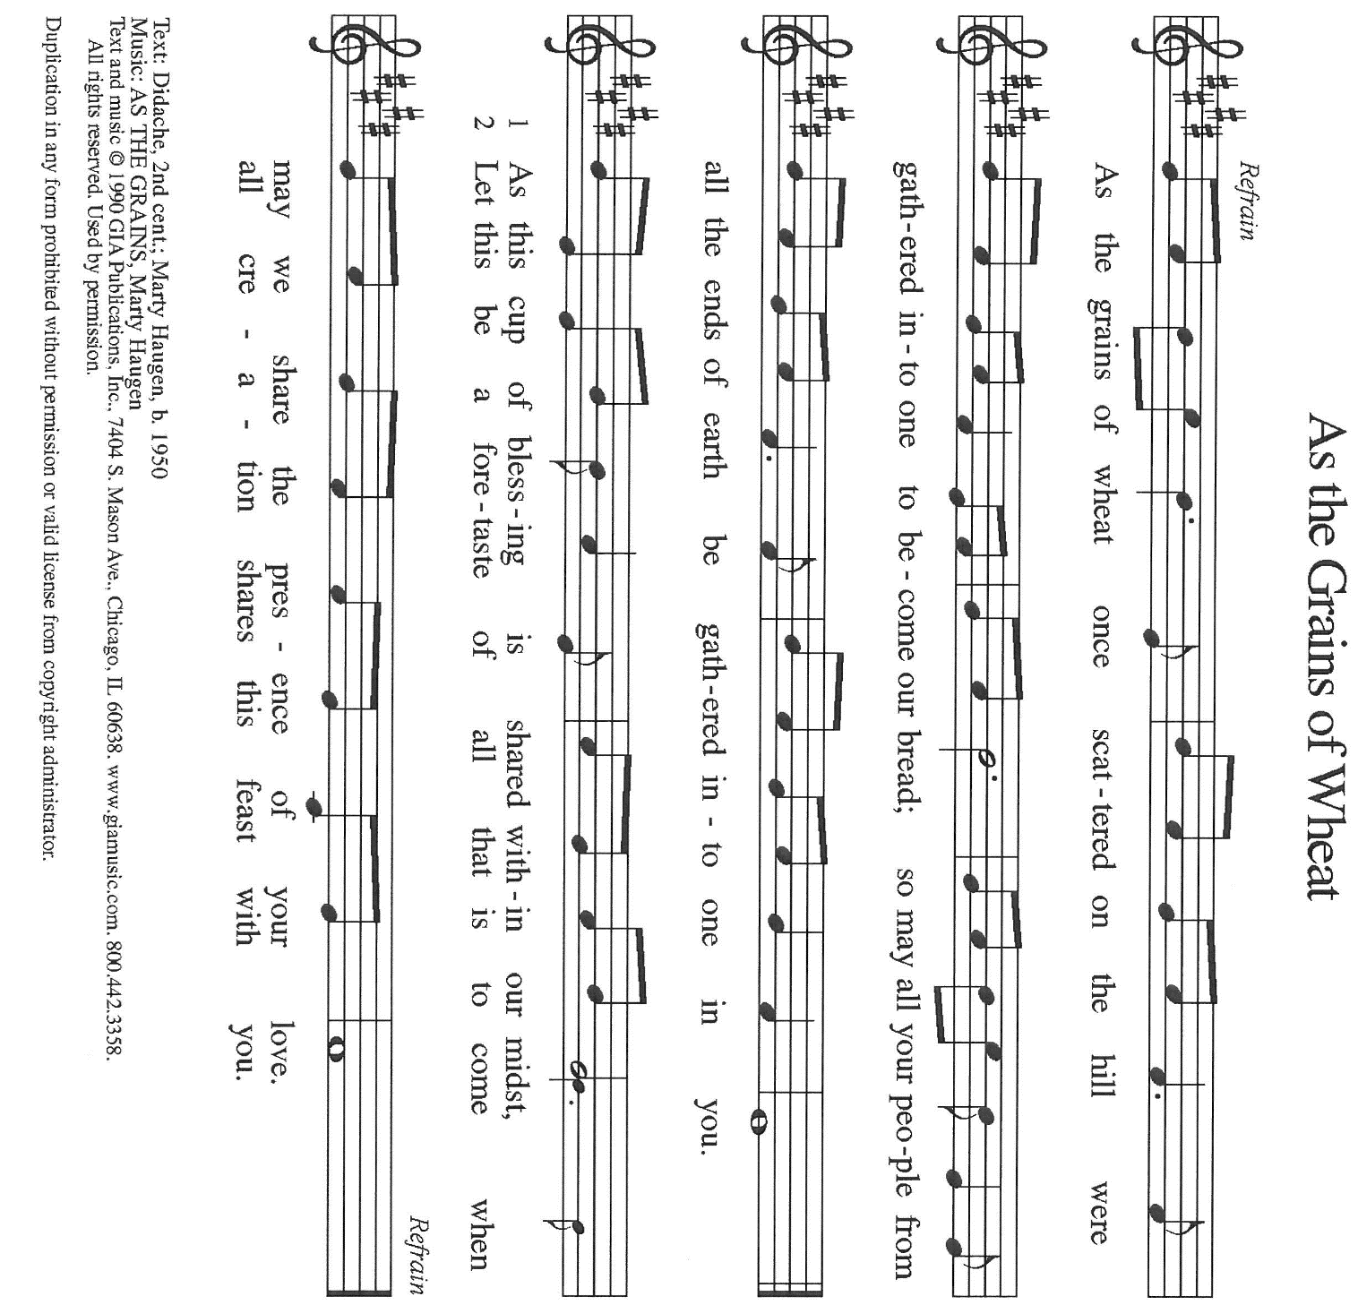

THE OFFERTORY PRAYER

A: Let us pray. Gracious God,

C: In great love You did not withhold Your Son, but gave Him up into death for all
of us. With these offerings we give over to You all that we are and have. Receive
them for the sake of Your Son, Jesus Christ, and by this holy Sacrament, work
good for us according to Your loving purpose. We ask this in the name of Jesus
the Lord. Amen.
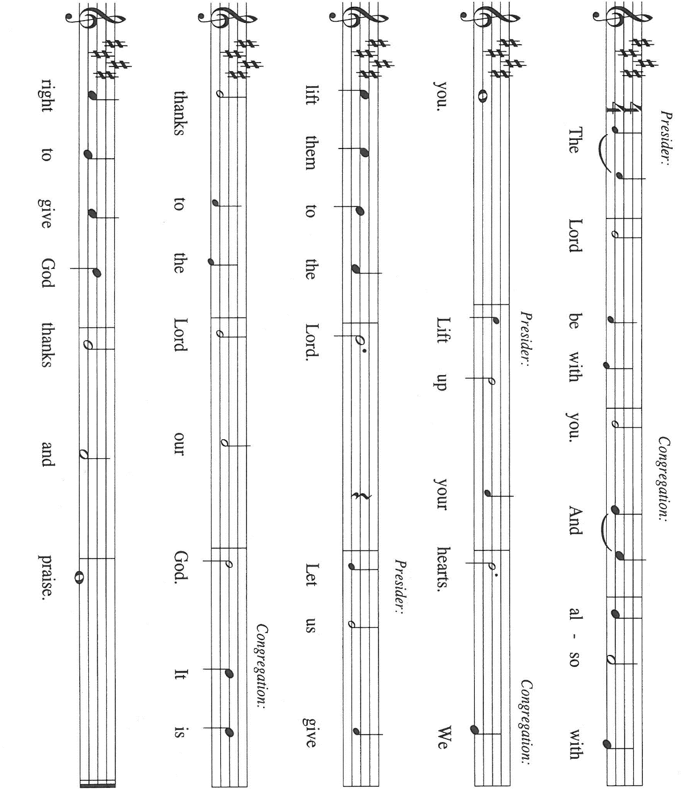
THE GREAT THANKSGIVING

P: It is our duty and delight …join their unending hymn:

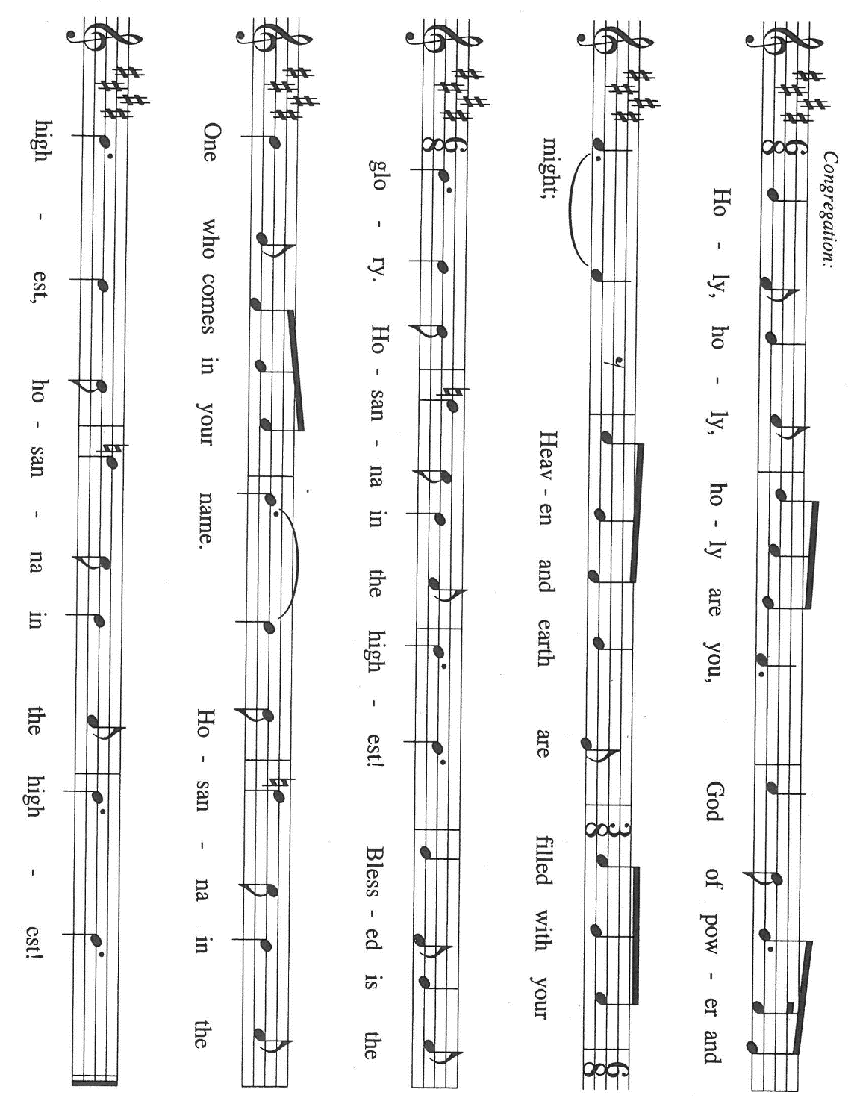

P: Sovereign God, You foreknew us, before the universe was created.
In Abraham and Moses You called us to be Your people.
You predestined us through the power of Your Holy Spirit to be conformed to the
image of Your crucified and risen Son.
In Jesus You justified us by Your grace, and on the last Day You will glorify us to
live with you forever.
You, Lord, are like a merchant Who sacrifices everything because You above all want
us, Your pearl, buried in the world’s field.
And in that field You also grow grain and grape to feed us from Your heart now and
forever.
Come among us now through the power of Your Spirit, that we may be transformed
into Your likeness, and that these gifts of bread and wine may become for us the
Body and Blood of Your Son, Jesus Christ,
Who, in the night ... “Do this for the remembrance of Me.”
As often as we eat ... we proclaim the Lord’s death until He comes.

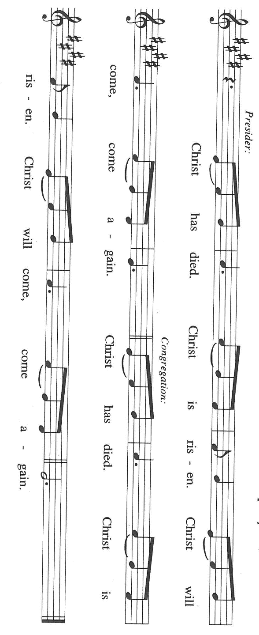

P: Everlasting God, You have promised that nothing can separate us from Your love.
Be with Your children who know hardship, distress, or persecution;
Visit Your beloved who experience famine, nakedness, peril, or sword;
Abide with us in death, as in life;
Give us nothing to fear from angels or rulers;
from things present, or things to come,
or in the face of powers, or height, or depth,
or anything else in all creation.
Knowing that You did not withhold Your own Son, but gave Him up for all of us,
Inscribe in us faith that You will with Him bestow upon us everything else as well.
We pray in union with Christ in the power of the Holy Spirit,
Who helps us in our weakness, and intercedes with signs too deep for words,
Father of all, now and forever.

C: Amen!

THE LORD’S PRAYER

P: Let the good seed of God’s Word bear fruit now as we offer the prayer Jesus taught us
to pray:

C: (Sung) Music is on the front cover of the red hymnal

INVITATION TO THE MEAL

P: Behold, the Lamb of God Who takes away the sin of the world. Blessed are those who
are called to the Supper of the Lamb. God’s holy gifts for God’s holy people. Come,
for all is now ready.

The assembly is seated

THE DISTRIBUTION Lamb of God (see p. 12)

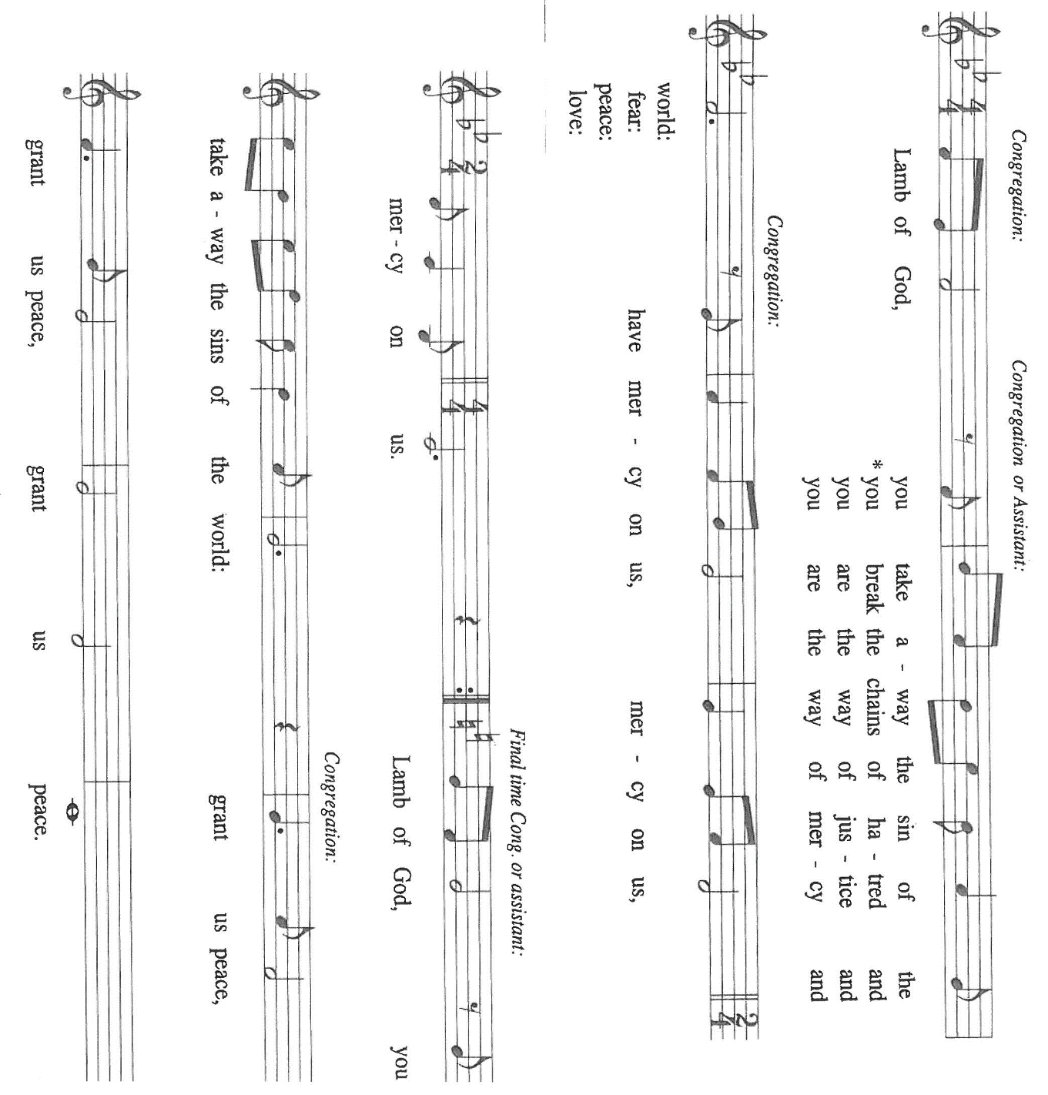

HYMN DURING DISTRIBUTION 793 Be Thou My Vision

Every Time I Feel the Spirit (see p. 13)

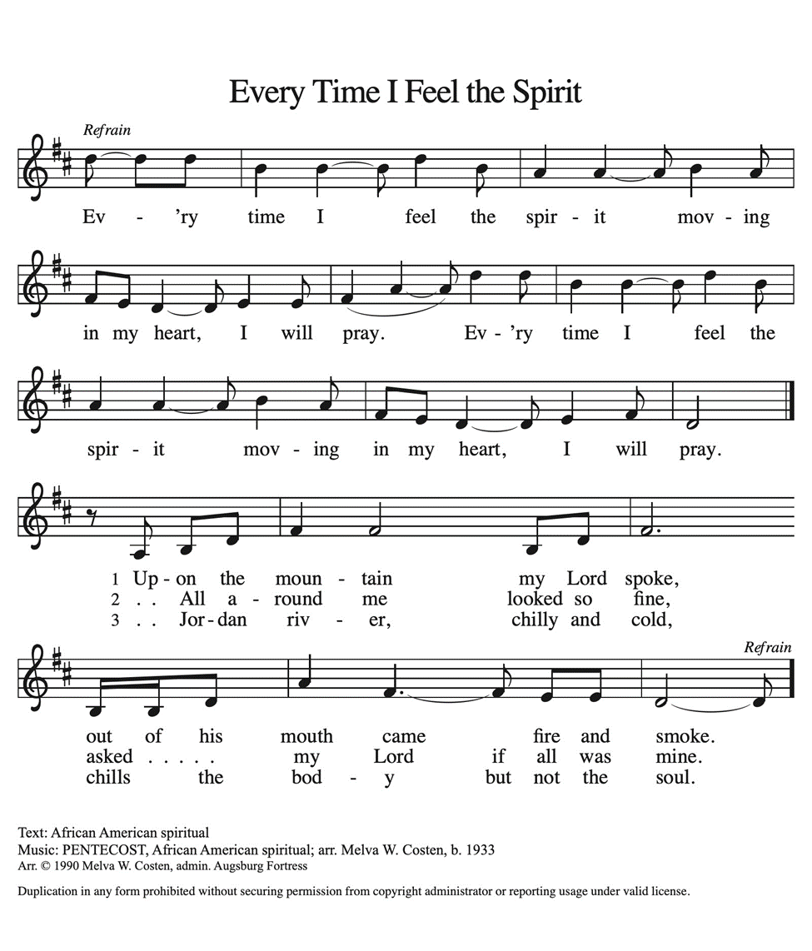

NSB 105 You Are My All in All
NSB 94 Turn Your Eyes Upon Jesus
NSB 45 He Who Began a Good Work in You

As you are able please rise

THE POST-COMMUNION BLESSING

P: The Body and Blood of our Lord Jesus Christ strengthen you and keep you in His grace.

C: Amen.

THE POST-COMMUNION PRAYER

A: Let us pray. Lord Jesus, once again You have fed us with the Bread from heaven. By
our eating and drinking, may we become like yeast that leavens the world with Your
life and Your peace. As You are for us, may we be for others. We bless You now and
forevermore.

C: Amen.

SENDING

THE BENEDICTION

P: Almighty God: Father, Son, and Holy Spirit bless you now and forever.

C: Amen.

THE SENDING HYMN 867 In Thee is Gladness

THE DISMISSAL

A: Go forth with God’s blessing to love and serve the Lord.

C: Thanks be to God!

POSTLUDE

To God Alone Be Glory

The Meditation is from Gordon W. Lathrop, Holy Things: A Liturgical Theology
(Minneapolis: Fortress, 1993), 24-25.

The Prayers, Introduction to the Lord’s Prayer, and Invitation to the Meal are from Prayers
for Sundays and Seasons. Year A. Peter J. Scagnelli. (Chicago: Liturgy Training
Publications, 1998) 104-105.

The musical setting of the liturgy, “Now the Feast and Celebration” by Marty Haugen, is
used by permission of GIA Publishers, Inc. OneLicense.net License #A-702836.

ANNOUNCEMENTS

Please remember to mail your offering to the Church Office at 818 Franklin Street, Michigan City, IN 46360. Another alternative is to give on-line through Tithe.ly. Please see your closure letter for information on how to set up a Tithe.ly account.

St. Paul Members are reminded to have a loved one contact the office if you are hospitalized. Many times, the Pastor doesn’t know someone is in the hospital. If you call and leave a message, please tell us at which hospital the patient is located.

PRAYER CONCERNS: Debbie Martin; Mark Tannehill; Kathy Stein; Jan Paholski; Laura Dovey; Bill Hazelgrove; Al Levenhagen; Carl Wipperman; Major Payne.

OFFICE HOURS: Libby will be in the office on Mondays, Wednesdays, and Fridays; volunteers will cover Tuesdays and Thursdays.

Monday & Wednesday 8:00 a.m. – 5 p.m.
Tuesday & Thursday 9:00 a.m. – 12:00 p.m.
Friday 8:00 a.m. – 12:00 p.m.

If you are listening to the worship broadcast on the radio and would like to watch the Sunday morning service live stream follow these steps:

(1) If you have You Tube available on your TV, search for
St. Paul Lutheran Church Michigan City, IN.

(2) The direct link on the computer is https://
www.youtube.com/channel/UC5AIPNaKr3QN50984jGOa1g

(3) This link is also on the main page of the church’s website in
the church section and will continue to be posted weekly on the St.
Paul Facebook page.

And it will always be available on the radio broadcast Sunday mornings at 11:00 a.m.
on WEFM (95.9), and on the local cable access station #99 for the previous week’s
service on Sundays at 4:00 p.m. and the current service on Wednesdays at 7:00 p.m.
and Fridays at 8:30 p.m.

To send e-mail to the church office, please use the following addresses:
Pastor Mark Reshan: seniorpastor@stpaulmichigancity.com
Church Office Secretary (Libby Pollock): churchsecretary@stpaulmichigancity.com
Church Treasurer (Karen Fleming): finance@stpaulmichigancity.com

2026 Church Council:
Pastor - Mark Reshan
President - Donna Knoll
Vice President - Jan Bakken
Secretary - Judy Hunt
Treasurer - Karen Fleming

Members: Sue Koziel; Jim Schraidt; Trish Sprague; Bob Kiser; Barry Anderson; and
Pam Soule

Worship Attendance:

Wednesday, July 15, 2026 Organ Concert @12:15 p.m. 36

Saturday, July 18, 2026 @ 4:00 p.m. 23

Sunday, July 19, 2026 @ 9:00 a.m. 71

TOTAL 130

Copies of the minutes from the May 21, 2026 and June 25, 2026 Church Council meetings are on the back table in the upper Narthex. They were approved by the council via email.

The Good News Newsletter: If you have an article or anything you want included in The Good News please send it to the following e-mail address: splcgoodnews@gmail.com. Pastor Pamela Thiede will be using this e-mail address to assemble The Good News each month. The deadline for getting information to Pastor Pamela will be the 20th of each month.

Next week’s lessons are Isaiah 55: 1-5; Psalm 145: 8-9, 14-21; Romans 9: 1-5;
Matthew 14: 13-21 for those of you who like to study them in advance.

MISSION OF THE MONTH FOR JULY, 2026
July’s mission of the month will be the Lutheran World Relief Kits. Attached is the order form for people to sponsor kits and place this order form with payment in the offering plate or send to the church office.



ICE CREAM SOCIAL UPDATE:

A great time was had by all, enjoying delicious ice cream Sundaes and fellowship! After paying our final bill, including tip, we are pleased to announce that Bubbles Ice Cream returned their check ($175) and asked us to donate it to Katie’s Purse. A BIG Thank You to Bubbles for their generosity and service in helping us celebrate our 150th Anniversary!

THANK YOU!

Thank you for the cards, gifts, and prayers for Maggie’s birth and for sharing in our joy and celebration of Maggie’s baptism with fellowship hour. Your blessings and warm wishes made our day even more meaningful!
Paul, Lora, Leah and Maggie Brooks

PLEASE NOTE:

From now through Wednesday, August 19, 2026 the front doors of the church (those doors facing Franklin Street) will be open on Wednesdays to invite new visitors in to hear the organ concert. Any Wednesday, at your choosing, at 11:30 a.m. Concerts begin at 12:15 p.m. Please come and help us greet visitors. Your help is appreciated.

DOG & SUDS COMING SOON!

Please know that we will be having a Dog & Suds Cookout on August 7, 2026 from 4:00 p.m.—8:00 p.m. in the church parking lot. The public is welcome. The event will include hotdogs with all the trimmings, chips and Carlson’s root beer. There will be musical entertainment by the Praise Band, games and time to spend with neighbors, family and friends. So, please extend an invitation to all. There will be a free will donation. Help us make this a huge success and show the community that St. Paul is alive and vibrant!

2026 Financial Stewardship

Weekly Church Operating Needs (x 2 weeks)
July 11-12, 2026 and July 18-19, 2026: $ 11,501.00

General Fund (including General Memorials): $ 8,925.00

Overage/Shortage: — $ 2,576.00

Restricted Income (not including Memorials)
Supports IK Synod & Church wide Ministries: $ 130.00

Ministries in our Community/Congregation: $ 1,350.00

Capital Fund: $ 235.00

ACTIVITIES, EVENTS & MEMORIALS
JULY 2026

Sunday, July 26, 2026 @ 9:00 a.m. 9 Pentecost Worship Service/Sanctuary; with coffee after
Wednesday, July 29, 2026 @ 10:00 a.m. God’s Purls/St. Paul Room
@ 12:15 p.m. Organ Concert Summer Series/Sanctuary

ACTIVITIES, EVENTS & MEETINGS
AUGUST 2026

Saturday, August 1, 2026 @ 4:00 p.m. !0th Pentecost Worship Service/Sanctuary

Sunday, August 2, 2026 @ 9:00 a.m. 10th Pentecost Worship Service/Sanctuary/coffee after

Monday, August 3, 2026 @ 7:00 p.m. Women’s Bible Study/St. Paul Room

Wednesday, August 5, 2026 @ 10:00 a.m. God’s Purls/St. Paul Room
@ 12:15 p.m. Organ Concert Summer Series/Sanctuary
@ 4:30 p.m. Choir Rehearsal/Sanctuary

Thursday, August 6, 2026 Faith Circle?

Friday, August 7, 2026 from 4:00 p.m. – 8:00 p.m. Dog & Suds Cookout In the church parking lot Saturday, August 8, 2026 @4:00 p.m. 11th Pentecost Worship Service/Sanctuary

Sunday, August 9, 2026 @ 9:00 a.m. 11th Pentecost Worship Service/Sanctuary/coffee after

Monday, August 10, 2026 @ 1:00 p.m. Hope Circle/Green Room

@ 7:00 p.m. Women’s Bible Study/St. Paul Room

Tuesday, August 11, 2026 @ 11:00 a.m. – close GIVE BACK at Holly’s

Wednesday, August 12, 2026 @ 10:00 a.m. God’s Purls/St. Paul Room

@12:15 p.m. Organ Concert Summer Series/Sanctuary
@ 3:30 p.m. Worship and Music Mtg./Luther House

Thursday, August 13, 2026 @ 5:00 p.m. Volunteer Dinner/St. Paul Rm

Saturday, August 15, 2026 @ 4:00 p.m. !2th Pentecost Worship Service/Sanctuary

Sunday, August 16, 2026 @ 9:00 a.m. 12th Pentecost Worship Service /Sanctuary/coffee after

Monday, August 17, 2026 @ 7:00 p.m. Women’s Bible Study/St. Paul Room

Wednesday, August 19, 2026 @ 10:00 a.m. God’s Purls/St. Paul Room

@ 12:15 p.m. Last Organ Concert Summer Series. 2026

@ 4:30 p.m. Choir Rehearsal/Sanctuary

Saturday, August 22, 2026 @ 4:00 p.m. 13th 21`Pentecost Worship Service/Sanctuary

Sunday, August 23, 2026 @ 9:00 a.m. 13th Pentecost Worship Service/Sanctuary/coffee after

Monday, August 24, 2026 @ 2:00 p.m Finance Comm. Mtg./Luther House

@ 3:00 p.m. Executive Board Mtg./Luther House

Wednesday, August 26, 2026 @ 10:00 a.m. God’s Purls/St. Paul Room

Thursday, August 27, 2026 @ 3:00 p.m. Church Council Mtg./St. Paul Room

Saturday, August 29, 2026 @ 4:00p.m 14 Pentecost Worship Service/Sanctuary

Sunday, August 30, 2026 @ 9:00 a.m. 14 Pentecost Worship Service/Sanctuary/coffee after

