THE FIFTH SUNDAY IN LENT
March 22, 2026

“What then did Christ say (at the tomb of Lazarus)? Consider well this raising to life. Lazarus came forth living from the tomb, yet could not walk. To his disciples the Lord says, “Unbind him, and let him go.” He raises the dead; they loose those bound. Observe well that here there is something which belongs to the majesty of God alone: raising the dead to life ...”
“ ... But, returning to life, they are unable to walk ... Those who have returned to life need to be loosed and let go. And this task the Lord has given to his disciples ...”

St. Augustine

"Jesus came to raise the dead. He did not come to teach the teachable; He did not come to improve the improvable; He did not come to reform the reformable. That stuff doesn’t work. The only qualification for the gift of the Gospel is to be dead. You don't have to be smart. You don't have to be good. You don't have to be wise. You don't have to be wonderful.
You just have to be dead. That's it."

Robert Farrar Capon

Lord of the living and of the dead,
You make the dry bones come together
and send Your Spirit to open our graves.
Unbind us, then,
from excuses and addictions
and send Your Church to proclaim the gospel.

Liturgy: From Ashes to Fire

In the Name of Jesus

INTRODUCTION

In today's gospel Jesus reveals his power over death by raising Lazarus from the dead. The prophet Ezekiel prophesies God breathing new life into dry bones. To those in exile or living in the shadows of death, these stories proclaim God's promise of resurrection. In baptism we die with Christ that we might also be raised with him to new life. At the Easter Vigil we will welcome new sisters and brothers at the baptismal font, as we renew our baptismal promises.

Jonathan Edwards, teacher, missionary to American Indians, died 1758

A Puritan minister in Connecticut, Edwards is remembered as being a great preacher. Though his most famous sermon talks at length about hell, he was more concerned with God's love. He served both as missionary to the Housatonic people in Massachusetts, and as president of the future Princeton University.
GATHERING

PRE-SERVICE MUSIC There’s A Stirring New Song Praise Band
(Annie Herring)

ANNOUNCEMENTS

As you are able please rise

THE BAPTISMAL HYMN 732 I Was There to Hear Your Borning Cry

THE GREETING

P: The grace of our Lord Jesus Christ, the love of God, and the communion of the Holy
Spirit be with you all.

C: And also with you.

The assembly is seated

THE SACRAMENT OF HOLY BAPTISM

Presentation

The presiding minister may address the assembly in these or similar words:

In baptism our gracious heavenly Father frees us from sin and death by joining us to the death and resurrection of our Lord Jesus Christ. We are born children of a fallen humanity; by water and the Holy Spirit we are reborn children of God and made members of the church, the body of Christ. Living with Christ and in the communion of saints, we grow in faith, love, and obedience to the will of God.

Sponsors for each candidate, in turn, present the candidates:

I present Charlotte Judith Lucille for baptism.

The presiding minister addresses parents or others who bring for baptism children who are not able to answer for themselves:

Called by the Holy Spirit, trusting in the grace and love of God, do you desire to have Charlotte Judith Lucille baptized into Christ?

Response:

I do.

The presiding minister continues:

As you bring Charlotte Judith Lucille to receive the gift of baptism, you are entrusted with responsibilities:

to live with her among God's faithful people,
bring her to the word of God and the holy supper,
teach her the Lord's Prayer, the Creed, and the Ten Commandments,
place in her hands the holy scriptures,
and nurture her in faith and prayer,
so that she may learn to trust God,
proclaim Christ through word and deed,
care for others and the world God made,
and work for justice and peace.
Do you promise to help Charlotte Judith Lucille grow in the Christian faith and life?

Response:

I do.

The presiding minister addresses sponsors:

Sponsors, do you promise to nurture Charlotte Judith Lucille in the Christian faith as you are empowered by God's Spirit, and to help her live in the covenant of baptism and in communion with the church?

Response:

I do.

The presiding minister addresses the assembly:

People of God, do you promise to support Charlotte Judith Lucille and pray for her in her new life in Christ?

We do.

Profession of Faith

The presiding minister addresses candidates for baptism as well as the parents and sponsors of young children. The assembly may join in the responses.

I ask you to profess your faith in Christ Jesus, reject sin, and confess the faith of the church.

Do you renounce the devil and all the forces that defy God?

Parents and sponsors:

I renounce them.

Do you renounce the powers of this world that rebel against God?

Parents and sponsors:

I renounce them.

Do you renounce the ways of sin that draw you from God?

Parents and sponsors:
I renounce them.

The presiding minister addresses the candidates and the assembly.

Do you believe in God the Father?

I believe in God, the Father almighty,
creator of heaven and earth.

Do you believe in Jesus Christ, the Son of God?

I believe in Jesus Christ, His only Son, our Lord.
He was conceived by the power of the Holy Spirit
and born of the virgin Mary.
He suffered under Pontius Pilate,
was crucified, died, and was buried.
He descended into hell.
On the third day He rose again.
He ascended into heaven,
and is seated at the right hand of the Father.
He will come again to judge the living and the dead.

Do you believe in God the Holy Spirit?

I believe in the Holy Spirit,
the holy catholic church,
the communion of saints,
the forgiveness of sins,
the resurrection of the body,
and the life everlasting. Amen.

Thanksgiving at the Font

Water may be poured into the font before or during the thanksgiving. At the font, the presiding minister begins the thanksgiving:

The Lord be with you.

And also with you.

Let us give thanks to the Lord our God.

It is right to give our thanks and praise.

Blessed are You, O God, maker and ruler of all things. Your voice thundered over the waters at creation. You water the mountains and send springs into the valleys to refresh and satisfy all living things.

Through the waters of the flood You carried those in the ark to safety. Through the sea You led Your people Israel from slavery to freedom. In the wilderness You nourished them with water from the rock, and You brought them across the river Jordan to the promised land.
By the baptism of His death and resurrection, Your Son Jesus has carried us to safety and freedom. The floods shall not overwhelm us, and the deep shall not swallow us up, for Christ has brought us over to the land of promise. He sends us to make disciples, baptizing in the name of the Father, and of the Son, and of the Holy Spirit.

Pour out Your Holy Spirit; wash away sin in this cleansing water; clothe the baptized with Christ; and claim Your daughters and sons, no longer slave and free, no longer male and female, but one with all the baptized in Christ Jesus, Who lives and reigns with You in the unity of the Holy Spirit, one God, now and forever.

Amen.

Baptism

The presiding minister baptizes each candidate. The candidate is immersed into the water, or water is poured on the candidate's head, as the presiding minister says:

Charlotte Judith Lucille, I baptize you in the name of the Father, and of the Son, and of the Holy Spirit.

Amen.

You belong to Christ,
in Whom you have been baptized.

The presiding minister continues:

Let us pray.
We give you thanks, O God, that through water and the Holy Spirit you give your daughters and sons new birth, cleanse them from sin, and raise them to eternal life.

Laying both hands on the head of each of the newly baptized, the minister prays for each:

Sustain Charlotte Judith Lucille with the gift of Your Holy Spirit: the spirit of wisdom and understanding, the spirit of counsel and might, the spirit of knowledge and the fear of the Lord, the spirit of joy in Your presence, both now and forever.

Amen.

The presiding minister marks the sign of the cross on the forehead of each of the baptized. Oil prepared for this purpose may be used. As the sign of the cross is made, the minister says:

Charlotte Judith Lucille, child of God, you have been sealed by the Holy Spirit and marked with the cross of Christ forever.

Amen.

Welcome

A lighted candle may be given to each of the newly baptized (to a sponsor of a young child) as a representative of the congregation says:
Let your light so shine before others
that they may see your good works
and glorify your Father in heaven.

The ministers and the baptismal group face the assembly. A representative of the congregation leads the assembly in the welcome.

Let us welcome the newly baptized.

We welcome you into the body of Christ and into the mission we share:
join us in giving thanks and praise to God
and bearing God's creative and redeeming word to all the world.

THE PRAYER OF THE DAY

P: The Lord be with you.

C: And also with you.

P: Let us pray. Almighty God, Your Son came into the world to free us all from sin and
death. Breathe upon us the power of Your Spirit, that we may be raised to new life in
Christ and serve You in righteousness all our days, through Jesus Christ, our Savior
and Lord, Who lives and reigns with You and the Holy Spirit, one God, now and
forever.

C: Amen.

The assembly is seated

WORD

FIRST READING Ezekiel 37: 1-14

Ezekiel's earlier vision of the glory of the Lord departing from the temple (10:18ff.) symbolizes Israel's defeat by Babylon and subsequent exile. Now, his vision of the valley of dry bones is a promise that Israel as a nation, though dead in exile, will live again in their land through God's life-giving Spirit.

The hand of the LORD came upon me, and He brought me out by the spirit of the LORD and set me down in the middle of a valley; it was full of bones. ²He led me all around them; there were very many lying in the valley, and they were very dry. ³He said to me, "Mortal, can these bones live?" I answered, "O Lord GOD, You know." ⁴Then He said to me, "Prophesy to these bones, and say to them: O dry bones, hear the word of the LORD. ⁵Thus says the Lord GOD to these bones: I will cause breath to enter you, and you shall live. ⁶I will lay sinews on you, and will cause flesh to come upon you, and cover you with skin, and put breath in you, and you shall live; and you shall know that I am the LORD."
⁷So I prophesied as I had been commanded; and as I prophesied, suddenly there was a noise, a rattling, and the bones came together, bone to its bone. ⁸I looked, and there were sinews on them, and flesh had come upon them, and skin had covered them; but there was no breath in them. ⁹Then He said to me, "Prophesy to the breath, prophesy, mortal, and say to the breath: Thus says the Lord GOD: Come from the four winds, O breath, and breathe upon these slain, that they may live." ¹⁰I prophesied as He commanded me, and the breath came into them, and they lived, and stood on their feet, a vast multitude.
¹¹Then He said to me, "Mortal, these bones are the whole house of Israel. They say, 'Our bones are dried up, and our hope is lost; we are cut off completely.' ¹²Therefore prophesy, and say to them, Thus says the Lord GOD: I am going to open your graves, and bring you up from your graves, O my people; and I will bring you back to the land of Israel. ¹³And you shall know that I am the LORD, when I open your graves, and bring you up from your graves, O My people. ¹⁴I will put My Spirit within you, and you shall live, and I will place you on your own soil; then you shall know that I, the LORD, have spoken and will act," says the LORD.

The Word of the Lord.

Thanks be to God.

THE PSALM: Psalm 130 Antiphon by Daniel Kallman

Choir sings refrain first, followed immediately by the congregation
and as indicated

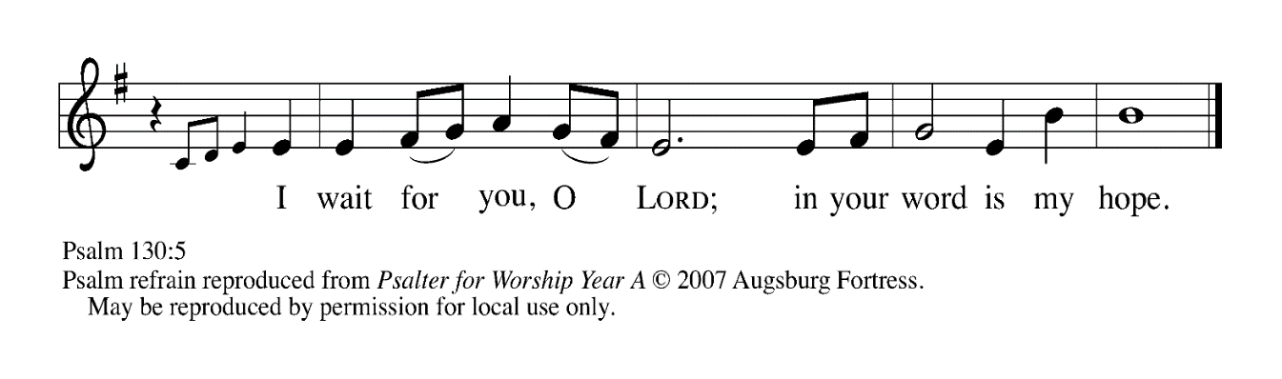
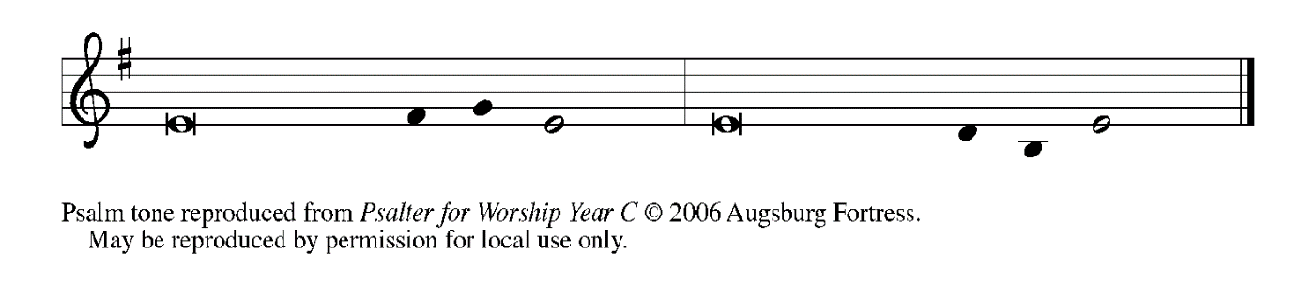
¹Out | of the depths
I cry to | You, O LORD;

²O LORD, | hear my voice!
Let Your ears be attentive to the voice of my | supplication.

³If You were to keep watch | over sins,
O LORD, | who could stand?

⁴Yet with You | is forgiveness,
in order that You | may be feared. REFRAIN

⁵I wait for You, O LORD; | my soul waits;
in Your word | is my hope.

⁶My soul waits for the Lord
more than those who keep watch | for the morning,
more than those who keep watch | for the morning.

⁷O Israel, wait for the LORD, for with the LORD there is | steadfast love;
with the LORD there is plen- | teous redemption.

⁸For the LORD shall | redeem Israel
from | all their sins. REFRAIN

SECOND READING Romans 8: 6-11

Paul contrasts two ways of living: The unspiritual life may seek to please God but cannot do so, for it is marked by self-reliance. The spiritual life begins with our justification by God and continues in the power of the Spirit who raised Christ from the dead.
To set the mind on the flesh is death, but to set the mind on the Spirit is life and peace. ⁷For this reason the mind that is set on the flesh is hostile to God; it does not submit to God's law--indeed it cannot, ⁸and those who are in the flesh cannot please God.
⁹But you are not in the flesh; you are in the Spirit, since the Spirit of God dwells in you. Anyone who does not have the Spirit of Christ does not belong to Him. ¹⁰But if Christ is in you, though the body is dead because of sin, the Spirit is life because of righteousness. ¹¹If the Spirit of Him Who raised Jesus from the dead dwells in you, He Who raised Christ from the dead will give life to your mortal bodies also through His Spirit that dwells in you.

The Word of the Lord.

Thanks be to God.

As you are able please rise

THE VERSE

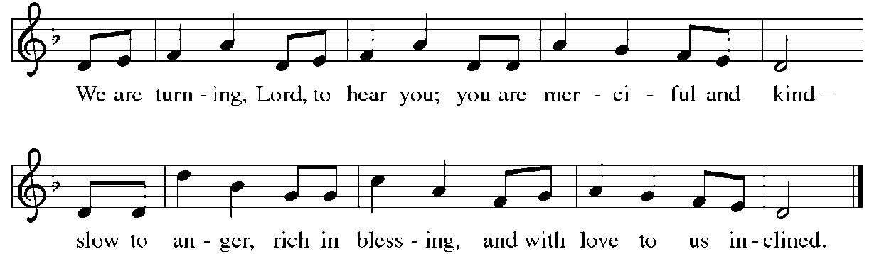

THE HOLY GOSPEL John 11: 1-45

The raising of Lazarus is presented as the last and greatest sign in John's gospel. It reveals Jesus as the giver of life. But as John 11:45-53 makes clear, this sign leads to the plan to execute Jesus.

P: The Holy Gospel according to St. John, the eleventh chapter.

C: Glory to You, O Lord!

Now a certain man was ill, Lazarus of Bethany, the village of Mary and her sister Martha. ²Mary was the one who anointed the Lord with perfume and wiped His feet with her hair; her brother Lazarus was ill. ³So the sisters sent a message to Jesus, "Lord, he whom You love is ill." ⁴But when Jesus heard it, He said, "This illness does not lead to death; rather it is for God's glory, so that the Son of God may be glorified through it." ⁵Accordingly, though Jesus loved Martha and her sister and Lazarus, ⁶after having heard that Lazarus was ill, He stayed two days longer in the place where He was.
⁷Then after this He said to the disciples, "Let us go to Judea again." ⁸The disciples said to Him, "Rabbi, the Judeans were just now trying to stone You, and are You going there again?" ⁹Jesus answered, "Are there not twelve hours of daylight? Those who walk during the day do not stumble, because they see the light of this world. ¹⁰But those who walk at night stumble, because the light is not in them." ¹¹After saying this, He told them, "Our friend Lazarus has fallen asleep, but I am going there to awaken him." ¹²The disciples said to Him, "Lord, if he has fallen asleep, he will be all right." ¹³Jesus, however, had been speaking about his death, but they thought that He was referring merely to sleep. ¹⁴Then Jesus told them plainly, "Lazarus is dead. ¹⁵For your sake I am glad I was not there, so that you may believe. But let us go to him." ¹⁶Thomas, who was called the Twin, said to his fellow disciples, "Let us also go, that we may die with Him."
¹⁷When Jesus arrived, He found that Lazarus had already been in the tomb four days. ¹⁸Now Bethany was near Jerusalem, some two miles away, ¹⁹and many of the Judeans had come to Martha and Mary to console them about their brother. ²⁰When Martha heard that Jesus was coming, she went and met Him, while Mary stayed at home. ²¹Martha said to Jesus, "Lord, if You had been here, my brother would not have died. ²²But even now I know that God will give You whatever You ask of Him." ²³Jesus said to her, "Your brother will rise again." ²⁴Martha said to Him, "I know that he will rise again in the resurrection on the last day." ²⁵Jesus said to her, "I am the resurrection and the life. Those who believe in Me, even though they die, will live, ²⁶and everyone who lives and believes in Me will never die. Do you believe this?" ²⁷She said to Him, "Yes, Lord, I believe that You are the Messiah, the Son of God, the One coming into the world."
²⁸When she had said this, she went back and called her sister Mary, and told her privately, "The Teacher is here and is calling for you." ²⁹And when she heard it, she got up quickly and went to Him. ³⁰Now Jesus had not yet come to the village, but was still at the place where Martha had met Him. ³¹The Judeans who were with her in the house, consoling her, saw Mary get up quickly and go out. They followed her because they thought that she was going to the tomb to weep there. ³²When Mary came where Jesus was and saw Him, she knelt at His feet and said to Him, "Lord, if You had been here, my brother would not have died." ³³When Jesus saw her weeping, and the Judeans who came with her also weeping, He was greatly disturbed in spirit and deeply moved. ³⁴He said, "Where have you laid him?" They said to Him, "Lord, come and see." ³⁵Jesus began to weep. ³⁶So the Judeans said, "See how He loved him!" ³⁷But some of them said, "Could not He Who opened the eyes of the blind man have kept this man from dying?"
³⁸Then Jesus, again greatly disturbed, came to the tomb. It was a cave, and a stone was lying against it. ³⁹Jesus said, "Take away the stone." Martha, the sister of the dead man, said to Him, "Lord, already there is a stench because he has been dead four days." ⁴⁰Jesus said to her, "Did I not tell you that if you believed, you would see the glory of God?" ⁴¹So they took away the stone. And Jesus looked upward and said, "Father, I thank you for having heard Me. ⁴²I knew that You always hear Me, but I have said this for the sake of the crowd standing here, so that they may believe that You sent Me." ⁴³When He had said this, He cried with a loud voice, "Lazarus, come out!" ⁴⁴The dead man came out, his hands and feet bound with strips of cloth, and his face wrapped in a cloth. Jesus said to them, "Unbind him, and let him go."
⁴⁵Many of the Judeans therefore, who had come with Mary and had seen what Jesus did, believed in Him.

The Gospel of the Lord.

Praise to You, O Christ!

The assembly is seated

THE SERMON

Silence for reflection follows the sermon

As you are able please rise

THE HYMN OF THE DAY (see p. 11) Christ is the Life
Stanza 2—Women; Stanza 3—Men
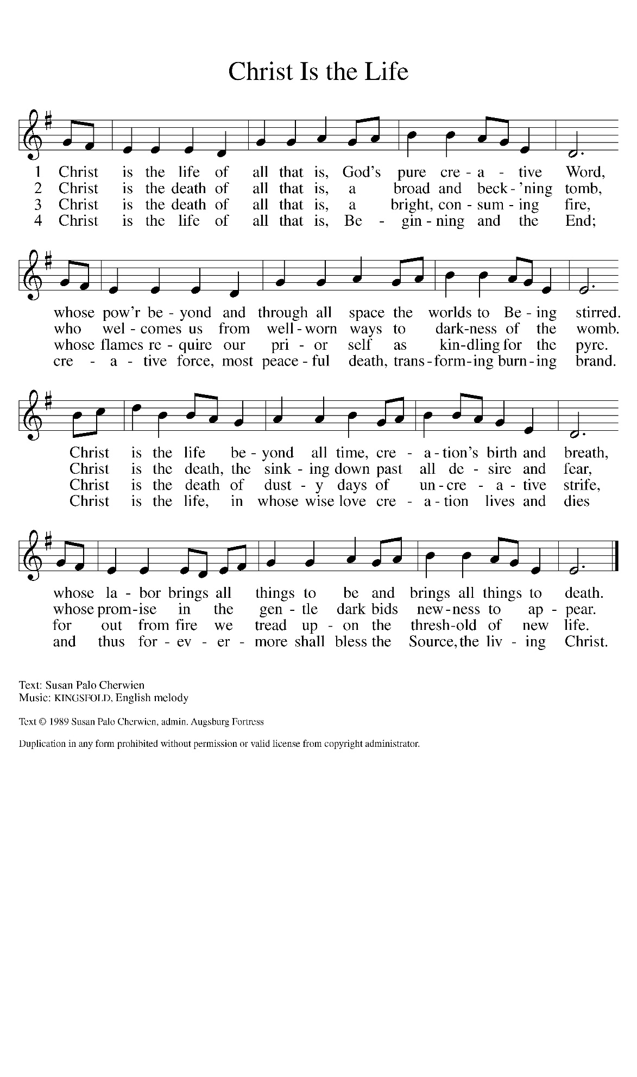
THE PRAYER OF THE CHURCH

A: Let us pray to God, Who raised Jesus from the dead as the resurrection and the life of
all who believe.

A: That wherever the power of death holds people bound the Church may summon forth
life in the name of Christ, let us pray to the Lord:

C: Lord, have mercy.

A: That in all lands and places where terrorism, natural disasters, economic or military
crises threaten to destroy, especially in Iran, Israel, Lebanon, and the Middle East God’s
Spirit might bring hope, life, and peace, let us pray to the Lord:

C: Lord, have mercy.

A: That Charlotte Judith Lucille, newly baptized, and those preparing for Baptism might
be kept in the faith and communion of the Church, let us pray to the Lord:

C: Lord, have mercy.

A: That this congregation’s Lenten journey would renew and strengthen our trust in the
promise of resurrection now in our living, let us pray to the Lord:

C: Lord, have mercy.

A: That those near death, the grieving, the hungry, and the sick, especially: Tim Miller;
Mark Tannehill; Major Payne; Jan Paholski; Laura Dovey; David Jocelyn;
Bill Homan; and Benny and Marcy Ortero may know the healing compassion of
Christ, let us pray to the Lord:

C: Lord, have mercy.

A: That those celebrating anniversaries, especially Wayne and Suzann Dolson, and
Marvin and Diane Dirks may grow in grace this day and every day and be filled with
grace for the days ahead, let us pray to the Lord:

C: Lord, have mercy.

A: That with all the faithful that are at rest we too may hear the voice of Jesus calling us
from our graves to resurrection and everlasting life, let us pray to the Lord:

C: Lord, have mercy.

P: Hear our prayers, O God, and grant us the faith to receive Your promise of resurrection,
both in this life, and in the life to come, through Your Son, Jesus Christ our Lord.

C: Amen.
MEAL

THE PEACE

P: Through Christ we have been reconciled to God, Who has given us the ministry of
reconciliation. Let us be reconciled with one another.

The peace of the Lord be with you always.

C: And also with you.

The assembly is seated

THE OFFERING

THE VOLUNTARY Wondrous Love St. Paul Senior Choir
(Arr. Paul Christiansen)

As you are able please rise

THE OFFERTORY (see p. 14) Create in Me a Clean Heart
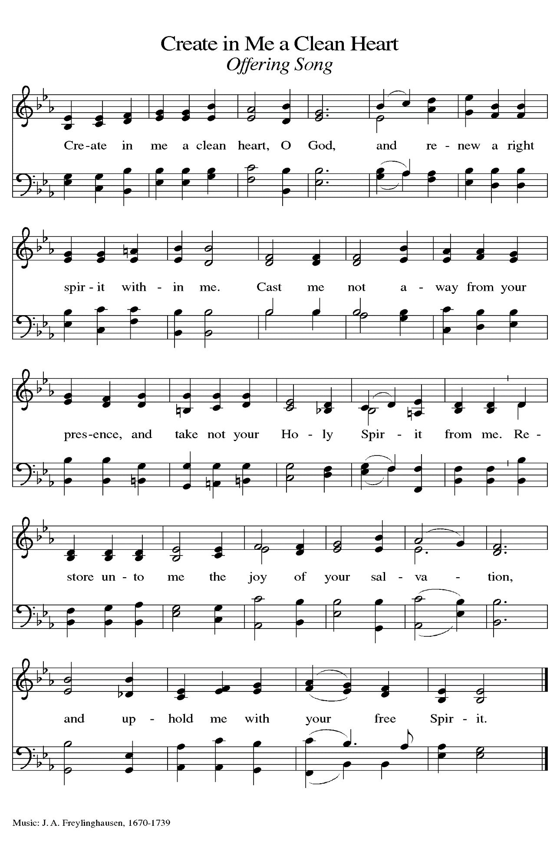
THE OFFERTORY PRAYER

A: God of mercy,

C: Your Son has destroyed the power of death for all those who believe in Him.
Accept these gifts as signs of our devotion and love. Through this holy Meal,
strengthen us in faith, fill us with the power of His resurrection, and grant us new
hope and joy. We ask this in the name of Jesus the Lord. Amen.

THE GREAT THANKSGIVING

P: The Lord be with you.

C: And also with you.

P: Lift up your hearts.

C: We lift them up to the Lord.

P: Let us give thanks to the Lord our God.

C: It is right to give Him thanks and praise.

P: It is indeed right, our duty, and our joy … join their unending hymn:

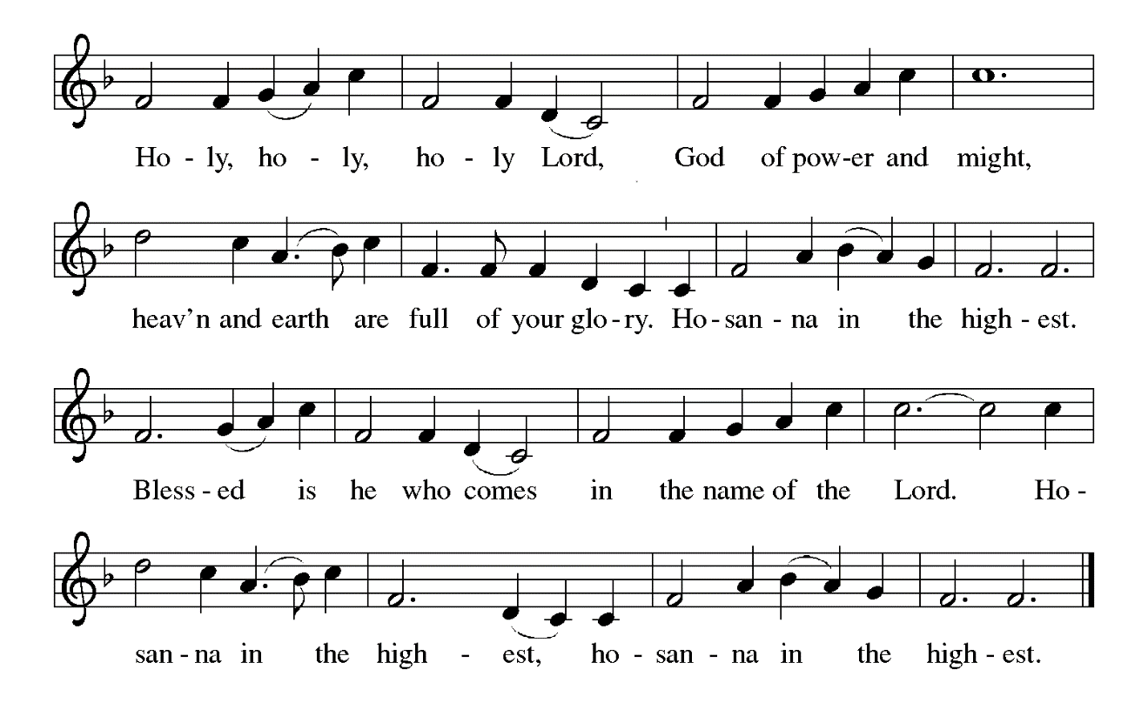

P: God of glory, You are worthy of thanks and praise, because You set humanity in a
garden of delight to glorify and enjoy You forever.
When that garden turned into a valley of bones, You entered the valley in the form of
Jesus Christ.
You breathed life into the dry bones and made them sing again.
You put Your Spirit in us that we might live.
In the crucified Christ You became dry bones for us, and at Easter You showed us how
to dance again.
Listening God, You heard Your Son Jesus when He called on You in the face of Lazarus’
death.
Hear us now as we call upon You to bring new life through this Meal of memory and hope.
Come among us in the power of Your Holy Spirit, that Your People may be transformed
from dry bones into Your living Body, and that these gifts of bread and wine may
become for us the Body and Blood of Your Son Jesus Christ,
Who, in the night ... “Do this for the remembrance of Me.”
As often as we eat ... we proclaim the Lord’s death until He comes.

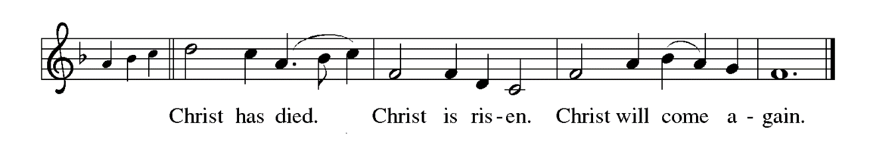

P: Resurrecting God, where Your People are in the valley of the shadow of death, bring
them words of prophecy and hope;
Where they are in the place of stench and decay, give them the balm of Your healing
and forgiveness;
Where they are under the weight of grief and depression, roll away the stone.
Make us, Your Church, a place where dust can dream, where dry bones become flesh,
where nobodies become Your Body.
Reveal through Lazarus a foretaste of the resurrection of all creation, where every
tearful eye will gaze upon Your consolation, and every weary throat be filled
with Your song;
Until every stone is rolled from every tomb and You sit in glory, the resurrection and
the life,
Father, Son, and Holy Spirit, now and forever.



THE LORD’S PRAYER

P: While we were still sinners, Christ died for us, that, with confidence in God’s love for
us, we might dare to pray:

C: (Sung) Music is on the front cover of the red hymnal

INVITATION TO THE MEAL

P: Behold our Savior Christ Jesus, Who abolished death and brought life through the
Gospel. Blessed are those called to the Banquet of the Lamb. God’s holy gifts for
God’s holy people. Come, for all is now ready.

The assembly is seated

THE DISTRIBUTION O Lamb of God

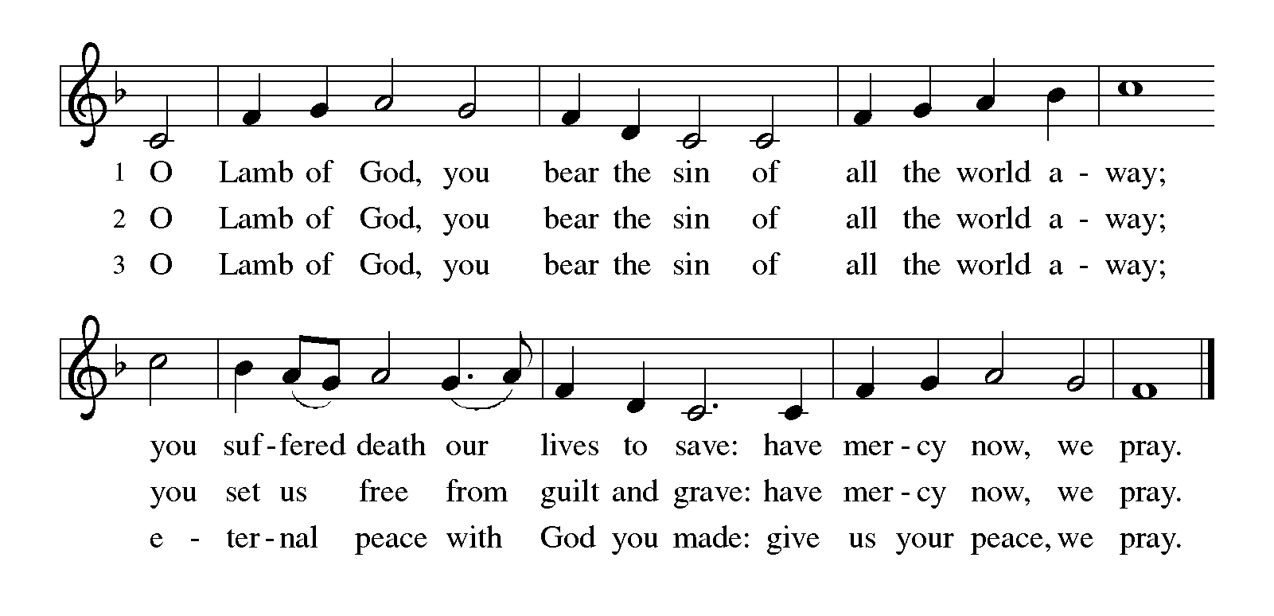

HYMN DURING DISTRIBUTION 485 I Am the Bread of Life

NSB 10 Beautiful Savior (All My Days)

NSB 28 Days of Elijah

ELW 886 Oh, For A Thousand Tongues to Sing

As you are able please rise

THE POST-COMMUNION BLESSING

P: The Body and Blood of our Lord Jesus Christ strengthen you and keep you in His grace.

C: Amen.

THE POST-COMMUNION PRAYER

A: Let us pray. God of life, in this Meal we have tasted the promise of Your heavenly
Banquet and the richness of eternal life. Sustain us now in our Lenten pilgrimage.
Unbind us from every death, that we who bear witness to the death of Your Son may
also proclaim the glory of His resurrection. Grant this through Christ our Lord.

C: Amen.
SENDING

THE BENEDICTION

P: Jesus took the form of a servant and was obedient to death, even death on a cross. May
you follow His example and share in the resurrection.

C: Amen.
P: Almighty God: Father, Son, and Holy Spirit bless you now and forever.

C: Amen.

SENDING HYMN Restore in Us, O God
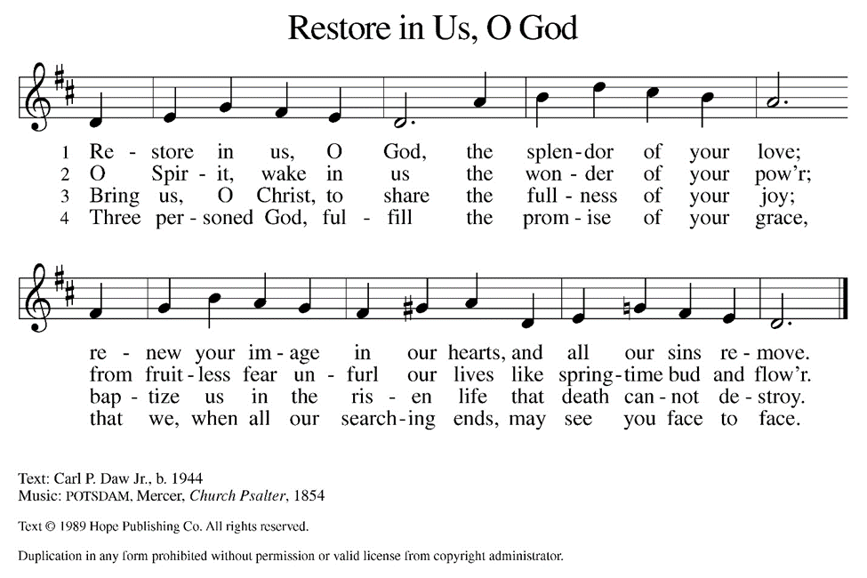

THE DISMISSAL

A: Reconciled to God through Christ, let us go out into the world in peace.

C: Thanks be to God!

THE POSTLUDE

To God Alone Be Glory

The Meditations are from Richer Fare for the Christian People. Gail Ramshaw, ed. (New
York: Pueblo Publishing Company, 1990) 29. and Liturgy: From Ashes to Fire. Lent 2002. (Washington, D.C.: The Liturgical Conference, 2002) 28.

The Greeting, Prayers, Peace, and Dismissal are adapted from Sundays and Seasons.
Copyright 2001 Augsburg Fortress.

The Offertory and Post-Communion Prayers are adapted from The Book of Alternative
Services of the Anglican Church of Canada. (Toronto: Anglican Book Centre,
1985) 294.

The Prayers, Introduction to the Lord’s Prayer, and Invitation to the Meal are adapted from
Prayers for Sundays and Seasons. Year A. Peter J. Scagnelli. (Chicago: Liturgy Training Publications, 1998) 36-37.

PLEASE SHARE your photos from St. Paul’s 150th Anniversary events and help us fill the bulletin board outside the St. Paul Room. Email your photos to Stacie Crozier at staciejcro@gmail.com or give prints to Sue Koziel or Stacie Crozier. Thank you so much!

SNOW EMERGENCY LIST
This is a reminder of where to turn to learn if worship has been canceled because of inclement weather conditions. There are two ways to learn about the status of the service.
First, you may turn to our church and school Facebook page: https://www.facebook.com/stpaulmichigancity/ for updated announcements. Or, perhaps most quickly and easily, you may call the church office number (219-874-7293) and press the “#” key and you will hear a recording about our “open/closed” status.

2026 Financial Stewardship

Weekly Church Operating Needs (x 2 weeks)
February 21-22 & February 28 & March 1, 2026 $ 11,827.00

General Fund (including General Memorials): $ 9,964.00

Overage/Shortage: - $ 1,863.00

Restricted Income (not including Memorials)
Supports IK Synod & Church wide Ministries: $ 204.00

Ministries in our Community/Congregation: $ 215.00

Capital Fund: $ 407.00

Memorials
General Fund: $ 420.00

ANNOUNCEMENTS

Please remember to mail your offering to the Church Office at 818 Franklin Street, Michigan City, IN 46360. Another alternative is to give on-line through Tithe.ly. Please see your closure letter for information on how to set up a Tithe.ly account.

St. Paul Members are reminded to have a loved one contact the office if you are hospitalized. Many times, the Pastor doesn’t know someone is in the hospital. If you call and leave a message, please tell us at which hospital the patient is located.

ANNIVERSARIES: Wayne & Suzann Dolson (3/23);
Marvin & Diane Dirks (3/24)

PRAYER CONCERNS: John Bennitt; Debbie Martin; Mark Tannehill; Kathy Stein; Jan Paholski; Laura Dovey; Bill Hazelgrove; Al Levenhagen; Carl Wipperman; Major Payne; and Tim Miller.

OFFICE HOURS: Libby will be in the office on Mondays, Wednesdays, and Fridays; volunteers will cover Tuesdays and Thursdays.

Monday & Wednesday 8:00 a.m. – 5 p.m.
Tuesday & Thursday 9:00 a.m. – 12:00 p.m.
Friday 8:00 a.m. – 12:00 p.m.

If you are listening to the worship broadcast on the radio and would like to watch the Sunday morning service live stream follow these steps:

(1) If you have You Tube available on your TV, search for
St. Paul Lutheran Church Michigan City, IN.

(2) The direct link on the computer is https://
www.youtube.com/channel/UC5AIPNaKr3QN50984jGOa1g

(3) This link is also on the main page of the church’s website in
the church section and will continue to be posted weekly on the St.
Paul Facebook page.

And it will always be available on the radio broadcast Sunday mornings at 11:00 a.m.
on WEFM (95.9), and on the local cable access station #99 for the previous week’s
service on Sundays at 4:00 p.m. and the current service on Wednesdays at 7:00 p.m.
and Fridays at 8:30 p.m.

To send e-mail to the church office, please use the following addresses:

Pastor Mark Reshan: seniorpastor@stpaulmichigancity.com

Church Office Secretary (Libby Pollock): churchsecretary@stpaulmichigancity.com

Church Treasurer (Karen Fleming): finance@stpaulmichigancity.com

2026 Church Council:

Pastor - Mark Reshan

President - Donna Knoll

Vice President - Jan Bakken

Secretary - Judy Hunt

Treasurer - Karen Fleming

Members: Sue Koziel; Jim Schraidt; Trish Sprague; Bob Kiser; Barry Anderson; and
Pam Soule

Worship Attendance:

Wednesday, March 11 @ 7:00 p.m. 32

Sunday, March 15, 2026 @ 9:00 a.m. 144

TOTAL 176

Copies of the minutes from the January 22, and February 26, 2026 Church Council meetings are on the back table in the upper Narthex. They were approved by the council via email.

The Good News Newsletter: If you have an article or anything you want included in The Good News please send it to the following e-mail address: splcgoodnews@gmail.com. Pastor Pamela Thiede will be using this e-mail address to assemble The Good News each month. The deadline for getting information to Pastor Pamela will be the 20th of each month.

Next week’s lessons are Isaiah 50: 4-9a; Psalm 31: 9-16; Philippians 2: 5-11 and Matthew 26: 14– 27: 66, or Matthew 27: 11-54 for those of you who like to study them in advance.

MISSION OF THE MONTH for MARCH 2026:

7th & 8th Grade STEAM Learning Opportunities

Daisy Lee is an extraordinary 7th and 8th grade environmental science teacher in our community. Every year, along with a few other extraordinary people, Daisy takes 30-40 girls to Indianapolis in January for the Sycamore STEAM Conference for Girls. This allows the girls to get hands on experience in various STEAM careers. They learn how everything functions in a real cadaver arm, how to do different types of stitches in a pig’s foot with Dermatologists, drill into arm bones and secure metal rods with Orthopedic Surgeons, create nutrition plans with Nutritionists, dissect cow hearts with Cardiologists, dissect sheep brains with Neurologists, code robots with IT specialists, and so much more!

Daisy also has a trip in May where she takes 70 students (at $110 each) on a 3 day, two night trip to the Dunes learning Center in Chesterton. Students will engage in hands on investigations of local ecosystems in this STEM and service – themed program. Participants learn and practice research procedures used by professional scientists such as quadrant surveys and chemical water monitoring to gather and analyze data and participate in stewardship activities within the park. Biodiversity, ecosystems, sustainability and human impacts on the environment are explored through real conservation and natural resource management experiences. Activities include: Ecosystem Hike where students embark on a hike to learn about various ecosystems and research tools that scientists use to collect data. They will have the opportunity to practice using different tools. This hike gives students the information they need to create a research question they will apply in the field. Field investigations: Trail Groups will work together to collect data on their research questions out in the field. They will collect, record, and analyze the data to determine their findings. Field investigations Presentations: Trail Groups will be able to share their findings with their classmates, just as a scientist would share their research!

To help Daisy make these trips possible, please make checks payable to St. Paul and mark for Daisy Lee and place in the offering. Noisy coin for the month of March will also go to support Daisy’s trips. Thank you for your generosity each month

EASTER PLANTS 2026
LAST CHANCE TO ORDER

A variety of spring plants will be available to order for decorating St. Paul Church on Easter Morning! The varieties available will be Lily, Daffodil, Hyacinth, Tulip, Hydrangea and 10 inch Fern in hanging basket. Color choices and cost of plants are as follows:

Lily(white) $10.00
Daffodil (yellow) $9.00
Hyacinth (purple or pink) $9.00
Tulip (white, yellow, pink, or red) $9.00
Hydrangea (pink or purple/blue) $15.00
10 inch Hanging Fern Basket $15.00
Please specify your choice of plant and color when applicable.

Orders MUST be placed by Wednesday morning, March 25th

Your order may be placed “In memory of or in honor of a Loved One.” Please call the church office at (219) 874-7293 to place your order. Or you can place your order in an envelope and title it ‘Easter Plants’ for ordering and place it in the offering. Remember you must specify what type of plant and what color, if applicable. All checks should be made out to St. Paul Church.
Also, please plan on picking up your plant after the Easter Morning Service by 10:45 a.m.

ACTIVITIES, EVENTS & MEETINGS
MARCH 2026

Wednesday, March 18, 2026 @ 9:15 a.m. Bible Study/Luther House

@ 10:00 a.m. God’s Purls/St. Paul Room

@ 4:00 p.m. Choir Rehearsal/Sanctuary

@5:00 p.m. Hand bell Rehearsal

@6:00 p.m. Mid-week Lenten Service/Sanctuary

Saturday, March 21, 2026 @ 4:00 p.m. 5 Lent Worship Service/Sanctuary

Sunday, March 22, 2026 @ 9:00 a.m. 5 Lent Worship with Baptism/Sanctuary with coffee after

Monday, March 23, 2026 @ 2:00 p.m. Finance Meeting/Luther House

@3:00 p.m. Executive Board Meeting/Luther House

Wednesday, March 25, 2026 @ 9:15 a.m. Bible Study/Luther House

@10:00 a.m. God’s Purls/St. Paul Room

@4:00 p.m. Choir Rehearsal/Sanctuary

@ 5:00 p.m. Hand bell Rehearsal

@6:00 p.m. Mid-week Lenten Service/ Sanctuary

Thursday, March 26, 2026 @ 3:00 p.m. Church Council Meeting/St. Paul Room

Saturday, March 28, 2026 @ 4:00 p.m. PASSION/PALM Saturday Worship/ Sanctuary

Sunday, March 29, 2026 @9:00 a.m. PASSION/PALM Sunday Worship/with
Coffee after.

