THE TWENTIETH SUNDAY AFTER PENTECOST
October 11, 2026

One early, cloudy morning when I was forty-six, I walked into a church, ate a piece of bread, took a sip of wine. This was my first communion. It changed everything. The mysterious sacrament turned out to be not a symbolic wafer at all but actual food—indeed, the bread of life.
I realized that what I’d been doing with my life all along was what I was meant to do: feed people. And so I did. I took communion, I passed the bread to others, and then I kept going, compelled to find new ways to share what I’d experienced. I started a food pantry and gave away literally tons of fruit and vegetables and cereal around the same altar where I’d first received the body of Christ. I organized new pantries all over my city to provide hundreds and hundreds of hungry families with free groceries each week. . . .
Holy communion knocked me upside down and forced me to deal with the impossible reality of God.

Sara Miles

In the Name of Jesus

GATHERING

INTRODUCTION

In Isaiah we are given a vision of the great feast to come, when God will wipe away death forever. In Jesus' parable about a great banquet, those invited do not come, so the invitation is extended to others. In our liturgy God spreads a table before us. Even amid anxiety and hardship we rejoice in the peace of God that surpasses all understanding. With great joy we feast at the table of the Lord, and we go forth to share the wonderful invitation with others hungering and thirsting for the abundant life of God.

PRELUDE

ANNOUNCEMENTS

As you are able please rise

CONFESSION AND ABSOLUTION

P: In the name of the Father and of the Son and of the Holy Spirit.

C: Amen.

P: Today our God invites us to the royal wedding Banquet, and offers to clothe us with the
life and gifts of Christ. Let us therefore confess our sins, that in the strength of God’s
forgiveness we may rejoice again in God’s goodness and mercy.

Silence for reflection and self-examination is kept

P: Most merciful God,

C: We confess that we are sinners in need of Your forgiveness. We have not shown
Christ in our words and deeds. We have not lived in ways that are true, honorable,
and just. (Philippians 4: 8). We have not been gentle with one another (4: 5). We
have neglected the poor and needy in our midst. We worry about much, and have
been negligent in prayer and supplication with thanksgiving (4: 6). For the sake
of Your Son, Jesus Christ, have mercy on us. Forgive us our sins, and renew us by
Your Holy Spirit. Fill us with Your peace, and guard our hearts and minds in
Christ Jesus (4: 7).

P: “Rejoice in the Lord always; again I will say, Rejoice.” (Philippians 4: 4) For “the God
of peace is and will be with you” for the sake of Jesus Christ, Who died and rose that
you may have God’s new life. Therefore, rejoice in this promise: as a called and
ordained minister of the Church of Christ, and by His authority, I therefore declare to
you the entire forgiveness of all your sins, in the name of the Father and of the Son,
and of the Holy Spirit.

C: Amen.

GATHERING HYMN 553 Christ, Whose Glory Fills the Skies

THE GREETING AND PRAYER OF THE DAY

P: The grace of our Lord Jesus Christ, the love of God, and the communion of the Holy
Spirit be with you all.

C: And also with you.

P: Let us pray. Lord of the feast, You have prepared a table before all peoples and poured
out Your life with abundance. Call us again to Your banquet. Strengthen us by what is
honorable, just, and pure, and transform us into a people of righteousness and peace,
through Jesus Christ, our Savior and Lord.

C: Amen.

The assembly is seated

WORD

FIRST READING Isaiah 25: 1-9

Today's reading begins with a hymn of thanksgiving and concludes with the promise of the banquet celebrating the day in which the Lord's sovereignty is fully established. This banquet symbolizes not only the establishment of God's reign on earth, it also symbolizes the joy, companionship, and prosperity characteristic of God's reign.

O LORD, You are my God;
I will exalt You, I will praise
Your name;
for You have done wonderful things,
plans formed of old, faithful and sure.
²For You have made the city a heap,
the fortified city a ruin;
the palace of aliens is a city no more,
it will never be rebuilt.
³Therefore strong peoples will glorify You;
cities of ruthless nations will fear You.
⁴For You have been a refuge to the poor,
a refuge to the needy in their distress,
a shelter from the rainstorm and a shade from the heat.
When the blast of the ruthless was like a winter rainstorm,
⁵the noise of aliens like heat in a dry place,
You subdued the heat with the shade of clouds;
the song of the ruthless was stilled.
⁶On this mountain the LORD of hosts will make for all peoples
a feast of rich food, a feast of well-aged wines,
of rich food filled with marrow, of well-aged wines strained clear.
⁷And He will destroy on this mountain
the shroud that is cast over all peoples,
the sheet that is spread over all nations;
He will swallow up death forever.
⁸Then the Lord God will wipe away the tears from all faces,
and the disgrace of His people He will take away from all the earth,
for the LORD has spoken.
⁹It will be said on that day,
Lo, this is our God; we have waited for Him, so that He might save us.
This is the LORD for Whom we have waited;
let us be glad and rejoice in His salvation.

The Word of the Lord.

Thanks be to God.

THE PSALM: Psalm 23 Read responsively

¹The Lord is my shepherd;
I shall not be in want.

²He makes me lie down in green pastures
and leads me beside still waters.

³He revives my soul
and guides me along right pathways for His name’s sake.

⁴Though I walk through the valley of the shadow of death, I shall fear no evil;
for You are with me; Your rod and Your staff, they comfort me.

⁵You spread a table before me in the presence of those who trouble me;
You have anointed my head with oil, and my cup is running over.

⁶Surely Your goodness and mercy shall follow me all the days of my life,
and I will dwell in the house of the Lord forever.

THE SECOND READING Philippians 4: 1-9

Paul's letter to the Philippians is written from prison at a time when the apostle faced possible martyrdom. Nevertheless, his words reveal concern for the needs of others and convey an attitude of joy, hope, gratitude, and peace.

My brothers and sisters, whom I love and long for, my joy and crown, stand firm in the Lord in this way, my beloved.
²I urge Euodia and I urge Syntyche to be of the same mind in the Lord. ³Yes, and I ask you also, my loyal companion, help these women, for they have struggled beside me in the work of the gospel, together with Clement and the rest of my co-workers, whose names are in the book of life.
⁴Rejoice in the Lord always; again I will say, Rejoice. ⁵Let your gentleness be known to everyone. The Lord is near. ⁶Do not worry about anything, but in everything by prayer and supplication with thanksgiving let your requests be made known to God. ⁷And the peace of God, which surpasses all understanding, will guard your hearts and your minds in Christ Jesus.
⁸Finally, beloved, whatever is true, whatever is honorable, whatever is just, whatever is pure, whatever is pleasing, whatever is commendable, if there is any excellence and if there is anything worthy of praise, think about these things. ⁹Keep on doing the things that you have learned and received and heard and seen in me, and the God of peace will be with you.

The Word of the Lord.

Thanks be to God.

As you are able please rise

THE VERSE
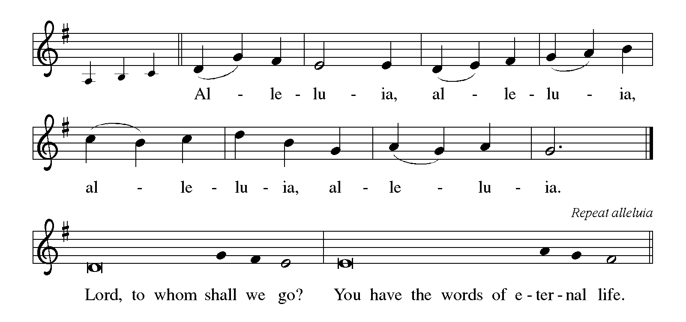

THE HOLY GOSPEL Matthew 22: 1-14

Jesus tells a parable to the religious leaders of his day, indicating that even though God's kingdom is a great feast open to all, its coming will prove disastrous for some.

P: The Holy Gospel according to St. Matthew, the twenty-second chapter.

C: Glory to You, O Lord!

Once more Jesus spoke to them in parables, saying: ²"The kingdom of heaven may be compared to a king who gave a wedding banquet for his son. ³He sent his slaves to call those who had been invited to the wedding banquet, but they would not come. ⁴Again he sent other slaves, saying, 'Tell those who have been invited: Look, I have prepared my dinner, my oxen and my fat calves have been slaughtered, and everything is ready; come to the wedding banquet.' ⁵But they made light of it and went away, one to his farm, another to his business, ⁶while the rest seized his slaves, mistreated them, and killed them.
⁷The king was enraged. He sent his troops, destroyed those murderers, and burned their city. ⁸Then he said to his slaves, 'The wedding is ready, but those invited were not worthy. ⁹Go therefore into the main streets, and invite everyone you find to the wedding banquet.' ¹⁰Those slaves went out into the streets and gathered all whom they found, both good and bad; so the wedding hall was filled with guests.
¹¹"But when the king came in to see the guests, he noticed a man there who was not wearing a wedding robe, ¹²and he said to him, 'Friend, how did you get in here without a wedding robe?' And he was speechless. ¹³Then the king said to the attendants, 'Bind him hand and foot, and throw him into the outer darkness, where there will be weeping and gnashing of teeth.' ¹⁴For many are called, but few are chosen."

P: The Gospel of the Lord.

C: Praise to You, O Christ!

The assembly is seated

THE SERMON

Silence for reflection follows the sermon

As you are able please rise

THE HYMN OF THE DAY 522 As We Gather at Your Table

THE APOSTLES’ CREED

A: God has made us His people through our Baptism into Christ. Living together in trust
and hope, we confess our faith.

C: I believe in God, the Father almighty,
creator of heaven and earth.

I believe in Jesus Christ, His only Son, our Lord.
He was conceived by the power of the Holy Spirit
and born of the virgin Mary.
He suffered under Pontius Pilate,
was crucified, died, and was buried.
He descended into hell.
On the third day He rose again.
He ascended into heaven,
and is seated at the right hand of the Father.
He will come again to judge the living and the dead.

I believe in the Holy Spirit,
the holy catholic Church,
the communion of saints,
the forgiveness of sins,
the resurrection of the body,
and the life everlasting. Amen.

THE PRAYER OF THE CHURCH

A: We are invited to the wedding Banquet which the Father is preparing for the Son’s
marriage to the Church. Let us pray to the Host of the eternal Feast, that we may be
drawn to the Banquet in truth, in deed, and in prayer for all people.

A: That Christians, clothed all alike in the shining garment of Baptism, may one day be
united at God’s great Feast of victory, let us pray to the Lord:

C: Lord, hear our prayer.

A: That God might still the terror, violence, and bloodshed of the ruthless, especially in
Ukraine, Russia; Nigeria; Ethiopia; Haiti; Sudan; and the Middle East; so all may live
in peace and without fear, let us pray to the Lord:

C: Lord, hear our prayer.

A: That Sarah Payne and Nik Vance, newly married, may grow in holy love as they begin
their new life together as husband and wife in Christ, let us pray to the Lord:
C: Lord, hear our prayer.

A: That the gentleness, compassion, mercy, and forgiveness of Christ might be known in
us this week, let us pray to the Lord:

C: Lord, hear our prayer.

A: That the weary, those for whom death draws near, the homeless, the abused and
exploited, and the sick, especially: Martha Schroeder; Mark Tannehill; Jon
Samuelson; Dale Thomas; Linda Barnes; Jim Tomscheck; Jean Warner;
Angela Cook; Mike Fitzgerald; Jeff Timmrick; Deb Prybylla; John Ripka
and Bill Hazelgrove might know God’s healing goodness and mercy, let us pray to
the Lord:

C: Lord, hear our prayer.

A: That the Day when God will destroy death and host His great and final Feast may come
soon, let us pray to the Lord:

C: Lord, hear our prayer.

P: O Lord, supply our needs out of Your magnificent riches in Christ Jesus our Lord. May
all one day appear clothed with amazing grace at Your Son’s wedding Banquet, to
Whom we glory forever and in Whose name we pray.

C: Amen.

MEAL

THE PEACE

P: The peace of the Lord be with you always.

C: And also with you.

The assembly is seated

THE OFFERING

THE VOLUNTARY

As you are able please rise

THE PRESENTATION OF GIFTS (see p. 8) Let the Vineyards Be Fruitful
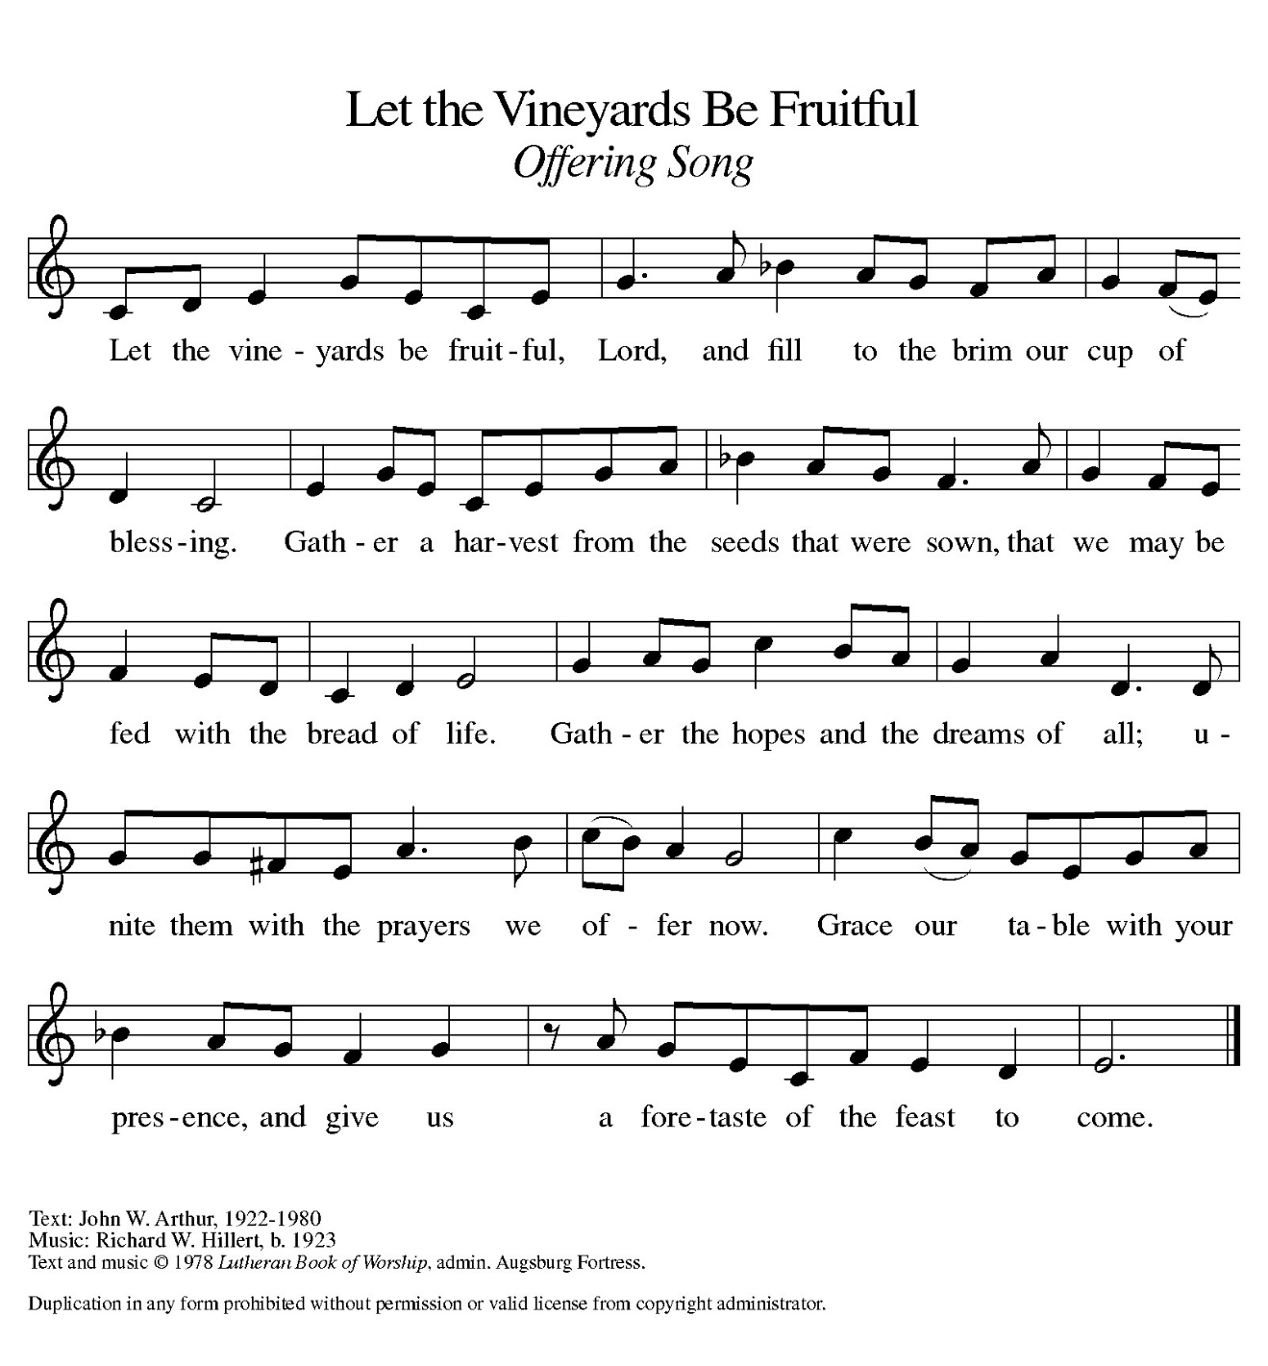
THE OFFERTORY PRAYER

A: Let us pray. Lord of Hosts,

C: As we wait for Your salvation, we bring You these offerings of our lives. Bless us
as we feast on the rich Food of the Body and Blood of Your Son. Fill us with joy,
revive our weariness, and be with us in peace. We ask this in the name of Jesus
the Lord. Amen.

THE GREAT THANKSGIVING

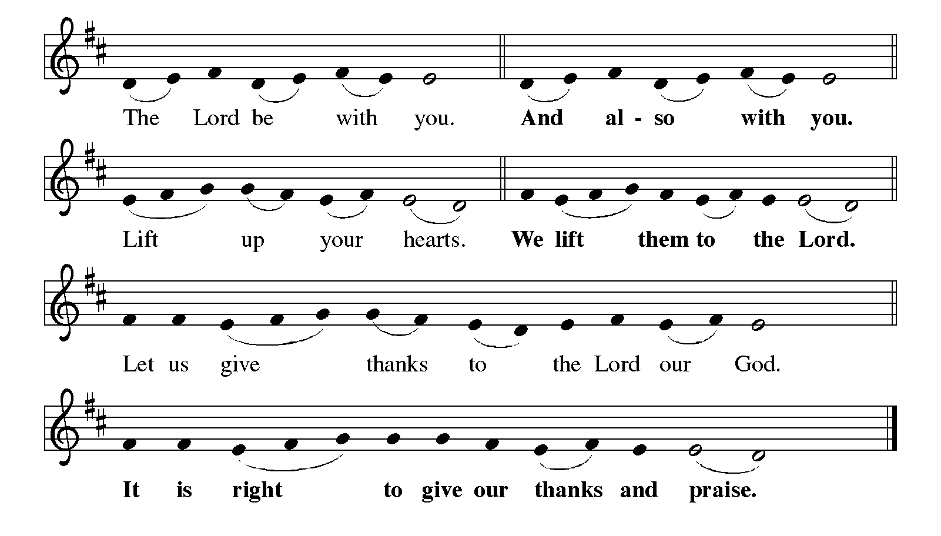

P: It is indeed right, our duty and our joy … join their unending hymn:

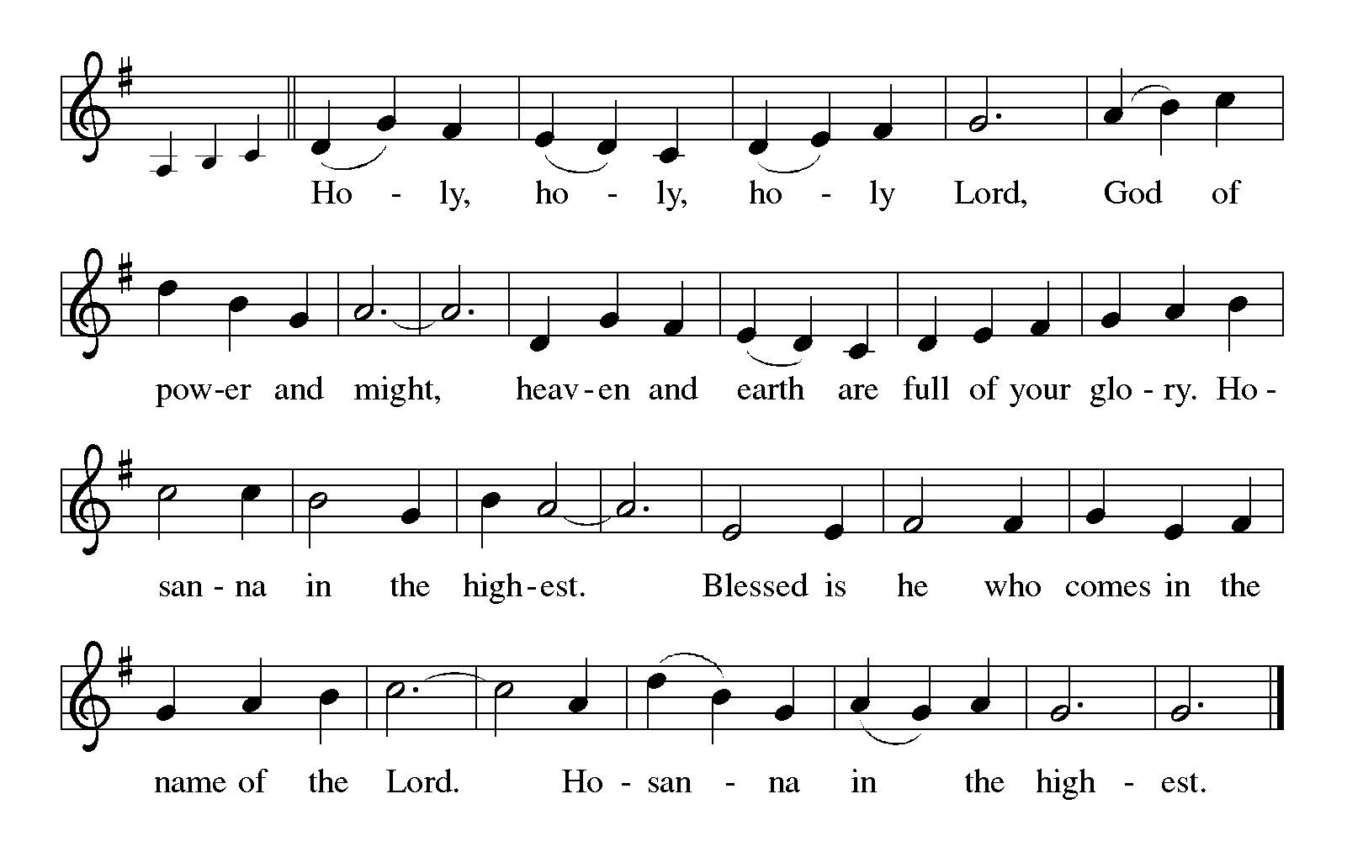
P: Holy God, our Bread of Life, we bless and exalt You.
You created heaven and earth and all creatures in them.
You formed us in Your own image, and made us stewards of Your bounty.
You chose Israel to make Your blessings known. In goodness and mercy You led
them from slavery and disobedience to right pathways of life.

At the last You raised up the faithful Shepherd, Your Son, Jesus Christ.
He is our peace, Who guards our hearts and minds in love.
In the night ... “Do this for the remembrance of Me.”
As often as we eat ... we proclaim the Lord’s death until He comes.

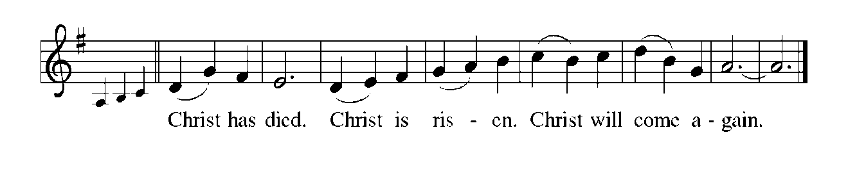
P: With this bread and cup, O God, we remember our Lord’s life given for us and His
Rising from the grave.
We await His coming again to swallow up death, wipe away all tears, and share with
us the everlasting Feast.
By Your Spirit nurture and sustain us with this Meal.
Robed in Christ’s life, strengthen us to serve all in hunger and want, until all the
world joins us on God’s holy mountain to rejoice in His salvation.
To You, O God: Father, Son, and Holy Spirit, be all honor and glory, in Your holy
Church, in heaven and on earth, now and forever.
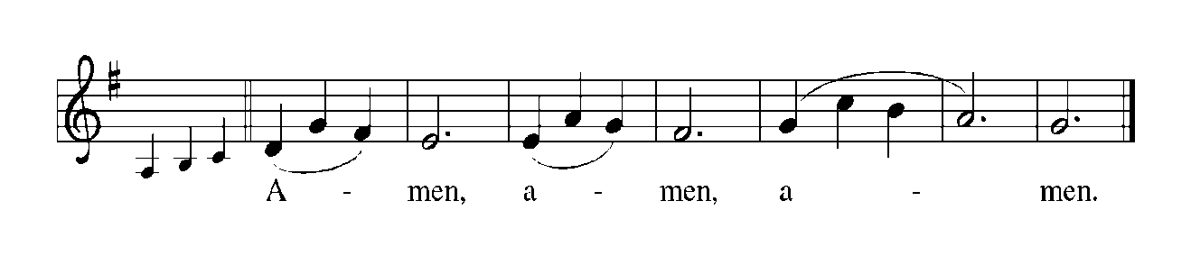

THE LORD’S PRAYER

P: Called to labor in the vineyard for the coming of God’s Kingdom, let us pray as Jesus
taught us:

C: Our Father in heaven, hallowed be Your name.
Your Kingdom come, Your will be done on earth as in heaven.
Give us today our daily bread, and forgive us our sins, as we forgive
those who sin against us.
Save us from the time of trial, and deliver us from evil.
For the Kingdom, the power, and the glory are Yours, now and forever.
Amen.

INVITATION TO THE MEAL

P: Behold the living Bread come down from heaven: Those who eat of it will never die.
Behold the cup of eternal life: Those who drink of it will live forever. God’s holy gifts
for God’s holy people. Come, for all is now ready.

The assembly is seated

THE DISTRIBUTION Lamb of God

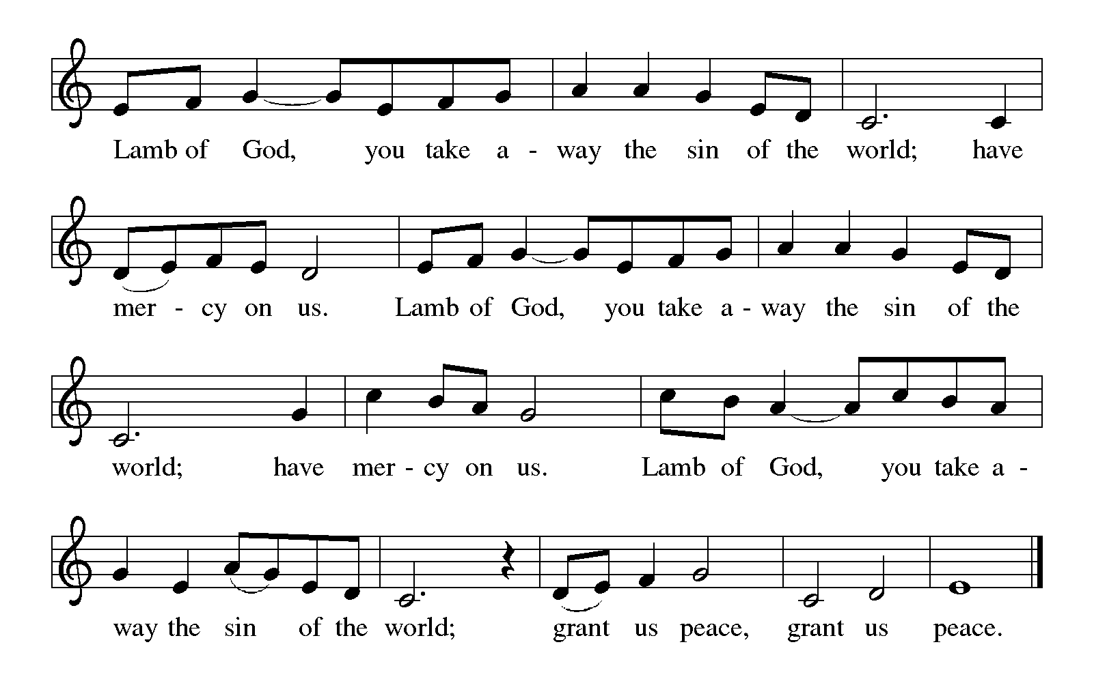

Those wishing to receive the Laying on of Hands, Anointing with Oil, and Prayer for
Healing may go to Pastor at the side aisle

HYMN DURING DISTRIBUTION 491 Come, Let Us Eat
462 Now We Join in Celebration
As you are able please rise

THE POST-COMMUNION BLESSING

P: The Body and Blood of our Lord Jesus Christ strengthen you and keep you in His grace.

C: Amen.

THE POST-COMMUNION PRAYER

A: Let us pray. God of peace, You have again drawn near to us in this Holy Sacrament.
Clothe us again in the life and love of Your Son, that we may with gentleness and joy
invite all to Your Feast of grace. Grant this through Christ our Lord.

C: Amen.

SENDING

THE BENEDICTION

P: Almighty God: Father, Son, and Holy Spirit bless you now and forever.

C: Amen.

SENDING SONG 547 Sent Forth By God’s Blessing

THE DISMISSAL

A: Go in peace to love and serve the Lord.

C: Thanks be to God!

POSTLUDE

To God Alone Be Glory

The Meditation is from Sundays and Seasons Online. Copyright 2017 Augsburg Fortress.

The Prayers, Introduction to the Lord’s Prayer, and Invitation to the Meal are adapted from Prayers for Sundays and Seasons. Year A. Peter J. Scagnelli. (Chicago: Liturgy Training Publications, 1998) 120-121.

THANK YOU!

We are blessed to have some conscientious and hard working fellows in our midst who step up to the plate every time there’s work to be done to keep our lovely house of worship in good working order. Last week when no one was looking, they were hard at work restaining our pews. Please be sure to thank them for all they do! Thank you Tim Crozier, Rich Fleming, Craig Hunt, and Mark Kloess, for the many hours you give to the care of “our home!” From Bob Kiser

ANNOUNCEMENTS

Please remember to mail your offering to the Church Office at 818 Franklin Street, Michigan City, IN 46360. Another alternative is to give on-line through Tithe.ly. Please see your closure letter for information on how to set up a Tithe.ly account.

St. Paul Members are reminded to have a loved one contact the office if you are hospitalized. Many times, the Pastor doesn’t know someone is in the hospital. If you call and leave a message, please tell us at which hospital the patient is located.

PRAYER CONCERNS: Debbie Martin; Mark Tannehill; Kathy Stein; Jan Paholski; Laura Dovey; Bill Hazelgrove; Al Levenhagen; Carl Wipperman; Major Payne.

OFFICE HOURS: Libby will be in the office on Mondays, Wednesdays, and Fridays; volunteers will cover Tuesdays and Thursdays.

Monday & Wednesday 8:00 a.m. – 5 p.m.
Tuesday & Thursday 9:00 a.m. – 12:00 p.m.
Friday 8:00 a.m. – 12:00 p.m.

If you are listening to the worship broadcast on the radio and would like to watch the Sunday morning service live stream follow these steps:

(1) If you have You Tube available on your TV, search for
St. Paul Lutheran Church Michigan City, IN.

(2) The direct link on the computer is https://
www.youtube.com/channel/UC5AIPNaKr3QN50984jGOa1g

(3) This link is also on the main page of the church’s website in
the church section and will continue to be posted weekly on the St.
Paul Facebook page.

And it will always be available on the radio broadcast Sunday mornings at 11:00 a.m.
on WEFM (95.9), and on the local cable access station #99 for the previous week’s
service on Sundays at 4:00 p.m. and the current service on Wednesdays at 7:00 p.m.
and Fridays at 8:30 p.m.

To send e-mail to the church office, please use the following addresses:

Pastor Mark Reshan: seniorpastor@stpaulmichigancity.com

Church Office Secretary (Libby Pollock): churchsecretary@stpaulmichigancity.com

Church Treasurer (Karen Fleming): finance@stpaulmichigancity.com

2026 Church Council:

Pastor - Mark Reshan

President - Donna Knoll

Vice President - Jan Bakken

Secretary - Judy Hunt

Treasurer - Karen Fleming

Members: Sue Koziel; Jim Schraidt; Trish Sprague; Bob Kiser; Barry Anderson; and
Pam Soule

Worship Attendance:

Saturday, October 3, 2026 @ 4:00 p.m. 28

Sunday, October 4, 2026 @ 9:00 a.m. 57

TOTAL 85

Copies of the minutes from the June 25, 2026 and July 23, 2026 Church Council meetings are on the back table in the upper Narthex. They were approved by the council via email.

Good News Newsletter: If you have an article or anything you want included in The Good News please send it to the following e-mail address: splcgoodnews@gmail.com. Pastor Pamela Thiede will be using this e-mail address to assemble The Good News each month. The deadline for getting information to Pastor Pamela will be the 20th of each month.

Next week’s lessons are Isaiah 45: 1-7; Psalm 96: 1-9 [10-13]; 1 Thessalonians 1: 1-10; Matthew 22: 15-22 for those of you who like to study them in advance.

Mission of the Month for October 2026
Our mission for October is collecting care kits for the Woodland Cancer Center. Please grab a bag or two from the bin in the outer narthex and fill with small items that will help bring a smile to someone’s face as they go through cancer treatments. Gender neutral socks, gloves, hats, snacks, chapstick, gum, mints, candy and small journals or activity books are just some examples of items to fill the care kits with. We will also collect monetary donations to go towards their fund that helps people with treatment expenses when needed. Please make checks out to St. Paul and mark for the Woodland Cancer Center and place in the offering. Noisy coin will also support the mission of the month. Thank you for your giving hearts!

Hymn Festival
The third and final celebration to commemorate our congregation’s 150th Anniversary of St. Paul Lutheran Church will take place on Sunday, October 25, 2026 when we celebrate Reformation Day. It will be held at 4:00 p.m. and will be led by Dr. Steven Wente, Professor Emeritus of Organ and Church Music at Concordia University-Chicago. Steve has played for us a number of times, and we have always been uplifted and inspired by his musical gifts.
We will sing hymns celebrating Reformation Day, All Saints and Christ the King. We will have a combined choir of members of the Harbor Country Singers, and those from our own Senior Choir; there will also be a brass quintet, all under the direction of Maggie Martin. It will be a powerful evening of song, Scripture readings, and prayer, followed by a light reception in the St. Paul Room.

ATTENTION PLEASE!
We are in need of volunteers to drop off the LWR kits to the ingathering at Christ Lutheran Church in Valparaiso on Saturday, October 17th, 2026 from 2pm – 5pm. We will have approximately 20 boxes that need to be delivered. We have been able to fit 9 boxes in the back of our truck in the past. If you are available to deliver, please contact Paul (219) 221-0254 or Lora (260) 701-1586 Brooks.

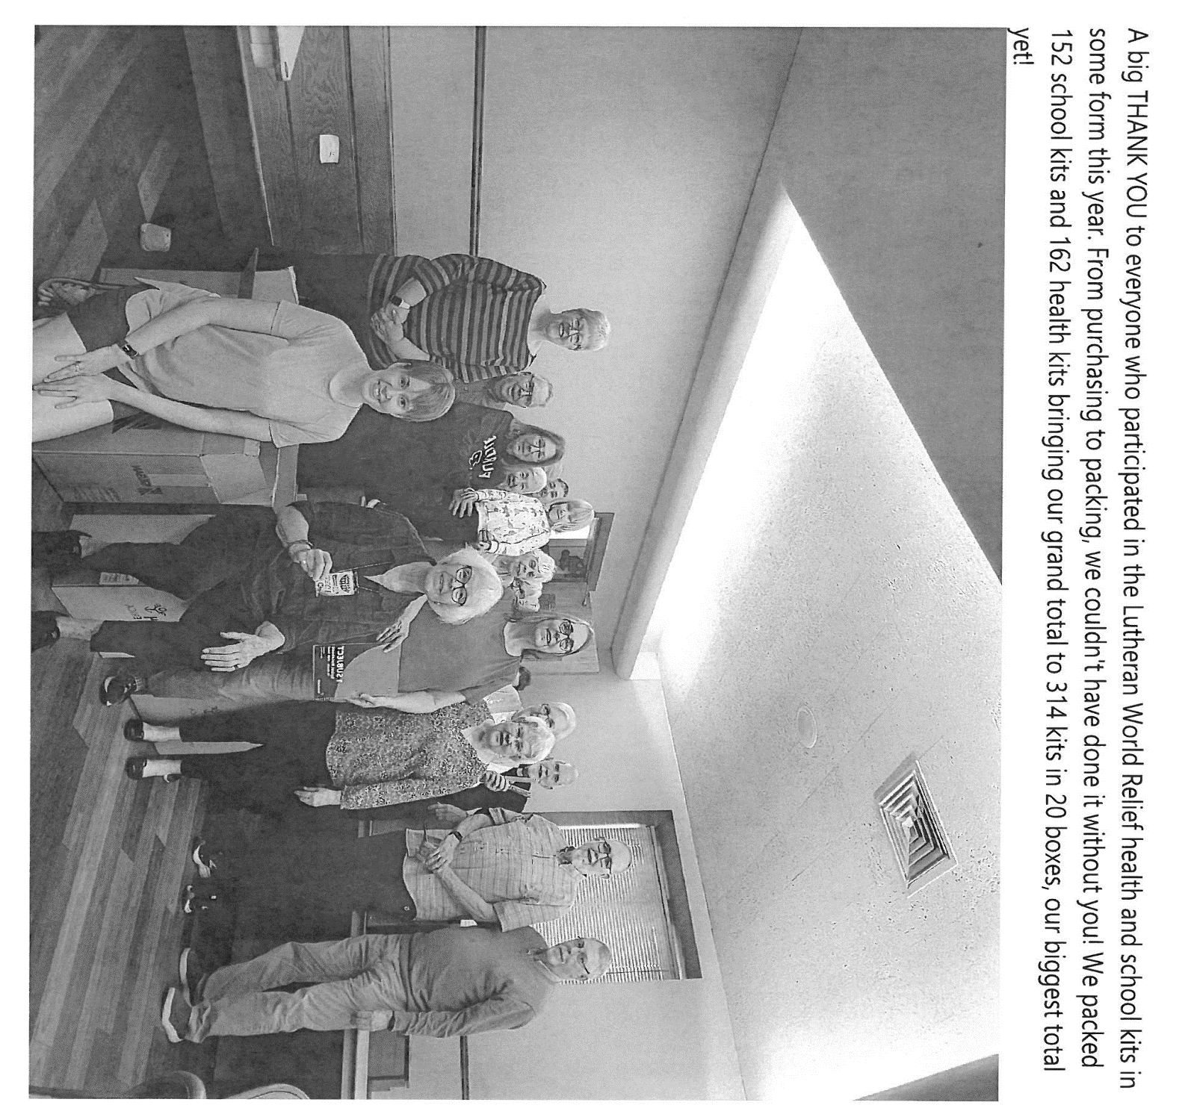

Retirement Luncheon for Pastor Reshan
To commemorate Pastor Reshan’s Retirement there will be a Potluck luncheon in the St. Paul Room following the service on Sunday morning, November 1, 2026. There will be no charge for the meal. Chicken from Al’s Supermarket will be provided. Then please bring a dish to pass.
Reservations are required due to seating capacity being limited to 120 persons in our fellowship hall. We will begin to receive reservations on September 27, 2026. Reservation forms will be printed in the bulletins and newsletter, and available in the narthex for people to fill out and place in the offering plate. If you are unable to attend a service in October and would like to reserve a seat for the luncheon, please email the church at: churchsecretary@stpaulmichigancity.com or call the church office at (219) 874-7293 and leave your name, number of seats to reserve, and phone number. Please respond in a timely manner and come enjoy great food and fellowship!
At our recent executive board and church council meetings it was decided to give a gift from the congregation to Pastor Reshan on his retirement. We are aware that many of you want to give a personal gift also. That’s absolutely wonderful and you are welcome to do that.
Every gift will be a blessing to him.
Reservations are coming in so if you want to attend the luncheon call the church office or fill out the form and put it in the offering plate.

Reservations for Pastor Reshan’s Retirement Luncheon
To commemorate Pastor Reshan’s Retirement there will be a luncheon in the St. Paul Room immediately following the service on Sunday, November 1, 2026. Reservations are required due to seating capacity being limited to 120 persons in our fellowship hall. Reservations will begin to be received on September 27, 2026. There will be no charge for the meal. Chicken from Al’s Supermarket will be provided. Then please bring a dish to pass. This is first come, first served. Once we reach the 120 person limit no more reservations will be accepted.
If you are unable to attend a service in October and would like to reserve a seat for the luncheon, please email the church at churchsecretary@stpaulmicigancity.com or call the church office at (219) 874-7293 with your name, number of seats to reserve, and phone number. Please respond in a timely manner and come enjoy great food and fellowship!
To reserve a seat, please fill out the form below and place in the offering plate during the month of October.

Name:__________________________________________________

Phone number:___________________________________________

# of seats to reserve:_______________________________________

If you have reserved a seat but are unable to attend, please let the church office know.

ACTIVITIES, EVENTS AND MEETINGS
OCTOBER 2026

Sunday, October 4, 2026 @ 9:00 a.m. 19th Pentecost Worship Service/Sanctuary with
Coffee after
Monday, October 5, 2026 @ 7:00 p.m. Women’s Bible Study/St. Paul Room

Wednesday, October 7, 2026 @ 9:15 a.m. Bible Study/Luther House

@10:00 a.m. God’s Purls
Thursday, October 8, 2026 @ 5– 6:30 p.m. Hymn Fest full rehearsal with Harbor
Country Singers and Dr. Steve Wente @ St. Paul Church

Saturday, October 10, 2026 @ 4:00 p.m. 20th Pentecost Worship Service/Sanctuary

Sunday, October 11, 2026 @ 9:00 a.m. 20th Pentecost Worship Service/Sanctuary with
Coffee after
Monday, October 12, 2026 @ 1:00 p.m. HOPE/FAITH CIRCLE/Green Room

@ 7:00 p.m. Women’s Bible Study/St. Paul Room

Wednesday, October 14, 2026 @ 9:15 a.m. Bible Study/Luther House

@ 10:00 a.m. God’s Purls

@ 4:30 p.m. Choir Rehearsal/Sanctuary

Saturday, October 17, 2026 @ 4:00 p.m. 21st Pentecost Worship Service/Sanctuary

Sunday, October 18, 2026 @ 9:00 a.m. 21st Pentecost Worship Service/Sanctuary with
coffee after
Monday, October 19, 2026 @ 2:00 p.m. Finance Committee Meeting/Luther House

@ 3:00 p.m. Executive Board Meeting/Luther House

@ 7:00 p.m. Women’s Bible Study/St. Paul Room

Tuesday, October 20, 2026 @ 4p—5p CST Hymn Fest rehearsal with Harbor Country Singers @ Episcopal Church in Harbert, MI

Wednesday, October 21, 2026 @ 10:00 a.m. God’s Purls

@ 4:30 p.m. Choir Rehearsal/Sanctuary

Thursday, October 22, 2026 @ 3:00 p.m. Church Council/St. Paul Room

Saturday, October 24, 2026 @ 4:00 p.m. 22nd Pentecost Reformation Worship
Service/Sanctuary

Sunday, October 25, 2026 @ 9:00 a.m. 22nd Pentecost Reformation Worship
Service with coffee after

OPEN TO PUBLIC @ 3:45 p.m. Pre- service Music/Sanctuary

@ 4:00 p.m. HYMN FESTIVAL/SANCTUARY with light
refreshments after/St. Paul Room

Monday, October 26, 2026 @ 7:00 p.m. Women’s Bible Study/St. Paul Room

Wednesday, October 28 2026 @ 10:00 God’s Purls
@4:30 p.m. Choir Rehearsal/Sanctuary

Saturday, October 31, 2026 NO SERVICE TODAY

Sunday, November 1, 2026 @ 9:00 a.m. ALL SAINTS DAY

PASTOR RESHAN’S LAST SERVICE with Retirement Luncheon

immediately following. POTLUCK: Chicken provided; then please

bring a dish to share.

