THE FOURTH SUNDAY IN ADVENT
December 21, 2025

“It is both terrible and comforting to dwell in the inconceivable nearness of God, and so to be loved by God that the first and last gift is infinity and inconceivability itself. But we have no choice. God is with us.”

Karl Rahner

In the Psalms of David,
in the words of the prophets,
in the dream of Joseph,
Your promise is spoken, eternal God,
and takes flesh at last
in the womb of the Virgin.
May Emmanuel find welcome in our hearts,
take flesh in our lives, and be for all peoples
the welcome advent of redemption and grace.
We ask this through Him Whose coming is certain,
Whose Day draws near:
Your Son, our Lord Jesus Christ,
Who lives and reigns with You and the Holy Spirit,
one God, for ever and ever.

Prayer for the Fourth Sunday in Advent

INTRODUCTION

Today Isaiah prophesies that a young woman will bear a son and name him Emmanuel. The gospel is Matthew's account of the annunciation and birth of the one named Emmanuel, God-with-us. During these final days of Advent we pray, "O come, O come, Emmanuel," a beloved hymn based on ancient prayers appointed for the seven days preceding Christmas. On this final Sunday in Advent we prepare to celebrate the birth of the one born to save us from the power of sin and death.

Katharina von Bora Luther, renewer of the church, died 1552

Born to an impoverished nobleman, Katie eventually took vows as a nun, but around age twenty-four she and several other nuns who were influenced by the writings of Martin Luther left the convent. Six children were born to Katie and Martin.

In the Name of Jesus

GATHERING

PRE-SERVICE MUSIC Come, Jesus Come New Song Praise Band
(Steven McWhirther)
ANNOUNCEMENTS

As you are able please rise

CONFESSION AND ABSOLUTION

P: In the name of the Father and of the Son and of the Holy Spirit.

C: Amen.

P: “Restore us, O LORD God of hosts; show the light of Your countenance, and we shall
be saved.” (Psalm 80: 7) In penitence and trust we come seeking God’s face this Day.
We believe that Christ is coming soon. Let us therefore prepare our hearts as we
confess our sins against God and one another, that we too might be restored and “saved”
by God’s gracious love.

Silence for self-examination and reflection is kept

P: Most merciful God,

C: We confess that we are sinners in need of Your mercy. We have wearied You by
our stubborn refusal to take You at Your Word (Isaiah 7: 13). By our thoughts,
words, and deeds, we have tested Your patience. We have failed to watch for Your
coming and to make ready Your way. Yet You are faithful, O Lord. Open us to
Your advent in grace and glory, O Christ. Make us ready to receive You. Grant
us a sign of Your forgiveness, that we may serve You in peace and joy.

P: God has given a sign of His forgiveness: His Word made flesh in Jesus-Emmanuel,
‘God-with-us.’ “You are to name the child Jesus, for He will save His people from
their sins.” (Matthew 1: 21) You have been saved from the power of sin and death, for
by the command and authority of Jesus-Emmanuel Himself, I declare to you the entire
forgiveness of all your sins, in the name of the Father and of the Son and of the Holy
Spirit.

C: Amen.

GATHERING SONG NSB 25 Crown Him King of Kings

THE GREETING AND PRAYER OF THE DAY

P: “Restore us, O LORD God of hosts,

C: Show us the light of Your countenance, and we shall be saved.” (Psalm 80 :3)

P: The grace of our Lord Jesus Christ, the love of God, and the communion of the Holy
Spirit be with you all.

C: And also with you.

P: Let us pray. Stir up Your power, Lord Christ, and come. With Your abundant grace
and might, free us from the sin that hinders our faith, that eagerly we may receive Your
promises, for You live and reign with the Father and the Holy Spirit, one God, now and
forever.

C: Amen.

The assembly is seated
WORD

LIGHTING OF ADVENT LOG Christ, Be Our Light! (see p. 4) Joel Raney
(All Stanzas)
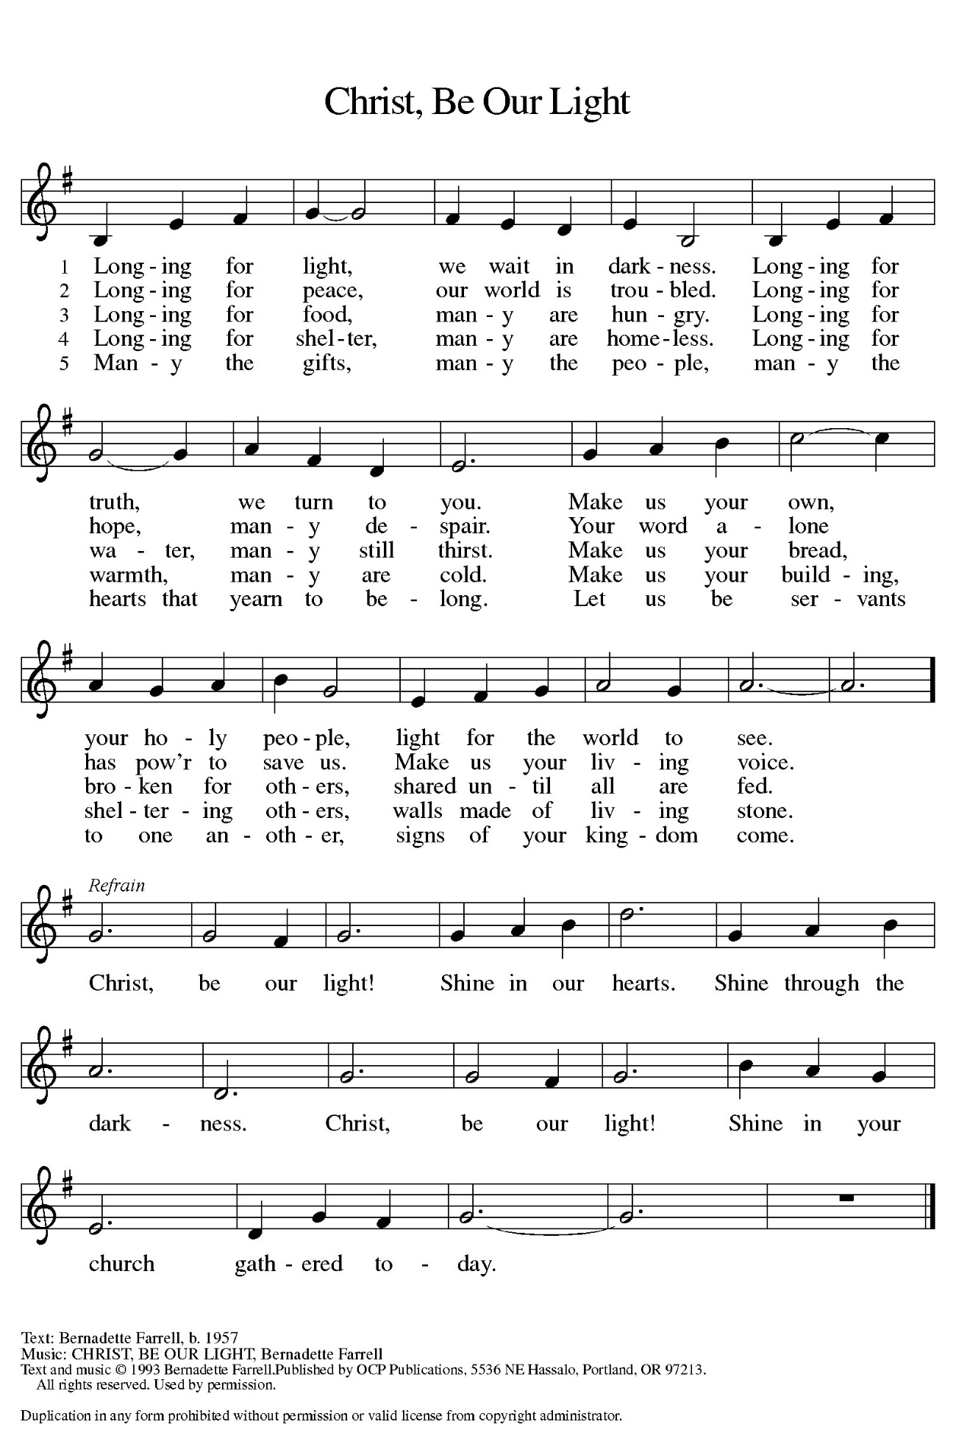
Hope for Those Who are Wounded

P: Advent is a time to bind up the broken hearted.

C: Come, Lord, and make all things new.

P: For past wrongs that prevent us from moving forward:

C: Come, Lord, and make all things new.

P: For any bitterness that scratches our soul:

C: Come, Lord, and make all things new.

P: For relationships left in decay and neglect:

C: Come, Lord, and make all things new.

P: For any action that has wounded us or by which we have wounded others:

C: Grant that we might have the peace of Christ as we wait, the love of Christ as we act, and the grace of Christ as we speak.

(During the candle lighting)

P: This morning we light four candles. The first candle is the light of hope for those in times of waiting. The second candle is the light of hope for those who are wearied by the circumstances of life. The third candle is the light of hope for those eagerly watching for God’s promised glory. The fourth candle is the light of hope for those who carry the wounds of life. Today we acknowledge our pain and the pain we have caused others. As the light shines, we turn to the Savior Who came to rescue the lost, to help the hurting, and to bind up the broken.

(Repeat the refrain)
All four candles are lit.

FIRST READING Isaiah 7: 10-16

An Israelite and Aramean military coalition presents a serious threat to King Ahaz of Judah. In response, Ahaz decides to secure his throne and kingdom by asking mighty Assyria for help. In today's reading, Isaiah reminds him that human attempts to establish security will only fail. The prophet repeats the promise that God alone will make God's people secure.

The LORD spoke to Ahaz, saying, ¹¹Ask a sign of the LORD your God; let it be deep as Sheol or high as heaven. ¹²But Ahaz said, I will not ask, and I will not put the LORD to the test. ¹³Then Isaiah said: "Hear then, O house of David! Is it too little for you to weary mortals, that you weary my God also?
¹⁴Therefore the Lord himself will give you a sign. Look, the young woman is with child and shall bear a son, and shall name him Immanuel. ¹⁵He shall eat curds and honey by the time he knows how to refuse the evil and choose the good. ¹⁶For before the child knows how to refuse the evil and choose the good, the land before whose two kings you are in dread will be deserted."

The Word of the Lord.

Thanks be to God.

THE PSALM: Psalm 80: 1-7, 7-19 Antiphon by Robert A. Hobby

Refrain is sung first by the choir, then followed immediately by the congregation
and as indicated
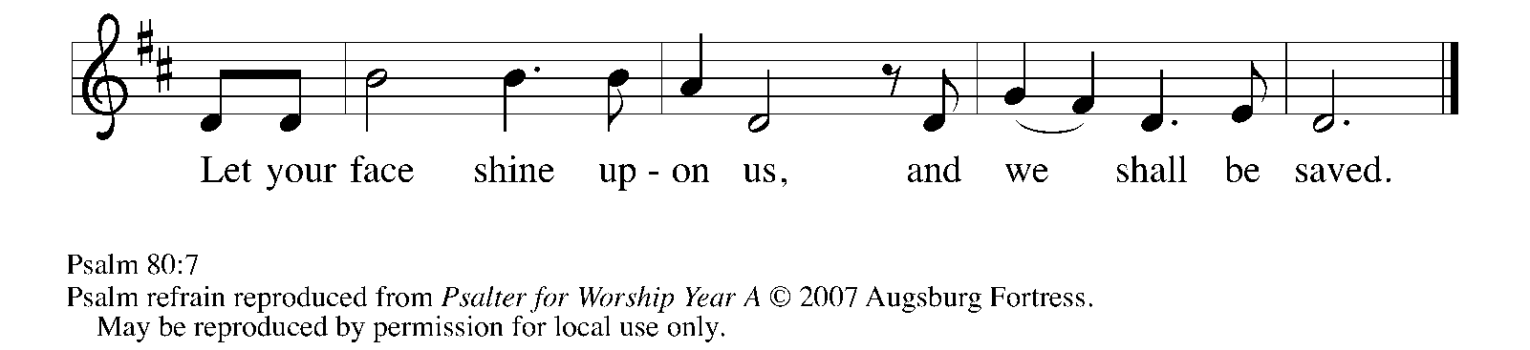

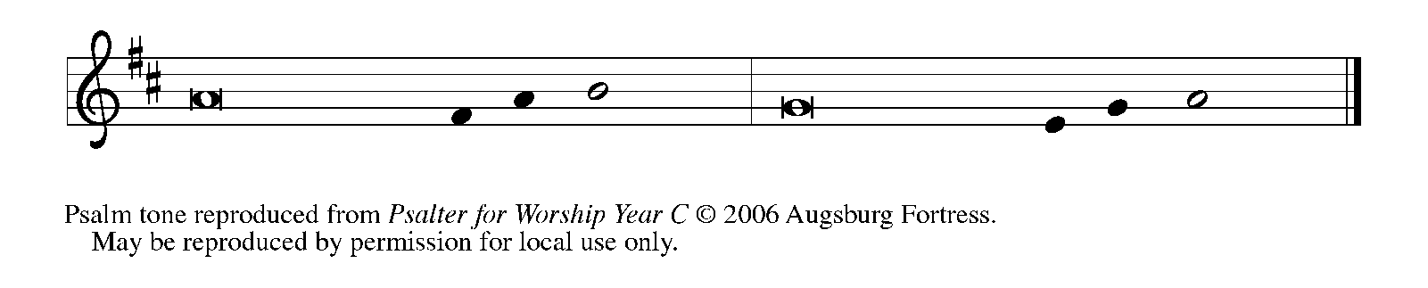

¹Hear, O Shepherd of Israel, leading Joseph | like a flock;
shine forth, You that are enthroned up- | on the cherubim.

²In the presence of Ephraim, Benjamin, | and Manasseh,
stir up Your strength and | come to help us.

³Restore | us, O God;
let Your face shine upon us, and we | shall be saved.

⁴O LORD | God of hosts,
how long will Your anger fume when your | people pray? REFRAIN

⁵You have fed them with the | bread of tears;
You have given them bowls of | tears to drink.

⁶You have made us the derision | of our neighbors,
and our enemies laugh | us to scorn.

⁷Restore us, O | God of hosts;
let Your face shine upon us, and we | shall be saved.

¹⁷Let Your hand be upon the one at | Your right hand,
the one you have made so strong | for Yourself.

¹⁸And so will we never turn a- | way from You;
give us life, that we may call up- | on Your name.

¹⁹Restore us, O LORD | God of hosts;
let Your face shine upon us, and we | shall be saved. REFRAIN

SECOND READING Romans 1: 1-7

Paul's letter to the Romans is devoted to presenting the gospel (or "good news") of God, which provides salvation for all who believe. This theme is introduced already in the opening words of the letter, where Paul expands the typical salutation to include a statement of faith.

Paul, a servant of Jesus Christ, called to be an apostle, set apart for the gospel of God, ²which He promised beforehand through His prophets in the holy scriptures, ³the gospel concerning His Son, Who was descended from David according to the flesh ⁴and was declared to be Son of God with power according to the spirit of holiness by resurrection from the dead, Jesus Christ our Lord,
⁵through Whom we have received grace and apostleship to bring about the obedience of faith among all the Gentiles for the sake of His name, ⁶including yourselves who are called to belong to Jesus Christ,
⁷To all God's beloved in Rome, who are called to be saints:
Grace to you and peace from God our Father and the Lord Jesus Christ.

The Word of the Lord.

Thanks be to God.

As you are able please rise

THE VERSE (see p. 8)

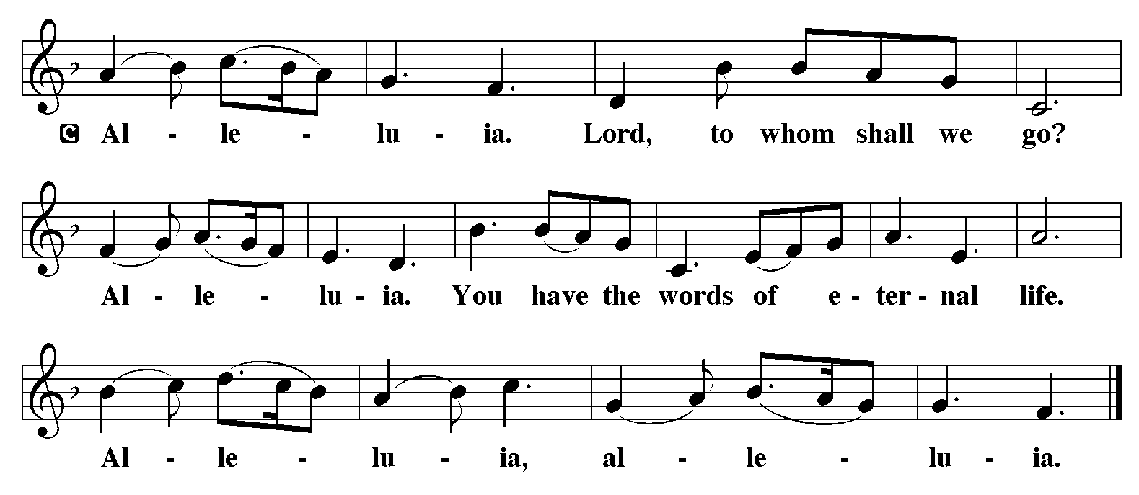

THE HOLY GOSPEL Matthew1: 18-25

Matthew's story of Jesus' birth focuses on the role of Joseph, who adopts the divinely begotten child into the family of David and obediently gives him the name Jesus, which means, literally, "God saves."

P: The Holy Gospel according to St. Matthew, the first chapter.

C: Glory to You, O Lord!

Now the birth of Jesus the Messiah took place in this way. When His mother Mary had been engaged to Joseph, but before they lived together, she was found to be with child from the Holy Spirit. ¹⁹Her husband Joseph, being a righteous man and unwilling to expose her to public disgrace, planned to dismiss her quietly.
²⁰But just when he had resolved to do this, an angel of the Lord appeared to him in a dream and said, "Joseph, son of David, do not be afraid to take Mary as your wife, for the child conceived in her is from the Holy Spirit. ²¹She will bear a son, and you are to name Him Jesus, for He will save His people from their sins." ²²All this took place to fulfill what had been spoken by the Lord through the prophet:
²³"Look, the virgin shall conceive and bear a son,
and they shall name him Emmanuel,"
which means, "God is with us."
²⁴When Joseph awoke from sleep, he did as the angel of the Lord commanded him; he took her as his wife, ²⁵but had no marital relations with her until she had borne a son; and he named Him Jesus.

P: The Gospel of the Lord.

C: Praise to You, O Christ!

The assembly is seated

THE SERMON

Silence for reflection follows the sermon

As you are able please rise

THE HYMN OF THE DAY 257 O Come, O Come, Emmanuel
(Stanzas 1, 2, 7, 8)

THE NICENE CREED

A: God has made us His people through our Baptism into Christ. Living together in trust
and hope, we confess our faith.

We believe in one God,
the Father, the Almighty,
maker of heaven and earth,
of all that is, seen and unseen.

We believe in one Lord, Jesus Christ,
the only Son of God,
eternally begotten of the Father,
God from God, Light from Light,
true God from true God,
begotten, not made,
of one Being with the Father.
Through Him all things were made.
For us and for our salvation
He came down from heaven;
by the power of the Holy Spirit
He became incarnate from the virgin Mary, and was made man.
For our sake He was crucified under Pontius Pilate;
He suffered death and was buried.
On the third day He rose again
in accordance with the Scriptures;
He ascended into heaven
and is seated at the right hand of the Father.
He will come again in glory to judge the living and the dead,
and His kingdom will have no end.

We believe in the Holy Spirit, the Lord, the giver of life,
Who proceeds from the Father and the Son.
With the Father and the Son He is worshiped and glorified.
He has spoken through the prophets.
We believe in one holy catholic and apostolic Church.
We acknowledge one Baptism for the forgiveness of sins.
We look for the resurrection of the dead,
and the life of the world to come. Amen

THE PRAYER OF THE CHURCH
A: As we anticipate the fullness of the presence of Christ, we join with the Church
throughout the world, praying for all who are in need.

A: For the Church and all servants of the Gospel; for poets and artists, for musicians and
preachers; for theologians and teachers, that they may enrich and enliven our
proclamation that God is with us in Christ, let us pray to the Lord:

C: Lord, hear our prayer.

A: For all plants and animals, seas and skies, snow and rain, and all of God’s marvels, that
it may grow and thrive as we bless, protect, and use with care God’s good creation
entrusted to us, let us pray to the Lord:

C: Lord, hear our prayer.

A: For all nations and those in authority; for peace and justice throughout the world; for
those who advocate on behalf of those who have no voice; for all those in positions of
leadership that they may refuse what is evil and choose what is good for those they
serve, let us pray to the Lord:

C: Lord, hear our prayer.

A: For those who travel in these days that their journeys might be safe and their
homecomings joyful, let us pray to the Lord:

C: Lord, hear our prayer.

A: For this congregation, that by the grace and peace of God we might live and serve as
the saints in Christ You have set us apart to be, let us pray to the Lord:

C: Lord, hear our prayer.

A: For those who find no joy in these days; the hungry, the homeless, the grieving, and
the sick, especially: Major Payne; Robert Bernth; Kevin Thiede; Carl
Wipperman; Chuck Payne; Martha Schroeder; Joyce Stark; Jackie Gaines;
David Weiss; Fred Weiss; Shirley Shikany Long; Shirley Freels; John Bennitt;
Catherine Lanigan; Debbie Martin; Christine Kiser; Lucas Bradshaw and DeNita
Ton that You would turn Your face toward them with blessing and grant them healing,
strength, and peace, let us pray to the Lord:

C: Lord, hear our prayer.

A: For those celebrating birthdays, especially Virgil Miller, that they may be filled with grace this day and every day, and grow in grace in the days ahead, let us pray to the Lord:

C: Lord, hear our prayer.

A: For Joseph and Mary and their obedience to Your will, and for all the saints, that we
might follow in their ways as Christ is born again into our hearts and lives, let us pray
to the Lord:

C: Lord, hear our prayer.

P: Hear the prayers of Your people, glorious God, for the sake of the One Who took on
our nature and our form to redeem the whole world, Jesus Christ our Lord.

C: Amen.

MEAL

THE PEACE

P: The peace of the Lord be with you always.

C: And also with you.

The assembly is seated

OFFERING

VOLUNTARY Shine the Light of Your Love St. Paul Senior Choir
M. Patterson

As you are able please rise

THE OFFERTORY (see p. 12) Let the Vineyards Be Fruitful, Lord
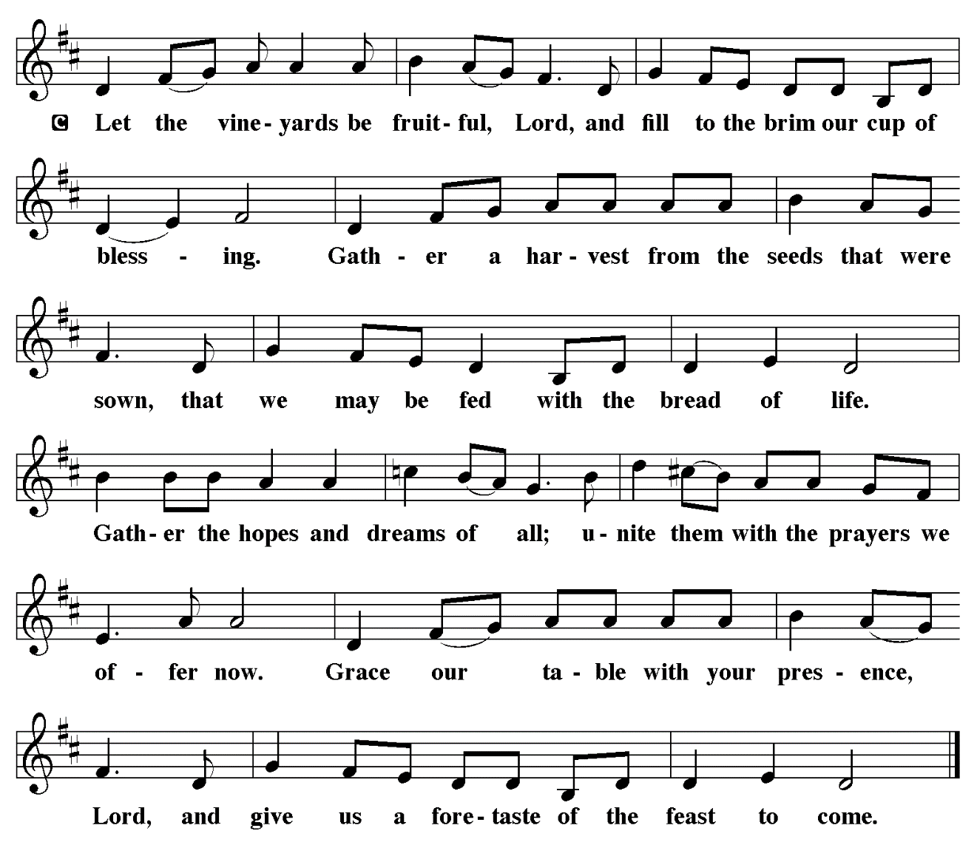

THE OFFERTORY PRAYER

A: Let us pray. God our Savior,

C: You call us to be patient and strong, for the Day of Your advent is near. You come
to us now in this holy Sacrament for our life, health, and hope. Receive these
offerings we bring, and by our eating and drinking strengthen our witness, that
we might with joy prepare Your way. We ask this in the name of Jesus the Lord.
Amen.

THE GREAT THANKSGIVING

P: The Lord be with you.

C: And also with you.

P: Lift up your hearts.

C: We lift them to the Lord.

P: Let us give thanks to the Lord our God.

C: It is right to give Him thanks and praise.

P: It is indeed right and salutary … we praise Your name and join their unending hymn:

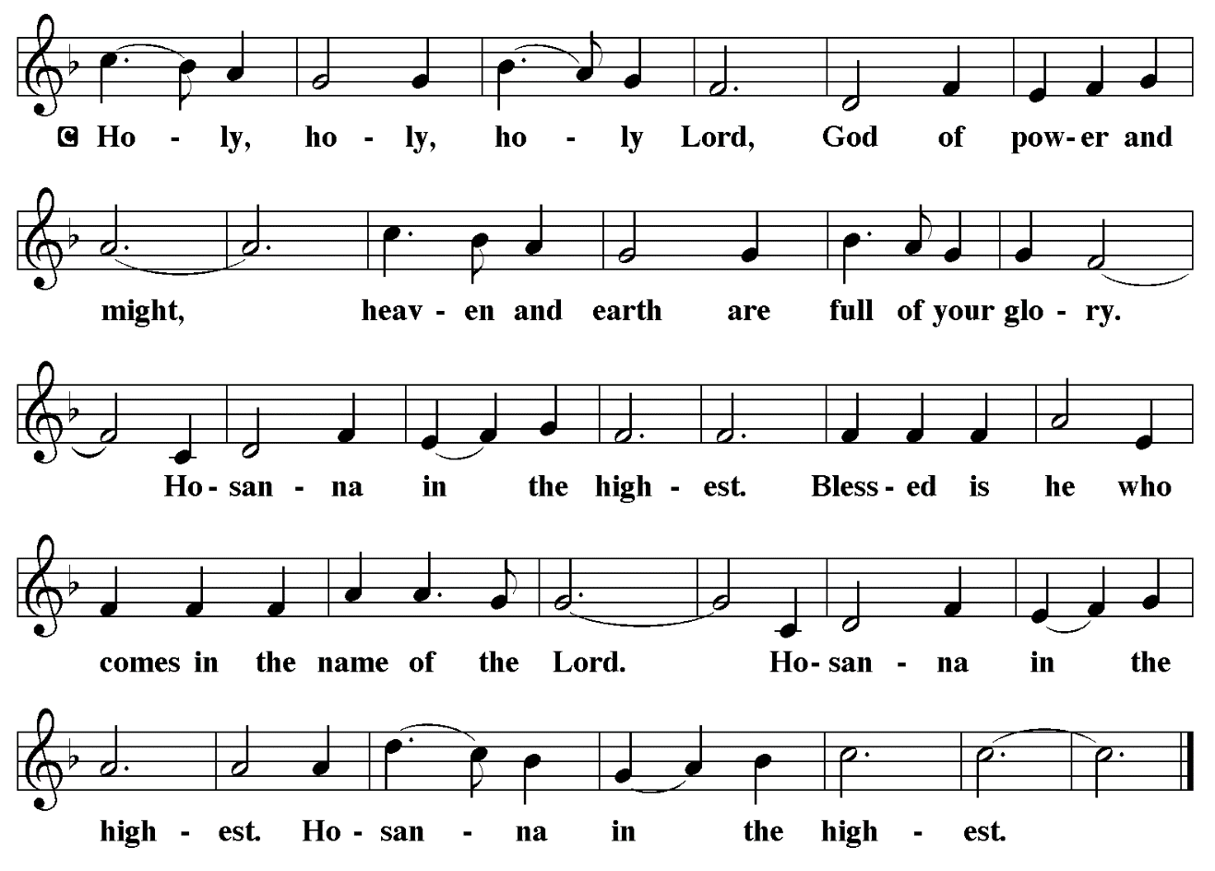

P: Holy God, the Beginning and the end, our Salvation and our Hope,
We praise You, for You are the God of our salvation.
You created a world of order and beauty; in You all things have life.
With a love higher than the heavens and deeper than Sheol You chose
Israel to be a sign of Your blessing for the world.
You delivered them from every threat and brought life for them out of
every death.

When the time had fully come, You sent Your Son, Jesus-Emmanuel,
born of the Holy Spirit and the Virgin Mary, to save us from
our sins.
In the night ... “Do this for the remembrance of Me.”
As often as we eat ... we proclaim the Lord’s death until He comes.

C: Christ has died. Christ is risen. Christ will come again.

P: With this bread and cup, O God, we remember the Incarnation of our
Lord’s life.
He was with us in life and in death, and raised by the power of Your
Spirit from death.
He will return to bring us, with all the saints, into Your eternal glory.
Send now Your Spirit on us and these gifts of bread and wine.
Grant us the grace to live as Your saints, joined with Christ as He has
joined Himself to us, in His work of preparing the world for the
birth of His justice and joy.
Through Him all glory and honor is Yours, Almighty Father, with the
Holy Spirit, in Your holy church, both now and forever.
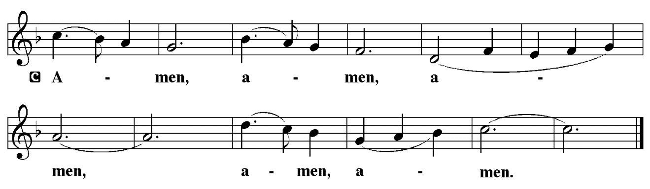

THE LORD’S PRAYER

P: Let us pray for the coming of God’s Reign as Jesus taught us:

C: Our Father in heaven, hallowed be Your name.
Your Kingdom come, Your will be done on earth as in heaven.
Give us today our daily bread, and forgive us our sins, as we forgive
those who sin against us.
Save us from the time of trial, and deliver us from evil.
For the Kingdom, the power, and the glory are Yours, now and forever.
Amen.

INVITATION TO THE MEAL

P: Behold the Lord Whose advent we await, Who will come with glory on the Day of
judgment. Blessed are those who are called to the Supper of the Lamb. God’s holy
gifts for God’s holy people. Come, for all is now ready.

The assembly is seated

THE DISTRIBUTION Lamb of God (see p. 15)

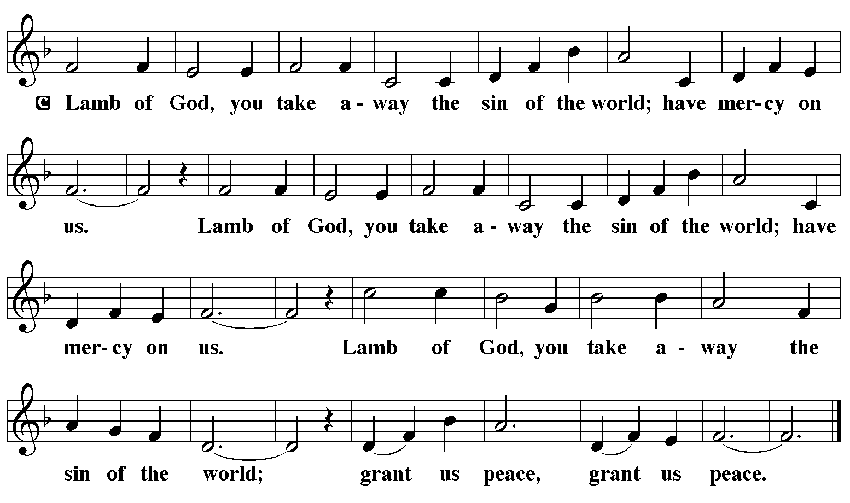

HYMN DURING DISTRIBUTION 266 All Earth is Hopeful
ELW 723 Canticle of the Turning
NSB 59 Jesus, Name Above All Names
NSB 32 Emmanuel (2x)
As you are able please rise

THE POST-COMMUNION PRAYER

A: Let us pray. Lord, in this Sacrament we receive the promise that You have saved us
from our sins. As Christmas draws near, make us grow in faith and love to celebrate
the coming of Jesus our Savior, Who is Lord forever and ever.

C: Amen.
SENDING

THE BENEDICTION

P: The Lord bless you and keep you. The Lord make His face shine on you and be gracious
to you. The Lord look upon you with favor and give you peace.

C: Amen.

SENDING HYMN 267 Joy to the World

THE DISMISSAL

A: Go in peace. Walk in the light of the Lord.

C: Thanks be to God!

POSTLUDE

To God Alone Be Glory

The Meditation is from An Advent Sourcebook. Thomas J. O’Gorman, ed. (Chicago:
Liturgy Training Publications, 1988) 154.

The Invitation to the Lord’s Prayer, the Prayers, and the Invitation to Communion are from
Prayers for Sundays and Seasons. Year A. Peter J. Scagnelli. (Chicago: Liturgy
Training Publications, 1998) 7-8.

ANNOUNCEMENTS

Please remember to mail your offering to the Church Office at 818 Franklin Street, Michigan City, IN 46360. Another alternative is to give on-line through Tithe.ly. Please see your closure letter for information on how to set up a Tithe.ly account.

St. Paul Members are reminded to have a loved one contact the office if you are hospitalized. Many times, the Pastor doesn’t know someone is in the hospital. If you call and leave a message, please tell us at which hospital the patient is located.

BIRTHDAYS: Virgil Miller (12/22)

PRAYER CONCERNS: Kevin Thiede; Robert Bernth; Barry Anderson; John Bennitt; Sarah McNabb; Debbie Martin; Mark Tannehill; Kathy Stein; Jan Paholski; Laura Dovey; Grace Romine; Bill Hazelgrove; Al Levenhagen; Carl Wipperman; Major Payne; Carol Hazelgrove; Allen Sydow and Elizabeth Sanders.

OFFICE HOURS: Libby will be in the office on Mondays, Wednesdays, and Fridays; volunteers will cover Tuesdays and Thursdays.

Monday & Wednesday 8:00 a.m. – 5 p.m.
Tuesday & Thursday 9:00 a.m. – 12:00 p.m.
Friday 8:00 a.m. – 12:00 p.m.

If you are listening to the worship broadcast on the radio and would like to watch the Sunday morning service live stream follow these steps:

(1) If you have You Tube available on your TV, search for
St. Paul Lutheran Church Michigan City, IN.

(2) The direct link on the computer is https://
www.youtube.com/channel/UC5AIPNaKr3QN50984jGOa1g.

(3) This link is also on the main page of the church’s website in
the church section and will continue to be posted weekly on the St.
Paul Facebook page.

And it will always be available on the radio broadcast Sunday mornings at 11:00 a.m.
on WEFM (95.9), and on the local cable access station #99 for the previous week’s
service on Sundays at 4:00 p.m. and the current service on Wednesdays at 7:00 p.m.
and Fridays at 8:30 p.m.

To send e-mail to the church office, please use the following addresses:

Pastor Mark Reshan: seniorpastor@stpaulmichigancity.com

Church Office Secretary (Libby Pollock): churchsecretary@stpaulmichigancity.com

Church Treasurer (Karen Fleming): finance@stpaulmichigancity.com

2025 Church Council:

Mark Reshan - Pastor

Janet Bakken – President

Donna Knoll – Vice President

Judy Hunt – Secretary

Karen Fleming – Treasurer

Members: Paul Brooks, Diane Egilske, Sue Koziel, Judy Mutchler, Jim Schraidt, Trish Sprague

Worship Attendance:

Saturday , December 13, 2025 @ 4:00 p.m. 14

Sunday, December 14, 2025 @ 9:00 a.m. 62

TOTAL 76

Copies of the minutes from the October 23, 2025 Church Council meeting are on the back table in the upper Narthex. It was approved by the council via email.

The Good News Newsletter: If you have an article or anything you want included in The Good News please send it to the following e-mail address: splcgoodnews@gmail.com. Pastor Pamela Thiede will be using this e-mail address to assemble The Good News each month. The deadline for getting information to Pastor Pamela will be the 20th of each month.

Sunday’s lessons are Isaiah 63: 7-9; Psalm 148; Hebrews 2: 10-18; and
Matthew 2: 13-23 for those of you who like to study them in advance.

SNOW EMERGENCY LIST

This is a reminder of where to turn to learn if worship has been canceled because of inclement weather conditions. There are two ways to learn about the status of the service.
First, you may turn to our church and school Facebook page: https://www.facebook.com/stpaulmichigancity/ for updated announcements. Or, perhaps most quickly and easily, you may call the church office number (219-874-7293) and press the “#” key and you will hear a recording about our “open/closed” status.

HELP NEEDED FOR OUR LOCAL SALVATION ARMY
Due to the pause taken by all the programs sponsored by SNAP, our local Salvation Army has been swamped with people needing help. All of the items placed in the grocery store cart located on the upper southwest corner of the outer Narthex is taken to our Michigan City Salvation Army location. The cart has a large hippo asking you to help “fill ‘er up!” Whatever you can do to help is greatly appreciated.

ACTIVITIES, EVENTS & MEETINGS
December 2025
Sunday, December 14, 2025 @ 9:00 a.m. 3rd Sunday in Advent Worship Service/ Sanctuary/ with coffee after service/St. Paul Room

Monday, December 15, 2025 @ 3:00 p.m. Executive Board Mtg/Luther House

Wednesday, December 17, 2025 @ 10:00 a.m. QUIET SR COMMUNION & LUNCHEON
@ 4:30 p.m. Choir Rehearsal/Sanctuary

Thursday, December 18, 2025 @ 3:00 p.m. and January 2026 Church Council Mtg/St. Paul Room

Saturday, December 20, 2025 @ 4:00 p.m. 4th Saturday in Advent Worship Service

Sunday, December 21, 2025 @ 9:00 a.m. 4th Sunday in Advent Worship Service/ Sanctuary with coffee after service/St. Paul Room

Wednesday, December 24, 2025 @ 5:45 p.m pre - service Music/Sanctuary

@ 6:00 p.m. Christmas Eve Worship Service/Sanctuary

Thursday, December 25, 2025 @ 9:00 a.m. Christmas Worship Service/Sanctuary

Saturday, December 27, 2025 @ 4:00 p.m. 1st Saturday After Christmas Worship
Service

Sunday, December 28, 2025 @ 9:00 a.m. 1st Sunday After Christmas Worship

First United Methodist Church in Michigan City

Presents their annual
Madrigal Service at

Trinity Episcopal Church
in Barker Hall
600 Franklin St.
Michigan City, IN 46360

On Saturday, December 20th at 5:00 p.m.
(doors open at 4:15 p.m.)

And again on Sunday, December 21st at 3:00 p.m. at
First United Methodist Church
121 E. 7th St.
Michigan City, IN 46360

A free will offering will be taken and proceeds divided
between all entities who helped provide space, supplies, support of any kind to the congregation and staff at
Methodist Church during their time of need.

