**THE SEVENTH SUNDAY OF EASTER**

**Observed as The Ascension of Our Lord**

**June 1, 2025**

“The next statement of the creed identifies Jesus as the one who “ascended into heaven, and is seated at the right hand of the Father.” Thereby, the creed reminds us that the friend of sinners is indeed at the reins of the universe. Far from being absent from them, he is where God is—in control of his world, and ruling it as a part of his love for the sinners he wills to befriend.

Like the statement about the descent to the netherworld, the confession of Jesus’ ascension makes no sense if it is taken as a cosmological or astronautical statement. The ascension was not like climbing up a ladder. Rather, it is imagery in the service of a profound theological truth: Jesus, who is the sinners’ friend, is not a pretender, a wishful thinker hoping that things will turn out for them in the end.

He is, in fact, in charge, and he is bringing about that good and gracious will of God which he spoke and lived.”

**Frederick Niedner, Jr. and David Truemper**

***Keeping the Faith***

The Ascension was a great and indescribable cause for joy, for in it the nature of humankind ascended, above the dignity of all the heavenly creatures, rising above the angelic order, above the sublimity of the archangels, until, received into the company of the eternal Father, it was made a sharer of the throne of God’s glory, to whose nature it was united in the Son. Therefore, the Ascension of Christ is our uplifting, for where the glory of Our Head shall go, there the hope of our body is called.

Let us then rejoice exceedingly with fitting joy, and let us be glad with devout thanksgiving. For on this day, not alone are we made sure heirs of paradise, but in Christ we have already reached the heights of heaven, and we have obtained more abundant gifts through the ineffable favor of Christ than we lost through the envy of the devil.

**Leo**

**✠ In the Name of Jesus ✠**

**✠ GATHERING ✠**

**INTRODUCTION**

*In today’s readings the risen Christ ascends into heaven and his followers are assured that the Spirit will empower them to be witnesses throughout the earth. The disciples were told to not gaze up into heaven to look for Jesus (Acts 1:11); we find his presence among us as we proclaim the word and share the Easter feast. We too long for the Spirit to enliven our faith and invigorate our mission.*

**Justin, martyr at Rome, died around 165**

*Born of pagan parents, Justin was influenced by an elderly Christian in Ephesus. He became a teacher of philosophy and the Christian faith. Jailed for practicing an unauthorized religion, he refused to renounce his faith and was beheaded.*

**PRE-SERVICE MUSIC  *You Raise Me Up*  New Song Praise Band**

**(Brandon Graham & Rolf Lovland)**

**THE EASTER ACCLAMATION**

P: Christ is risen and ascended! Alleluia!

**C: He is risen and ascended indeed! Alleluia!**

**ANNOUNCEMENTS**

*As you are able please rise*

**THE GATHERING SONG Band**

**THE GREETING AND PRAYER OF THE DAY**

P: Alleluia! Christ is risen!

**C: Christ is risen indeed! Alleluia!**

P: The grace of our Lord Jesus Christ, the love of God, and the communion of the Holy Spirit be

with you all.

**C: And also with you.**

P: Let us pray. Almighty God, Your blessed Son, our Savior Jesus Christ, ascended far above all

heavens that He might fill all things. Mercifully give us faith to trust that, as He promised, He

abides with us on earth to the end of time, Who lives and reigns with You and the Holy Spirit,

one God, now and forever.

**C: Amen.**

*The assembly is seated*

**✠ WORD ✠**

**FIRST READING Acts 1: 1-11**

Before he is lifted into heaven, Jesus promises that the missionary work of the disciples will spread out from Jerusalem to all the world. His words provide an outline of the book of Acts.

In the first book, Theophilus, I wrote about all that Jesus did and taught

from the beginning

2until the day when He was taken up to heaven, after giving instructions through

the Holy Spirit to the apostles whom He had chosen.

3After His suffering He presented Himself alive to them by many convincing

proofs, appearing to them during forty days and speaking about the

kingdom of God.

4While staying with them, He ordered them not to leave Jerusalem, but to wait

there for the promise of the Father. "This," He said, "is what you have

heard from Me;

5for John baptized with water, but you will be baptized with the Holy Spirit

not many days from now."

6So when they had come together, they asked Him, "Lord, is this the time when

You will restore the kingdom to Israel?"

7He replied, "It is not for you to know the times or periods that the Father has

set by His own authority.

8But you will receive power when the Holy Spirit has come upon you; and

you will be My witnesses in Jerusalem, in all Judea and Samaria, and

to the ends of the earth."

9When He had said this, as they were watching, He was lifted up, and a cloud took

Him out of their sight.

10While He was going and they were gazing up toward heaven, suddenly

two men in white robes stood by them.

11They said, "Men of Galilee, why do you stand looking up toward heaven?

This Jesus, who has been taken up from you into heaven, will come in

the same way as you saw Him go into heaven."

The Word of the Lord.

**Thanks be to God.**

**THE PSALM: Psalm 47 Antiphon by Walter Pelz**

Choir sings refrain first, followed immediately by the congregation and as indicated

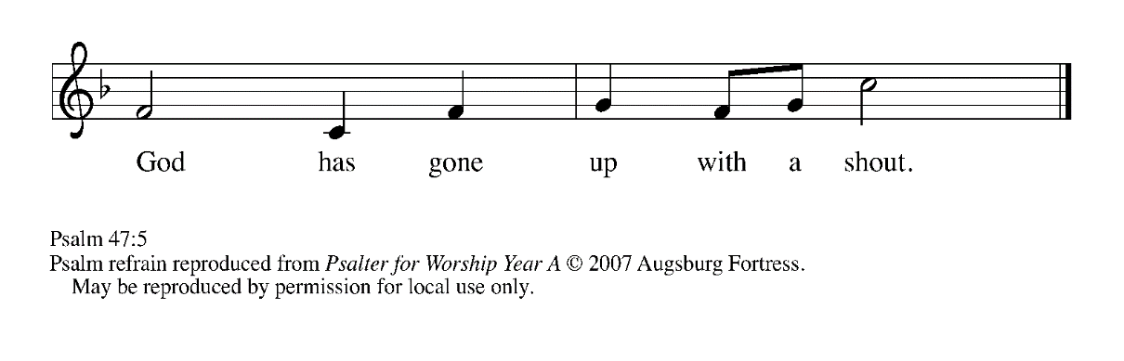

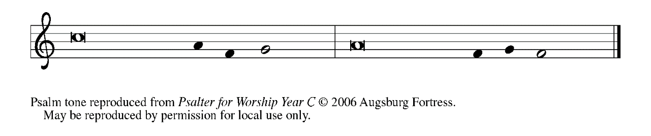

1Clap your hands, | all you peoples;

     shout to God with a | joyful sound.

**2For the LORD Most High is | to be feared:**

**a great King over | all the earth,**

3Who subdues the | peoples under us,

     and the nations un- | der our feet;

**4Who chooses our inheri- | tance for us,**

**the pride of Jacob, | whom God loves.   REFRAIN**

5God has gone up | with a shout,

     the LORD with the sound | of the ram's horn.

**6Sing praises to | God, sing praises;**

**sing praises to our | King, sing praises.**

7For God is King of | all the earth;

     sing praises | with a song.

**8God reigns o- | ver the nations;**

**God is en- | throned on high.**

9The nobles of the peoples have gathered as the people of the | God of Abraham.

     The rulers of the earth belong to God, who is high- | ly exalted.   **REFRAIN**

**SECOND READING Ephesians 1: 15-23**

The risen and exalted Christ reigns over the entire universe. The author of Ephesians prays that we would be given the wisdom to comprehend this and display it through love toward others.

15I have heard of your faith in the Lord Jesus and your love toward all the saints,

and for this reason

16I do not cease to give thanks for you as I remember you in my prayers.

17I pray that the God of our Lord Jesus Christ, the Father of glory, may give

you a spirit of wisdom and revelation as you come to know Him,

18so that, with the eyes of your heart enlightened, you may know what is the

hope to which He has called you, what are the riches of His glorious

inheritance among the saints,

19and what is the immeasurable greatness of His power for us who believe,

according to the working of His great power.

20God put this power to work in Christ when He raised Him from the dead and

seated Him at His right hand in the heavenly places,

21far above all rule and authority and power and dominion, and above every

name that is named, not only in this age but also in the age to come.

22And He has put all things under His feet and has made Him the head over

all things for the church,

23which is His body, the fullness of him who fills all in all.

The Word of the Lord.

**Thanks be to God.**

*As you are able please rise*

**THE VERSE**

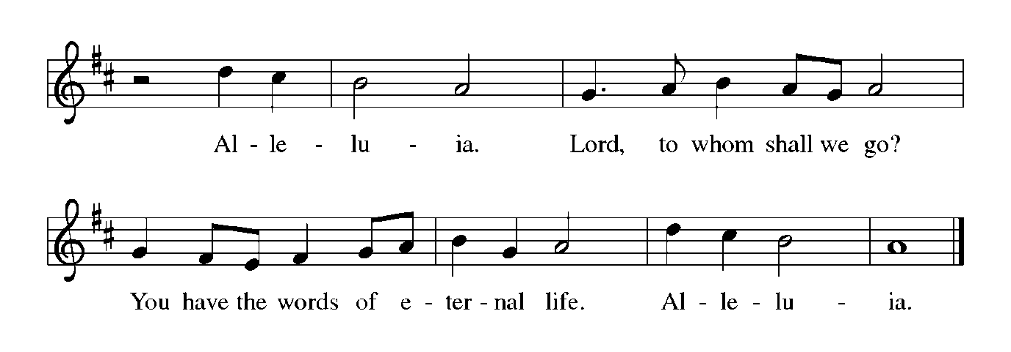

**THE HOLY GOSPEL Luke 24: 44-53**

On the day of his ascension, Jesus leaves his disciples with a commission, a blessing, and a promise of the Holy Spirit.

P: The Holy Gospel according to St. Luke, the twenty-fourth chapter.

**C: Glory to You, O Lord!**

44Then He said to the disciples, "These are My words that I spoke to you while I was

still with you — that everything written about Me in the law of Moses,

the prophets, and the psalms must be fulfilled."

45Then He opened their minds to understand the scriptures,

46and He said to them, "Thus it is written, that the Messiah is to suffer and to rise

from the dead on the third day,

47and that repentance and forgiveness of sins is to be proclaimed in

His name to all nations, beginning from Jerusalem.

48You are witnesses of these things.

49And see, I am sending upon you what My Father promised; so stay here in the

city until you have been clothed with power from on high."  
50Then He led them out as far as Bethany, and, lifting up His hands, He blessed them.

51While He was blessing them, He withdrew from them and was carried up into heaven.

52And they worshiped Him, and returned to Jerusalem with great joy;

53and they were continually in the temple blessing God.

P: The Gospel of the Lord.

**C: Praise to You, O Christ!**

*The assembly is seated*

**THE SERMON**

*Silence for meditation follows the sermon*

*As you are able please rise*

**THE HYMN OF THE DAY 393 *A Hymn of Glory Let Us Sing***

Stanza 2—Women/children; Stanza 3--Men

**THE NICENE CREED**

A: God has made us His people through our Baptism into Christ. Living together in trust and

hope, we confess our faith.

**We believe in one God,**

**the Father, the Almighty,**

**maker of heaven and earth,**

**of all that is, seen and unseen.**

**We believe in one Lord, Jesus Christ,**

**the only Son of God,**

**eternally begotten of the Father,**

**God from God, Light from Light,**

**true God from true God,**

**begotten, not made,**

**of one Being with the Father.**

**Through Him all things were made.**

**For us and for our salvation**

**He came down from heaven;**

**by the power of the Holy Spirit**

**He became incarnate from the virgin Mary, and was made man.**

**For our sake He was crucified under Pontius Pilate;**

**He suffered death and was buried.**

**On the third day He rose again**

**in accordance with the Scriptures;**

**He ascended into heaven**

**and is seated at the right hand of the Father.**

**He will come again in glory to judge the living and the dead,**

**and His kingdom will have no end.**

**We believe in the Holy Spirit, the Lord, the giver of life,**

**Who proceeds from the Father and the Son.**

**With the Father and the Son He is worshiped and glorified.**

**He has spoken through the prophets.**

**We believe in one holy catholic and apostolic Church.**

**We acknowledge one Baptism for the forgiveness of sins.**

**We look for the resurrection of the dead,**

**and the life of the world to come. Amen**

**THE PRAYER OF THE CHURCH**

A: Our risen and ascended Lord offers up priestly intercessions before the throne of God. Let us

offer our prayers for the Church, the world, and all those who long for the grace of new life.

A: That the Church may faithfully witness to Jesus and repentance and forgiveness in His name,

we pray:

**C: Hear us, risen Lord.**

A: That the Jesus Who rules the world at the Father’s right hand might fill all leaders and nations

with wisdom, and all things with His Spirit of justice, reconciliation, and peace, we pray:

**C: Hear us, risen Lord.**

A: That we might be clothed with power from on high to be “taken up” into Jesus’ own love and

mission for the world, we pray:

**C: Hear us, risen Lord.**

A: That those in the healing professions: doctors, nurses, surgeons, therapists, aides, and

counselors might bring the immeasurable power of God’s healing love to the lonely, the

forgotten, the institutionalized, and the sick, especially: **Carol Pauluhn; Lucas Bradshaw;**

**Nick Henrich; Joyce Stark; Sue Koziel; Martha Schroeder; Carol Radke; Jess Kalvaitis;**

**and Fred Weiss** we pray:

**C: Hear us, risen Lord.**

A: That those celebrating anniversaries, especially **Mike and Marge Bockover** might be filled

with grace this day and every day and grow in grace in the days ahead, we pray:

**C: Hear us, risen Lord.**

A: That with all the saints we too might be received into the fullness of Christ’s everlasting rule

and glory, we pray:

**C: Hear us, risen Lord.**

P: Ascended Lord, You have not left us, but gone before us into the heavenly glory. Raise these

our prayers to heaven, and present them to God in union with Your eternal sacrifice, that we

may know Your divine love in this life and may be one with You in the life to come.

**C: Amen.**

**✠ MEAL ✠**

**THE PEACE**

P: The peace of the risen Lord be with you always.

**C: And also with you.**

*The assembly is seated*

**THE OFFERING**

**THE VOLUNTARY** ***Celtic Communion*  St. Paul Senior Choir**

(Arr. M. Hayes)

*As you are able please rise*

**THE PRESENTATION OF THE GIFTS**

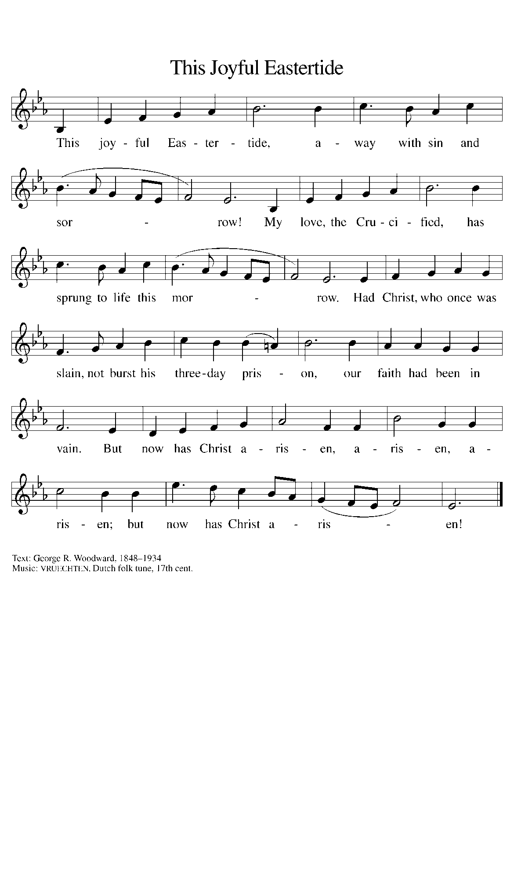

**THE OFFERTORY PRAYER**

A: Let us pray. Eternal God,

**C: Our Savior Jesus Christ has promised to be with us until the end of time. Accept all we**

**offer You this day, and renew in us His risen and ascended life. We ask this in the name**

**of Jesus the Lord. Amen.**

**THE GREAT THANKSGIVING**

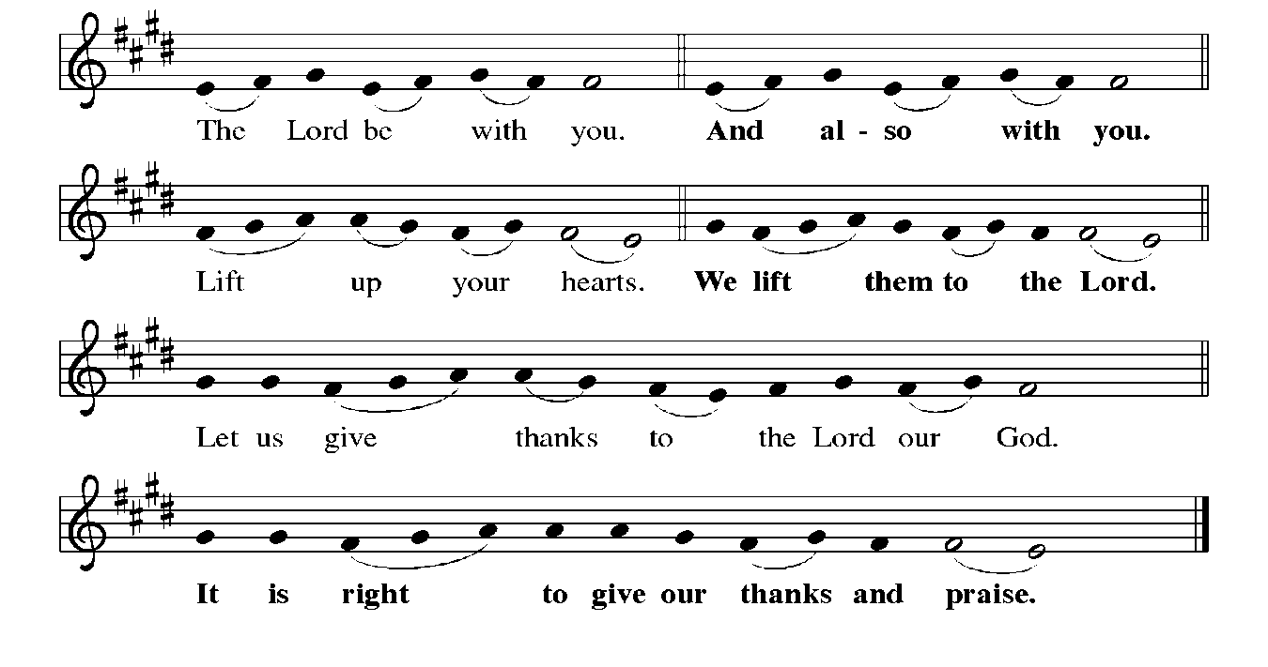

P: It is indeed right, our duty, and our joy … join their unending hymn:

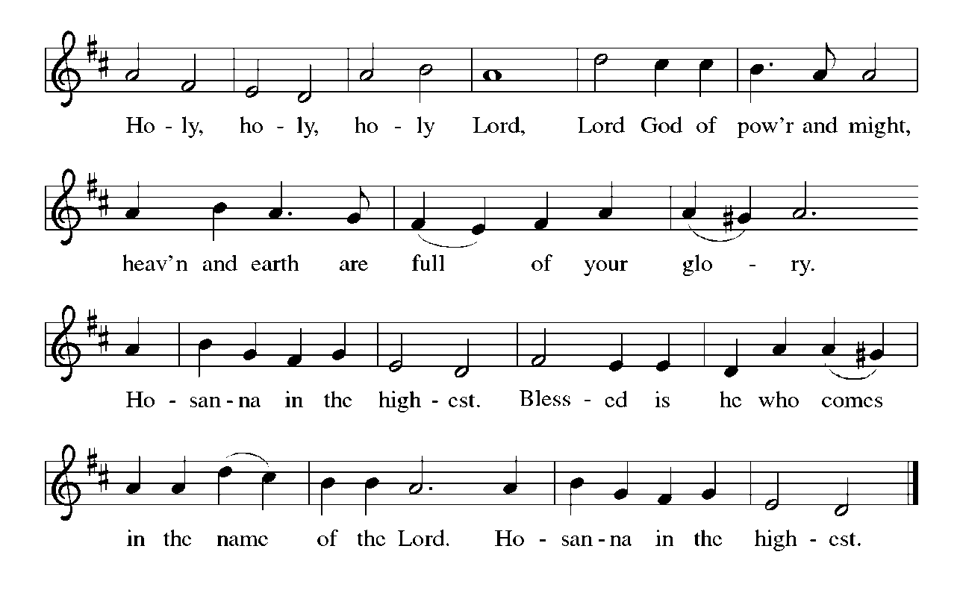

P: Holy God, You alone are holy.

You alone are God.

The universe declares Your praise:

Beyond the stars;

beneath the sea;

within each cell;

with every breath.

**C: We praise You, O God.**

P: Generations bless Your faithfulness;

Through the water;

by night and day;

across the wilderness;

out of exile;

into the future.

**C: We bless You, O God.**

P: We give You thanks for Your dear Son:

At the heart of human life;

near to those who suffer;

beside the sinner;

among the poor;

With us now.

**C: We thank You, O God.**

In the night ... “Do this for the remembrance of Me.”

As often as we eat ... we proclaim the Lord’s death until He comes.

Remembering His love for us on the way,

at the table,

and to the end,

we proclaim the mystery of faith:

**C: Christ has died. Christ is risen. Christ will come again.**

P: We pray for the gift of Your Spirit:

In our gathering;

within this Meal;

among Your people;

throughout the world.

Blessings, praise, and thanks to You,

Holy God,

through Christ Jesus,

by Your Spirit,

in Your Church,

without end.

**C: Amen!**

**THE LORD’S PRAYER**

P: Risen from the dead, Jesus lives to intercede for us and join us as He taught us to pray:

**C: Our Father, Who art in heaven, hallowed by Thy name.**

**Thy Kingdom come, Thy will be done on earth as it is in heaven.**

**Give us this day our daily bread, and forgive us our trespasses as we forgive those**

**who trespass against us.**

**And lead us not into temptation, but deliver us from evil.**

**For Thine is the Kingdom, and the power, and the glory, forever and ever. Amen.**

**INVITATION TO THE MEAL**

P: Alleluia! Christ the Lamb of God has been sacrificed. Therefore, let us celebrate His Feast

with joy. Blessed are those who are called to the Supper of the Lamb. God’s holy gifts for

God’s holy people. Come, for all is now ready.

*The assembly is seated*

**DISTRIBUTION**

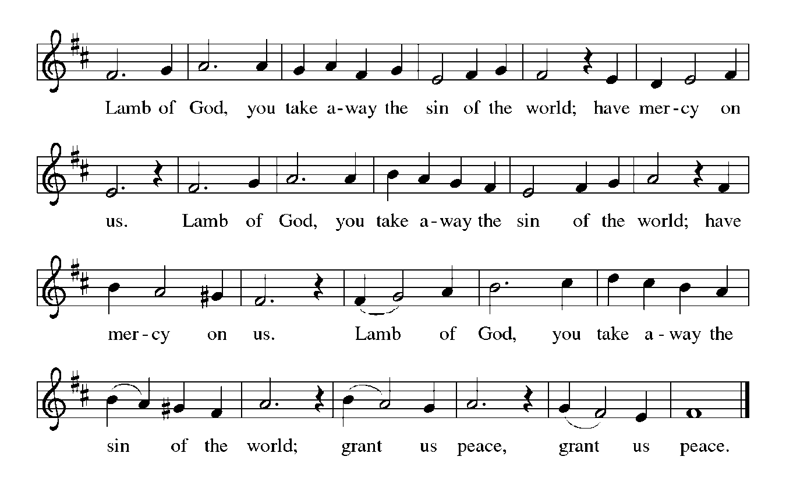

**HYMN DURING DISTRIBUTION 604 *O Christ, Our Hope***

**NSB 2 *Above All***

**NSB 86 *The Power of Your Love***

**NSB 88 *There is A Redeemer***

*As you are able please rise*

**THE POST-COMMUNION BLESSING**

P: The Body and Blood of our Lord Jesus Christ strengthen you and keep you in His grace.

**C: Amen.**

**THE POST-COMMUNION PRAYER**

A: Let us pray. Heavenly Father, in the Eucharist we celebrate the Ascension of Your Son into

glory. May the gifts of His Body and Blood help us to rise with Him to the joys of heaven,

where He lives and reigns with You and the Holy Spirit, one God, now and forever.

**C: Amen.**

**✠ SENDING ✠**

**THE BENEDICTION**

P: May God the Father Who raised Christ from the dead open to you the gate of everlasting life.

**C: Amen.**

P: May God the Son Who burst from the grave give you joy as you celebrate His resurrection.

**C: Amen.**

P: May God the Holy Spirit Who brought you to birth in Baptism fill you with strength and peace.

**C: Amen.**

P: Almighty God: Father, Son, **✠** and Holy Spirit bless you now and forever.

**C: Amen.**

**THE RECESSIONAL HYMN 838 *Beautiful Savior***

**THE DISMISSAL**

A: Alleluia! Christ is risen!

**C: He is risen indeed! Alleluia!**

A: Go in the peace of Christ, alleluia!

**C: Thanks be to God! Alleluia!**

**POSTLUDE**

**✠ To God Alone Be Glory ✠**

The Meditation is from *Keeping the Faith. A Guide to the Christian Faith.* David Truemper and

Frederick Niedner, Jr. (Valparaiso University, Department of Theology, 1980). 67.

The Greeting, Peace, Offertory, Post-Communion Prayers, and Dismissal are from *Sundays and*

*Seasons.* Copyright 2000 Augsburg Fortress.

The Prayers are adapted from *Prayers for Sundays and Seasons. Year B.* Peter Scagnelli.

(Chicago: Liturgy Training Publications, 1996, 72-73.

**ANNOUNCEMENTS**

**Please remember to mail your offering to the Church Office** at 818 Franklin Street, Michigan City, IN 46360**.** Another alternative is to give on-line through Tithe.ly. Please see your closure letter for information on how to set up a Tithe.ly account.

**St. Paul Members are reminded to have** a loved one contact the office if you are hospitalized. Many times, the Pastor doesn’t know someone is in the hospital. If you call and leave a message, please tell us at which hospital the patient is located.

**Anniversaries: Mike & Marge Bockover (6/6)**

**PRAYER CONCERNS:** Larry Litchford, Sarah McNabb, Carol Radke, Jeanie Boatman Shepple, Nolan Wilson, Debbie Martin, Mark Tannehill, Brian Wiseman, Kathy Stein, Danielle Schnell, Jan Paholski, Laura Dovey, and Grace Romine.

**OFFICE HOURS:** Libby will be in the office on Mondays, Wednesdays, and Fridays; volunteers will cover Tuesdays and Thursdays.

Monday & Wednesday 8:00 a.m. – 5 p.m.

Tuesday & Thursday 9:00 a.m. – 12:00 p.m.

Friday 8:00 a.m. – 12:00 p.m.

**If you are listening to the worship broadcast on the radio and would like to watch the Sunday morning service live stream follow these steps:**

(1) If you have You Tube available on your TV, search for

**St. Paul Lutheran Church Michigan City, IN.**

(2) The direct link on the computer is

https://www.youtube.com/channel/UC5AIPNaKr3QN50984jGOa1g.

   (3) This link is also on the main page of the church’s website in

the church section and will continue to be posted weekly on the St.

Paul Facebook page.

And it will always be available on the radio broadcast Sunday mornings at 11:00 a.m.

on WEFM (95.9), and on the local cable access station #99 for the previous week’s

service on Sundays at 4:00 p.m. and the current service on Wednesdays at 7:00 p.m.

and Fridays at 8:30 p.m.

**Next Sunday’s lessons are Acts 2: 1-21 or Genesis 11: 1-9; Psalm 104: 24-34, 35b; Romans 8: 14-17; John 14: 8-17 (25-27):** for those of you who like to study them in advance.

**To send e-mail to the church office**, please use the following addresses:

Pastor Mark Reshan: seniorpastor@stpaulmichigancity.com

Church Office Secretary (Libby Pollock): churchsecretary@stpaulmichigancity.com

Church Treasurer (Karen Fleming): finance@stpaulmichigancity.com

**2025 Church Council:**

Mark Reshan - Pastor

Janet Bakken – President

Donna Knoll – Vice President

Judy Hunt – Secretary

Karen Fleming – Treasurer

Members: Paul Brooks, Diane Egilske, Sue Koziel, Judy Mutchler,

Jim Schraidt, Trish Sprague

**Worship Attendance:**

**Saturday , May 24, 2025 @ 4:00 p.m. 31**

**Sunday, May 25, 2025 @ 9:00 a.m. 63**

**TOTAL 94**

**2025 Financial Stewardship**

Weekly Church Operating Needs (x 2 weeks)

May 17-18, 2025; May 24-25, 2025: $ 13,545.00

General Fund (including General Memorials): $ 16,174.00

Overage/Shortage: + $ 2,629.00

Restricted Income (not including Memorials)

Supports IK Synod & Church wide Ministries: $ 320.00

Ministries in our Community/Congregation: $ 70.00

Capital Fund: $ 275.00

**ACTIVITIES, EVENTS & MEETINGS**

**JUNE 2025**

**Saturday,** May 31, 2025 @ 4:00 p.m. 7th Easter Worship Service

**Sunday,** June 1, 2025 @ 9:00 a.m. 7th Easter/Observed Ascension Worship Service

Coffee in St. Paul Room after service

**Tuesday,** June 3, 2025 @ 10:00 a.m. Altar Guild/St. Paul Room

**Wednesday,** June 4, 2025@ 10:00 a.m.God’s Purls/St. Paul Room

@ 4:30 p.m. Choir Rehearsal/Sanctuary

**Thursday,** June 5, 2025 Faith Circle

**Saturday,** June 7, 2025 @ 4:00 p.m. Day of Pentecost Worship Service/Sanctuary

**Sunday,** June 8, 2025 @ 9:00 a.m. Day of Pentecost Worship Service/Sanctuary

**NO COFFEE TODAY**

**Monday,** June 9, 2025 @ 1:00 p.m. Hope Circle/Green Room

**Tuesday,** June 10, 2025 **from 11:00 a.m. – close GIVE BACK AT HOLLY’S**

@ 7:00 p.m. Estuary/Luther House

**Wednesday,** June 11, 2025 @ 10:00 a.m. God’s Purls/St. Paul Room

**@ 4:30 p.m. OPEN CHOIR REHEARSAL/Sanctuary**

(this will also be the last rehearsal of the season)

**Saturday,** June 14, 2025 @4:00 p.m. The Holy Trinity Worship Service/Sanctuary

**Sunday,** June 15, 2025 @ 9:00 a.m. The Holy Trinity Worship Service/Sanctuary

Coffee in St. Paul Room after service

**Wednesday,** June 18, 2025 @ 10:00 a.m. God’s Purls/St. Paul Room

**Saturday,** June 21, 2025 @ 4:00 p.m. Pent 2 Worship Service/Sanctuary

**Sunday,** June 22, 2025 @ 9:00 a.m. Pent 2 Worship Service/Sanctuary

Coffee in St. Paul Room after service

**Monday,** June 23, 2025 @ 2:00 p.m. Finance Comm. Mtg./Luther House

@3:00 p.m. Executive Board Meeting/Luther House

**Wednesday,** June 25, 2025 @ 10:00 a.m. God’s Purls/St. Paul Room

@5:00 p.m. 150th Anniversary Comm. Mtg./Luther House

**Thursday,** June 26, 2025 @ 5:30 p.m. Church Council Mtg./St. Paul Room

**Saturday,** June 28, 025 @ 4:00 p.m. Pent 3 Worship Service/Sanctuary

**Sunday,** June 29, 2025 @9:00 a.m. Pent 3 Worship Service/Sanctuary

Coffee in St. Paul Room after service HOSTED BY THE ALTAR GUILD

**MISSION OF THE MONTH FOR JUNE 2025**

**The mission of the month for St. Paul Lutheran is the Team Kentucky Storm Relief Fund.** The governor of Kentucky has established this fund to assist those impacted by the severe weather and tornadoes this year. The fund has no administration fees, so every dollar goes to help Kentuckians affected by the historic flooding and sever weather. Governor Beshear has said that the fund will first go towards paying funeral expenses for those lost to the storms, stating that people who have lost so much in a natural disaster shouldn’t have to worry about how to bury their loved ones. Please make checks payable to St. Paul and mark for the June Mission of the Month and place in the offering plate. June noisy coin offering will also support the mission of the month. Thank you for your generosity in helping those affected by this natural disaster as well as your continued prayers for the victims and their loved ones.

**Copies of the minutes from the March 27, 2025 and the May 1, 2025 Church Council meetings are on the back table in the upper Narthex. They were approved by the council via email.**

**FYI:**

In response to the ever rising costs for postage we will be putting your copy

of the “Good News” in your hanging file folder in the narthex each month

from now on. Those of you who are unable to attend services on a regular

basis may still receive your copies through your email address or in the

U.S. mail. If you normally receive your copy of the newsletter via your

email address anyway, nothing will change for you. Thank you so much for

your understanding and cooperation!

**The Good News Newsletter**: If you have an article or anything you want included in **The Good News** please send it to the following e-mail address: splcgoodnews@gmail.com. Pastor Pamela Thiede will be using this e-mail address to assemble **The Good News** each month. The deadline for getting information to Pastor Pamela will be the 20th of each month.

**Do you love to sing?**

**The St. Paul Choir is hosting an open rehearsal on Wednesday, June 11, 2025 from 4:30 p.m. – 5:30 p.m. in the Sanctuary.** It’s OK if you don’t know if you are a Bass, Tenor, Alto or Soprano (our rockstar director, Maggie, can help you with that) and you don’t need to know how to read music! During the open rehearsal we will learn a simple song to sing during the service on Sunday, June 15. Then the choir will be on summer break from mid-June until after Labor Day, giving you time to consider joining in September. We look forward to seeing everyone on June 11th!

Thank$ for $haring

Thank you for all who participate in our Give Back days! On April 3 we met at Galveston Steakhouse and earned $150. Our May 7th Give Back at Swingbelly’s earned $125. Our next Give Back will be at Holly’s on Tuesday, June 10th from 11:00 am — close. A coupon is required in order for us to claim the discount. Here are two coupons: one for you and one for a friend.

