REFORMATION
The Twenty-Second Sunday after Pentecost
October 25, 2026

“When it comes to defining something as elusive and misunderstood as ‘faith,’ perhaps the way to begin is to say what it isn’t. There are at least three fundamental misconceptions of ‘faith’ at work in our society ...
...First, ‘faith’ is not assent to doctrines about God, creation, Jesus Christ, etc. This does not mean that ‘faith’ has nothing to do with ‘beliefs’ or cherished ‘truths’ of the tradition; it has. But ‘faith’ isn’t to be equated with giving credence to these teachings ...
...Second, ‘faith’ is not accepting ‘on authority’ (the authority of the church, the tradition, the Bible, parents and teachers, etc.) what one cannot personally experience or feel to be true. There is a necessary personal dimension in ‘faith’...
...Third, faith is not a vague spirituality, a belief-ful attitude towards life ...Like most of the primary concepts of biblical religion (love, hope, grace, compassion, forgiveness, wrath, repentance) ‘faith’ is a category of relationship ...Faith is response in relationship; it is an ongoing thing, a process. You can never say that you ‘have’ it as if it were a possession! Christians sometimes affirm that ‘faith’ is ‘a gift.’ This is true if it means that the faith response is a consequence of God’s grace. But the statement is misleading if it implies that the ‘gift’ is something one is allowed to keep.
One has to continue receiving it like the manna of the wilderness or the `daily bread' of Jesus' prayer. When the Protestant Reformers, following St. Paul (e.g. Rom. 4: 16 f.), used the slogan, "justification by faith," they did not mean that we are considered righteous by God because we give assent to theological truths, or accept the teachings of the tradition on the church's authority, or cultivate a positive outlook; all such things the Reformers would have consigned to "works righteousness"! Rather, they meant that we are acceptable to God because we trust God. It is as simple and as profound as that.”

Douglas John Hall
“Faith: In Response to Relationship”

In the Name of Jesus

INTRODUCTION

On this day we celebrate the heart of our faith: the gospel of Christ—the good news—that makes us free! We pray that the Holy Spirit would continue to unite the church today in its proclamation and witness to the world. In the waters of baptism we are made one body; we pray for the day that all Christians will also be one at the Lord’s table.

Reformation Day

By the end of the seventeenth century, many Lutheran churches celebrated a festival commemorating Martin Luther's posting of the Ninety-five Theses, a summary of abuses in the church of his time. At the heart of the reform movement was the gospel, the good news that it is by grace through faith that we are justified and set free.

Simon and Jude, Apostles

Little is known about them. Simon is never mentioned apart from the list of disciples whom Jesus called, and Jude, sometimes called Thaddeus, is also mentioned as part of the Twelve. A traditional story about them says they traveled together on a missionary journey to Persia and were martyred there.

GATHERING

PRELUDE

ANNOUNCEMENTS

As you are able please rise

THE PROCESSIONAL HYMN 504 A Mighty Fortress

The congregation faces the cross as it enters

THE GREETING AND PRAYER OF THE DAY

P: The grace of our Lord Jesus Christ, the love of God, and the communion of the Holy
Spirit be with you all.

C: And also with you.

P: Let us pray. Almighty God, gracious Lord, we thank You that Your Holy Spirit renews
the church in every age. Pour out Your Holy Spirit on Your faithful people. Keep them
steadfast in Your word, protect and comfort them in times of trial, defend them against
all enemies of the gospel, and bestow on the church Your saving peace, through Jesus
Christ, our Savior and Lord, Who lives and reigns with You and the Holy Spirit, one
God, now and forever.

C: Amen.

The assembly is seated

WORD

FIRST READING Jeremiah 31: 31-34

In contrast to Judah's sin, which Jeremiah describes as "engraved on the tablet of their hearts" (17: 1), the prophet envisions a future day when the law will be written "on their hearts" (31: 33). To know God in this way is to have a direct and profound connection to God. Forgiveness of sins, which is so complete as to be forgotten, is the motivating force for keeping the law.

The days are surely coming, says the LORD, when I will make a new covenant with the house of Israel and the house of Judah. ³²It will not be like the covenant that I made with their ancestors when I took them by the hand to bring them out of the land of Egypt--a covenant that they broke, though I was their husband, says the LORD.
³³But this is the covenant that I will make with the house of Israel after those days, says the LORD: I will put my law within them, and I will write it on their hearts; and I will be their God, and they shall be my people. ³⁴No longer shall they teach one another, or say to each other, "Know the LORD," for they shall all know me, from the least of them to the greatest, says the LORD; for I will forgive their iniquity, and remember their sin no more.

The Word of the Lord.

Thanks be to God.

THE PSALM: Psalm 46 Antiphon by Aaron David Miller

Choir sings refrain first
followed immediately by the congregation and as indicated

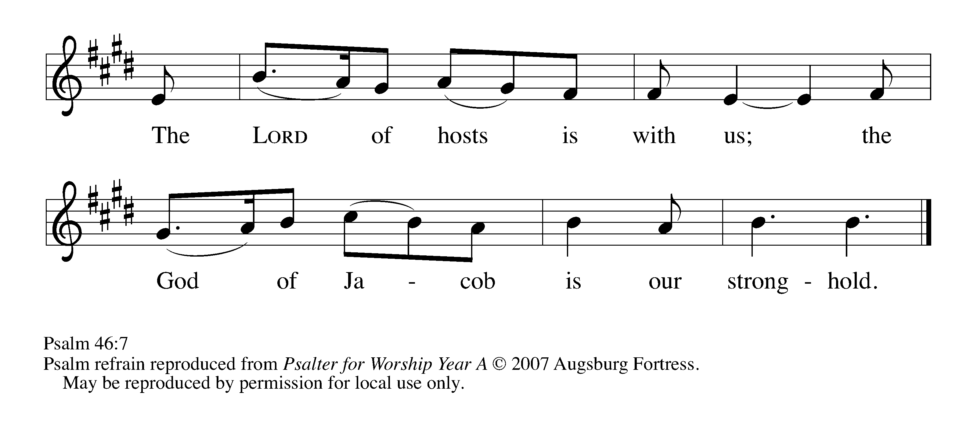

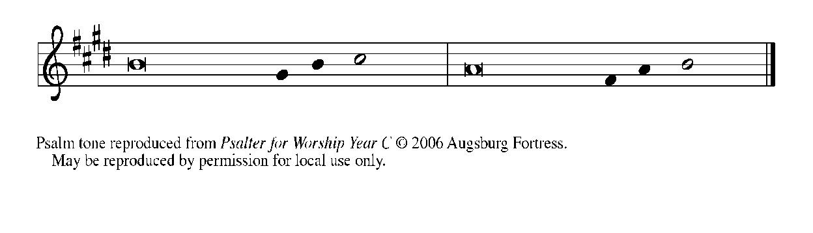

¹God is our ref- | uge and strength,*
a very present | help in trouble.

²Therefore we will not fear, though the | earth be moved,*
and though the mountains shake in the depths | of the sea;

³though its waters | rage and foam,*
and though the mountains tremble | with its tumult.

⁴There is a river whose streams make glad the cit- | y of God,*
the holy habitation of | the Most High.

⁵God is in the midst of the city; it shall | not be shaken;*
God shall help it at the | break of day.

⁶The nations rage, and the | kingdoms shake;*
God speaks, and the earth | melts away. REFRAIN

⁷The Lord of | hosts is with us;*
the God of Jacob | is our stronghold.

⁸Come now, regard the works | of the Lord,*
what desolations God has brought up-| on the earth.

⁹Behold the One Who makes war to cease in | all the world;*
Who breaks the bow, and shatters the spear, and burns the | shields with fire.

¹⁰"Be still, then, and know that | I am God;*
I will be exalted among the nations; I will be exalted | in the earth."

¹¹The Lord of | hosts is with us;*
the God of Jacob | is our stronghold. REFRAIN

SECOND READING Romans 3: 21-28

Martin Luther and other leaders of the Reformation believed the heart of the gospel was found in these words of Paul written to the Romans. All people have sinned, but God offers forgiveness of sins through Christ Jesus. We are justified--put right with God--by the gift of God's grace, through faith in Jesus.

¹⁹Now we know that whatever the law says, it speaks to those who are under the law, so that every mouth may be silenced, and the whole world may be held accountable to God. ²⁰For "no human being will be justified in his sight" by deeds prescribed by the law, for through the law comes the knowledge of sin.
²¹But now, apart from law, the righteousness of God has been disclosed, and is attested by the law and the prophets, ²²the righteousness of God through faith in Jesus Christ for all who believe. For there is no distinction, ²³since all have sinned and fall short of the glory of God; ²⁴they are now justified by His grace as a gift, through the redemption that is in Christ Jesus, ²⁵Whom God put forward as a sacrifice of atonement by His blood, effective through faith. He did this to show his righteousness, because in His divine forbearance He had passed over the sins previously committed; ²⁶it was to prove at the present time that He Himself is righteous and that He justifies the one who has faith in Jesus.
²⁷Then what becomes of boasting? It is excluded. By what law? By that of works? No, but by the law of faith. ²⁸For we hold that a person is justified by faith apart from works prescribed by the law.

The Word of the Lord.

Thanks be to God.

As you are able please rise

THE VERSE (see p. 5)

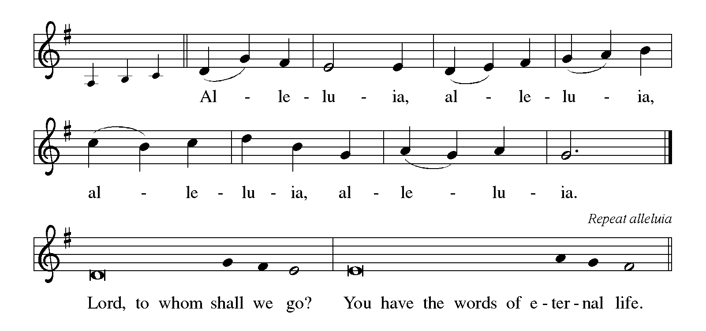

THE HOLY GOSPEL John 8: 31-36

True freedom is not related to ethnic distinctions or social class. Only Jesus can free us from slavery to sin, and he does this through the truth of the gospel.

P: The Holy Gospel according to St. John, the eighth chapter.

C: Glory to You, O Lord!

Jesus said to the Judeans who had believed in him, "If you continue in my word, you are truly my disciples; ³²and you will know the truth, and the truth will make you free." ³³They answered him, "We are descendants of Abraham and have never been slaves to anyone. What do you mean by saying, 'You will be made free'?"
³⁴Jesus answered them, "Very truly, I tell you, everyone who commits sin is a slave to sin. ³⁵The slave does not have a permanent place in the household; the son has a place there forever. ³⁶So if the Son makes you free, you will be free indeed."

P: The Gospel of the Lord.

C: Praise to You, O Christ!

The assembly is seated

THE SERMON

Silence for reflection follows the sermon

As you are able please rise

THE HYMN OF THE DAY (see p. 6) By Grace We Have Been Saved

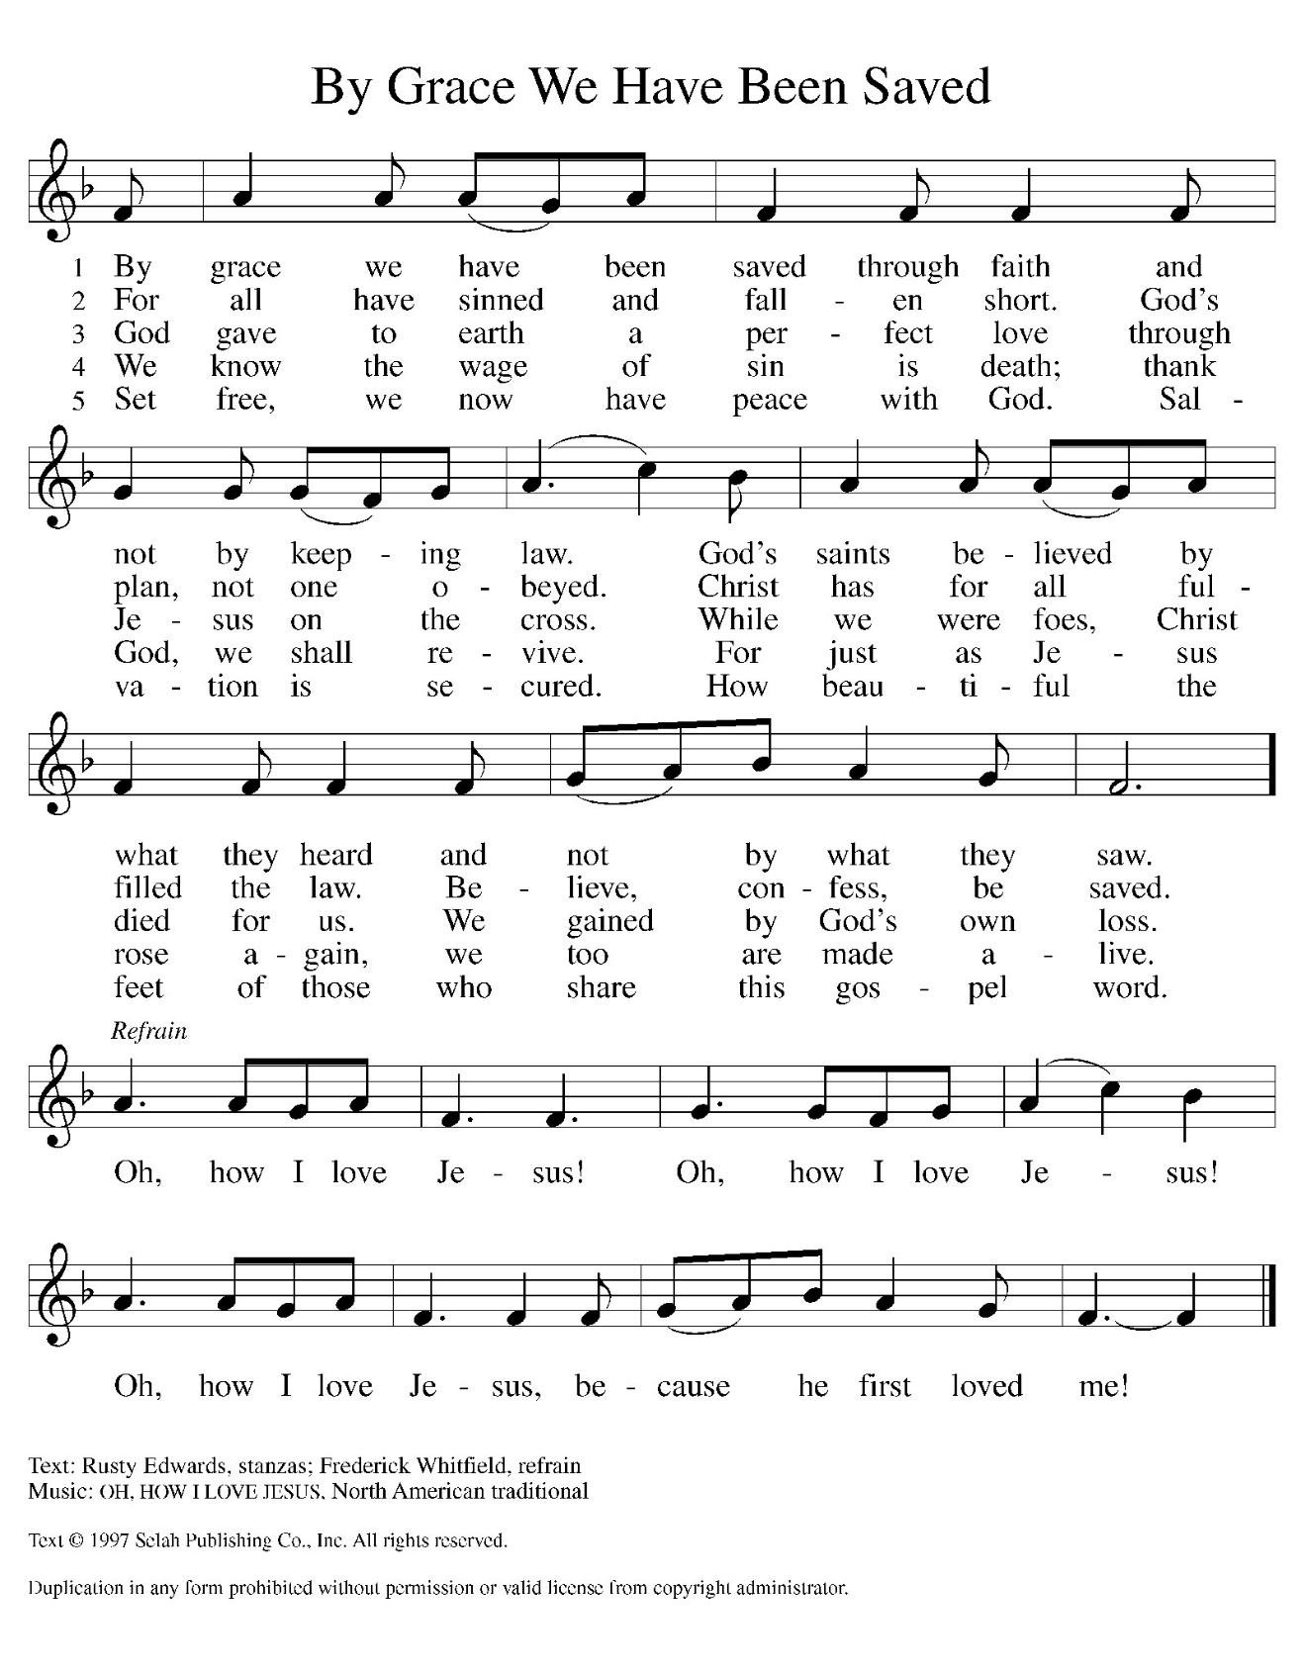

THE PRAYER OF THE CHURCH

A: That all people may come to know the grace of God in Christ, and be reformed into
God’s one people, let us now offer our prayer for the Church, the world, and all those
in need.

A: That the Church may constantly be reformed and renewed by God’s law of love written
on our hearts that we may proclaim Your hope, grace, and new life to the world, let us
pray to the Lord:

C: Lord, hear our prayer.

A: That by rain, rivers and oceans we might be reminded of how Your Word flows through
creation, surrounding us with grace and sealing us in the covenant of water and the
Spirit, let us pray to the Lord:

C: Lord, hear our prayer.

A: That God might break the bow, shatter the spear, burn the shield, and make wars to
cease, reconciling the nations to one another, let us pray to the Lord:

C: Lord, hear our prayer.

A: That this congregation might be renewed and re-formed by Jesus’ Word and live out
His forgiveness with humble, thankful, and loving hearts, let us pray to the Lord:

C: Lord, hear our prayer.

A: That caregivers might find respite, medical workers be infused with skill and
compassion, scientists and researchers might find cures, and those who need healing
and strength, especially: Marvin Dirks; Joan Seifert; Martha Schroeder; Mark
Tannehill; Jon Samuelson; Dale Thomas; Linda Barnes; Jim Tomscheck; Jean
Warner; Angela Cook; Mike Fitzgerald; Jeff Timmrick; Deb Prybylla; and John
Ripka might find in God a very present stronghold of rest and peace, let us pray to the
Lord:

C: Lord, hear our prayer.

A: That those celebrating birthdays, especially Bob Kiser and Sandy Sobecki, may be
filled with grace this day and every day, and grow in grace in the days ahead, let us
pray to the Lord:

C: Lord, hear our prayer.

A: That with Martin Luther, renewer of the Church, and Simon and Jude, Apostles,
whom we commemorate this Day, and all the saints who have called the Church to
faithfulness to Christ we might continue in His Word until we receive a place in God’s
household forever, let us pray to the Lord:

C: Lord, hear our prayer.

P: Into Your gracious hands, O Lord, we commend all for whom we pray, trusting in Your
mercy through Your Son, Jesus Christ our Lord.

C: Amen.

MEAL

THE PEACE

P: The peace of the Lord be with you always.

C: And also with you.

The assembly is seated

THE OFFERING

THE VOLUNTARY I Will Rejoice St. Paul Senior Choir
(B. Harlan)

As you are able please rise

THE PRESENTATION OF GIFTS (see p. 9) Let the Vineyards be Fruitful
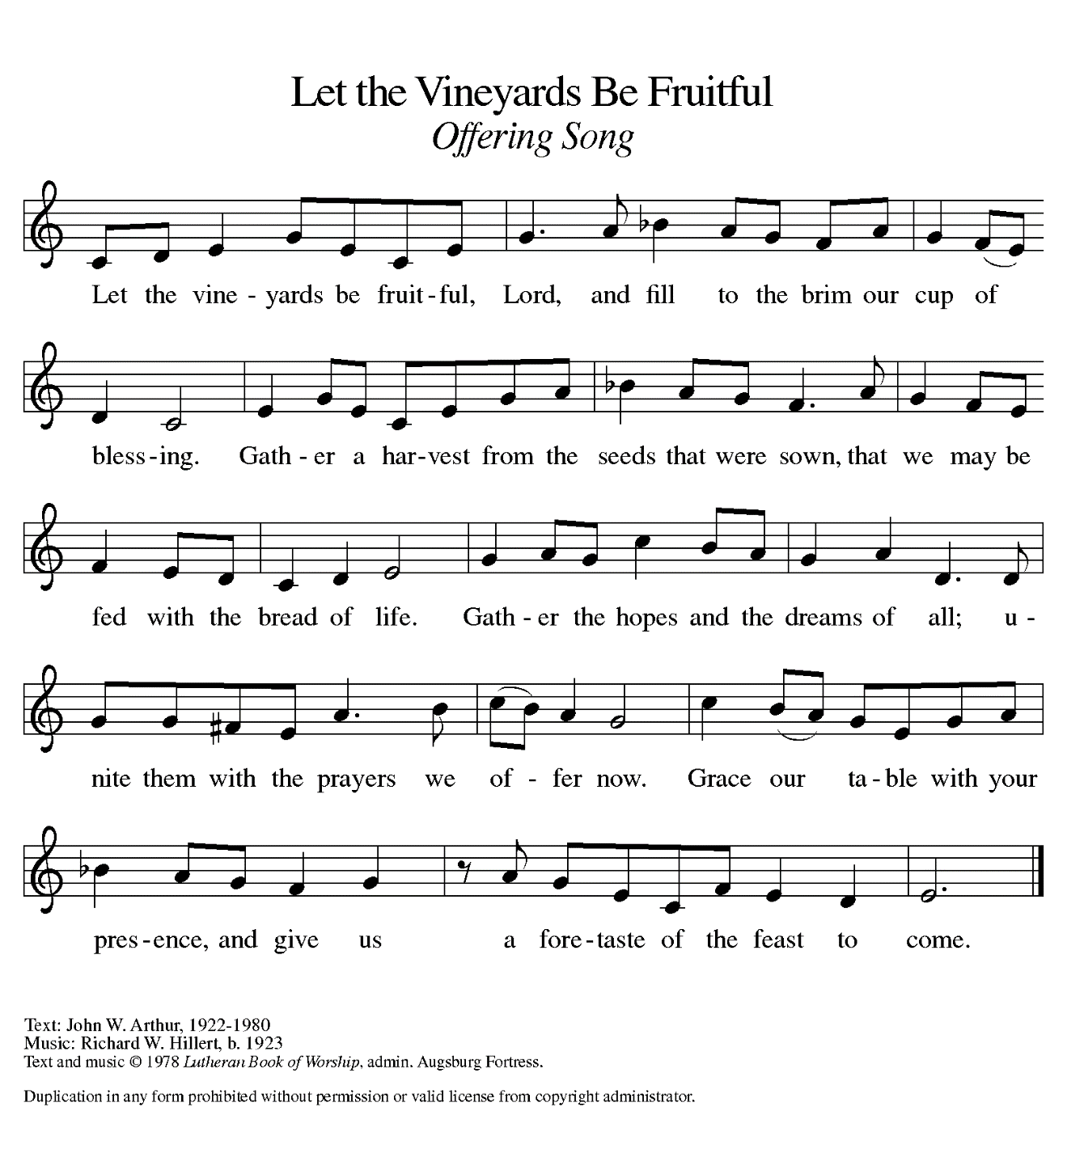
THE OFFERTORY PRAYER

A: Let us pray. Gracious God,

C: You put forward Your Son, Jesus Christ, as a sacrifice to make us one with You.
We put forward these gifts as a pledge to You of our whole lives. Receive them
and bless them for Your service. By this holy Sacrament, help us to know Your
grace, and free us to live and serve with joy as Your beloved people. We ask this
in the name of Jesus the Lord. Amen.

THE GREAT THANKSGIVING

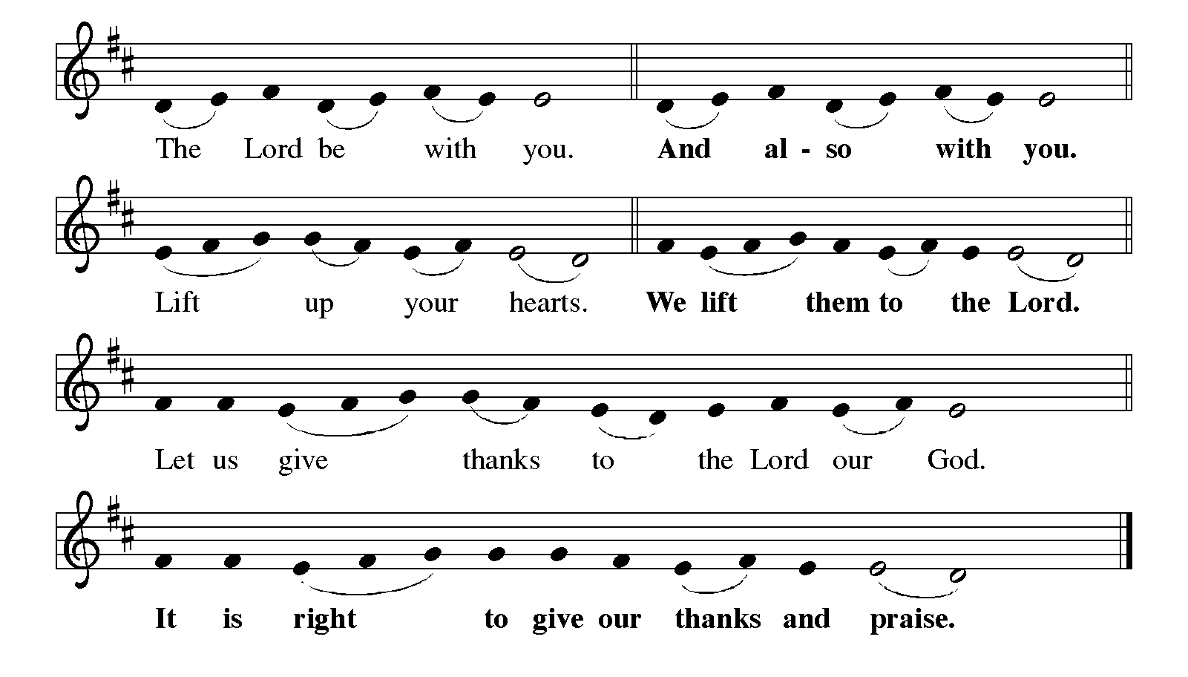
P: It is our duty and delight … and join their unending hymn:

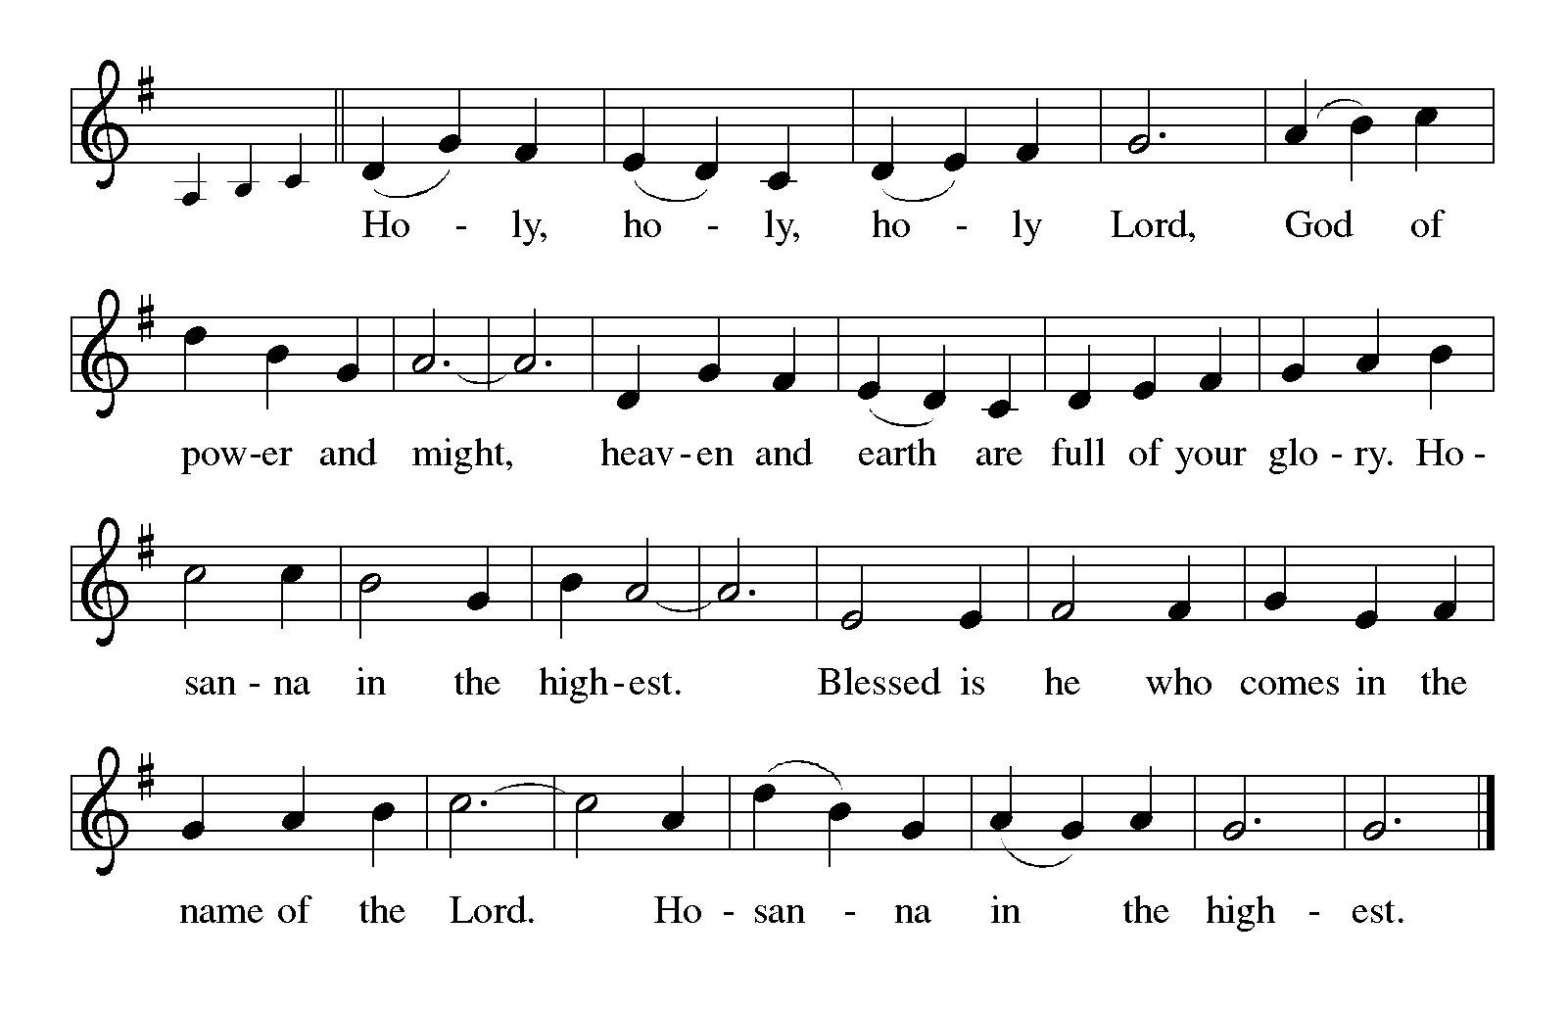
P: Holy God, our Refuge and Strength, we bless and praise You.
You are righteous in Your determination to always and forever have mercy.
That Your blessings of mercy might be known by all people, You chose Israel to be a
light of hope to the nations.
Ever faithful, even when they turned away, You promised a new covenant of
forgiveness that cannot be broken, and will yet come to pass.

At the last, You revealed Your righteousness in Your Son, Jesus Christ.
He is Your Word of truth Who makes us free.
In the night ... “Do this for the remembrance of Me.”
As often as we eat ... we proclaim the Lord’s death until He comes.

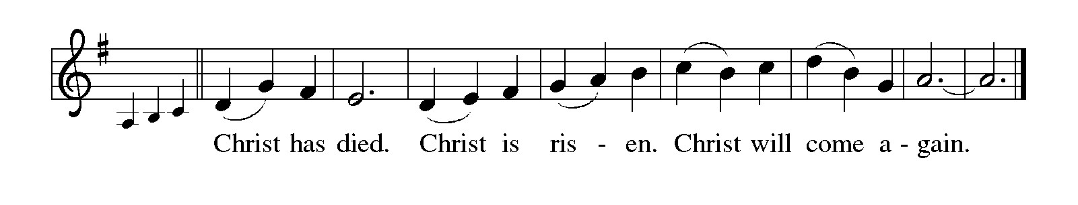
P: With this bread and cup we remember our Lord’s life, Your mercy in flesh and blood,
and His willing death that made us right with You.
You raised Him from death that we might live in freedom from the powers of sin, evil,
and death.
He has promised to return to fulfill Your promise that You will be our God and we will
be Your people forever.
Send Your Spirit on us and these Your gifts of bread and wine.
May we who share the Lord’s Body and Blood be kept from fear and despair and
strengthened in our trust in Your covenant of life with all the world.
To You, O God: Father, Son, and Holy Spirit, be all honor and glory, in Your holy
heaven and on earth, now and forever.

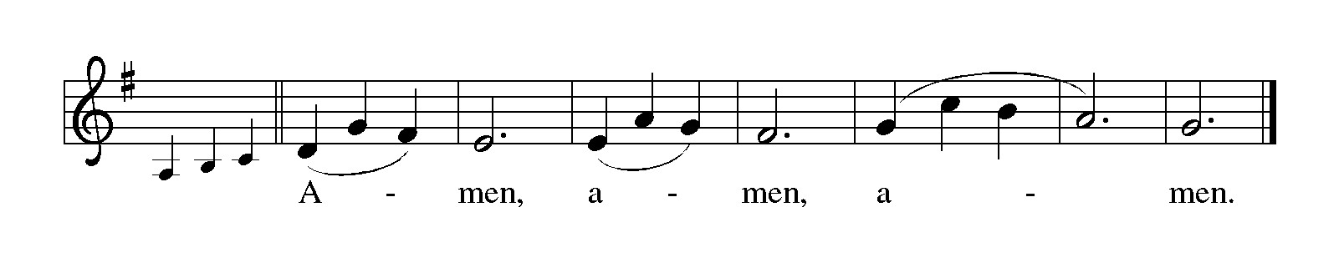
THE LORD’S PRAYER

P: That we may continue in Jesus’ word, let us pray as He taught His disciples:

C: (Sung) Music is on the front cover of the red hymnal

INVITATION TO THE MEAL

P: This is the Lamb of God Who takes away the sin of the world. Blessed are those who
are called to the Supper of the Lamb. God's holy gifts for God's holy people. Come,
for all is now ready.

The assembly is seated

THE DISTRIBUTION Lamb of God (see p. 12)
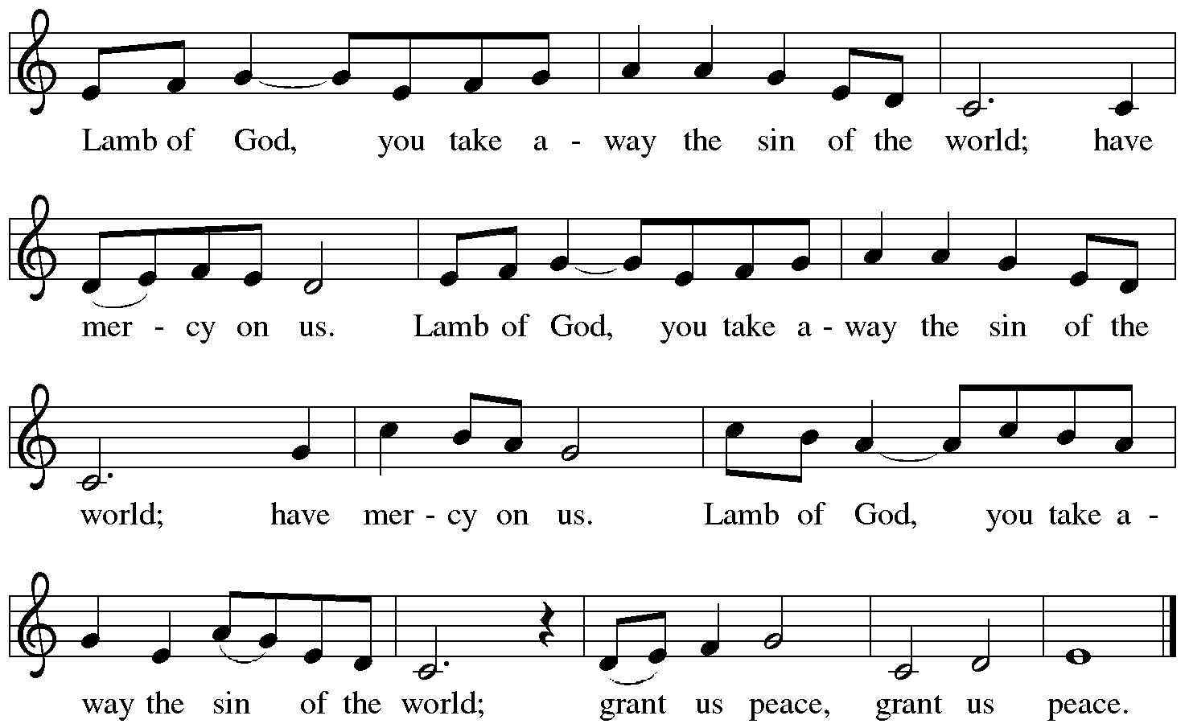

ELW 581 You Are Mine

NSB 92 Trading My Sorrows

NSB 104 You Are My Hiding Place

NSB 323 Emmanuel

As you are able please rise

POST-COMMUNION BLESSING

P: The Body and Blood of our Lord Jesus Christ strengthen you and keep you in His grace.

C: Amen.

THE POST-COMMUNION PRAYER

A: Let us pray. Merciful God, in this bread and cup of the new covenant You have again
forgiven our sins and drawn us into Your love. Help us to grow in faith as we proclaim
the truth of Your love. Grant this through Christ our Lord.

C: Amen.
SENDING

THE BENEDICTION

P: Almighty God: Father, Son, and Holy Spirit, bless you now and forever.

C: Amen.

RECESSIONAL HYMN (Sung to the tune of, “When in Our Music God is Glorified”)

The congregation faces the cross as it leaves

1 Founded on faith, the church—alive by grace—
proclaims the gospel here and ev'ry place.
The word of God resounds through time and space:
Alleluia!

2 Your cross, O Christ, renews our life each day.
Baptized in You, we learn and teach and pray.
Fed by Your love, with thankful hearts, we say:
Alleluia!

3 Equipped by prayer, we live the Spirit's call.
Empow'red to serve with gifts, both great and small,
we bring the living hope of God to all.
Alleluia!

4 Growing in grace for God's created earth,
we yearn for justice, peace, and human worth;
a world restored; a faithful, caring church.
Alleluia!

5 Founded on faith, called forth, empow'red to serve,
we share God's endless love without reserve.
Then let us shout aloud the living Word!
Alleluia!

THE DISMISSAL

A: Go in peace to love and serve the Lord.

C: Thanks be to God!

POSTLUDE
To God Alone Be Glory

The Meditation is from The Text This Week Online: Lectionary, Scripture Study, and
Worship Resources.

Please leave the parking spaces in front of the Luther House and in front of the entrance to the St. Paul Room open for our members who have canes or walkers or other mobility issues. Having to park further back in the lot can be a struggle for them to get to the church entrance. This will become particularly important as winter approaches and there is ice and snow on the ground. Thank you for your consideration in making it easier for them to join us for worship.
