THE SECOND SUNDAY IN LENT
March 1, 2026

You can enter the kingdom of God only by being born anew. Nicodemus' question (How can anyone be born after having grown old? Can one enter a second time into the mother's womb?) shows a double misunderstanding. Like the Samaritan woman who asks for the never-failing water, he takes what Jesus is saying literally. But he also misunderstands by thinking that being born is something we can manage or achieve.
Nicodemus is a religious leader, a theologian, and he wants to know how to meet the requirements. Jesus is describing the "way in" as a process that is not susceptible to definition or control. A baby doesn't have control in the process of being born. And neither do we in an even more un-pin-downable event: we are to be born of the wind. Jesus uses a pun here, because "spirit" and "wind" are the same word in Greek. The wind/spirit blows wherever it wishes. You cannot tell where it comes from or where it is going. It eludes all our attempts to get a fix on it.
It is tempting for us to hear this story and think, We know what it means to be born from water and the Spirit, and we've done it. We are baptized. We have a lock on it. But here is a reality that won't be locked down, a new life we can't control. It is one of the reasons why we need to come back to our baptism continually, as we do especially in Lent, letting the rebirth happen to us in ways we can't control, with outcomes we can't predict. All we can be sure of is that this new, eternal life is a gift of God's love, a whirlwind that brings no destruction, but that rearranges the world in order to make it whole.

Words for Worship

Exult with joy in Christ. For now the saving warmth of the eternal font invites you. Now your mother adopts you to make you her child. Thanks to your faith, the wave of rebirth has already begotten you. Run, then, forward to the mother who experiences no pains of labor, although she cannot count the number of those to whom she gives birth. Happily you are going to drink the new milk together. Fly to the fountain, to the sweet womb of your mother.

Zeno of Verona
[Zeno of Verona, in Baptism: Ancient Liturgies and Patristic Texts, ed. A Hamman OFM (Staten Island, NY: Alba, 1967), 64-66.]

In the Name of Jesus

INTRODUCTION

During Lent we journey with all those around the world who will be baptized at the Easter Vigil. In today's gospel Jesus tells Nicodemus that he must be born of water and Spirit. At the font we are given a new birth as daughters and sons of God. As God made a covenant with Abraham, in baptism God promises to raise us up with Christ to new life. From worship we are sent forth to proclaim God's love for all the world.

George Herbert, hymnwriter, died 1633

An excellent scholar, Herbert served briefly in the English parliament, then became a parish priest. He was known for devoted care of his parishioners, as well as for writing poetry and hymns, including "Come, my way, my truth, my life." He died at age 40.

GATHERING

PRELUDE

ANNOUNCEMENTS

As you are able please rise

CONFESSION AND ABSOLUTION

P: In the name of the Father and of the Son and of the Holy Spirit.

C: Amen.

P: “God did not send the Son into the world to condemn the world, but in order that the
world might be saved through Him.” (John 3: 17) In Lent we are called to return to the
Lord with all our heart, for God wishes us to be reconciled to Him and one another.
Therefore, let us confess our sins and seek the life and salvation God freely offers in
Christ.

Silence for self-examination and reflection is kept

P: Most merciful God,

C: You sent Your Son, Jesus Christ to save the lost and offer eternal life to all who
believe in Him. (John 3: 16) We confess that we have strayed from You and turned
aside from Your way. We have been afraid to risk going with You as You search
for the lost and those in darkness. You have called us to new ventures of faith but
we have chosen what is known and secure. (Genesis 12: 1) On this forty-day
journey, cleanse us of our fear. Grant us the courage to follow into Your future
of life and blessing. Forgive us our sins, O God, that with Christ we too may reveal
Your suffering love and proclaim His death for the life of all the world.

P: Almighty God have mercy on you, forgive you all your sins through our Lord Jesus
Christ, strengthen you in all goodness, and by the power of the Holy Spirit keep you in
everlasting life.

C: Amen.

GATHERING HYMN 448 This is the Spirit’s Entry Now

THE GREETING

P: The grace of our Lord Jesus Christ, the love of God, and the communion of the Holy
Spirit be with you all.
C: And also with you.

THE KYRIE
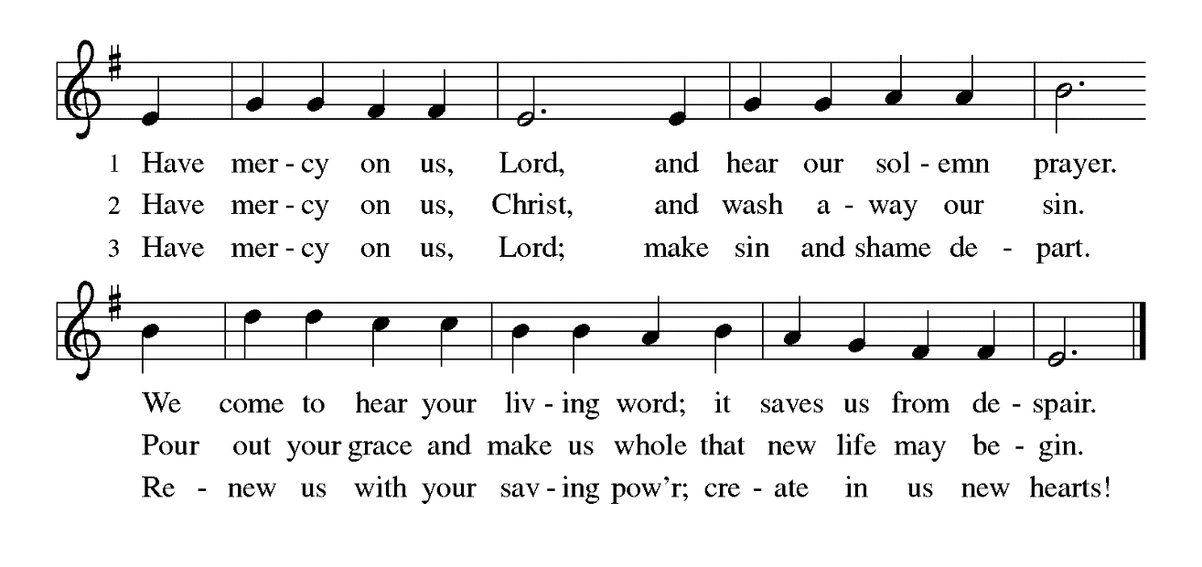

THE PRAYER OF THE DAY

P: The Lord be with you.

C: And also with you.

P: Let us pray. O God, our leader and guide, in the waters of Baptism You bring us to new
birth to live as Your children. Strengthen our faith in Your promises, that by Your Spirit
we may lift up Your life to all the world through Your Son, Jesus Christ, our Savior and
Lord, Who lives and reigns with You and the Holy Spirit, one God, now and forever.

C: Amen.

The assembly is seated

WORD

FIRST READING Genesis 12: 1-4

Genesis 1-11, often called the "primeval history," provides the background for today's reading. The repeated pattern of human rebellion and God's response ends with the Tower of Babel incident (11: 1-9). In today's reading, God begins the relationship with humanity anew, starting with the person of Abram.

The LORD said to Abram, "Go from your country and your kindred and your father's house to the land that I will show you. ²I will make of you a great nation, and I will bless you, and make your name great, so that you will be a blessing. ³I will bless those who bless you, and the one who curses you I will curse; and in you all the families of the earth shall be blessed."
⁴So Abram went, as the LORD had told him.

The Word of the Lord.

Thanks be to God.

THE PSALM: Psalm 121 Antiphon by Mark Sheppherd
Choir sings refrain first, followed immediately by the congregation
and as indicated

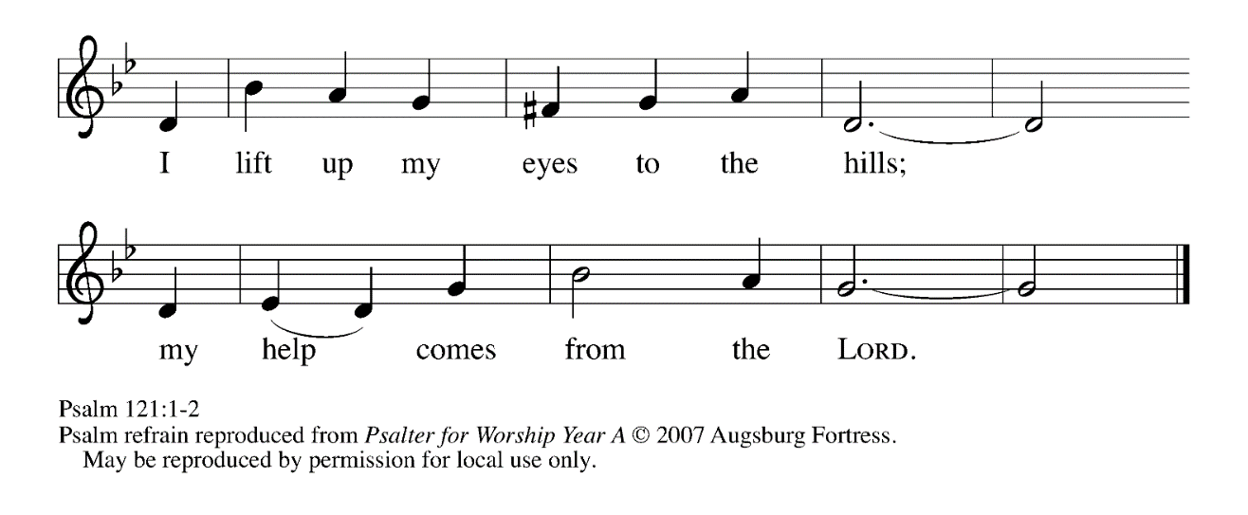
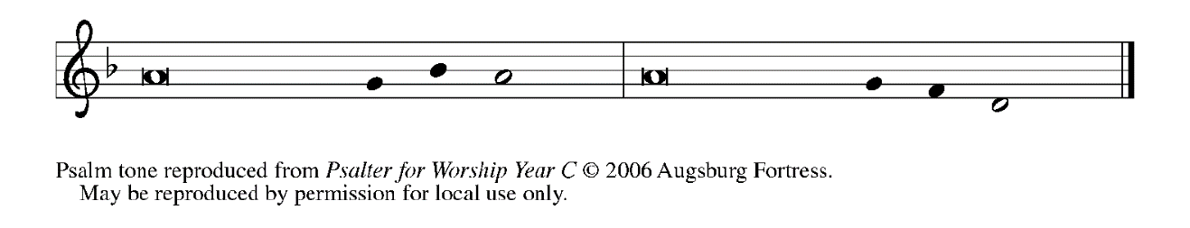

¹I lift up my eyes | to the hills;
from where is my | help to come?

²My help comes | from the LORD,
the maker of heav- | en and earth.

³The LORD will not let your | foot be moved
nor will the One Who watches over you | fall asleep.

⁴Behold, the keep- | er of Israel
will neither slum- | ber nor sleep; REFRAIN

⁵the LORD watches | over you;
the LORD is your shade at | your right hand;

⁶the sun will not strike | you by day,
nor the | moon by night.

⁷The LORD will preserve you | from all evil
and will | keep your life.

⁸The LORD will watch over your going out and your | coming in,
from this time forth for- | evermore. REFRAIN

SECOND READING Romans 4: 1-5, 13-17
Paul has taught that Jews and Gentiles alike are made right with God through faith. Abraham and his trust in God’s promises made him “the father of many nations.”

What are we to say was gained by Abraham, our ancestor according to the flesh? ²For if Abraham was justified by works, he has something to boast about, but not before God. ³For what does the scripture say? "Abraham believed God, and it was reckoned to him as righteousness." ⁴Now to one who works, wages are not reckoned as a gift but as something due. ⁵But to one who without works trusts Him Who justifies the ungodly, such faith is reckoned as righteousness.
¹³For the promise that he would inherit the world did not come to Abraham or to his descendants through the law but through the righteousness of faith. ¹⁴If it is the adherents of the law who are to be the heirs, faith is null and the promise is void. ¹⁵For the law brings wrath; but where there is no law, neither is there violation.
¹⁶For this reason it depends on faith, in order that the promise may rest on grace and be guaranteed to all his descendants, not only to the adherents of the law but also to those who share the faith of Abraham (for he is the father of all of us, ¹⁷as it is written, "I have made you the father of many nations")--in the presence of the God in Whom he believed, Who gives life to the dead and calls into existence the things that do not exist.

The Word of the Lord.

Thanks be to God.

As you are able please rise

THE VERSE
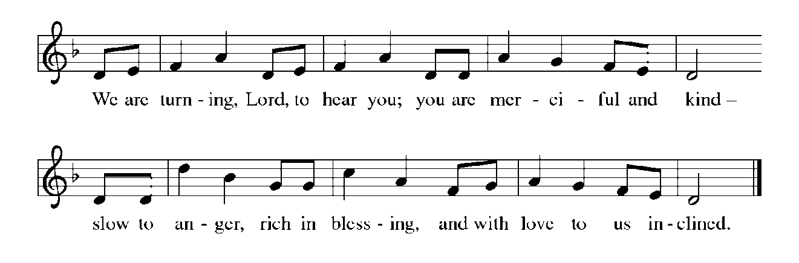
THE HOLY GOSPEL John 3: 1-17

Nicodemus learns from Jesus that the Father’s love He brings for the world is received as a gift through water and the Spirit.

P: The Holy Gospel according to St. John, the third chapter.

C: Glory to You, O Lord!

Now there was a Pharisee named Nicodemus, a leader of the Judeans. ²He came to Jesus by night and said to Him, "Rabbi, we know that You are a teacher Who has come from God; for no one can do these signs that You do apart from the presence of God."
³Jesus answered him, "Very truly, I tell you, no one can see the kingdom of God without being born from above." ⁴Nicodemus said to Him, "How can anyone be born after having grown old? Can one enter a second time into the mother's womb and be born?" ⁵Jesus answered, "Very truly, I tell you, no one can enter the kingdom of God without being born of water and Spirit.
⁶What is born of the flesh is flesh, and what is born of the Spirit is spirit. ⁷Do not be astonished that I said to you, 'You must be born from above.' ⁸The wind blows where it chooses, and you hear the sound of it, but you do not know where it comes from or where it goes. So it is with everyone who is born of the Spirit." ⁹Nicodemus said to him, "How can these things be?" ¹⁰Jesus answered him, "Are you a teacher of Israel, and yet you do not understand these things?
¹¹"Very truly, I tell you, we speak of what we know and testify to what we have seen; yet you do not receive our testimony. ¹²If I have told you about earthly things and you do not believe, how can you believe if I tell you about heavenly things?
¹³No one has ascended into heaven except the One Who descended from heaven, the Son of Man. ¹⁴And just as Moses lifted up the serpent in the wilderness, so must the Son of Man be lifted up, ¹⁵that whoever believes in Him may have eternal life.
¹⁶"For God so loved the world that He gave His only Son, so that everyone who believes in Him may not perish but may have eternal life.
¹⁷"Indeed, God did not send the Son into the world to condemn the world, but in order that the world might be saved through Him."

P: The Gospel of the Lord.

C: Praise to You, O Christ!

The assembly is seated

THE SERMON

Silence for reflection follows the sermon

As you are able please rise

THE HYMN OF THE DAY NSB 90 ‘Tis So Sweet to Trust in Jesus

THE NICENE CREED

A: God has made us His people through our Baptism into Christ. Living together in trust
and hope, we confess our faith.

We believe in one God,
the Father, the Almighty,
maker of heaven and earth,
of all that is, seen and unseen.

We believe in one Lord, Jesus Christ,
the only Son of God,
eternally begotten of the Father,
God from God, Light from Light,
true God from true God,
begotten, not made,
of one Being with the Father.
Through Him all things were made.
For us and for our salvation
He came down from heaven;
by the power of the Holy Spirit
He became incarnate from the virgin Mary, and was made man.
For our sake He was crucified under Pontius Pilate;
He suffered death and was buried.
On the third day He rose again
in accordance with the Scriptures;
He ascended into heaven
and is seated at the right hand of the Father.
He will come again in glory to judge the living and the dead,
and His kingdom will have no end.

We believe in the Holy Spirit, the Lord, the giver of life,
Who proceeds from the Father and the Son.
With the Father and the Son He is worshiped and glorified.
He has spoken through the prophets.
We believe in one holy catholic and apostolic Church.
We acknowledge one Baptism for the forgiveness of sins.
We look for the resurrection of the dead,
and the life of the world to come. Amen

THE PRAYER OF THE CHURCH

A: Let us ask God to bless all families of the earth in the name of Jesus, the Beloved Son
in Whom God is well pleased.

A: That all who lead and teach in the Church would guide God’s people ever more fully
into Christ’s way of forgiveness, reconciliation, and peace, let us pray to the Lord:

C: Lord, have mercy.

A: That in Peru, Brazil, Ukraine and other places of turmoil hatred and violence might be
replaced by the Spirit’s gift of peace and stability, let us pray to the Lord:

C: Lord, have mercy.

A: That those seeking Baptism might receive the blessings of God, let us pray to the Lord:

C: Lord, have mercy.

A: That this congregation might follow in faithful service wherever the Spirit leads, let us
pray to the Lord:

C: Lord, have mercy.

A: That the hungry, the homeless, the unemployed, and the sick, especially: Tim Miller;
Kathy Stein; Major Payne; Martha Schroeder; Joyce Stark; Jackie Gaines; Carl
Wipperman; Shirley Shikany Long; John Bennitt; Catherine Lanigan; Elizabeth
Saunders; David Jocelyn and Rob Steinborn might find help and healing from the
Lord, let us pray to the Lord:

C: Lord, have mercy.

A: That those celebrating birthdays, especially: Marshall Schnick; Ken Baker; and Gail
Leffew might grow in grace this day and every day and be filled with grace for the days
ahead, let us pray to the Lord:

C: Lord, have mercy.

A: That those who mourn, especially the family and friends of Pastor Erik Bernth,
whose father, Robert, died in the Lord this week, may be comforted by the promise
of resurrection to life everlasting, and of being reunited with those they love before
the throne of the Lamb, let us pray to the Lord:

C: Lord, have mercy.

A: That with all the saints, especially George Herbert, hymnwriter, whom we
commemorate this Day we may enter God’s eternal life, let us pray to the Lord:

C: Lord, have mercy.

P: God of Abraham and Sarah, we give You thanks for the signs of Your radiant presence
in the faith of our forebears. Transfigure us by the gift of faith for our life’s journey,
until we behold Your glorious beauty face to face, through Jesus Christ our Lord.

C: Amen.

MEAL

THE PEACE

P: Through Christ we have been reconciled to God, Who has given us the ministry of
reconciliation. Let us be reconciled with one another.

The peace of the Lord be with you always.

C: And also with you.

The assembly is seated

THE OFFERING

THE VOLUNTARY God So Loved the World St. Paul Senior Choir
(J. Stainer)

As you are able please rise

THE OFFERTORY (see p. 9) Create in Me a Clean Heart
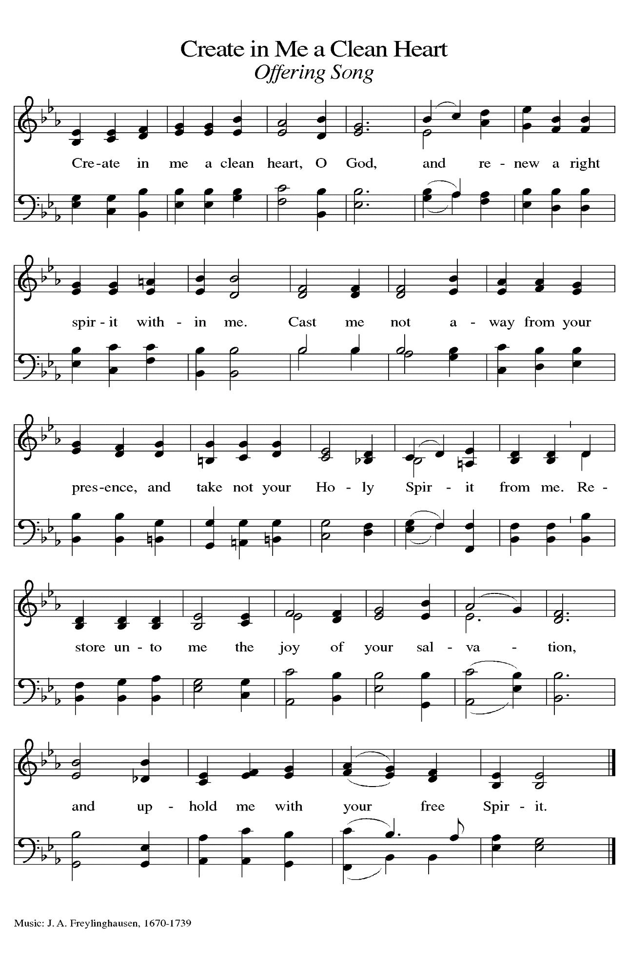
THE OFFERTORY PRAYER

A: Let us pray. God of mercy,

C: As Jesus was lifted up on the cross for our salvation, so we lift these gifts before
You with joy and thanksgiving. By our eating and drinking of this holy
Sacrament, draw us up into Your eternal life. We ask this in the name of Jesus
the Lord. Amen.

THE GREAT THANKSGIVING

P: The Lord be with you.

C: And also with you.

P: Lift up your hearts.

C: We lift them up to the Lord.

P: Let us give thanks to the Lord our God.

C: It is right to give Him thanks and praise.

P: It is indeed right, our duty, and our joy … join their unending hymn:
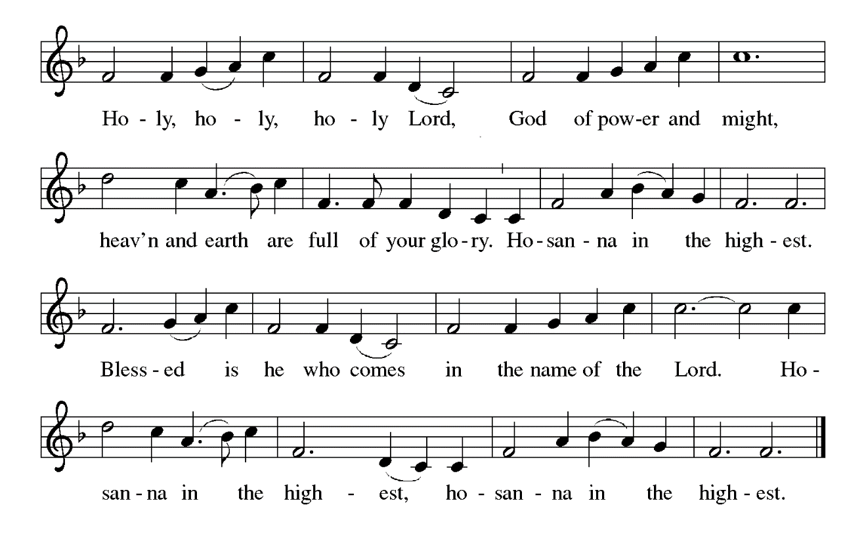
P: Blessings and thanks belong to You, promising God.
You make the sands of the desert and the stars of the sky, and in Abraham and Sarah
You called a people to be a great nation in whom all families of the earth
would find a blessing.
In Jesus You raised up a new Abraham to be a blessing to all the people.
In His death and resurrection, sin died and eternal life was born.
Faithful God, in Jesus You fulfilled all righteousness.
In Him You turn our duty into joy, and our sorrow into dancing.
You give us new birth through water and the Spirit.
Send down Your Holy Spirit now, that Your people may become a blessing to You and
all the world, and that the bread of sustenance and the wine of celebration may
become for us the Body and Blood of Your Son, Jesus Christ,
Who, in the night … “Do this for the remembrance of Me.”
As often as we eat … we proclaim the Lord’s death until He comes.
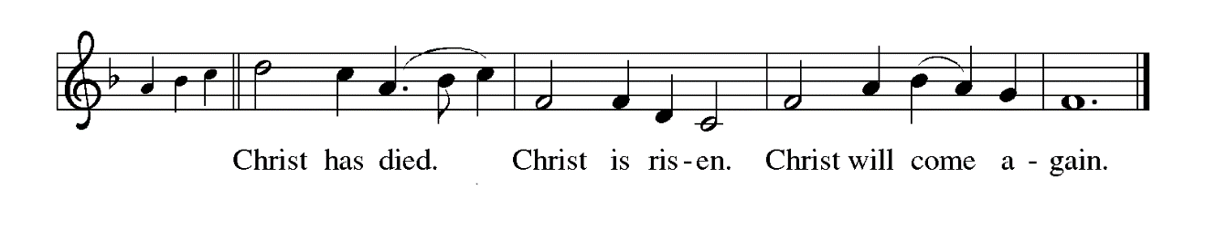
P: Generous God, You loved the world so much that You gave Your only Son; look now
upon the places where Your people are perishing, where they are being
condemned, where they are being born under the shadow of disease and
destruction and despair.
Infuse Your Church with Spirit and truth, walk with Your beloved ancestors of
Abraham and Sarah as they seek security, companionship, and freedom in
Your world,
And fill all Your saints with the hope of eternal life, that all may come to praise Your
name, and every grain of sand and star in the sky be stirred with the wonders
of Your grace,
Ever one God: Father Son, and Holy Spirit, now and forever.
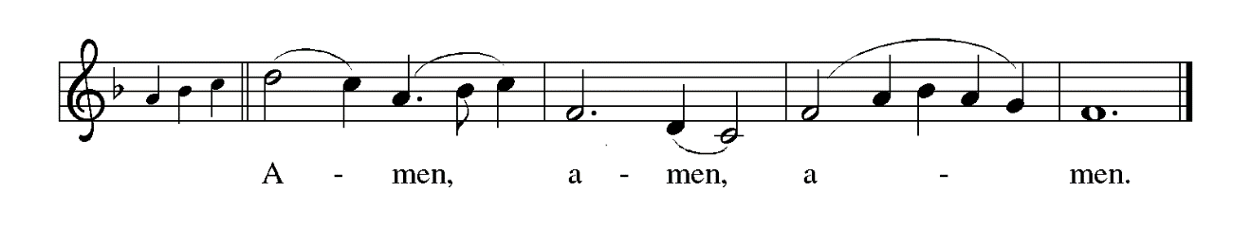

THE LORD’S PRAYER

P: While we were still sinners, Christ died for us, that, with confidence in God’s love for
us, we might dare to pray:

C: Our Father in heaven, hallowed be Your name.
Your Kingdom come, Your will be done on earth as in heaven.
Give us today our daily bread, and forgive us our sins, as we forgive
those who sin against us.
Save us from the time of trial, and deliver us from evil.
For the Kingdom, the power, and the glory are Yours, now and forever.
Amen.

INVITATION TO THE MEAL

P: Behold our Savior Christ Jesus, Who abolished death and brought life through the
Gospel. Blessed are those called to the Banquet of the Lamb. God’s holy gifts for
God’s holy people. Come, for all is now ready.

The assembly is seated

THE DISTRIBUTION Lamb of God
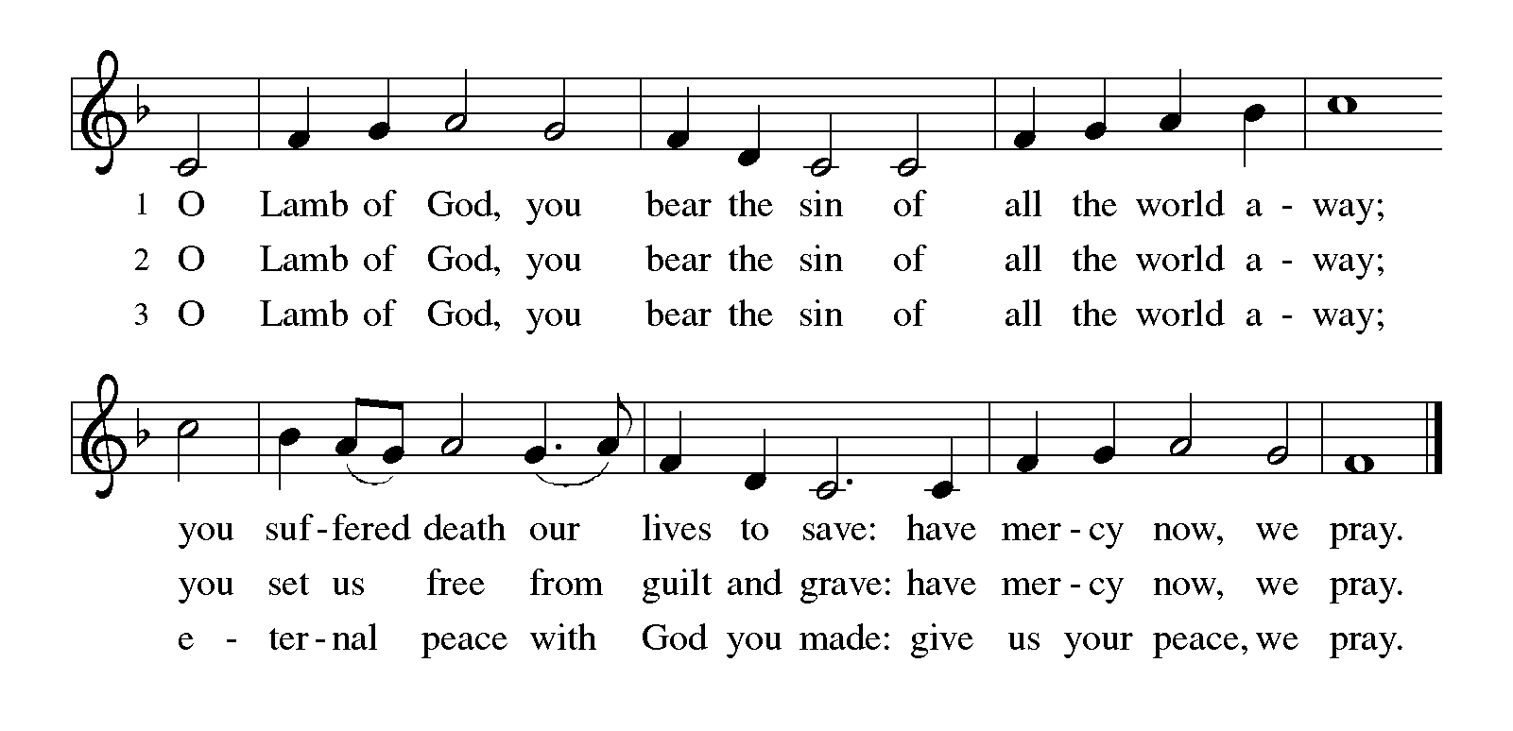
HYMN DURING DISTRIBUTION 323 God Loved the World

785 When Peace Like a River

793 Be Thou My Vision

NSB 88 There is A Redeemer
As you are able please rise

THE POST-COMMUNION BLESSING

P: The Body and Blood of our Lord Jesus Christ strengthen you and keep you in His grace.

C: Amen.

THE POST-COMMUNION PRAYER

A: Let us pray. Lord Jesus, in this Meal we have again seen You lifted up in all Your life-
giving glory. Grant us a share of Your eternal life now, that with hope and joy we may
journey with You both now and into the life to come. You are the Lord forevermore.

C: Amen.

SENDING

THE BENEDICTION

P: Jesus took the form of a servant and was obedient to death, even death on a cross. May
you follow His example and share in the resurrection.

C: Amen.

P: Almighty God: Father, Son and Holy Spirit bless you now and forever.

C: Amen.

SENDING HYMN 660 Lift High the Cross

THE DISMISSAL

A: Reconciled to God through Christ, let us go out into the world in peace.

C: Thanks be to God!

THE POSTLUDE
To God Alone Be Glory

The Meditation is from Words for Worship. Copyright 1999 Augsburg Fortress.

The Greeting, Prayers, Peace, Offertory, Post-Communion, and Dismissal are adapted
from Sundays and Seasons. Copyright 2001 Augsburg Fortress.

The Prayers, Introduction to the Lord’s Prayer, and Invitation to the Meal are adapted from
Prayers for Sundays and Seasons. Year A. Peter J. Scagnelli. (Chicago: Liturgy Training Publications, 1998) 32-33.

ANNOUNCEMENTS

Please remember to mail your offering to the Church Office at 818 Franklin Street, Michigan City, IN 46360. Another alternative is to give on-line through Tithe.ly. Please see your closure letter for information on how to set up a Tithe.ly account.

St. Paul Members are reminded to have a loved one contact the office if you are hospitalized. Many times, the Pastor doesn’t know someone is in the hospital. If you call and leave a message, please tell us at which hospital the patient is located.

BIRTHDAYS: Marshall Schnick (2/21); Ken Baker (3/4); and Gail Leffew (3/6)

PRAYER CONCERNS: John Bennitt; Debbie Martin; Mark Tannehill; Kathy Stein; Jan Paholski; Laura Dovey; Bill Hazelgrove; Al Levenhagen; Carl Wipperman; Major Payne; Elizabeth Saunders; and Tim Miller.

OFFICE HOURS: Libby will be in the office on Mondays, Wednesdays, and Fridays; volunteers will cover Tuesdays and Thursdays.

Monday & Wednesday 8:00 a.m. – 5 p.m.
Tuesday & Thursday 9:00 a.m. – 12:00 p.m.
Friday 8:00 a.m. – 12:00 p.m.

If you are listening to the worship broadcast on the radio and would like to watch the Sunday morning service live stream follow these steps:

(1) If you have You Tube available on your TV, search for
St. Paul Lutheran Church Michigan City, IN.

(2) The direct link on the computer is https://
www.youtube.com/channel/UC5AIPNaKr3QN50984jGOa1g

(3) This link is also on the main page of the church’s website in
the church section and will continue to be posted weekly on the St.
Paul Facebook page.

And it will always be available on the radio broadcast Sunday mornings at 11:00 a.m.
on WEFM (95.9), and on the local cable access station #99 for the previous week’s
service on Sundays at 4:00 p.m. and the current service on Wednesdays at 7:00 p.m.
and Fridays at 8:30 p.m.

To send e-mail to the church office, please use the following addresses:

Pastor Mark Reshan: seniorpastor@stpaulmichigancity.com

Church Office Secretary (Libby Pollock): churchsecretary@stpaulmichigancity.com

Church Treasurer (Karen Fleming): finance@stpaulmichigancity.com

2026 Church Council:

Pastor - Mark Reshan

President - Donna Knoll

Vice President - Jan Bakken

Secretary - Judy Hunt
Treasurer - Karen Fleming

Members: Sue Koziel; Jim Schraidt; Trish Sprague; Bob Kiser; Barry Anderson; and
Pam Soule

Worship Attendance:
Ash Wednesday, February 18, 2026 10:00 a.m. 36
7:00 p.m. 28
Saturday, February 21, 2026 @ 4:00 p.m. 31
Sunday, February 22, 2026 @ 9:00 a.m. 46
TOTAL 141

Copies of the minutes from the December 18, 2025 Church Council meeting are on the back table in the upper Narthex. It was approved by the council via email.

The Good News Newsletter: If you have an article or anything you want included in The Good News please send it to the following e-mail address: splcgoodnews@gmail.com. Pastor Pamela Thiede will be using this e-mail address to assemble The Good News each month. The deadline for getting information to Pastor Pamela will be the 20th of each month.

Next week’s lessons are Exodus 17: 1-7; Psalm 95; Romans 5: 1-11 and John 4: 5-42 for those of you who like to study them in advance.

SNOW EMERGENCY LIST

This is a reminder of where to turn to learn if worship has been canceled because of inclement weather conditions. There are two ways to learn about the status of the service.
First, you may turn to our church and school Facebook page: https://www.facebook.com/stpaulmichigancity/ for updated announcements. Or, perhaps most quickly and easily, you may call the church office number (219-874-7293) and press the “#” key and you will hear a recording about our “open/closed” status.

2026 Financial Stewardship

Weekly Church Operating Needs (x 2 weeks)
February 7-8, 2026 and February 14-15, 2026 $ 12,141.00

General Fund (including General Memorials): $ 16,975.00

Overage/Shortage: + $ 4,843.00

Restricted Income (not including Memorials)
Supports IK Synod & Church wide Ministries: $ 171.00

Ministries in our Community/Congregation: $ 75.00

Capital Fund: $ 307.00

Memorials
General Fund: $ 20.00

MISSION OF THE MONTH for MARCH 2026:

7th & 8th Grade STEAM Learning Opportunities

Daisy Lee is an extraordinary 7th and 8th grade environmental science teacher in our community. Every year, along with a few other extraordinary people, Daisy takes 30-40 girls to Indianapolis in January for the Sycamore STEAM Conference for Girls. This allows the girls to get hands on experience in various STEAM careers. They learn how everything functions in a real cadaver arm, how to do different types of stitches in a pig’s foot with Dermatologists, drill into arm bones and secure metal rods with Orthopedic Surgeons, create nutrition plans with Nutritionists, dissect cow hearts with Cardiologists, dissect sheep brains with Neurologists, code robots with IT specialists, and so much more!

Daisy also has a trip in May where she takes 70 students (at $110 each) on a 3 day, two night trip to the Dunes learning Center in Chesterton. Students will engage in hands on investigations of local ecosystems in this STEM and service – themed program. Participants learn and practice research procedures used by professional scientists such as quadrant surveys and chemical water monitoring to gather and analyze data and participate in stewardship activities within the park. Biodiversity, ecosystems, sustainability and human impacts on the environment are explored through real conservation and natural resource management experiences. Activities include: Ecosystem Hike where students embark on a hike to learn about various ecosystems and research tools that scientists use to collect data. They will have the opportunity to practice using different tools. This hike gives students the information they need to create a research question they will apply in the field. Field investigations: Trail Groups will work together to collect data on their research questions out in the field. They will collect, record, and analyze the data to determine their findings. Field investigations Presentations: Trail Groups will be able to share their findings with their classmates, just as a scientist would share their research!

To help Daisy make these trips possible, please make checks payable to St. Paul and mark for Daisy Lee and place in the offering. Noisy coin for the month of March will also go to support Daisy’s trips. Thank you for your generosity each month!

EASTER PLANTS 2026

A variety of spring plants will be available to order for decorating St. Paul Church on Easter Morning! The varieties available will be Lily, Daffodil, Hyacinth, Tulip, Hydrangea and 10 inch Fern in hanging basket. Color choices and cost of plants are as follows:

Lily(white) $10.00
Daffodil (yellow) $9.00
Hyacinth (purple or pink) $9.00
Tulip (white, yellow, pink, or red) $9.00
Hydrangea (pink or purple/blue) $15.00
10 inch Hanging Fern Basket $15.00

Please specify your choice of plant and color when applicable.
Orders MUST be placed by Wednesday morning, March 25th.

Your order may be placed “In memory of or in honor of a Loved One.” Please call the church office at (219) 874-7293 to place your order. Or you can place your order in an envelope and title it ‘Easter Plants’ for ordering and place it in the offering. Remember you must specify what type of plant and what color, if applicable. All checks should be made out to St. Paul Church.

Also, please plan on picking up your plant after the Easter Morning Service by 10:45 a.m.

ACTIVITIES, EVENTS & MEETINGS
MARCH 2026

Sunday, March 1, 2026 @ 9:00 a.m. 2 Lent Worship/Sanctuary with coffee after

Wednesday, March 4, 2026 @ 9:15 a.m. Bible Study/Luther House
@ 10:00 a.m. God’s Purls/St. Paul Room
@ 4:30 p.m. Choir Rehearsal/Sanctuary
@ 6:00 p.m. Mid-week Lenten Service/Sanctuary
Saturday, March 7, 2026 @ 4:00 p.m. 3 Lent Worship Service/Sanctuary

Sunday, March 8, 2026 @ 9:00 a.m. 3 Lent Worship/Sanctuary with coffee after
Tuesday, March 10, 2026 from 11 a.m. – 10 p.m. GIVE BACK @ Holly’s Restau- rant & Pub
Wednesday, March 11, 2026 @ 9:15 a.m. Bible Study/Luther House
@ 10:00 a.m. God’s Purls
@ 3:30 p.m. Worship & Music Mtg./Luther House
@ 4:30 p.m. Choir Rehearsal/Sanctuary
@6:00 p.m. Mid-week Lenten Service/Sanctuary
Saturday, March 14, 2026 NO WORSHIP SERVICE @ 4 p.m. TODAY

Sunday, March 15, 2026 @ 9:00 a.m. 4 Lent Worship/Sanctuary: celebrating
150 YEARS OF ST. PAUL LUTHERAN CHURCH with Banquet to follow
Wednesday, March 18, 2026 @ 9:15 a.m. Bible Study/Luther House
@ 10:00 a.m. God’s Purls/St. Paul Room
@ 4:30 p.m. Choir Rehearsal/Sanctuary
@6:00 p.m. Mid-week Lenten Service/Sanctuary
Saturday, March 21, 2026 @ 4:00 p.m. 5 Lent Worship Service/Sanctuary

Sunday, March 22, 2026 @ 9:00 a.m. 5 Lent Worship with Baptism/Sanctuary with coffee after
Wednesday, March 25, 2026 @ 9:15 a.m. Bible Study/Luther House
@10:00 a.m. God’s Purls/St. Paul Room
@4:30 p.m. Choir Rehearsal/Sanctuary
@6:00 p.m. Mid-week Lenten Service/ Sanctuary
Saturday, March 28, 2026 @ 4:00 p.m. PASSION/PALM Saturday Worship/ Sanctuary

Thank$ for $haring
Thank you to all who participate in our Give-Back opportunities each month where we earn $$ to add to our Mission of the Month donations from our congregation to those in our community who need our help!
On Tuesday, March 10, 2026 we’re meeting at Holly’s Restaurant And Pubfor our GIVE BACK from 11am—close. Here are two coupons—one for you and one for a friend.

