THE TRANSFIGURATION OF OUR LORD
The Last Sunday After the Epiphany
February 15, 2026

“When You were transfigured before Your crucifixion, O Lord, the mount resembled heaven, and a cloud spread out like a canopy, and the Father bore witness to You. And there were present Peter, James, and John, since they were to be with You at Your betrayal; so that seeing Your wonders they might not be dismayed at Your sufferings.
Make us, therefore, to worship the same in peace for Your great mercy.”

Cozma the Anchorite

The disciples upon the mountain behold two suns: one, to which they were accustomed, shining in the sky; and another, to which they were unaccustomed, shining down on them and from the firmament giving light to the whole world, and which then shone for them alone, which was the face of Jesus before them.
His face shone, not like the face of Moses, from without; from his face the glory of his divinity poured forth, yet remained with him. From himself came his own light. Moses and Elijah were filled with joy, and the apostles likewise, in their ascent of the mountain.
The prophets rejoiced because they had seen Jesus’ humanity, which they had not known. And the apostles rejoiced because they had seen the glory of his divinity, which they had not known.

Ephraem
Fourth century

In the Name of Jesus

INTRODUCTION

Today's festival is a bridge between the Advent-Christmas-Epiphany cycle that comes to a close today and the Lent-Easter cycle that begins in several days. On the mount of transfiguration Jesus is revealed as God's beloved Son, echoing the words at his baptism. This vision of glory sustains us as Jesus faces his impending death in Jerusalem.
We turn this week to Ash Wednesday and our yearly baptismal journey from Lent to Easter. Some churches put aside the alleluia at the conclusion of today's liturgy. This word of joy will be omitted during the penitential season of Lent and will be sung again at Easter.

Martin Luther, renewer of the church, died 1546

Though he began his adult church life as a simple Augustinian monk, Luther challenged the abuses he saw in the church, and his work eventually led to the Protestant Reformation. Luther's accomplishments included liturgical reform, translation of the Bible, and creation of the Small and Large Catechisms.

GATHERING

PRE-SERVICE MUSIC Mountain of the Lord New Song Praise Band
(Andy Parks)

ANNOUNCEMENTS

As you are able, please rise

THE GATHERING SONG (see p. 3) Come to the Mountain

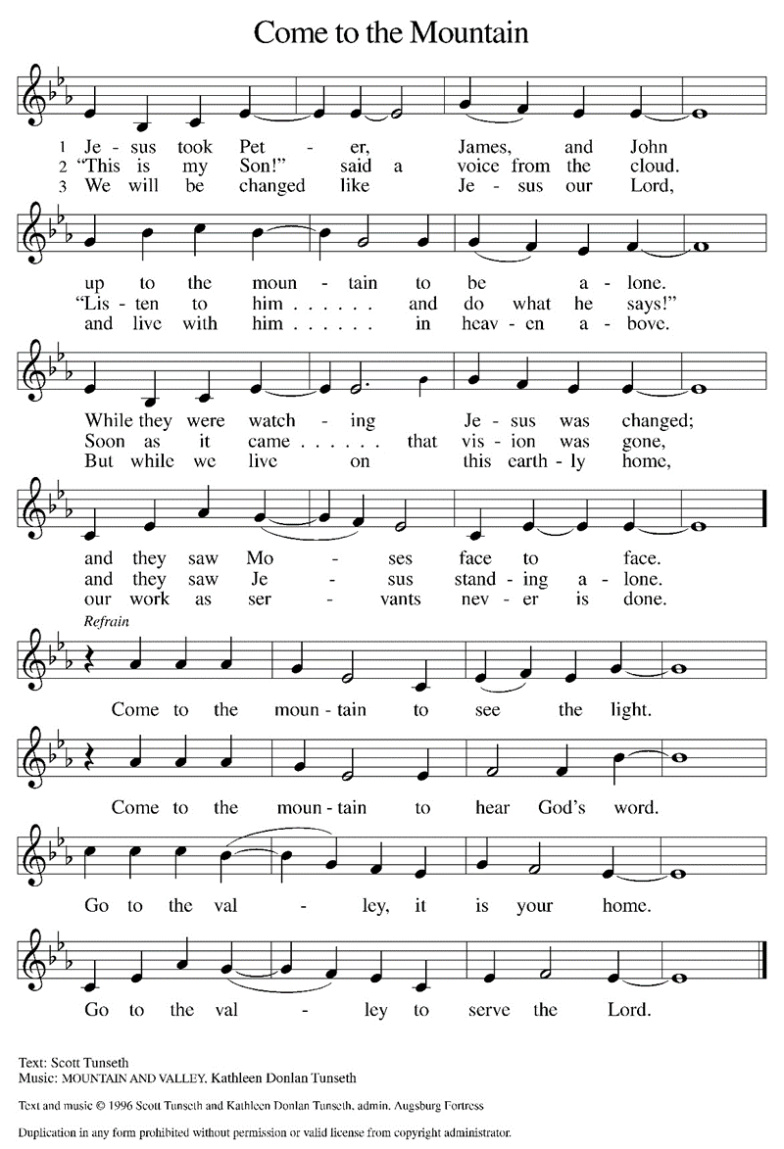

THE GREETING AND PRAYER OF THE DAY

P: To the Church of God in this place, to those who are called to be saints, to all those who
call upon the name of our Lord Jesus Christ:

The grace of our Lord Jesus Christ, the love of God, and the communion of the Holy
Spirit be with you all.

C: And also with you.

P: Let us pray. O God, in the transfiguration of Your Son You confirmed the mysteries of
the faith by the witness of Moses and Elijah, and in the voice from the bright cloud
declaring Jesus Your beloved Son You foreshadowed our adoption as Your children.
Make us heirs with Christ of Your glory, and bring us to enjoy its fullness, through
Jesus Christ, our Savior and Lord, Who lives and reigns with You and the Holy Spirit,
one God, now and forever.

C: Amen.

The assembly is seated

WORD

FIRST READING Exodus 24: 12-18

In the Bible, mountains often serve as places of revelation. Moses' six-day wait on the mountain covered by the cloud is a way of telling the reader that something important is about to be revealed: God's law. Similarly the experience of Jesus, Peter, James, and John on a mountain reveals something important: God's Son.

The LORD said to Moses, "Come up to Me on the mountain, and wait there; and I
will give you the tablets of stone, with the law and the commandment, which
I have written for their instruction."
¹³So Moses set out with his assistant Joshua, and Moses went up into the mountain of
God.
¹⁴To the elders he had said, "Wait here for us, until we come to you again; for Aaron and
Hur are with you; whoever has a dispute may go to them."
¹⁵Then Moses went up on the mountain, and the cloud covered the mountain.
¹⁶The glory of the LORD settled on Mount Sinai, and the cloud covered it for six days;
on the seventh day He called to Moses out of the cloud.
¹⁷Now the appearance of the glory of the LORD was like a devouring fire on the top
of the mountain in the sight of the people of Israel.
¹⁸Moses entered the cloud, and went up on the mountain. Moses was on the mountain
for forty days and forty nights.

The Word of the Lord.

Thanks be to God.

THE PSALM: Psalm 2 Antiphon by Robert Wetzler
Choir sings refrain first, followed immediately by the congregation
and as indicated
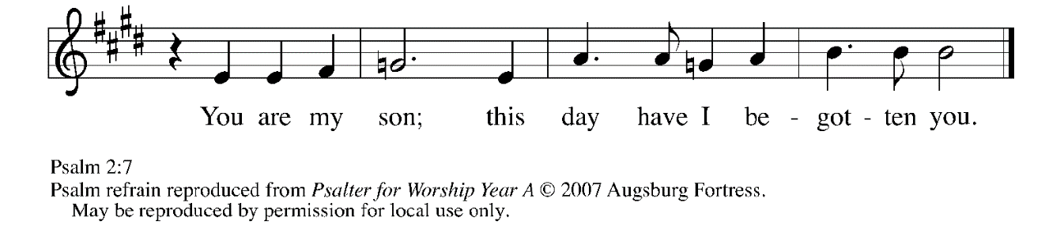
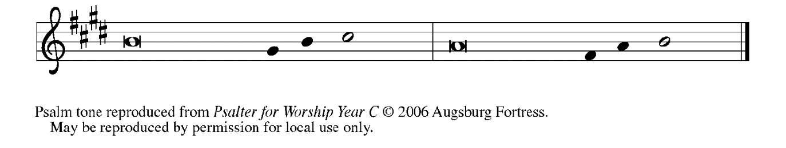

¹Why are the nations | in an uproar?
Why do the peoples mutter | empty threats?

²Why do the kings of the earth rise up in revolt,
and the princes | plot together,
against the LORD and against the | LORD's anointed?

³"Let us break their | yoke," they say;
"let us cast off their | bonds from us."

⁴God whose throne is in heav- | en is laughing;
the LORD holds them | in derision. REFRAIN

⁵Then in wrath God | speaks to them,
and in rage fills | them with terror.

⁶"As for Me, I have anoint- | ed My king
upon Zion, My | holy mountain."

⁷Let me announce the decree | of the LORD,
Who said to me, "You are my son; this day have I be- | gotten you.

⁸Ask of Me, and I will give you the nations for | your inheritance
and the ends of the earth for | your possession. REFRAIN

⁹You shall crush them with an | iron rod
and shatter them like a | piece of pottery."

¹⁰And now, you | kings, be wise;
be warned, you rulers | of the earth.

¹¹Submit to the | LORD with fear,
and with trembling | bow in worship;
¹²lest the LORD be angry, and you perish in a sudden | blaze of wrath.
Happy are all who take ref- | uge in God! REFRAIN

SECOND READING 2 Peter 1: 16-21

At the transfiguration of Jesus, Peter heard the voice of God speak from heaven. This same voice speaks to us from the holy word.

We did not follow cleverly devised myths when we made known to you the power
and coming of our Lord Jesus Christ, but we had been eyewitnesses of His
majesty.
¹⁷For He received honor and glory from God the Father when that voice was conveyed to
Him by the Majestic Glory, saying, "This is My Son, My Beloved, with Whom I
am well pleased."
¹⁸We ourselves heard this voice come from heaven, while we were with Him on the
holy mountain.
¹⁹So we have the prophetic message more fully confirmed. You will do well to be
attentive to this as to a lamp shining in a dark place, until the day dawns and
the morning star rises in your hearts.
²⁰First of all you must understand this, that no prophecy of scripture is a matter of
one's own interpretation,
²¹because no prophecy ever came by human will, but men and women moved by the
Holy Spirit spoke from God.

The Word of the Lord.

Thanks be to God.

As you are able please rise

THE VERSE

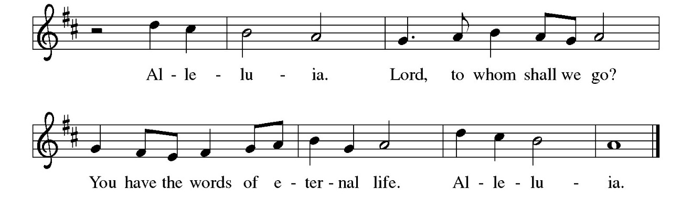

THE HOLY GOSPEL Matthew 17: 1-9

Shortly before he enters Jerusalem, where he will be crucified, Jesus is revealed to his disciples in a mountaintop experience of divine glory called the transfiguration.

P: The Holy Gospel according to St. Matthew, the seventeenth chapter.

C: Glory to You, O Lord!

Jesus took with Him Peter and James and his brother John and led them up a high
mountain, by themselves.
²And He was transfigured before them, and His face shone like the sun, and His
clothes became dazzling white.
³Suddenly there appeared to them Moses and Elijah, talking with Him.
⁴Then Peter said to Jesus, "Lord, it is good for us to be here; if You wish, I will make three
dwellings here, one for You, one for Moses, and one for Elijah."
⁵While he was still speaking, suddenly a bright cloud overshadowed them, and from the
cloud a voice said, “This is My Son, the Beloved; with Him I am well pleased;
listen to Him!”
⁶When the disciples heard this, they fell to the ground and were overcome by fear.
⁷But Jesus came and touched them, saying, "Get up and do not be afraid."
⁸And when they looked up, they saw no one except Jesus Himself alone.
⁹As they were coming down the mountain, Jesus ordered them, "Tell no one about
the vision until after the Son of Man has been raised from the dead."

P: The Gospel of the Lord.

C: Praise to You, O Christ!

The assembly is seated

THE SERMON

Silence for reflection follows the sermon

As you are able please rise

THE HYMN OF THE DAY Dazzling Presence on the Mountain
(Sung to the tune of, Joyful, Joyful, We Adore Thee)

1 Dazzling presence on the mountain:
human eye had never seen
such a wonder, such resplendence,
heav'n and earth in cloud convene.
"This is My Son, the Beloved,"
thund'rous voice from cloud exclaimed.
Word made flesh to heal creation,
to disciples God proclaimed.

2 From this mount of mystic splendor
to the cross Christ presses on;
here no Moses nor Elijah,
only thieves Christ's wings adorn.
"Lord, have mercy, Christ, have mercy,"
was one's penitential sigh.
With transfiguring assurance,
Christ rejoins his fervent cry.
3 From the heights of new creation,
Christ beholds His world, redeemed;
as with Peter and companions,
brings us now to sights unseen.
Justice, mercy, and compassion:
these the booths He bids us build,
that the earth He loves may flourish
as each life with grace is filled.

4 Let our praise ring from each mountain,
into deepest valleys pour,
where, with lives of grateful service,
we adore Christ evermore.
To the Son, God's own Beloved,
and the Spirit endlessly,
may the church's praise be lifted
to the blessed Trinity.

Text: Paul E. Hoffman, b. 1956
Text © 2015 Augsburg Fortress

Duplication in any form prohibited without securing permission from copyright administrator or reporting usage under valid license.

THE NICENE CREED

A: God has made us His people through our Baptism into Christ. Living together in trust
and hope, we confess our faith.

We believe in one God,
the Father, the Almighty,
maker of heaven and earth,
of all that is, seen and unseen.

We believe in one Lord, Jesus Christ,
the only Son of God,
eternally begotten of the Father,
God from God, Light from Light,
true God from true God,
begotten, not made,
of one Being with the Father.
Through Him all things were made.
For us and for our salvation
He came down from heaven;
by the power of the Holy Spirit
He became incarnate from the virgin Mary, and was made
man.
For our sake He was crucified under Pontius Pilate;
He suffered death and was buried.
On the third day He rose again
in accordance with the Scriptures;
He ascended into heaven
and is seated at the right hand of the Father.
He will come again in glory to judge the living and the dead,
and His kingdom will have no end.

We believe in the Holy Spirit, the Lord, the giver of life,
Who proceeds from the Father and the Son.
With the Father and the Son He is worshiped and glorified.
He has spoken through the prophets.
We believe in one holy catholic and apostolic Church.
We acknowledge one Baptism for the forgiveness of sins.
We look for the resurrection of the dead,
and the life of the world to come. Amen

THE PRAYER OF THE CHURCH

A: As God’s beloved children, let us pray that the light of Christ shine on the nations, the
Church, and on all those in need.

A: That the Church might proclaim the Gospel of Christ in such creative and transforming
ways that the world will “listen” with joy and hope, we pray:

C: Send forth Your light, O God.

A: That the rulers of the earth might submit to the Lord and His way of justice and peace,
we pray:

C: Send forth Your light, O God.

A: That by Your Word and holy Meal this assembly might be transfigured into the dazzling
and compassionate presence of Christ to this neighborhood and community this week,
we pray:

C: Send forth Your light, O God.

A: That the suffering and sick, especially: Grace and Roy Romine; Major Payne;
Martha Schroeder; Fred Weiss; David Weiss; Joyce Stark; Jackie Gaines; Carl
Wipperman; Shirley Shikany Long; John Bennitt; Catherine Lanigan; and
Robert Bernth, might be touched by the Lord’s healing, we pray:

C: Send forth Your light, O God.

A: That those celebrating anniversaries, especially Tim and Laura Mellen; Donna and
Mike Knoll; and Chuck and Sherry Payne might grow in grace this day and be filled
with grace for the days ahead, we pray:

C: Send forth Your light, O God.

A: That with all the saints who have listened to Christ, especially Martin Luther, renewer
of the Church whom we commemorate this Day we too may one Day see the fullness
of His glory, we pray:

C: Send forth Your light, O God.

P: Receive our prayers and hopes, God of mercy and justice, for we pray in the name of
Christ, the light of the world.

C: Amen.

MEAL

THE PEACE

P: The peace of the Lord be with you always.

C: And also with you.

The assembly is seated

THE OFFERING

THE VOLUNTARY What Is This Light? St. Paul Senior Choir (L. Shackley)

As you are able please rise

THE PRESENTATION OF GIFTS Jesus, Come! For We Invite You
(stanzas 1, 4)

(Sung to the tune of, Angels From the Realms of Glory)

Jesus, come! for we invite You,
Guest and Master, Friend and Lord;
now, as once at Cana's wedding,
speak and let us hear Your word:
lead us through our need or doubting,
hope be born and joy restored.

Jesus, come! surprise our dullness,
make us willing to receive
more than we can yet imagine,
all the best You have to give:
let us find Your hidden riches,
taste Your love, believe, and live!

THE OFFERTORY PRAYER

A: Let us pray. Holy God,

C: By the Transfiguration of Your Son You revealed Your glory and His holiness.
Make these gifts we offer holy for Your service, and by this Holy Sacrament,
strengthen us to shine more fully with Your Light, Jesus Christ our Lord. Amen.

THE GREAT THANKSGIVING
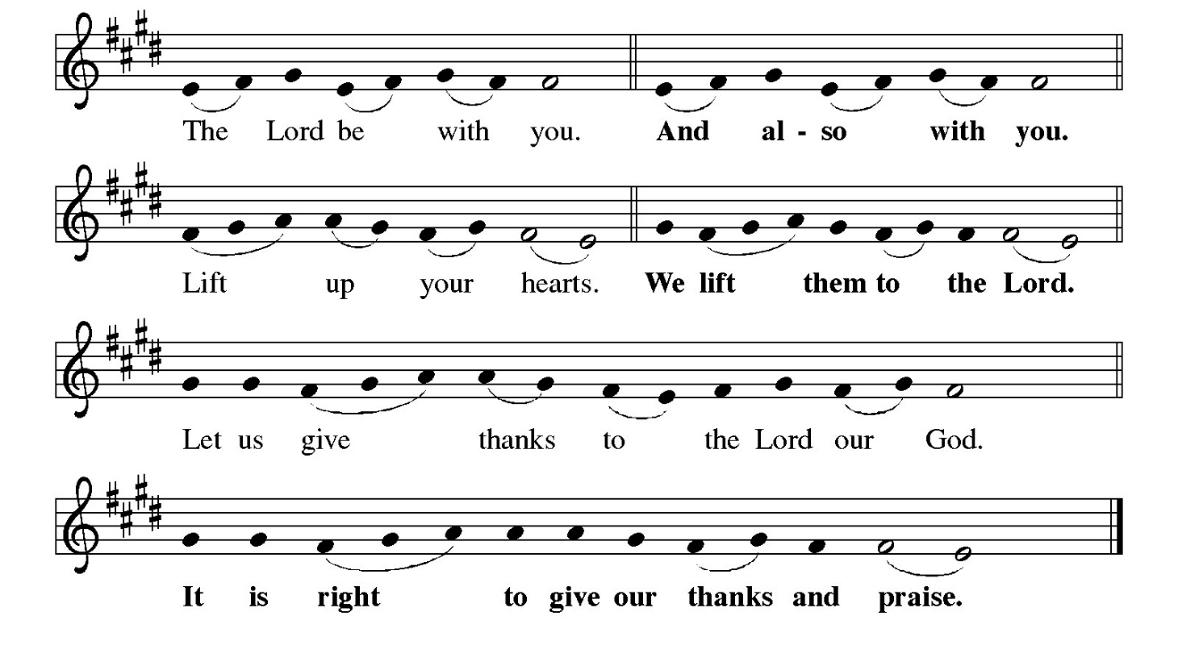P: It is indeed right and salutary …and join their unending hymn:
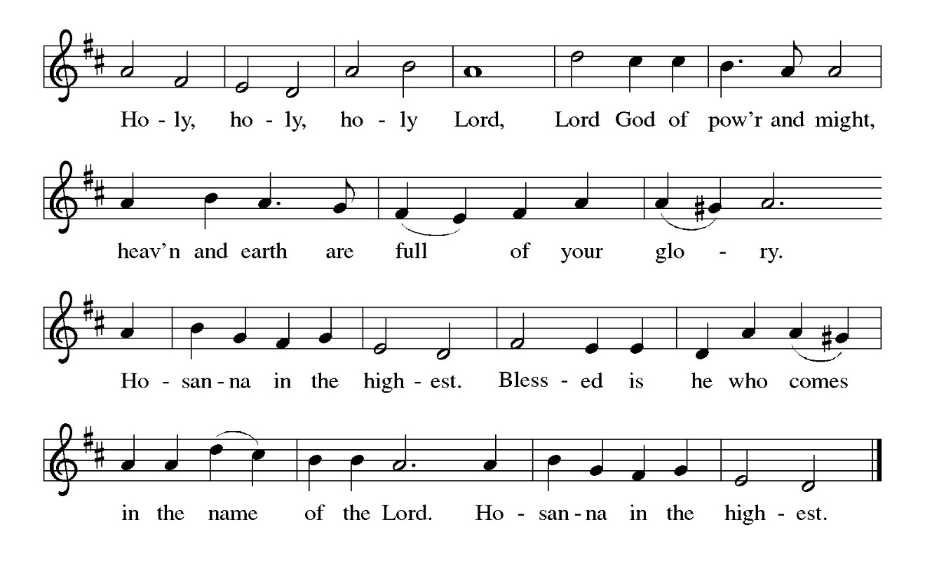
P: Creating and liberating God, You called Your people into covenant with You and
sealed Your trust with Moses on the mountain.
You called Your people back to that covenant through Your prophets and spoke in
a still small voice to Elijah on a mountain.
Then, in Your Son Jesus, on a mountain You stood between the Law and the
Prophets and revealed the radiance of Your Gospel.
On Calvary’s hill Your Son redeemed us by the blood of Your new covenant,
and on the mountain in the Galilee He ascended to Your right hand on
high.
Dazzling God, You set up Your tent and make Your dwelling among us.
Abide with us now through the power of Your Holy Spirit, that Your people may
become a temple of Your presence, and these gifts of bread and wine
may be for us the Body and Blood of Your Son Jesus Christ,
Who, in the night ... “Do this for the remembrance of Me.”
As often as we eat ... we proclaim the Lord’s death until He comes.

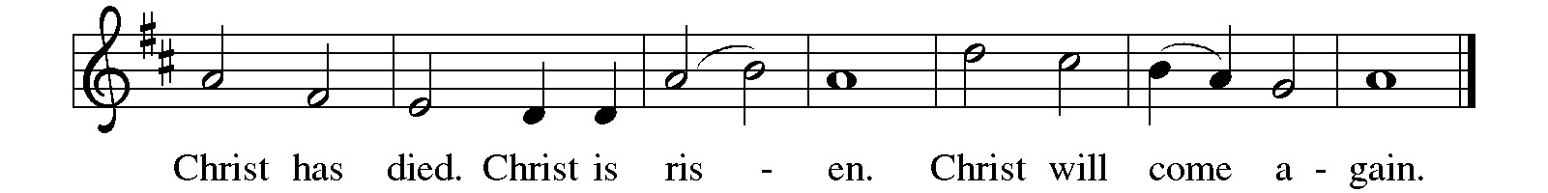

P: Transfiguring God, it is good for us to be here.
Through this holy sacrament make us Your daughters and sons, and be close to
all children who have no one to share Your love and mercy with them.
Make us Your beloved, and visit all who have no one to call them beloved.
Give us grace to listen to Your voice, and bring to Your heart any who have
no one to listen to them.
Surround us with Your prophetic company and take us up into the whirlwind of
Your glory, until the Day comes when the waters of the Jordan are parted
and the heavens are opened and the chariots bring us home to You,
Ever one God: Father, Son, and Holy Spirit.

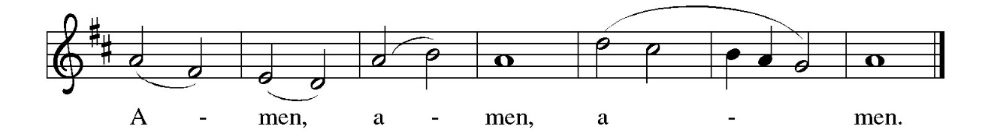

THE LORD’S PRAYER

P: Because in Christ we have received the Spirit of adoption, as daughters and sons of
God, we dare to pray:

C: Our Father in heaven, hallowed be Your name. Your Kingdom come. Your will
be done on earth as in heaven. Give us this day our daily bread, and forgive us
our sins as we forgive those who sin against us. Save us from the time of trial
and deliver us from evil, for the Kingdom, the power, and the glory are Yours,
now and forever. Amen.

INVITATION TO THE MEAL
P: Behold the true Light of the world, the Beloved of God, anointed by the Spirit. Blessed
are those who are called to the Supper of the Lamb. God’s holy gifts for God’s holy
people. Come, for all is now ready.

The assembly is seated

THE DISTRIBUTION Lamb of God

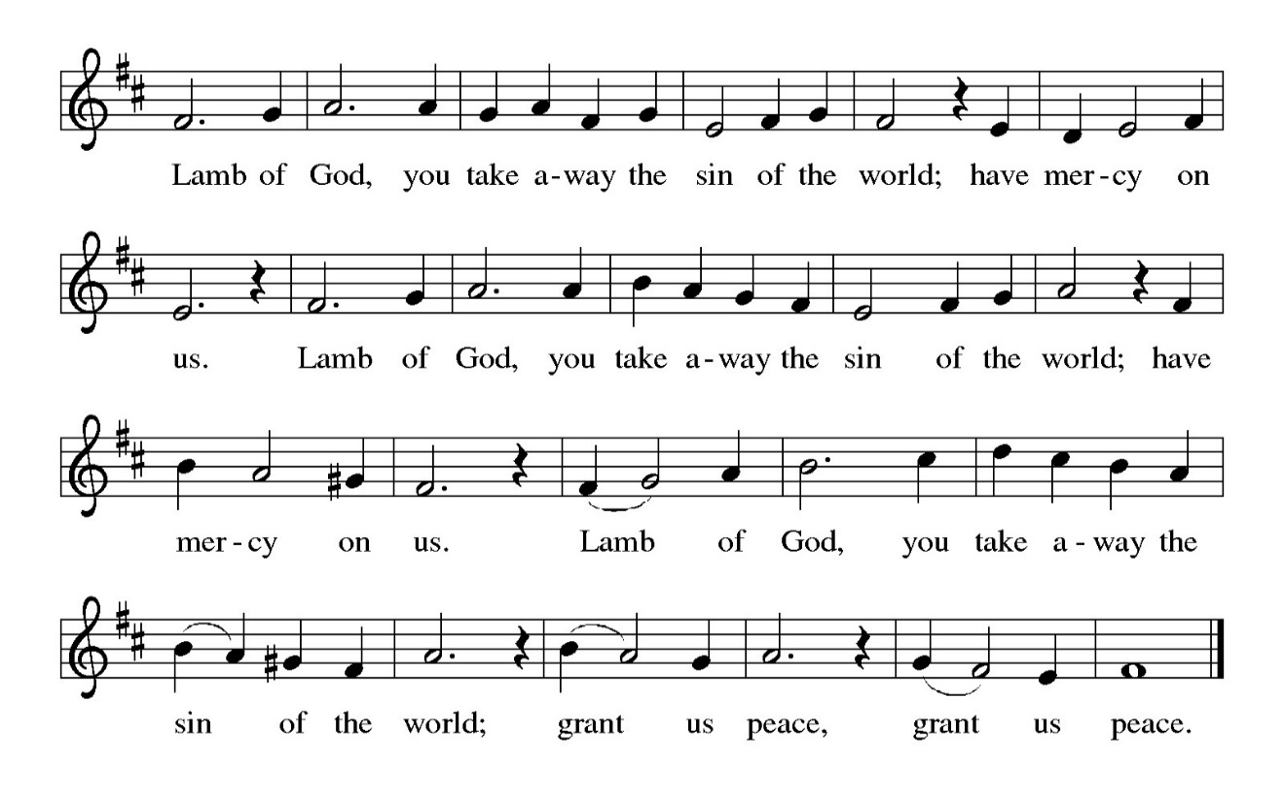

HYMN DURING DISTRIBUTION 838 Beautiful Savior
NSB 48 I Am the Bread of Life
NSB 23 Come and See
ELW 483 Here is Bread
ELW 482 I Come with Joy

As you are able please rise

THE POST-COMMUNION BLESSING

P: The Body and Blood of our Lord Jesus Christ strengthen you and keep you in His grace.

C: Amen.

THE POST-COMMUNION PRAYER

A: Let us pray. Heavenly Father, You revealed the true radiance of Your Son in the glory
of His Transfiguration. Give us the grace and vision to behold Him in this Food from
heaven, and by our eating and drinking, transform us daily to ever more live as Your
faithful and beloved daughters and sons. Grant this through Christ our Lord.

C: Amen.

SENDING

THE BENEDICTION

P: Almighty God: Father, Son, and Holy Spirit bless you now and forever.

C: Amen.

THE RECESSIONAL HYMN 318 Alleluia, Song of Gladness

The congregation faces the cross as it leaves

THE DISMISSAL

A: You are servants of God; you are light to the nations.
Go in peace. Serve the Lord.

C: Thanks be to God!

POSTLUDE

To God Alone Be Glory

The Meditations are from New Proclamation. Year A. Marshall D. Johnson, ed.
(Minneapolis: Augsburg Fortress, 2001) 147; and Sundays and Seasons Online. Copyright 2020 Augsburg Fortress.

The Prayers, Introduction to the Lord’s Prayer, and Invitation to the Meal are adapted from
Prayers for Sundays and Seasons. Year A. Peter J. Scagnelli. (Chicago: Liturgy Training Publications, 1998) 146-147.

The Post-Communion Prayer is also adapted from The Book of Alternative Services.
(Toronto: Anglican Book Centre, 1985) 231.



HAPPY BIRTHDAY/HAPPY MARDI GRAS!

Did you observe a birthday during December 2025, January 2026, or February 2026? If so, come join us during the Coffee Hour on today, February 15th. We will be celebrating all the people who turned 1 year older during that time. All you need to do is come down to the St. Paul Room after the 9:00 a.m. service and we’ll celebrate your
Birthday with Mardi Gras/Shrove Tuesday and home-made King Cake!

Thank You!

Thank you for your generous support of Meals on Wheels for our January Monthly Mission! We donated $1,091 which MOW will use for insulated bags and other needs so they can continue to feed the people in our community! Again, thank you for your giving hearts!

ANNOUNCEMENTS

Please remember to mail your offering to the Church Office at 818 Franklin Street, Michigan City, IN 46360. Another alternative is to give on-line through Tithe.ly. Please see your closure letter for information on how to set up a Tithe.ly account.

St. Paul Members are reminded to have a loved one contact the office if you are hospitalized. Many times, the Pastor doesn’t know someone is in the hospital. If you call and leave a message, please tell us at which hospital the patient is located.

ANNIVERSARIES: Tim & Laura Mellen (2/20); Chuck &Sherry Payne (2/21);
and Mike & Donna Knoll (2/21)

PRAYER CONCERNS: Robert Bernth; John Bennitt; Sarah McNabb; Debbie Martin; Mark Tannehill; Kathy Stein; Jan Paholski; Laura Dovey; Grace Romine; Bill Hazelgrove; Al Levenhagen; Carl Wipperman; Major Payne; Carol Hazelgrove; Allen Sydow; Elizabeth Sanders; Roy Romine and Tim Miller.

OFFICE HOURS: Libby will be in the office on Mondays, Wednesdays, and Fridays; volunteers will cover Tuesdays and Thursdays.

Monday & Wednesday 8:00 a.m. – 5 p.m.
Tuesday & Thursday 9:00 a.m. – 12:00 p.m.
Friday 8:00 a.m. – 12:00 p.m.

If you are listening to the worship broadcast on the radio and would like to watch the Sunday morning service live stream follow these steps:

(1) If you have You Tube available on your TV, search for
St. Paul Lutheran Church Michigan City, IN.

(2) The direct link on the computer is https://
www.youtube.com/channel/UC5AIPNaKr3QN50984jGOa1g

(3) This link is also on the main page of the church’s website in
the church section and will continue to be posted weekly on the St.
Paul Facebook page.

And it will always be available on the radio broadcast Sunday mornings at 11:00 a.m.
on WEFM (95.9), and on the local cable access station #99 for the previous week’s
service on Sundays at 4:00 p.m. and the current service on Wednesdays at 7:00 p.m.
and Fridays at 8:30 p.m.

To send e-mail to the church office, please use the following addresses:
Pastor Mark Reshan: seniorpastor@stpaulmichigancity.com
Church Office Secretary (Libby Pollock): churchsecretary@stpaulmichigancity.com
Church Treasurer (Karen Fleming): finance@stpaulmichigancity.com

2026 Church Council:
Pastor - Mark Reshan
President - Donna Knoll
Vice President - Jan Bakken
Secretary - Judy Hunt
Treasurer - Karen Fleming

Members: Sue Koziel; Jim Schraidt; Trish Sprague; Bob Kiser; Barry Anderson; and
Pam Soule

Worship Attendance:
Saturday, February7, 2026 @ 4:00 p.m. 23
Sunday, February 8, 2026 @ 9:00 a.m. 50
TOTAL 73

Copies of the minutes from the December 18, 2025 and the January 22, 2026 Church Council meetings are on the back table in the upper Narthex. They were approved by the council via email.

The Good News Newsletter: If you have an article or anything you want included in The Good News please send it to the following e-mail address: splcgoodnews@gmail.com. Pastor Pamela Thiede will be using this e-mail address to assemble The Good News each month. The deadline for getting information to Pastor Pamela will be the 20th of each month.

Next week’s lessons are Genesis 2: 15-17; 3: 1-7; Psalm 32; Romans 5: 12-19; and Matthew 4: 1-11 for those of you who like to study them in advance.

FEBRUARY 2026 MISSION OF THE MONTH is the Makerspace at the Michigan City Public Library.
The Makerspace is a place where young people can tinker, design, craft, create and explore. It includes a variety of equipment and projects for guided exploration and hands-on learning in the STEAM areas (science, technology, engineering, arts, and math). Some of the items currently available are art supplies (markers, crayons, colored pencils, glue sticks), etch-a-sketch, rubiks cube, building toys, and 3D printers. Lots of youth visit makerspace and many of the art supplies could use a refill. We will be collecting art supplies, or other STEAM supplies. Please place your supplies in the bin in the outer narthex. If you wish to make a monetary donation, please make checks out to the church marked for the makerspace and place in the offering plate. Thank you for your generous donations to our community!

SNOW EMERGENCY LIST
This is a reminder of where to turn to learn if worship has been canceled because of inclement weather conditions. There are two ways to learn about the status of the service.
First, you may turn to our church and school Facebook page: https://www.facebook.com/stpaulmichigancity/ for updated announcements. Or, perhaps most quickly and easily, you may call the church office number (219-874-7293) and press the “#” key and you will hear a recording about our “open/closed” status.

ACTIVITIES, EVENTS & MEETINGS
FEBRUARY 2026

Wednesday. February 11, 2026 @ 9:15 a.m. Bible Study/Luther House

@10:00 a.m. God’s Purls/St. Paul Room

@ 3:30 p.m. Worship & Music Mtg./Luther House

@ 4:30 p.m. Choir Rehearsal/Sanctuary

Saturday, February 14, 2026 @ 4:00 p.m. Transfiguration of Our Lord Worship

Sunday, February 15, 2026 @ 9:00 a.m. Transfiguration of Our Lord Worship/ Sanctuary with Coffee after

Wednesday, February 18, 2026 @ 10:00 a.m. Ash Wednesday Worship Service

@ 7:00 p.m. Ash Wednesday Worship Service

Saturday, February 21, 2026 @ 4:00 p.m. 1st Lent Worship Service/Sanctuary

Sunday, February 22, 2026 @ 9:00 a.m. 1st Lent Worship Service/Sanctuary with Coffee after
Monday, February 23, 2026 @ 2:00 p.m. Finance Comm. Mtg./Luther House

@ 3:00 p.m. Executive Board Meeting/ Luther House

Tuesday, February 24, 2026 @ 4:00 p.m. 150th Anniv. Comm. Mtg./Luther House

Wednesday, February 25, 2026 @ 9:15 a.m. Bible Study/Luther House

@ 10:00 a.m. God’s Purls/St. Paul Room

@ 6:00 p.m. midweek Lenten Service/Sanctuary

Thursday, February 26, 2026 @ 3:00 p.m. Church Council Meeting/St. Paul Room

Saturday, February 28, 2026 @ 4:00 p.m. 2nd Lent Worship Service/Sanctuary

