THE FOURTH SUNDAY OF EASTER
April 26, 2026

“The description given in Acts 2: 42-47 suggests what the Holy Spirit can do. These verses do not lay down rules or specific structures for Christian living. In their context they indicate that the reign of the resurrected Lord Jesus Christ creates the potential for mutual service that embodies God's justice. The life and work of a Christian community can reflect--even if only dimly--the reign of God that Jesus proclaimed while on earth and secured through his death, resurrection, and exaltation. ..”

“ …Certainly, then, this passage paints an idealistic portrait, proposing to ancient readers that Christian community offers the path to such a desirable vision of human existence. But just because an assertion might be idealized or hyperbolic does not mean that it can be easily dismissed. Acts anchors humanity's deepest hopes for community, justice, generosity, and meaning specifically as a result of people coming to embrace the crucified, risen, and glorified Christ as God's designated agent, as the particular means by which God institutes and exercises God's reign within creation.

Do not assume that this passage celebrates community or the church for its own sake. The community of faith exists as an extension of the ascended Lord Jesus' commitment to bring salvation to the world.”

Matt Skinner

And this is what Easter is all about, isn’t it? Not just an empty tomb, but a presence, a person, a voice calling each of us by name.

Edward Steimle

So if sometimes you have trouble hearing the voice of your shepherd, be patient with yourself--because some days it sounds like a whistle and some days like a cluck; some days it sounds like a love song and some days like a curse. It is not a voice that always speaks in words, much less complete sentences, but it can usually be heard sometime between your getting up and your lying down each day, leading you beside the still waters, restoring your soul.

Barbara Brown Taylor

In the Name of Jesus

INTRODUCTION

Today is sometimes called "Good Shepherd Sunday." Jesus is called the "gate" of the sheep in today's gospel. The risen Christ opens the way to abundant life. He anoints our heads with oil and guides us beside the still waters of our baptism. Each Sunday he spreads a feast before us in the midst of the world's violence and war. We go forth to be signs of the resurrection and extend God's tender care to all creation.

Catherine of Siena, theologian, died 1380

This theologian was the first woman among Roman Catholics to receive the title "Doctor [teacher] of the Church." Catherine was a Dominican sister known for her mystical visions as well as her work on behalf of people who were poor and imprisoned.

GATHERING

PRELUDE

THE EASTER ACCLAMATION

P: Christ is risen! Alleluia!

C: He is risen indeed! Alleluia!

ANNOUNCEMENTS

As you are able please rise

CONFESSION AND ABSOLUTION

P: In the name of the Father and of the Son and of the Holy Spirit.

C: Amen.

P: “(Jesus) Himself bore our sins on His body on the cross, so that, free from sins, we
might live for righteousness; by His wounds you have been healed. For you were going
astray like sheep, but now you have returned to the shepherd and guardian of your
souls.” (1 Peter 2: 24-25) Let us confess the ways in which we have “gone astray,” that
we too may be returned to God’s abundant mercy and life and life rightly toward God
and others.

Silence for self-examination and reflection is kept

P: Most merciful God,

C: We confess to You that we are in bondage to sin and cannot free ourselves. We
have wandered far from You. We have not devoted ourselves to fellowship and
prayer. (Acts 2: 42) We have not followed in the footsteps of Christ. We have
listened to other voices than Yours. (John 10: 5) When hurt, we have returned
the hurt in anger. (1 Peter 2: 23) We have not been patient in suffering. (2: 19)
Forgive us, O Shepherd of our souls. Heal us of our wounds. Gather us again into
Your loving arms, then send us with Your Spirit to rescue others who have
strayed, for their life and Your glory.

P: Jesus said, “The shepherd of the sheep ... calls His own sheep by name and leads them
out ... I came that they may have life, and have it abundantly.” (John 10: 2-3, 10) Jesus
comes to give You His abundant life and mercy this day. Hear now His voice, for as a
called and ordained minister of the church of Christ, and by His authority, I therefore
declare to You the entire forgiveness of all your sins, in the name of the Father and of
the Son and of the Holy Spirit.
C: Amen.
GATHERING HYMN (see p. 4) You, Lord, Are Both Lamb and Shepherd
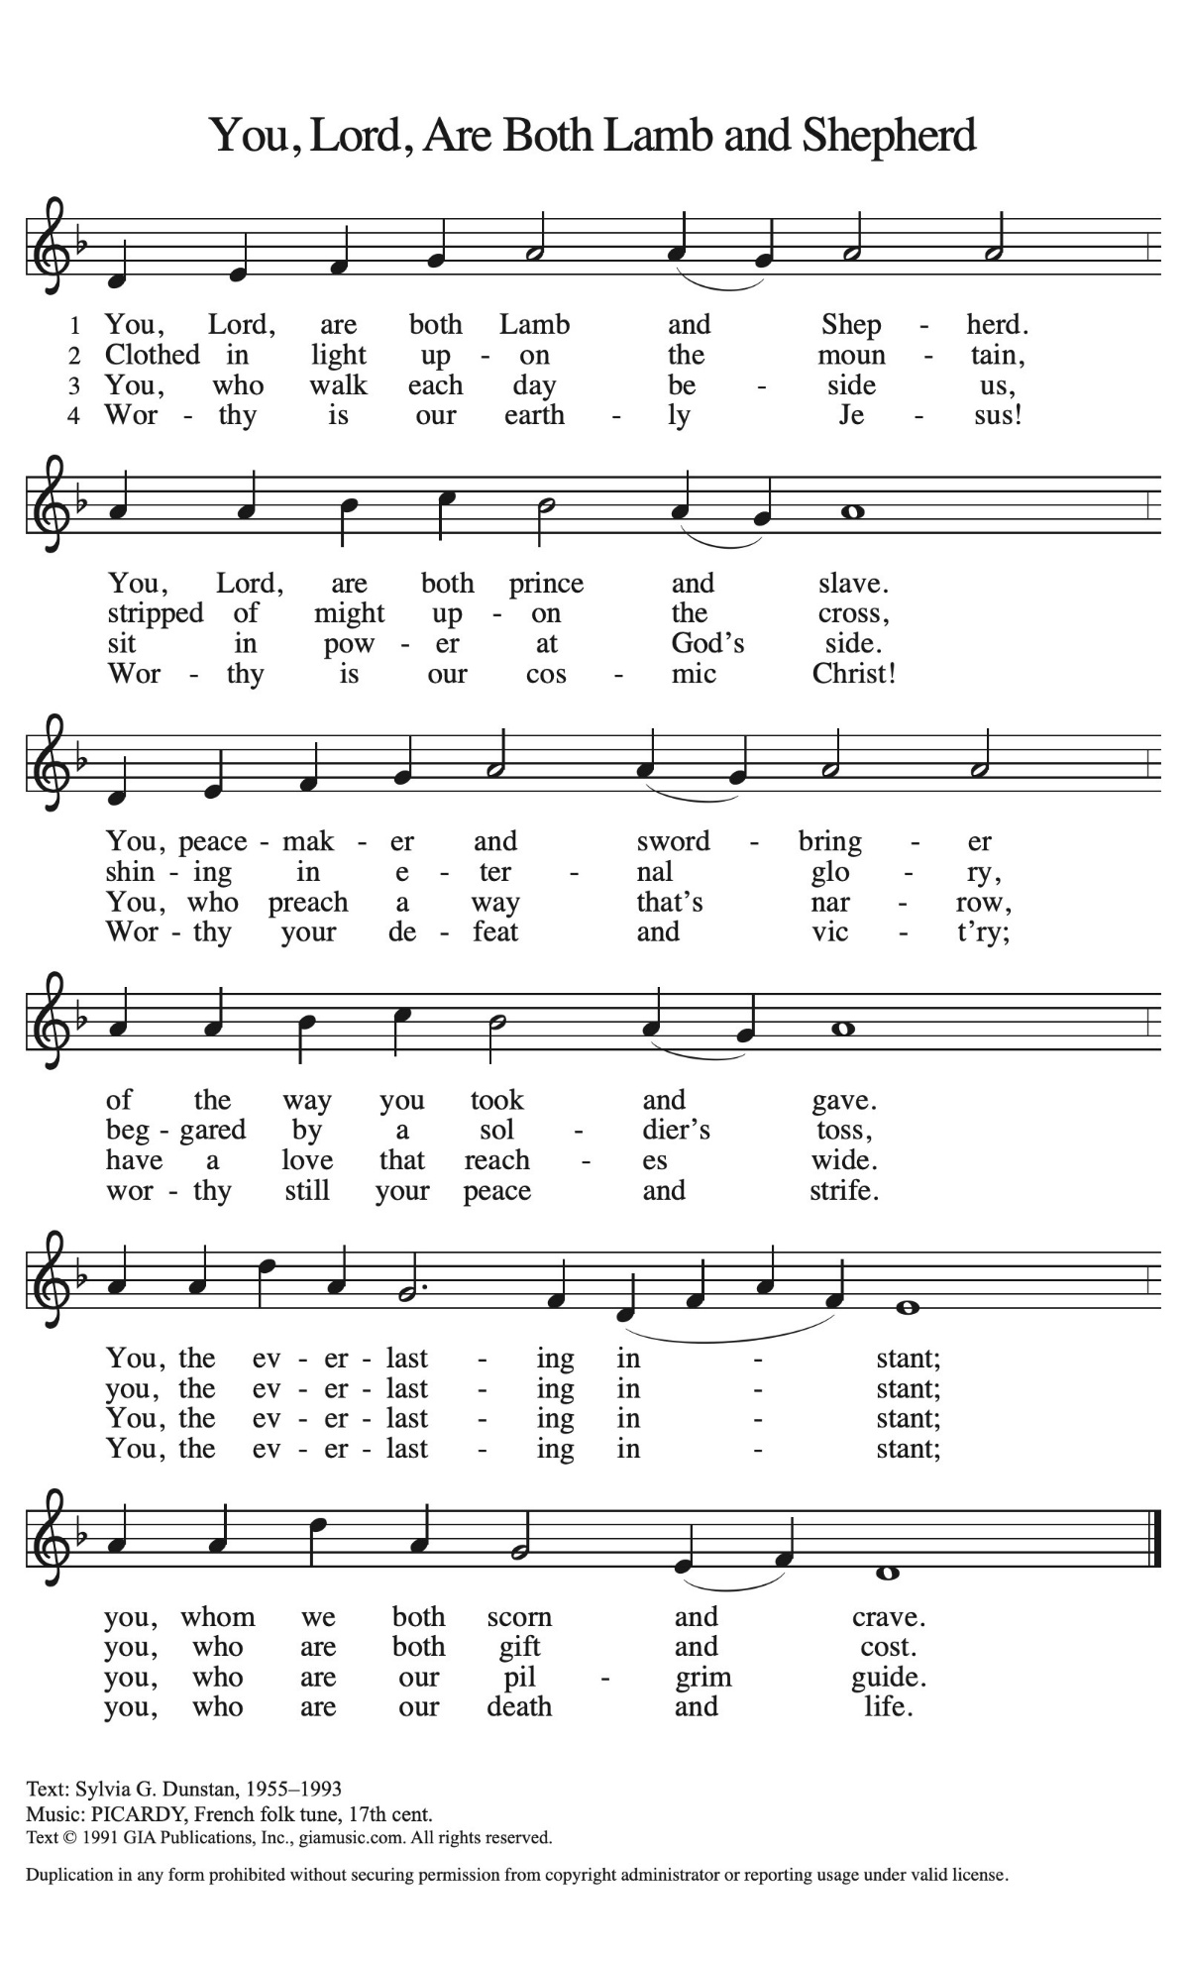
THE GREETING AND PRAYER OF THE DAY

P: Alleluia! Christ is risen!

C: Christ is risen indeed! Alleluia!

P: The grace of our Lord Jesus Christ, the love of God, and the communion of the Holy
Spirit be with you all.

C: And also with you.

P: Let us pray. O God our Shepherd, You know Your sheep by name and lead us to safety
through the valleys of death. Guide us by Your voice, that we may walk in certainty
and security to the joyous Feast prepared in Your house, through Jesus Christ, our
Savior and Lord, Who lives and reigns with You and the Holy Spirit, one God, now
and forever.

C: Amen.

The assembly is seated
WORD

FIRST READING Acts 2: 42-47

Today's reading is a description of life in the community following Peter's sermon on the day of Pentecost, when the Spirit was outpoured on God's people. This new community is founded on the teachings of the apostles and sustained in the breaking of the bread.

[The baptized] devoted themselves to the apostles' teaching and fellowship, to the breaking of bread and the prayers.
⁴³Awe came upon everyone, because many wonders and signs were being done by the apostles. ⁴⁴All who believed were together and had all things in common; ⁴⁵they would sell their possessions and goods and distribute the proceeds to all, as any had need. ⁴⁶Day by day, as they spent much time together in the temple, they broke bread at home and ate their food with glad and generous hearts, ⁴⁷praising God and having the goodwill of all the people. And day by day the Lord added to their number those who were being saved.

The Word of the Lord.

Thanks be to God.

THE PSALM: 780 Shepherd Me, O God
(A hymnic version of Psalm 23)
Choir sings verses; congregation sings refrain

SECOND READING 1 Peter 2: 19-25

The First Letter of Peter addresses the theme of suffering. Jesus, the shepherd and guardian of our souls, models for Christians how one suffers for doing what is right.

It is a credit to you if, being aware of God, you endure pain while suffering unjustly. ²⁰If you endure when you are beaten for doing wrong, what credit is that? But if you endure when you do right and suffer for it, you have God's approval. ²¹For to this you have been called, because Christ also suffered for you, leaving you an example, so that you should follow in His steps.
²²"He committed no sin,
and no deceit was found in His mouth."
²³When He was abused, He did not return abuse; when He suffered, He did not threaten; but He entrusted Himself to the One Who judges justly.
²⁴He Himself bore our sins in His body on the cross, so that, free from sins, we might live for righteousness; by His wounds you have been healed. ²⁵For you were going astray like sheep, but now you have returned to the Shepherd and Guardian of your souls.

The Word of the Lord.

Thanks be to God.

As you are able please rise

THE VERSE
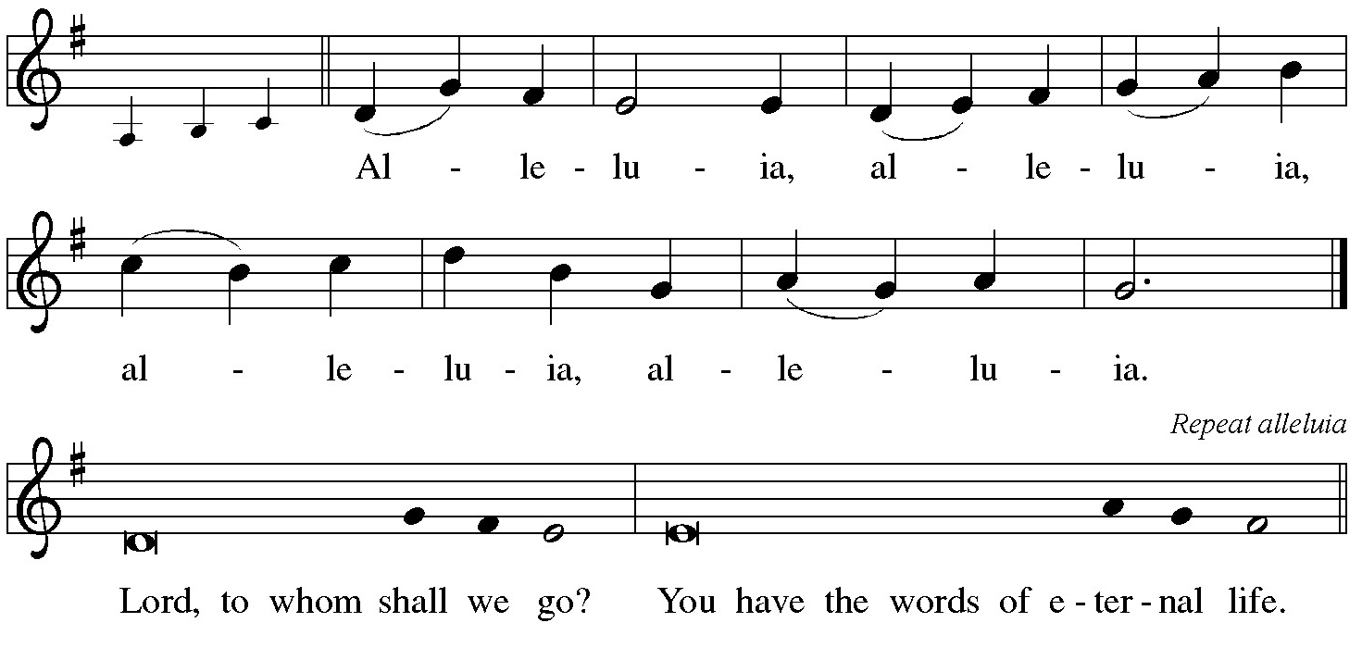
THE HOLY GOSPEL John 10: 1-10

Jesus uses an image familiar to the people of his day to make a point about spiritual leadership. Good shepherds bring people to life through Jesus, but those who avoid Jesus are dangerous to the flock.

P: The Holy Gospel according to St. John, the tenth chapter.

C: Glory to You, O Lord!

[Jesus said:] "Very truly, I tell you, anyone who does not enter the sheepfold by the gate but climbs in by another way is a thief and a bandit. ²The one who enters by the gate is the shepherd of the sheep. ³The gatekeeper opens the gate for him, and the sheep hear his voice. He calls his own sheep by name and leads them out. ⁴When he has brought out all his own, he goes ahead of them, and the sheep follow him because they know his voice. ⁵They will not follow a stranger, but they will run from him because they do not know the voice of strangers." ⁶Jesus used this figure of speech with them, but they did not understand what He was saying to them.
⁷So again Jesus said to them, "Very truly, I tell you, I am the gate for the sheep. ⁸All who came before Me are thieves and bandits; but the sheep did not listen to them. ⁹I am the gate. Whoever enters by Me will be saved, and will come in and go out and find pasture. ¹⁰The thief comes only to steal and kill and destroy. I came that they may have life, and have it abundantly."

P: The Gospel of the Lord.

C: Praise to You, O risen Christ!

The assembly is seated

THE SERMON

Silence for reflection follows the sermon

As you are able please rise

THE HYMN OF THE DAY 798 The Summons

THE NICENE CREED

A: God has made us His people through our Baptism into Christ. Living together in trust
and hope, we confess our faith.

We believe in one God,
the Father, the Almighty,
maker of heaven and earth,
of all that is, seen and unseen.

We believe in one Lord, Jesus Christ,
the only Son of God,
eternally begotten of the Father,
God from God, Light from Light,
true God from true God,
begotten, not made,
of one Being with the Father.
Through Him all things were made.
For us and for our salvation
He came down from heaven;
by the power of the Holy Spirit
He became incarnate from the virgin Mary, and was made man.
For our sake He was crucified under Pontius Pilate;
He suffered death and was buried.
On the third day He rose again
in accordance with the Scriptures;
He ascended into heaven
and is seated at the right hand of the Father.
He will come again in glory to judge the living and the dead,
and His kingdom will have no end.

We believe in the Holy Spirit, the Lord, the giver of life,
Who proceeds from the Father and the Son.
With the Father and the Son He is worshiped and glorified.
He has spoken through the prophets.
We believe in one holy catholic and apostolic Church.
We acknowledge one Baptism for the forgiveness of sins.
We look for the resurrection of the dead,
and the life of the world to come. Amen

THE PRAYER OF THE CHURCH

A: Through Jesus the shepherd and guardian of our souls we have the confidence and
courage to intercede to God on behalf of the Church, the world, and all those in need.

A: That those who preach, teach, and pray; those who seek the lost; those who keep vigil
with the dying, and all who minister to God’s people may be filled with the compassion
of Christ, we pray:

C: Hear us, risen Lord.

A: That this world, so shadowed by death, may be filled with God’s goodness, mercy, and
new Easter life, we pray:

C: Hear us, risen Lord.

A: That the victims and the families of the shootings in Shreveport and near the University
of Iowa might be comforted in their deep grief, and that lawmakers and those in
positions of power would have the courage and conviction to enact laws that will curb
gun violence and promote safety and justice, we pray:

C: Hear us, risen Lord.

A: That this assembly may faithfully devote ourselves to teaching, fellowship, prayer, the
breaking of bread, and the care of those in need, we pray:

C: Hear us, risen Lord.

A: That the weary, the lost, the forgotten, the lonely, and the sick, especially: Mark
Tannehill; Martha Schroeder; Amanda Seedorf; John Bennitt; and Kathy
Thielman may endure by the love and strength of Christ, we pray:

C: Hear us, risen Lord.
A: That those celebrating birthdays, especially Karen Fleming; and Virginia Murray;
and anniversaries, especially Leigh and Beverly Coburn; Charles and Carol
Thomas II; Jim and Bernadette Krueger; Marshall and Belinda Schnick; and
Chris and Cynthia Scheuchner might grow in grace this day and be filled with grace
for the days ahead, we pray:

C: Hear us, risen Lord.

A: That with those known to our Shepherd by name, especially Catherine of Siena,
theologian, whom we commemorate this Day we too may one day dwell in His house
forever, we pray:

C: Hear us, risen Lord.

P: Generous God, You know each of us by name. Hear our prayers and let Your Holy
Spirit fill our hearts. We ask this in the name of Your loving Shepherd, Jesus Christ
our Lord.

C: Amen.

MEAL

THE PEACE

P: The risen Christ stood among the disciples and said, “Peace be with you.”
The peace of the risen Lord be with you always.

C: And also with you.

The assembly is seated

THE OFFERING

THE VOLUNTARY Softly and Tenderly Calling St. Paul Senor Choir
(Arr. by P. Drennan)

As you are able please rise

THE OFFERTORY (see p. 10) This Joyful Eastertide

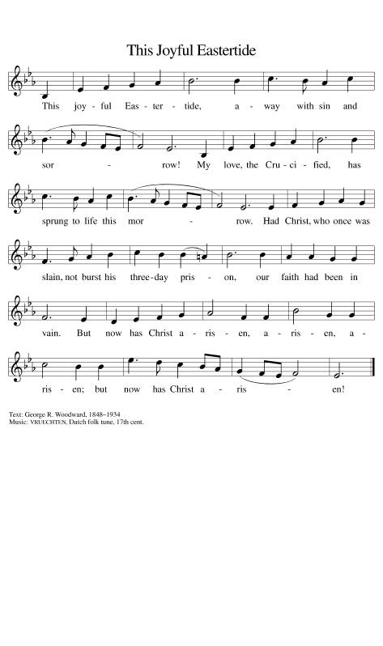
THE OFFERTORY PRAYER

A: Let us pray. God our Shepherd,

C: You have again set Your Table before us, and our cup is overflowing with Your
goodness and mercy. As Christ laid down His life for His sheep, so we lay before
You these gifts of our lives. Receive them for Jesus’ sake. Restore us by these
Easter mysteries, and grant us the abundance of the Life they offer. We ask this
in the name of Jesus the Lord. Amen.

THE GREAT THANKSGIVING
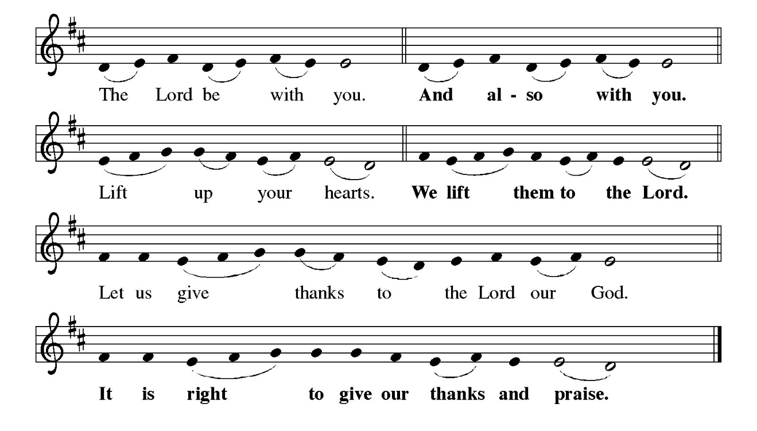
P: It is indeed right, our duty and our joy … and join their unending hymn:

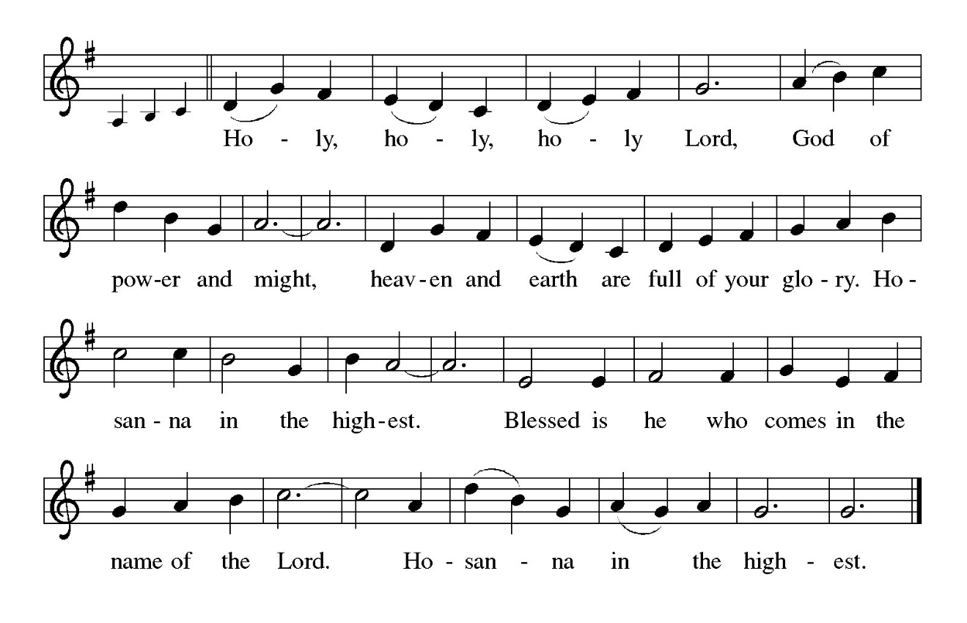
P: Shepherding God, we praise and thank You because You gathered Your flock around
Abraham, and through Moses and Joshua You brought Your sheep to a place
of safety.
In Jesus You came to us as a Passover Lamb to take away the sins of the world.
As our everlasting Shepherd You promise that all those who hear Your voice will
never be in want, for You know Your sheep by name, and You call us Your
own and give to each of us a place in the sheepfold of Your Kingdom.
Sustaining God, as You lead Your sheep to green pastures and guide them beside
still waters, so You have led us to this Table where in bread and wine You
restore our soul.
Send down Your Holy Spirit and restore Your Church through the abundance of this
sacred Meal.
As we remember the story of Your Son’s life laid down for us, make this bread and
cup holy that they may be for us the Body and Blood of Your Son Jesus,
Who in the night ... “Do this for the remembrance of Me.”
As often as we eat ... we proclaim the Lord’s death until He comes.

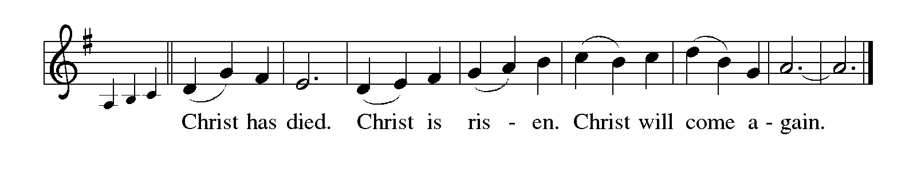
P: Saving God, Your rod and staff comfort all who look to You in faith.
Search out Your sheep that are lost and bring them home.
When You find them in the valley of fear, gather them in Your arms.
When they face evil in the presence of enemies, follow them with Your goodness
and mercy all the days of their lives.
On that day when the shadow of death covers them bring them to dwell in Your house
forever.
Shepherd us with all Your saints of every age into Your glorious presence, where we
shall behold Your Lamb seated in glory,
Most Holy Trinity, now and always.

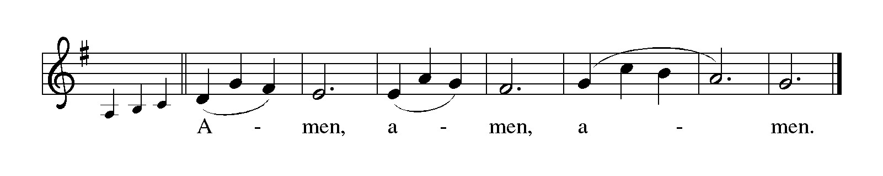

THE LORD’S PRAYER

P: Alleluia! The risen Christ intercedes on our behalf before the throne of God. Let us
therefore join Him in His prayers in the words He taught us:

C: (Sung) Music is on the front cover of the red hymnal

INVITATION TO THE MEAL

P: Jesus said, I am the true Vine. Abide in Me as I abide in you. Blessed are those who
are called to the Supper of the Lamb. God’s holy gifts for God’s holy people. Come,
for all is now ready.

The assembly is seated

THE DISTRIBUTION Lamb of God

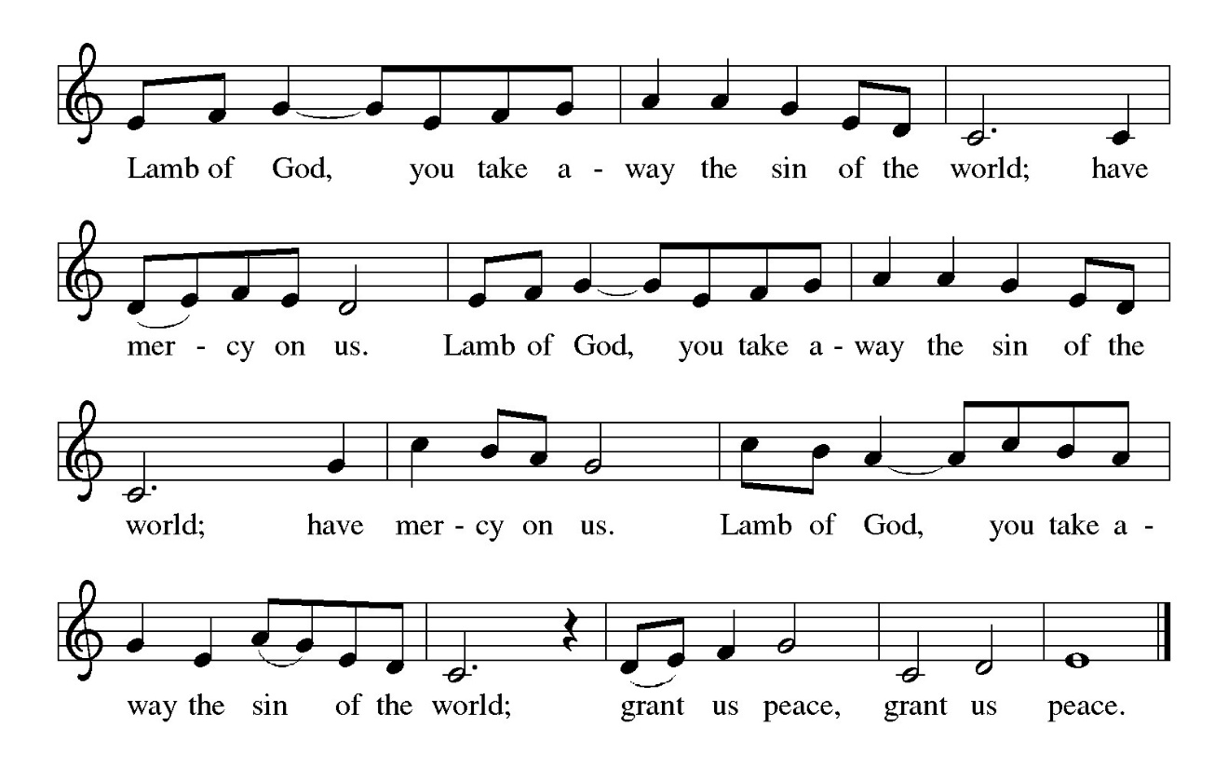

HYMN DURING DISTRIBUTION 385 Good Christian Friends, Rejoice and Sing!

NSB 2 Above All

NSB 10 Beautiful Savior (All My Days)

NSB 104 You Are My Hiding Place

NSB 821 Spirit Song

As you are able please rise

THE POST-COMMUNION BLESSING

P: The Body and Blood of our Lord Jesus Christ strengthen you and keep you in His grace.

C: Amen.

THE POST-COMMUNION PRAYER

A: Let us pray. Lord Jesus, eternal Shepherd, You are the Gate to abundant Life. In this
holy Sacrament we have again heard Your voice promising forgiveness and peace.
Lead us in safety this week, and send us to the lost with Your hope and grace. You are
the Lord forevermore.

C: Amen.

SENDING

THE BENEDICTION

P: Almighty God: Father, Son, and Holy Spirit bless you now and forever.

C: Amen.

SENDING SONG 774 What a Fellowship

THE DISMISSAL

A: Go in peace. Proclaim the risen Lord. Alleluia! Alleluia!

C: Thanks be to God! Alleluia! Alleluia!

THE POSTLUDE

To God Alone Be Glory

The Meditations are from Pulpit Resource. William Willimon, ed. Vol. 27 No. 2 (Inver
Heights,MN: Logos Productions, Inc., 1999) 22.

The Greeting, Prayers, Peace, and Dismissal are adapted from Sundays and Seasons.
Copyright 2001 Augsburg Fortress.

The Prayers, Introduction to the Lord’s Prayer, and Invitation to the Meal are adapted from
Prayers for Sundays and Seasons. Year A. Peter J. Scagnelli. (Chicago: Liturgy Training +-`Publications, 1998) 60-61.

ANNOUNCEMENTS

Please remember to mail your offering to the Church Office at 818 Franklin Street, Michigan City, IN 46360. Another alternative is to give on-line through Tithe.ly. Please see your closure letter for information on how to set up a Tithe.ly account.

St. Paul Members are reminded to have a loved one contact the office if you are hospitalized. Many times, the Pastor doesn’t know someone is in the hospital. If you call and leave a message, please tell us at which hospital the patient is located.

BIRTHDAYS: Karen Fleming (4/26); Virginia Murray (4/28)

ANNIVERSARIES: Leigh & Beverly Coburn (5/1); Charles & Carol Thomas 11

(5/2); Jim & Bernadette Krueger (5/5); Marshall & Belinda Schnick (5/5); and

Chris & Cynthia Scheuchner (5/6)

PRAYER CONCERNS: John Bennitt; Debbie Martin; Mark Tannehill; Kathy Stein; Jan Paholski; Laura Dovey; Bill Hazelgrove; Al Levenhagen; Carl Wipperman; Major Payne.

OFFICE HOURS: Libby will be in the office on Mondays, Wednesdays, and Fridays; volunteers will cover Tuesdays and Thursdays.

Monday & Wednesday 8:00 a.m. – 5 p.m.
Tuesday & Thursday 9:00 a.m. – 12:00 p.m.
Friday 8:00 a.m. – 12:00 p.m.

If you are listening to the worship broadcast on the radio and would like to watch the Sunday morning service live stream follow these steps:

(1) If you have You Tube available on your TV, search for
St. Paul Lutheran Church Michigan City, IN.

(2) The direct link on the computer is https://
www.youtube.com/channel/UC5AIPNaKr3QN50984jGOa1g

(3) This link is also on the main page of the church’s website in
the church section and will continue to be posted weekly on the St.
Paul Facebook page.

And it will always be available on the radio broadcast Sunday mornings at 11:00 a.m.
on WEFM (95.9), and on the local cable access station #99 for the previous week’s
service on Sundays at 4:00 p.m. and the current service on Wednesdays at 7:00 p.m.
and Fridays at 8:30 p.m.

To send e-mail to the church office, please use the following addresses:

Pastor Mark Reshan: seniorpastor@stpaulmichigancity.com

Church Office Secretary (Libby Pollock): churchsecretary@stpaulmichigancity.com

Church Treasurer (Karen Fleming): finance@stpaulmichigancity.com

2026 Church Council:

Pastor - Mark Reshan

President - Donna Knoll

Vice President - Jan Bakken

Secretary - Judy Hunt

Treasurer - Karen Fleming

Members: Sue Koziel; Jim Schraidt; Trish Sprague; Bob Kiser; Barry Anderson; and
Pam Soule

Worship Attendance:

Saturday, April 18, 2026 @ 4:00 p.m. 25

Sunday, April 19, 2026 @ 9:00 a.m. 70

TOTAL 95

Copies of the minutes from the February 26, 2026 and March 26, 2026 Church Council meetings are on the back table in the upper Narthex. They were approved by the council via email.

The Good News Newsletter: If you have an article or anything you want included in The Good News please send it to the following e-mail address: splcgoodnews@gmail.com. Pastor Pamela Thiede will be using this e-mail address to assemble The Good News each month. The deadline for getting information to Pastor Pamela will be the 20th of each month.

Next week’s lessons are Acts 7: 55-60; Psalm 31: 1-5, 15-16; 1 Peter 2: 2-10; John 14: 1-14 for those of you who like to study them in advance.

MONTHLY MISSION FOR APRIL 2026
BOYS & GIRLS CLUBS OF LAPORTE COUNTY

The Boys & Girls Clubs of LaPorte County provide a safe space for kids to go after school, during the summer, and while school is operating online, to learn and grow beyond the classroom. Members receive access to homework help, mentoring, sports programs, STEAM enrichment, community service opportunities, and much more. Their programs include the following:

Career Explorations SMART Moves and SMART Decisions
Food Programs Ultimate Journey/STEAM
Game Changers Volunteering
Homework Help/Tutoring/Power Hour

If you would like to support this mission, we will be collecting both supplies and monetary donations. Please make checks payable to St. Paul and mark for the Boys & Girls Clubs and place in the offering. Noisy coin for the month of April will also go to support the Boys & Girls Clubs. The following supplies can be placed in the bin in the upper Narthex:

Felt Dixie Cups
Glue bottles, sticks, or bulk pourable Plain block Legos
Bulk pourable tempura paint Play Doh
Markers & crayons

Construction paper and card stock of all colors; and plain white paper
Paper towels, Kleenex, disinfectant/cleaning wipes
K-8th grade appropriate board and card games
Small “treasure box” type prizes

Thank you for your support of Daisy Lee’s STEM trips for our young students. We raised $476 to help fund this year’s STEM trips! Thank you for your unwavering support for our community each month! Lora

FOR THOSE WHO WOULD LIKE TO KNOW MORE ABOUT THE BOYS & GIRLS CLUBS there are printed handouts on the table in the lower narthex for your reading pleasure!

MISSION OF THE MONTH FOR MAY 2026

The Dolly Fund at Lubeznik Center for the Arts is our Mission of the Month for May 2026. The Dolly Fund is an endowment fund that supports scholarships for students age 7- 18 to LCA’s art classes for youth. It was initiated by Paul Marshall, in honor of his late wife and former LCA director, Dolly Marshall. Dolly had a life-long belief that arts education for children was crucial to their development. Some of the classes LCA offers are abstract painting, mixed media for young artists, figure drawing, digital illustration, abstract landscapes, poetry and performance workshops, printmaking, and much more!

Please make checks payable to St. Paul and mark for the Dolly Fund and place in the offering. Noisy coin offering for the month of May will also go to support the Dolly Fund. Thank you for your generosity each month! Lora

SIMPLY GRATEFUL
Dear Pastor Reshan and the people of St. Paul Lutheran Church,

The peace of the risen Christ be with you. I want to offer my heartfelt thanks for the gracious invitation to preach and preside with you on the significant occasion of your 150th anniversary. It was a deep joy and an honor to share in worship and celebration with you.

Your hospitality was warm and spirit-filled. The meal we shared was wonderfully delightful, and the humor and laughter that filled the space were a gift, a true sign of the love and life you share as a community of faith.

Thank you as well for the wonderful cups you gave to both Meme and me, especially with our names inscribed. That thoughtful and generous gesture means more than you know, and we will remember you each time we use them.

Thank you again for your kindness, your generosity, and the privilege of joining you in this celebration.

With deep appreciation, and in Christ’s love,

Bishop Tim and Meme

ACTIVITIES, EVENTS & MEETINGS
APRIL 2026

Monday, April 20, 2026 @ 1:00 p.m. Hope Circle/Green Room
@ 2:00 p.m. Finance Committee Mtg./Luther House
@ 3:00 p.m. Executive Board Mtg./Luther House
Wednesday, April 22, 2026 @ 9:15 a.m. Bible Study/Luther House
@ 10:00 a.m. God’s Purls/St. Paul Room
@ 4:30 p.m. Choir Rehearsal/Sanctuary
Thursday, April 23, 2026 @ 3:00 p.m. Church Council Mtg/St. Paul Room

Saturday, April 25, 2026 @ 4:00 p.m. 4 Easter Worship Service/Sanctuary

Sunday, April 26, 2026 @ 9:00 a.m. 4 Easter Worship Service/Sanctuary
with coffee after
Wednesday, April 29, 2026 @ 9:15 a.m. Bible Study/Luther House
@ 10:00 a.m. God’s Purls/St. Paul Room
@ 4:30 p.m. Choir Rehearsal/Sanctuary
Saturday, May 2, 2026 @ 4:00 p.m. 5 Easter Worship Service/Sanctuary

Sunday, May 3, 2026 @ 9:00 a.m. 5 Easter Worship Service/Sanctuary with the Annual SPRING CONGREGATIONAL MEETING immediately after worship AND A True POTLUCK following the meeting. Please bring a dish to share.



The annual Spring Congregational Meeting 2026
The annual Spring Congregational Meeting will be held on Sunday, May 3, 2026 immediately after Sunday morning worship. It is very important to attend the meeting as we will be approving the budget for the 2026-2027 year. There will also be updates on the 150th anniversary events and some information on Evangelism events on which we need your input. And finally, there will be a true Potluck following the meeting. Please bring a dish to pass and let’s enjoy each other’s fellowship!

Thank$ for $haring
Thank you to all who participate in our Give-Back opportunities each month where we earn $$ to add to our Mission of the Month donations, from our congregation to those in our community who need our help! On Tuesday, March 10th, we earned $263 from our GIVE BACK AT Holly’s Restaurant & Pub
On Thursday, May 7, 2026 we’re meeting at Galveston for our GIVE BACK from 4p.m.—10p.m. Here are two coupons—one for you and one for a friend.

