THE THIRTEENTH SUNDAY AFTER PENTECOST
August 23, 2026

Peter, who before was called Simon, receives from the Lord the name of Peter, because of the strength and constancy of his faith; for with a firm and tenacious soul he clung to him of whom it was written, “And the rock was Christ.”

And this rock, that is, the Lord Savior, who gave to him who knew him, loved him, and confessed him, the privilege of sharing his name, said that he would be called Peter, from Petra (the rock), upon which the church is built. For only through the faith and the love of Christ, through receiving the sacraments of Christ, through keeping the commandments of Christ, can we come to share in the lot of the elect and to eternal life.

The Venerable Bede
Sixth century

INTRODUCTION

In Isaiah the people are bid to look to their spiritual ancestors as the rock from which they were hewn. Jesus declares that the church will be built on the rock of Peter's bold confession of faith. God's word of reconciliation and mercy are keys to the church's mission. Paul urges us to not be conformed to this world, but to offer our bodies as a living sacrifice, using our individual gifts to build up the body of Christ. From the table we go forth to offer our spiritual worship through word and deed.

Bartholomew, Apostle

Mentioned as one of Jesus' disciples in Matthew, Mark, and Luke, Bartholomew's name is replaced in John's gospel by Nathanael, leading many to believe that the two are different names for the same person. Little is known about his work, though some traditions place him later in India or Armenia.

GATHERING

PRE-SERVICE MUSIC Change Me On the Inside New Song Praise Band
(Brian Doerksen)

ANNOUNCEMENTS

As you are able please rise

CONFESSION AND ABSOLUTION

P: In the name of the Father and of the Son and of the Holy Spirit.

C: Amen.

P: “Do not be conformed to this world, but be transformed by the renewing of your minds, so that
you may discern what is the will of God–what is good and acceptable and perfect.” (Romans
12: 2) Such a “renewing of our minds” comes from a daily return to the call and promise of
Baptism. Let us therefore confess our sins, that through the power of forgiveness our wills
might again be transformed to the will of God.

Silence for self-examination and reflection is kept

P: Most merciful God,

C: We confess that we have sinned against You in thought, word, and deed. We have not
presented our bodies and lives as living sacrifices, holy and acceptable to You. (Romans
12: 1) We have thought more highly of ourselves that we ought, and less than those who
are different from us. (12: 3) We have not used Your gifts for the good of the Body of
Christ. (12: 6) We have failed to proclaim Your Son as the Messiah. (Matthew 16: 16)
Have mercy on us, O God, and forgive us. Increase our strength within us (Psalm 138:
4), that we may faithfully use the gifts You have given to bear witness to Your Son.

P: “The LORD will make good His purpose for me; O LORD, Your love endures forever; do not
abandon the works of Your hands.” (Psalm 138: 9) God’s “purpose” is that you live as a
testimony to His Son. He has not nor will He “abandon” you. You are in His “hands” forever.
For as a called and ordained minister of the Church of Christ, and by His authority, I therefore
declare to you the entire forgiveness of all your sins, in the name of the Father and of the
Son and of the Holy Spirit.

C: Amen.

GATHERING SONG NSB 58 I Will Call Upon the Lord

THE GREETING AND PRAYER OF THE DAY

P: The grace of our Lord Jesus Christ, the love of God, and the communion of the Holy Spirit be
with you all.

C: And also with you.

P: Let us pray. O God with all Your faithful followers of every age, we praise You, the rock of
our life. Be our strong foundation and form us into the body of Your Son, that we may gladly
minister to all the world, through Jesus Christ, our Savior and Lord.

C: Amen.

The assembly is seated

WORD

FIRST READING Isaiah 51: 1-6

In this text, the writer appeals to a people who seem apathetic, if not despairing. Isaiah reminds Israel that God's actions in the past (v. 2) are the basis for hope in the present.

Listen to Me, you that pursue righteousness,
you that seek the LORD.
Look to the rock from which you were hewn,
and to the quarry from which you were dug.
²Look to Abraham your father
and to Sarah who bore you;
for he was but one when I called him,
but I blessed him and made him many.
³For the LORD will comfort Zion;
He will comfort all her waste places,
and will make her wilderness like Eden,
her desert like the garden of the LORD;
joy and gladness will be found in her,
thanksgiving and the voice of song.
⁴Listen to Me, My people,
and give heed to Me, My nation;
for a teaching will go out from Me,
and My justice for a light to the peoples.
⁵I will bring near My deliverance swiftly,
My salvation has gone out
and My arms will rule the peoples;
the coastlands wait for Me,
and for My arm they hope.
⁶Lift up your eyes to the heavens,
and look at the earth beneath;
for the heavens will vanish like smoke,
the earth will wear out like a garment,
and those who live on it will die like gnats;
but My salvation will be forever,
and My deliverance will never be ended.

The Word of the Lord.

Thanks be to God.

THE PSALM: Psalm 138 Antiphon by Thomas Keesecker
Choir sings refrain first, followed immediately by the congregation
and as indicated

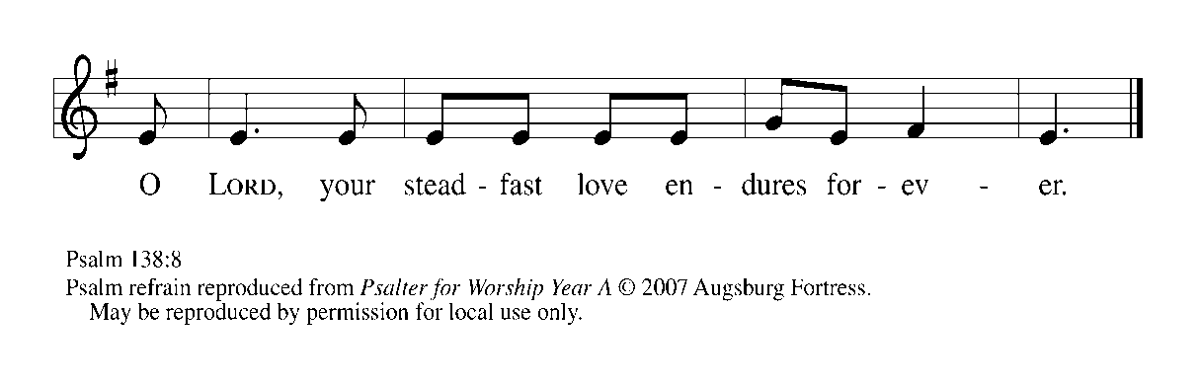
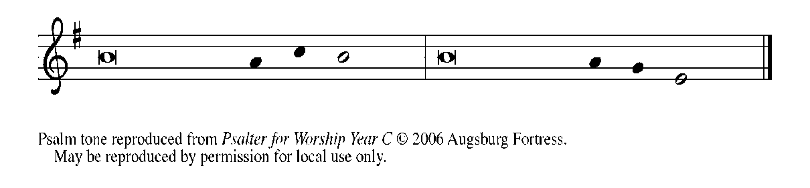

¹I will give thanks to You, O LORD, with | my whole heart;
before the gods I will | sing Your praise.

²I will bow down toward Your holy temple and praise Your name,
because of Your steadfast | love and faithfulness;
for You have glorified Your name and Your word
- | bove all things.

³When I called, You | answered me;
You increased my | strength within me.

⁴All the rulers of the earth will praise | You, O LORD,
when they have heard the words | of Your mouth. REFRAIN

⁵They will sing of the ways | of the LORD,
that great is the glory | of the LORD.

⁶The LORD is high, yet cares | for the lowly,
perceiving the haughty | from afar.

⁷Though I walk in the midst of trouble, You | keep me safe;
You stretch forth Your hand against the fury of my enemies;
Your right | hand shall save me.

⁸You will make good Your pur- | pose for me;
O LORD, Your steadfast love endures forever;
do not abandon the works | of Your hands. REFRAIN

SECOND READING Romans 12: 1-8

Paul offers practical advice to the Roman Christians, suggesting new ways of relating to God, to the world, to the self, and to other believers.

I appeal to you therefore, brothers and sisters, by the mercies of God, to present your bodies as a living sacrifice, holy and acceptable to God, which is your spiritual worship. ²Do not be conformed to this world, but be transformed by the renewing of your minds, so that you may discern what is the will of God--what is good and acceptable and perfect.
³For by the grace given to me I say to everyone among you not to think of yourself more highly than you ought to think, but to think with sober judgment, each according to the measure of faith that God has assigned. ⁴For as in one body we have many members, and not all the members have the same function, ⁵so we, who are many, are one body in Christ, and individually
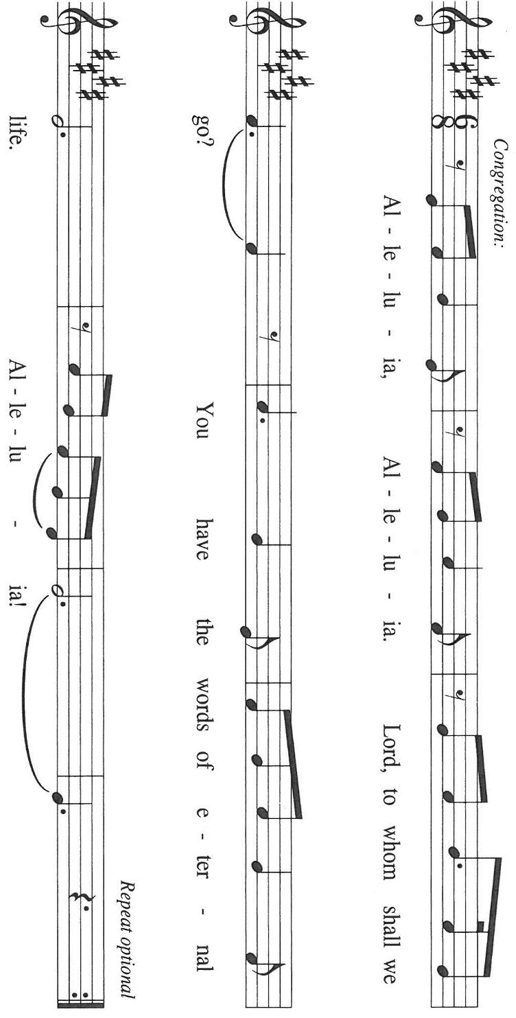
we are members one of another. ⁶We have gifts that differ according to the grace given to us: prophecy, in proportion to faith; ⁷ministry, in ministering; the teacher, in teaching; ⁸the exhorter, in exhortation; the giver, in generosity; the leader, in diligence; the compassionate, in cheerfulness.

The Word of the Lord.

Thanks be to God.

As you are able please rise

THE VERSE Sung twice

THE HOLY GOSPEL Matthew 16: 13-20

At a climactic point in Jesus' ministry, God reveals to Peter that Jesus is "the Messiah, the Son of the living God," and Jesus responds by revealing his vision of the church.

P: The Holy Gospel according to St. Matthew, the sixteenth chapter.

C: Glory to You, O Lord!

Now when Jesus came into the district of Caesarea Philippi, He asked His disciples, "Who do people say that the Son of Man is?" ¹⁴And they said, "Some say John the Baptist, but others Elijah, and still others Jeremiah or one of the prophets." ¹⁵He said to them, "But who do you say that I am?"
¹⁶Simon Peter answered, "You are the Messiah, the Son of the living God." ¹⁷And Jesus answered him, "Blessed are you, Simon son of Jonah! For flesh and blood has not revealed this to you, but My Father in heaven. ¹⁸And I tell you, you are Peter, and on this rock I will build My church, and the gates of Hades will not prevail against it.
¹⁹I will give you the keys of the kingdom of heaven, and whatever you bind on earth will be bound in heaven, and whatever you loose on earth will be loosed in heaven." ²⁰Then He sternly ordered the disciples not to tell anyone that He was the Messiah.

P: The Gospel of the Lord.

C: Praise to You, O Christ!

The assembly is seated

THE SERMON

Silence for reflection follows the sermon

As you are able please rise

THE HYMN OF THE DAY 652 Built on a Rock
Stanza 2—Men; Stanza 4--Women

THE APOSTLES’ CREED

A: God has made us His people through our Baptism into Christ. Living together in trust and
hope, we confess our faith.

C: I believe in God, the Father almighty,
creator of heaven and earth.

I believe in Jesus Christ, His only Son, our Lord.
He was conceived by the power of the Holy Spirit
and born of the virgin Mary.
He suffered under Pontius Pilate,
was crucified, died, and was buried.
He descended into hell.
On the third day He rose again.
He ascended into heaven,
and is seated at the right hand of the Father.
He will come again to judge the living and the dead.

I believe in the Holy Spirit,
the holy catholic Church,
the communion of saints,
the forgiveness of sins,
the resurrection of the body,
and the life everlasting. Amen

THE PRAYER OF THE CHURCH

A: Through the power of God, Peter saw Jesus in spirit and truth. For the power of God to be felt
in our own time, let us offer our intercessions for the Church, the world, and all those in need.

A: That all peoples of the earth and powers of the world may come to know Christ as God’s
Messiah, we pray: Lord Jesus, Son of the living God,

C: Hear our prayer.

A: That the Church may stand firm on the rock of faith in Christ, God’s life and love for the world,
we pray: Lord Jesus, Son of the living God,

C: Hear our prayer.

A: That those who hold the keys of authority in this world may open doors that lead to peace,
especially in Ukraine, Russia, Lebanon, Iran, the Middle East, Myanmar, and all places of
violence, racial unrest, and turmoil, we pray: Lord Jesus, Son of the living God,

C: Hear our prayer.

A: That this assembly’s profession of faith in Jesus may be made in deeds that build up the Church,
we pray: Lord Jesus, Son of the living God,

C: Hear our prayer.

A: That those who are bound by loneliness, grief, addiction, depression, and illness, especially:
David Jocelyn; Martha Schroeder; Pastor Dale Zylstra; Mark Tannehill; Debbie Martin;
Jon Samuelson; Hazel Miller; Dale Thomas; and Amanda Seedorf would be loosed from
their suffering into God’s healing, we pray: Lord Jesus, Son of the living God,

C: Hear our prayer.

A: That with Peter and all who have confessed Christ as Lord, especially Bartholomew, Apostle,
whom we commemorate this Day we too may prevail in faithful discipleship into everlasting
life, we pray: Lord Jesus, Son of the living God,

C: Hear our prayer.

P: Living God, You wish to be among us in Your Son and in His Church. Hear the petitions we
place before You. Increase our faith that we may see Your works more clearly. Purify our
actions that we may reveal Your love more surely. We ask this in the name of Jesus, Your
Son, and our Lord.

C: Amen.

MEAL

THE PEACE

P: The peace of the Lord be with you always.

C: And also with you.

The assembly is seated

THE OFFERING

THE VOLUNTARY Commit Your Way St. Paul Senior Choir
(J. Parker & R. Schram)

As you are able please rise

THE PRESENTATION OF GIFTS As the Grains of Wheat
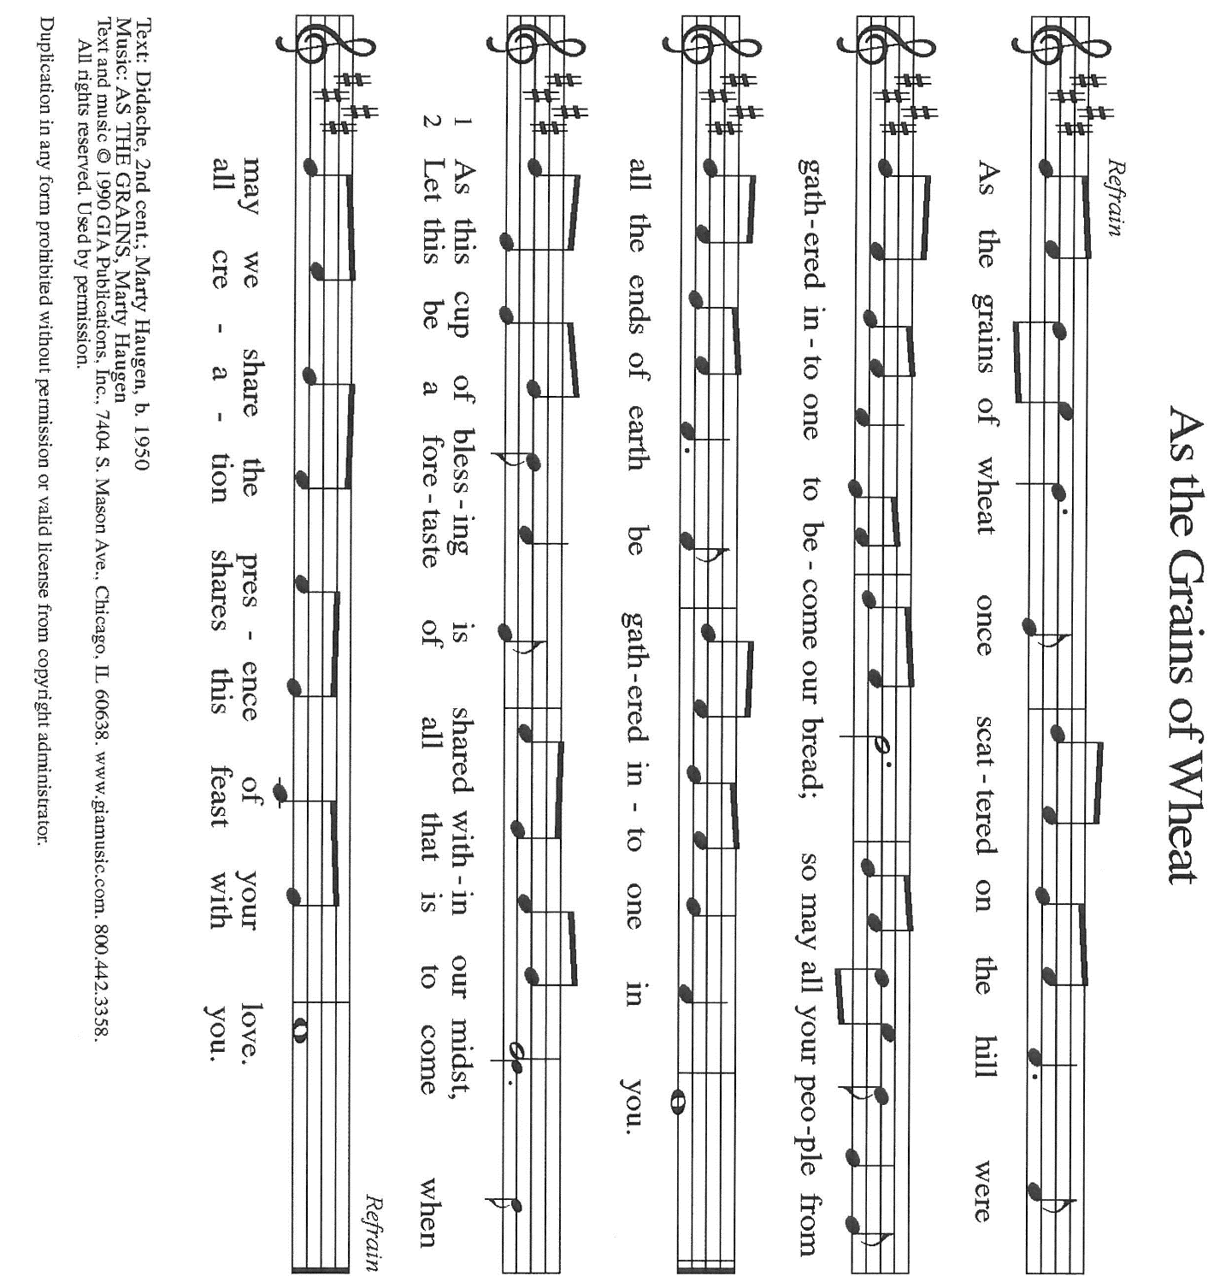

THE OFFERTORY PRAYER

A: Let us pray. God of mercy,

C: With these gifts we present our whole lives to You as a living sacrifice. Receive them for
the sake of Your Son, Jesus Christ, and make them holy and acceptable in Your sight.
By this Sacrament of life, grant us again Your gifts of grace, that we may boldly confess
Christ in all we say and do. We ask this in the name of Jesus the Lord. Amen.
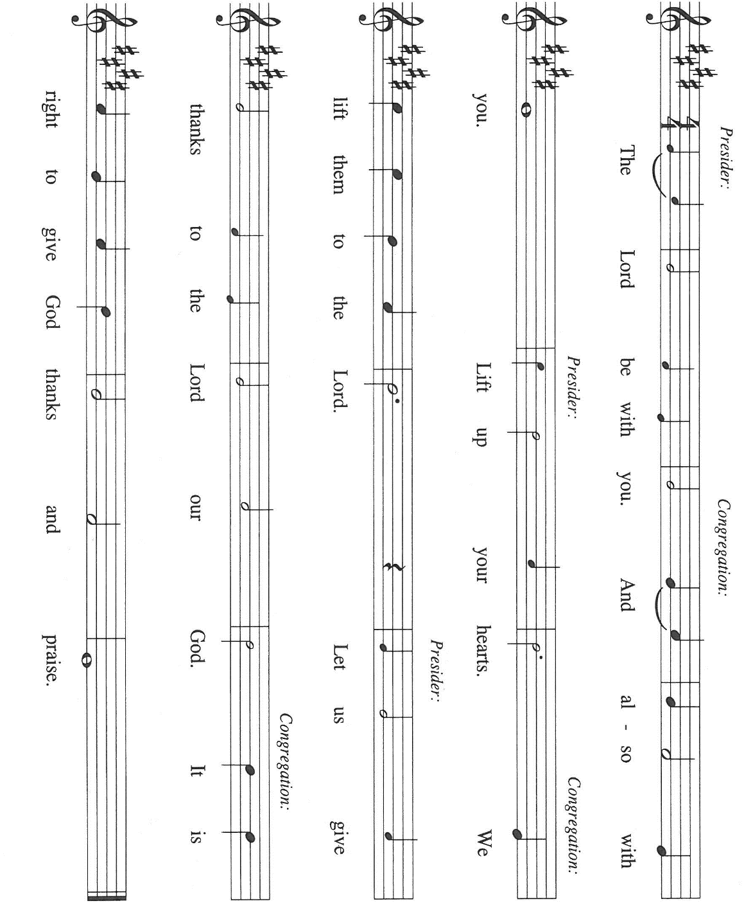
THE GREAT THANKSGIVING

P: It is our duty and delight …join their unending hymn:

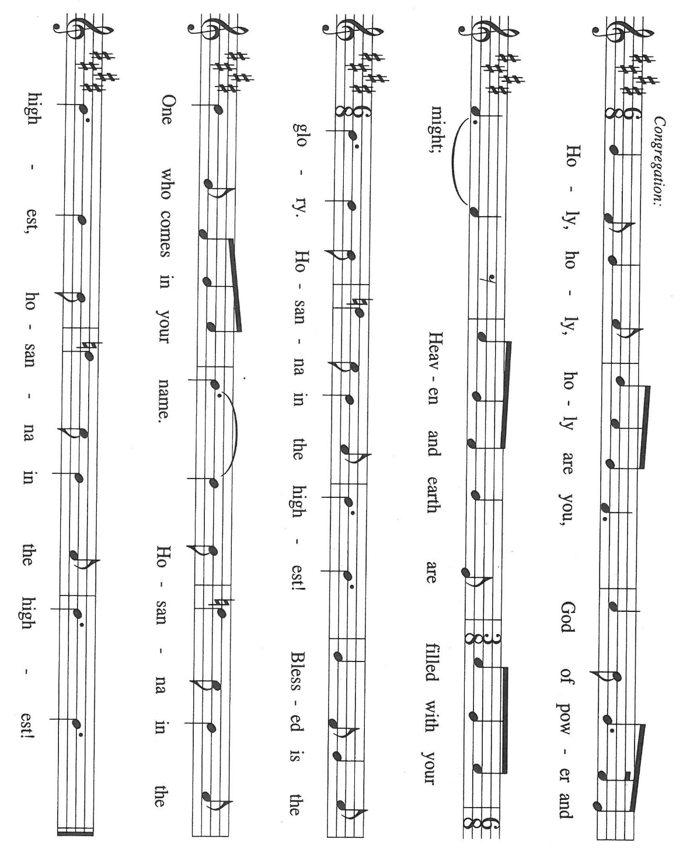

P: Blessed are You, O Lord our God, because of Your love and faithfulness.
Great is Your glory; Your love endures forever. You sustain and enliven all the works of Your
hands.
From Abraham and Sarah You called forth Israel to be a light of justice so that Your salvation
might draw swiftly to all nations.

At the last Your deliverance drew near in Your only Son, Jesus Christ.
In Him You will make good all Your purposes for us.
In the night ... “Do this for the remembrance of Me.”
As often as we eat ... we proclaim the Lord’s death until He comes.

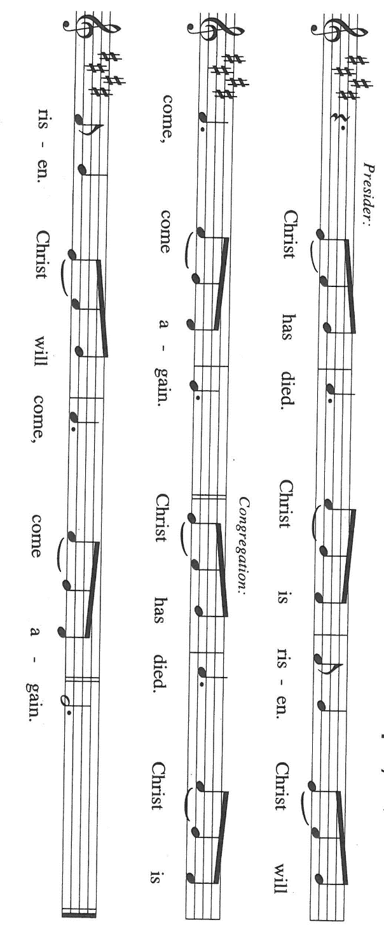

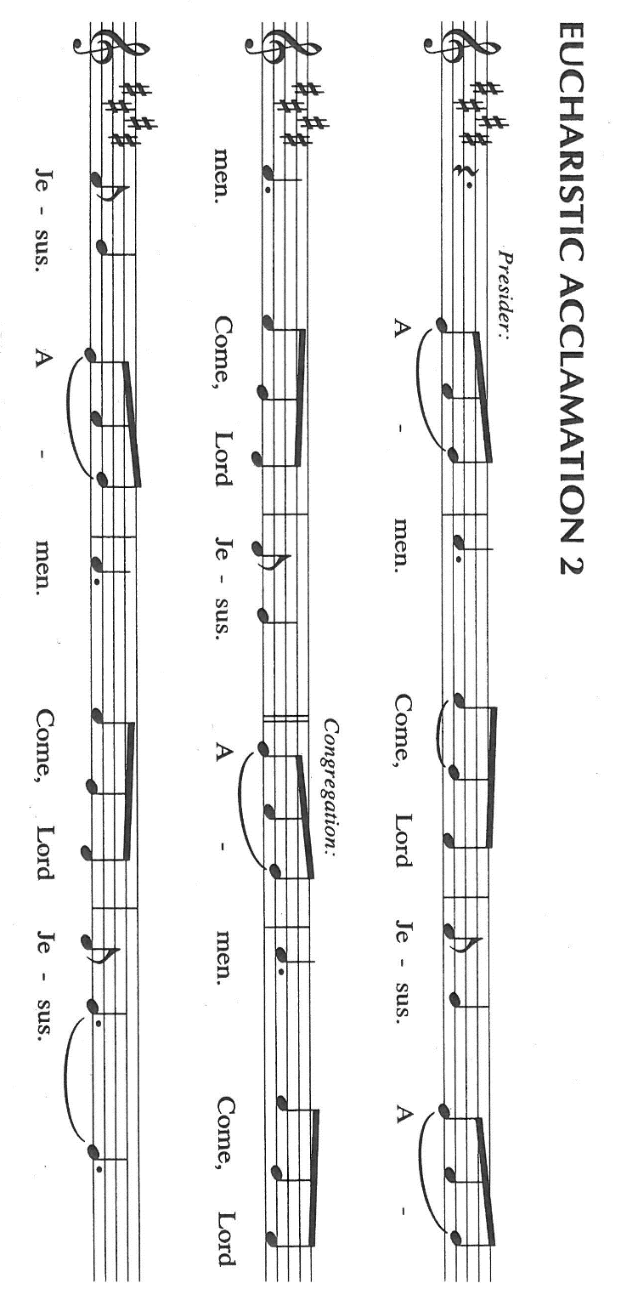

P: With this bread and cup we remember the holy and acceptable sacrifice of His life and death,
His resurrection and ascension.
Until He returns in promised glory, keep us strong in faith and hope as we bind the powers
of sin and death to His cross and loose broken hearts and lives into His forgiveness
and unending love.

Send Your Spirit on us and these gifts, that we and all who share the Lord’s Body and Blood
May be transformed by the renewing of our minds into bold witnesses to Christ in and for the
life of the world.

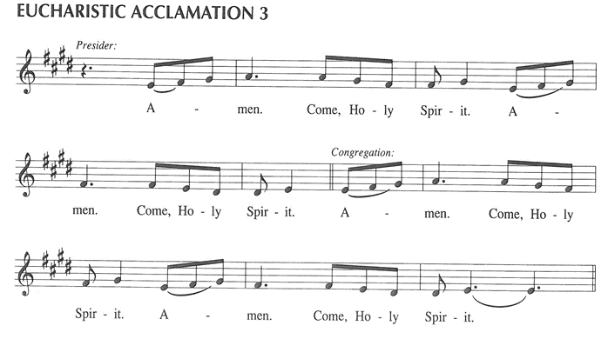

To You, O God: Father, Son, and Holy Spirit, be all honor and glory, in Your holy Church,
In heaven and on earth, now and forever.

C: Amen!

THE LORD’S PRAYER

P: With trust in God Whose providence nourishes and sustains us, we pray now as Jesus taught
us:

C: (Sung) Music is on the front cover of the red hymnal

INVITATION TO THE MEAL

P: Behold the living Bread come down from heaven: those who eat of it will never die. Behold
the cup of eternal life: those who drink of it will live forever. God’s holy gifts for God’s holy
people. Come, for all is now ready.

The assembly is seated

THE DISTRIBUTON Lamb of God (see p. 13)

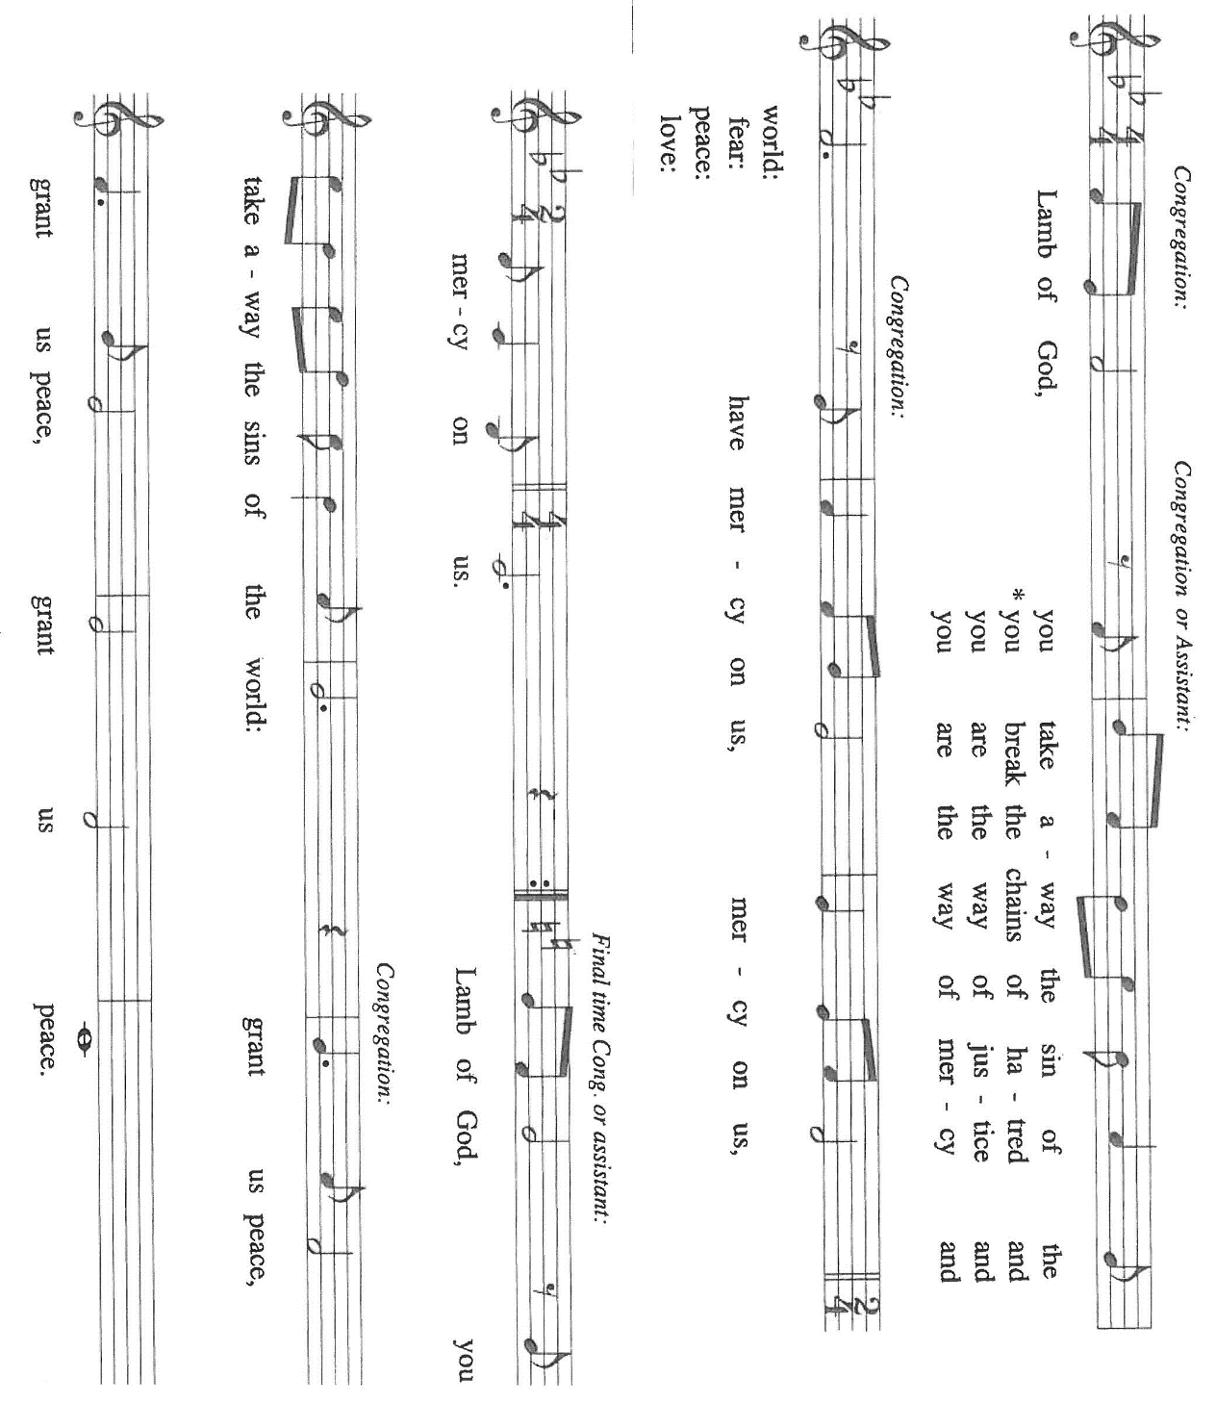

HYMN DURING DISTRIBUTION 623 Rock of Ages, Cleft for Me

NSB 92 Trading My Sorrow
ELW 333 Jesus is a Rock in a Weary Land
ELW 485 I Am the Bread of Life
ELW 770 Give Me Jesus

As you are able please rise

THE POST-COMMUNION BLESSING

P: The Body and Blood of our Lord Jesus Christ strengthen you and keep you in His grace.

C: Amen.

THE POST-COMMUNION PRAYER

A: Let us pray. Lord Jesus, once again You have revealed Yourself to us in Your Body and Blood.
Send us now, armed with Your Spirit, strong with the keys of the Kingdom, that we may bind
all that brings death and loose the power of Your life and love to all the works of Your hands.
We bless You now and forever.

C: Amen.

SENDING

THE BENEDICTION

P: Almighty God: Father, Son, and Holy Spirit bless you now and forever.

C: Amen.

THE SENDING HYMN 820 O Savior, Precious Savior

THE DISMISSAL

A: Go forth with God’s blessing to love and serve the Lord.

C: Thanks be to God!

POSTLUDE

To God Alone Be Glory

The Meditation is from Sundays and Seasons Online. Copyright Augsburg Fortress 2016.

The Prayers, Introduction to the Lord’s Prayer, and Invitation to the Meal are adapted from Prayers
For Sundays and Seasons. Year A. Peter J. Scagnelli. (Chicago: Liturgy Training Publications, 1998) 120-21.

The musical setting of the liturgy, “Now the Feast and Celebration” by Marty Haugen, is used by
permission of GIA Publishers, Inc. OneLicense.net License #A-702836.

ANNOUNCEMENTS

Please remember to mail your offering to the Church Office at 818 Franklin Street, Michigan City, IN 46360. Another alternative is to give on-line through Tithe.ly. Please see your closure letter for information on how to set up a Tithe.ly account.

St. Paul Members are reminded to have a loved one contact the office if you are hospitalized. Many times, the Pastor doesn’t know someone is in the hospital. If you call and leave a message, please tell us at which hospital the patient is located.

BIRTHDAYS: David Jocelyn (8/27); Sandy Galinowski (8/31)

PRAYER CONCERNS: Debbie Martin; Mark Tannehill; Kathy Stein; Jan Paholski; Laura Dovey; Bill Hazelgrove; Al Levenhagen; Carl Wipperman; Major Payne.

OFFICE HOURS: Libby will be in the office on Mondays, Wednesdays, and Fridays; volunteers will cover Tuesdays and Thursdays.

Monday & Wednesday 8:00 a.m. – 5 p.m.
Tuesday & Thursday 9:00 a.m. – 12:00 p.m.
Friday 8:00 a.m. – 12:00 p.m.

If you are listening to the worship broadcast on the radio and would like to watch the Sunday morning service live stream follow these steps:

(1) If you have You Tube available on your TV, search for
St. Paul Lutheran Church Michigan City, IN.

(2) The direct link on the computer is https://
www.youtube.com/channel/UC5AIPNaKr3QN50984jGOa1g

(3) This link is also on the main page of the church’s website in
the church section and will continue to be posted weekly on the St.
Paul Facebook page.

And it will always be available on the radio broadcast Sunday mornings at 11:00 a.m.
on WEFM (95.9), and on the local cable access station #99 for the previous week’s
service on Sundays at 4:00 p.m. and the current service on Wednesdays at 7:00 p.m.
and Fridays at 8:30 p.m.

To send e-mail to the church office, please use the following addresses:

Pastor Mark Reshan: seniorpastor@stpaulmichigancity.com

Church Office Secretary (Libby Pollock): churchsecretary@stpaulmichigancity.com

Church Treasurer (Karen Fleming): finance@stpaulmichigancity.com

2026 Church Council:

Pastor - Mark Reshan

President - Donna Knoll

Vice President - Jan Bakken

Secretary - Judy Hunt

Treasurer - Karen Fleming

Members: Sue Koziel; Jim Schraidt; Trish Sprague; Bob Kiser; Barry Anderson; and
Pam Soule

Worship Attendance:

Wednesday, August 12, 2026 Organ Concert @12:15 p.m. 19

Saturday, August 15, 2026 @ 4:00 p.m. 19

Sunday, August 16, 2026 @ 9:00 a.m. 53

TOTAL 91

Copies of the minutes from the June 25, 2026 and July 23, 2026 Church Council meetings are on the back table in the upper Narthex. They were approved by the council via email.

Good News Newsletter: If you have an article or anything you want included in The Good News please send it to the following e-mail address: splcgoodnews@gmail.com. Pastor Pamela Thiede will be using this e-mail address to assemble The Good News each month. The deadline for getting information to Pastor Pamela will be the 20th of each month.

Next week’s lessons are Jeremiah 15: 15-21; Psalm 26: 1-8; Romans 12: 9-21;
Matthew 16: 21-28 for those of you who like to study them in advance.

MISSION OF THE MONTH FOR AUGUST 2026
Mission of the Month for August 2026 is for Michigan City Area Schools – we will be collecting money to support different projects in various elementary schools in Michigan City through Donors Choose. Donors Choose provides a list of teacher-led classroom projects that need funding. Please consider donating to help fund our local teachers’ classroom projects. Checks can be written to St. Paul and can be marked for MCAS and placed in the offering plate. Noisy coin offering will also support the mission of the month. To see a full list of projects, visit www.donorschoose.org and search for Michigan City.

2026 Financial Stewardship

Weekly Church Operating Needs (x 2 weeks)
August 8-9, 2026 and August 15-16, 2026: $ 11,211.00

General Fund (including General Memorials): $ 5,206.00

Overage/Shortage: — $ 6,005.00

Restricted Income (not including Memorials)
Supports IK Synod & Church wide Ministries: $ 344.00

Ministries in our Community/Congregation: $ 35.00

Capital Fund: $ 202.00

SEPTEMBER 2026 MONTHLY MISSION:
SHRINER’S CHILDREN’S HOSPITAL

We all know Shriner’s from their commercials and their little red hats, but nearly 20,000 children each year get to know Shriner’s Children’s Hospital in Chicago for their incredible pediatric specialty care. The hospital opened in March of 1926 with 60 beds.

60 0% of patients suffered with polio and often lived at the hospital for up to a year. Over the next few decades, an orthopedic residency, bone rodding surgery, halo ring implantation, cleft lip and palate repair, pediatric spinal cord injury surgery, and motion analysis services were added. Our very own little one, Maggie Brooks, has been visiting Shriner’s in Chicago since four weeks old to correct bilateral clubfoot, a condition where she was born with both feet turned inward and upward. Shriner’s offers care to all families no matter their ability to pay or insurance status. They even have financial assistance programs that help reimburse for transportation or lodging if needed.

At Shriner’s Chicago, every child who is inpatient receives a handmade blanket and goody bag upon arrival to the hospital. We will be collecting the following items to help fill their goody bags:
Small cars or toys
Card games
Small activity books
New or gently used children’s books
Please place items in the bin in the outer narthex. If you would like to support Shriner’s financially, please make checks out to St. Paul’s and mark for Shriner’s Children’s Hospital and place in the offering plate. Noisy coin offering will also go towards the mission of the month. Thank you for your generosity!

ACTIVITIES, EVENTS & MEETINGS
AUGUST 2026

Sunday, August 16, 2026 @ 9:00 a.m. 12th Pentecost Worship Service /Sanctuary/coffee after
Monday, August 17, 2026 @ 7:00 p.m. Women’s Bible Study/St. Paul Room
Wednesday, August 19, 2026 @ 10:00 a.m. God’s Purls
@ 12:15 p.m. Last Organ Concert Summer Series. 2026
@ 4:30 p.m. Choir Rehearsal/Sanctuary
Saturday, August 22, 2026 @ 4:00 p.m. 13th 21`Pentecost Worship Service/Sanctuary

Sunday, August 23, 2026 @ 9:00 a.m. 13th Pentecost Worship Service/Sanctuary/coffee after
Monday, August 24, 2026 @ 2:00 p.m Finance Comm. Mtg./Luther House
@ 3:00 p.m. Executive Board Mtg./Luther House
Wednesday, August 26, 2026 @ 10:00 a.m. God’s Purls
Thursday, August 27, 2026 @ 3:00 p.m. Church Council Mtg./St. Paul Room
Saturday, August 29, 2026 @ 4:00p.m 14 Pentecost Worship Service/Sanctuary

Sunday, August 30, 2026 @ 9:00 a.m. 14 Pentecost Worship Service/Sanctuary/coffee after

PLEASE NOTE:
God’s Purls are still meeting every week on Wednesdays at 10:00 a.m. but they are no longer meeting in the St. Paul Room at the church. If you have any questions or concerns please contact Judy Mutchler at: (219) 229-4764.

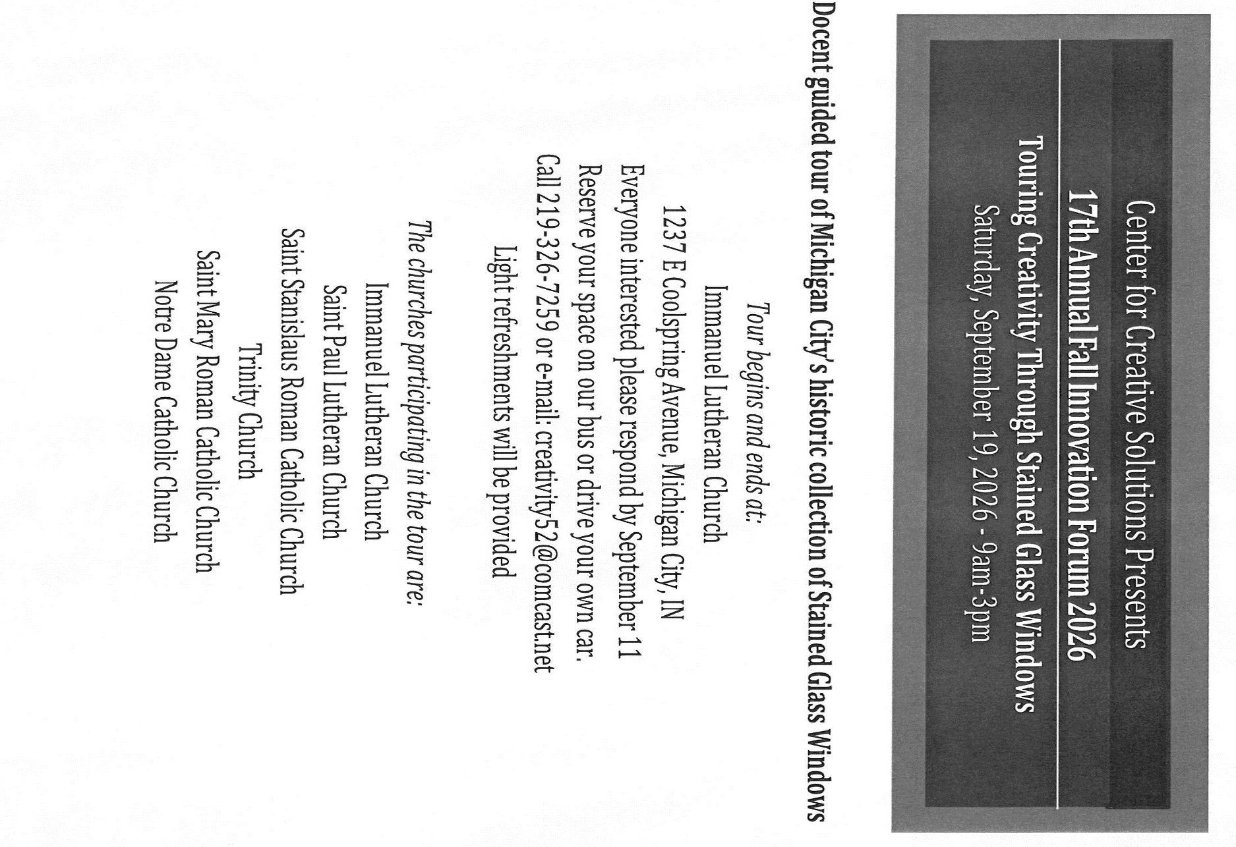



SUMMER BIRTHDAYS
Did you have your birthday this summer, in June, July or August? Next weekend, during the coffee hour after the Sunday morning service, on August 30th, we will celebrate you and your birthday with cake, coffee and water. Plan on joining us after Sunday service!

PANCAKE BREAKFAST
There will be a pancake breakfast at St. Paul Lutheran Church, 818 Franklin Street in Michigan City on Saturday, September 12th from 8:30 am – 11:00 am and everyone is welcome! Menu includes pancakes, sausage, scrambled eggs, orange juice, and coffee – all for just $5. Come join us for food and fellowship!

