**THE SUNDAY OF THE PASSION/PALM SUNDAY**

**April 10, 2022**

The cross is the tree of my eternal salvation nourishing and delighting me. I take root in its roots, and I am wholly delighted by its fruits. This is my nourishment when I am hungry, my fountain when I am thirsty, my covering when I am stripped, for my leaves are no longer fig leaves but the breath of life.

This is my safeguard when I fear God and my support when I falter. This is the ladder of Jacob, the way of angels, at the summit of which the Lord is truly established. This is my tree, wide as the firmament, which extends from earth to the heavens. It is the pillar of the universe, the support of the whole world, holding together the variety of human nature, and riveted by the invisible bolts of the Spirit, so that it may remain fastened to the divinity and impossible to detach.

**Anonymous third-century homily**

It is ourselves that we must spread under Christ’s feet, not coats or lifeless branches or shoots of trees, matter which wastes away and delights the eye for only a few brief hours. But we have clothed ourselves with Christ’s grace, with the whole Christ—“for as many of you were baptized into Christ have put on Christ”—so let us spread ourselves like coats under his feet.

**Andrew of Crete**

**Eighth century**

***✠******In the Name of Jesus ✠***

**INTRODUCTION**

*On this day, the church continues in procession with our crucified and risen Lord. He is in our midst as we hear of his life-giving death and as we share his body and blood. At the beginning of this great week, the gospel reading sets forth the central mystery of the Christian faith: Christ emptied himself in death so that we might know God's mercy and love for all creation.*

**Mikael Agricola, Bishop of Turku, died 1557**

*Consecrated bishop of Turku, Finland, without the approval of the pope, Agricola began a reform along Lutheran lines. In only three years, he translated the New Testament and worship texts into Finnish, in the process establishing the rules of Finnish writing that are still used today.*

**✠ GATHERING ✠**

**PRELUDE**

**ANNOUNCEMENTS**

**THE PROCESSION WITH PALMS**

P: Blessed is He Who comes in the name of the Lord.

C: **Hosanna to the Son of David.**

P: The Lord be with you.

C: **And also with you.**

P: Let us pray. Mercifully assist us, O Lord God of our salvation, that we may enter with

joy upon the contemplation of those mighty acts whereby You have given us life

everlasting; through Your Son, Jesus Christ our Lord.

C: **Amen.**

**THE PROCESSIONAL GOSPEL: Luke 19:28-40**

28After He had said this, He went on ahead, going up to Jerusalem. 29When He had come near Bethphage and Bethany, at the place called the Mount of Olives, He sent two of the disciples, 30saying, "Go into the village ahead of you, and as you enter it you will find tied there a colt that has never been ridden. Untie it and bring it here. 31If anyone asks you, 'Why are you untying it?' just say this, 'The Lord needs it.'" 32So those who were sent departed and found it as He had told them. 33As they were untying the colt, its owners asked them, "Why are you untying the colt?" 34They said, "The Lord needs it."

35Then they brought it to Jesus; and after throwing their cloaks on the colt, they set Jesus on it. 36As He rode along, people kept spreading their cloaks on the road. 37As He was now approaching the path down from the Mount of Olives, the whole multitude of the disciples began to praise God joyfully with a loud voice for all the deeds of power that they had seen, 38saying,

"Blessed is the king who comes in the name of the Lord!

Peace in heaven, and glory in the highest heaven!"

39Some of the Pharisees in the crowd said to Him, "Teacher, order your disciples to stop." 40He answered, "I tell you, if these were silent, the stones would shout out."

A: The Gospel of the Lord.

C: **Praise to You, O Christ!**

*The congregation raises their palm branches*

P: The Lord be with you.

C: **And also with you.**

P: Let us give thanks to the Lord our God.

C: **It is right to give Him thanks and praise.**

P: We praise and thank You, O God, for the great acts of love by which You have redeemed

us through Your Son, Jesus Christ our Lord. On this day He entered the holy city of

Jerusalem in triumph, and was acclaimed Son of David and King of kings by those who

scattered their garments and branches of palm in His path.

We ask that You bless these branches and those who bear them, and grant that we may

ever hail Him as our Lord and King and follow Him with perfect confidence; through

the same Jesus Christ, our Lord, Who lives and reigns with You and the Holy Spirit,

one God, now and forever.

C: **Amen.**

P: Let us go forth in peace.

C: **In the name of the Lord.**

**THE PROCESSIONAL HYMN** *All Glory, Laud, and Honor*

The hymn is repeated until all are in their seats

**Refrain: All glory, laud, and honor to You, redeemer, King,**

**To Whom the lips of children made sweet hosannas ring.**

1. You are the King of Israel, and David’s royal Son, now in the Lord’s name coming,

our King and Blessed One. **Refrain**

2. The company of angels are praising You on high; creation and all mortals in chorus

make reply. **Refrain**

3. The multitude of pilgrims with palms before You went. Our praise and prayer and

anthems before You we present. **Refrain**

4. To You, before Your Passion, they sang their hymns of praise. To You, now high

exalted, our melody we raise. **Refrain**

5. Their praises You accepted; accept the prayers we bring, great Author of all

goodness, O good and gracious King. **Refrain**

*When all have reached their seats*

P: Blessed is He Who comes in the name of the Lord.

C: **Hosanna in the highest!**

**THE PRAYER OF THE DAY**

P: The Lord be with you.

C: **And also with you.**

P: Let us pray. Sovereign God, You have established Your rule in the human heart through

the servanthood of Jesus Christ. By Your Spirit, keep us in the joyful procession of

those who with their tongues confess Jesus as Lord and with their lives praise Him as

Savior, Who lives and reigns with You and the Holy Spirit, one God, now and forever.

C: **Amen.**

*The assembly is seated*

**✠ WORD ✠**

**FIRST READING Isaiah 50:4-9a**

*This text, the third of the "Servant Songs" that arose in the last years of Israel's exile in Babylon, speaks of the servant's obedience in the midst of persecution. Though the servant has been variously understood as the prophet himself or a remnant of faithful Israel, Christians have often recognized the figure of Christ in these poems.*

4The Lord God has given me

the tongue of a teacher,

that I may know how to sustain

the weary with a word.

Morning by morning He wakens--

wakens my ear

to listen as those who are taught.

5The Lord God has opened my ear,

and I was not rebellious,

I did not turn backward.

6I gave my back to those who struck me,

and my cheeks to those who

pulled out the beard;

I did not hide my face

from insult and spitting.

7The Lord God helps me;

therefore I have not been disgraced;

therefore I have set my face like flint,

and I know that I shall not be put to shame;

8He Who vindicates me is near.

Who will contend with me?

Let us stand up together.

Who are my adversaries?

Let them confront me.

9It is the Lord God who helps me;

who will declare me guilty?

The Word of the Lord.

**Thanks be to God.**

**THE PSALM: Psalm 31:9-16** Refrain by Robert Buckley Farlee

Choir sings refrain first, followed immediately by

congregation, and as indicated

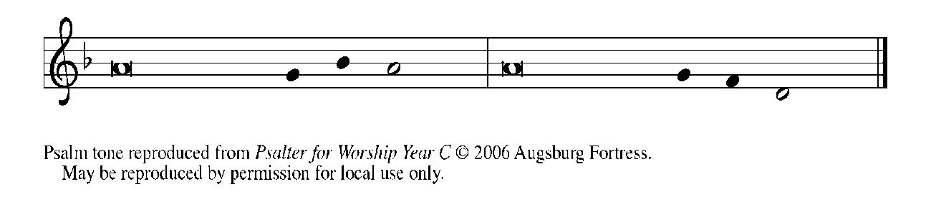

9Have mercy on me, O Lord, for I | am in trouble;*

my eye is consumed with sorrow, and also my throat | and my belly.

**10For my life is wasted with grief, and my | years with sighing;\***

**my strength fails me because of affliction, and my bones | are consumed.**

11I have become a reproach to all my enemies and even to my neighbors,

a dismay to those of | my acquaintance;*

when they see me in the street | they avoid me.

**12I am forgotten like a dead man, | out of mind;\***

**I am as useless as a | broken pot. REFRAIN**

13For I have heard the whispering of the crowd; fear is | all around;*

they put their heads together against me; they plot to | take my life.

**14But as for me, I have trusted in | You, O Lord.\***

**I have said, "You | are my God.**

15My times are | in Your hand;*

rescue me from the hand of my enemies, and from those who | persecute me.

**16Make Your face to shine up- | on Your servant,\***

**and in Your loving- | kindness save me." REFRAIN**

**SECOND READING Philippians 2:5-11**

*Paul quotes from an early Christian hymn that describes Jesus' humble obedience, even to death, and his exaltation as Lord of all.*

5Let the same mind be in you that was in Christ Jesus,

6Who, though He was in the form of God,

did not regard equality with God

as something to be exploited,

7but emptied Himself,

taking the form of a slave,

being born in human likeness.

And being found in human form,

8He humbled Himself

and became obedient to the point of death --

even death on a cross.

9Therefore God also highly exalted Him

and gave Him the name

that is above every name,

10so that at the name of Jesus

every knee should bend,

in heaven and on earth and

under the earth,

11and every tongue should confess

that Jesus Christ is Lord,

to the glory of God the Father.

The Word of the Lord.

**Thanks be to God.**

**THE HOMILY**

*As you are able please rise*

**THE VERSE**

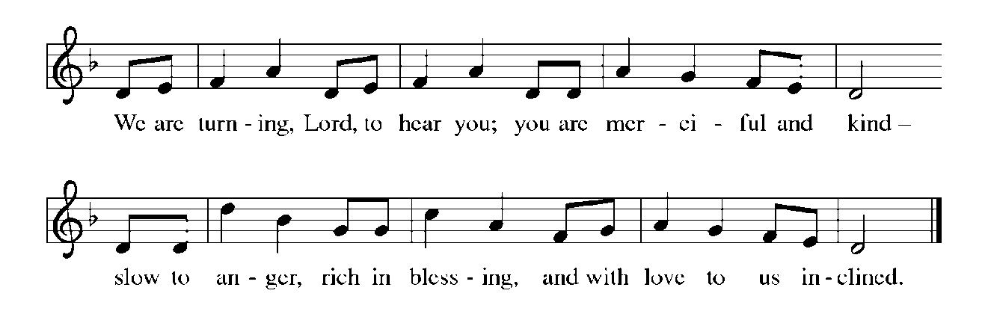

**THE HOLY GOSPEL Luke 23:1-49**

Through the teachings and events of the passion story we see and hear the great contradictions that characterize the coming of God’s reign. The leader serves, the empty disciples are able to fill others, proud Peter is revealed in his cowardice, and Jesus—the innocent bringer of life—is arrested, beaten, executed, and buried.

P: The Passion of our Lord Jesus Christ according to St. Luke.

C: **Glory to You, O Lord!**

*The assembly is seated and responds as indicated in the Passion account insert*

P: The Gospel of the Lord.

C: **Praise to You, O Christ!**

*The assembly is seated*

*Silence for meditation is kept*

*As you are able please rise*

**HYMN OF THE DAY NSB 6 *Amazing Love***

**THE PRAYER OF THE CHURCH**

A: Christ Jesus was obedient unto death on a cross and exalted by God. He continues to

plead for all humanity. Let us join Him in prayer for the Church, the world, and all

those in any need.

A: That the love of God shown in the passion of Christ might be reflected in the Church’s

words of hope and its works of compassion, let us pray to the Lord:

C: **Lord, have mercy.**

A: That the celebrations of Passover and Easter be delivered from violence and bloodshed,

let us pray to the Lord:

C: **Lord, have mercy.**

A: That through our journey again with Christ to death and into resurrection life this

congregation’s ministry might be renewed and our faith and hope strengthened, let us

pray to the Lord:

C: **Lord, have mercy.**

A: That those in any need, especially the sick: especially . . .might find comfort and healing

from the Christ Who bears all our suffering, let us pray to the Lord:

C: **Lord, have mercy.**

A: That those celebrating birthdays, especially **Lucille Tryon and Karen Kiser** may be

filled with grace this day and every day and grow in grace in the days ahead, let us pray

to the Lord:

C: **Lord, have mercy.**

A: That with all the faithful, especially **Mikael Agricola, Bishop of Turku,** whom we

commemorate this Day we may one day celebrate with them the unending Feast of the

Paschal Lamb, let us pray to the Lord:

C: **Lord, have mercy.**

P: Father, the prayer of Christ brought forgiveness to those who crucified Him, and the

prayer of the thief brought him a place with Christ at Your side. Hear the prayers we

now make to You, and sustain Your people in their need. We ask this through Christ,

our crucified Lord.

C: **Amen.**

**✠ MEAL✠**

**THE PEACE**

P: The peace of the Lord be with you always.

C: **And also with you.**

*The assembly is seated*

**THE OFFERING**

**THE VOLUNTARY  *Hosana* St. Paul Senior Choir**

(by Hazel Hedges)

*As you are able please rise*

**THE OFFERTORY**

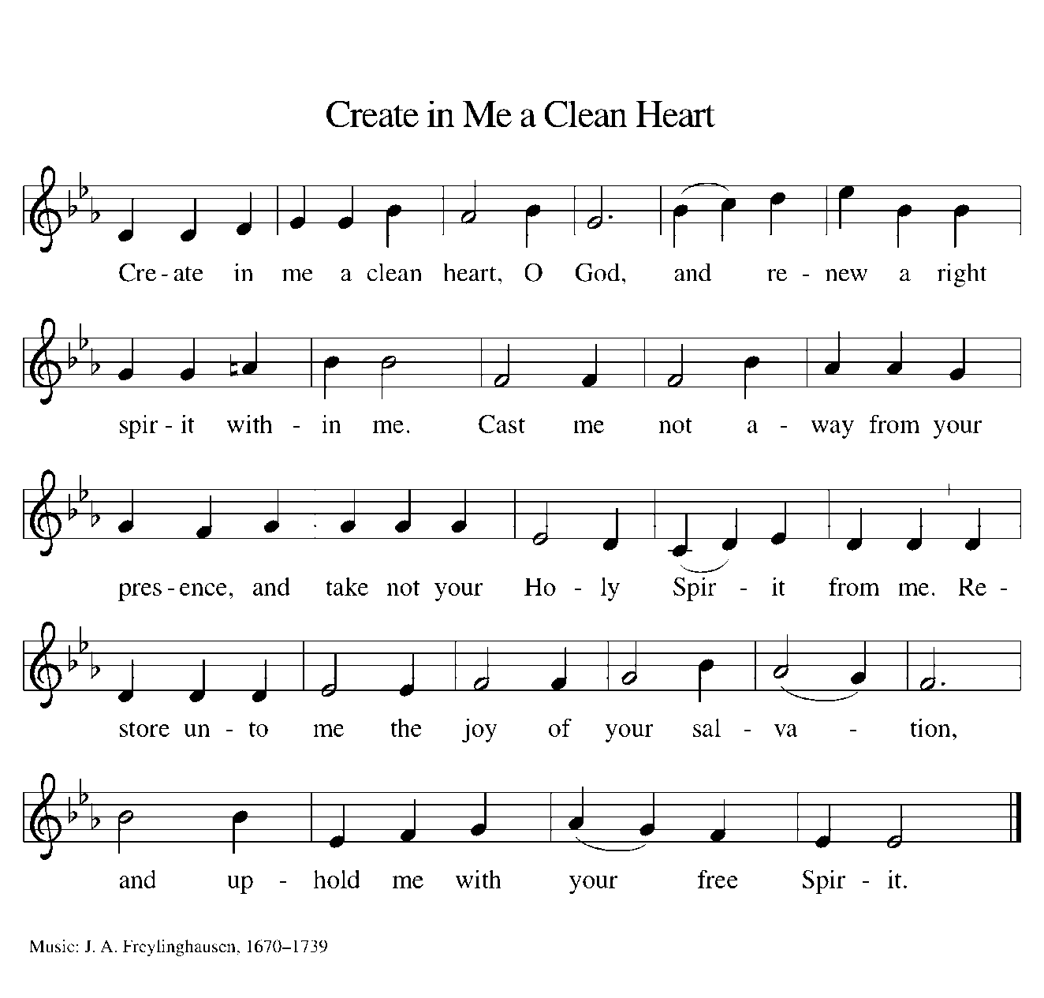

**THE OFFERTORY PRAYER**

A: Let us pray. Gracious God,

C: **Receive these offerings as the fruit of our deep love for Your Son Who loved us**

**even into death. Through the sacrifice of His life, may we receive Your love and**

**mercy. We ask this in the name of Jesus the Lord. Amen.**

**THE GREAT THANKSGIVING**

P: The Lord be with you.

C: **And also with you.**

P: Lift up your hearts.

C: **We lift them up to the Lord.**

P: Let us give thanks to the Lord our God.

C: **It is right to give Him thanks and praise.**

P: It is our joy and destiny to praise You, Lord God, for in wondrous love You cast stars

into space, and in meek obedience Your Son surrendered to cruel nails.

With loving-kindness You called Your people in Abraham, and in covenant with

Moses You bound up Your life in theirs.

Through exile You stayed close to them, and in Jesus You came among them, bearing

the fullness of grace and truth.

Your Son Jesus faced rejection, cruelty, and death, yet in resurrection You exalted

Him, and in sending Your Spirit You shed glory on all people.

Hosanna is our cry, Blessed One.

You Son comes on a donkey in Your name.

As Jesus entered Jerusalem to bear our sorrows and to suffer for our sins, enter our

hearts and confront our waywardness today.

Send Your Holy Spirit upon us, that we may be Your Son’s crucified and risen Body.

Send Your Spirit upon this bread that it may be living Bread, and on this wine that

it may be the cup of salvation, that together they may be for us the Body

and Blood of Your Son Jesus Christ,

Who in the night ... “Do this for the remembrance of Me.”

As often as we eat ... we proclaim the Lord’s death until He comes.

C: **Christ has died. Christ is risen. Christ will come again.**

P: Humble God, Your Son did not exploit His status but emptied Himself.

Pour out Your Spirit on all who are exploited, in world or Church, on all who are

humbled, by state or employer or family member, on all who are emptied

of hope, faith, or love.

As You highly exalted Your Son Who had become a slave, highly exalt Your

children who suffer for righteousness, or grieve those they have cherished,

or bend the knee to one who does not honor them.

Fill the earth with Your justice and peace, until every heart shall sing and every

tongue confess that You are the joy of their desiring:

Father, ✠ Son, and Holy Spirit, ever one God, in all ages and forevermore.

C: **Amen!**

**THE LORD’S PRAYER**

P: Baptized into Christ’s death that we might share in the resurrection, let us pray for the

fulfillment of the mystery as Jesus taught us:

C: **Our Father in heaven, hallowed be Your name. Your Kingdom come. Your will**

**be done on earth as it is in heaven. Give us this day our daily bread, and forgive**

**us our sins as we forgive those who sin against us. Save us from the time of trial**

**and deliver us from evil. For the Kingdom, the power, and the glory are Yours,**

**now and forever. Amen.**

**INVITATION TO THE MEAL**

P: Behold the Servant of God, obedient unto death on a cross, highly exalted as Lord of

glory. Blessed are those who are called to the banquet of the Lamb. God’s holy gifts

for God’s holy people. Come, for all is now ready.

*The assembly is seated*

**THE DISTRIBUTION**

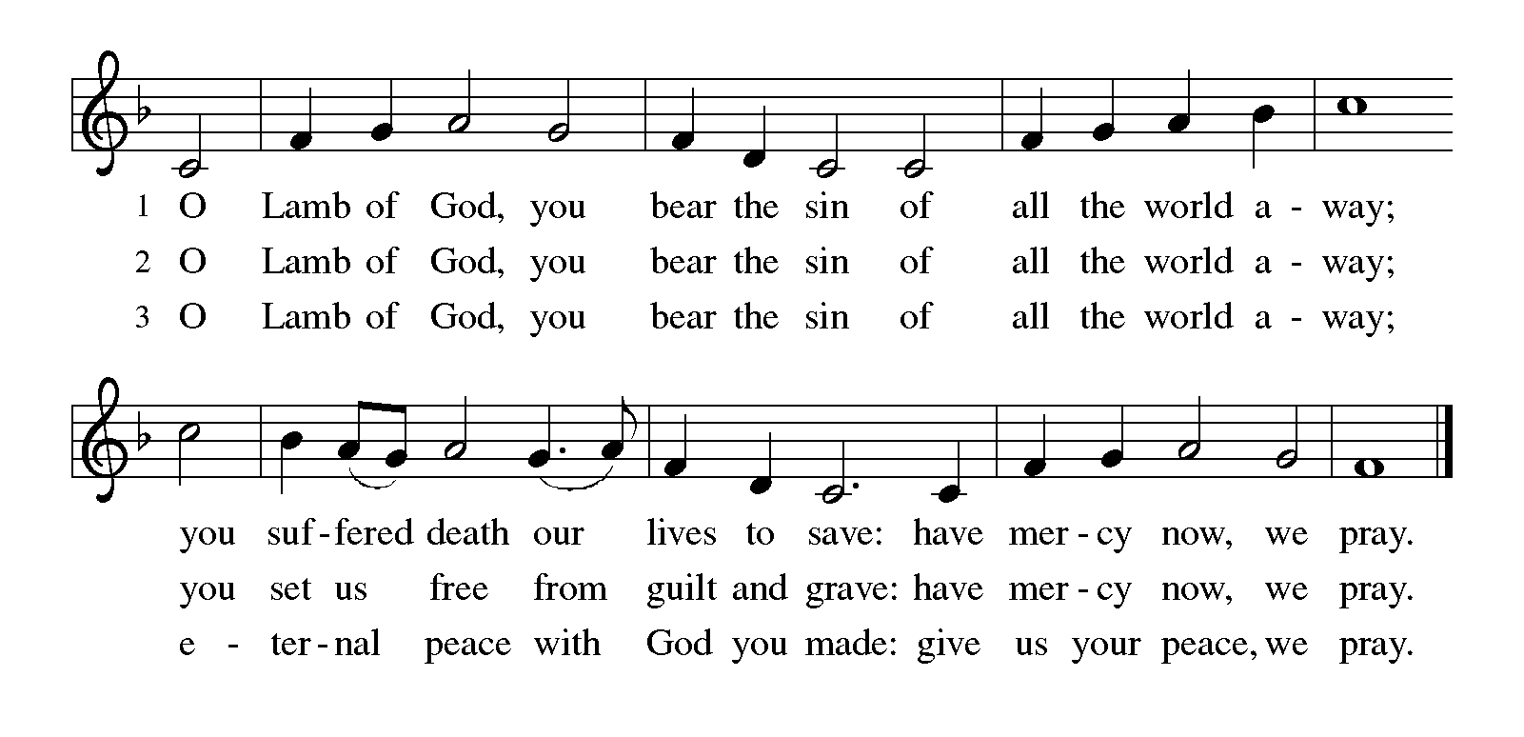

Those wishing to receive the Laying on of Hands, Anointing with Oil, and Prayer for Healing may go to Pastor or the Assisting Minister at each side aisle

**HYMN DURING DISTRIBUTION 616 *Jesus, Remember Me (sung three times)***

**NSB 88 *There is a Redeemer***

**NSB 66 *Make Me a Servant***

**NSB 59 *Jesus, Name Above All Names***

*As you are able please rise*

**THE POST COMMUNION BLESSING**

P: The Body and Blood of our Lord Jesus Christ strengthen you and keep you in His

grace.

C: **Amen.**

**THE POST-COMMUNION PRAYER**

A: Let us pray. Lord God, by His death on the cross Your Son freed us from bondage to

sin and death. Watch over Your Church, and all who celebrate these Holy Mysteries.

Help us in this Week to follow in His path from death to new life. We ask this through

Christ our Lord.

C: **Amen.**

**✠ SENDING ✠**

**THE BENEDICTION**

P: Jesus took the form of a servant and was obedient to death, even death on a cross. May

you follow His example and share in the resurrection.

C: **Amen.**

P: Almighty God: Father, Son, ✠ and Holy Spirit bless you now and forever.

C: **Amen.**

**SENDING SONG NSB 44 *He is Exalted***

**THE DISMISSAL**

A: Reconciled to God through Christ, let us go out into the world in peace.

C: **Thanks be to God!**

***✠ To God Alone Be Glory ✠***

The Mediation is from "The Pasch History," in The Paschal Mystery: Ancient Liturgies

and Patristic Texts, ed. A. Hamman, O.F.M. (Staten Island, NY: Alba, 1969), pp.

64-65.

The Eucharistic Prayer is adapted from *Eucharistic Prayers.* Samuel Wells and Abigail

Kocher. (Grand Rapids: Eerdmann’s Publishing Company, 2016) 150-51.

**ANNOUNCEMENTS**

**Please remember to mail your offering to the Church Office** at 818 Franklin Street, Michigan City, IN 46360**.** Another alternative is to give on-line through Tithe.ly. Please see your closure letter for information on how to set up a Tithe.ly account.

**St. Paul Members are reminded to have** a loved one contact the office if you are hospitalized. Many times, the Pastor doesn’t know someone is in the hospital. If you call and leave a message, please tell us which hospital the patient is at.

**Next Sunday’s lessons are Isaiah 65: 17-25 or Acts 10: 34-43; Psalm 118: 1-2, 14-24; I Corinthians 15: 19-26; Luke 24: 1-12 or John 20: 19-31** for those of you who like to study them in advance.

**Birthdays: Jana Thomas (4/1); Lyle Peters (4/2); Sarah McNabb (4/3).**

**PRAYER CONCERNS:** Audrey Beyer, Ryan Krueger, Donna Bostater, Maxine Powell, Jim Tomscheck, Ken Mulder, Roger Milzarek, Eloise Ponder, Mark & Jary Tannehill and Leonard Cross.

**If you requested someone’s name to be on the prayer list and are aware that they need continued imminent prayer then contact the church office and let us know.** Otherwise we will gradually transfer names to the long-term list.

**OFFICE HOURS:** Libby will be in the office on Mondays, Wednesdays, and Fridays; volunteers will cover Tuesdays and Thursdays.

Monday & Wednesday 8:00 a.m. – 5 p.m.

Tuesday & Thursday 9:00 a.m. – 12:00 p.m.

Friday 8:00 a.m. – 12:00 p.m.

**If you are listening to the worship broadcast on the radio and would like to watch the Sunday morning service live stream follow these steps:**

1. If you have You.Tube available on your TV, search for

**St. Paul Lutheran Church Michigan City, IN.**

(2) The direct link on the computer is

https://www.youtube.com/channel/UC5AIPNaKr3QN50984jGOa1g.

(3) This link is also on the main page of the church’s website in the church section and will continue to be posted weekly on the St. Paul Facebook page.

And it will always be available on the radio broadcast Sunday mornings at 11:00 a.m. on WEFM (95.9), and on the local cable access station #99 for the previous week’s service on Sundays at 4:00 p.m. and the current service on Wednesdays at 7:00 p.m. and Fridays at 8:30 p.m.

**To send e-mail to the church office**, please use the following addresses:

Pastor Mark Reshan: seniorpastor@stpaulmichigancity.com

Church Office Secretary (Libby Pollock): churchsecretary@stpaulmichigancity.com

Church Treasurer (Karen Fleming) and Bookkeeper (Billie Atchinson):

finance@stpaulmichigancity.com.

**The Good News Newsletter**: If you have an article or anything you want included in **The Good News** please send it to the following e-mail address: splcgoodnews@gmail.com. Pastor Pamela Thiede will be using this e-mail address to assemble **The Good News** each month. The deadline for getting information to Pastor Pamela will be the 20th of each month.

**WORSHIP ATTENDANCE for March 30, 2022**

**6:30 p.m.**

**WORSHIP ATTENDANCE for April 2 and 3, 2022**

**4:00 p.m. 25**

**9:00 a.m. 48**

**Total = 73**

**The Community Soup Kitchen serving out of First United Methodist is in need of volunteers.** Sunday through Tuesday is always need, as is occasionally Wednesdays and Thursdays. Hours are 9:30 a.m. to 1:15 p.m. and it is not necessary to stay the entire time. There is also a need for volunteers to be available to help pick up deliveries from the Food Bank when they arrive. If you are able to help please contact their church office at 872-7200.

**SENIOR COMMUNION LUNCHEON—**Immediately following the Senior Communion Service this coming Thursday, April 14, a light luncheon will be served in the St. Paul Room. You are invited to come and enjoy a time of fellowship and good food hosted by our Altar Guild.

**APRIL 2022 MEETINGS & ACTIVITIES**

Worship Service: **Palm Saturday**, April 9, 2022 at 4:00 p.m.

Worship Service: **Palm Sunday**, April 10, 2022 at 9:00 a.m.

Harmony Circle: Monday, April 11, 2022 at 12:30 p.m./Nursery

School Board Meeting: Monday, April 11, 2022 at 3:30 p.m./Luther House

Choir Rehearsal: Wednesday, April 13, 2022 at 7:00 p.m.

**Maundy Thursday Senior Communion & Luncheon**: April 14, 2022 at 10:00 a.m.

**Maundy Thursday**: April 14, 2022 at 7:00 p.m.

**Good Friday Tre Ore Worship:** April 15, 2022 at 12:00 p.m.—3:00 p.m.

**Good Friday Service of the Word:** April 15, 2022 at 7:00 p.m.

**Holy Saturday/The Great Vigil of Easter:** April 16, 2022 at 7:00 p.m.

**Easter Sunday:** April 17, 2022 at 9:00 a.m.

Finance Committee Meeting: Monday, April 18, 2022 at 4:00 p.m./St. Paul Room

Executive board Meeting: Monday, April 18, 2022 at 5:30 p.m./Luther House

Wednesday Bible Study: April 20, 2022 at 9:45 a.m./Luther House

God’s Purls: Wednesday, April 20, 2022 at 10:00 a.m./St. Paul Room

Worship & Music Committee: Wednesday, April 20, 2022 at 6:00 p.m.

Choir Rehearsal: Wednesday, April 20, 2022 at 7:00 p.m.

Church Council Meeting: Thursday, April 21, 2022 at 5:30 p.m./St. Paul Room

Worship Service: Saturday, April 23, 2022 at 4:00 p.m.

Worship Service: Sunday, April 24, 2022 at 9:00 a.m.

Wednesday Bible Study: April 27, 2022 at 9:45 a.m./Luther House

God’s Purls: Wednesday, April 27, 2022 at 10:00 a.m./St. Paul Room

GALVESTON GIVE-BACK: Thursday, April 28, 2022 4p.m.--10:00 p.m.

Worship Service: Saturday, April 30, 2022 at 4:00 p.m.

**REMINDER ABOUT EASTER PLANTS THAT WERE ORDERED:**

**Please plan on picking up your plant** after the Easter Morning Service by 11:30 a.m..

**2022 Financial Stewardship**

Weekly Church Operating Needs (x 2 weeks): $14,116.36

March 26 and 27, April 2 and 3, 2022

General Fund (including General Memorials): $10,377.00

Overage/Shortage: --$ 3,789.36

Restricted Income (not including Memorials)

Supports IK Synod & Churchwide Ministries: $635.00

Capital Fund: $ 375.00

**Memorials:**

General Fund: $ 100.00

Capital Fund: $ 20.00

Although this schedule was published last month, it might be helpful to repeat the list of worship services offered this Holy Week and Easter:

**April 9—4:00 p.m. Saturday of the Passion/Palm Saturday**

Procession with Palms; Holy Communion; the Passion according to St. Luke

**April 10—9:00 a.m. Sunday of the Passion/Palm Sunday**

Procession with Palms; Holy Communion; the Passion according to St. Luke

**April 14—10:00 a.m. Maundy Thursday Senior Communion**

**7:00 p.m. Maundy Thursday**

Foot Washing; Holy Communion; Stripping of the Altar

**April 15—12:00-3:00 p.m. Good Friday**

Tre Ore worship on “The Seven Last Words of Christ”

**7:00 p.m. Good Friday**

Service of the Word; the Passion according to St. John

**April 16—7:00 p.m. Holy Saturday**

The Great Vigil of Easter; the lighting of the new fire; Holy Communion

**April 17—9:00 a.m. Easter Sunday**

The Resurrection according to St. Luke; Holy Communion