REFORMATION
The Twenty-third Sunday after Pentecost
October 31, 2021

“When it comes to defining something as elusive and misunderstood as ‘faith,’ perhaps the way to begin is to say what it isn’t. There are at least three fundamental misconceptions of ‘faith’ at work in our society ...
...First, ‘faith’ is not assent to doctrines about God, creation, Jesus Christ, etc. This does not mean that ‘faith’ has nothing to do with ‘beliefs’ or cherished ‘truths’ of the tradition; it has. But ‘faith’ isn’t to be equated with giving credence to these teachings ...
...Second, ‘faith’ is not accepting ‘on authority’ (the authority of the church, the tradition, the Bible, parents and teachers, etc.) what one cannot personally experience or feel to be true. There is a necessary personal dimension in ‘faith’...
...Third, faith is not a vague spirituality, an belief-ful attitude towards life ...Like most of the primary concepts of biblical religion (love, hope, grace, compassion, forgiveness, wrath, repentance) ‘faith’ is a category of relationship ...Faith is response in relationship; it is an ongoing thing, a process. You can never say that you ‘have’ it as if it were a possession! Christians sometimes affirm that ‘faith’ is ‘a gift.’ This is true if it means that the faith response is a consequence of God’s grace. But the statement is misleading if it implies that the ‘gift’ is something one is allowed to keep.
One has to continue receiving it like the manna of the wilderness or the `daily bread' of Jesus' prayer. When the Protestant Reformers, following St. Paul (e.g. Rom. 4:16 f.),used the slogan, "justification by faith," they did not mean that we are considered righteous by God because we give assent to theological truths, or accept the teachings of the tradition on the church's authority, or cultivate a positive outlook; all such things the Reformers would have consigned to "works righteousness"! Rather, they meant that we are acceptable to God because we trust God. It is as simple and as profound as that.”

Douglas John Hall
“Faith: In Response to Relationship”

In the Name of Jesus

INTRODUCTION

On this day we celebrate the heart of our faith: the gospel of Christ—the good news—that makes us free! We pray that the Holy Spirit would continue to unite the church today in its proclamation and witness to the world. In the waters of baptism we are made one body; we pray for the day that all Christians will also be one at the Lord’s table.

GATHERING

PRELUDE Fanfare & Processional Lynn Trapp

ANNOUNCEMENTS

As you are able please rise

GATHERING SONG 654 The Church’s One Foundation page 10

THE GREETING AND PRAYER OF THE DAY

P: The grace of our Lord Jesus Christ, the love of God, and the communion of the Holy
Spirit be with you all.

C: And also with you.

P: Let us pray. Almighty God, gracious Lord, we thank You that Your Holy Spirit renews
the church in every age. Pour out Your Holy Spirit on Your faithful people. Keep them
steadfast in Your word, protect and comfort them in times of trial, defend them against
all enemies of the gospel, and bestow on the church Your saving peace, through Jesus
Christ, our Savior and Lord, Who lives and reigns with You and the Holy Spirit, one
God, now and forever.

C: Amen.

The assembly is seated
WORD

FIRST READING Jeremiah 31:31-34

In contrast to Judah's sin, which Jeremiah describes as "engraved on the tablet of their hearts" (17:1), the prophet envisions a future day when the law will be written "on their hearts" (31:33). To know God in this way is to have a direct and profound connection to God. Forgiveness of sins, which is so complete as to be forgotten, is the motivating force for keeping the law.

The days are surely coming, says the LORD, when I will make a new covenant with the house of Israel and the house of Judah. ³²It will not be like the covenant that I made with their ancestors when I took them by the hand to bring them out of the land of Egypt--a covenant that they broke, though I was their husband, says the LORD.
³³But this is the covenant that I will make with the house of Israel after those days, says the LORD: I will put my law within them, and I will write it on their hearts; and I will be their God, and they shall be my people. ³⁴No longer shall they teach one another, or say to each other, "Know the LORD," for they shall all know me, from the least of them to the greatest, says the LORD; for I will forgive their iniquity, and remember their sin no more.”

The Word of the Lord.

Thanks be to God.

THE PSALM: Psalm 46 Read responsively

¹God is our refuge and strength,
a very present help in trouble.

²Therefore we will not fear, though the earth be moved,
and though the mountains be toppled into the depths of the sea;

³though its waters rage and foam,
and though the mountains tremble at its tumult.

⁴The Lord of hosts is with us;
the God of Jacob is our stronghold.

⁵There is a river whose streams make glad the city of God,
the holy habitation of the Most High.

⁶God is in the midst of her; she shall not be overthrown;
God shall help her at the break of day.

⁷The nations make much ado, and the kingdoms are shaken;
God has spoken, and the earth shall melt away.

⁸The Lord of hosts is with us;
the God of Jacob is our stronghold.

⁹Come now and look upon the works of the Lord,
what awesome things He has done on earth.

¹⁰It is He Who makes war to cease in all the world;
He breaks the bow, and shatters the spear, and burns the shields with fire.

¹¹"Be still, then, and know that I am God;
I will be exalted among the nations; I will be exalted in the earth."

¹²The Lord of hosts is with us;
the God of Jacob is our stronghold.

SECOND READING Romans 3:21-28

Martin Luther and other leaders of the Reformation believed the heart of the gospel was found in these words of Paul written to the Romans. All people have sinned, but God offers forgiveness of sins through Christ Jesus. We are justified--put right with God--by the gift of God's grace, through faith in Jesus.

¹⁹Now we know that whatever the law says, it speaks to those who are under the law, so that every mouth may be silenced, and the whole world may be held accountable to God. ²⁰For "no human being will be justified in his sight" by deeds prescribed by the law, for through the law comes the knowledge of sin.
²¹But now, apart from law, the righteousness of God has been disclosed, and is attested by the law and the prophets, ²²the righteousness of God through faith in Jesus Christ for all who believe. For there is no distinction, ²³since all have sinned and fall short of the glory of God; ²⁴they are now justified by His grace as a gift, through the redemption that is in Christ Jesus, ²⁵Whom God put forward as a sacrifice of atonement by His blood, effective through faith. He did this to show his righteousness, because in His divine forbearance He had passed over the sins previously committed; ²⁶it was to prove at the present time that He Himself is righteous and that He justifies the one who has faith in Jesus.
²⁷Then what becomes of boasting? It is excluded. By what law? By that of works? No, but by the law of faith. ²⁸For we hold that a person is justified by faith apart from works prescribed by the law.

The Word of the Lord.

Thanks be to God.

As you are able please rise
THE VERSE

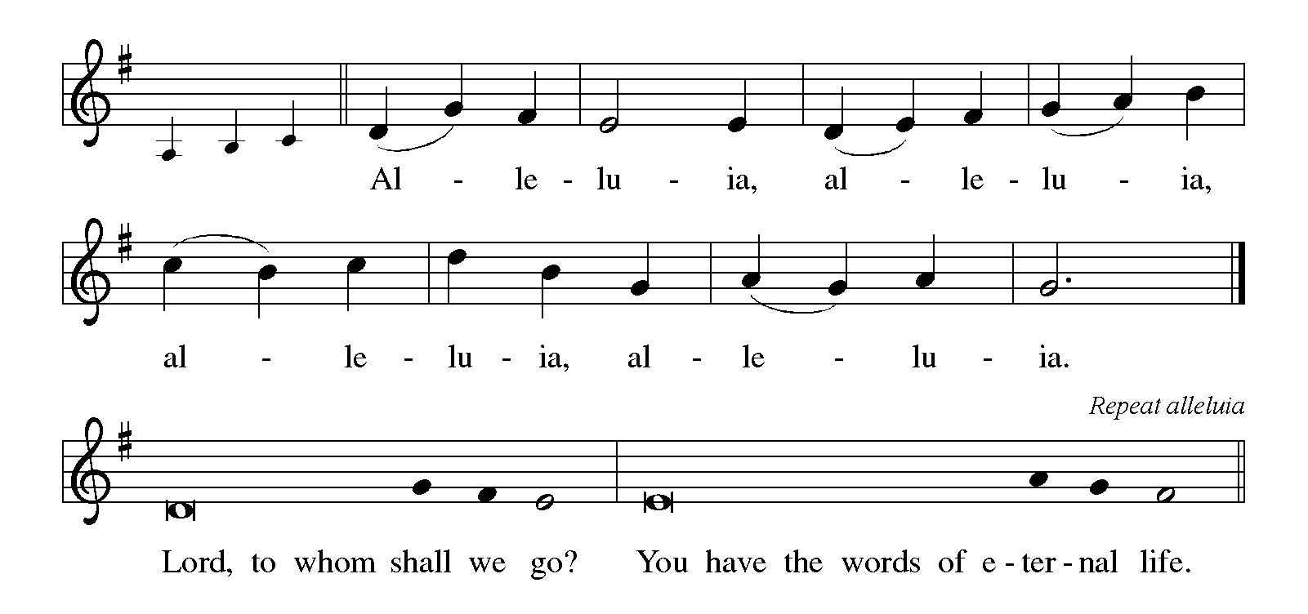

THE HOLY GOSPEL John 8:31-36

True freedom is not related to ethnic distinctions or social class. Only Jesus can free us from slavery to sin, and he does this through the truth of the gospel.

P: The Holy Gospel according to St. John, the eighth chapter.

C: Glory to You, O Lord!

Jesus said to the Judeans who had believed in him, "If you continue in my word, you are truly my disciples; ³²and you will know the truth, and the truth will make you free." ³³They answered him, "We are descendants of Abraham and have never been slaves to anyone. What do you mean by saying, 'You will be made free'?"
³⁴Jesus answered them, "Very truly, I tell you, everyone who commits sin is a slave to sin. ³⁵The slave does not have a permanent place in the household; the son has a place there forever. ³⁶So if the Son makes you free, you will be free indeed."

P: The Gospel of the Lord.

C: Praise to You, O Christ!

The assembly is seated

THE SERMON
Silence for reflection follows the sermon

As you are able please rise

THE HYMN OF THE DAY 517 Lord, Keep Us Steadfast in Your Word page 11

THE NICENE CREED

A: God has made us His people through our Baptism into Christ. Living together in trust
and hope, we confess our faith.

C: We believe in one God,
the Father, the Almighty,
maker of heaven and earth,
of all that is, seen and unseen.

We believe in one Lord, Jesus Christ,
the only Son of God,
eternally begotten of the Father,
God from God, Light from Light,
true God from true God,
begotten, not made,
of one Being with the Father.
Through Him all things were made.
For us and for our salvation
He came down from heaven;
by the power of the Holy Spirit
He became incarnate from the virgin Mary, and was made man.
For our sake He was crucified under Pontius Pilate;
He suffered death and was buried.
On the third day He rose again
in accordance with the Scriptures;
He ascended into heaven
and is seated at the right hand of the Father.
He will come again in glory to judge the living and the dead,
and His kingdom will have no end.

We believe in the Holy Spirit, the Lord, the giver of life,
Who proceeds from the Father and the Son.
With the Father and the Son He is worshiped and glorified.
He has spoken through the prophets.
We believe in one holy catholic and apostolic Church.
We acknowledge one Baptism for the forgiveness of sins.
We look for the resurrection of the dead,
and the life of the world to come. Amen

THE PRAYER OF THE CHURCH

A: That all people may come to know the grace of God in Christ, and be reformed into
God’s one people, let us know offer our prayer for the Church, the world, and all those
in need.

A: That the Church may constantly be reformed and renewed by God’s law of love written
on our hearts that we may proclaim Your hope, grace, and new life to the world, let us
pray to the Lord:

C: Lord, hear our prayer.

A: That by rain, rivers and oceans we might be reminded of how Your Word flows through
creation, surrounding us with grace and sealing us in the covenant of water and the
Spirit, let us pray to the Lord:

C: Lord, hear our prayer.

A: That God might break the bow, shatter the spear, burn the shield, and make wars to
cease, reconciling the nations to one another, let us pray to the Lord:

C: Lord, hear our prayer.

A: That this congregation might be renewed and re-formed by Jesus’ Word and live out
His forgiveness with humble, thankful, and loving hearts, let us pray to the Lord:

C: Lord, hear our prayer.

P: That caregivers might find respite, medical workers be infused with skill and
compassion, scientists and researchers might find cures, and those who need healing
and strength, especially …might find in God a very present stronghold of rest and
peace, let us pray to the Lord:

C: Lord, hear our prayer.

A: That those celebrating birthdays, especially Allen Sydow may be filled with grace this
day and every day and grow in grace in the days ahead, let us pray to the Lord:

C: Lord, hear our prayer.

A: That with Martin Luther, renewer of the Church, and all the saints who have called
the Church to faithfulness to Christ we might continue in His Word until we receive a
place in God’s household forever, let us pray to the Lord:

C: Lord, hear our prayer.

P: Into Your gracious hands, O Lord, we commend all for whom we pray, trusting in Your
mercy through Your Son, Jesus Christ our Lord.

C: Amen.
MEAL

THE PEACE

P: The peace of the Lord be with you always.

C: And also with you.

THE VOLUNTARY Lord, Keep Us Steadfast in Your Word Anton Wilhelm Leupold

As you are able please rise

THE OFFERTORY PRAYER

A: Let us pray. Gracious God,

C: You put forward Your Son, Jesus Christ, as a sacrifice to make us one with You.
We put forward these gifts as a pledge to You of our whole lives. Receive them
and bless them for Your service. By this holy Sacrament, help us to know Your
grace, and free us to live and serve with joy as Your beloved people. We ask this
in the name of Jesus the Lord. Amen.

THE GREAT THANKSGIVING

P: The Lord be with you.

C: And also with you.

P: Lift up your hearts.

C: We lift them up to the Lord.

P: Let us give thanks to the Lord our God.

C: It is right to give Him thanks and praise.

P: Holy God, our Refuge and Strength, we bless and praise You.
You are righteous in Your determination to always and forever have mercy.
That Your blessings of mercy might be known by all people, You chose Israel to be a
light of hope to the nations.
Ever faithful, even when they turned away, You promised a new covenant of
forgiveness that cannot be broken, and will yet come to pass.

At the last, You revealed Your righteousness in Your Son, Jesus Christ.
He is Your Word of truth Who makes us free.
In the night ... “Do this for the remembrance of Me.”
As often as we eat ... we proclaim the Lord’s death until He comes.

C: Christ has died. Christ is risen. Christ will come again.

P: With this bread and cup we remember our Lord’s life, Your mercy in flesh and blood,
and His willing death that made us right with You.
You raised Him from death that we might live in freedom from the powers of sin, evil,
and death.
He has promised to return to fulfill Your promise that You will be our God and we will
be Your people forever.
Send Your Spirit on us and these Your gifts of bread and wine.
May we who share the Lord’s Body and Blood be kept from fear and despair and
strengthened in our trust in Your covenant of life with all the world.
To You, O God: Father, Son, and Holy Spirit, be all honor and glory, in Your holy
heaven and on earth, now and forever.

C: Amen!

THE LORD’S PRAYER

P: That we may continue in Jesus’ word, let us pray as He taught His disciples:

C: Our Father in heaven, hallowed be Your name. Your Kingdom come. Your will
be done on earth as in heaven. Give us this day our daily bread. Forgive us our
sins as we forgive those who sin against us. Save us from the time of trial and
deliver us from evil. For the Kingdom, the power, and the glory are Yours, now
and forever. Amen.

INVITATION TO THE MEAL

P: This is the Lamb of God Who takes away the sin of the world. Blessed are those who
are called to the Supper of the Lamb. God's holy gifts for God's holy people. Come,
for all is now ready.

The assembly is seated

THE DISTRIBUTION

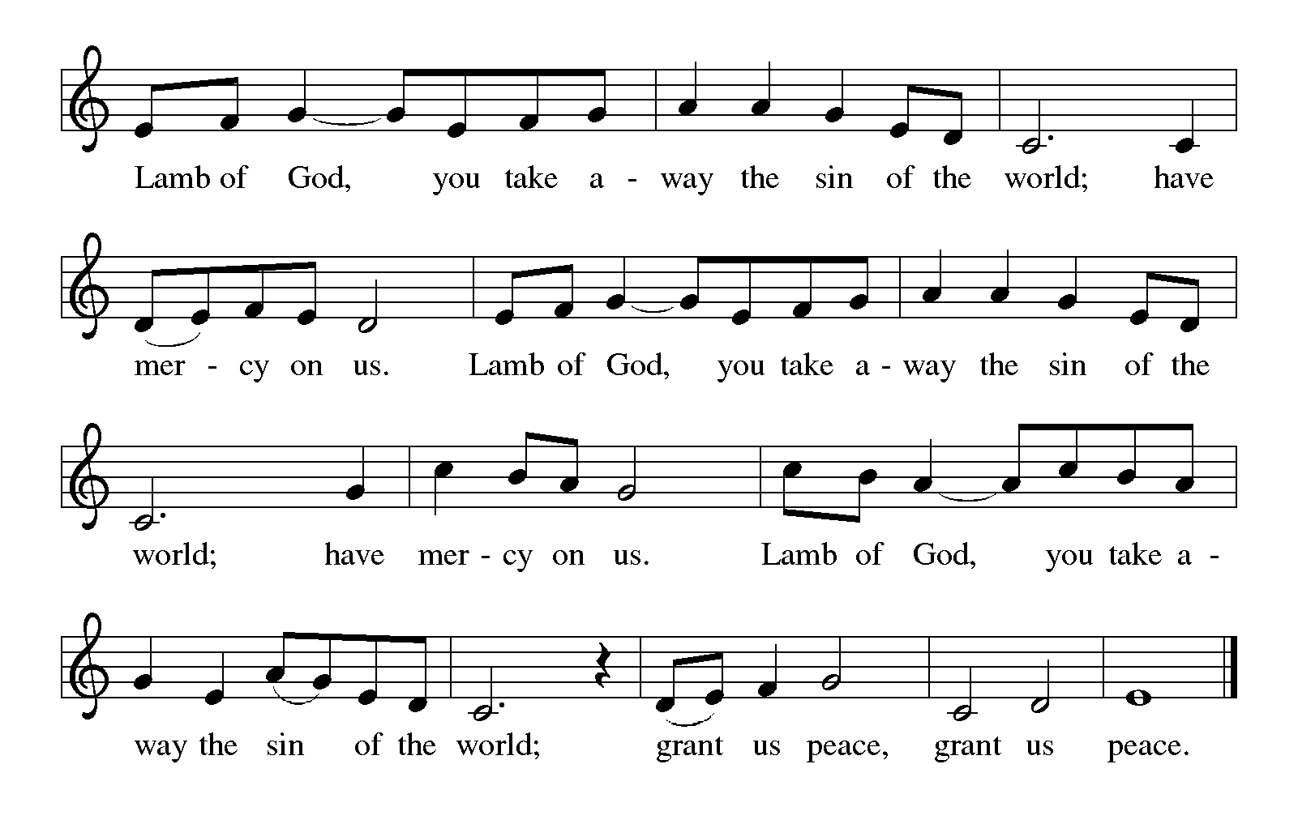

HYMNS DURING DISTRIBUTION 779 Amazing Grace page 12
515 Break Now the Bread of Life page 13

As you are able please rise

POST-COMMUNION BLESSING

P: The Body and Blood of our Lord Jesus Christ strengthen you and keep you in His grace.

C: Amen.

THE POST-COMMUNION PRAYER

A: Let us pray. Merciful God, in this bread and cup of the new covenant You have again
forgiven our sins and drawn us into Your love. Help us to grow in faith as we proclaim
the truth of Your love. Grant this through Christ our Lord.

C: Amen.

SENDING
THE BENEDICTION

P: Almighty God: Father, Son, and Holy Spirit, bless you now and forever.

C: Amen.

SENDING HYMN 504 A Mighty Fortress page 14

THE DISMISSAL

A: Go in peace to love and serve the Lord.

C: Thanks be to God!

POSTLUDE A Mighty Fortress is Our God Michael Helman

To God Alone Be Glory

The Meditation is from The Text This Week Online: Lectionary, Scripture Study, and
Worship Resources.

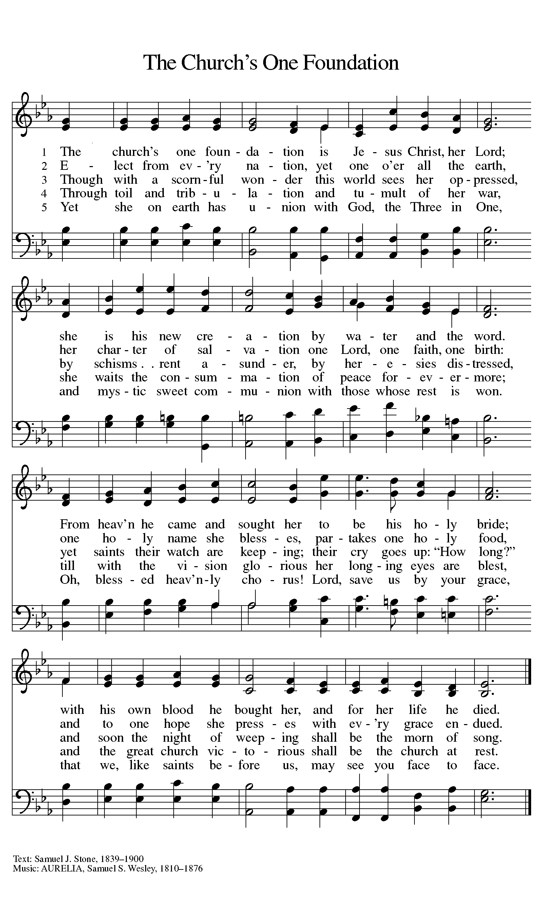
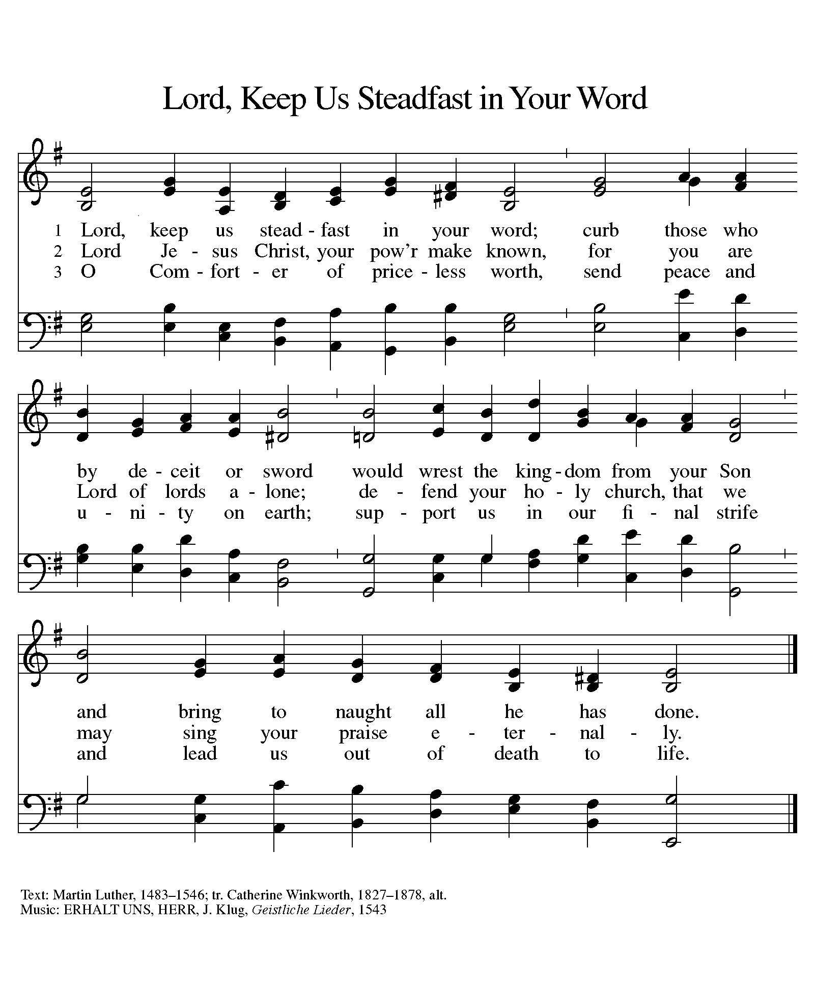

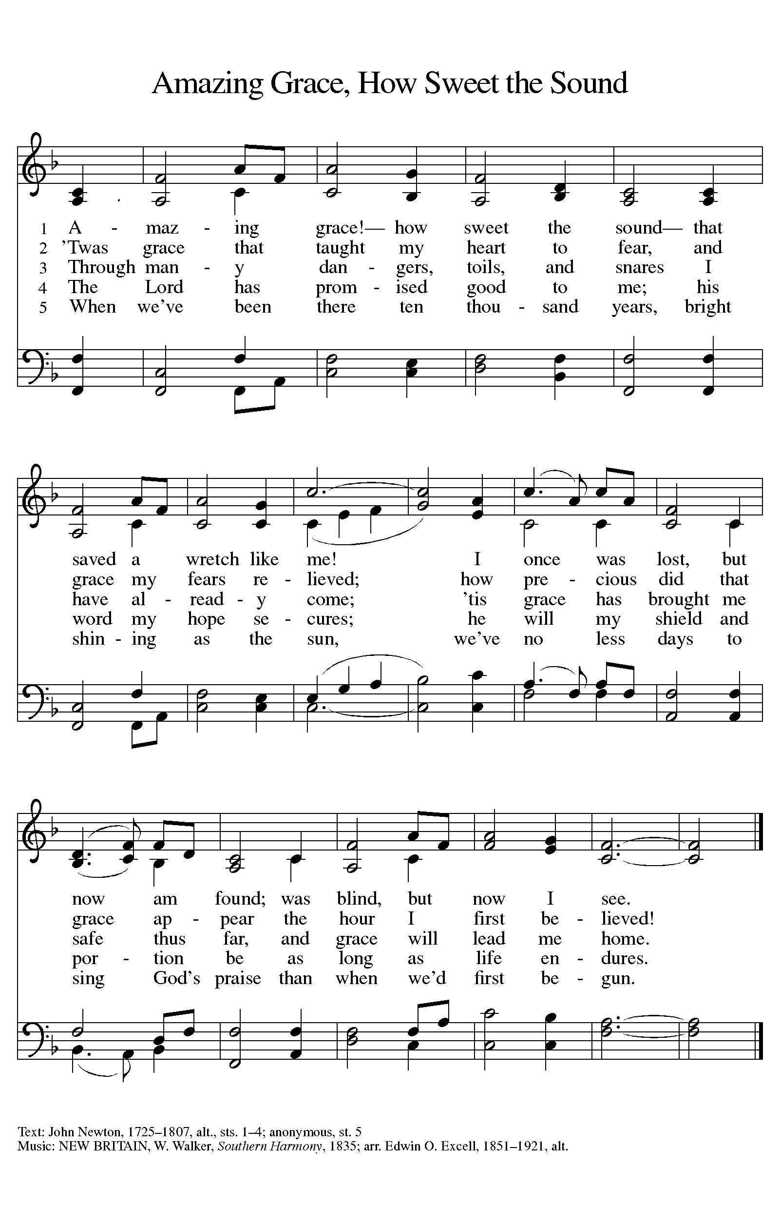
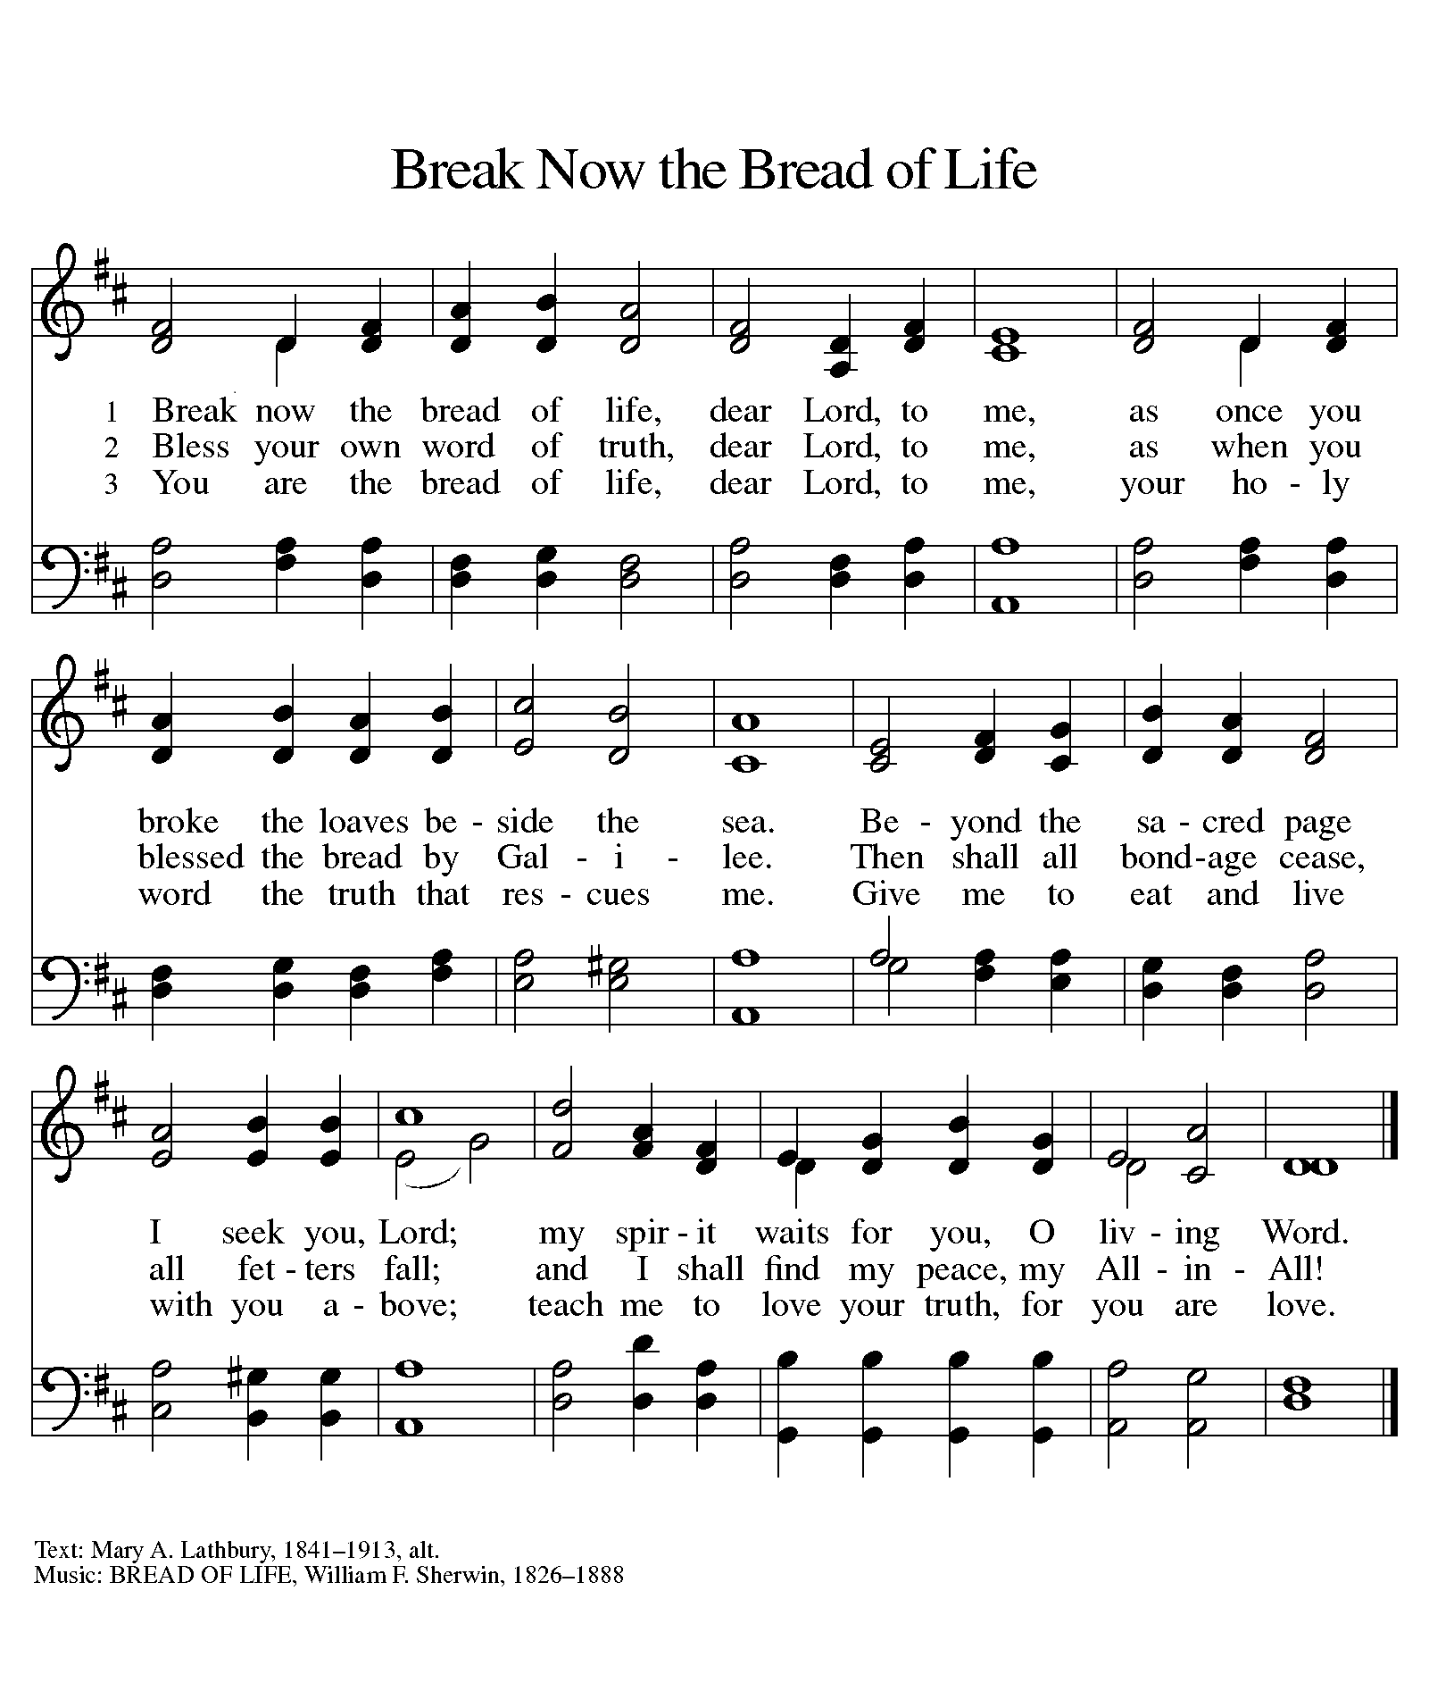

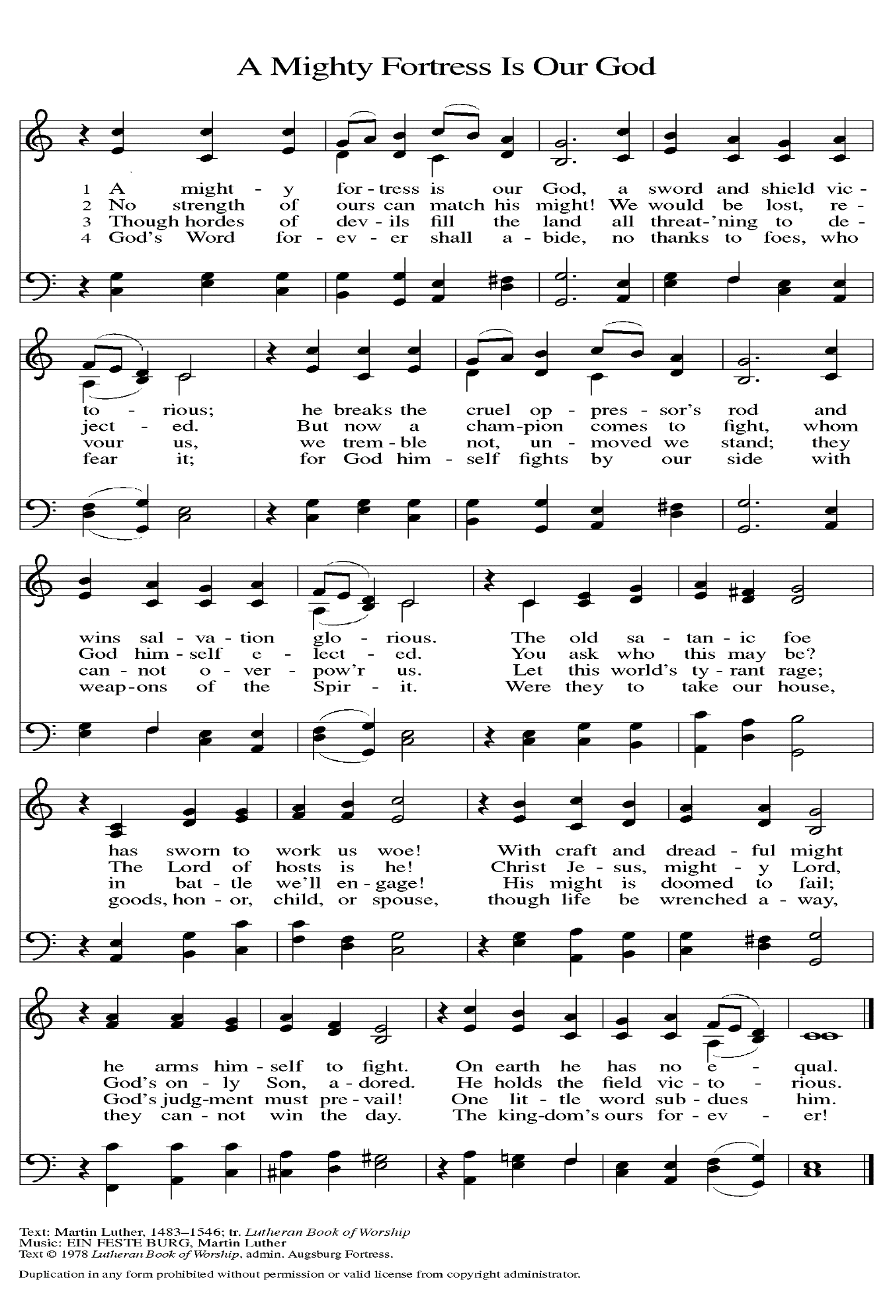
ANNOUNCEMENTS

Please remember to mail your offering to the Church Office at 818 Franklin Street, Michigan City, IN 46360. Another alternative is to give on-line through Tithe.ly. Please see your closure letter for information on how to set up a Tithe.ly account.

St. Paul Members are reminded to have a loved one contact the office if you are hospitalized. Many times, the Pastor doesn’t know someone is in the hospital. If you call and leave a message, please tell us which hospital the patient is at.

Next Sunday’s lessons are Isaiah 25: 6-9; Psalm 24; Revelations 21: 1-6a; John 11: 32-44 for those of you who like to study them in advance.

BIRTHDAYS: Allen Sydow (11/6)

ANNIVERSARIES: Warren & Kathryn Glanz (11/1)

PRAYER CONCERNS: Kathy Thielman, Audrey Beyer, Joyce and Bethany Manning, Marla Furness, Delores Hackett, Kay Peglow, Lee Timm, Ryan Krueger, Donna Bostater, Diane Gielow, Jeff Jensen, Maxine Powell, Jess Kalvaitis, Pastor Al Lorentzen, Jan Paholski, Laura Dovey, Heidi Happel, Shane Nevels, Irene Bohnstadt, Joan Coughlin, Jim Tomscheck, Wally & Betty Ratliff, Laura Moore, Cameron Rackard, Erik Tannehill, Ruth Lubs, Ed Gustum, Ken Mulder, Ashton Steele, Christian Martinez, Nancy Wisser, Ryan Sirk, Tyler Brown, Jary Tannehill and Susan McKinnon.

If you requested someone’s name to be on the prayer list and are aware that they need continued imminent prayer then contact the church office and let us know. Otherwise we will gradually transfer names to the long-term list.

OFFICE HOURS: Libby will be in the office on Mondays, Wednesdays, and Fridays; volunteers will cover Tuesdays and Thursdays.

Monday & Wednesday 8:00 a.m. – 5 p.m.
Tuesday & Thursday 9:00 a.m. – 12:00 p.m.
Friday 8:00 a.m. – 12:00 p.m.

If you are listening to the worship broadcast on the radio and would like to watch it live stream but you aren’t on Facebook, follow these four steps:

1) Go to your search engine (Google, Bing, etc.).
2) Search for St. Paul Lutheran Church & School, Michigan City, Indiana
3) Click on the option for St. Paul Lutheran Church & School—Home/Facebook
4) Click on “Videos” in the menu on the left side of the screen.

That should take you to the former videos and there should be one with a little red box that says “LIVE.’ Click on that video to enlarge it.

We will continue to live stream/broadcast the Sunday morning service on our Facebook page, and it will always be available on the radio broadcast Sunday mornings at 11:00 a.m. on WEFM (95.9), and on the local cable access station #99 for the previous week’s service on Sundays at 4:00 p.m. and the current service on Wednesdays at 7:00 p.m. and Fridays at 8:30 p.m.

To send e-mail to the church office, please use the following addresses:
Pastor Mark Reshan: seniorpastor@stpaulmichigancity.com
Church Office Secretary (Libby Pollock): churchsecretary@stpaulmichigancity.com
Church Treasurer (Karen Fleming) and Bookkeeper (Billie Atchinson):
finance@stpaulmichigancity.com.

The Good News Newsletter: If you have an article or anything you want included in The Good News please send it to the following e-mail address: splcgoodnews@gmail.com. Pastor Pamela Thiede will be using this e-mail address to assemble The Good News each month. The deadline for getting information to Pastor Pamela will be the 20th of each month.

WORSHIP ATTENDANCE for October 23 and 24, 2021
4:00 p.m. 43
9:00 a.m. 45
Total = 88

Artspace is sponsoring an “Old-Fashioned Trick or Treat on Franklin Street” this Sunday, the 31st from 3:00-5:00 p.m. They are seeking volunteers to pass out candy to trick or treaters at one of the stores on Franklin Street. If you are able to help please report to their location at 717 Franklin and they will provide the goodies for the children.

The Community Soup Kitchen serving out of First United Methodist is in need of volunteers. Sunday through Tuesday is always need, as is occasionally Wednesdays and Thursdays. Hours are 9:30 a.m. to 1:15 p.m. and it is not necessary to stay the entire time. There is also a need for volunteers to be available to help pick up deliveries from the Food Bank when they arrive. If you are able to help please contact their church office at 872-7200.

MEETINGS AND ACTIVITIES IN OCTOBER:

Worship Service: Saturday October 30, 2021 at 4:00 pm

Worship Service: Sunday October 31, 2021 at 9:00 am

From Paul Brooks:
Live streaming via You Tube for Sunday morning services: I have posted this link on our church website on the main page in the church section. By this Sunday, October 31, we should be able to start our streaming and it will go live on You Tube. This is the direct link: https://www.youtube.com/channel/UC5AIPNaKr3QN50984jGOa1g.

MEETINGS & ACTIVITIES IN NOVEMBER

Altar Guild: Tuesday, November 2, 2021 at 10:00 am/St. Paul Room
Wednesday Bible Study: Wednesday, November 3, 2021 at 9:45 am/ Luther House
God’s Purls: Wednesday, November 3, 2021 at 10:00 am/St. Paul Room
Worship Service: Saturday, November 6, 2021 at 4:00 pm

Worship Service: All Saints Sunday, November 7, 2021 at 9:00 am
Harmony Circle: Tuesday, November 9, 2021 at 9:30 am/Green Room
Wednesday Bible Study: Wednesday, November 10, 2021 at 9:45 am/Luther House
Worship & Music Committee: Wednesday, November 10, 2021 at 6:00 pm
Choir Rehearsal: Wednesday, November 10, 2021 at 7:00 pm
Give-back at Galveston: Thursday, November 11, 2021 from 4:00 pm – 10:00 pm
Worship Service: Saturday, November 13, 2021 at 4:00 pm

Worship Service: Sunday, November 14, 2021 at 9:00 am
Finance Committee: Monday, November 15, 2021 at 4:00 pm/St. Paul Room
Wednesday Bible Study: Wednesday, November 17, 2021 at 9:45 am/ Luther House
Worship Service: Saturday, November 20, 2021 at 4:00 pm

Worship Service: Sunday, November 21, 2021 at 9:00 am
Wednesday Bible Study: Wednesday November 24, 2021 at 9:45 am/Luther House
THANKSGIVING
Worship Service: Saturday, November 27, 2021 at 4:00 pm

Worship Service: Sunday, November 28, 2021 at 9:00 am

Next Give-back is on Thursday, November 11, 2021 from 4:00 pm – 10:00 pm at
Galveston Steak House in Michigan City. Please come out and enjoy the fellowship! There will be extra coupons in the church office as well. Our previous take from Galveston was $250.00. Thank you for your participation and support!

