THE FIRST SUNDAY AFTER CHRISTMAS
The Festival of the Name of Jesus
January 1, 2023

“In 153 B.C., January 1, the beginning of the month immediately following the winter solstice, was accepted by the Roman Empire as the beginning of the year. Previously, March 1 had been observed as New Year’s Day; later, in the sixth century A.D., March 25, the Annunciation, was adopted throughout Christendom as the beginning of the year. In 1582 Pope Gregory XIII reformed the calendar and restored the beginning of the year to January 1. It was not accepted in England and America until 1752.
In the pagan world, New Year’s Day was a time of widespread license. For some centuries, therefore, the Church gave no liturgical notice to the day whatever ...When the Church noted the day at all, it was kept as a day of fasting and penitence, church attendance being seen as an antidote to participation in pagan revels ...”
“ ...In the seventh century, however, probably under Pope Boniface IX (615), January 1 was made a church holiday, simply called “The Octave (eighth day) of the Lord” in imitation of the eighth day of Easter and of the Epiphany. Since the celebration of the new year could not be suppressed, the Church did as it has often done and transformed the pagan holiday into a church festival ...”
“...The celebration of the Circumcision of Jesus began about the middle of the sixth century in Gaul ...In the Middle Ages, the day also came to be associated with devotion to the Holy Name of Jesus, since the brief Gospel reading (Luke 2:21) reported both the circumcision and the giving of the name ...”

Philip Pfatteicher
Festivals and Commemorations

INTRODUCTION

The observance of the octave (eighth day) of Christmas has roots in the sixth century. Until the recent past, Lutheran calendars called this day “The Circumcision and Name of Jesus.” The emphasis on circumcision is the older emphasis. Every Jewish boy was circumcised and formally named on the eighth day of his life. Already in his youth, Jesus bears the mark of a covenant that he makes new through the shedding of his blood, now and on the cross. That covenant, like Jesus’ name, is a gift that marks the children of God. Baptized into Christ, the church begins a new year in Jesus’ name.

The Name of Jesus

By Jewish law, every baby boy was circumcised and named on the eighth day of life, so on the eighth day of Christmas the church celebrates this event in Jesus' life. The keeping of the covenant as well as Jesus' name are signs of God's salvation given to us through him.

Johann Konrad Wilhelm Loehe, renewer of the church, died 1872

A nineteenth-century German Lutheran pastor, Loehe worked to enliven the church with the eucharist at its center, from which would flow evangelism and social ministry. He sent pastors to North America, Australia, New Guinea, Brazil, and the Ukraine.

In the Name of Jesus
GATHERING

PRE-SERVICE MUSIC Coventry Carol Praise Band

ANNOUNCEMENTS

As you are able please rise

THE GATHERING SONG 296 What Child is This

A CHRISTMAS DIALOGUE

P: The people who walked in darkness have seen a great light.

C: The light shines in the darkness, and the darkness has not overcome it.

P: Those who dwelt in a land of deep darkness, on them light has shined.

C: We have beheld Christ’s glory, glory as of the only Son from the Father.

P: For to us a child is born, to us a Son is given.

C: In Him was life, and the life was the life of all people.

P: Out of the mouths of infants and children, Your majesty is praised above the
heavens.
C: O Lord, our Lord, who exalted is your name in all the earth.

P: The grace of our Lord Jesus Christ, the love of God, and the communion of the
Holy Spirit be with you all.

C: And also with you.

THE PRAYER OF THE DAY

P: Let us pray. Eternal Father, You gave Your incarnate Son the holy name of Jesus to be
a sign of our salvation. Plant in every heart the love of the Savior of the world, Jesus
Christ, our Savior and Lord, Who lives and reigns with You and the Holy Spirit, one
God, now and forever.

C: Amen.

The assembly is seated
WORD

FIRST READING Numbers 6:22-27

God commanded Aaron to say these words, known as the Aaronic benediction, in blessing the people of Israel. We too are marked with God’s name and God’s blessing as we are sent from our assemblies into the world.
²²The LORD spoke to Moses, saying: ²³Speak to Aaron and his sons, saying, Thus you
shall bless the Israelites: You shall say to them,
²⁴The LORD bless you and keep you;
²⁵the LORD make His face to shine upon you, and be gracious to you;
²⁶the LORD lift up His countenance upon you, and give you peace.
²⁷So they shall put My name on the Israelites, and I will bless them.

The Word of the Lord.

Thanks be to God.

THE PSALM: Psalm 8 Read responsively

¹O LORD our Lord,
how majestic is Your name in all the earth!—

²You Whose glory is chanted above the heavens
out of the mouths of infants and children;
You have set up a fortress against Your enemies,
to silence the foe and avenger.

³When I consider Your heavens, the work of Your fingers,
the moon and the stars You have set in their courses,

⁴what are mere mortals that You should be mindful of them,
human beings that You should care for them?

⁵Yet You have made them little less than divine;
with glory and honor You crown them.

⁶You have made them rule over the works of Your hands;
You have put all things under their feet:

⁷all flocks and cattle,
even the wild beasts of the field,

⁸the birds of the air, the fish of the sea,
and whatever passes along the paths of the sea.

⁹O LORD our Lord,
how majestic is Your name in all the earth!

SECOND READING Galatians 4:4-7

Paul proclaims the ultimate significance of the nativity: Jesus was born the Son of God so that, because of him, we all may be God's children.
⁴But when the fullness of time had come, God sent His Son, born of a woman, born under
the law,
⁵in order to redeem those who were under the law, so that we might receive adoption as
children.
⁶And because you are children, God has sent the Spirit of His Son into our
hearts, crying, "Abba! Father!"
⁷So you are no longer a slave but a child, and if a child then also an heir, through God.

The Word of the Lord.

Thanks be to God.
As you are able please rise

THE VERSE 886 (Stanzas 1-3) Oh, For a Thousand Tongues to Sing

THE HOLY GOSPEL Luke 2:15-21

Eight days after his birth, Jesus is circumcised according to Jewish law and given the name announced by the angel before his conception.

P: The Holy Gospel according to St. Luke, the second chapter.

C: Glory to You, O Lord!

¹⁵When the angels had left them and gone into heaven, the shepherds said to one another,
"Let us go now to Bethlehem and see this thing that has taken place, which the Lord
has made known to us."
¹⁶So they went with haste and found Mary and Joseph, and the child lying in the manger.
¹⁷When they saw this, they made known what had been told them about this child;
¹⁸and all who heard it were amazed at what the shepherds told them.
¹⁹But Mary treasured all these words and pondered them in her heart.
²⁰The shepherds returned, glorifying and praising God for all they had heard and seen, as
it had been told them.
²¹After eight days had passed, it was time to circumcise the child; and He was called Jesus,
the name given by the angel before he was conceived in the womb.

P: The Gospel of the Lord.

C: Praise to You, O Christ!

THE HYMN 886 (Stanzas 4-6) Oh, For a Thousand Tongues to Sing

The assembly is seated

THE SERMON
Silence for reflection follows the sermon

As you are able please rise

THE HYMN OF THE DAY 620 How Sweet the Name of Jesus Sounds

THE NICENE CREED

A: God has made us His people through our Baptism into Christ. Living together in trust
and hope, we confess our faith.

We believe in one God,
the Father, the Almighty,
maker of heaven and earth,
of all that is, seen and unseen.

We believe in one Lord, Jesus Christ,
the only Son of God,
eternally begotten of the Father,
God from God, Light from Light,
true God from true God,
begotten, not made,
of one Being with the Father.
Through Him all things were made.
For us and for our salvation
He came down from heaven;
by the power of the Holy Spirit
He became incarnate from the virgin Mary, and was made
man.
For our sake He was crucified under Pontius Pilate;
He suffered death and was buried.
On the third day He rose again
in accordance with the Scriptures;
He ascended into heaven
and is seated at the right hand of the Father.
He will come again in glory to judge the living and the dead,
and His kingdom will have no end.

We believe in the Holy Spirit, the Lord, the giver of life,
Who proceeds from the Father and the Son.
With the Father and the Son He is worshiped and glorified.
He has spoken through the prophets.
We believe in one holy catholic and apostolic Church.
We acknowledge one Baptism for the forgiveness of sins.
We look for the resurrection of the dead,
and the life of the world to come. Amen

THE PRAYER OF THE CHURCH

A: Glorifying and praising God for the Good News we have heard and seen, let us offer
intercession in the name of Jesus for the Church, the world, and all in need.

A: That God’s face may shine upon the Church as we proclaim the saving name of Jesus,
until every tongue confesses Him as Lord to the glory of God: God of our salvation,

C: Hear our prayer.

A: That God’s face may shine upon the nations of the world, that in this New Year
governments and leaders may more justly work for peace and the well-being of all:
God of our salvation,

C: Hear our prayer.

A: That God’s face may shine upon this congregation, that in this New Year our faith may
be strengthened and our minds and lives more closely conformed to Christ: God of our
salvation,

C: Hear our prayer.

A: That God’s face may shine upon those in need: the poor, the unemployed, the addicted,
the homeless, the dying, and the sick, especially . . . that the light of His face may fill
them with peace: God of our salvation,

C: Hear our prayer.

A: That those celebrating birthdays, especially Mary Peters and Jo Ann Kring may be
filled with grace this day and every day and grow in grace in the days ahead: God of
our salvation,

C: Hear our prayer.

A: That with the saints of every age we too may reflect Your grace and blessing until Your
face is turned to us for all eternity: God of our salvation,

C: Hear our prayer.

P: As shepherds were astonished by Your marvels, O God, so too do we stand in awe of
Your goodness. Be merciful to us today in our need that we may learn to be Your
compassion in the world. We ask this in the name of Jesus.

C: Amen.
MEAL
THE PEACE

P: Unto us a Child is born; unto us a Son is given.
And His name is Prince of peace.

The peace of Christ be with you always.

And also with you.

The assembly is seated

THE OFFERING

THE VOLUNTARY Mary Did You Know Praise Band

FAREWELLS AND WELCOME

As you are able please rise

THE OFFERTORY PRAYER

A: Let us pray. Gracious God,

C: The name of Jesus brings salvation to the world. In all we offer You this Day,
may we honor Him, and through this eating and drinking, may our lives and
minds be conformed to His. We ask this in the name of Jesus the Lord. Amen.

THE GREAT THANKSGIVING

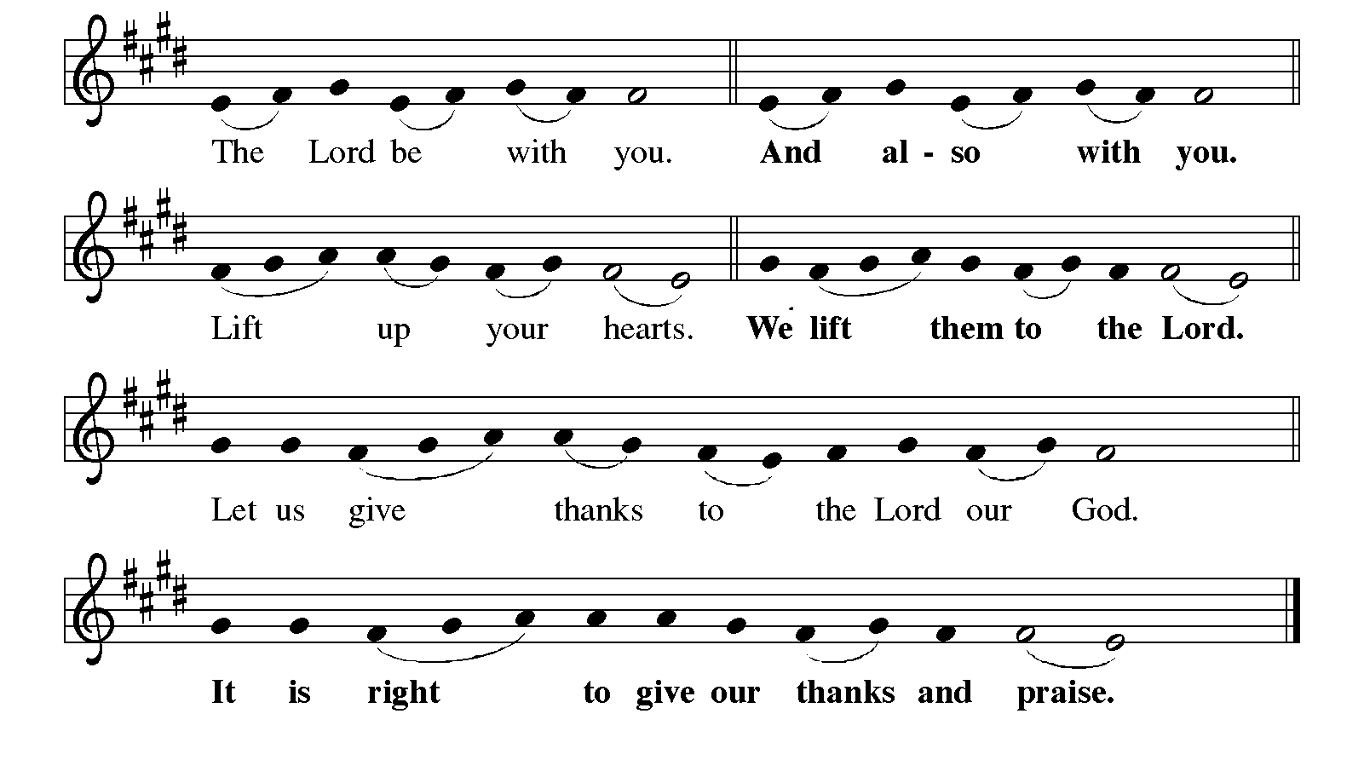
P: It is indeed right, our duty, and our joy … join their unending hymn:

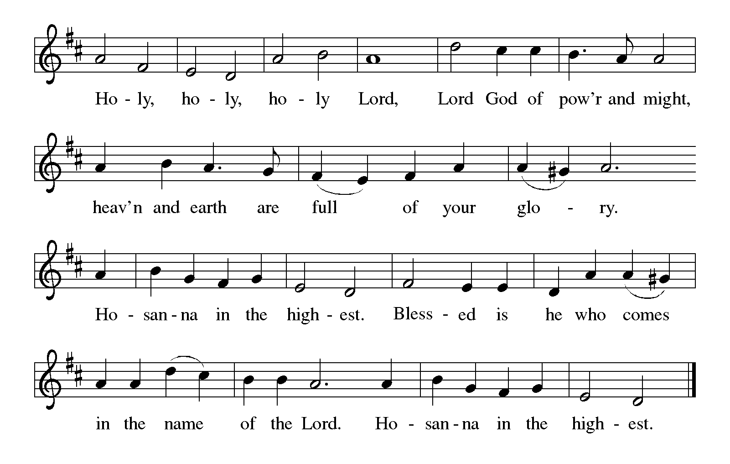

P: Father, we thank You with our lips and in our lives, that having created us and all things
through Your Word You welcome and prayer and praise.
For the goodness of creation and the glory to which You call us by our redemption, we
praise You.
For the law and prophets, calling us to obedience, and warning us against disobedience,
we praise You.
Above all, we offer You praise and thanksgiving over this bread and cup because in
Jesus Christ You have joined Yourself to us, uniting heaven and earth.

We remember Jesus’ birth into our humanity, His baptism for our sin, His compassion
for our suffering, His intimacy with our frailty, His rebuke of our pride, His
bearing of the cross, and His rising from the dead.
According therefore to His command and promise of presence we now thankfully
remember that in the night ... “Do this for the remembrance of Me.”
As often as we eat ... we proclaim the Lord’s death until He comes.
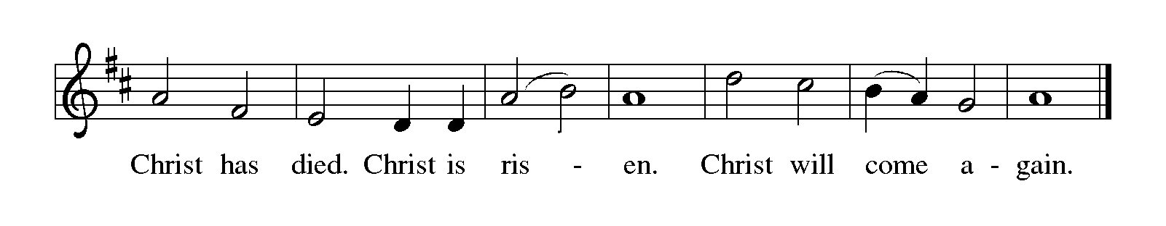

P: We ask You, Father: pour out Your Holy Spirit on us and these Your gifts of bread and
wine.
May we, marked again with His holy Name be one with Christ, one with each other,
and one in His ministry of blessing to all the world.
May our communion with Him Who was, Who is, and Who is to come be a sign of His
eternal rule over all the world until every knee bows and every tongue
confesses Him as Lord.
This sacrifice of praise and thanksgiving we offer You, gracious God, in the name
of Jesus, in the unity of the Holy Spirit, one God, to ages of ages.
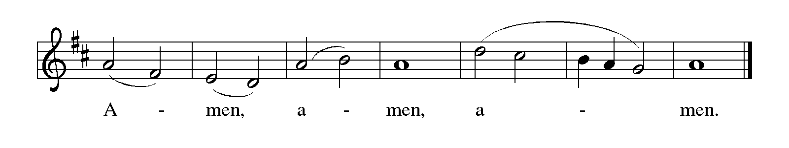

THE LORD’S PRAYER

P: The Word became flesh and dwelled among us, that as children of God we might dare
to pray:

C: Our Father, Who art in heaven, hallowed be Thy Name. Thy Kingdom come.
Thy will be done on earth as it is in heaven. Give us this day our daily bread, and
forgive us our trespasses as we forgive those who trespass against us. And lead us
not into temptation, but deliver us from evil, for Thine is the Kingdom, and the
power, and glory, forever and ever. Amen.

INVITATION TO THE MEAL

P: Behold the Light of the world, begotten of the Father’s glory, of Whose fullness and
grace we have all received. Blessed are those who are called to the Supper of the Lamb.
Come, for all is now ready.
The assembly is seated

THE DISTRIBUTION

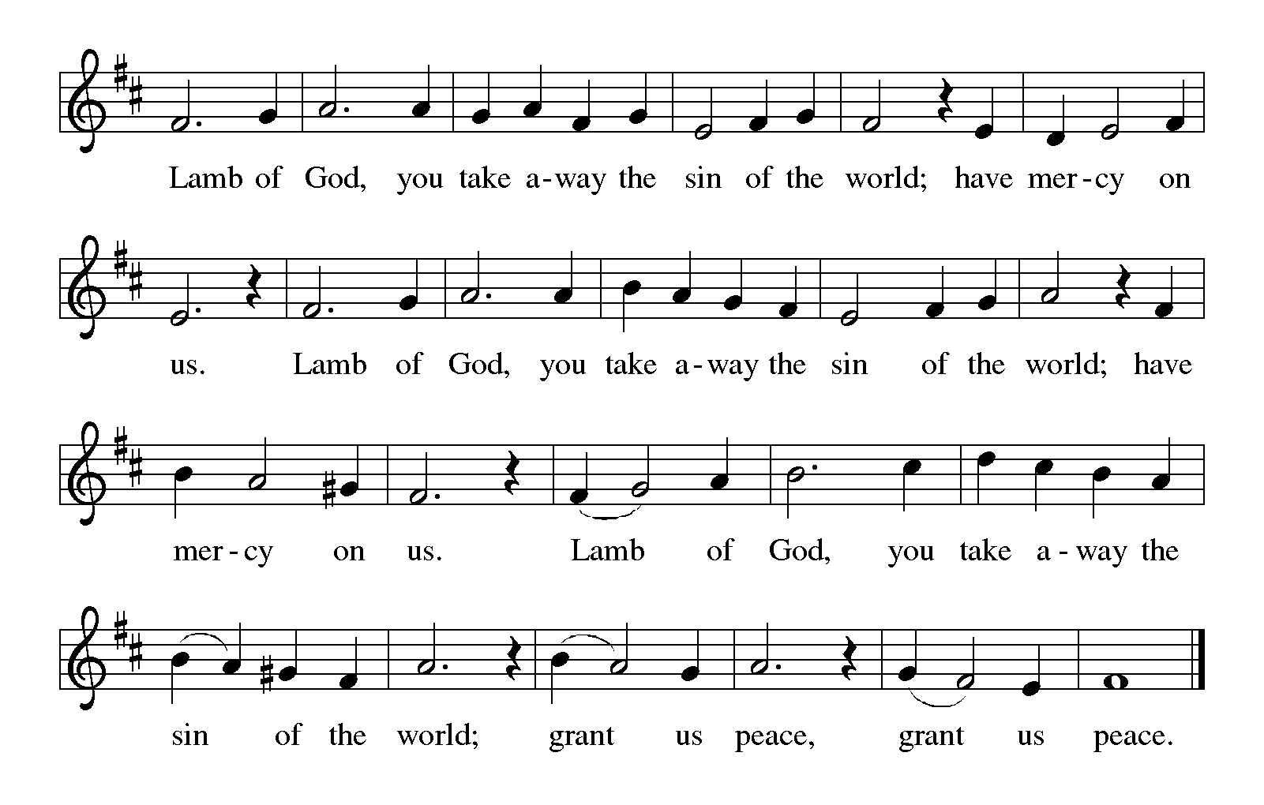
HYMN DURING DISTRIBUTION 820 O Savior, Precious Savior
NSB 24 Come and See
NSB 59 Jesus, Name Above All Names
NSB 46 How Majestic is Your Name
As you are able please rise

THE POST-COMMUNION BLESSING

P: The Body and Blood of our Lord Jesus Christ strengthen you and keep you in His grace.

C: Amen.

THE POST-COMMUNION PRAYER

A: Let us pray. Emmanuel, God with us, You grace us with life and breath and give us
bread for the journey. Send us who bear the name of Jesus out in service to this world
that You love, blessed to be a blessing of Your life and love to all.

C: Amen.
SENDING

THE BENEDICTION

P: The Lord bless you and keep you.
The Lord make His face shine upon you and be gracious to you.
The Lord look upon you with favor and give you peace.

C: Amen.

THE SENDING HYMN 299 Cold December Flies Away
THE DISMISSAL

A: You are called to belong to Jesus Christ. Go in grace and peace to exalt his name in all
the earth. Alleluia, Alleluia!

C: Thanks be to God! Alleluia! Alleluia!

POSTLUDE O Come All Ye Faithful arr. Bish

To God Alone Be Glory

The Meditation is from Festivals and Commemorations. Philip Pfatteicher. (Minneapolis:
Augsburg Press, 1980) 167.

The Offertory and Post-Communion Prayers are adapted from The Book of Alternative
Services of the Anglican Church of Canada. (Toronto: Anglican Book Centre,
191985) 278-79.

The Prayers are adapted from Sundays and Seasons.com (Augsburg Fortress Press) 2005
and Prayers for Sundays and Seasons. Year B. Peter J. Scagnelli. (Chicago:
Liturgy Training Publications, 1992) 21.

ANNOUNCEMENTS

Please remember to mail your offering to the Church Office at 818 Franklin Street, Michigan City, IN 46360. Another alternative is to give on-line through Tithe.ly. Please see your closure letter for information on how to set up a Tithe.ly account.

St. Paul Members are reminded to have a loved one contact the office if you are hospitalized. Many times, the Pastor doesn’t know someone is in the hospital. If you call and leave a message, please tell us which hospital the patient is at.

Birthdays: Mary Peters (1/6); Jo Ann Kring(1/60)
Anniversaries: Kenneth & Carol Hanft Sr (1/1)

PRAYER CONCERNS: Audrey Beyer, Ryan Krueger, Donna Bostater, Maxine Powell, Jim Tomscheck, Eloise Ponder, Mark & Jary Tannehill, Marvin Dirks, Leonard Cross, George Ottersen, Valerie Waltz, Margie Torres, Dan Pursely, Jayla Jacobi and Lyle Peters.
If you requested someone’s name to be on the prayer list and are aware that they need continued imminent prayer then contact the church office and let us know. Otherwise we will gradually transfer names to the long-term list.
There are some names on the long-term prayer list that have been listed for many months. We would like to keep the list current so if you requested them to be included please contact the church office and tell us whether you would still like them on the list: Robert Atwood; Laura Eilers-Straight; Terry Hygema; Jess Kalvaitis; Tom and Larry Lueth; Duane Ormsby; Cameron Rackard; Ryan Sirk; Jean Thomas; Heidi Happel; Christian Martinez; Ron Armer.

OFFICE HOURS: Libby will be in the office on Mondays, Wednesdays, and Fridays; volunteers will cover Tuesdays and Thursdays.

Monday & Wednesday 8:00 a.m. – 5 p.m.
Tuesday & Thursday 9:00 a.m. – 12:00 p.m.
Friday 8:00 a.m. – 12:00 p.m.

If you are listening to the worship broadcast on the radio and would like to watch the Sunday morning service live stream follow these steps:
(1) If you have You.Tube available on your TV, search for
St. Paul Lutheran Church Michigan City, IN.

(2) The direct link on the computer is
https://www.youtube.com/channel/UC5AIPNaKr3QN50984jGOa1g.

(3) This link is also on the main page of the church’s website in the church sec-
tion and will continue to be posted weekly on the St. Paul Facebook page.

And it will always be available on the radio broadcast Sunday mornings at 11:00 a.m. on WEFM (95.9), and on the local cable access station #99 for the previous week’s service on Sundays at 4:00 p.m. and the current service on Wednesdays at 7:00 p.m. and Fridays at 8:30 p.m.
To send e-mail to the church office, please use the following addresses:
Pastor Mark Reshan: seniorpastor@stpaulmichigancity.com
Church Office Secretary (Libby Pollock): churchsecretary@stpaulmichigancity.com
Church Treasurer (Karen Fleming): finance@stpaulmichigancity.com

The Good News Newsletter: If you have an article or anything you want included in The Good News please send it to the following e-mail address: splcgoodnews@gmail.com. Pastor Pamela Thiede will be using this e-mail address to assemble The Good News each month. The deadline for getting information to Pastor Pamela will be the 20th of each month.

WORSHIP ATTENDANCE for December 24 and 25, 2022
This week’s attendance was Zero due to freezing (below O`)temperatures and blowing wind up to 50 mph.
A Reminder

The discussion group “Estuary” led by Pastor Dale Zylstra meets the second Tuesday of the month in the Luther House at 7:00 p.m. The group addresses topics of interest to the participants and is open to everyone.

**PLEASE NOTE**

VERY IMPORTANT: Please be advised there will be a special meeting of the congregaton on Sunday, January 15, 2023, at 10:00 a.m. (following the 9:00 a.m. service)
The subject of this meeting will be the closing of the school. Please mark your calendar to attend.

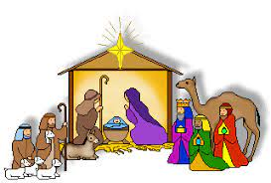 Christmas Decorations

We are blessed to have volunteers who are willing year after year to organize and put up the beautiful decorations for our celebration of Advent and The Twelve Days of Christmas. Normally, we list those generous and hard workers after the decorations have come down; but this year, it seemed good to honor them beforehand so that when you see them you might thank them for all their faithful work. Many of them have been doing the same jobs for a long time, and we are so grateful to them for their selfless service at a time of year when everyone is busy and weary.

Christmas Tree Bob and Karen Kiser; Larry and Judy
Litchford; Wayne and Suzann Dolson;
Kyle Petter; Casey, Kelly and Brad Neulieb

Advent Log Virginia Murray

Poinsettia plants Virginia Murray; Sue Koziel

Large wooden cross Janet Bakken; Sue Koziel; Karen Steinborn

Garland (outer narthex and Communion railings) Karen Steinborn; Sue Koziel

Window treatments (nave and outside) Mary Knaup

Upper narthex nativity scene and creche Pastor Mark Kloess; Jary Tannehill; Stacie Crozier

POINSETTIA MEMORIALS 2022

Mike & Marge Bockover: in memory of loved ones

Nancy Mauman; Tom & Gail Mauman;
And TJ & Megan Pruzin and family: in loving memory of Dorothy & Walter Liebig and
John Mauman and loved ones

Janice White; her niece Elizabeth and her husband John: in honor of Diane Egilske; and in memory of loved ones

William, Jr, Bethany, and Kirk Manning: in loving memory of our parents William, Sr & Joyce Manning

Sandy Robbins: in memory of Henry (Sonny) Robbins

Beverly Johnson: in memory of Ron Johnson from Bev

Ivye Benson: in memory of my parents Irv & Pearl Carlson

Sally Timm: in memory of my husband Lee Timm

Jim & Bernadette Krueger: in memory of Mom & Dad Krueger and in memory of Mom & Dad Losiniecki

Rick & Nancy Hawkins and Tom Gielow: in memory of Roger & Diane Gielow from their children
Nancy and Tom

Janet Bakken: in memory of Diane Gielow

Steve & Lauretta Hapke: in memory of Norma Wolgast and Elizabeth Hapke

Susan Dolson: in memory of Howard & Yvonne Johnson; and Maurits & Adrianna VanGemeren from their family

John & Amy VanGemeren: in memory of George & Irma Dolson from their grandchildren

Fred Weiss: in memory of wife Carol and son Donald

Virginia Murray: in memory of loved ones

Bob & Karen Kiser: in memory of loved ones

Susan Koziel: in memory of husband Joseph Koziel and in honor of my children and grandchildren

Tim & Stacie Crozier: in memory of our parents

Chip & Audrey Claussen: in memory of loved ones who have passed away and in honor of all family and friends

Chuck & Sherry Payne: in memory of loved ones

Charles, Sr. & Jana Thomas: in memory of Otto Mayer & family and Allie Thomas family

Charles, Jr. & Carol Thomas: in memory of Stanley & Gloria Redmon

The Johnson Women: in memory of their father Ron Johnson

2022 Financial Stewardship

Weekly Church Operating Needs (x 2 weeks): $ 14,615.68
December 17 and 18, and 24 and 25, 2022
General Fund (including General Memorials): $ 11,300.00
Overage/Shortage: -- $ 3,315.68

Restricted Income (not including Memorials)
Supports IK Synod & Church wide Ministries: $268.00
Ministries in our Community/Congregation: ----------
Capital Fund: $ 3,125.00

ACTIVITIES, EVENTS & MEETINGS
January 2023

Saturday, December 31, 2022 at 4:00 p.m. Worship Service

Sunday, January 1, 2023 at 9:00 a.m. Worship Service

Wednesday, January 4, 2023 at 9:45 a.m. Bible Study/Luther House

at 10:00 a.m. God’s Purls/St. Paul Room

Saturday, January 7, 2023 at 4:00 p.m. Worship Service

Sunday, January 8, 2023 at 9:00 a.m. Worship Service

Monday, January 9, 2023 at 12:30 p.m. Harmony Circle/Nursery

at 3:30 p.m. School Board Meeting/Luther House

Tuesday, January 10, 2023 at 9:30 p.m. Charity Circle/Nursery

at 7:00 p.m. Estuary/Luther House

Wednesday, January 11, 2023 at 9:45 a.m. Bible Study/Luther House

at 10:00 a.m. God’s Purls/St Paul Room

Saturday, January 14, 2023 at 4:00 p.m. Worship Service

Sunday, January 15, 2023 at 9:00 a.m. Worship Service

at 10:00 a.m. Congregation Meeting/St. Paul Room

Tuesday, January17, 2023 all day and evening GIVE BACK at Holly’s

Wednesday, January 18, 2023 at 9:45 a.m. Bible Study/Luther House

at 10:00 a.m. God’s Purls/St. Paul Room

Saturday, January 21,2023 at 4:00 p.m. Worship Service

Sunday, January 22, 2023 at 9:00 a.m. Worship Service

Monday, January 23, 2023 at 4:00 p.m. Finance Committee Mtg./Luther House

at 5:30 p.m. Executive Board Mtg./Luther House

Wednesday, January 25, 2023 at 9:45 a.m. Bible Study/Luther House

at 10:00 a.m. God’s Purls/St Paul Room

Thursday, January 26, 2023 at 5:00 p.m. Ann. Plan.Comm. Mtg./Luther House

At 5:30 p.m. Church Council Mtg./St. Paul Room

Saturday, January 28, 2023 at 4:00 p.m. Worship Service

Sunday, January 29, 2023 at 9:00 a.m. Worship Service

