**THE THEOPHANY OF OUR LORD**

**The Observance of The Epiphany of Our Lord**

**and the Baptism of Our Lord**

**January 8, 2023**

In choosing to be born for us, God chose to be known by us. He therefore reveals himself in this way, in order that this great sacrament of his love may not be an occasion for us of great misunderstanding.

Today the magi find, crying in a manger, the one they have followed as he shone in the sky. Today the magi see clearly, in swaddling clothes, the one they have long awaited as he lay hidden among the stars.

Today the magi gaze in deep wonder at what they see: heaven on earth, earth in heaven, humanity in God, God in humanity, one whom the whole universe cannot contain now enclosed in a tiny body. As they look, they believe and do not question, as they symbolic gifts bear witness: incense for God, gold for a king, myrrh for one who is to die ...

Today Christ enters the Jordan to wash away the sin of the world. John himself testifies that this is why he has come: Behold the Lamb of God, behold him who takes away the sin of the world ...

**Peter Chrysologus, Fifth century**

The Spirit came down from on high and hallowed the waters by brooding over them. In the baptism of John, the Spirit passed by the rest and abode on the one (Jesus); but now the Spirit has descended and abides upon all that are born of the water. Out of all that John baptized, on only one did the Spirit dwell, but now the Spirit has flown and come down in order to dwell on the many; and as each one after another comes up from the water, they are loved and abide in God.

**Ephrem the Syrian**

Obedience (to the will of God as seen in Jesus’ submission to Baptism to “fulfill all righteousness”) is not as burdensome as it seems at first blush. We are doing nothing more than falling head over heels in love with the everlasting Lover of our souls.

**Richard Foster**

***✠ In the Name of Jesus✠***

**✠ GATHERING ✠**

**INTRODUCTION**

*In the East three great epiphanies are celebrated on this day: the magi's adoration of the Christ Child, Jesus' baptism in the Jordan river, and his first miracle in which he changes water into wine. Epiphany celebrates Christ being made known, or made "manifest," to all nations.*

*The sacraments are for us the great epiphany of God's grace in which we behold the mystery of God among us. The magi offered gifts of gold, frankincense, and myrrh. Having seen the light of Christ, we offer the gift of ourselves, our time, and our possessions--that others may also know the epiphany of God's mercy and love.*

*In the waters of baptism, we have been joined to the Son in whom the Father is well pleased. The font is our Jordan where the Holy Spirit comes to us, strengthening and enlightening us for service in the world. On this great baptismal day, the church prays that all who are reborn as daughters and sons of God will continue to grow in faith, hope, and love.*

**PRELUDE *How Brightly Shines the Morning Star* Pachelbel**

**ANNOUNCEMENTS**

*As you are able please rise*

**REMEMBERING OUR BAPTISM**

P: In one and the same instant you died and were born again.

**C: “Do you not know that all of us who were baptized into Christ Jesus were baptized**

**into His death?”** (Romans 6:3)

P: The Bible tells us that there is “a time to be born and a time to die.” (Ecclesiastes 3:2).

For you, however, it was the reverse: first you died, and then you were born again.

**C: “We were buried therefore with Christ through Baptism into death so that as**

**Christ was raised from the dead through the glory of the Father, we too might live**

**a new life.”** (Romans 6:4)

P: Daily--in the morning, when you rise, and in the evening, when you go to bed—

member that you have died and been reborn through your Baptism. Make the sign

holy cross and say:

**C. In the name of the Father and of ✠ the Son and of the Holy Spirit. Amen.**

**THE PROCESSIONAL HYMN 673** ***God, Whose Almighty Word***

The congregation faces the cross as it enters

**THE GREETING AND PRAYERS OF THE DAY**

P: The grace of our Lord Jesus Christ, the love of God, and the communion of the Holy

Spirit be with you all.

**C: And also with you.**

P: Let us pray. Everlasting God, the radiance of all faithful people, You brought the

nations to the brightness of Your rising. Fill the world with Your glory, and show

Yourself to all the world through Him Who is the true Light and the bright Morning

Star, Jesus Christ, our Savior and Lord, Who lives and reigns with You and the Holy

Spirit, one God, now and forever.

**C: Amen.**

P: Let us pray. Holy God, Creator of light and Giver of goodness, Your voice moves over

the waters. Immerse us in Your grace, and transform us by Your Spirit, that we may

follow after Your Son, Jesus Christ, our Savior and Lord, Who lives and reigns with

You and the Holy Spirit, one God, now and forever.

**C: Amen.**

*The assembly is seated*

**✠ WORD ✠**

**THE FIRST READING Isaiah 60:1-6**

*Isaiah promises that God's salvation, light, and glory will shine out to all nations, and people shall come bearing gifts to the place of that light, the restored Jerusalem.*

Arise, shine; for your light has come,

and the glory of the LORD has risen upon you.

2For darkness shall cover the earth,

and thick darkness the peoples;

but the LORD will arise upon you,

and His glory will appear over you.

3Nations shall come to your light,

and kings to the brightness of your dawn.

4Lift up your eyes and look around;

they all gather together, they come to you;

your sons shall come from far away,

and your daughters shall be carried on their nurses' arms.

5Then you shall see and be radiant;

your heart shall thrill and rejoice,

because the abundance of the sea shall be brought to you,

the wealth of the nations shall come to you.

6A multitude of camels shall cover you,

the young camels of Midian and Ephah;

all those from Sheba shall come.

They shall bring gold and frankincense,

and shall proclaim the praise of the LORD.

A: The Word of the Lord.

**C: Thanks be to God.**

**From Martin Luther’s *Small Catechism***

A: What is Baptism?

**C: Baptism is not just plain water. Instead it is water used according to God’s**

**command and connected with God’s Word.**

A: What then is that Word of God?

**C: Where our Lord Jesus Christ says in Matthew, “Go therefore and make disciples**

**of all nations, baptizing them in the name of the Father and of the Son and of the**

**Holy Spirit.”**

**THE PSALM: Psalm 29** Antiphon by Robert Hobby

Choir sings refrain first, followed immediately by the congregation

and as indicated

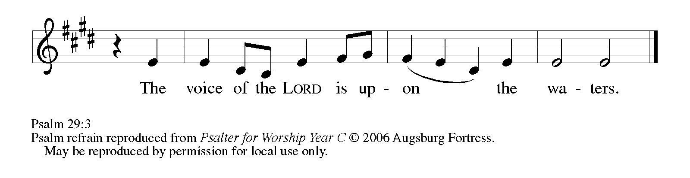

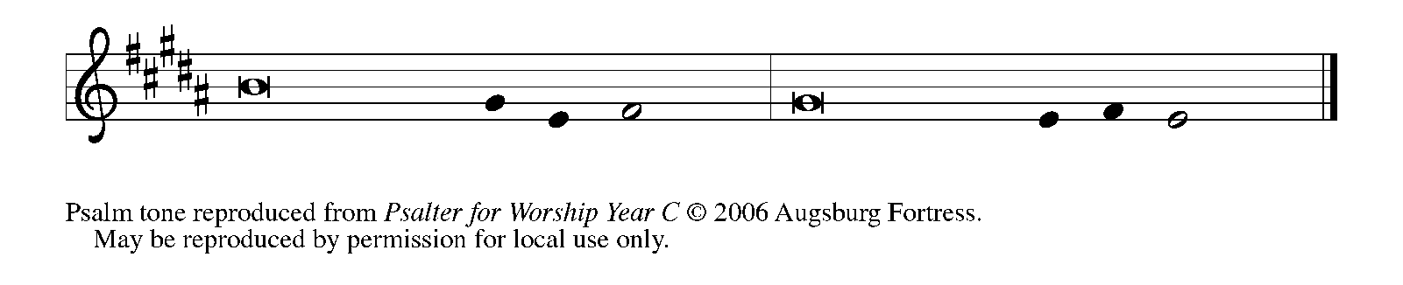

Ascribe to the | LORD, you gods,

     ascribe to the LORD glo- | ry and strength.

**2Ascribe to the LORD the glory | due God's name;**

**worship the LORD in the beau- | ty of holiness.**

3The voice of the LORD is upon the waters; the God of | glory thunders;

     the LORD is upon the | mighty waters.

**4The voice of the LORD is a pow- | erful voice;**

**the voice of the LORD is a | voice of splendor.   REFRAIN**

5The voice of the LORD breaks the | cedar trees;

     the LORD breaks the ce- | dars of Lebanon;

**6the LORD makes Lebanon skip | like a calf,**

**and Mount Hermon like a | young wild ox.**

7The voice | of the LORD

     bursts forth in | lightning flashes.

**8The voice of the LORD | shakes the wilderness;**

**the LORD shakes the wilder- | ness of Kadesh.  REFRAIN**

9The voice of the LORD makes the oak trees writhe

and strips the | forests bare.

     And in the temple of the LORD all are | crying, "Glory!"

**10The LORD sits enthroned a- | bove the flood;**

**the LORD sits enthroned as king for- | evermore.**

11O LORD, give strength | to Your people;

     give them, O LORD, the bless- | ings of peace.   **REFRAIN**

**SECOND READING Ephesians 3:1-12**

*Though it had been hidden for years, Paul now reveals the secret that has shaped his apostolic witness: in Jesus Christ, God's salvation extends beyond the Jews to include all people. The light of Christ shines upon Jew and Gentile alike.*

This is the reason that I Paul am a prisoner for Christ Jesus for the sake of you Gentiles—

2for surely you have already heard of the commission of God's grace that was given

me for you,

3and how the mystery was made known to me by revelation, as I wrote above in a few words,

4a reading of which will enable you to perceive my understanding of the mystery of Christ.

5In former generations this mystery was not made known to humankind, as it has

now been revealed to his holy apostles and prophets by the Spirit:

6that is, the Gentiles have become fellow heirs, members of the same body, and sharers

in the promise in Christ Jesus through the gospel.

7Of this gospel I have become a servant according to the gift of God's grace that was given

me by the working of His power.

8Although I am the very least of all the saints, this grace was given to me to bring to

the Gentiles the news of the boundless riches of Christ,

9and to make everyone see what is the plan of the mystery hidden for ages in God Who

created all things;

10so that through the church the wisdom of God in its rich variety might now be made

known to the rulers and authorities in the heavenly places.

11This was in accordance with the eternal purpose that He has carried out in Christ

Jesus our Lord,

12in Whom we have access to God in boldness and confidence through faith in Him.

The Word of the Lord.

**Thanks be to God.**

A: How can water do such great things?

**C: Clearly the water does not do it, but the Word of God, which is with, in, and**

**among the water, and faith, which trusts this Word of God in the water. For**

**without the Word of God the water is plain water and not a baptism, but with the**

**Word of God it is a baptism, that is, a grace-filled water of life and a “bath of the**

**new birth in the Holy Spirit.”**

*As you are able please rise*

**THE VERSE**

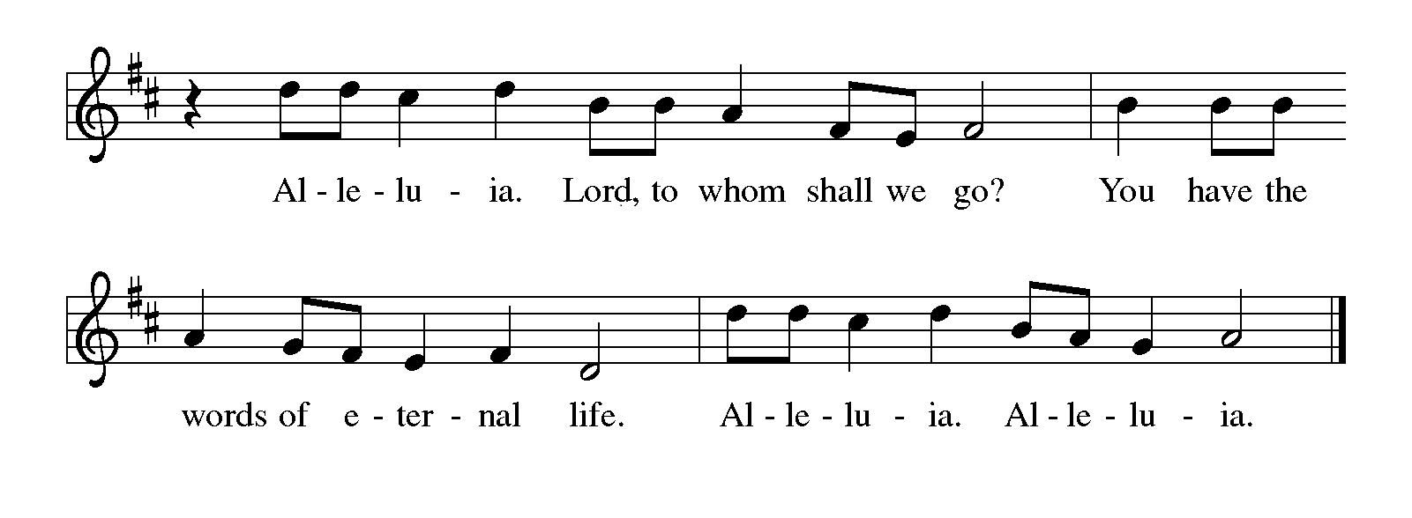

**THE HOLY GOSPEL Matthew 2:1-12**

*The spiritual quest of all human beings is mirrored in the journey of the magi. They find and adore the Christ child, the fulfillment of their hope, the epiphany and glory of God.*

P: The Holy Gospel according to St. Matthew, the second chapter.

**C: Glory to You, O Lord!**

In the time of King Herod, after Jesus was born in Bethlehem of Judea, wise men from the East came to Jerusalem, 2asking, "Where is the child who has been born king of the Judeans? For we observed His star at its rising, and have come to pay Him homage." 3When King Herod heard this, he was frightened, and all Jerusalem with him; 4and calling together all the chief priests and scribes of the people, he inquired of them where the Messiah was to be born. 5They told him, "In Bethlehem of Judea; for so it has been written by the prophet:

6'And you, Bethlehem, in the land of Judah,

are by no means least among the rulers of Judah;

for from you shall come a ruler

who is to shepherd my people Israel.' "

7Then Herod secretly called for the wise men and learned from them the exact time when the star had appeared. 8Then he sent them to Bethlehem, saying, "Go and search diligently for the child; and when you have found Him, bring me word so that I may also go and pay Him homage."

9When they had heard the king, they set out; and there, ahead of them, went the star that they had seen at its rising, until it stopped over the place where the child was. 10When they saw that the star had stopped, they were overwhelmed with joy. 11On entering the house, they saw the child with Mary His mother; and they knelt down and paid him homage. Then, opening their treasure chests, they offered Him gifts of gold, frankincense, and myrrh. 12And having been warned in a dream not to return to Herod, they left for their own country by another road.

**THE HOLY GOSPEL Matthew 3:13-17**

P: The Holy Gospel according to St. Matthew, the third chapter.

Jesus came from Galilee to John at the Jordan, to be baptized by him. 14John would have prevented him, saying, "I need to be baptized by You, and do You come to me?" 15But Jesus answered him, "Let it be so now; for it is proper for us in this way to fulfill all righteousness." Then he consented.

16And when Jesus had been baptized, just as He came up from the water, suddenly the heavens were opened to Him and He saw the Spirit of God descending like a dove and alighting on Him. 17And a voice from heaven said, "This is My Son, the Beloved, with Whom I am well pleased."

P: The Gospel of the Lord.

**C: Praise to You, O Christ!**

A: What then is the significance of such baptism with water?

**C: It signifies that daily the old person in us with all our sins and evil desires is to be**

**drowned through sorrow for sin and repentance, and that daily a new person is to**

**come forth and rise up to live before God in righteousness and purity forever.**

*The assembly is seated*

**THE SERMON**

*Silence for reflection follows the sermon*

*As you are able please rise*

**THE SONG OF THE DAY NSB 81 *Spirit Song***

*The assembly is seated*

**THE AFFIRMATION OF BAPTISM**

**Presentation**

P: Dear friends, we give thanks for the gift of baptism as we come before God to make

public affirmation of baptism into Christ.

Let us pray.

Merciful God, You have made us Your own by water and the Word in baptism. You

have called us to Yourself, enlightened us with the gifts of Your Spirit, and nourished

us in the community of faith. Uphold us in the gifts and promises of baptism, and unite

the hearts of all whom you have brought to new birth. We ask this in the name of Christ.

**C: Amen.**

**Profession of Faith**

*The presiding minister addresses those making public affirmation of baptism. The assembly may stand and join in the responses.*

I ask you to profess your faith in Christ Jesus, reject sin, and confess the faith of the church.

Do you renounce the devil and all the forces that defy God?

*Response:*

**I renounce them.**

Do you renounce the powers of this world that rebel against God?

*Response:*

**I renounce them.**

Do you renounce the ways of sin that draw you from God?

*Response:*

**I renounce them.**

*The presiding minister addresses the candidates and the assembly.*

Do you believe in God the Father?

**I believe in God, the Father almighty,**

**creator of heaven and earth.**

Do you believe in Jesus Christ, the Son of God?

**I believe in Jesus Christ, His only Son, our Lord,**

**He was conceived by the Holy Spirit,**

**born of the virgin Mary,**

**suffered under Pontius Pilate,**

**was crucified, died, and was buried;**

**He descended into hell.**

**On the third day He rose again;**

**He ascended into heaven,**

**and is seated at the right hand of the Father,**

**He will come to judge the living and the dead.**

Do you believe in God the Holy Spirit?

**I believe in the Holy Spirit,**

**the holy catholic church,**

**the communion of saints,**

**the forgiveness of sins,**

**the resurrection of the body,**

**and the life everlasting. Amen.**

**Affirmation of Baptism**

P: You have made public profession of your faith. Do you intend to continue in the

covenant God made with you in holy baptism:

to live among God's faithful people,

to hear the word of God and share in the Lord's Supper,

to proclaim the good news of God in Christ through word and deed,

to serve all people, following the example of Jesus,

and to strive for justice and peace in all the earth?

*The assembly makes affirmation:*

**I do, and I ask God to help and guide me.**

*The minister addresses the assembly.*

People of God, do you promise to support and pray for one another in your life in Christ?

**We do, and we ask God to help and guide us.**

*The presiding minister prays for God's blessing.*

Let us pray.

We give You thanks, O God, that through water and the Holy Spirit You give us new birth, cleanse us from sin, and raise us to eternal life. Stir up in Your people the gift of Your Holy Spirit: the spirit of wisdom and understanding, the spirit of counsel and might, the spirit of knowledge and the fear of the Lord, the spirit of joy in Your presence, both now and forever.

**Amen.**

**HYMN DURING THE SPRINKLING 452 *Awake, O Sleeper, Rise From Death***

*As you are able please rise*

**THE PRAYER OF THE CHURCH**

A: Baptized into Christ, let us offer our prayer in the name of Jesus, God’s Beloved Son,

that God’s glory might shine on the Church and the world.

A: That the light of Christ might burn brightly in the Church to beckon a rich diversity of

peoples, let us pray to the Lord:

**C: Lord, hear our prayer.**

A: That as the waters of Baptism daily refresh us in Christ, so may all nations work

diligently to provide clean water to prevent disease and nourish the land, let us pray to

the Lord:

**C: Lord, hear our prayer.**

A: That those affected by the ravages of flood waters, especially in northern California

and the Philippines might find quick aid and support from relief agencies and strength

and endurance as they rebuild their lives, homes and communities, let us pray to the

Lord:

**C: Lord, hear our prayer.**

A: That members of this congregation might offer Christ the gold of a living faith, the

incense of vibrant worship and prayer, and the myrrh of compassion, let us pray to the

Lord:

**C: Lord, hear our prayer.**

A: That those in need: the falsely accused and imprisoned, the homeless, the addicted, the

hungry, and the sick, especially . . . may know the grace-full healing of God’s radiant

presence, let us pray to the Lord:

**C: Lord, hear our prayer.**

A: That those celebrating birthdays, especially **Susan Bagby and Jim Burdett;** and

anniversaries, especially **Brad and Kelly Neulieb; and Jeff and Marla Furness** may

be filled with grace this day and every day and grow in grace in the days ahead, let us

pray to the Lord:

**C: Lord, hear our prayer.**

A: That with all those who followed in faith the star of Christ we may dwell in God’s

everlasting light, let us pray to the Lord:

**C: Lord, hear our prayer.**

P: O God of stars and journeys, You lead us day by day to the joyful vision of Your light.

Move us by the power of Your Word that we too might open our gifts for others. So

may You be praised and adored through Christ our Lord.

**C: Amen.**

**✠ MEAL ✠**

**THE PEACE**

P: The peace of the Lord be with you always.

**C: And also with you.**

*The assembly is seated*

**THE OFFERING**

**THE VOLUNTARY *Your Touch is Loving*  Praise Band**

*As you are able please rise*

**THE OFFERTORY 300 (Stanzas 1, 3, 5) *The First Noel***

**THE OFFERTORY PRAYER**

A: Let us pray. Merciful God,

**C: As the magi offered gifts to the Christ child, receive the treasures we offer of**

**ourselves, our time, and our possessions. Through this Meal make us new in Him**

**Who makes all creation new, that we may be a light of Your love to all the nations.**

**We ask this in the name of Jesus the Lord. Amen.**

**THE GREAT THANKSGIVING**

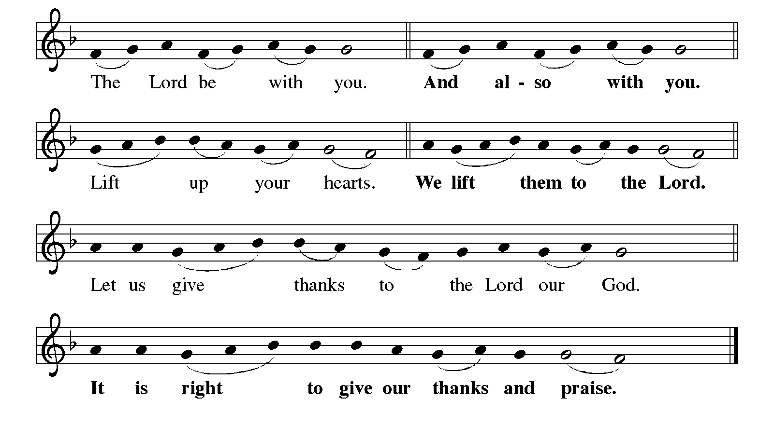

P: It is indeed right, our duty, and our joy …join their unending hymn:

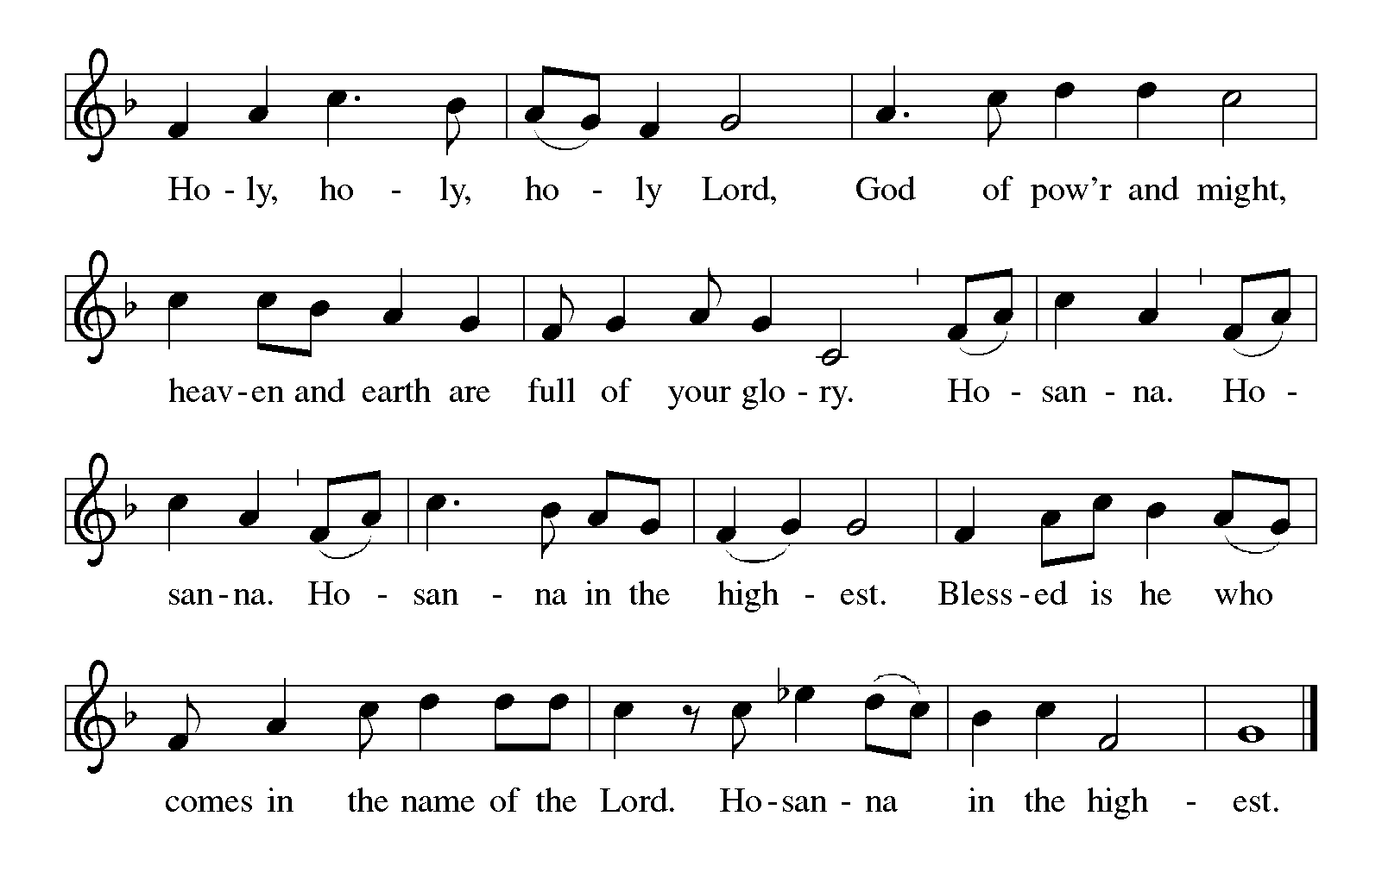

P: Holy God, Lord of glory and strength, we bless and praise You.

We worship You in the beauty of holiness, for You rule as King forevermore.

You created light from darkness; Your voice moved over the waters and You

formed the dry land.

You created us in Your image, and breathed into us Your Breath of Life.

You chose Israel to be a light to the nations, and through the prophets You called

them to rise and shine with Your glory.

At the last You revealed Your saving will in Your Son, Jesus Christ.

You sent a star to guide the magi to where the Christ was born, and Your signs and

witnesses in every age and through all the world have led Your people from

far places to His light.

In the night ... “Do this for the remembrance of Me.”

As often as we eat ... we proclaim the Lord’s death until He comes.

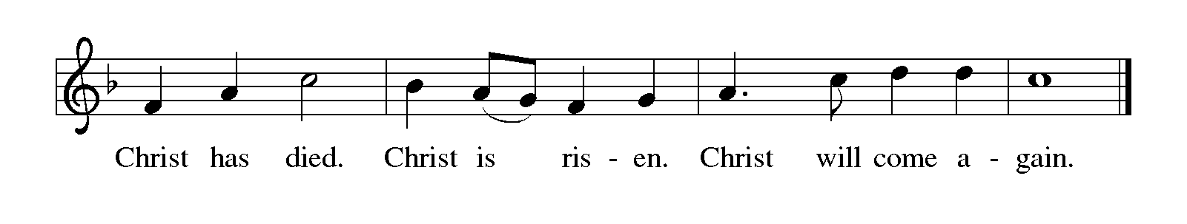

P: With this bread and cup, we remember the life our Lord offered for us.

In His Baptism He took His place with sinners; by His suffering, death, and

resurrection. You delivered us from our slavery to sin and death.

We await His promised return, when all the universe will rejoice in Your holy and

Life giving Light.

Send now Your Spirit on us and these Your gifts of bread and wine.

By this Meal may we, as beloved sons and daughters, be living epiphanies of

Christ’s light and glory until all are embraced in Your reconciling love.

To You, O God: Father, Son, and Holy Spirit, be all honor and glory, in Your holy

Church, in heaven and on earth, now and forever.

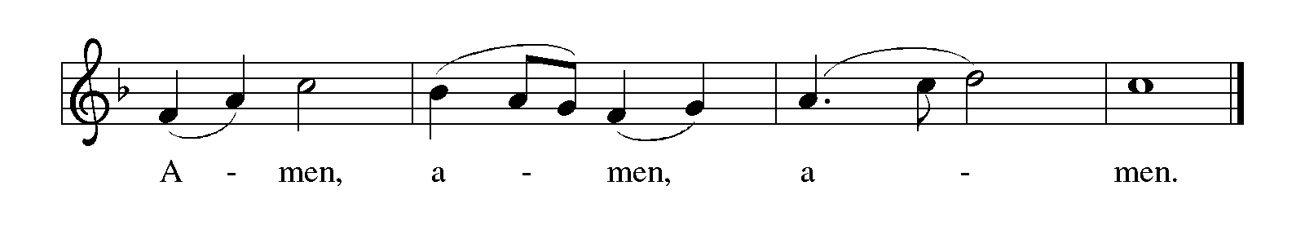

**THE LORD’S PRAYER**

P: In Christ we have received the Spirit of adoption. Now, as beloved daughters and sons

of God we dare to pray:

**C: Our Father in heaven, hallowed be Your name. Your Kingdom come. Your will**

**be done on earth as in heaven. Give us this day our daily bread, and forgive us**

**our sins as we forgive those who sin against us. Save us from the time of trial**

**and deliver us from evil, for the Kingdom, the power, and the glory are Yours,**

**now and forever. Amen.**

**INVITATION TO THE MEAL**

P: Behold the true Light of the world, the Beloved of God, anointed by the Spirit. Blessed

are those who are called to the Supper of the Lamb. God’s holy gifts for God’s holy

people. Come, for all is now ready.

*The assembly is seated*

**THE DISTRIBUTION**

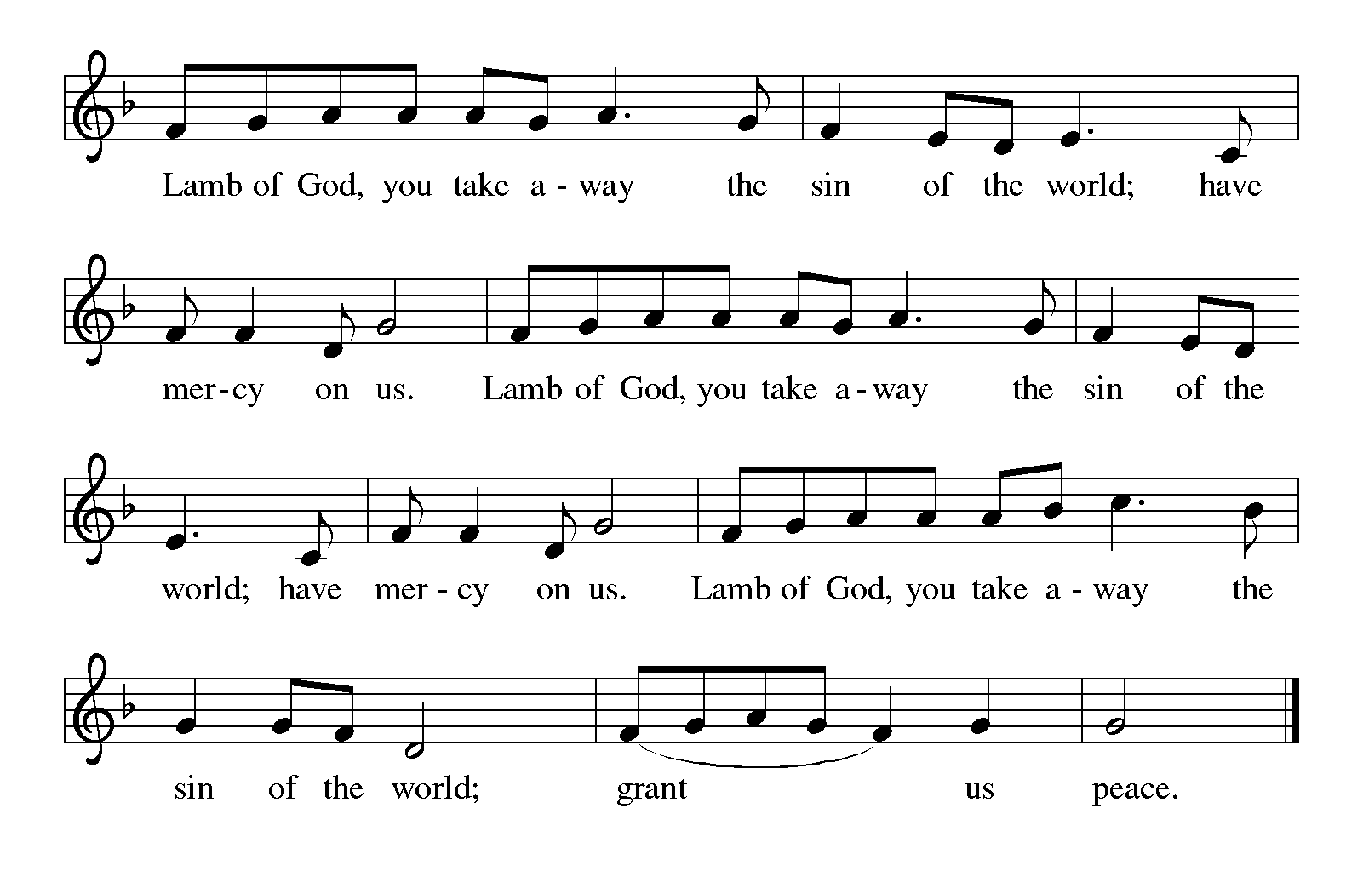

Those wishing to receive the Laying on of Hands, Anointing with Oil, and Prayer

may go to Pastor at the side aisle

**HYMN DURING DISTRIBUTION 310 *Songs of Thankfulness and Praise***

**393 *Spirit of Gentleness***

**423 *Shall We Gather at the River***

*As you are able please rise*

**THE POST-COMMUNION BLESSING**

P: The Body and Blood of our Lord Jesus Christ strengthen you and keep you in His grace.

**C: Amen.**

**THE POST-COMMUNION PRAYER**

A: Let us pray. God of all nations, in the Body and Blood of Your Son, You have again

confirmed that we are Your beloved ones. With the power that comes from its

forgiveness, give us joy and courage in our mission of shining His light into all the

darkness of this world. Grant this through Christ our Lord.

**C: Amen.**

**✠ SENDING ✠**

**THE BENEDICTION**

P: God the Father, Light-Creator;

God the Son, Light from Light;

God the Holy Spirit, Light-revealer bless you and ✠ give you peace.

**C: Amen.**

**THE SENDING SONG 866 *We Are Marching***

The congregation faces the cross as it leaves

**THE DISMISSAL**

A: Go in peace to spread the Light of Christ.

**C: Thanks be to God!**

**✠ To God Alone Be Glory✠**

The Meditation is from *A Christmas Sourcebook.* Mary Ann Simcoe, ed. (Chicago: Liturgy Training Publications, 1990) 47.

The Introduction to the Prayers, the Lord’s Prayer, and Invitation to the Meal are adapted

from *Prayers for Sundays and Seasons.* Peter J. Scagnelli. (Chicago: Liturgy

Training Publications, 1998). 27.

The Benediction is from *Sundays and Seasons.* Copyright Augsburg Fortress. 2011.

**ANNOUNCEMENTS**

**Please remember to mail your offering to the Church Office** at 818 Franklin Street, Michigan City, IN 46360**.** Another alternative is to give on-line through Tithe.ly. Please see your closure letter for information on how to set up a Tithe.ly account.

**St. Paul Members are reminded to have** a loved one contact the office if you are hospitalized. Many times, the Pastor doesn’t know someone is in the hospital. If you call and leave a message, please tell us which hospital the patient is at.

**Next Saturday’s lessons are: Isaiah 49: 1-7; Psalm40: 1-11; 1 Corinthians 1: 1-9; and John 1: 29-42** for those of you who like to study them in advance.

**Birthdays:** Mary Peters (1/6); Jo Ann Kring(1/60)

**Anniversaries:** Kenneth & Carol Hanft Sr (1/1)

**PRAYER CONCERNS:** Audrey Beyer, Ryan Krueger, Donna Bostater, Maxine Powell, Jim Tomscheck, Eloise Ponder, Mark & Jary Tannehill, Marvin Dirks, Leonard Cross, George Ottersen, Valerie Waltz, Margie Torres, Dan Pursely, Jayla Jacobi and Lyle Peters.

**If you requested someone’s name to be on the prayer list and are aware that they need continued imminent prayer then contact the church office and let us know.** Otherwise we will gradually transfer names to the long-term list.

**There are some names on the long-term prayer list that have been listed for many months.** We would like to keep the list current so if you requested them to be included please contact the church office and tell us whether you would still like them on the list: Robert Atwood; Laura Eilers-Straight; Terry Hygema; Jess Kalvaitis; Tom and Larry Lueth; Duane Ormsby; Cameron Rackard; Ryan Sirk; Jean Thomas; Heidi Happel; Christian Martinez; Ron Armer.

**OFFICE HOURS:** Libby will be in the office on Mondays, Wednesdays, and Fridays; volunteers will cover Tuesdays and Thursdays.

  Monday & Wednesday 8:00 a.m. – 5 p.m.

Tuesday & Thursday 9:00 a.m. – 12:00 p.m.

Friday 8:00 a.m. – 12:00 p.m.

**If you are listening to the worship broadcast on the radio and would like to watch the Sunday morning service live stream follow these steps:**

(1) If you have You.Tube available on your TV, search for

**St. Paul Lutheran Church Michigan City, IN.**

(2) The direct link on the computer is

<https://www.youtube.com/channel/UC5AIPNaKr3QN50984jGOa1g>.

  (3) This link is also on the main page of the church’s website in the church sec-

tion and will continue to be posted weekly on the St. Paul Facebook page.

And it will always be available on the radio broadcast Sunday mornings at 11:00 a.m. on WEFM (95.9), and on the local cable access station #99 for the previous week’s service on Sundays at 4:00 p.m. and the current service on Wednesdays at 7:00 p.m. and Fridays at 8:30 p.m.

**To send e-mail to the church office**, please use the following addresses:

Pastor Mark Reshan: seniorpastor@stpaulmichigancity.com

Church Office Secretary (Libby Pollock): churchsecretary@stpaulmichigancity.com

Church Treasurer (Karen Fleming): [finance@stpaulmichigancity.com](mailto:finance@stpaulmichigancity.com)

**The Good News Newsletter**: If you have an article or anything you want included in **The Good News** please send it to the following e-mail address: splcgoodnews@gmail.com. Pastor Pamela Thiede will be using this e-mail address to assemble **The Good News** each month. The deadline for getting information to Pastor Pamela will be the 20th of each month.

**WORSHIP ATTENDANCE for December 24 and 25, 2022**

This week’s attendance was Zero due to freezing (below O`)temperatures and blowing wind up to 50 mph.

**A Reminder**

**The discussion group “Estuary”** led by Pastor Dale Zylstra meets the second Tuesday of the month in the Luther House at 7:00 p.m. The group addresses topics of interest to the participants and is open to everyone.

**\*\*PLEASE NOTE\*\***

**VERY IMPORTANT:** Please be advised there will be a special meeting of the congregaton on Sunday, January 15, 2023, at 10:00 a.m. (following the 9:00 a.m. service)

The subject of this meeting will be the closing of the school. Please mark your calendar to attend.

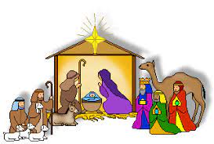 Christmas Decorations

We are blessed to have volunteers who are willing year after year to organize and put up the beautiful decorations for our celebration of Advent and The Twelve Days of Christmas. Normally, we list those generous and hard workers after the decorations have come down; but this year, it seemed good to honor them beforehand so that when you see them you might thank them for all their faithful work. Many of them have been doing the same jobs for a long time, and we are so grateful to them for their selfless service at a time of year when everyone is busy and weary.

Christmas Tree Bob and Karen Kiser; Larry and Judy

Litchford; Wayne and Suzann Dolson;

Kyle Petter; Casey, Kelly and Brad Neulieb

Advent Log Virginia Murray; also, Bernadette Krueger;

Sandy Galinowsi

Poinsettia plants Virginia Murray; Sue Koziel

Large wooden cross Janet Bakken; Sue Koziel; Karen Steinborn

Garland (outer narthex and Communion railings) Karen Steinborn; Sue Koziel

Window treatments (nave and outside) Mary Knaup

Upper narthex nativity scene and creche Pastor Mark Kloess; Jary Tannehill; Stacie Crozier

**January 2023**

**Saturday,** December 31, 2022 at 4:00 p.m. Worship Service

**Sunday,** January 1, 2023 at 9:00 a.m. Worship Service

**Wednesday,** January 4, 2023 at 9:45 a.m. Bible Study/Luther House

at 10:00 a.m. God’s Purls/St. Paul Room

**Saturday,** January 7, 2023 at 4:00 p.m. Worship Service

**Sunday,** January 8, 2023 at 9:00 a.m. Worship Service

**Monday,** January 9, 2023 at 12:30 p.m. Harmony Circle/Nursery

at 3:30 p.m. School Board Meeting/Luther House

**Tuesday,** January 10, 2023 at 9:30 p.m. Charity Circle/Nursery

at 7:00 p.m. Estuary/Luther House

**Wednesday,** January 11, 2023 at 9:45 a.m. Bible Study/Luther House

at 10:00 a.m. God’s Purls/St Paul Room

**Saturday,** January 14, 2023 at 4:00 p.m. Worship Service

**Sunday,** January 15, 2023 at 9:00 a.m. Worship Service

**at 10:00 a.m. Congregation Meeting/St. Paul Room**

**Tuesday,** January17, 2023 all day and evening GIVE BACK at Holly’s

**Wednesday,** January 18, 2023 at 9:45 a.m. Bible Study/Luther House

at 10:00 a.m. God’s Purls/St. Paul Room

**Saturday,** January 21,2023 at 4:00 p.m. Worship Service

**Sunday,** January 22, 2023 at 9:00 a.m. Worship Service

**Monday,** January 23, 2023 at 4:00 p.m. Finance Committee Mtg./Luther House

at 5:30 p.m. Executive Board Mtg./Luther House

**Wednesday,** January 25, 2023 at 9:45 a.m. Bible Study/Luther House

at 10:00 a.m. God’s Purls/St Paul Room

**Thursday,** January 26, 2023 at 5:00 p.m. Ann. Plan.Comm. Mtg./Luther House

At 5:30 p.m. Church Council Mtg./St. Paul Room

**Saturday,** January 28, 2023 at 4:00 p.m. Worship Service

**Sunday,** January 29, 2023 at 9:00 a.m. Worship Service

