**THE THEOPHANY OF OUR LORD**

**The Observance of The Epiphany of Our Lord**

**and the Baptism of Our Lord**

**January 9, 2022**

The star was a particularly evocative symbol. Variously interpreted as a figure of an angel or as a sign of the Holy Spirit, it pointed the magi (and so also the members of the church who meditate on the gospel) to Christ.

“Is it to be wondered at,” asked John Chrysostom, “that a divine star ministers to the rising Sun of Righteousness? It halts above the head of the child as if saying, ‘This is he.’”

**John Gunstone**

You were led to the holy pool of divine baptism. And each of you was asked, whether you believed in the name of the Father, and of the Son, and of the Holy Spirit. You made that saving confession, and descended three times into the water, and ascended again—here also, in a hidden and figurative way, pointing at the three-day burial of Christ.

For as our Savior passed three days and three nights in the heart of the earth, so you also, in your first ascent out of the water, represented the first day of Christ in the earth, and by your descent, the night. For as they who are in the night see no more, but they who are in the day remain in the light, so in descending you saw nothing, as in the night, but in ascending again, we were as in the day.

Let no one suppose that baptism is merely the grace of remission of sins, as was John’s baptism. No: baptism conveys to us the gift of the Holy Spirit, and God, who has presented you, as it were, alive from the dead, is able to grant you to walk in newness of life.

**Cyril of Jerusalem**

*✠* ***In the Name of Jesus ✠***

**✠ GATHERING ✠**

**INTRODUCTION**

*In the East three great epiphanies are celebrated on this day: the magi's adoration of the Christ Child, Jesus' baptism in the Jordan river, and his first miracle in which he changes water into wine. Epiphany celebrates Christ being made known, or made "manifest," to all nations.*

*The sacraments are for us the great epiphany of God's grace in which we behold the mystery of God among us. The magi offered gifts of gold, frankincense, and myrrh. Having seen the light of Christ, we offer the gift of ourselves, our time, and our possessions--that others may also know the epiphany of God's mercy and love.*

*In the waters of baptism, we have been joined to the Son in whom the Father is well pleased. The font is our Jordan where the Holy Spirit comes to us, strengthening and enlightening us for service in the world. On this great baptismal day, the church prays that all who are reborn as daughters and sons of God will continue to grow in faith, hope, and love.*

**PRELUDE *Angels from the Realms of Glory*  J. Wayne Kerr**

**ANNOUNCEMENTS**

*As you are able please rise*

**REMEMBERING OUR BAPTISM**

P: In one and the same instant you died and were born again.

C: **“Do you not know that all of us who were baptized into Christ Jesus were baptized into**

**His death?”** (Romans 6:3)

P: The Bible tells us that there is “a time to be born and a time to die.” (Ecclesiastes 3:2). For

you, however, it was the reverse: first you died, and then you were born again.

C: **“We were buried therefore with Christ through Baptism into death so that as Christ was**

**raised from the dead through the glory of the Father, we too might live a new life.”**

(Romans 6:4)

P: Daily--in the morning, when you rise, and in the evening, when you go to bed--remember that

you have died and been reborn through your Baptism. Make the sign of the holy cross and

say:

C: **In the name of the Father and of ✠ the Son and of the Holy Spirit. Amen.**

**THE PROCESSIONAL HYMN 275** ***Angels, From the Realms of Glory* page 14**

The congregation faces the cross as it enters

**THE GREETING AND PRAYERS OF THE DAY**

P: The grace of our Lord Jesus Christ, the love of God, and the communion of the Holy Spirit be

with you all.

C: **And also with you.**

P: Let us pray. Almighty and ever-living God, You revealed the incarnation of Your Son by the

brilliant shining of a star. Shine the light of Your justice always in our hearts and over all lands,

and accept our lives as the treasure we offer in Your praise and for Your service, through Jesus

Christ, our Savior and Lord, Who lives and reigns with You and the Holy Spirit, one God, now

and forever.

C: **Amen.**

P: Let us pray. Almighty God, You anointed Jesus at His baptism with the Holy Spirit and

revealed Him as Your beloved Son. Keep all who are born of water and the Spirit faithful in

Your service, that we may rejoice to be called children of God, through Jesus Christ, our Savior

and Lord, Who lives and reigns with You and the Holy Spirit, one God, now and forever.

C: **Amen.**

*The assembly is seated*

**✠ WORD ✠**

**THE FIRST READING Isaiah 60:1-6**

*Isaiah promises that God's salvation, light, and glory will shine out to all nations, and people shall come bearing gifts to the place of that light, the restored Jerusalem.*

Arise, shine; for your light has come,

and the glory of the LORD has risen upon you.

2For darkness shall cover the earth,

and thick darkness the peoples;

but the LORD will arise upon you,

and His glory will appear over you.

3Nations shall come to your light,

and kings to the brightness of your dawn.

4Lift up your eyes and look around;

they all gather together, they come to you;

your sons shall come from far away,

and your daughters shall be carried on their nurses' arms.

5Then you shall see and be radiant;

your heart shall thrill and rejoice,

because the abundance of the sea shall be brought to you,

the wealth of the nations shall come to you.

6A multitude of camels shall cover you,

the young camels of Midian and Ephah;

all those from Sheba shall come.

They shall bring gold and frankincense,

and shall proclaim the praise of the LORD.

A: The Word of the Lord.

C: **Thanks be to God.**

**THE PSALM: Psalm 29 Read responsively**

Ascribe to the LORD, you gods,

     ascribe to the LORD glory and strength.

**2Ascribe to the LORD the glory due God's name;**

**worship the LORD in the beauty of holiness.**

3The voice of the LORD is upon the waters; the God of glory thunders;

     the LORD is upon the mighty waters.

**4The voice of the LORD is a powerful voice;**

**the voice of the LORD is a voice of splendor.**

5The voice of the LORD breaks the cedar trees;

     the LORD breaks the cedars of Lebanon;

**6the LORD makes Lebanon skip like a calf,**

**and Mount Hermon like a young wild ox.**

7The voice of the LORD

     bursts forth in lightning flashes.

**8The voice of the LORD shakes the wilderness;**

**the LORD shakes the wilderness of Kadesh.**

9The voice of the LORD makes the oak trees writhe

and strips the forests bare.

     And in the temple of the LORD all are crying, "Glory!"

**10The LORD sits enthroned above the flood;**

**the LORD sits enthroned as king forevermore.**

11O LORD, give strength to Your people;

     give them, O LORD, the blessings of peace.

**SECOND READINGS Ephesians 3:1-12**

*Though it had been hidden for years, Paul now reveals the secret that has shaped his apostolic witness: in Jesus Christ, God's salvation extends beyond the Jews to include all people. The light of Christ shines upon Jew and Gentile alike.*

This is the reason that I Paul am a prisoner for Christ Jesus for the sake of you Gentiles—

2for surely you have already heard of the commission of God's grace that was given

me for you,

3and how the mystery was made known to me by revelation, as I wrote above in a few words,

4a reading of which will enable you to perceive my understanding of the mystery of Christ.

5In former generations this mystery was not made known to humankind, as it has

now been revealed to his holy apostles and prophets by the Spirit:

6that is, the Gentiles have become fellow heirs, members of the same body, and sharers

in the promise in Christ Jesus through the gospel.

7Of this gospel I have become a servant according to the gift of God's grace that was given

me by the working of His power.

8Although I am the very least of all the saints, this grace was given to me to bring to

the Gentiles the news of the boundless riches of Christ,

9and to make everyone see what is the plan of the mystery hidden for ages in God Who

created all things;

10so that through the church the wisdom of God in its rich variety might now be made

known to the rulers and authorities in the heavenly places.

11This was in accordance with the eternal purpose that He has carried out in Christ

Jesus our Lord,

12in Whom we have access to God in boldness and confidence through faith in Him.

**Acts 8:14-17**

*Peter and John are sent to support the new Christians in Samaria, a group that was recently baptized after hearing the good news of Christ through the preaching of Philip. Here the Samaritans receive the gift of the Holy Spirit in the laying on of hands.*

14Now when the apostles at Jerusalem heard that Samaria had accepted the word of God, they sent Peter and John to them. 15The two went down and prayed for them that they might receive the Holy Spirit 16(for as yet the Spirit had not come upon any of them; they had only been baptized in the name of the Lord Jesus). 17Then Peter and John laid their hands on them, and they received the Holy Spirit.

The Word of the Lord.

**Thanks be to God.**

*As you are able please rise*

**THE VERSE**

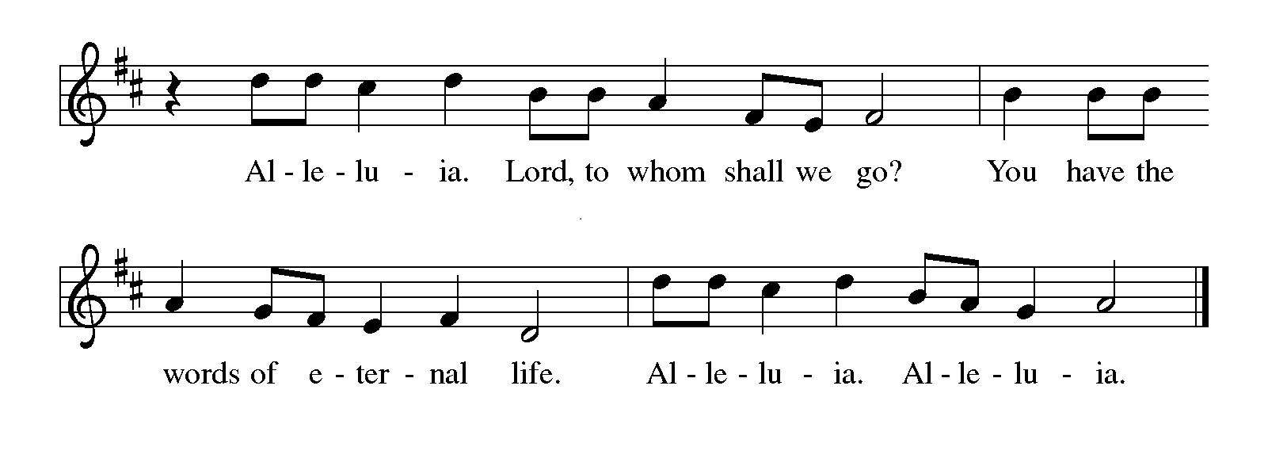

**THE HOLY GOSPEL Matthew 2:1-12**

*The spiritual quest of all human beings is mirrored in the journey of the magi. They find and adore the Christ child, the fulfillment of their hope, the epiphany and glory of God.*

P: The Holy Gospel according to St. Matthew, the second chapter.

C: **Glory to You, O Lord!**

In the time of King Herod, after Jesus was born in Bethlehem of Judea, wise men from the East came to Jerusalem, 2asking, "Where is the child who has been born king of the Jews? For we observed His star at its rising, and have come to pay Him homage." 3When King Herod heard this, he was frightened, and all Jerusalem with him; 4and calling together all the chief priests and scribes of the people, he inquired of them where the Messiah was to be born. 5They told him, "In Bethlehem of Judea; for so it has been written by the prophet:

6'And you, Bethlehem, in the land of Judah,

are by no means least among the rulers of Judah;

for from you shall come a ruler

who is to shepherd my people Israel.' "

7Then Herod secretly called for the wise men and learned from them the exact time when the star had appeared. 8Then he sent them to Bethlehem, saying, "Go and search diligently for the child; and when you have found Him, bring me word so that I may also go and pay Him homage."

9When they had heard the king, they set out; and there, ahead of them, went the star that they had seen at its rising, until it stopped over the place where the child was. 10When they saw that the star had stopped, they were overwhelmed with joy. 11On entering the house, they saw the child with Mary His mother; and they knelt down and paid him homage. Then, opening their treasure chests, they offered Him gifts of gold, frankincense, and myrrh. 12And having been warned in a dream not to return to Herod, they left for their own country by another road.

**THE HOLY GOSPEL Luke 3:15-17, 21-22**

*The reading opens with questions about the identity of the Messiah. John the Baptist insists that he is not the Messiah; instead he points ahead to one who is coming. And whether the voice of God was heard by all or only by Jesus, God settles the matter: Jesus is God’s beloved Son.*

P: The Holy Gospel according to St. Luke, the third chapter.

15As the people were filled with expectation, and all were questioning in their hearts concerning John, whether he might be the Messiah, 16John answered all of them by saying, “I baptize you with water; but One Who is more powerful than I is coming; I am not worthy to untie the thong of His sandals. He will baptize you with the Holy Spirit and fire. 17His winnowing fork is in His hand, to clear His threshing floor and to gather the wheat into His granary; but the chaff He will burn with unquenchable fire.”

21Now when all the people were baptized, and when Jesus also had been baptized and was praying, the heaven was opened, 22and the Holy Spirit descended upon Him in bodily form like a dove. And a voice came from heaven, “You are My Son, the Beloved; with You I am well pleased.”

P: The Gospel of the Lord.

C: **Praise to You, O Christ!**

*The assembly is seated*

**THE SERMON**

*Silence for reflection follows the sermon*

*As you are able please rise*

**THE HYMN OF THE DAY 671 *Shine, Jesus, Shine*  page 15**

*The assembly is seated*

**THE AFFIRMATION OF BAPTISM**

**Presentation**

P: Dear friends, we give thanks for the gift of baptism as we come before God to make public

affirmation of baptism into Christ.

Let us pray.

Merciful God, You have made us Your own by water and the Word in baptism. You have

called us to Yourself, enlightened us with the gifts of Your Spirit, and nourished us in the

community of faith. Uphold us in the gifts and promises of baptism, and unite the hearts of all

whom you have brought to new birth. We ask this in the name of Christ.

C: **Amen.**

**Profession of Faith**

*The presiding minister addresses those making public affirmation of baptism. The assembly may stand and join in the responses.*

I ask you to profess your faith in Christ Jesus, reject sin, and confess the faith of the church.

Do you renounce the devil and all the forces that defy God?

*Response:*

**I renounce them.**

Do you renounce the powers of this world that rebel against God?

*Response:*

**I renounce them.**

Do you renounce the ways of sin that draw you from God?

*Response:*

**I renounce them.**

*The presiding minister addresses the candidates and the assembly.*

Do you believe in God the Father?

**I believe in God, the Father almighty,**

**creator of heaven and earth.**

Do you believe in Jesus Christ, the Son of God?

**I believe in Jesus Christ, His only Son, our Lord,**

**He was conceived by the Holy Spirit,**

**born of the virgin Mary,**

**suffered under Pontius Pilate,**

**was crucified, died, and was buried;**

**He descended into hell.**

**On the third day He rose again;**

**He ascended into heaven,**

**and is seated at the right hand of the Father,**

**He will come to judge the living and the dead.**

Do you believe in God the Holy Spirit?

**I believe in the Holy Spirit,**

**the holy catholic church,**

**the communion of saints,**

**the forgiveness of sins,**

**the resurrection of the body,**

**and the life everlasting. Amen.**

**Affirmation of Baptism**

P: You have made public profession of your faith. Do you intend to continue in the covenant God

made with you in holy baptism:

to live among God's faithful people,

to hear the word of God and share in the Lord's Supper,

to proclaim the good news of God in Christ through word and deed,

to serve all people, following the example of Jesus,

and to strive for justice and peace in all the earth?

*The assembly makes affirmation:*

**I do, and I ask God to help and guide me.**

*The minister addresses the assembly.*

People of God, do you promise to support and pray for one another in your life in Christ?

**We do, and we ask God to help and guide us.**

*The presiding minister prays for God's blessing.*

Let us pray.

We give You thanks, O God, that through water and the Holy Spirit You give us new birth, cleanse us from sin, and raise us to eternal life. Stir up in Your people the gift of Your Holy Spirit: the spirit of wisdom and understanding, the spirit of counsel and might, the spirit of knowledge and the fear of the Lord, the spirit of joy in Your presence, both now and forever.

**Amen.**

**HYMN DURING THE SPRINKLING 449 *We Know That Christ is Raised*  page 16**

**THE INSTALLATION OF CHURCH COUNCIL AND SCHOOL BOARD**

P: The following persons, having been elected by the congregation to positions of leadership, are

asked to come forward as their offices and names are read.

**Church council**

President Judy Mutchler

Vice-President Paul Brooks

Secretary Carey Howard

Treasurer Karen Fleming

Shirley McCarty

Fred Hart

Janet Bakken

Diane Waltz

Jim Schraidt

Wayne Dolson

Susan Bagby

Susan Koziel

**School Board**

Principal Tracey McCay

Judy Hunt

Pastor Pamela Thiede

Melinda Nagle

Sarah McNabb

P: St. Paul writes: There are different kinds of spiritual gifts, but the same Spirit gives them.

There are different ways of serving, but the same Lord is serviced. There are different abilities

to perform service, but the same God gives to everyone ability for particular service. The

Spirit’s presence is shown in some way in each person, for the good of all. (1 Corinthians 12:4-

7)

You have been elected to positions of leadership and trust in this congregation. You are to see

that the words and deeds of this household of faith reflect Him in Whose name we gather.

You are to work together with other members to see that the worship and work of Christ are

done in this congregation, and that God’s will is done in this community and in the whole

world.

You are to be diligent in your specific area of serving, that the one Lord Who empowers you

is glorified.

You are to be examples of faith active in love, to help maintain the life and harmony of this

congregation.

On behalf of your sisters and brothers in Christ, I ask you: Are you ready to accept and

faithfully to carry out the duties of the offices to which you have been elected?

*R: Yes, by the help of God.*

*As you are able please rise*

P: People of God, I ask you: Will you support these, your elected leaders, and will you share in

the mutual ministry that Christ has given to all who are baptized?

C: **Yes, by the help of God.**

P: I now declare you installed as council members of this congregation. God bless you with His

Holy Spirit, that you may prove faithful servants of Christ.

*R: Amen.*

**THE PRAYER OF THE CHURCH**

A: Baptized into Christ, let us offer our prayer in the name of Jesus, God’s Beloved Son, that

God’s glory might shine on the Church and the world.

A: That the light of Christ might burn brightly in the Church to beckon a rich diversity of peoples,

let us pray to the Lord:

C: **Lord, hear our prayer.**

A: That as the waters of Baptism daily refresh us in Christ, so may all nations work diligently to

provide clean water to prevent disease and nourish the land, let us pray to the Lord:

C: **Lord, hear our prayer.**

A: That members of this congregation might offer Christ the gold of a living faith, the incense of

vibrant worship and prayer, and the myrrh of compassion, let us pray to the Lord:

C: **Lord, hear our prayer.**

A: That our church council: **Judy and Paul; Karen and Carey; Susan and Shirley; Fred and**

**Wayne; Diane and Janet; Jim and Sue;** and our school board: **Pastor Pamela and Melinda;**

**Tracey, Judy and Sarah** may lead us, our students and their families into God’s own wisdom

and compassion, let us pray to the Lord:

C: **Lord, hear our prayer.**

A: That those in need: the falsely accused and imprisoned, the homeless, the addicted, the hungry,

and the sick, especially; . . . may know the grace-full healing of God’s radiant presence, let us

pray to the Lord:

C: **Lord, hear our prayer.**

A: That those celebrating birthdays, especially **Jim Burdett;** and anniversaries, especially **Kelly**

**and Brad Neulieb; Dick and Donna Collins; and Jeff and Marla Furness** may be filled

with grace this day and every day and grow in grace in the days ahead, let us pray to the Lord:

C: **Lord, hear our prayer.**

A: That with all those who followed in faith the star of Christ we may dwell in God’s everlasting

light, let us pray to the Lord:

C: **Lord, hear our prayer.**

P: O God of stars and journeys, You lead us day by day to the joyful vision of Your light. Move

us by the power of Your Word that we too might open our gifts for others. So may You be

praised and adored through Christ our Lord.

C: **Amen.**

**✠ MEAL✠**

**THE PEACE**

P: The peace of the Lord be with you always.

C: **And also with you.**

*The assembly is seated*

**THE VOLUNTARY *Waterlife* Praise Band**

*As you are able please rise*

**THE OFFERTORY PRAYER**

A: Let us pray. Merciful God,

C: **As the magi offered gifts to the Christ child, receive the treasures we offer of ourselves,**

**our time, and our possessions. Through this Meal make us new in Him Who makes all**

**creation new, that we may be a light of Your love to all the nations. We ask this in the**

**name of Jesus the Lord. Amen.**

**THE GREAT THANKSGIVING**

P: The Lord be with you.

C: **And also with you.**

P: Lift up your hearts.

C: **We lift them up to the Lord.**

P: Let us give thanks to the Lord our God.

C: **It is right to give Him thanks and praise.**

P: Holy God, Lord of glory and strength, we bless and praise You.

We worship You in the beauty of holiness, for You rule as King forevermore.

You created light from darkness; Your voice moved over the waters and You form

dry land.

You created us in Your image, and breathed into us Your Breath of Life.

You chose Israel to be a light to the nations, and through the prophets You called them to

rise and shine with Your glory.

At the last You revealed Your saving will in Your Son, Jesus Christ.

You sent a star to guide the magi to where the Christ was born, and Your signs and

witnesses in every age and through all the world have led Your people from far

places to His light.

In the night ... “Do this for the remembrance of Me.”

As often as we eat ... we proclaim the Lord’s death until He comes.

C: **Christ has died. Christ has risen. Christ will come again.**

With this bread and cup, we remember the life our Lord offered for us.

In His Baptism He took His place with sinners; by His suffering, death, and resurrection

You delivered us from our slavery to sin and death.

We await His promised return, when all the universe will rejoice in Your holy and Life-

giving Light.

Send now Your Spirit on us and these Your gifts of bread and wine.

By this Meal may we, as beloved sons and daughters, be living epiphanies of Christ’s

light and glory until all are embraced in Your reconciling love.

To You, O God: Father, Son, and Holy Spirit, be all honor and glory, in Your holy

Church, in heaven and on earth, now and forever.

C: **Amen!**

**THE LORD’S PRAYER**

P: In Christ we have received the Spirit of adoption. Now, as beloved daughters and sons of God

we dare to pray:

C: **Our Father, Who art in heaven, hallowed be Thy Name.**

**Thy Kingdom come. Thy will be done on earth as it is in heaven.**

**Give us this day our daily bread, and forgive us our trespasses as we forgive those**

**who trespass against us.**

**And lead us not into temptation, but deliver us from evil.**

**For Thine is the Kingdom, and the power, and the glory, forever and ever. Amen.**

**INVITATION TO THE MEAL**

P: Behold the true Light of the world, the Beloved of God, anointed by the Spirit. Blessed are

those who are called to the Supper of the Lamb. God’s holy gifts for God’s holy people. Come,

for all is now ready.

*The assembly is seated*

**THE DISTRIBUTION**

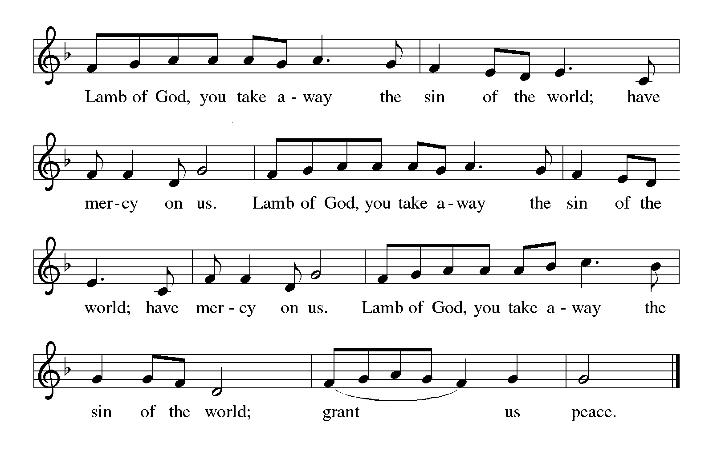

*Those wishing to receive the Laying on of Hands, Anointing with Oil, and Prayer for*

*Healing may go to Pastor at the side aisle*

**HYMN DURING DISTRIBUTION 677 *This Little Light of Mine*  page 17**

**459 *Wade in the Water*  page 18**

**NSB 80  *Spirit of the Living God*  page 19**

*As you are able please rise*

**THE POST-COMMUNION BLESSING**

P: The Body and Blood of our Lord Jesus Christ strengthen you and keep you in His grace.

C: **Amen.**

**THE POST-COMMUNION PRAYER**

A: Let us pray. God of all nations, in the Body and Blood of Your Son, You have again confirmed

that we are Your beloved ones. With the power that comes from its forgiveness, give us joy

and courage in our mission of shining His light into all the darkness of this world. Grant this

through Christ our Lord.

C: **Amen.**

**✠ SENDING ✠**

**THE BENEDICTION**

P: God the Father, Light-Creator;

God the Son, Light from Light;

God the Holy Spirit, Light-revealer bless you and ✠ give you peace.

C: **Amen.**

**THE RECESSIONAL SONG 866 *We Are Marching in the Light of God* page 20**

The congregation faces the cross as it leaves

**THE DISMISSAL**

A: Go in peace to spread the Light of Christ.

C: **Thanks be to God!**

**✠ To God Alone Be Glory ✠**

The Meditations are from *An Advent Sourcebook.* Mary Ann Simcoe, ed. (Chicago: Liturgy

Training Publications, 1988) 132; and *Sundays and Seasons Online.* Copyright Augs-

burg Fortress, 2017.

The Introduction to the Prayers, the Lord’s Prayer, and Invitation to the Meal are adapted from

*Prayers for Sundays and Seasons.* Peter J. Scagnelli. (Chicago: Liturgy Training

Publications, 1998). 27.

The Benediction is from *Sundays and Seasons.* Copyright Augsburg Fortress. 2011.

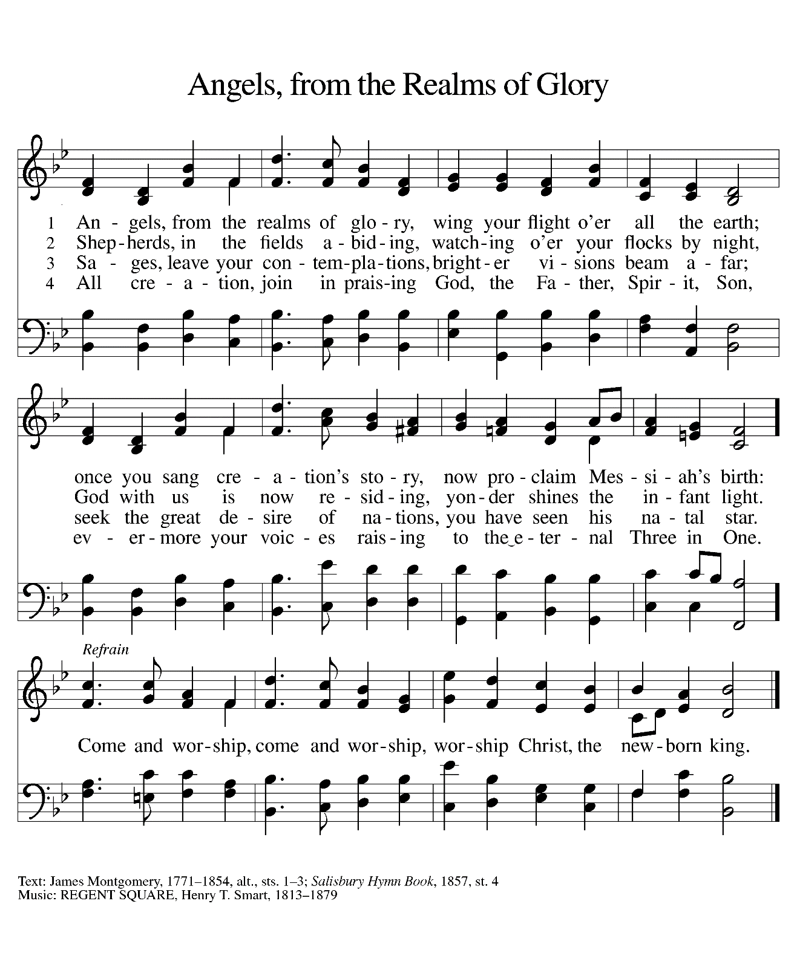

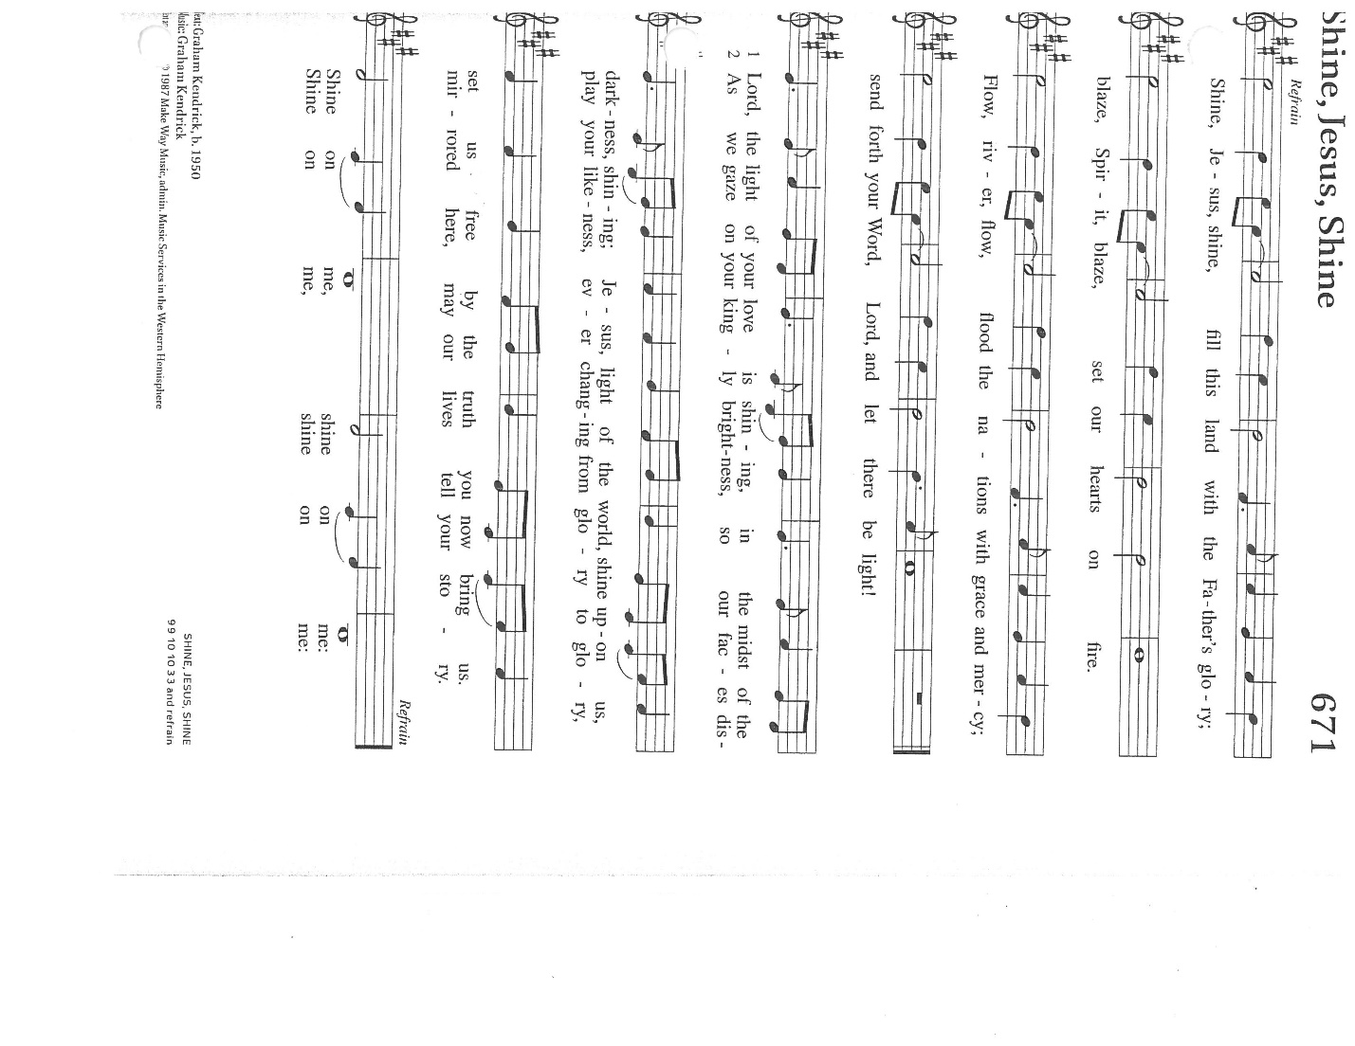

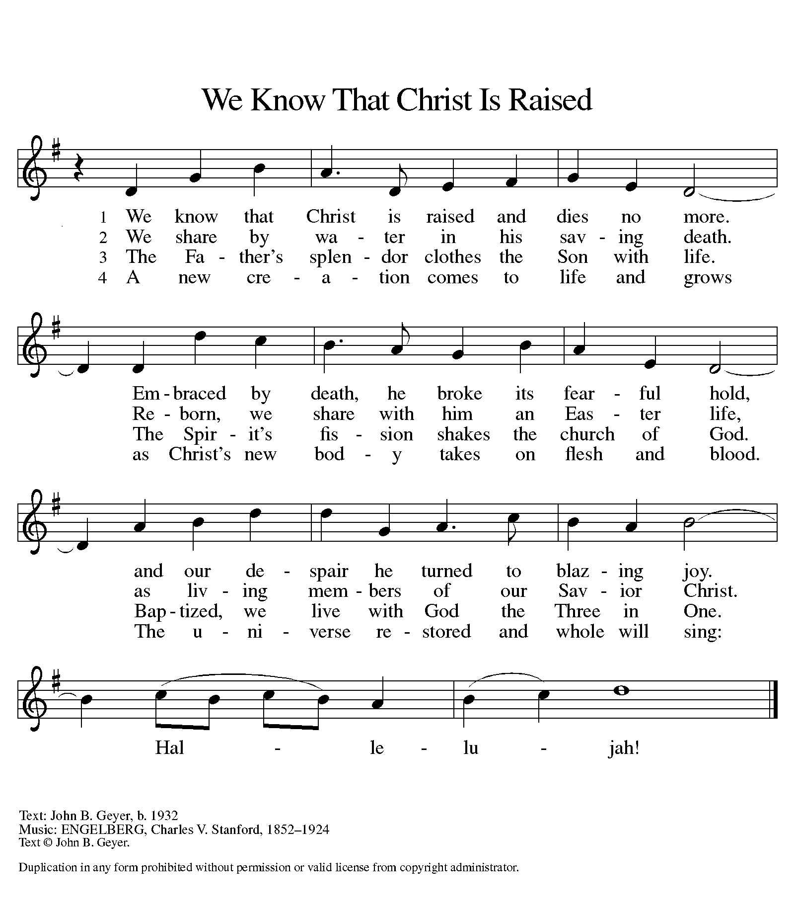

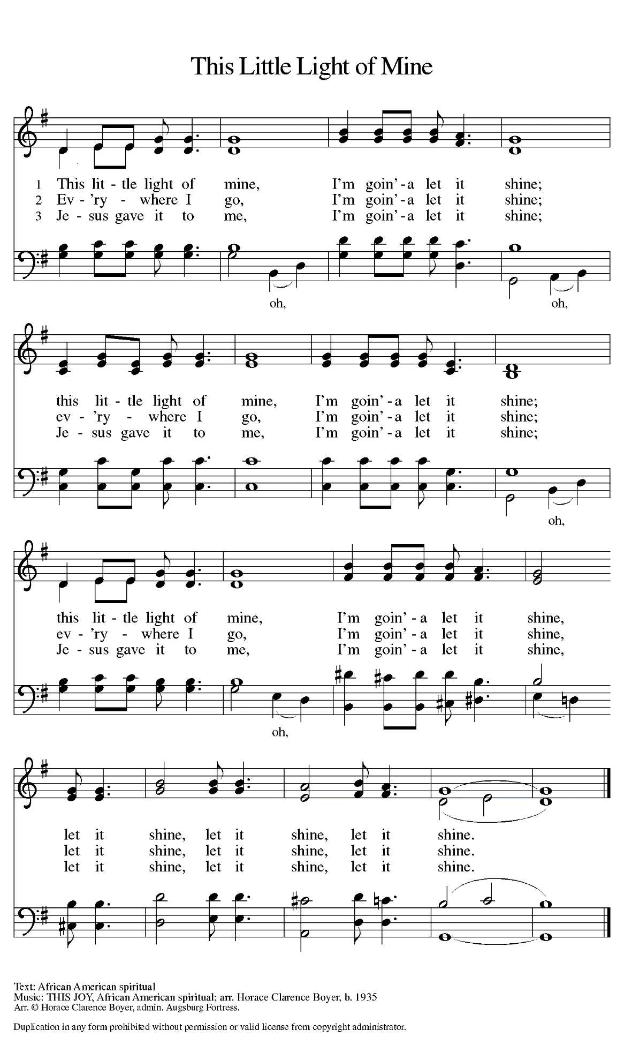

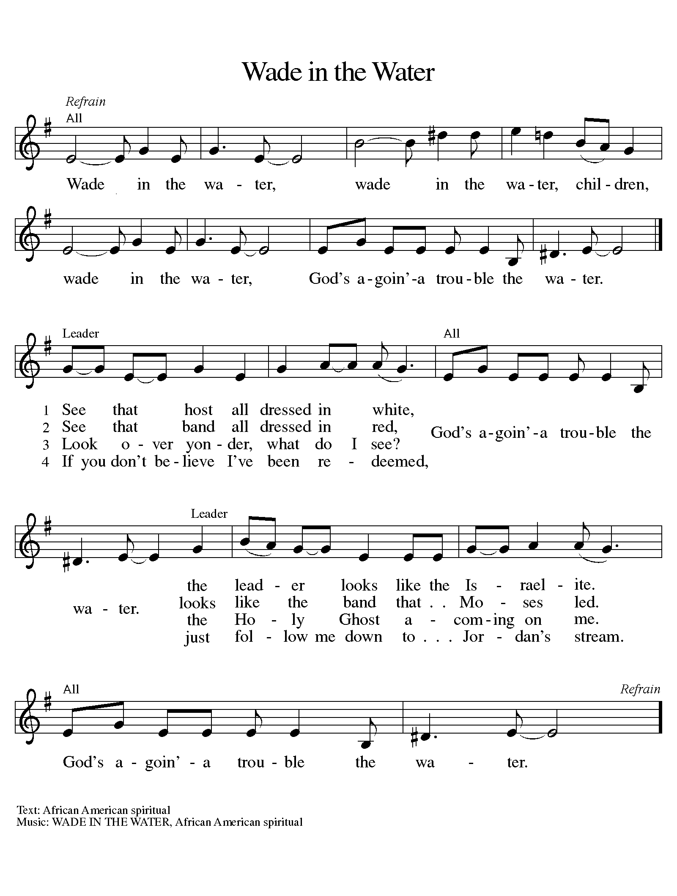

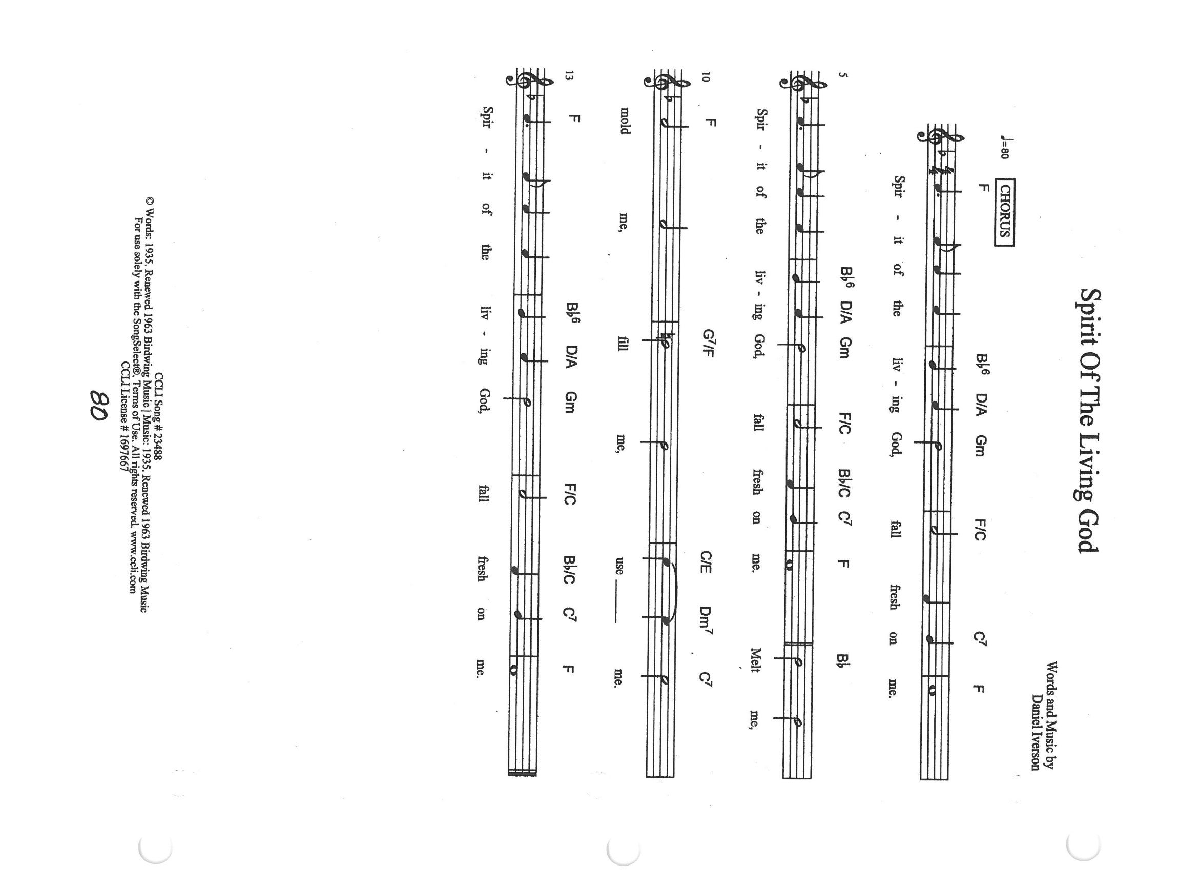

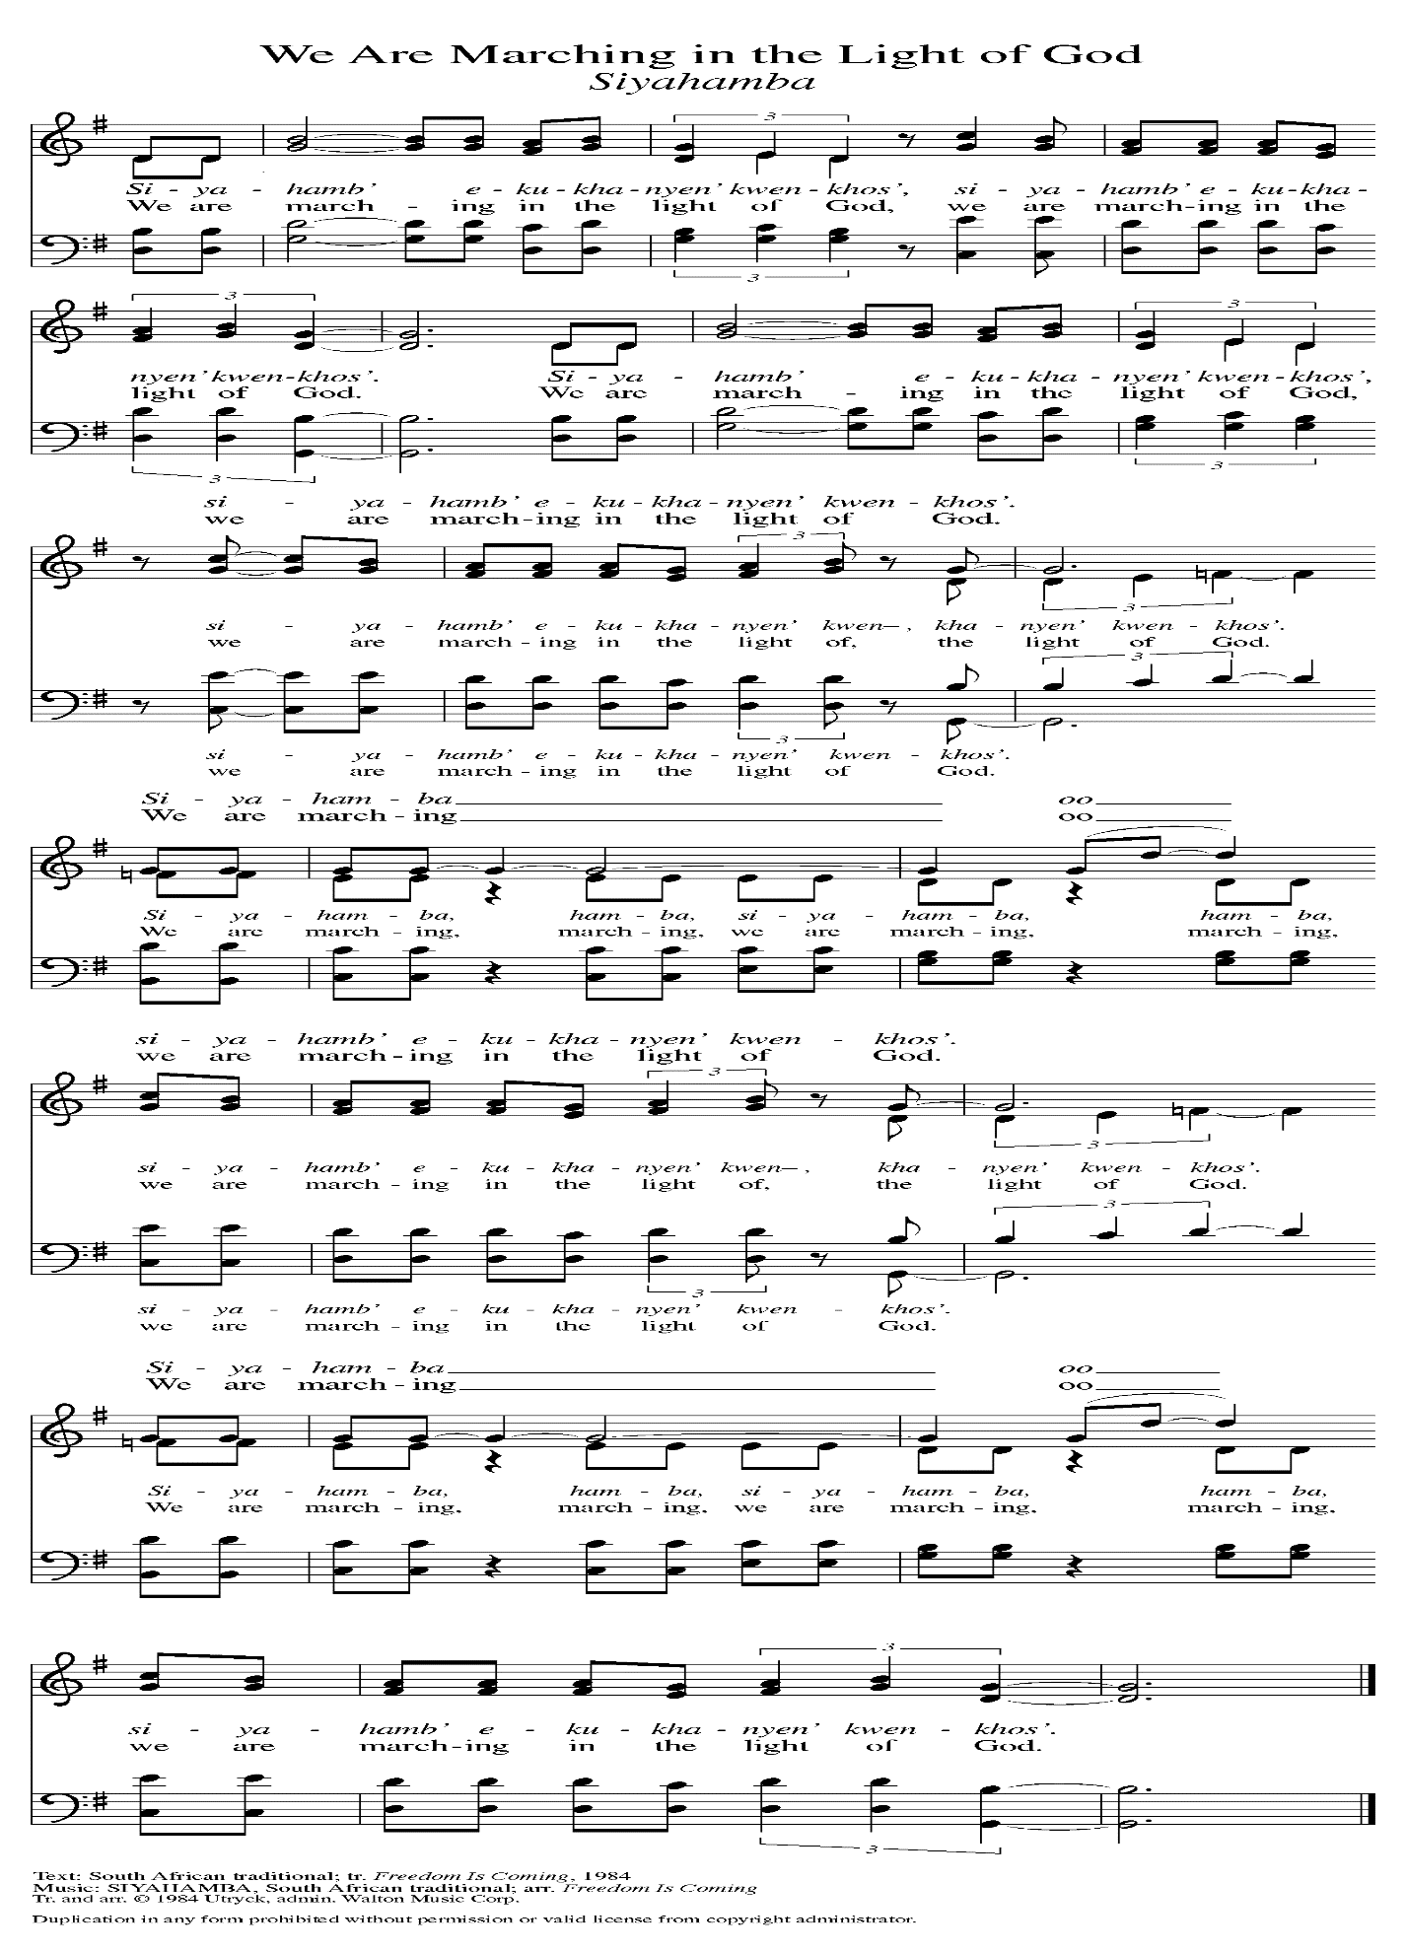

**ANNOUNCEMENTS**

**Please remember to mail your offering to the Church Office** at 818 Franklin Street, Michigan City, IN 46360**.** Another alternative is to give on-line through Tithe.ly. Please see your closure letter for information on how to set up a Tithe.ly account.

**St. Paul Members are reminded to have** a loved one contact the office if you are hospitalized. Many times, the Pastor doesn’t know someone is in the hospital. If you call and leave a message, please tell us which hospital the patient is at.

**Next Sunday’s lessons are Isaiah 62: 1-5; Psalm 36: 5-10; I Corinthians 12: 1-11; John 2: 1-11** for those of you who like to study them in advance.

**Birthdays: James Burdett (1/12)**

**Anniversaries: Kelly & Bradford Neulieb (1/12); Richard & Donna Collins (1/14);**

**Jeffrey & Marla Furness (1/15)**

**PRAYER CONCERNS:** Kathy Thielman, Audrey Beyer, Bethany Manning, Marla Furness, Ryan Krueger, Donna Bostater, Maxine Powell, Jess Kalvaitis, Jan Paholski, Laura Dovey, Heidi Happel, Shane Nevels, Irene Bohnstadt, Joan Coughlin, Jim Tomscheck, Erik Tannehill, Ed Gustum, Ken Mulder, Ashton Steele, Christian Martinez, Nancy Wisser, Ryan Sirk, Jary Tannehill, Jim Gleason, Carl Loetz, Patsy Humbers, Ed Riddle and Blythe Topa.

**If you requested someone’s name to be on the prayer list and are aware that they need continued imminent prayer then contact the church office and let us know.** Otherwise we will gradually transfer names to the long-term list.

**OFFICE HOURS:** Libby will be in the office on Mondays, Wednesdays, and Fridays; volunteers will cover Tuesdays and Thursdays.

Monday & Wednesday 8:00 a.m. – 5 p.m.

Tuesday & Thursday 9:00 a.m. – 12:00 p.m.

Friday 8:00 a.m. – 12:00 p.m.

**If you are listening to the worship broadcast on the radio and would like to watch the Sunday morning service live stream follow these steps:**

1. If you have You.Tube available on your TV, search for

**St. Paul Lutheran Church Michigan City, IN.**

(2) The direct link on the computer is

https://www.youtube.com/channel/UC5AIPNaKr3QN50984jGOa1g.

(3) This link is also on the main page of the church’s website in the church section and will continue to be posted weekly on the St. Paul Facebook page.

And it will always be available on the radio broadcast Sunday mornings at 11:00 a.m. on WEFM (95.9), and on the local cable access station #99 for the previous week’s service on Sundays at 4:00 p.m. and the current service on Wednesdays at 7:00 p.m. and Fridays at 8:30 p.m.

**To send e-mail to the church office**, please use the following addresses:

Pastor Mark Reshan: seniorpastor@stpaulmichigancity.com

Church Office Secretary (Libby Pollock): churchsecretary@stpaulmichigancity.com

Church Treasurer (Karen Fleming) and Bookkeeper (Billie Atchinson):

finance@stpaulmichigancity.com.

**The Good News Newsletter**: If you have an article or anything you want included in **The Good News** please send it to the following e-mail address: splcgoodnews@gmail.com. Pastor Pamela Thiede will be using this e-mail address to assemble **The Good News** each month. The deadline for getting information to Pastor Pamela will be the 20th of each month.

**WORSHIP ATTENDANCE for January 1 and 2, 2022**

**4:00 p.m. 13**

**9:00 a.m. 35**

**Total= 48**

**The Community Soup Kitchen serving out of First United Methodist is in need of volunteers.** Sunday through Tuesday is always need, as is occasionally Wednesdays and Thursdays. Hours are 9:30 a.m. to 1:15 p.m. and it is not necessary to stay the entire time. There is also a need for volunteers to be available to help pick up deliveries from the Food Bank when they arrive. If you are able to help please contact their church office at 872-7200.

**For information regarding worship closure due to inclement weather or COVID concerns** please utilize one of these resources:

* If the decision is made early enough in the week to cancel worship an email will be sent to those on the church email list
* You may tune to WEFM 95.9 for an announcement during their broadcast
* The church and school Facebook page ([St Paul Lutheran Church & School - Michigan City, IN | Facebook](https://www.facebook.com/stpaulmichigancity)) will post an announcement
* You may dial the church office number (219-874-7293) and when the automated menu begins press the # button for a recorded announcement

Between these sources we hope to keep everyone informed as to the status of our worship services.

**JANUARY MEETINGS AND ACTIVITIES**

Worship Service: Saturday, January 8, 2022 at 4:00pm

Worship Service: Sunday, January 9, 2022 at 9:00 am

School Board Meeting: Monday, January 10, 2022 at 3:30pm/Luther House

Wednesday Bible Study: January 12, 2022 at 9:45am/Luther House

God’s Purls: Wednesday, January 12, 2022 at 10:00am/St. Paul Room

Worship & Music Committee: Wednesday, January 12, 2022 at 6:00pm

Choir Rehearsal: Wednesday, January 12, 2022 at 7:00pm

Worship Service: Saturday, January 15, 2022 at 4:00pm

Worship Service: Sunday, January 16, 2022 at 9:00am

Finance Committee Meeting: Monday, January 17, 2022 at 4:00pm/St. Paul Room

Executive Board Meeting: Monday, January 17, 2022at 5:30pm/Luther House

Wednesday Bible Study: January 19, 2022 at 9:45am/Luther House

God’s Purls: Wednesday, January 19, 2022 at 10:00am/St. Paul Room

Church Council Meeting: Thursday, January 20, 2022 at 5:30pm/St. Paul Room

Worship Service: Saturday, January 22, 2022 at 4:00pm

Worship Service: Sunday, Jauary 23, 2022 at 9:00am

Wednesday Bible Study: January 26, 2022 at 9:45am/Luther House

God’s Purls: Wednesday, January 26, 2022 at 10:00am/St. Paul Room

GIVE-BACK AT Galveston Steakhouse: Thursday, January 27, 2022 at 4pm—10pm

Worship Service: Saturday, January 29, 2022 at 4:00pm

Worship Service: Sunday, January 30, 2022 at 9:00am