**THE TRANSFIGURATION OF OUR LORD**

**The Last Sunday After the Epiphany**

**February 19, 2023**

“When You were transfigured before Your crucifixion, O Lord, the mount resembled heaven, and a cloud spread out like a canopy, and the Father bore witness to You. And there were present Peter, James, and John, since they were to be with You at Your betrayal; so that seeing Your wonders they might not be dismayed at Your sufferings.

Make us, therefore, to worship the same in peace for Your great mercy.”

**Cozma the Anchorite**

The disciples upon the mountain behold two suns: one, to which they were accustomed, shining in the sky; and another, to which they were unaccustomed, shining down on them and from the firmament giving light to the whole world, and which then shone for them alone, which was the face of Jesus before them.

His face shone, not like the face of Moses, from without; from his face the glory of his divinity poured forth, yet remained with him. From himself came his own light. Moses and Elijah were filled with joy, and the apostles likewise, in their ascent of the mountain.

The prophets rejoiced because they had seen Jesus’ humanity, which they had not known. And the apostles rejoiced because they had seen the glory of his divinity, which they had not known.

**Ephraem**

**Fourth century**

**✠ In the Name of Jesus ✠**

**INTRODUCTION**

Today's festival is a bridge between the Advent-Christmas-Epiphany cycle that comes to a close today and the Lent-Easter cycle that begins in several days. On the mount of transfiguration Jesus is revealed as God's beloved Son, echoing the words at his baptism. This vision of glory sustains us as Jesus faces his impending death in Jerusalem.

We turn this week to Ash Wednesday and our yearly baptismal journey from Lent to Easter. Some churches put aside the alleluia at the conclusion of today's liturgy. This word of joy will be omitted during the penitential season of Lent and will be sung again at Easter.

**Martin Luther, renewer of the church, died 1546**

*Though he began his adult church life as a simple Augustinian monk, Luther challenged the abuses he saw in the church, and his work eventually led to the Protestant Reformation. Luther's accomplishments included liturgical reform, translation of the Bible, and creation of the Small and Large Catechisms.*

**✠ GATHERING ✠**

**PRELUDE *Amazing Grace*  arr. Bish**

**ANNOUNCEMENTS**

*As you are able, please rise*

**THE PROCESSIONAL HYMN 631 *Love Divine, All Loves Excelling***

The congregation faces the cross as it enters

**THE GREETING PRAYER OF THE DAY**

P: To the Church of God in this place, to those who are called to be saints, to all those who

call upon the name of our Lord Jesus Christ:

The grace of our Lord Jesus Christ, the love of God, and the communion of the Holy

Spirit be with you all.

**C: And also with you.**

**THE HYMN OF PRAISE**

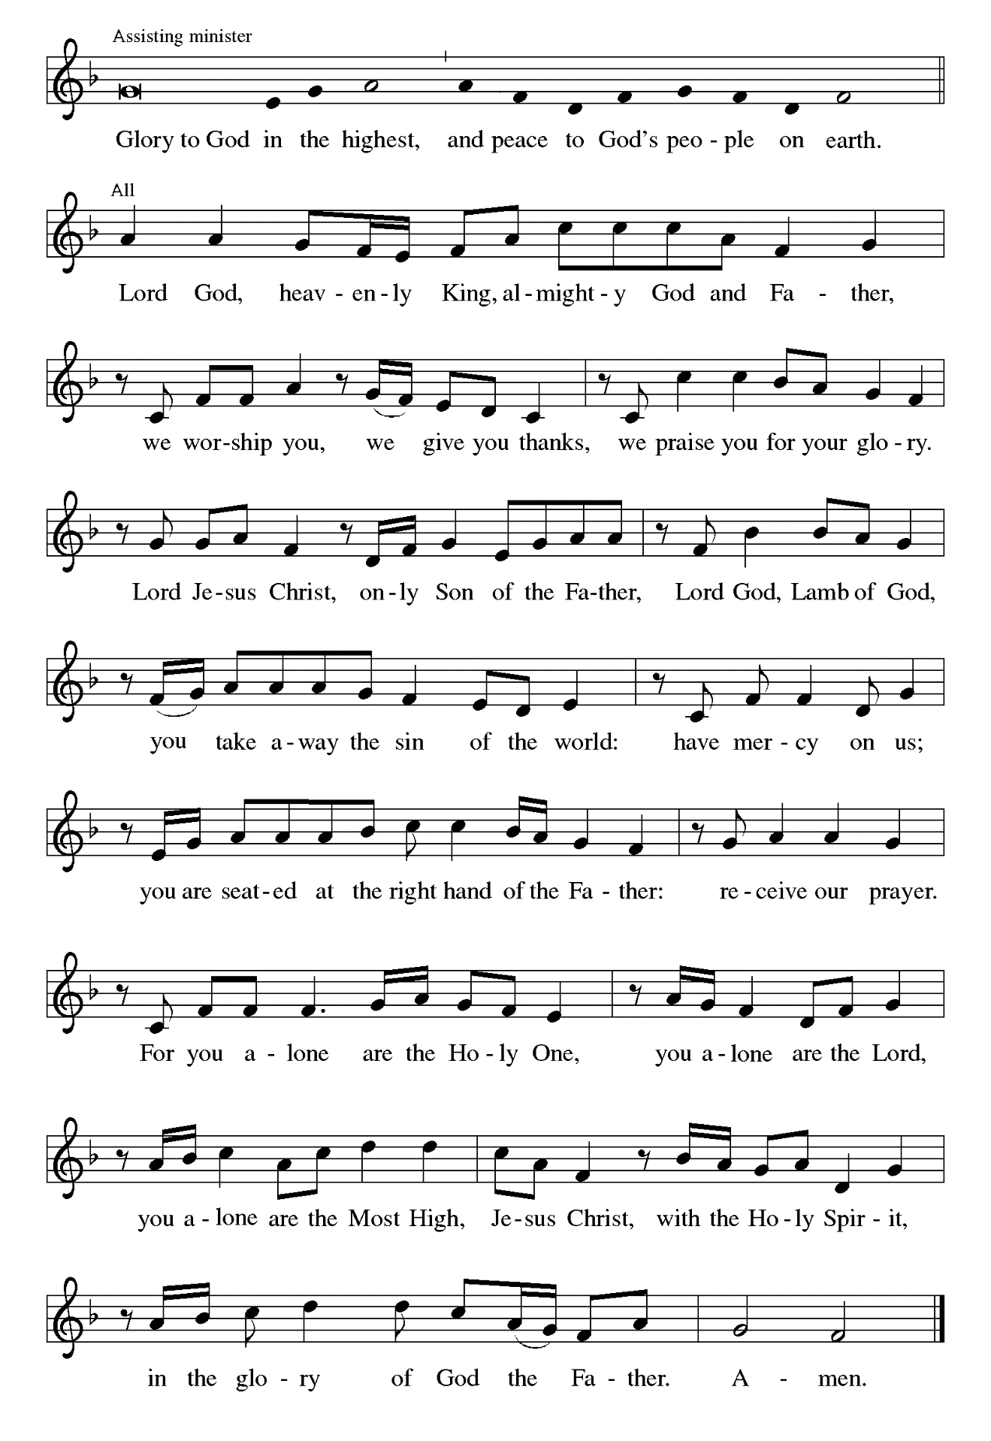

**THE PRAYER OF THE DAY**

P: The Lord be with you.

**C: And also with you.**

P: Let us pray. O God, in the transfiguration of Your Son You confirmed the mysteries of

the faith by the witness of Moses and Elijah, and in the voice from the bright cloud

declaring Jesus Your beloved Son You foreshadowed our adoption as Your children.

Make us heirs with Christ of Your glory, and bring us to enjoy its fullness, through

Jesus Christ, our Savior and Lord, Who lives and reigns with You and the Holy Spirit,

one God, now and forever.

**C: Amen.**

*The assembly is seated*

**✠ WORD ✠**

**FIRST READING Exodus 24:12-18**

*In the Bible, mountains often serve as places of revelation. Moses' six-day wait on the mountain covered by the cloud is a way of telling the reader that something important is about to be revealed: God's law. Similarly the experience of Jesus, Peter, James, and John on a mountain reveals something important: God's Son.*

The LORD said to Moses, "Come up to Me on the mountain, and wait there; and I

will give you the tablets of stone, with the law and the commandment, which

I have written for their instruction."

13So Moses set out with his assistant Joshua, and Moses went up into the mountain of

God.

14To the elders he had said, "Wait here for us, until we come to you again; for Aaron and

Hur are with you; whoever has a dispute may go to them."

15Then Moses went up on the mountain, and the cloud covered the mountain.

16The glory of the LORD settled on Mount Sinai, and the cloud covered it for six days;

on the seventh day He called to Moses out of the cloud.

17Now the appearance of the glory of the LORD was like a devouring fire on the top

of the mountain in the sight of the people of Israel.

18Moses entered the cloud, and went up on the mountain. Moses was on the mountain

for forty days and forty nights.

The Word of the Lord.

**Thanks be to God.**

**THE PSALM: Psalm 2** Antiphon by Robert Wetzler

Cantor sings refrain first, followed immediately by the congregation

and as indicated

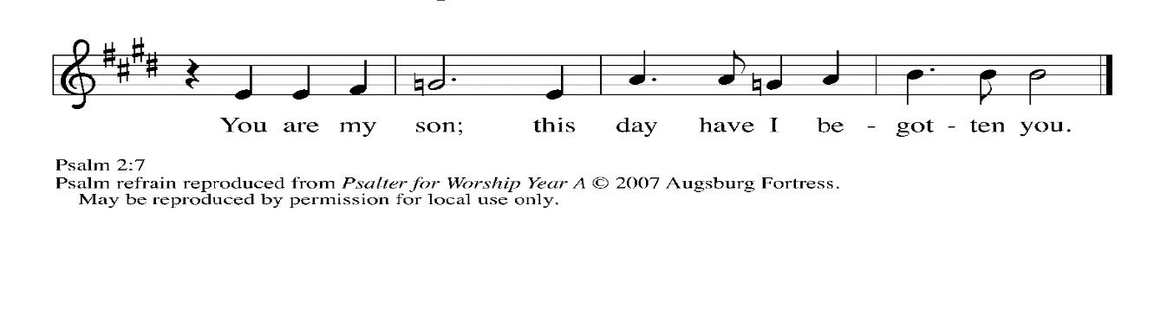

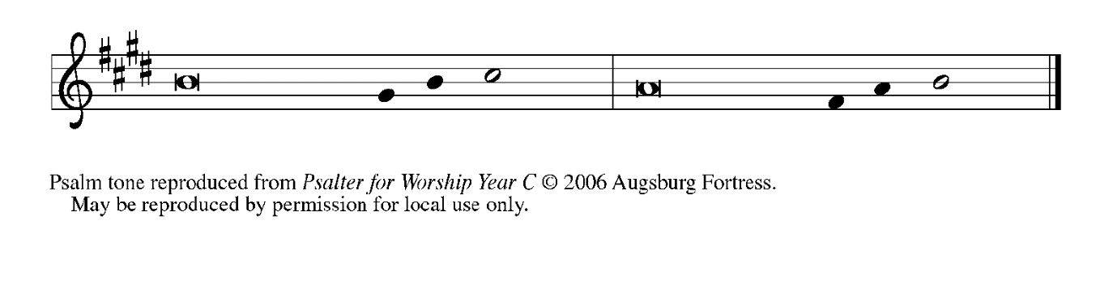

1Why are the nations | in an uproar?

     Why do the peoples mutter | empty threats?

**2Why do the kings of the earth rise up in revolt,**

**and the princes | plot together,**

**against the LORD and against the | LORD's anointed?**

3"Let us break their | yoke," they say;

     "let us cast off their | bonds from us."

**4God whose throne is in heav- | en is laughing;**

**the LORD holds them | in derision.   REFRAIN**

5Then in wrath God | speaks to them,

     and in rage fills | them with terror.

**6"As for Me, I have anoint- | ed My king**

**upon Zion, My | holy mountain."**

7Let me announce the decree | of the LORD,

     Who said to me, "You are my son; this day have I be- | gotten you.

**8Ask of Me, and I will give you the nations for | your inheritance**

**and the ends of the earth for | your possession.   REFRAIN**

9You shall crush them with an | iron rod

     and shatter them like a | piece of pottery."

**10And now, you | kings, be wise;**

**be warned, you rulers | of the earth.**

11Submit to the | LORD with fear,

     and with trembling | bow in worship;

**12lest the LORD be angry, and you perish in a sudden | blaze of wrath.**

**Happy are all who take ref- | uge in God!   REFRAIN**

**SECOND READING 2 Peter 1:16-21**

*At the transfiguration of Jesus, Peter heard the voice of God speak from heaven. This same voice speaks to us from the holy word.*

We did not follow cleverly devised myths when we made known to you the power

and coming of our Lord Jesus Christ, but we had been eyewitnesses of His

majesty.  
17For He received honor and glory from God the Father when that voice was conveyed to

Him by the Majestic Glory, saying, "This is My Son, My Beloved, with Whom I

am well pleased."

18We ourselves heard this voice come from heaven, while we were with Him on the

holy mountain.

19So we have the prophetic message more fully confirmed. You will do well to be

attentive to this as to a lamp shining in a dark place, until the day dawns and

the morning star rises in your hearts.

20First of all you must understand this, that no prophecy of scripture is a matter of

one's own interpretation,

21because no prophecy ever came by human will, but men and women moved by the

Holy Spirit spoke from God.

The Word of the Lord.

**Thanks be to God.**

*As you are able please rise*

**THE VERSE**

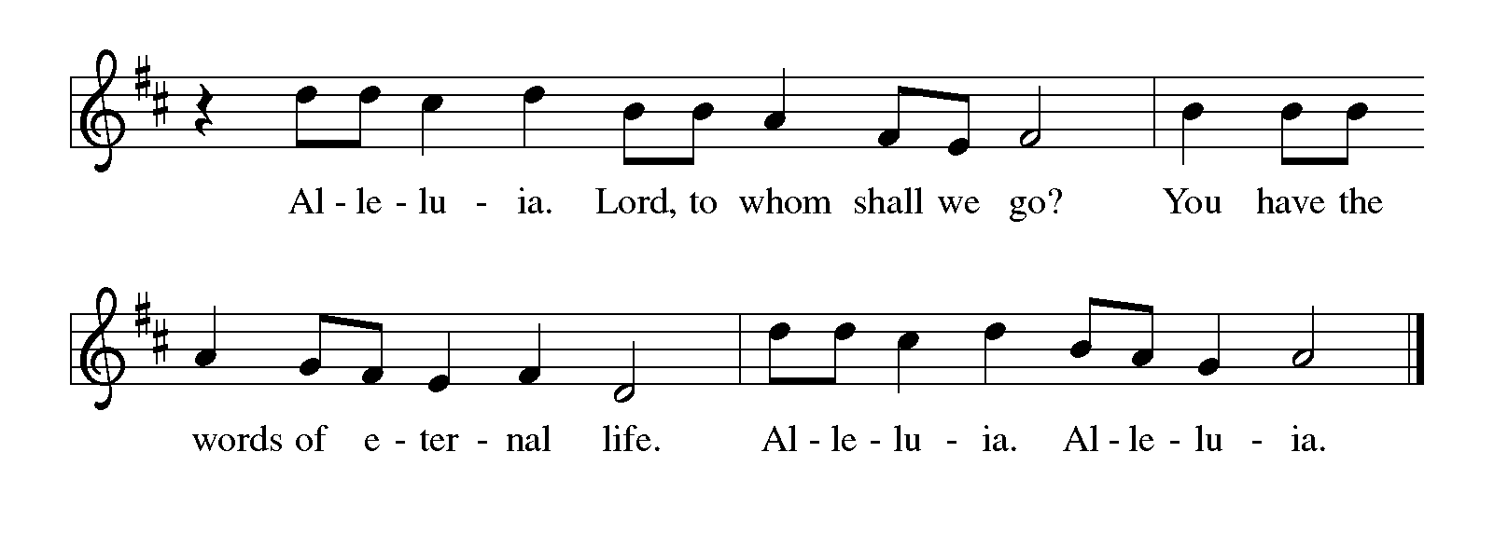

**THE HOLY GOSPEL Matthew 17:1-9**

*Shortly before he enters Jerusalem, where he will be crucified, Jesus is revealed to his disciples in a mountaintop experience of divine glory called the transfiguration.*

P: The Holy Gospel according to St. Matthew, the seventeenth chapter.

**C: Glory to You, O Lord!**

Jesus took with Him Peter and James and his brother John and led them up a high

mountain, by themselves.

2And He was transfigured before them, and His face shone like the sun, and His

clothes became dazzling white.

3Suddenly there appeared to them Moses and Elijah, talking with Him.

4Then Peter said to Jesus, "Lord, it is good for us to be here; if You wish, I will make

three dwellings here, one for You, one for Moses, and one for Elijah."

5While he was still speaking, suddenly a bright cloud overshadowed them, and from the

cloud a voice said, “This is My Son, the Beloved; with Him I am well pleased;

listen to Him!”

6When the disciples heard this, they fell to the ground and were overcome by fear.

7But Jesus came and touched them, saying, "Get up and do not be afraid."

8And when they looked up, they saw no one except Jesus Himself alone.

9As they were coming down the mountain, Jesus ordered them, "Tell no one about

the vision until after the Son of Man has been raised from the dead."

P: The Gospel of the Lord.

**C: Praise to You, O Christ!**

*The assembly is seated*

**THE SERMON**

*Silence for reflection follows the sermon*

*As you are able please rise*

**THE HYMN OF THE DAY 671 *Shine Jesus Shine***

**THE NICENE CREED**

A: God has made us His people through our Baptism into Christ. Living together in trust

and hope, we confess our faith.

**We believe in one God,**

**the Father, the Almighty,**

**maker of heaven and earth,**

**of all that is, seen and unseen.**

**We believe in one Lord, Jesus Christ,**

**the only Son of God,**

**eternally begotten of the Father,**

**God from God, Light from Light,**

**true God from true God,**

**begotten, not made,**

**of one Being with the Father.**

**Through Him all things were made.**

**For us and for our salvation**

**He came down from heaven;**

**by the power of the Holy Spirit**

**He became incarnate from the virgin Mary, and was made**

**man.**

**For our sake He was crucified under Pontius Pilate;**

**He suffered death and was buried.**

**On the third day He rose again**

**in accordance with the Scriptures;**

**He ascended into heaven**

**and is seated at the right hand of the Father.**

**He will come again in glory to judge the living and the dead,**

**and His kingdom will have no end.**

**We believe in the Holy Spirit, the Lord, the giver of life,**

**Who proceeds from the Father and the Son.**

**With the Father and the Son He is worshiped and glorified.**

**He has spoken through the prophets.**

**We believe in one holy catholic and apostolic Church.**

**We acknowledge one Baptism for the forgiveness of sins.**

**We look for the resurrection of the dead,**

**and the life of the world to come. Amen**

**THE PRAYER OF THE CHURCH**

A: As God’s beloved children, let us pray that the light of Christ shine on the nations, the

Church, and on all those in need.

A: That the Church might proclaim the Gospel of Christ in such creative and transforming

ways that the world will “listen” with joy and hope, we pray:

**C: Send forth Your light, O God.**

A: That the rulers of the earth might submit to the Lord and His way of justice and peace,

we pray:

**C: Send forth Your light, O God.**

A: That by Your Word and holy Meal this assembly might be transfigured into the dazzling

and compassionate presence of Christ to this neighborhood and community this week,

we pray:

**C: Send forth Your light, O God.**

A: That the suffering and sick, especially . . . might be touched by the Lord’s healing,

we pray:

**C: Send forth Your light, O God.**

A: That those celebrating anniversaries, especially **Tim and Laura Mellen; and Chuck**

**and Sherry Payne** might grow in grace this day and be filled with grace for the days

ahead, we pray:

**C: Send forth Your light, O God.**

A: That those who mourn, especially the family and friends of **Irene Stier Bohnstadt,**

whose brother, Paul Stier died in the Lord this week, may be comforted by the

promise of resurrection to life everlasting and of being reunited with those they love

before the throne of the Lamb, we pray:

**C: Send forth Your light, O God.**

A: That with all the saints who have listened to Christ,especially **Martin Luther, renewer**

**of the Church** whom we commemorate this Day we too may one Day see the fullness

of His glory, we pray:

**C: Send forth Your light, O God.**

P: Receive our prayers and hopes, God of mercy and justice, for we pray in the name of

Christ, the light of the world.

**C: Amen.**

**✠ MEAL ✠**

**THE PEACE**

P: The peace of the Lord be with you always.

**C: And also with you.**

**THE OFFERING**

**THE VOLUNTARY *Come to the Mountain* Praise Band**

*As you are able please rise*

**THE PRESENTATION OF THE GIFTS 312 *Jesus, Come! For We Invite You***

(Stanzas 1, 4)

**THE OFFERTORY PRAYER**

A: Let us pray. Holy God,

**C: By the Transfiguration of Your Son You revealed Your glory and His holiness.**

**Make these gifts we offer holy for Your service, and by this Holy Sacrament,**

**strengthen us to shine more fully with Your Light, Jesus Christ our Lord. Amen.**

**THE GREAT THANKSGIVING**

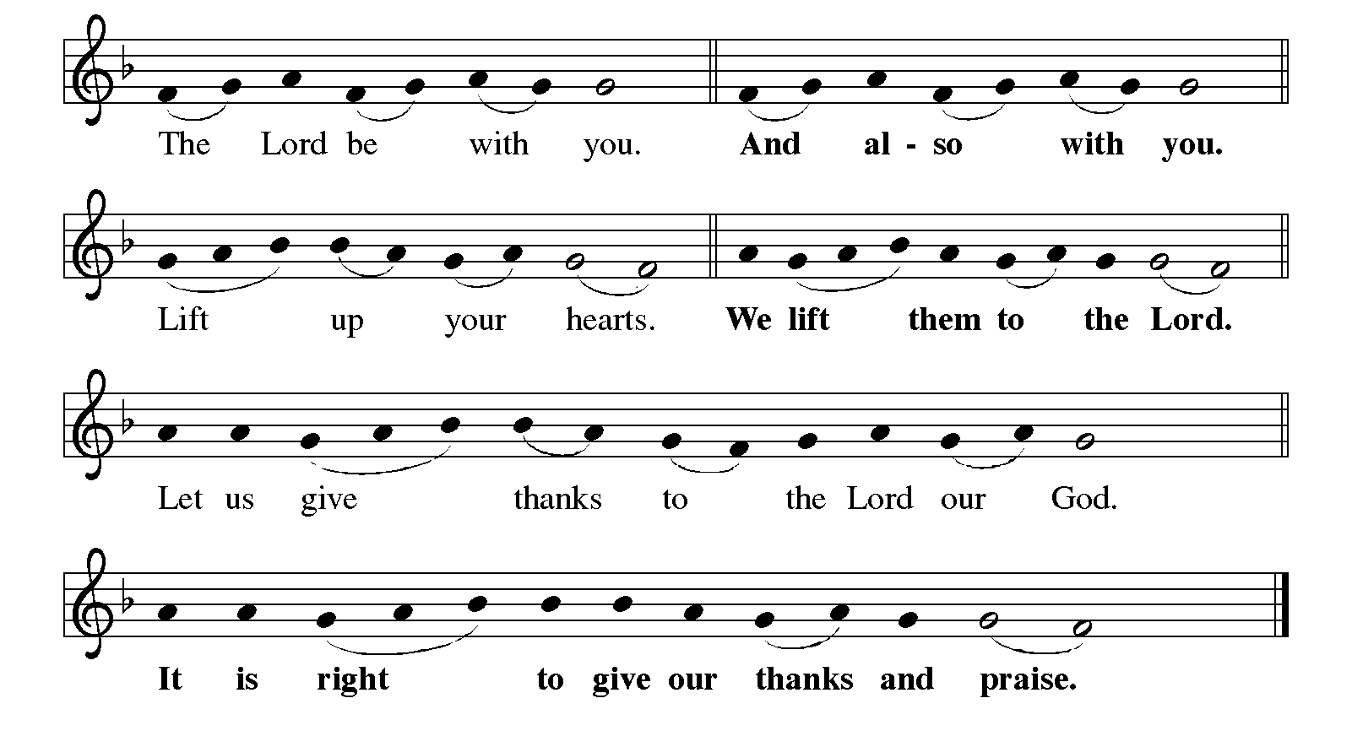

P: It is indeed right, our duty, and our joy …join their unending hymn:

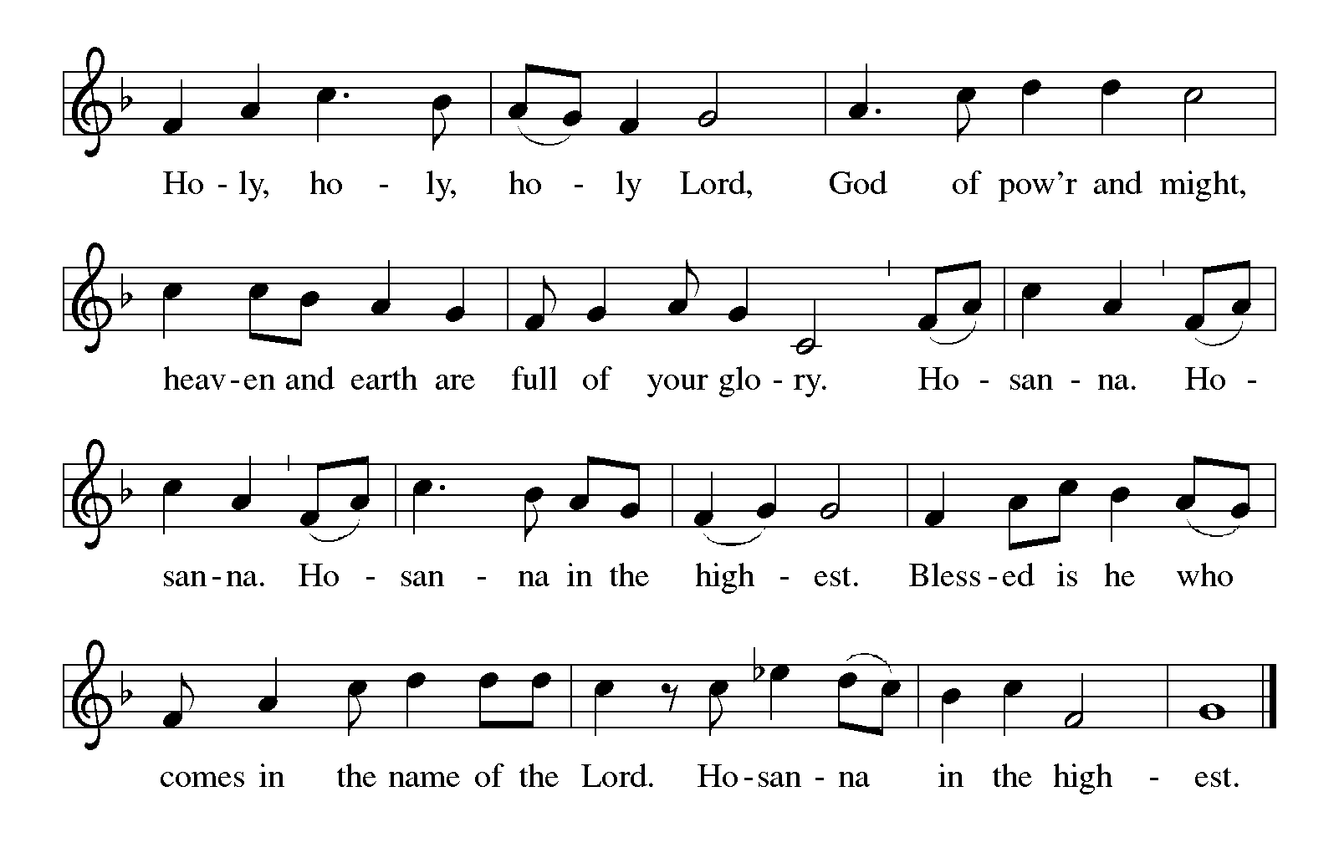

P: Creating and liberating God, You called Your people into covenant with You and

sealed Your trust with Moses on the mountain.

You called Your people back to that covenant through Your prophets and spoke in

a still small voice to Elijah on a mountain.

Then, in Your Son Jesus, on a mountain You stood between the Law and the

Prophets and revealed the radiance of Your Gospel.

On Calvary’s hill Your Son redeemed us by the blood of Your new covenant,

and on the mountain in the Galilee He ascended to Your right hand on

high.

Dazzling God, You set up Your tent and make Your dwelling among us.

Abide with us now through the power of Your Holy Spirit, that Your people may

become a temple of Your presence, and these gifts of bread and wine

may be for us the Body and Blood of Your Son Jesus Christ,

Who, in the night ... “Do this for the remembrance of Me.”

As often as we eat ... we proclaim the Lord’s death until He comes.

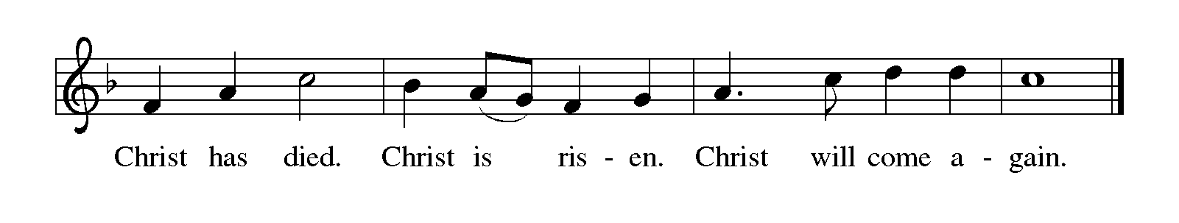

P: Transfiguring God, it is good for us to be here.

Through this holy sacrament make us Your daughters and sons, and be close to

all children who have no one to share Your love and mercy with them.

Make us Your beloved, and visit all who have no one to call them beloved

Give us grace to listen to Your voice, and bring to Your heart any who have

no one to listen to them.

Surround us with Your prophetic company and take us up into the whirlwind of

Your glory, until the Day comes when the waters of the Jordan are parted

and the heavens are opened and the chariots bring us home to You,

Ever one God: Father, ✠ Son, and Holy Spirit.

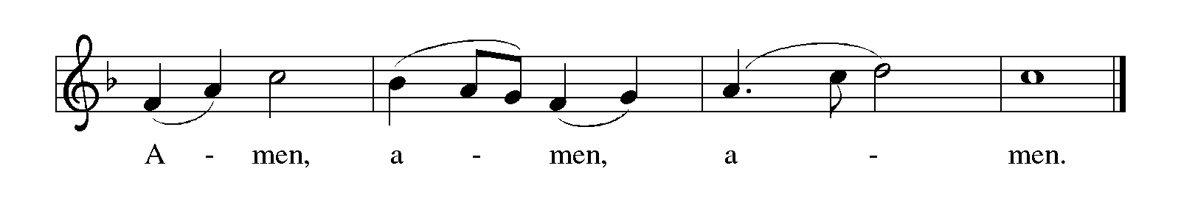

**THE LORD’S PRAYER**

P: Because in Christ we have received the Spirit of adoption, as daughters and sons of

God, we dare to pray:

**C: Our Father in heaven, hallowed be Your name. Your Kingdom come. Your will**

**be done on earth as in heaven. Give us this day our daily bread, and forgive us**

**our sins as we forgive those who sin against us. Save us from the time of trial and**

**deliver us from evil, for the Kingdom, the power, and the glory are Yours, now**

**and forever. Amen.**

**INVITATION TO THE MEAL**

P: Behold the true Light of the world, the Beloved of God, anointed by the Spirit. Blessed

are those who are called to the Supper of the Lamb. God’s holy gifts for God’s holy

people. Come, for all is now ready.

*The assembly is seated*

**THE DISTRIBUTION**

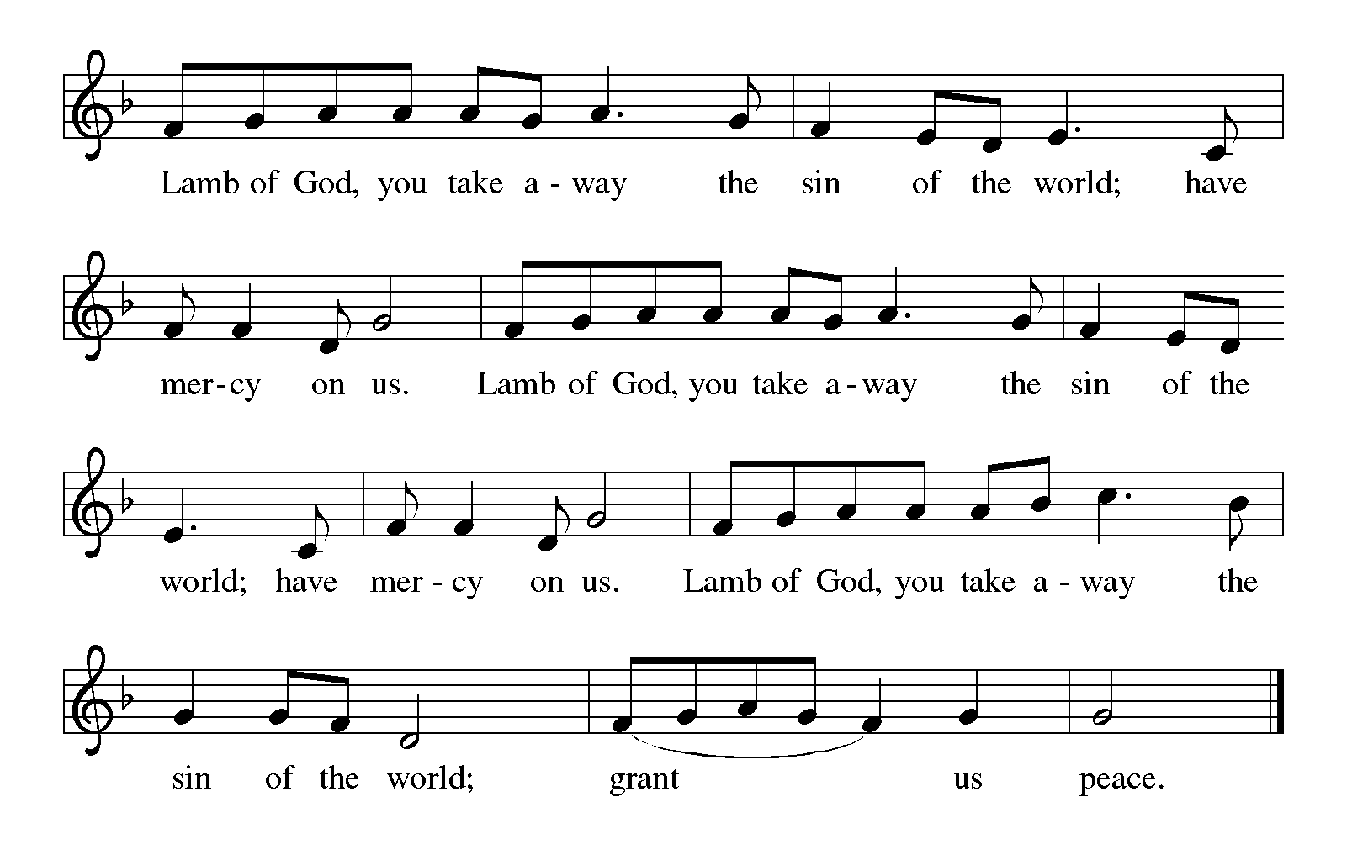

**HYMN DURING DISTRIBUTION 315 *How Good Lord, to be Here***

**ELW 472** ***Eat This Bread***

**ELW 484 *You Satisfy the Hungry Heart***

**NSB 50 *I Exalt Thee***

*As you are able please rise*

**THE POST-COMMUNION BLESSING**

P: The Body and Blood of our Lord Jesus Christ strengthen you and keep you in His grace.

**C: Amen.**

**THE POST-COMMUNION PRAYER**

A: Let us pray. Heavenly Father, You revealed the true radiance of Your Son in the glory

of His Transfiguration. Give us the grace and vision to behold Him in this Food from

heaven, and by our eating and drinking, transform us daily to ever more live as Your

faithful and beloved daughters and sons. Grant this through Christ our Lord.

**C: Amen.**

**✠ SENDING ✠**

**THE BENEDICTION**

P: Almighty God: Father, Son, ✠ and Holy Spirit bless you now and forever.

**C: Amen.**

**SENDING HYMN 318 *Alleluia, Song of Gladness***

**THE DISMISSAL**

A: You are servants of God; you are light to the nations.

Go in peace. Serve the Lord.

**C: Thanks be to God!**

**POSTLUDE *Fantasy in A minor* J. S. Bach**

**✠ To God Alone Be Glory ✠**

The Meditations are from *New Proclamation. Year A.* Marshall D. Johnson, ed.

(Minneapolis: Augsburg Fortress, 2001) 147; and *Sundays and Seasons Online.*

Copyright 2020 Augsburg Fortress.

The Prayers, Introduction to the Lord’s Prayer, and Invitation to the Meal are adapted from

*Prayers for Sundays and Seasons. Year A.* Peter J. Scagnelli. (Chicago: Liturgy

Training Publications, 1998) 146-147.

The Post-Communion Prayer is also adapted from *The Book of Alternative Services.*

(Toronto: Anglican Book Centre, 1985) 231.

**ANNOUNCEMENTS**

**Please remember to mail your offering to the Church Office** at 818 Franklin Street, Michigan City, IN 46360**.** Another alternative is to give on-line through Tithe.ly. Please see your closure letter for information on how to set up a Tithe.ly account.

**St. Paul Members are reminded to have** a loved one contact the office if you are

hospitalized. Many times, the Pastor doesn’t know someone is in the hospital. If you call and leave a message, please tell us which hospital the patient is at.

**Next Saturday’s lessons are: Genesis 2: 15-17, 3: 1-7; Psalm 32; Romans 5: 12-19; and Matthew 4: 1-11** for those of you who like to study them in advance.

**Anniversaries: Tim & Laura Mellen (2/20) and Charles & Sherry Payne (2/21)**

**PRAYER CONCERNS:** Audrey Beyer, Donna Bostater, Maxine Powell, Jim Tomscheck, Eloise Ponder, Mark & Jary Tannehill, Leonard Cross, Margie Torres, Jayla Jacobi and Barbara Reichert.

**OFFICE HOURS:** Libby will be in the office on Mondays, Wednesdays, and Fridays; volunteers will cover Tuesdays and Thursdays.

Monday & Wednesday 8:00 a.m. – 5 p.m.

Tuesday & Thursday 9:00 a.m. – 12:00 p.m.

Friday 8:00 a.m. – 12:00 p.m.

**If you are listening to the worship broadcast on the radio and would like to watch the Sunday morning service live stream follow these steps:**

(1) If you have You.Tube available on your TV, search for

**St. Paul Lutheran Church Michigan City, IN.**

(2) The direct link on the computer is

https://www.youtube.com/channel/UC5AIPNaKr3QN50984jGOa1g.

(3) This link is also on the main page of the church’s website in the church sec-

tion and will continue to be posted weekly on the St. Paul Facebook page.

And it will always be available on the radio broadcast Sunday mornings at 11:00 a.m. on WEFM (95.9), and on the local cable access station #99 for the previous week’s service on Sundays at 4:00 p.m. and the current service on Wednesdays at 7:00 p.m. and Fridays at 8:30 p.m.

**To send e-mail to the church office**, please use the following addresses:

Pastor Mark Reshan: seniorpastor@stpaulmichigancity.com

Church Office Secretary (Libby Pollock): churchsecretary@stpaulmichigancity.com

Church Treasurer (Karen Fleming): finance@stpaulmichigancity.com

**The Good News Newsletter**: If you have an article or anything you want included in **The Good News** please send it to the following e-mail address: splcgoodnews@gmail.com. Pastor Pamela Thiede will be using this e-mail address to assemble **The Good News** each month. The deadline for getting information to Pastor

Pamela will be the 20th of each month.

**WORSHIP ATTENDANCE for February 11 and 12, 2023**

**4:00 p.m. 35**

**9:00 a.m. 47**

**TOTAL 82**

**Warren Schacht has generously offered to convert audio tapes and cassettes to CD’s and VHS tapes to DVDs** at no charge! He is currently converting our church audio tapes/cassettes and has extended the offer to anyone who is interested in updating their material. You may call him directly at: 219-448-1444 or email him at: [w.schacht230@comcast.net](mailto:w.schacht230@comcast.net). Thank you, Warren!

**In an effort to save money on postage**: yearly donation state-ments have been emailed to those members who have email. Any members without email will find your statements in your hanging file folder in the Narthex. If you are unable to attend church please let the church office know so we can send your statement through the regular mail.

**The approved minutes of the December 20, 2022 Church Council meeting are on the table at the back of the church in the Narthex.**

**ACTIVITIES, EVENTS & MEETINGS**

**February 2023**

**Saturday,** February 11, 2023 at 4:00 p.m. Worship Service

**Sunday,** February 12, 2023 at 9:00 a.m. Worship Service

**Monday,** February 13, 2023 at 12:30 p.m. Harmony Circle/Green Room

at 3:30 p.m. School Board Meeting/Luther House

**Tuesday,** February 14, 2023 at 9:30 a.m. Charity Circle/Green Room

at 7:00 p.m. Estuary/Luther House

**Wednesday,** February 15, 2023 at 9:45 a.m. Bible Study/Luther House

at 10:00 a.m. God’s Purls/ St. Paul Room

at 5:00 p.m. Worship & Music Committee Mtg.

at 6:00 p.m. Choir Rehearsal

**Thursday,** February 16, 2023 from 4p.m. – 10:00 p.m. **GIVE-BACK** night at

Galveston Steakhouse

**Saturday,** February18, 2023 at 4:00 p.m. Worship Service

**Sunday,** February 19, 2023 at 9:00 a.m. Worship Service

**Monday,**  February 20, 2023 at 4:00 p.m. Finance Committee Mtg./Luther House

at 5:30 p.m. Executive Board Mtg./Luther House

**Wednesday,** February 22, 2023 at10:00 a.m. ASH Wednesday Worship Service

at 7:00 p.m. Ash Wednesday Worship service

**Thursday,** February 23, 2023 at 5:30 p.m. Church Council Meeting/St. Paul Room

**Saturday,** February 25, 2023 at 4:00 p.m. Worship Service

**Sunday,** February 26, 2023 at 9:00 a.m. Worship Service

**Wednesday,** March 1, 2023 at 9:45 a.m. Bible Study/Luther House

at 10:00 a.m. God’s Purls/St. Paul Room

at 6:00 p.m. “Holden” Evening Prayer