THE TRANSFIGURATION OF OUR LORD
The Last Sunday after the Epiphany
February 11, 2024

Christ brings before the disciples the one who had died and the one who had not yet died. Both had lost their life, and had found it. Both had courageously withstood a tyrant: one the Egyptian, the other Arab. Both were simple, unlearned men. One was slow of speech and weak of voice, the other a rough countryman.
And both were men who had despised the riches of this world. For Moses possessed nothing, and Elijah had nothing but his sheepskin. Christ brought these men before the disciples, for he wished them to imitate their courage of soul and their steadfastness in leading their people, so that they might be as gentle as Moses, possessed of the zeal of Elijah, and as devoted as both were.
He brought these men before them in glory, that the disciples might surpass them. That Christ might uplift their courage against all such dangers, he here brings before them these two men who were such shining lights of the Old Testament.
John Chrysostom

Epiphany began a few weeks ago with a story about a manifestation of Jesus’ identity, but it was a much more covert incident: Jesus’ baptism. In Mark’s account of the baptism, it’s not clear that anyone else sees the heavens slashed apart or the Holy Spirit diving into Jesus. The voice from heaven is Jesus’ alone to hear. Nothing’s public. Nothing’s obvious. Similarly, most of the epiphanies we get to experience in life consist of glimpses, and sometimes we aren’t even sure that they are really ours to see.
The Transfiguration is a very different kind of a revealing, however. Jesus becomes a beacon, like a lighthouse planted in the middle of the desert. The heavenly voice addresses all the witnesses: Peter, James, and John. On this Sunday, there is a promise that Jesus can and will be noticed. Epiphanies aren’t always subtle…
…In Mark’s Gospel, a story so full of concealment and secrecy, the Transfiguration says that this Jesus has plans to be conspicuous. What he will disclose is not necessarily the secrets of the universe or the meaning of life; rather, it’s himself.
Matt Skinner

In the Name of Jesus

GATHERING

INTRODUCTION

The Sundays after Epiphany began with Jesus' baptism and end with three disciples' vision of his transfiguration. In Mark's story of Jesus' baptism, apparently only Jesus sees the Spirit descending and hears the words from heaven. But now Jesus' three closest friends hear the same words naming him God's beloved son. As believers, Paul writes, we are enabled to see the God-light in Jesus' face, because the same God who created light in the first place has shone in our hearts to give us that vision. The light of God's glory in Jesus has enlightened us through baptism and shines in us also for others to see.
PRELUDE Shall We Gather at the River Charles Callahan
Dan McNabb, Organ; Betsy Kohn, flute
ANNOUNCEMENTS

As you are able please rise

THE PROCESSIONAL HYMN 838 Beautiful Savior

The congregation faces the cross as it enters

THE GREETING AND PRAYER OF THE DAY

P: The grace of our Lord Jesus Christ, the love of God, and the communion of the Holy
Spirit be with you all.

C: And also with you.

P: Let us pray. Almighty God, the resplendent light of Your truth shines from the
mountaintop into our hearts. Transfigure us by Your beloved Son, and illumine the
world with Your image, through Jesus Christ, our Savior and Lord, Who lives and
reigns with You and the Holy Spirit, one God, now and forever.

C: Amen.

The assembly is seated

WORD

St. Paul Senior Choir Beloved, God’s Chosen Robert Hobby Betsy Kohn, flute

FIRST READING 2 Kings 2: 1-12

Today's reading centers on the transfer of power and authority from the prophet Elijah to Elisha. Their travels, which retrace the path of Joshua back to Moab (the place where Moses died), and the parting of the waters demonstrate that Elisha and Elijah are legitimate successors of the great lawgiver Moses.

Now when the LORD was about to take Elijah up to heaven by a whirlwind, Elijah and Elisha were on their way from Gilgal. ²Elijah said to Elisha, "Stay here; for the LORD has sent me as far as Bethel." But Elisha said, "As the LORD lives, and as you yourself live, I will not leave you." So they went down to Bethel. ³The company of prophets who were in Bethel came out to Elisha, and said to him, "Do you know that today the LORD will take your master away from you?" And he said, "Yes, I know; keep silent."
⁴Elijah said to him, "Elisha, stay here; for the LORD has sent me to Jericho." But he said, "As the LORD lives, and as you yourself live, I will not leave you." So they came to Jericho. ⁵The company of prophets who were at Jericho drew near to Elisha, and said to him, "Do you know that today the LORD will take your master away from you?" And he answered, "Yes, I know; be silent."
⁶Then Elijah said to him, "Stay here; for the LORD has sent me to the Jordan." But he said, "As the LORD lives, and as you yourself live, I will not leave you." So the two of them went on. ⁷Fifty men of the company of prophets also went, and stood at some distance from them, as they both were standing by the Jordan. ⁸Then Elijah took his mantle and rolled it up, and struck the water; the water was parted to the one side and to the other, until the two of them crossed on dry ground.
⁹When they had crossed, Elijah said to Elisha, "Tell me what I may do for you, before I am taken from you." Elisha said, "Please let me inherit a double share of your spirit." ¹⁰He responded, "You have asked a hard thing; yet, if you see me as I am being taken from you, it will be granted you; if not, it will not."
¹¹As they continued walking and talking, a chariot of fire and horses of fire separated the two of them, and Elijah ascended in a whirlwind into heaven. ¹²Elisha kept watching and crying out, "Father, father! The chariots of Israel and its horsemen!" But when he could no longer see him, he grasped his own clothes and tore them in two pieces.

The Word of the Lord.

Thanks be to God.

THE PSALM: Psalm 50: 1-6 Read responsively
¹The mighty one, God the LORD, has spoken;
calling the earth from the rising of the sun to its setting.

²Out of Zion, perfect in its beauty,
God shines forth in glory.

³Our God will come and will not keep silence;
with a consuming flame before, and round about a raging storm.

⁴God calls the heavens and the earth from above
to witness the judgment of the people.

⁵"Gather before Me My loyal followers,
those who have made a covenant with Me
and sealed it with sacrifice."

⁶The heavens declare the rightness of God's cause,
for it is God Who is judge.

THE SECOND READING 2 Corinthians 4: 3-6
The epiphany, or revelation of God, at Jesus' transfiguration is renewed in every believer's life when the light of Christ shines in the heart to reveal God's glory.
Even if our gospel is veiled, it is veiled to those who are perishing. ⁴In their case the god of this world has blinded the minds of the unbelievers, to keep them from seeing the light of the gospel of the glory of Christ, Who is the image of God.
⁵For we do not proclaim ourselves; we proclaim Jesus Christ as Lord and ourselves as your slaves for Jesus' sake. ⁶For it is the God Who said, "Let light shine out of darkness," Who has shone in our hearts to give the light of the knowledge of the glory of God in the face of Jesus Christ.

The Word of the Lord.

Thanks be to God.

As you are able please rise

THE VERSE

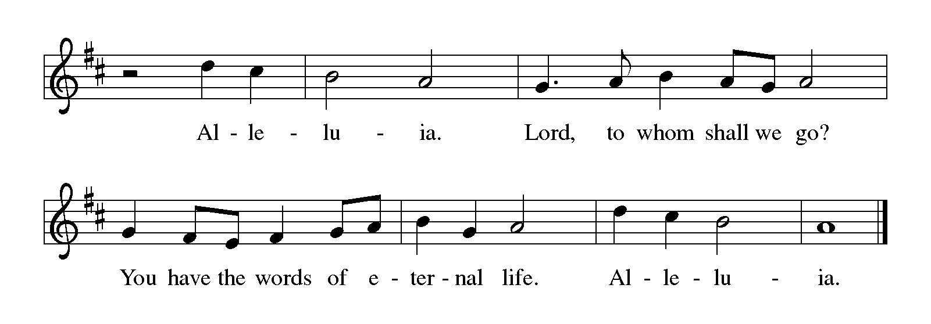
THE HOLY GOSPEL Mark 9: 2-9

Mark’s gospel presents the transfiguration as a preview of what would become apparent to Jesus’ followers after He rose from the dead. Confused disciples are given a vision of God’s glory manifest in the beloved Son.

P: The Holy Gospel according to St. Mark, the ninth chapter.

C: Glory to You, O Lord!

Six days later, Jesus took with Him Peter and James and John, and led them up a high mountain apart, by themselves. And He was transfigured before them, ³and His clothes became dazzling white, such as no one on earth could bleach them.
⁴And there appeared to them Elijah with Moses, who were talking with Jesus. ⁵Then Peter said to Jesus, "Rabbi, it is good for us to be here; let us make three dwellings, one for You, one for Moses, and one for Elijah." ⁶He did not know what to say, for they were terrified.
⁷Then a cloud overshadowed them, and from the cloud there came a voice, "This is My Son, the Beloved; listen to Him!" ⁸Suddenly when they looked around, they saw no one with them any more, but only Jesus.
⁹As they were coming down the mountain, He ordered them to tell no one about what they had seen, until after the Son of Man had risen from the dead.

P: The Gospel of the Lord.

C: Praise to You, O Christ!

The assembly is seated

THE SERMON

Silence for meditation follows the sermon

As you are able please rise

THE HYMN OF THE DAY 315 How Good, Lord, to Be Here

THE NICENE CREED

A: God has made us His people through our Baptism into Christ. Living together in trust
and hope, we confess our faith.

C: We believe in one God,
the Father, the Almighty,
maker of heaven and earth,
of all that is, seen and unseen.

We believe in one Lord, Jesus Christ,
the only Son of God,
eternally begotten of the Father,
God from God, Light from Light,
true God from true God,
begotten, not made,
of one Being with the Father.
Through Him all things were made.
For us and for our salvation
He came down from heaven;
by the power of the Holy Spirit
He became incarnate from the virgin Mary, and was made man.
For our sake He was crucified under Pontius Pilate;
He suffered death and was buried.
On the third day He rose again
in accordance with the Scriptures;
He ascended into heaven
and is seated at the right hand of the Father.
He will come again in glory to judge the living and the dead,
and His kingdom will have no end.

We believe in the Holy Spirit, the Lord, the giver of life,
Who proceeds from the Father and the Son.
With the Father and the Son He is worshiped and glorified.
He has spoken through the prophets.
We believe in one holy catholic and apostolic Church.
We acknowledge one Baptism for the forgiveness of sins.
We look for the resurrection of the dead,
and the life of the world to come. Amen

The assembly is seated

RECEPTION OF NEW MEMBERS

P: These persons have expressed their desire to transfer their membership into our
community of faith:

Kyle Petter
Melanie and Tyler Albano
Barry Anderson
Adisen Putnam (Sophia and Athena)
Judy Zimmermann
Clay and Tina Putnam
Bernadette Krueger
Emily England
John Konkel

A: We welcome you as members of St. Paul Lutheran Church to join with us in worshiping
God, hearing His Word and sharing His Supper, proclaiming the Good News of God
in Christ through word and deed, serving all people, and striving for justice and peace
in all the earth.

P: Let us pray. We thank You, Lord, for these new members of our congregation. By
Your life-giving power, bind us to each other in You, strengthen us for service, support
us all our days, and bring us at last to that Day when all Your children will be one and
You will be All-in-All.

C: Amen.

As you are able please rise

THE PRAYER OF THE CHURCH

A: The Word of God calls us to see that all the places and occasions of the world, even
places of sorrow and death, are transfigured by the presence of the glory of God in
Christ Jesus. Let us therefore call to mind all who are in need and commend them to
God’s transforming care.

A: For faithful bishops, especially Elizabeth and Bill; pastors, especially Al and Dale,
Mark, Pamela and Mark, and leaders, who will direct people to see Christ’s face and
hear His voice in Word and Sacrament, we pray: O God of light and glory,

C: hear our prayer.

A: For an end to violence in Syria, the Ukraine, Iraq and Nigeria, for the defeat of
terrorism, and peace in all places of hatred and division, we pray: O God of light and
glory,

C: hear our prayer.

A: For this community of faith as we claim our spiritual gifts, that we may be transformed
into ever-more faithful disciples of Jesus, we pray: O God of light and glory,

C: hear our prayer.

A: For our new members: Kyle; Tyler and Melanie; Barry; Adisen; Clay and Tina;
Judy; Bernadette; Emily; and John that with their gifts of the Spirit they may enrich
our mission to this neighborhood and community, we pray: O God of light and glory,

C: Hear our prayer.

A: For the sick, especially . . . that God strengthen them with healing and hope, we pray:
O God of light and glory,

C: hear our prayer.

A: For those celebrating birthdays, especially Wayne Dolson; that they may be filled with
grace this day and every day and grow in grace in the days ahead, we pray: O God of
light and glory,

C: hear our prayer.

A: For the faithful departed, that with them we may one day behold Christ in all His radiant
majesty, we pray: O God of light and glory,

C: hear our prayer.

P: With Moses and Elijah and all the people of God, with the Church throughout the ages
bearing witness to the great light of God shining in dark places, we commend to You,
O God, all for whom we pray, through Your beloved Son, our Lord, Jesus Christ.

C: Amen.

MEAL

THE PEACE

P: The peace of the Lord be with you always.

C: And also with you.

The assembly is seated

THE OFFERING

THE VOLUNTARY Seek Ye First Karen Lafferty
Betsy Kohn, Flute Dan McNabb

As you are able please rise

THE PRESENTATION OF GIFTS 302 As With Gladness Men of Old Stanza 3

THE OFFERTORY PRAYER

A: Let us pray. Holy God,

C: Receive all we offer You this day. Through the foretaste of this Holy Sacrament,
bring us to that radiant glory which we see in the transfigured face of Your Son,
Jesus Christ our Lord. Amen.

THE GREAT THANKSGIVING

P: The Lord be with you.

C: And also with you.

P: Lift up your hearts.

C: We lift them up to the Lord.

P: Let us give thanks to the Lord our God.

C: It is right to give Him thanks and praise.

P: Creating and liberating God, You called Your people into covenant with You and
sealed Your trust with Moses on the mountain;
You called Your people back to that covenant through Your prophets and spoke
in a still small voice to Elijah on a mountain.
Then, in Your Son Jesus, on a mountain You stood between the Law and the
Prophets and revealed the radiance of Your Gospel.
On Calvary’s hill Your Son redeemed us by the blood of Your new covenant,
and on the mountain in Galilee He ascended to Your right hand
on high.
Dazzling God, You set up Your tent and make Your dwelling among us.
Abide with us now through the power of Your Holy Spirit, that Your people may
be a temple of Your presence, and these gifts of bread and wine may be
for us the Body and Blood of Your Son, Jesus Christ,
Who, in the night ... “Do this for the remembrance of Me.”
As often as we eat ... we proclaim the Lord’s death until He comes.

C: Christ has died. Christ is risen. Christ will come again.

P: Transfiguring God, it is good for us to be here.
Through this holy Sacrament make us Your sons and daughters, and be close
to all children who have no one to share Your love and mercy with them.
Make us Your beloved, and visit all who have no one to call them beloved.
Give us grace to listen to Your voice, and bring to Your heart any who have no
one to listen to them.
Surround us with Your prophetic company and take us up into the whirlwind of
Your glory, until the Day comes when the waters of the Jordan are
parted and the heavens opened and the chariots bring us home to You,
Ever one God, Father, Son, and Holy Spirit.
C: Amen!
THE LORD’S PRAYER

P: Because in Christ we have received the Spirit of adoption, as daughters and sons of
God, we dare to pray:

C: Our Father, Who art in heaven, hallowed be Thy name.
Thy Kingdom come, Thy will be done on earth as it is in heaven.
Give us this day our daily bread, and forgive us our trespasses as we forgive
those who trespass against us.
And lead us not into temptation, but deliver us from evil.
For Thine is the Kingdom, and the power, and the glory, forever and ever. Amen.

INVITATION TO THE MEAL

P: Behold the true Light of the world, the Beloved of God, anointed by the Spirit. Blessed
are those who are called to the Supper of the Lamb. God’s holy gifts for God’s holy
people. Come, for all is now ready.

The assembly is seated

THE DISTRIBUTION

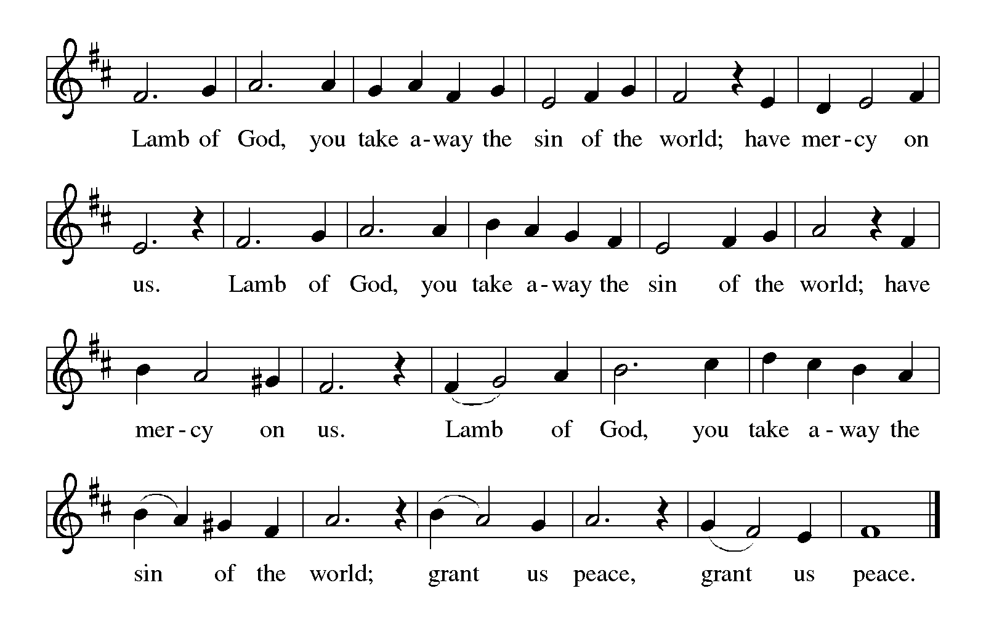
HYMNS DURING DISTRIBUTION You, Lord, Are Both Lamb and Shepherd
(Sung to the tune of, Let All Mortal Flesh Keep Silent)

1 You, Lord, are both Lamb and Shepherd.
You, Lord, are both prince and slave.
You, peacemaker and sword-bringer
of the way You took and gave.
You, the everlasting instant;
You, Whom we both scorn and crave.
2 Clothed in light upon the mountain,
stripped of might upon the cross,
shining in eternal glory,
beggared by a soldier's toss,
You, the everlasting instant;
You, Who are both gift and cost.

3 You, Who walk each day beside us,
sit in power at God's side.
You, Who preach a way that's narrow,
have a love that reaches wide.
You, the everlasting instant;
You, Who are our pilgrim guide.

4 Worthy is our earthly Jesus!
Worthy is our cosmic Christ!
Worthy Your defeat and vict'ry;
worthy still Your peace and strife.
You, the everlasting instant;
You, Who are our death and life.

715 Christ, Be Our Light

As you are able please rise

THE POST-COMMUNION BLESSING

P: The body and blood of our Lord Jesus Christ strengthen you and keep you in His grace.

C: Amen.
THE POST-COMMUNION PRAYER

A: Let us pray. Holy God, we see Your glory in the face of Jesus Christ. May we who are
partakers of His Table reflect His life in word and deed, that all the world may know
His power to bring us from darkness into Your glorious Light. Grant this through Christ
our Lord.

C: Amen.

SENDING

THE BENEDICTION

P: The Lord bless you and keep you. The Lord make His face shine upon you and be
gracious to you. The Lord look upon you with favor and give you peace.

C: Amen.

FAREWELL TO ALLELUIA

P: We are an Easter people.

C: And Alleluia is our song.

P: Alleluia! Alleluia!

C: Alleluia! Alleluia!

P: The author of Ecclesiastes writes:
For everything there is a season, and a time for every matter under heaven.

A time to be born and a time to die.

C: A time to plant and a time to pluck up what is planted.

P: A time to break down and a time to build up.
C: A time to weep and a time to laugh.

P: A time to mourn and a time to dance.
C: A time to keep silence and a time to speak.

P: As a sign of our repentance, we now say Farewell to the Alleluia until our rejoicing at
the resurrection of our Lord.

SENDING HYMN 318 Alleluia, Song of Gladness

THE DISMISSAL

A: How good it is for us to be here.
C: Amen! Alleluia!
A: Go in peace and do not be afraid. Christ is with you. Alleluia, alleluia!
C: Thanks be to God! Alleluia! Alleluia!

To God Alone Be Glory

POSTLUDE

The Meditation is taken from Sundays and Seasons Online. Copyright 2018 Augsburg Fortress.

The Greeting, Offertory Prayer, Post-Communion Prayer, and Dismissal are adapted from Sundays and Seasons. Copyright Augsburg Fortress, 1999.

The Prayer of the Church is also adapted from Prayers for Sundays and Seasons. Year B. Peter J. Scagnelli. (Chicago: Liturgy Training Publications, 1996) 158-159.
ANNOUNCEMENTS

Please remember to mail your offering to the Church Office at 818 Franklin Street, Michigan City, IN 46360. Another alternative is to give on-line through Tithe.ly. Please see your closure letter for information on how to set up a Tithe.ly account.

St. Paul Members are reminded to have a loved one contact the office if you are hospitalized. Many times, the Pastor doesn’t know someone is in the hospital. If you call and leave a message, please tell us which hospital the patient is at.

Birthdays: Wayne Dolson (2/14)

PRAYER CONCERNS: Sue Koziel, Jana Thomas, Margie Torres, Jayla Jacobi, Jim Gleason, Ronwynn Jones, Chris Jones, Mark Tannehill, Joan Seifert, Virginia Murray, Brian Wiseman, Jary Tannehill and Sue Granacki.

OFFICE HOURS: Libby will be in the office on Mondays, Wednesdays,
and Fridays; volunteers will cover Tuesdays and Thursdays.

Monday & Wednesday 8:00 a.m. – 5 p.m.
Tuesday & Thursday 9:00 a.m. – 12:00 p.m.
Friday 8:00 a.m. – 12:00 p.m.

If you are listening to the worship broadcast on the radio and would like to watch the Sunday morning service live stream follow these steps:

(1) If you have You Tube available on your TV, search for
St. Paul Lutheran Church Michigan City, IN.

(2) The direct link on the computer is
https://www.youtube.com/channel/UC5AIPNaKr3QN50984jGOa1g.

(3) This link is also on the main page of the church’s website in
the church section and will continue to be posted weekly on the St.
Paul Facebook page.

And it will always be available on the radio broadcast Sunday mornings at 11:00 a.m.
on WEFM (95.9), and on the local cable access station #99 for the previous week’s
service on Sundays at 4:00 p.m. and the current service on Wednesdays at 7:00 p.m. and
Fridays at 8:30 p.m.

The approved and signed minutes of the November 16, 2023 and December 28, 2023 Church Council Meetings are on the table at the back of the church in the Narthex. Please take a copy with you as you go.

To send e-mail to the church office, please use the following addresses:

Pastor Mark Reshan: seniorpastor@stpaulmichigancity.com

Church Office Secretary (Libby Pollock): churchsecretary@stpaulmichigancity.com

Church Treasurer (Karen Fleming): finance@stpaulmichigancity.com

The Good News Newsletter: If you have an article or anything you want included in The Good News please send it to the following e-mail address: splcgoodnews@gmail.com. Pastor Pamela Thiede will be using this e-mail address to assemble The Good News each month. The deadline for getting information to PastorPamela will be the 20th of each month.

Worship Attendance: February 3 and 4, 2024;
4:00 p.m. 38
9:00 a.m. 36
TOTAL 74

LOOKING FOR IDEAS

We’d like to continue to highlight a different mission each month. We are looking for suggestions! If you volunteer somewhere or have a mission that is close to your heart, please let Paul or Lora Brooks know so we can set up a month to support that cause! Paul: (219) 221-0254, paulbrooks@gmail.com; or Lora: (260) 701-1586, loralmartin15@gmail.com.

DONATION/GIVING STATEMENTS

Beginning on January 16, 2024 your annual “giving statements” are now available to you. If you have an email address on record in the church office you will receive your statement via email. If you don’t find it right away make sure to look in your junk mail files first. Otherwise you can find your printed statement in your hanging file at the back of the church in the narthex. If you still haven’t received it by the end of next week please notify the church office and we will work as quickly as possible to take care of this. We greatly appreciate everyone’s patience and cooperation in this matter as it will help alleviate the high cost of postage for sending them through the post office. Thanking you in advance and may God bless you!

LOCAL MONTHLY MISSION FOR FEBRUARY
Our local monthly mission for February 2024 for St. Paul Lutheran Church will be the LaPorte County Meals On Wheels. Meals on Wheels provides a hot, nutritious meal 5 days a week; as well as a safety check, to seniors with limited mobility, allowing them to stay in their home and remain independent. The idea of Meals on Wheels in Michigan City was formed in 1973 when the Pastor of Immanuel Lutheran Church asked the Bible Class, “If Immanuel Lutheran Church disappeared from the face of the earth, do you think anyone in the community would miss us?” Meals on Wheels started serving 5 people in Michigan City in 1974, and it has grown to serving over 370 people in the county over 66,000 meals in 2010. We have many congregation members who graciously volunteer with Meals on Wheels to deliver meals weekly. Please consider donating to support our community’s seniors! Please mark your donation to Meals on Wheels and place in the offering plate throughout the month of February.

If St. Paul disappeared from the face of the earth, do you think anyone in the community would miss us? Let’s continue to positively impact our community with our monthly missions. If you have a mission that is close to your heart, or an organization you would like to see supported, please give your ideas to Lora or Paul Brooks. We are always looking for suggestions on ways we can continue to support our community! Lora: 260-701-1586, loralmartin15@gmail.com; or Paul: 219-221-0254, paulbrooks@gmail.com

2024 Financial Stewardship
Weekly Church Operating Needs (x 2 weeks): $ 13,850.00

January 27 and 28, February 3 and 4, 2024

General Fund (including General Memorials): $ 12,245.50

Overage/Shortage: —- $ 1,605.00

Restricted Income (not including Memorials)

Supports IK Synod & Church wide Ministries: $ 380.00

Ministries in our Community/Congregation: $ ——--

Capital Fund: $ 676.00

Memorials
General Fund: $ 251.00
Altar Guild: $ 75.00

ACTIVITIES, EVENTS & MEETINGS
FEBRUARY 2024

Sunday, February 11, 2024 @ 9:00 a.m. Worship Service

Monday, February 12, 2024 @1:00 p.m. Hope Circle/Green Room

Tuesday, February 13, 2024 @ 7:00 p.m. Estuary/Luther House

Wednesday, February 14, 2024 @ 10:00 a.m. Ash Wednesday Service

@ 10:00 a.m. God’s Purls/St. Paul Room

@ 4:00 p.m. Choir Rehearsal

@ 7:00 p.m. Ash Wednesday Service

Saturday, February 17, 2024 @4:00 p.m. Worship Service

Sunday, February 18, 2024 @ 9:00 a.m. Worship Service

Monday, February 19, 2024 @ 3:00 p.m. Executive Board Mtg./Luther House

@ 4:00 p.m. Finance Comm. Mtg./Luther House

Wednesday, February 21, 2024 @ 10:00 p.m. God’s Purls/ St. Paul Room

@ 4:00 p.m. Choir Rehearsal

Thursday, February 22, 2024 @ 5:30 p.m. Church Council Mtg.

Saturday, February 24, 2024 @ 4:00 p.m. Worship service

Sunday, February 25, 2024 @ 9:00 a.m. Worship Service

Wednesday, February 28, 2024 @ 10:00 a.m. God’s Purls/St. Paul Room

@ 4:00 p.m. Choir Rehearsal

Thursday, February 29, 2024 4:00 p.m. – 9:00 p.m. GIVE BACK @ GALVESTON

