TAC MEETING
December 17, 2025

Board Member/Office Staff Attendees:
Joe D’Urso Mary Cavuto Matt Higgins
Carrie McDermott Wendy McBrayer
Tenant Attendees:
Helen Haynes Virginia Dudys Rosa Saccone Nelson Mendoza
Cliff Staub Barbara Reiton Dan Williams Irene Adler

RECERTIFICATION REMINDERS
- 30/60/90 letters: The USDA requires the office to send these letters to residents, so you have ample notice. The verbiage is that of the USDA, not our office. You do not necessarily have to call to schedule an appointment with the office, just be sure to have your documentation in by the 10th of the month prior to your recertification. This will give the office sufficient time to review your documentation, as well as notify you if anything is missing. Let the office know if you will be receiving any information after the 10th.
- Proof of medical expenses: A payment stub with your check number will not suffice. The USDA requires proof showing to whom you made your check payable. Canceled checks, receipts from the doctor/pharmacy or a statement of account from the doctor/pharmacy showing your payments are perfect. Most doctors/pharmacies can print an entire year quite easily.
- Starting January 1, 2026, if you file a tax return, you must submit a copy with your recertification paperwork.
- When submitting bank/investment statements, please do not redact the account number. MASH is required to provide the number, or a portion of it, when submitting your information to the USDA.

LAUNDRY COSTS
There is a new company who owns our shared laundry equipment. They said our costs are on the low side and want to raise the price of each load. MASH will negotiate with them to keep the increase as low as possible. For comparison purposes, CASH (Chester Area Senior Housing) charges their residents $2.00 per load.
You will see new signage in our laundry area soon with guidelines for use: prohibited items (large comforters, rugs, etc.), reminders not to overload the machine and to use the appropriate amount of detergent. Virtually all of our service calls for broken machines are due to user misuse.
Please clean the machines after each use. MASH will provide wipes for this purpose.
Concern was raised over the height of the shelf in the laundry room as a few residents have hit their heads on it while using the machines against the wall. We will have the shelf raised.

JCP&L POWER OUTAGES
- To report a power outage:
  - Call 1-888-LIGHTSS (1-888-544-4877).
  - Web https://www.firstenergycorp.com/outages_help/Report_Power_Outages.html
  - To check power outage status by Zip Code:
  - https://www.firstenergycorp.com/outages_help/current_outages_maps/outages-map.html

- Unfortunately, the MASH office cannot report the outage for you after hours, as you are the customer.
- The community center has a generator. Please utilize it as needed during a power outage to get warm, charge phones, cook, etc.
- MASH will explore options for solar lighting for the parking lot, as well as providing a rechargeable flashlight for each apartment.
- Dan Williams shared a small, rechargeable, motion activated light bar with the group. They are magnetic or stick on and can be purchased on Amazon as a 2-pack for $15.97, currently.
  - 10inch Under Cabinet Lighting, 2 Pack Rechargeable Motion Sensor Light Indoor, 5 Levels Dimmable Magnetic Closet Lights, Wireless Under Counter Lights for Kitchen, Stairs

SIGN-UP SHEETS FOR EVENTS
Sign-up sheets are on the table in the laundry room. Please RSVP for each event as we use them to plan space, food, and prizes. Thank you!

KINGS SHOPPING CARTS
Kings would like their carts returned. Please take one back on your next trip.

SNOW EVENT
In the case of a known, upcoming snow event, please move your cars to the center spaces of the parking lot prior to the arrival of the snow. This will enable a larger area of our lot to be plowed.

PHYSICIANS INDEPENDENT LIVING FORM
New forms will be in your mailboxes in January. You can have your doctor complete the form at any time during your recertification year. Please look for the form next month and take it to your next appointment.

CHECK ON YOUR NEIGHBORS
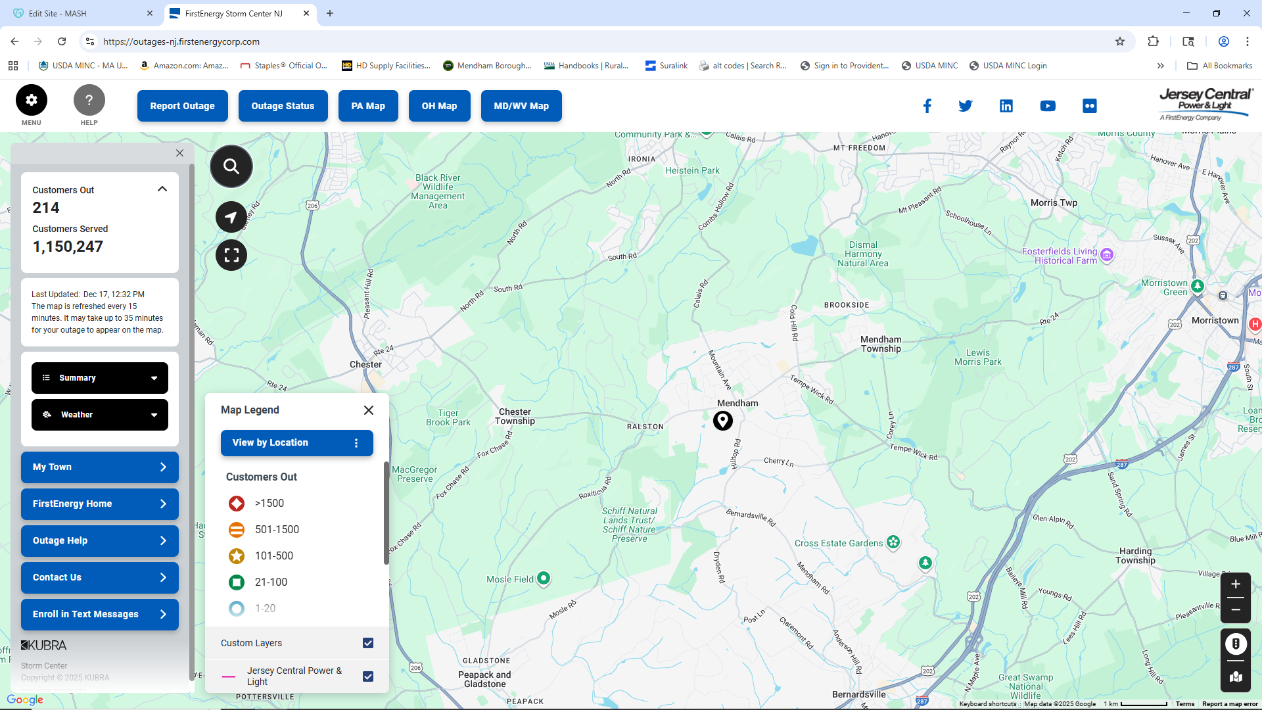
Dan Williams voiced that he was touched by the level of tenant interaction during the recent snow and black-out events, and it was great to see neighbors helping neighbors. This serves as a good reminder that MASH is a community and please continue to check in on each other.

SPECIAL GUESTS: LIFE MEDICAL
https://www.mobilecare.life/
973-607-4911

Life Medical is a mobile medical service that provides the following services in your home:
Wound care Transport Medical Equipment Senior Placement
Urgent care Podiatry Imaging Life Therapy
Palliative/Hospice/Transitional Care Primary Care

Life Medical accepts most insurance. No need to sign up for services – it works exactly like your doctor. You call one number for any need. A nurse answers each call and assesses your needs right away. Most often, a doctor or nurse practitioner can get to you same day or the following day.
- Call: 973-607-4911
- Web: https://medical.life/

You may also find a direct link to their website on the MASH website (mashnj.org).
There are a few extra magnets and brochures in our office for anyone who could not attend the meeting.

