GISMO GIRL’S BADGE GUIDE

G.I.S.M.O Scholars L3C
Badges

This guide contains a description of each GISMO Girl Badge and instructions for earning them. Be sure to read carefully and follow the guidelines to ensure you earn your desired badge.

Leadership Badge
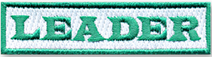

Pick a STEM activity. Prepare a list of materials and instructions. Lead a workshop with your family. Take pictures to document your experience.
(3 – 5 photos)

Cyber Safe Badge

Make a video about the importance of online safety. Be sure to mention cyberbullying and ways to keep personal information safe. Your video must be 2:00 minutes or less.

Girl Power Badge

Make a PowerPoint Presentation about the importance of girls participating in STEM classes and activities and pursuing STEM careers.
(No more than 10 slides. Must include a title slide and credits on the final slide.) You may also use Prezi, Google Slides, or Sway.

Make a Difference Badge

Identify an environmental problem in your neighborhood. Think of one possible way to address the issue. Write a letter to a neighbor asking for their help. Make a copy of your letter before you mail it. Write a paragraph describing how your neighbor responded.

Technology Museum Badge

Visit SciPort – Louisiana’s Science Center. Participate in some activities or see an IMAX movie. Document your visit with at least 5 photos and write a paragraph about something you learned. Ask an employee to take a photo with you and sign their name at the bottom of your paragraph.

STEM Career Badge

Research a STEM career that interests you. Write a report that includes…
Education requirements and skills
Typical duties and responsibilities
Places a person in this field would work
Salary range
Explain why you are interested in the chosen career.

Photo Scavenger Hunt Badge

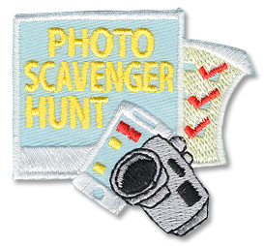

Visit a local park and collect photos of an unusual rock, an interesting leaf, a peculiar insect, and a familiar tree. Don’t forget to photograph the name of the park. What kind of leaf is it? What kind of insect is that? Do you know the name of the tree? After you explore, write a reflection that describes what you learned.
(No more than 2 paragraphs.)

Kitchen Chemistry Badge

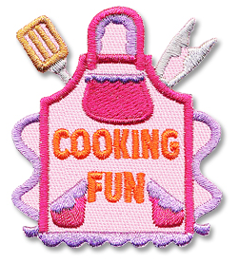

Pick a recipe. Cook it! Let Mom take a few photos of you as you work. Take a photo of your final product and your family enjoying your masterpiece. Explain how science, technology, engineering, and math were evident in your cooking experience. (No more than 2 paragraphs.)
Severe Weather Badge

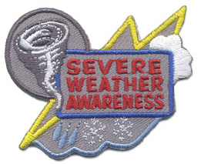

Louisiana sees its share of tornadoes each year. Make a poster that explains how to stay safe during a severe weather event. Do some research before you begin. Your poster can be made with paper and other art supplies or you may use a platform like Google slides, Google docs, or a Microsoft Word document.

Engineering Badge

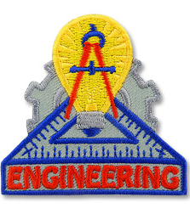

Build a prototype for a car powered by rubber bands. Answer this question, “Why does it work?”. Include an explanation of how you observed kinetic energy, potential energy, friction, and acceleration.

Virtual STEM Badge

Actively participate in 6 or more virtual workshops. Be attentive. Listen actively. Ask questions. Answer questions.

*********************************
Email badge work documents and photos to gismoscholars@gmail.com. Arrangements can be made to deliver prototypes and other artifacts.
*********************************

Badge Rank
3-5 Badges – Novice
6-8 Badges – Expert
9-11 Badges – Badge Slayer

Coming Soon!

Road Trip Badge

Escape Room Badge
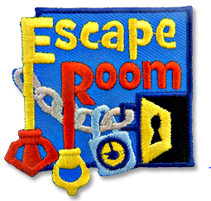

Aquarium Trip Badge
