**ANITA APPARELS LTD**

**(Manufacturers &100 % exporters of Readymade Garments)**

**3325/3898,Alongkar Shopping Complx(3Rd Floor),**

**Alongkar Mour, Pahartali , Chattogram.**

**[FACTORY PROFILE]**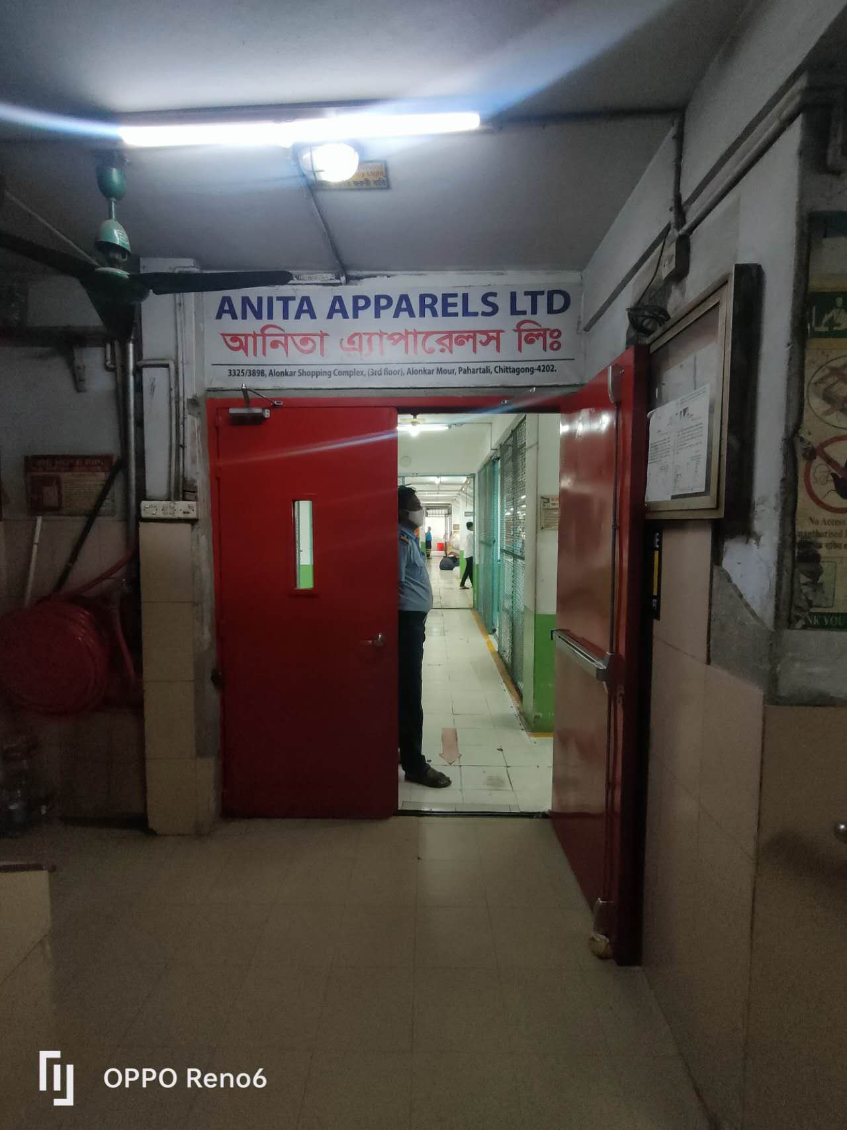

INTRODUCTION

We are committed to providing excellence at all levels of production. Established in 2022**ANITA APPARELS LTD**. Which means flawless service to excellence in product development. We are going to earn a reputation through the global apparel industries as one of the local factories in Bangladesh or our commitment to quality, timely delivery and total value. Through our sourcing network, we have the ability to effectively procure the best materials. Our customers can deliver the best quality product and superb service, which enable them to successfully complete in earning marketplace.

**ANITA APPARELS LTD**a wide range of product development capabilities. Our management team has an extensive understanding of companies in the west as well as capabilities of firms in the East, making overseas sourcing.

**ANITA APPARELS LTD**, known as Anita Apparels of industriesfamily in whole world” focuses entirely on the clothing industry, the productmarketing sourcing-control unit in Chittagong, Bangladesh,Though we are 100% agree ifcustomers went To involve their 3rdparty inspector, we have a plan to introduce modern machine for total production capacity of about 10,00,000 garments per month depending on items & style. We are total 600 in this family.

**CONTRACT PERSON:**

|  |
| --- |
| **MD. ABDUL BAREK**  Managing Director  Cell- 01714-306729  Email- [anitaapparelsltd@gmail.com](mailto:anitaapparelsltd@gmail.com)  **SAJIB BARUA**  Marketing & Merchandising (Manager)  Mobile number: +88-0-0188-0472176 (Whats app)  Sajibbarua0176@gmail.com |

**Our Bank:**

**Islami Bank Bangladesh Ltd.**

**Dewanhat Branch, Chittagong.**

**PROFILE**

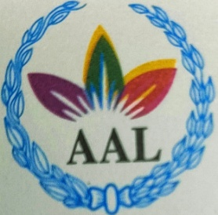**3325/3898,Alongkar Shopping Complx(3Rd Floor),**

**Alongkar Mour, Pahartali , Chattogram.**

**FACTORY AREA:**

|  |  |
| --- | --- |
| Fields | Square/fit |
| Office | 3000 |
| Warehouse ( in ) | 9000 |
| Cutting Section & Finished Goods | 5000 |
| Sewing & Canteen | 13000 |
| Finishing | 5000 |
| Store &Ins-pection Room | 3000 |
| Parking | 2000 |

**PRODUCTION CAPACITY:**

|  |  |
| --- | --- |
| Item | Pieces Capacity / Month |
| T-Shirt | 350000 |
| Ladies Panty | 1000000 |
| Boys& Mans Boxer | 700000 |
| Exclusive Lady’s top | 500000 |
| Brief & A shirt | 800000 |
| Kid’s Top Bottom Set | 350000 |
| **Polo Shirt** | 200000 |

**Machine List:**

|  |  |  |
| --- | --- | --- |
| SI | Type of Machine | Qnty/Set |
| 1 | Single needle plain Machine | 60 |
| 2 | Two needle Machine | 05 |
| 3 | Over-lock Machine | 80 |
| 4 | Nero Over-lock Machine | 02 |
| 5 | Flat Lock Machine | 65 |
| 4 | Bar-tack Machine | 21 |
| 5 | ZigZag Machine | 20 |
| 6 | Back Tap Machine | 02 |
| 7 | Rib cutter Machine | 02 |
| 8 | Cutting Machine | 04 |
| 9 | Layer Cutter Machine | 01 |
| 10 | Hit-sell Machine | 10 |
| 11 | Sticker / Number Machine | 02 |
|  | TOTAL | 274 |

**EQUIPMENT**

|  |
| --- |
| **Special Equipment:**  **-Diesel Generator**  **-Thread Re-coning Machine**  **-Required all equipment of fire safety**  **-Air Compressor**  **-Strum Broiler** |

|  |
| --- |
| **CURRENT KEY CUSTOMER:**  We have regular customer from US, Canada (Sub Contract)  *ZawPaw US (Buying House Color Fab)  *VF WalmartIntex Link  *VandelWelmartIntex Link  *Cotton on (Four H group)  *LPP (Four H group)  *Pure And Happy (Four H group )  *7J1 (Four H group)  *Borman (Moontaha Apparels Ltd)  *Dollarama (Moontaha Apparels Ltd)  *D. WrarWelmart ( Benchmark)  *Saramax (Stitch Tone Apparels)  *Dreamwear (Stitch Tone Ltd)  *Mega (Scope One)  *Tex-Planet (Knitmoon BD LTD)  *Zanfan (Arina Group) |

|  |
| --- |
| **FRIENDLY EXPERIEENCE TEAM:**  We are leading here with best dedication of our most experience stuffs in every section. Some of them were stared their carrier at the same time of factory started. Still they are being with us.  **WE LOVE WHAT WE DO:**  It’s easy to think to work continuously for long term, the boredom can exist at any team work. But it’s true we love our job what we are doing each n every day.  **NO TO CHILD LABOR:**  We never allowed Child labor despite of they are wishing to have work with small wages.  **ALWAYS ON TIME:**  Start to End, we always keep us in punctuality or proper time shape in every stapes. For this reason we never faced any shipping schedule massacre with customer.  **GOAL:**  Buyers satisfaction. Our goal is remain a responsible apparel producer through adherence to internationally established social business practices.  **THE TEAM:**  Team spirit is our main strength. |

**Our Fashion’s Gallery:**

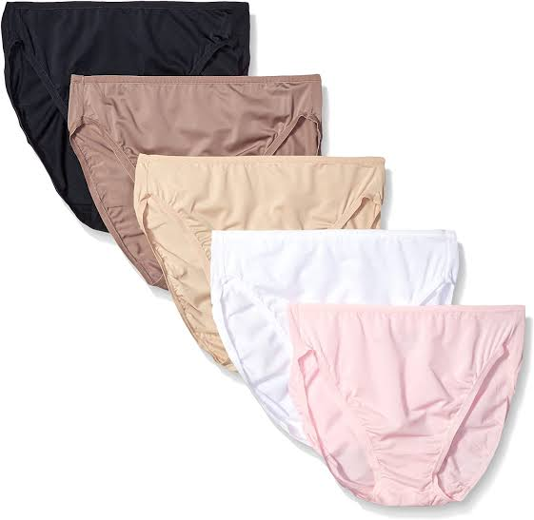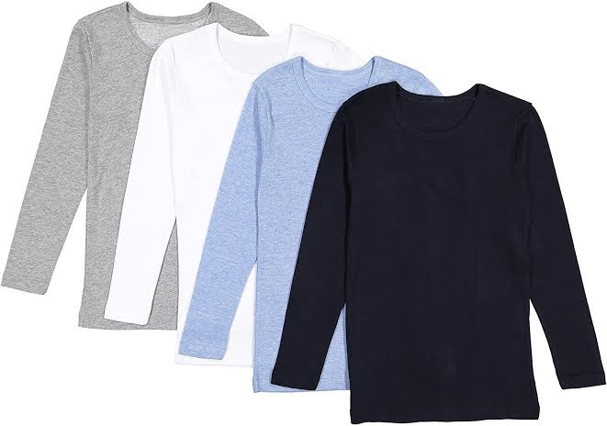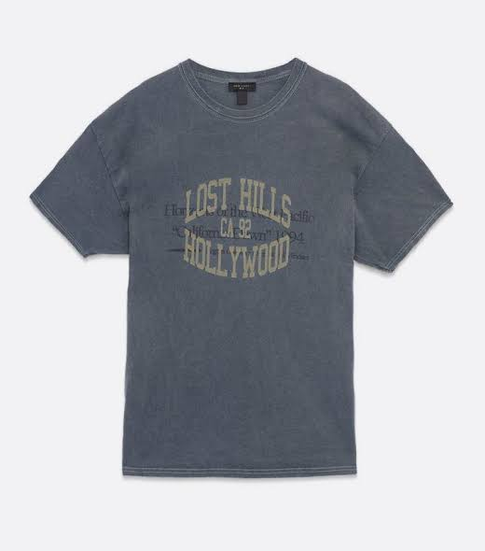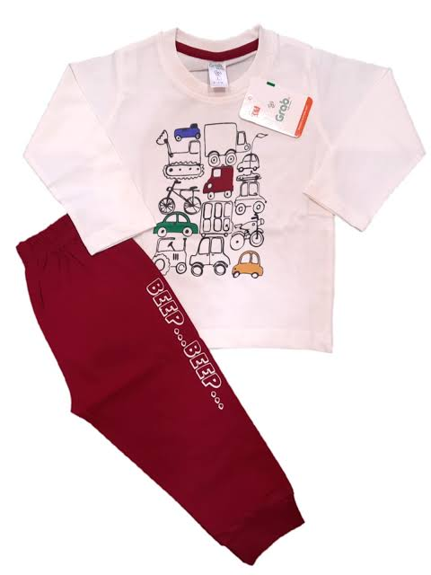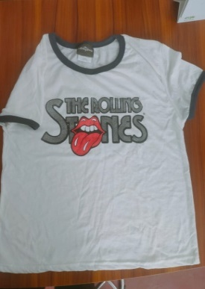

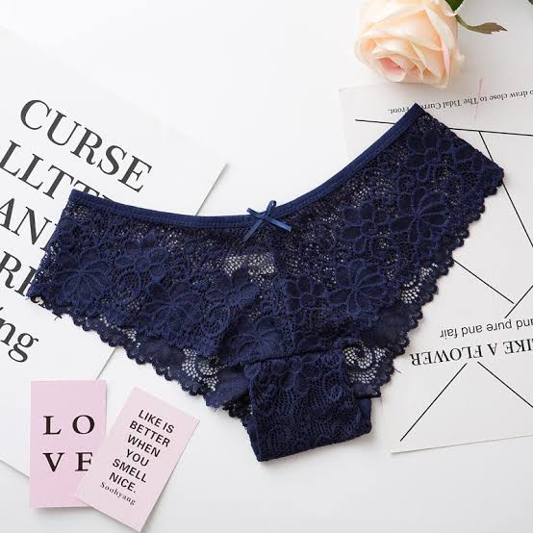

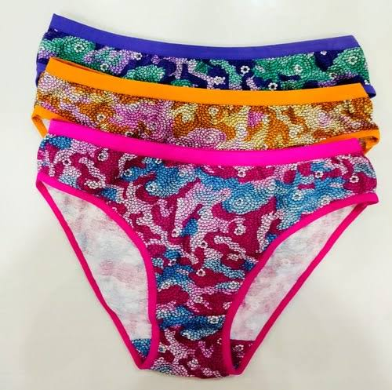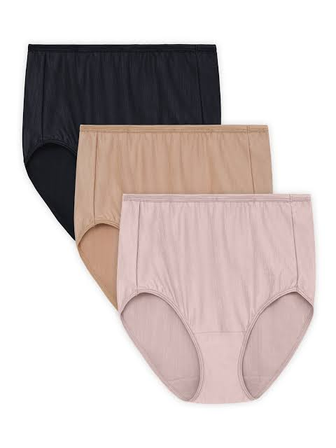

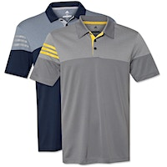

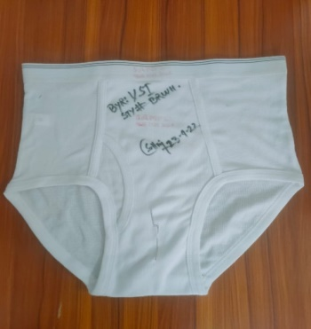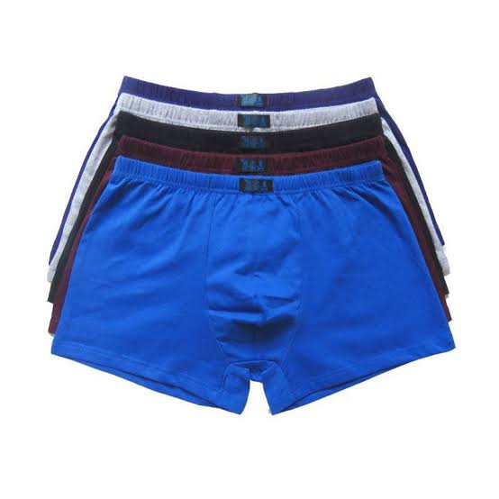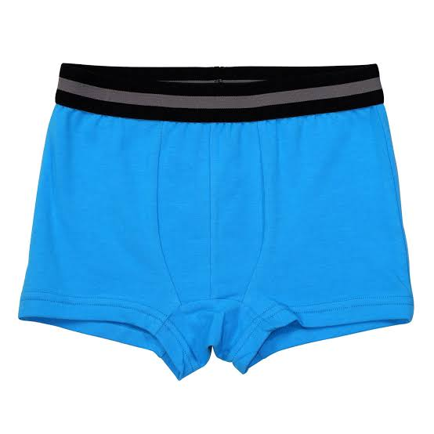

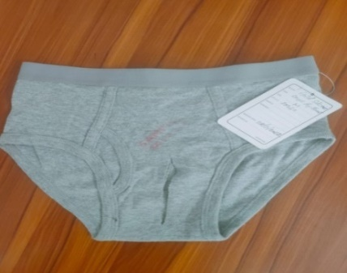

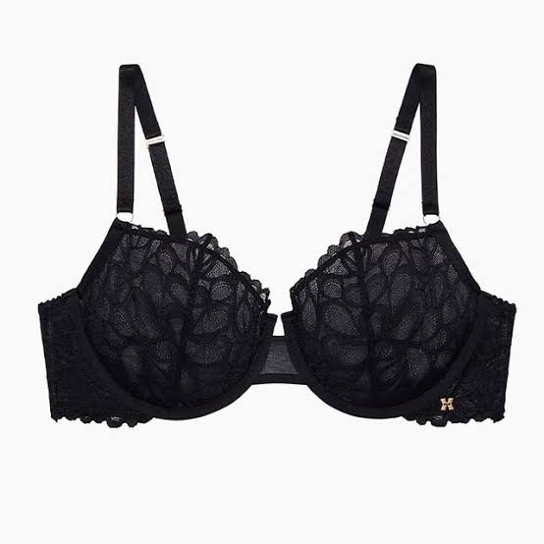

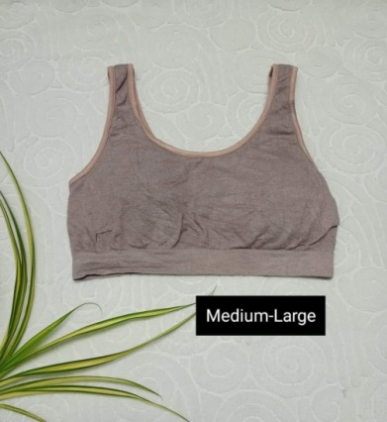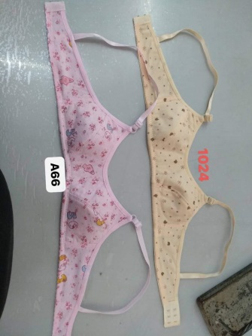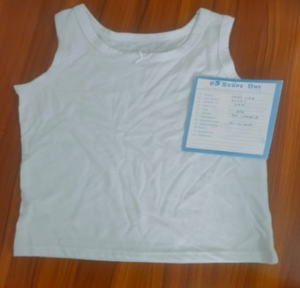

**Our Dream Comes True!**



**OUR MAIN GATE:**

**OUR SECTIONS:**

**CUTTING:**

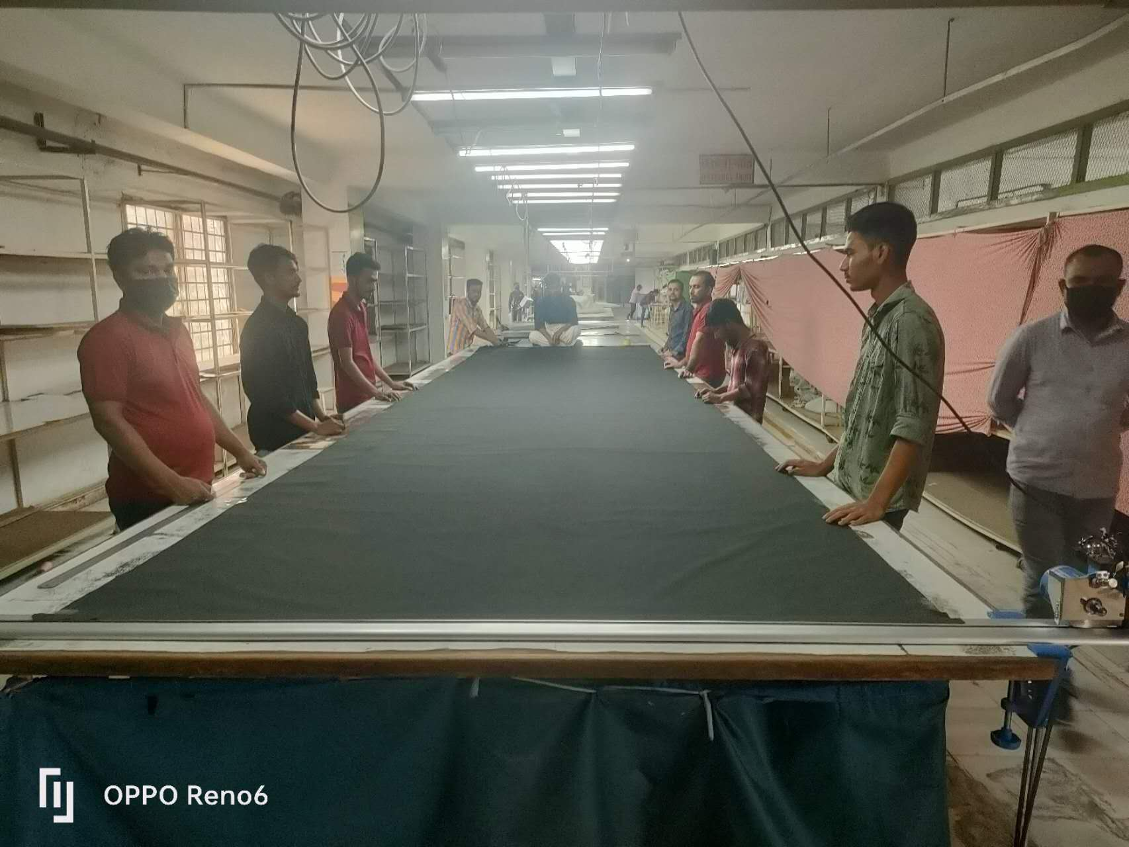

SEWING: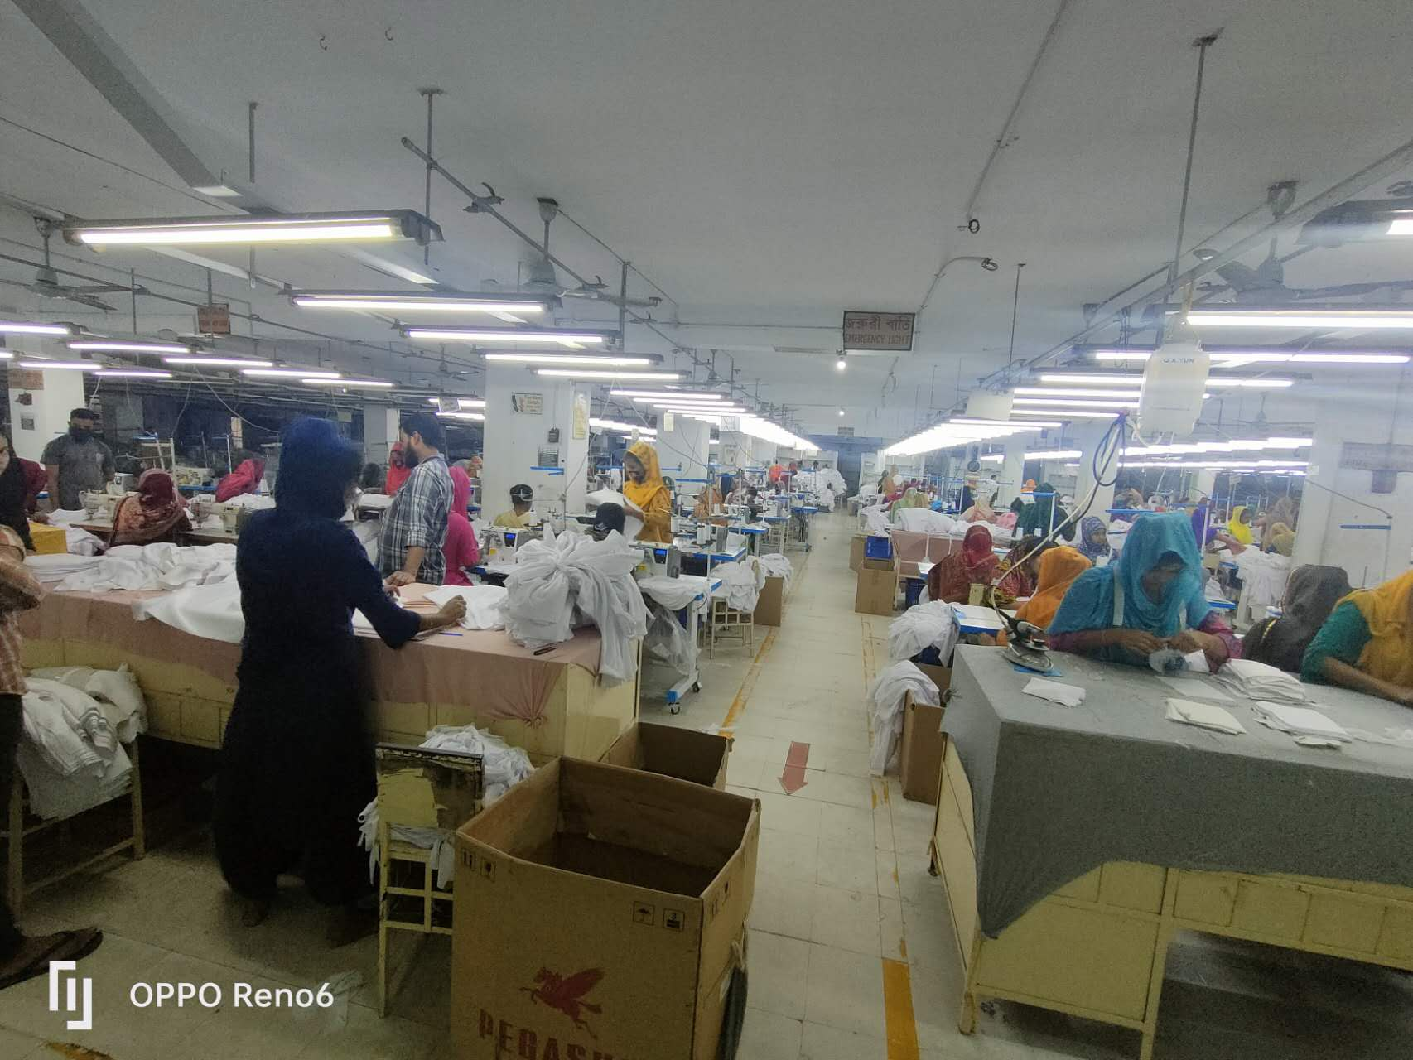

FINISHING:

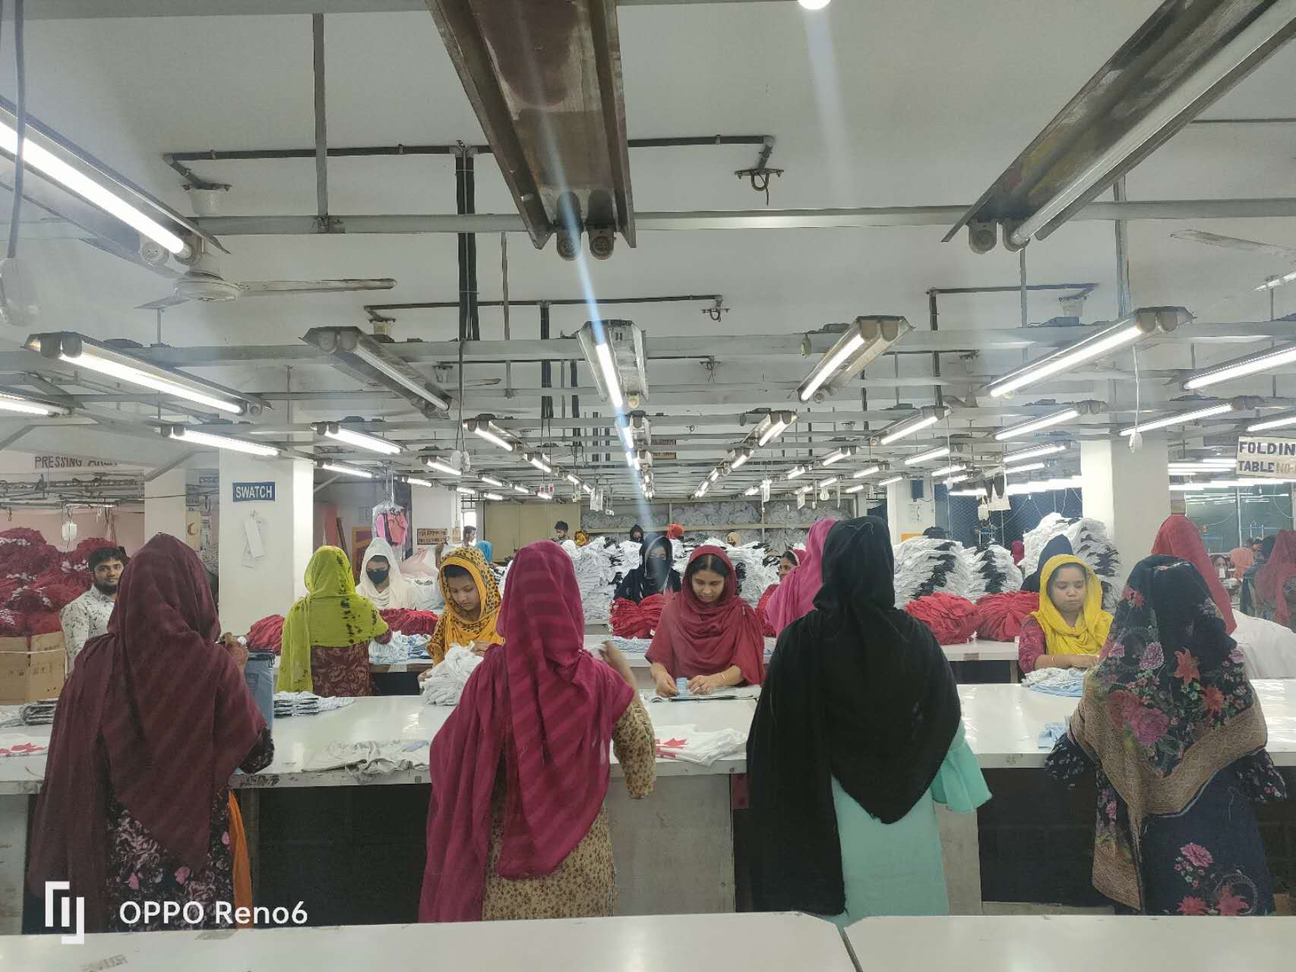

OFFICE: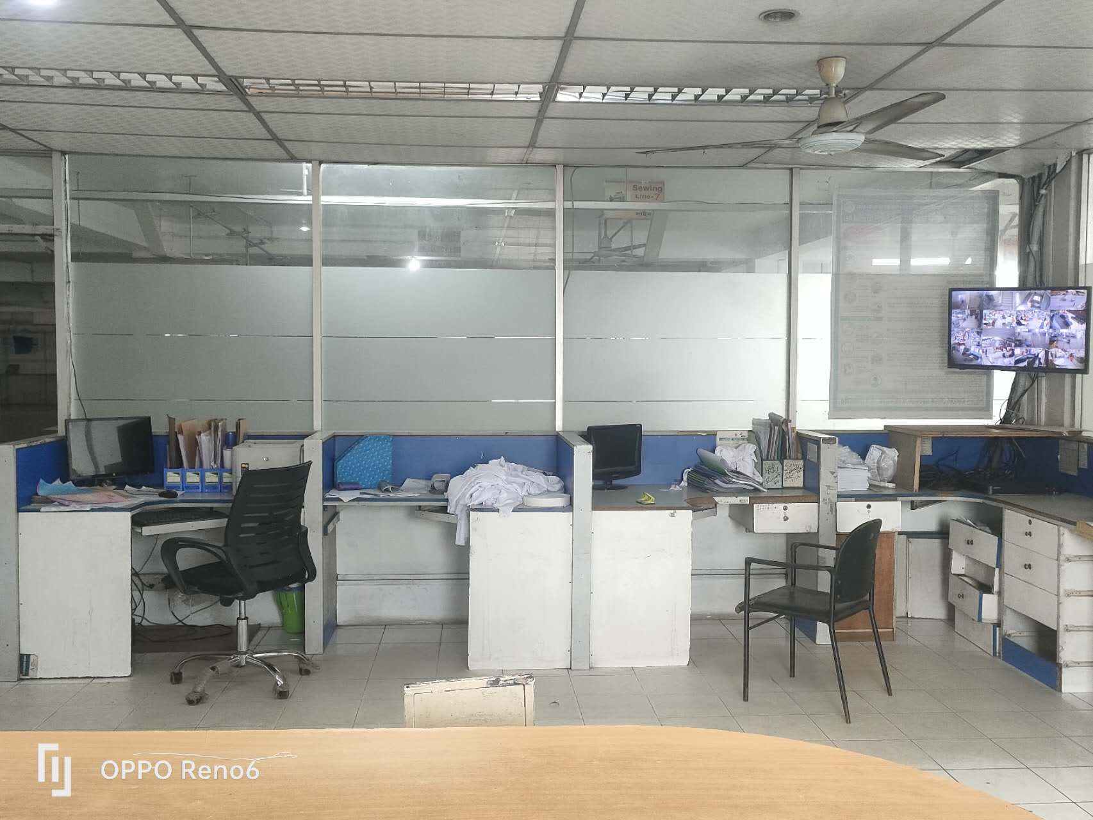

MD SIR ROOM:

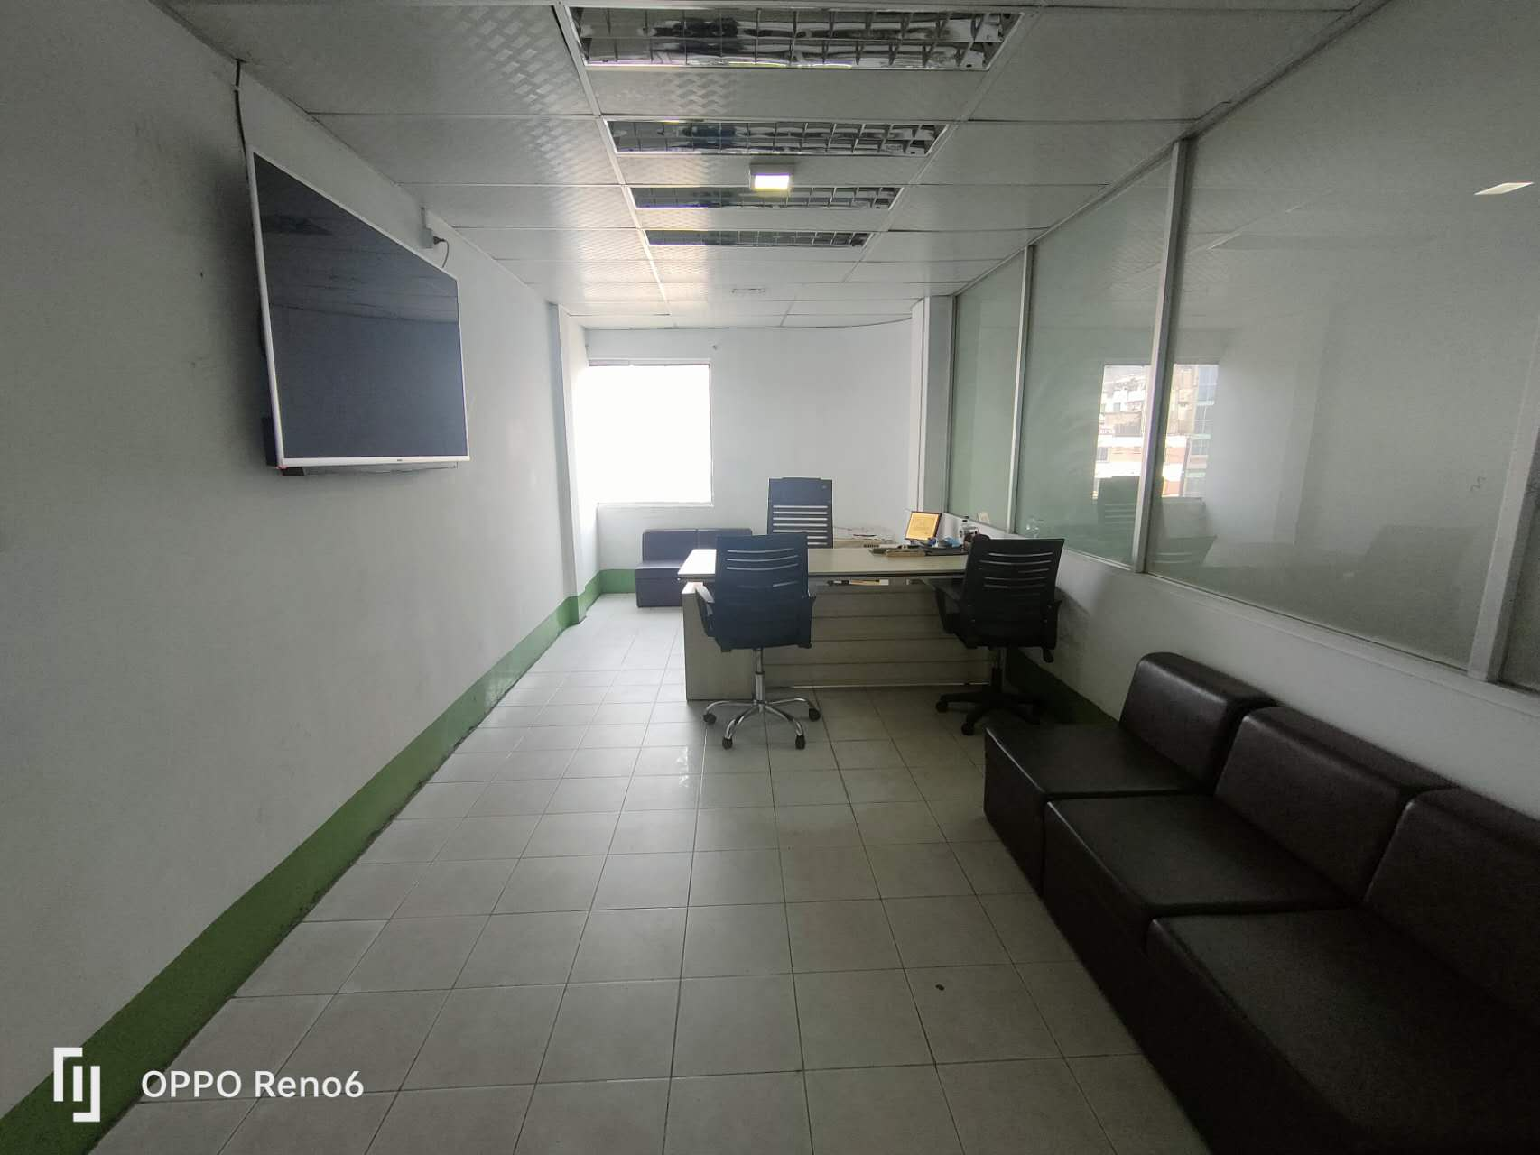

DIRECTOR SIR ROOM:

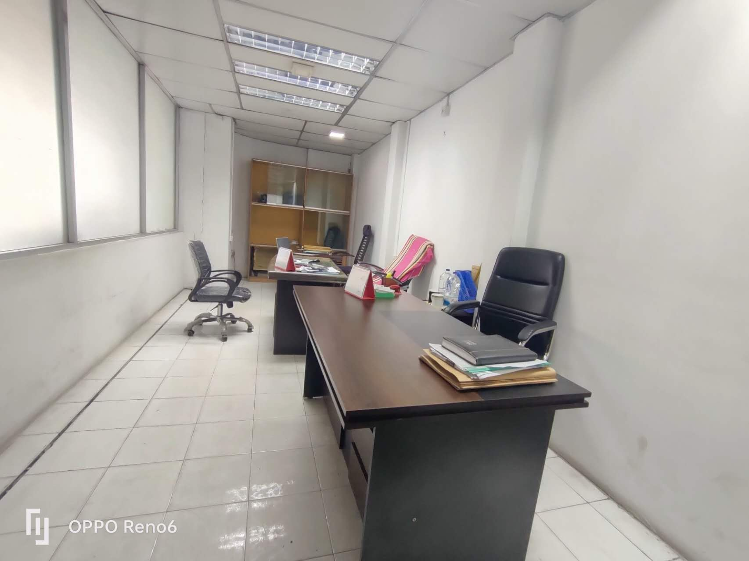

GENERATOR: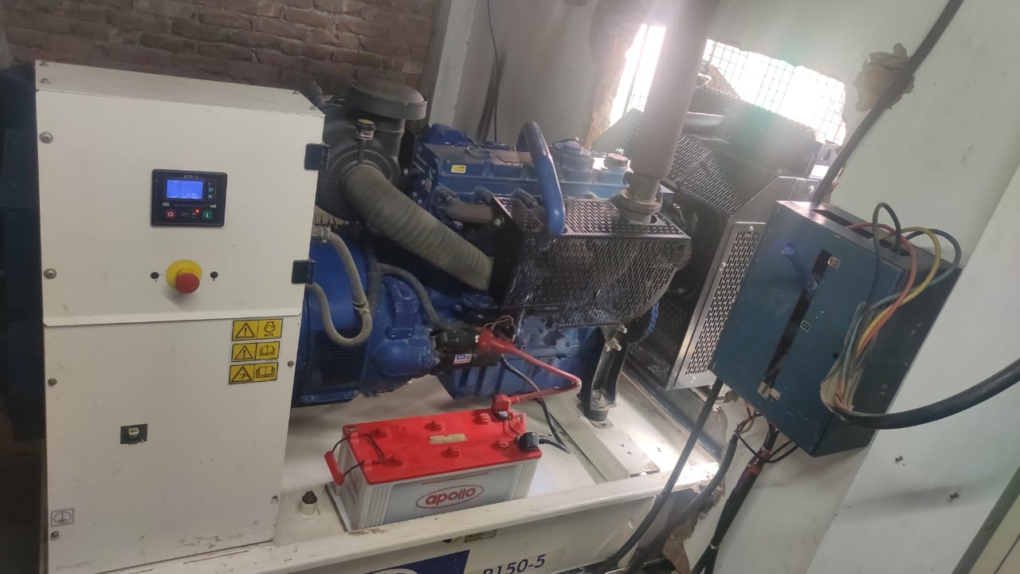

MAINTENANCE ROOM:

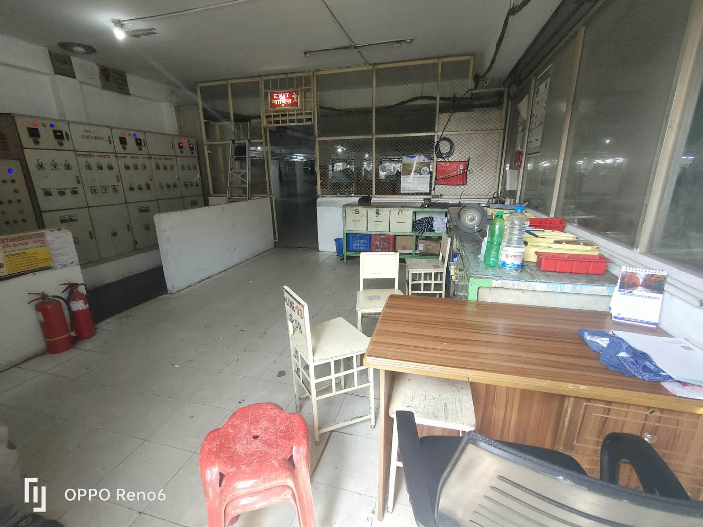

CANTEEN:

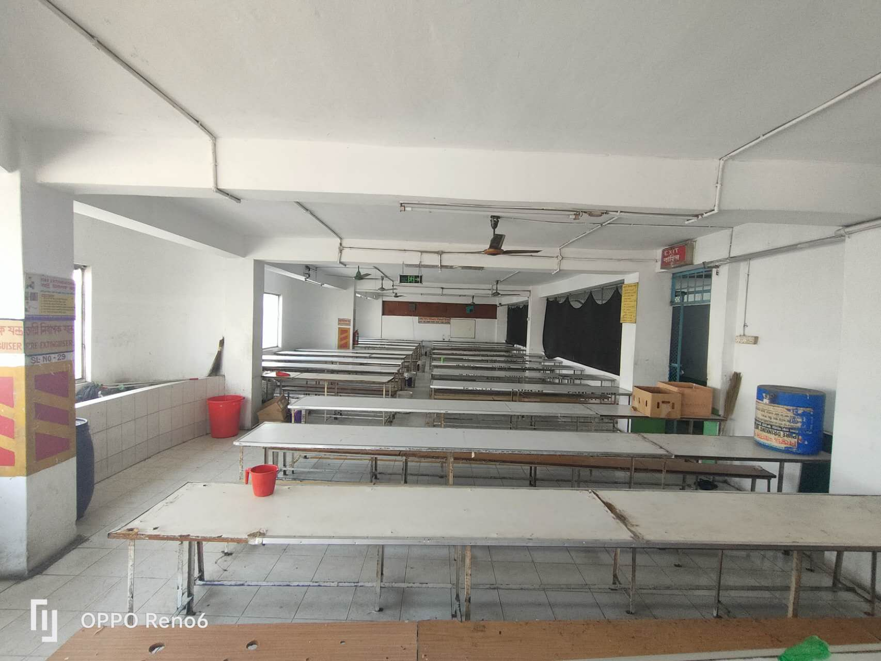

INBOND AREA :

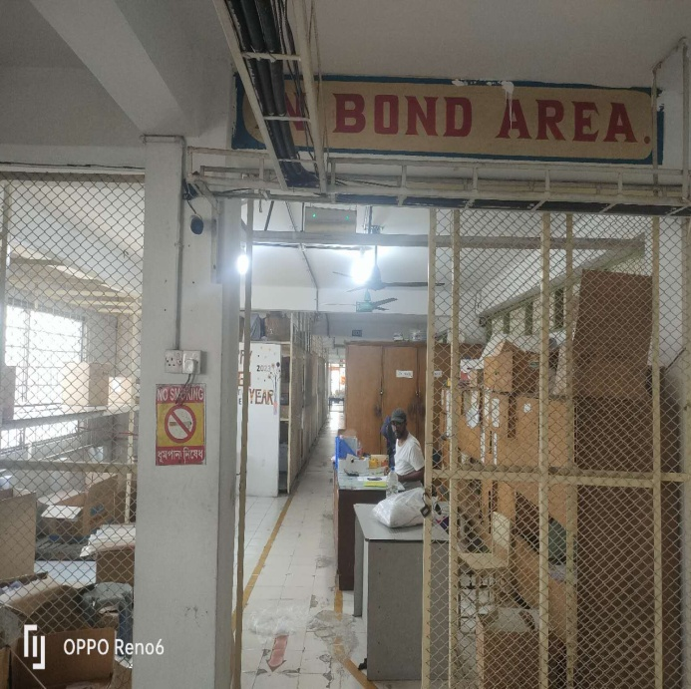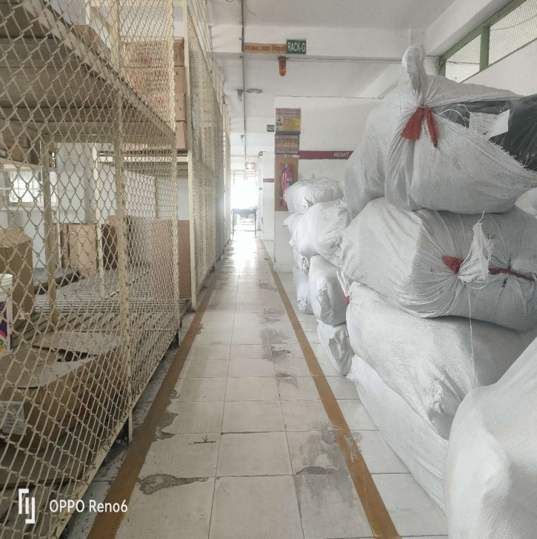

ACCOUNTS DEPT:

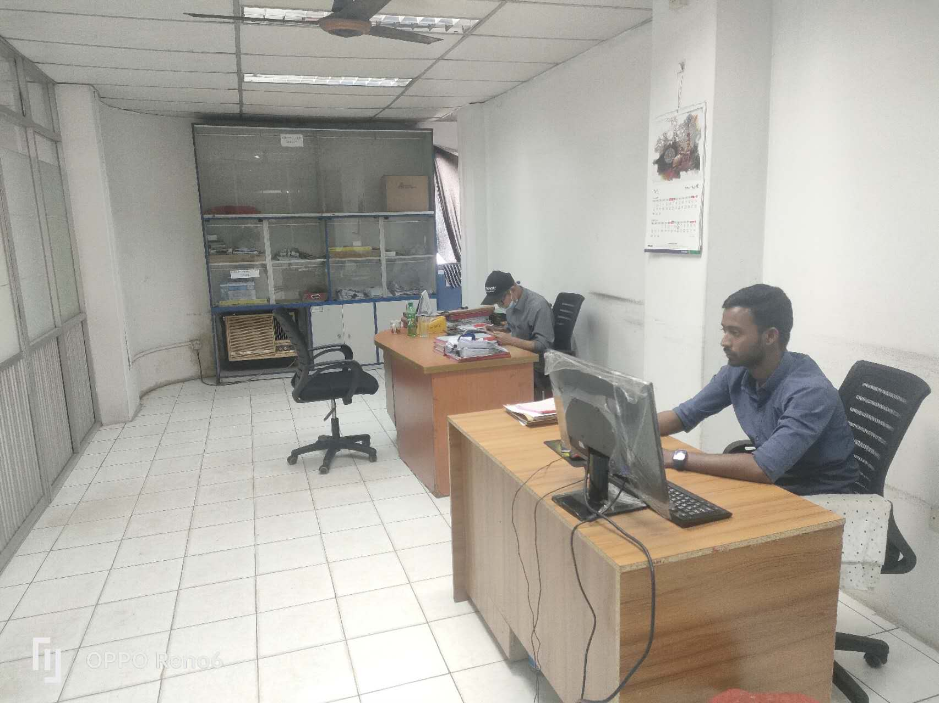

HR & ADMIN DEPT: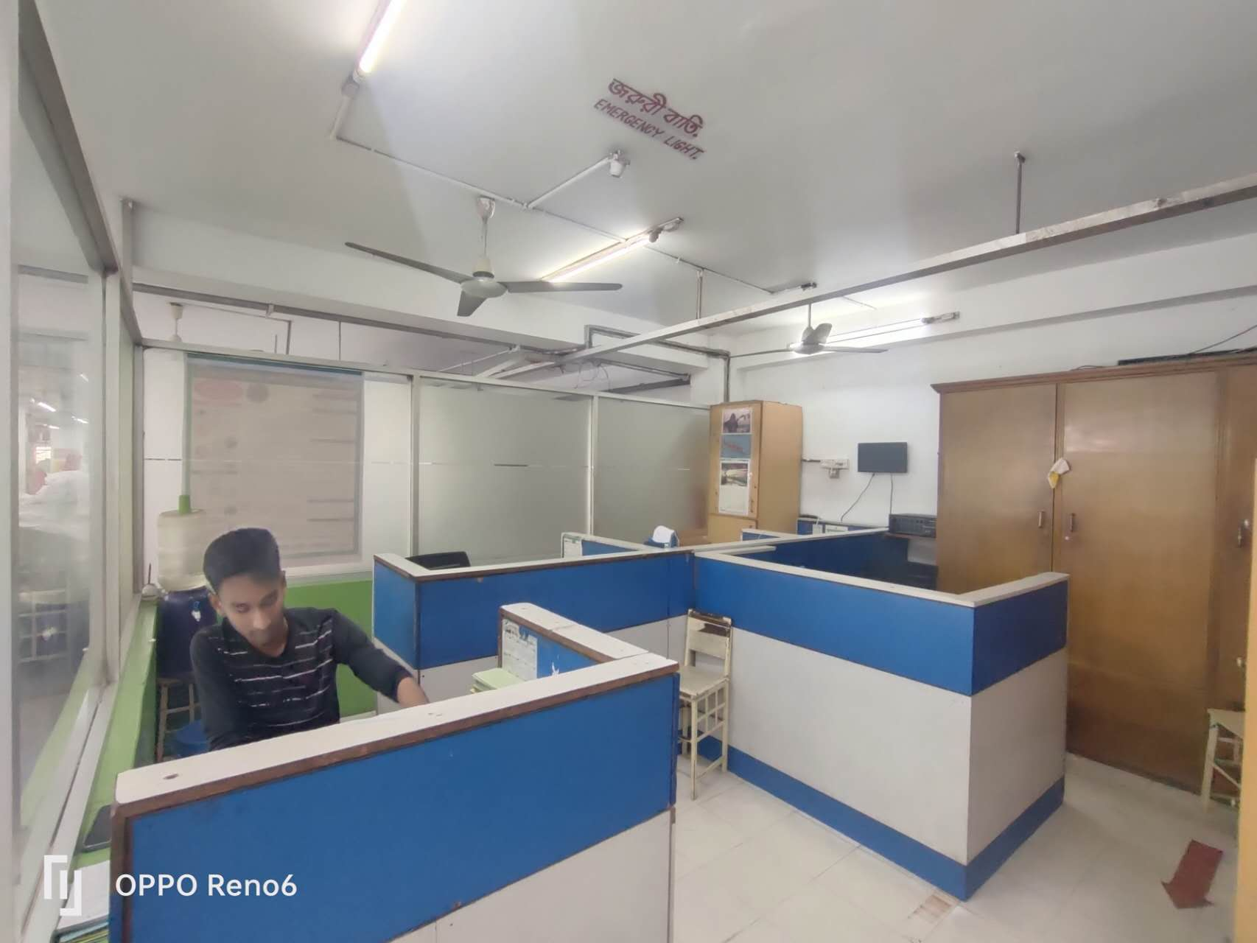

DOCTOR’S ROOM:

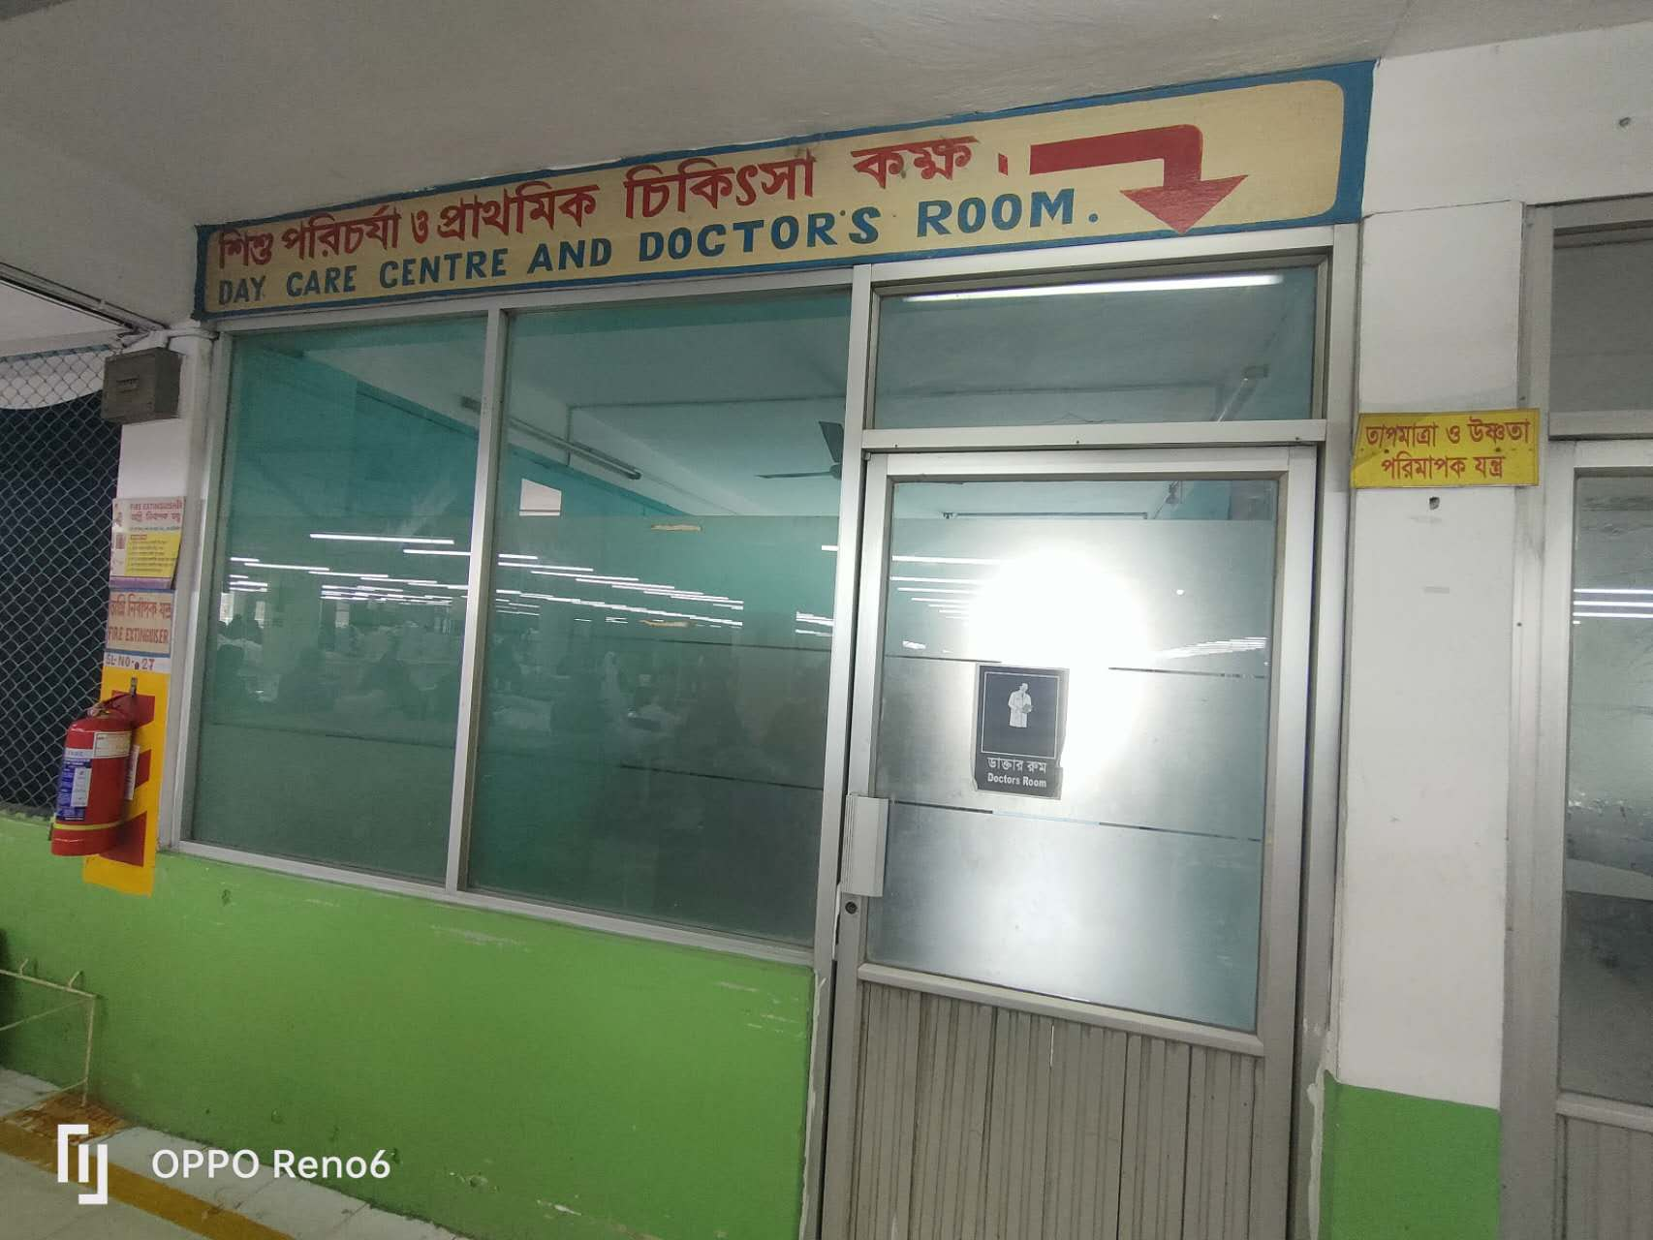

IMERGENCY EXIT:

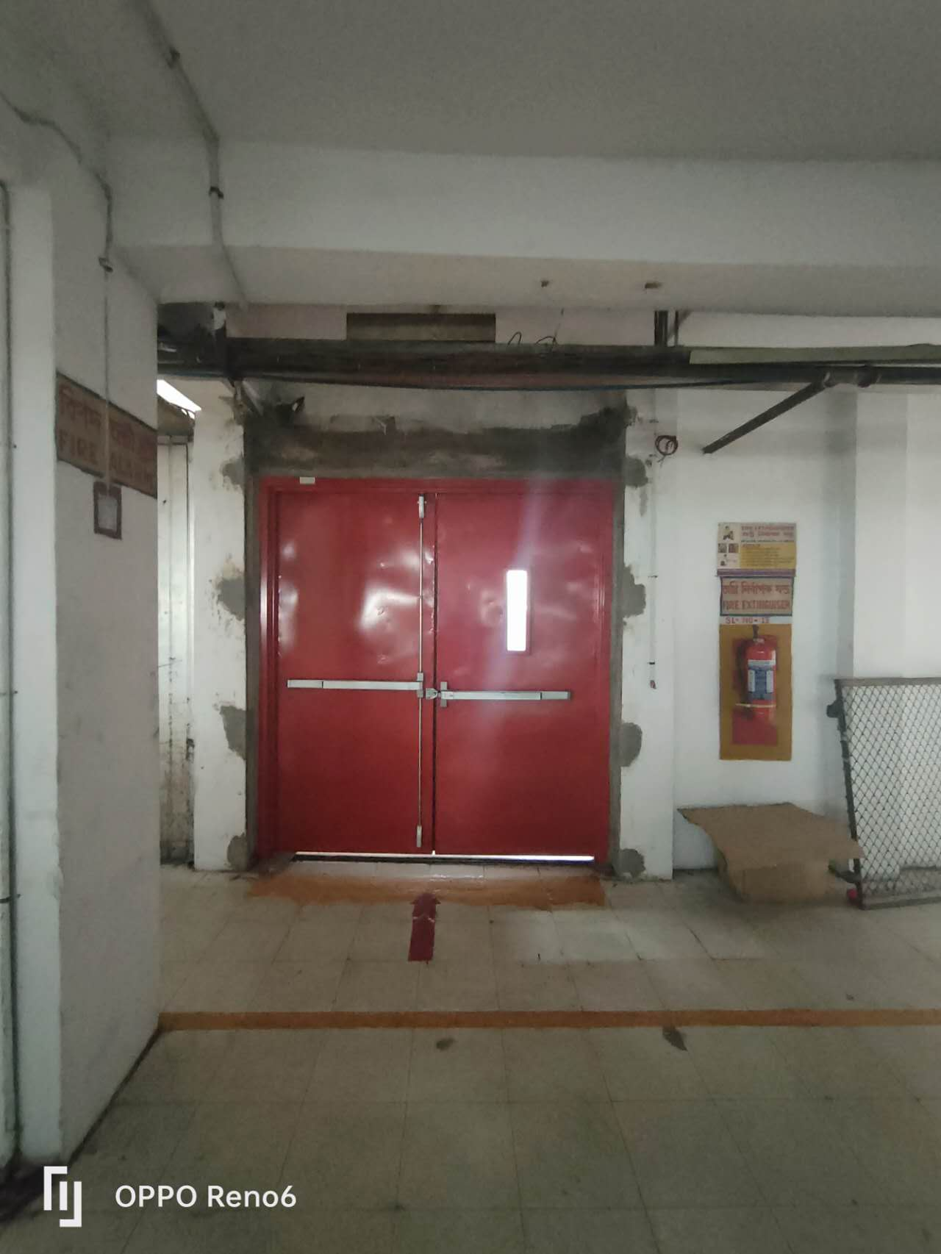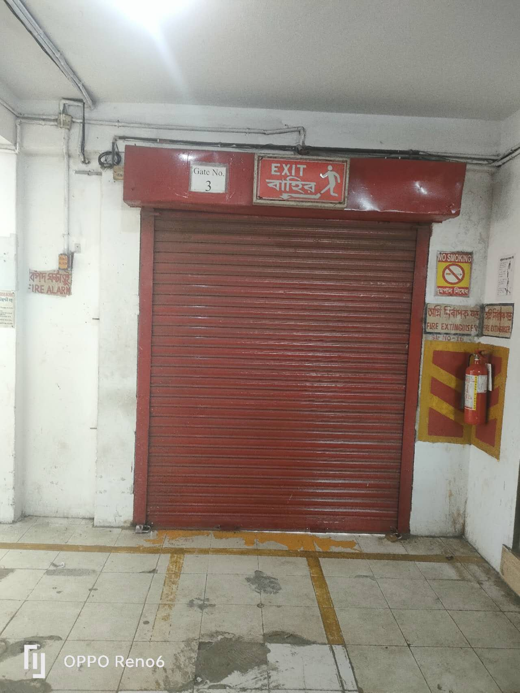

IN WAY:

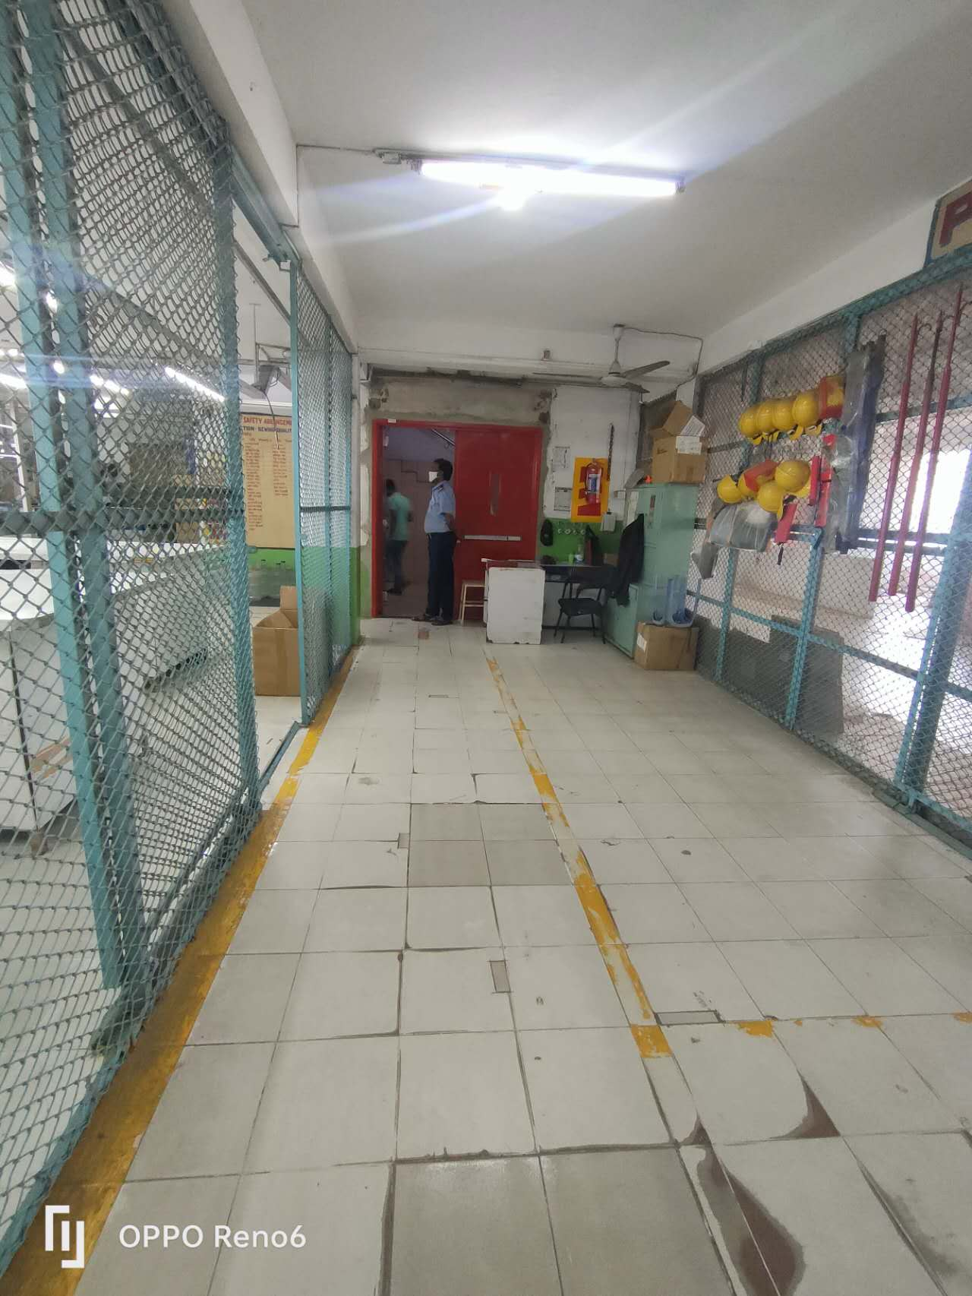

Exit way: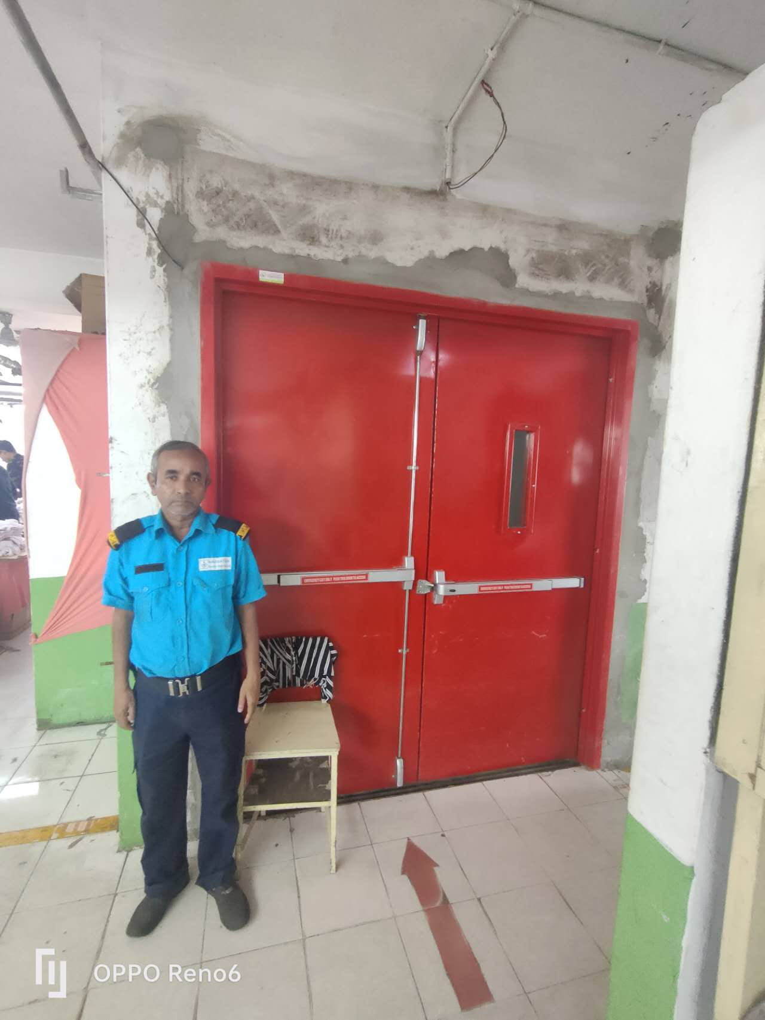

ANITA APPARELS LTD:

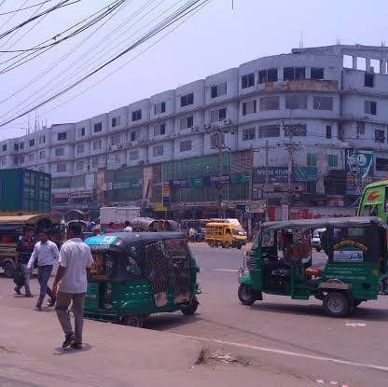

THE END