Aviemore Primary School/ELC
Planning the Outcomes of Learning – Termly Organiser
Session: 2024-25 Term: 3
Class: Rainbow Yellow and Blue Teachers: Mrs Johnson, Mrs Sharp & Miss Anderson
Topic: Weather & Seasons / Scotland

In Rainbow we strive to provide a mix of child led, adult initiated and adult directed experiences, including learners in decisions as much as possible. We use multi-sensory opportunities in all our learning and provide play experiences both indoors and outdoors (as weather permits!). We are excited to say we also focus on a speech and language therapy structure called ‘Attention Autism’ for our learning in Yellow. This is designed for children with neurodiversities to work on the early fundamentals of language including: awareness of others, attention, listening, shared attention, switching attention and turn-taking. We refer to this as ‘Bucket Time’ as Stage 1 of the intervention has highly motivating items that come out of a bucket! We also use this as a way of delivering other curricular areas such as numeracy, phonics and topic.

In response to children’s developmental needs, we encourage interaction with peers through integration within mainstream classes. Children’s timetables vary based on individual need. Most Rainbow children will spend some of their school day within their mainstream classes. Most often, they will participate in practical subjects within their classes such as: Health and Wellbeing, PE, Art, Languages and Science. The main Literacy and Numeracy focuses are experienced within Rainbow.

In Rainbow Yellow, we predominantly focus on the acquisition of early literacy and numeracy skills, alongside fostering emotional literacy in line with health and wellbeing. This stems from the ASN Milestones as part of the Curriculum for Excellence. We create multi-sensory learning experiences and incorporate many of the expressive arts in our everyday routines and learning. This is to best encourage retention of learning around children’s individual targets and foster positive relationships through shared experiences. We specialise in Augmentative and Alternative Communication and use a Total Communication Approach with all learning – this approach utilizes Boardmaker visuals, Makaton signing, objects of reference and Intensive Interactions to support communication and comprehension of learning.
Dates for the diary  January  6th Return to school and nursery  10th Assembly – Mrs McMaster New Year and Visions, Values and Aims.  17th Termly Planners Out  17th Assembly – Mrs Creber – SHANARRI – Active  22nd Nursery Parent appointments  22nd, 23rd and 24th Garden designer in to visit  classes  24th Assembly – Whole School Scotland topic  February  4th and 6th School parent evening appointments  7th Class assembly P1- Miss Ross  14th Assembly – Stage/Reflective – Children’s Mental Health Week  17th 18th Holidays School and ELC closed to pupils and staff.  19th Inservice day- school and ELC closed to pupils  21st Class assembly P3/4 Mrs McIntyre  28th Assembly Mrs McMaster – SHANARRI (responsible)  March  6th World Book Day  7th Class Assembly P3/4 Mrs Tannock Josey  14th Comic Relief Assembly and Ptarmigan House enterprise  21st Lots of Socks- Downs Syndrome Awareness Day  21st Class Assembly P1/2 Miss Anderson and Ms Lewis  28th Star Assembly  April  1st House Treat  2nd Autism Awareness Day  4th Easter Assembly  4th School and ELC close for the holidays  We will return to school and nursery on 22nd April. | Curricular Areas  Languages & Literacy:  - Phonological Awareness – focus on word boundaries (supported by colourful semantics)  - Phonics sounds as appropriate (one sound per fortnight)  - Core Word Sensory work daily (using Makaton signing and visuals)  - Sensory stories daily (themed around contextual topic)  - TACPAC daily (themed around contextual topic)  - Bucket Time/Attention Autism – listening, talking, turn taking, sharing, attention and engagement  - Morning and afternoon meet – familiar songs, rhymes, dances, routines and turn taking.  - Mark making and pre-handwriting skills, alongside letter formation, where appropriate.  Writing:  We will be blending together Talk for Writing and Foundations for Writing approaches to writing. This will allow us to deliver concepts of storytelling such as sequencing and development sentence construction through using colourful semantics and Makaton symbols. We will do this through the context of nursery rhymes linking to our topics:  Incy Wincy Spider (Weather), Three Craws (Scotland), Old MacDonald (Seasons)  Mathematics & Numeracy:  - Calendars (Specifically months and seasons)  - 2D shape  - Ordinal numbers  - Counting forwards and backwards (up to 20 and back from 10) alongside early addition and subtraction  - Number formation  Health & Wellbeing:  - Emotions  - Similarities and differences - inclusion  - PE with mainstream classes  Science:  - Water cycle – how it changes forms  Social Studies:  - Seasons and Weather – describing and recording weather, its effects, how it makes me feel.  - Features of local landscapes (Scotland)  Expressive Arts:  - Music – daily songs throughout curriculum (literacy, numeracy, health and wellbeing, sensory stories)  - Sensory play  - TACPAC  - Art – exploring different artist’s techniques and re-creating artworks  - Scottish dance and music
Opportunities for Personal Achievement
May include:
Cooking and Baking
Gardening in ASN garden (and supporting development of school garden)
Working with different adults and children
Developing relationships within mainstream classes
Library visits
School assemblies
House meetings
Learning life and independence skills
Developing ability to use communication systems
House Points
Class star certificates
Right respecting school certificates
Post cards home
Class Charters
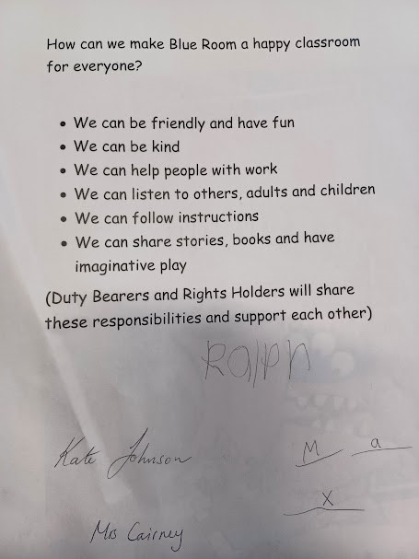 | 