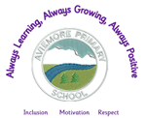
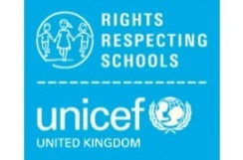
Aviemore Primary’s Right of the Month and SDG’s
Term 3 (2025-2026)
Please find below our focus right of the months. The aim of extending the time spent on each right is to ensure that we can focus on ACTION as well as knowledge. The children should be aware and be able to speak about the rights, but we should all be looking at how we can promote these rights and TAKE ACTION to ensure that all children are having these rights MET.

January -Right of the Month: Access to health, water, food and environment- Article 24 and SDG Goal 3 Good health and well-being. (Linking to Children’s Mental Health Week)

February - Right of the Month: No Discrimination Article 2 (linked to International Women’s Day and SDG 5 (Gender Equality).

March - Right of the Month: Health and health services and an adequate standard of living (Linking with World Water Day) Articles 24 and 27 and SDG 6 (Clean water and sanitation)

