Aviemore Primary School/ELC
Planning the Outcomes of Learning – Termly Organiser
Session: 2024-25 Term: 4
Class: Rainbow Yellow and Blue Teacher: Mrs Johnson, Mrs Sharp & Miss Anderson
Topic: Being Healthy and Safe (Plants, Animals, Body parts, Keeping safe and consent, People who help us - Family and other people)

In Rainbow we strive to provide a mix of child led, adult initiated and adult directed experiences, including learners in decisions as much as possible. We use multi-sensory opportunities in all our learning and provide play experiences both indoors and outdoors (as weather permits!). We are excited to say we also focus on a speech and language therapy structure called ‘Attention Autism’ for our learning in Yellow. This is designed for children with neurodiversities to work on the early fundamentals of language including: awareness of others, attention, listening, shared attention, switching attention and turn-taking. We refer to this as ‘Bucket Time’ as Stage 1 of the intervention has highly motivating items that come out of a bucket! We also use this as a way of delivering other curricular areas such as numeracy, phonics and topic.

In response to children’s developmental needs, where appropriate, we encourage interaction with peers through integration within mainstream classes. Children’s timetables vary based on individual need.

In Rainbow Yellow, we predominantly focus on breaking barriers to learning for individuals. As such targets are highly personalised and opportunities to meet theses are provided throughout the entire school day in multiple contexts. This stems from the ASN Milestones as part of the Curriculum for Excellence. We specialise in Augmentative and Alternative Communication and use a Total Communication Approach with all learning – this approach utilizes Boardmaker visuals, Makaton signing, objects of reference and Intensive Interactions to support communication and comprehension of learning.
April  22nd Back to school and nursery  24th Gardening club after school  25th Assembly - Visions, Values, Aims  28th Dr Bike Day  30th Boeing and RAF visit into school  May  1st Gardening club after school  2nd Assembly- Mental Health Awareness Week  5th May Day Bank Holiday-School and ELC closed  8th Open Day (am) and picnic  8th Gardening club after school  9th Pupil Groups Assembly Digital Leaders Online Safety Week  15th Nursery Sports Day (back up date 22nd)  15th Gardening club after school  16th Star Assembly  SATURDAY 17th Garden Work Party 10-12am  21st Cultural Diversity Day  22nd Gardening club after school  23rd P6 Class Assembly - Cultural Diversity  28th NEW P1 Parent Information session  21st P7 Science Day at KHS  29th P3/4 (both classes) Class Trip to Nairn Links  29th Gardening club after school  30th Stage/Reflective Assembly – Healthy  OR  30th School Sports Day (back up date 6th June)  June  2nd Inservice Day- School and ELC closed to pupils 5th Gardening club after school  6th School Sports Day (back-up date) OR  6th Stage Reflective Assembly  Week of 9th Nursery Parents Appointments  10th, 11th and 12th Kingussie High School Move Up Days  11th NEW P1 Parents Coffee morning (am)  12th Nursery Parents Information session  12th Gardening club after school  13th P2/3 Class Assembly  SATURDAY 14th Garden Work Party 10-12am  17th Aquabox fundraiser (sponsored walk) more details to follow. (Back-up date 18th)  19th Gardening club after school  20th Nursery Sharing Learning Assembly  20th Parent Council Summer Fun Night  20th End of year reports issued  25th Move Up Day  26th Gardening club after school  27th – Year Review Assembly  July  1st House Treat  2nd Nursery Leavers’ Assembly  3rd Prize-giving/Leavers’ Assembly  Thursday 3rd July - School and nursery close for Summer holidays at 12pm and reopen on August 19th | Languages & Literacy:  - Phonological Awareness – focus on Listening and attention, Auditory Discrimination, Word Boundaries and Rhyme awareness and detection  - Phonics sounds as appropriate (one sound per week  - Core Word Sensory work daily (using Makaton signing and visuals)  - Sensory stories (themed around contextual topic)  - TACPAC daily (themed around contextual topic)  - Bucket Time/Attention Autism – listening, talking, turn taking, sharing, attention and engagement  - Morning and afternoon meet – familiar songs, routines and turn taking.  - Mark making and pre-handwriting skills, alongside letter formation, where appropriate.  - Reading – ORT books with Makaton symbolised sentences to support visual learners  - Spelling – common words with Makaton symbols  Writing:  We blend together Talk for Writing and Foundations for Writing approaches to writing. This will allow us to deliver concepts of storytelling such as sequencing and development sentence construction through using colourful semantics and Makaton symbols.  Mathematics & Numeracy:  - Personalised and targeted intervention and teaching around numeracy concepts for each child.  - Opportunities through play for practical maths subjects (capacity, measure etc.)  Health & Wellbeing:  - Food preparation and social opportunities for eating a variety of foods  - PE – athletics  - SHANARRI Indicators Safe and Healthy Being Healthy and Safe (Plants, Animals, Body parts, Keeping safe and consent, People who help us - Family and other people)
Opportunities for Personal Achievement
Cooking and Baking/Food preparation
Gardening in ASN garden (and supporting development of school garden)
Working with different adults and children
Developing relationships within mainstream classes
Library visits
School assemblies
House meetings
Learning life and independence skills
Developing ability to use communication systems
House Points
Class star certificates
Class Trips
Class Charter
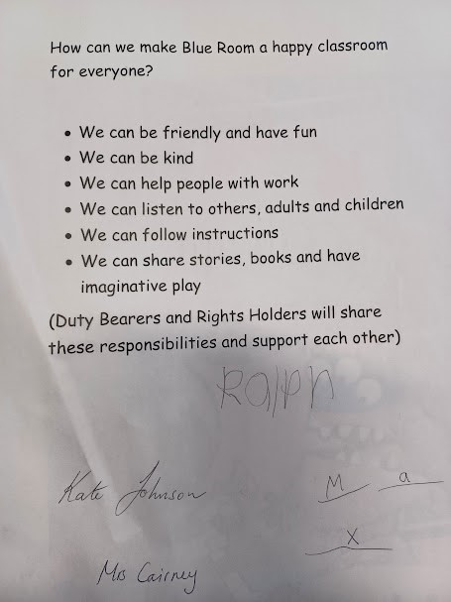 | 