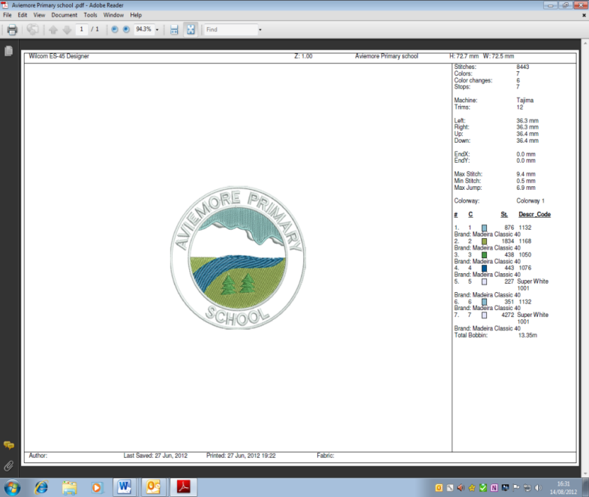**AVIEMORE PRIMARY SCHOOL/ELC NEWSLETTER**

***Vision:*** *Always Learning, Always Growing, Always Positive*

*ELC: Playing and Learning Together*

**Welcome back to school and nursery following the October break, we are looking forward to a busy term ahead!**

**Learning This Term**

This term the topic focus for all classes will be Science based and we will be learning about ‘Forces’ as well as lots of seasonal work on Bonfire Night, Remembrance Day and…Christmas!

For more details please see your child’s Termly Planner which also has other dates for your diary on the school website - [www.aviemoreprimary.co.uk](http://www.aviemoreprimary.co.uk) available from Friday 6th November.

**Staffing Update**

We are very sorry to be saying goodbye to Miss Nicola Beattie in a few weeks time. Nicola has been a PSA at Aviemore Primary School for 7 years and we have benefited hugely from her skills and experience, particularly those gained in her part time work as a Counsellor. Nicola leaves us to take up a full time position as a Counsellor working in secondary schools across the region.

**Nursery/ELC 1140 Update**

We are hoping to move to an 1140 hours provision at some point this term. We are waiting for the recruitment of two new posts to be able to do this and will keep you up to date.

**Blythswood Shoebox Appeal**

A reminder that shoeboxes should be handed in by Thursday 5th November. More information can be found online at https://blythswood.org/shoeboxappeal/ and the leaflet can be downloaded at https://blythswood.org/wp-content/uploads/2020/08/2020-SBA-checklist.pdf

**Outdoor Classroom Day**

Outdoor Classroom Day is on Thursday 5th November. This year due to Covid restrictions we will not be able to rotate classes and activities so we have decided that we will make this a shorter event. Children will spend one session of the day outdoors (either morning until break, break until lunch or the afternoon.) Please ensure your child is dressed appropriately in warm layers with a waterproof jacket.

**Parent/Carer Appointments**

We are due to have parent/carer meetings with teachers at the end of November. These had originally been scheduled for Thursday 28th November. However in the current climate it looks unlikely these will go ahead. We are awaiting further guidance from Highland Council as a decision may be made across the Local Authority on an alternative arrangement. However it is our plan to have some consultation with parents/carers this term. (Nursery meetings have already been arranged.)

**Children in Need**

The Children in Need national campaign this year focuses on Health and Wellbeing and in particular the ‘Five to Thrive’ which are: *Be active*, *Connect*, *Take Notice*, *Be Curious and Give*. See more details at bbc.co.uk/Pudsey

In school we will also focus on Health and Wellbeing culminating in a ‘Feel Good Friday’ where children can dress up for school and nursery in *‘something that makes me feel good’* and bring a donation of £1.

**Christmas performance – Born This Night**

At the moment in school, due to Covid, we are not allowed to sing or have visitors in school as you are aware. As we must anticipate that this will still be the case in December, this has made planning our Christmas performance challenging! However, we have devised an alternative performance which we hope you will enjoy. We will be preparing a Makaton Nativity, Born this Night, which tells the story of the first Christmas through Makaton songs which each class including Nursery will take part in and *sign rather than sing*! We will be filming this production and sharing on Google Classrooms on Friday 11th December. Your child’s teacher will let you know if and when they need to bring in a costume for filming day.

**Christmas Events**

***Christmas Lunch*** will be on Wednesday 9th December. It should be ordered in advance the week before. We will send more information out nearer the time. Lunch costs £2.30. Please make sure that we are aware of any allergies, particularly for children who do not usually have a school lunch.

***Christmas Jumper Day*** will be on Friday 11th December. We ask children to wear a festive jumper to school. No money is required this year – it is just for fun.

**Reminders**

* **Clothing –** Please ensure children have appropriate clothing now that we are into the winter months. At nursery in particular please make sure children have a change of clothes and that these are in a waterproof bag.
* **Allergies -** A reminder that we have some children in school with nut allergies, we would appreciate if you do not give your child nuts or nut products such as peanut butter as a snack/lunch for school.
* **Head Lice** – we continue to be aware that there are head lice in school. Please check your child’s hair thoroughly and treat appropriately. Please let us know if you need further advice.
* **Social distancing -** Thank you for adhering to social distancing guidelines at drop off and collection points at school. Please remember to stay 2 metres away from other adults and avoid gathering.
* **Parking** – please do not park in the school or nursery turning circles, these are for drop off only.

**Dates for your Diary**

**Nov**

4th Parent Council AGM

5th Outdoor Classroom Day

5th Last day for Shoeboxes to be handed in

13th Children in Need

28th Alternative Parent/Carer Consultations

**Dec**

9th School Christmas lunch

11th Christmas Performance Shared Digitally

11th Christmas Jumper Day

**School closes for the Christmas holidays on Tuesday 22nd December and reopens on Wednesday 6th January 2020**



***Our Values***

*Aviemore ELC*

*Values are…*

*Inclusion*

*Everyone works together*

*Making friendships*

*Opportunities to play and learn*

*Respecting everyone*

*Exploring new things*

***Our Values***

*Aviemore Primary*

*Values are:*

*Inclusion*

*Everyone learning and happy*

*Motivated*

*Open-minded*

*Respectful, resilient and responsible*

*Exploring new things*

Miss E MacCallum

Headteacher 30th October 2020