Aviemore Primary School
Planning the Outcomes of Learning – Termly Organiser
Session: 2021 - 2022 Class: Primary 1/2
Term: Autumn Topic: Rights, Equalities and Diversity – Everyone’s Welcome Teacher: Ms Millar
Skills: The explorers support us with skills: The Focussed Fox, The Curious Cat, The Ready Rabbit, Parker the Problem Solver, The Calm Horse, The Painter Penguin and more to be introduced.
Dates for the diary  August  16th In-service Day  17th School and nursery return  September  1st M&M Productions – Wizard of Oz  2nd Parent Council Meeting  13th and 14th In-service Day  13th but celebrated on 10th Roald Dahl Day  October  8th School and nursery close for October holidays.  Other dates such as Open events TBC depending on Covid guidance nearer the time.  This Autumn term P2 are going to have a mix of child led, adult initiated and adult directed experiences. We are going to be indoors and outdoors, spend time on our whole school shared topic and we are going to have time for our own projects and for play. We are going to be working in the garden every week too. | Literacy  Listening and Talking:  - active listening & turn taking games  - daily together time –calendar/news  Reading and Phonics:  - retelling stories using pictures  - simple phonics code  - letter and sounds recognition using songs/actions  - sounding out and blending  - simple punctuation  - choosing books  - tricky words  Writing:  - strategies for spelling – segmenting cvc words – ‘Hear it and say it! Stretch it and count it!’  - trying by ourselves, using our word wall and phonics charts to help us  - Talk for Writing – story maps  Handwriting:  - daily fine motor and letter formation activities  - shape and direction  - writing on the line (for some)  Numeracy and Mathematics  - counting songs – ordering and number recognition  - counting sets of objects, ordering numerals, subitising numbers/patterns and sequences  - grouping and place value  - addition and subtraction  - measure - time – learning days of the week, months of the year, daily routines  Health and Wellbeing  Emotional Literacy  - recognise, express and talk about our feelings  - daily check in and weekly circle time  - introduce the 8 wellbeing indicators SHANARRI  - Resilient Kids (P1)  - show respect for the rights of others  PE  - listening games  - follow rules and take turns  - movement and coordination  Food and Health  - tasting new things from our garden safely  - Harvest  - How do we know this is safe to eat?  - washing hands  - where food comes from  Planning for choices and change  - choosing activities by myself during play  - begin to talk about my interests, skills and abilities  Relationships  - what makes a good friend, sharing and caring link to our UNCRC topic  - High 5 strategies  Social Studies  - UNCRC Rights of the Child through stories such as ‘Elmer’ and ‘Everybody’s Welcome’ ‘Whoever you Are’  - same and different  - Our class charter  - Our playground charter  - The Global Goals for Sustainable Development  Science  - identify senses and use them to explore  - sun, moon and stars  Technology  - design and construct models  Expressive Arts  Art –collage Henri Matisse and Mark Hearld, sketchbooks and how to use them  Dance – expressing feelings  Drama - explore real and imaginary situations – Rights Respecting  Music - singing games and rhymes  RME  - Rights of the Child linked to stories the importance of rights respecting values: kindness, sharing, respect and fairness  - stories from Christianity and Buddhism  French  - greetings and introductions
P1/2 Class Charter

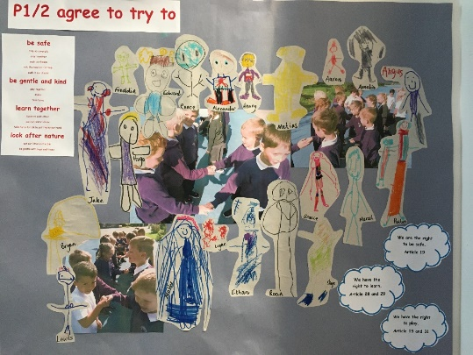

Opportunities for Personal Achievement
Weekly Assembly Celebration – class stars
Star of the week certificates
Sharing work on Google Classroom and wider achievement sharing
Class crystals
Star writer

