Aviemore Primary School
Planning the Outcomes of Learning – Termly Organiser
Session: 2019 - 2020 Class: P2/3
Term: 2 Topic: Enterprise Teacher: Mr Wilkins
Contribution to the Ethos and Life of the School as a Community  Nov  8th Assembly – Mrs McMaster  Termly Planner out  12th Flu Immunisation day  14th Parent Information Session 2-2.45pm  15th Children in Need  Assembly – Pupil Groups  20th Author visit (P4-7)  21st and 22nd – In-service Days  25th – 30th The Book People Book Fair  28th Parent Appointments  29th Assembly – St Andrew’s Day  30th Parent Council Christmas Fayre  Dec  4th Open Event – pm  5th Christmas lunch  6th Stage Assembly/Reflective  11th & 12th Christmas Concert  13th Christmas Jumper Day  Star Assembly  16th Christmas Party Week  19th House Treats  20th Carol Service 11.00-11.30  School closes for holidays    Jan  6th School re-opens  10th Assembly – Miss MacCallum  17th Assembly – Mrs McMaster | Literacy & English  Reading & Spelling:  - ORT books  - Regular comprehension checks  - Wraparound Spelling & Phonics with more work on digraphs and blends→ blending/segmenting words - stretching words  Listening & Talking:  - active listening & turn taking  - story times  - Presenting items of homework  - Asking and answering comprehension questions  Writing:  - Descriptive writing using, similes, metaphors, senses  - Poetry  - Parts of speech - Adjectives, adverbs  - Letter Writing  - Persuasive writing  - Upper and lower case letter and number formation  Numeracy & Mathematics  - Addition/subtraction within and beyond 100  - Mental strategies for simple problem solving  - money  - Shape – symmetry  Health & Wellbeing  - expressing emotions- check in  - our rights and our class charter  - road safety  - who to call in an emergency  - Physical Education: gymnastics  Social Studies  - Enterprise topic – learning about business – costings, price setting to allow for a profit – link to maths, art and design, technology  Science  - sun and moon – patterns of changes over time that effect seasons – length of days – daylight etc  Technology  - Simple coding with Sphero robots  - designing and making things for Enterprise topic  Expressive Arts  - drama: practice/ performing for Christmas production  - art: choose/design/create crafts for Enterprise topic  - music – songs for Christmas production  RME  - Celebrations in different cultures  - Christmas story  French  - Recap greetings  - days of the week  - numbers to 20  - colours  - weather  - Christmas traditions
Opportunities for Personal Achievement

Star of the Week, Star Assemblies, Playground certificates, Postcard home, Tidy Table Championship points, House Points

ASSEMBLY TIME ON FRIDAYS - 11.00am

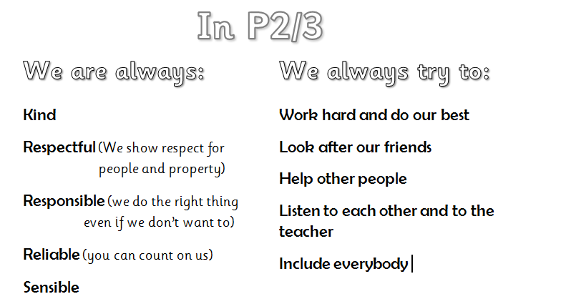
Class Charter

