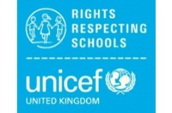
Aviemore Primary’s Right of the Fortnight
The Rights of the Fortnight and Global Goals for Term 1 (2020-21) are:

Week beginning 24th August 2020-
Article 12 - you have the right to give your opinion and for adults to listen and take it seriously.
Global Goal 16
(16.7: 'Ensure responsive, inclusive and participatory and representative decision making at all levels')

Week beginning 7th September 2020-
Article 39 - You have the right to help if you have been hurt, neglected or treated unfairly.
Global Goal 16
(16.1: 'significantly reduce all forms of violence and related death rates everywhere.')

Week beginning 21st September 2020 -
Article 24 - You have the right to the best health care possible, safe water to drink, nutritious food, a clean and safe environment and information to help you stay well.
Global Goal 3

