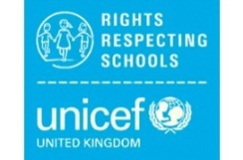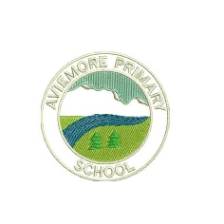**Aviemore Primary’s Right of the Fortnight**

Our Rights Respecting School Group – Aviemore Rights Champions – ARC have decided to have a *Right of the Fortnight*. This will be celebrated in assembly and can be seen as a discussion task on the Home Learning Grid.

The *Rights of the Fortnight* for Term 2 (2019-20) are:

**4th November –** Article 24

You have the right to the best health care possible, safe water to drink, nutritious food, a clean and safe environment, and information to help you stay well.

Links to Global Goal 3 - Good health and well-being

**18th November 2019 –** Article 27

You have the right to food, clothing, a safe place to live and to have your basic needs met.

Links to Global Goal 2 - No Hunger & 10 - Reduced inequality

**2nd December –** Article 32

You have the right to protection from work that harms you, and is bad for your health and education. If you work, you have the right to be safe and paid fairly.

Links to Global Goal 8 (Decent work and economic growth)