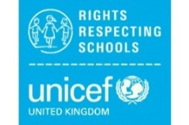
Aviemore Primary’s Right of the Fortnight
The Rights of the Fortnight and Global Goals for Term 2 (2020-21) are:
Week beginning 2nd November 2020-
Article 29 – Your education should help you use and develop your talents and abilities. It should also help you learn to live peacefully, protect the environment and respect other people.
Global Goal 4- Quality Education and Global Goal 13- Climate Action
Week beginning 16th November 2020-
Article 8 – You have the right to an identity-an official record of who you are. No-one should take this away from you.
Global Goal 5- Gender equality
Week beginning 30th November 2020 -
Article 23 –You have the right to special education and care if you have a disability as well as all the rights in this Convention, so that you can live a full life.
Global Goal 8- Decent work and economic growth
(8.5 By 2030, achieve full and productive employment and decent work for all women and men, including for young people and persons with disabilities, and equal pay for work of equal value.)

Week beginning 14th December 2020-
Article 30- You have the right to practice your own culture, language and religion-or any you choose. Minority and indigenous groups need special protection of this right.
Global Goal 10- Reduced inequalities

(10.2 By 2030, empower and promote the social, economic and political inclusion of all, irrespective of age, sex, disability, race, ethnicity, origin,
religion or economic or other status)

