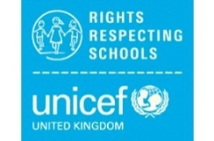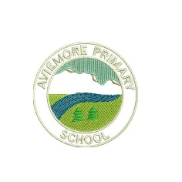**Aviemore Primary’s Right of the Fortnight**

I have tried to link Articles and Global Goals to the Malawi/Rivers topic

The *Rights of the Fortnight and Global Goals* for Term 4 (2021) are:

**Week beginning 26th April 2021**-

Article 2- All children have these rights, no matter who they are, where they live, what their parents do, what language they speak, what their religion is, whether they are a boy or girl, what their culture is, whether they have a disability, whether they are rich or poor. No child should be treated unfairly on any basis.

Global Goal 14- Life below water

**Week beginning 10th May 2021**-

Article 24- You have the right to the best healthcare possible, safe water to drink, nutritious food, a clean and safe environment, and information to help you stay well.

Global Goal 6- Clean water and sanitation

**Week beginning 24th May 2021**-

Article 27- You have the right to food, clothing, a safe place to live and to have your basic needs met. You should not be disadvantaged so that you can’t do many of the things other kids can do.

Global Goal 1- No poverty

**Week beginning 7th June 2021-**

Article 28- You have the right to a good quality education. You should be encouraged to go to school to the highest level you can.

Global Goal 4- Quality Education

**Week beginning 21st June March 2021-**

Article 7-You have the right to a name, and this should be officially recognized by a government. You have the right to a nationality (to belong to a country).

Global goal 15- Life on land