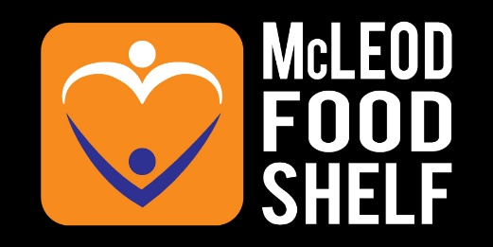
Carrie Opheim
www.mcleodemergencyfoodshelf.org | 719 13th St E GLencoe MN 55336
2025 ANNUAL REPORT
January 1 - December 31, 2025

Mission
Mcleod Emergency Food Shelf is committed to eliminating hunger and food insecurity as well as improving the health and well-being of our community through equitable access to healthy and nutritious foods, community education, and advocacy.

Vision
We envision a community where everyone has access to good quality nutritious food, understands the consequences of hunger and poor nutrition, and is committed to creating a stronger, healthier community.

We also recognize the dignity of all people and believe food is an essential need.

GUIDING PRINCIPLES
We are responsible and accountable to the respectful, effective, and efficient avenues of food procurement and distribution.

We incorporate a dignified and client-centered model where nutrition, health, and education opportunities are shared.

We believe innovation and community collaboration is essential to support initiatives and meet challenges.

SERVICE AREA
McLeod Emergency Food Shelf (MEFS) serves the general McLeod County area which includes the primary cities of Glencoe, Hutchinson, Brownton, Stewart, Silver Lake, Lester Prairie, Winsted, and Plato.

In accordance with The Emergency Food Assistance Program (TEFAP) requirement, any individual requesting support and physically present, or represented by proxy, at either distribution site or mobile location, shall be served.

LEADERSHIP

2025 Board of Directors
Peter Hallberg, President
Barbara Jenneke, Vice President
Jeff Albers, Treasurer
Marilyn Dunbar, Secretary
Jerilyn Shearer
Melissa Sanchez
Ryan Hansch
Scott Trebesch
Rev. Erik Karlson
Wendy Broderson

2025 Staff
Carrie Opheim, Executive Director & Glencoe Site Manager
Tiffany Waller, Hutchinson Site Manager
Shelly Cardinal, Glencoe Site Assistant
Ryan Toups, Hutchinson Site Assistant
Catherine Kraemer, MOP Program Manager
Shiloh Schnabel, MOP Program Manager

2025 Volunteer Support
mission and work of MFS wouldn’t be possible without the selfless commitment of volunteers. According to the Independent Sector, the 2025 value of volunteer service per hour was $34.79, making our total volunteer contribution $350,161.35 worth of service. MFS volunteers are essential to client support, food logistics, food rescue, and special events and projects.

88 Regularly scheduled volunteers



10,065 Documented hours of service

MFS is also host to various short-term project volunteers for school, employee engagement, and church service hours as well as community service and Sentence-to-Serve volunteers. Both on-site locations also partner with Central Minnesota Jobs & Training as employment experience stations. Nearly one-quarter of the years volunteer service fits within these categories.

PROGRAM description & objectives

On-Site Client-Choice Grocery Distribution in Glencoe & Hutchinson
The primary program function of MEFS is to provide a variety of well-balanced food options – at no charge! The variety of foods available are in accordance with SuperShelf standards and are supported through robust food rescue partnerships with local grocers. In 2025, each household was welcome once per month for full grocery access as well as additional weekly, fresh produce-only distributions.

Mobile Outreach Program - Driving Away Hunger (MOP)
MOP provides the same quality and service as the On-Site Client Choice Distribution program while addressing transportation and mobility issues by bringing stocked shelves and coolers to designated locations throughout McLeod County. Cities served are Hutchinson, Winsted, Lester Prairie, Silver Lake, Brownton, and Stewart. MOP parked at designated locations up to two times per month, offering groceries and fresh produce much like the On-site SuperShelf model.

Nutrition Assistance Program for Senior (NAPS)*
NAPS Distribution Site (Glencoe Site only). NAPS boxes are distributed Wednesdays following the 1st Tuesday of every month. Commodity Food Supplemental Program (CFSP) Authorized program for persons age 60+ who meet income requirements. All program requirements must be met to receive a box.

*NAPS boxes are not included in budgeted income or expenses as MEFS serves only as a distribution site for this program. Pounds/Meals through this program are not totalled by MFS.

2025 Distribution Statistics


This Photo by Unknown Author is licensed under CC BY-SA-NC
- In total, 771,025 pounds were distributed throughout 2025, providing ingredients and prepared foods for 569,354 meals
- 6,095 distinct individuals (Unduplicated) were served. 1814 individuals were under 18, 3587 were between 18-64, and 691 were over the age of 65. Special referrals to our shelves increased by 32% in 2025.
- Shoppers indicated “Low-income” and accessing weekly produce pickups as the top two reasons for utilizing our service.

Service by Age

Top 2 Distribution Reasons:
Low Income
Produce Only Pick-up

771,072* Pounds Distributed
569,354 Meals* Provided
*(1.3 lbs=1 meal)

*Migrant individuals living in independent housing within McLeod County are included in the On-site Grocery Distribution totals.

2025 Donation Summary

In partnership with the Feeding America Food Rescue Program, eight (8) community grocers across the county coordinate with MFS. This coordination supported a robust food rescue program where more than 435,000 pounds of food were gleaned through by grocery staff, transported to MFS distribution sites, and safely entered the MFS food stream for re-distribution. In 2025, 74% of food donated to MFS was a direct result of these rescue efforts.

Without the daily support of grocery store staff and MFS volunteer drivers, the food rescue program would not exist, and fresh varied options found on MFS shelves would be extremely limited. MFS Retail Rescue partners include:
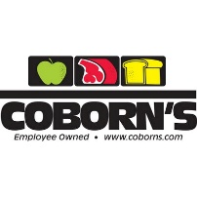
This Photo by Unknown Author is licensed under CC BY-SA-NC
OUTSTANDING OUTCOMES & SIGNIFICANT EVENTS of 2025
The year 2025 brought remarkable growth, meaningful improvements, and an outpouring of community support for McLeod Food Shelf. One of the highlights of the year was the Annual “Empty Bowls” fundraiser hosted each spring by Minnesota Pottery Festival. This beloved community event raised $3,810 in support of our mission to fight food insecurity throughout McLeod County. The continued support from local artists, volunteers, sponsors, and attendees made this event another tremendous success and a reminder of the strength of our community partnerships.
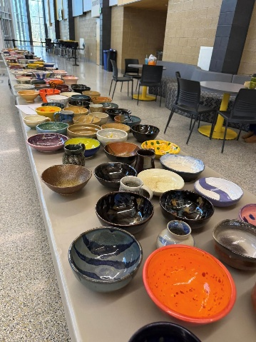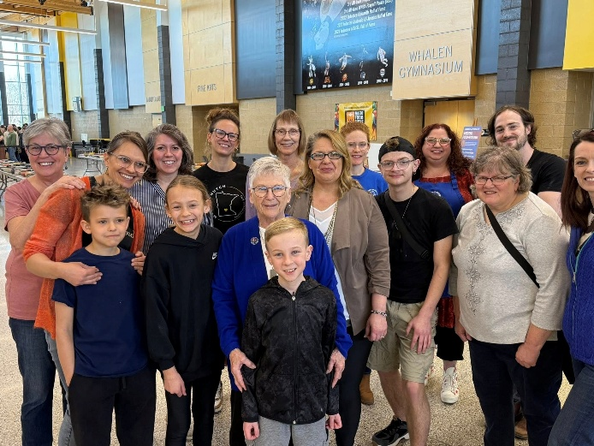

As summer began, we completed several long-overdue facility improvements at our Glencoe distribution site, including a full roof replacement and major electrical upgrades. These important investments helped ensure the safety, functionality, and long-term sustainability of our operations as the demand for services continues to grow. In addition, thanks to the generosity of our local Lions Clubs, new AED equipment was installed at both of our distribution sites, helping us better prepare for medical emergencies and further improving the safety of our spaces for volunteers, staff, and guests alike.

Throughout the year, we also focused on improving the shopping experience for the individuals and families we serve. A dedicated volunteer constructed beautiful new produce fixtures for both sites, helping create a more welcoming and accessible environment. With the incredible support of volunteers from McLeod for Tomorrow, we revitalized our Glencoe shopping area to better reflect a traditional grocery store experience. These updates support dignity-centered service by allowing guests to shop independently and comfortably, just as they would in any local grocery store.

Community support continued strong into the fall during the annual Hutchinson Area Youth food drive. This outstanding effort brought in an incredible 15,655 pounds of food to support local families facing food insecurity. The dedication shown by area youth, volunteers, schools, churches, and community members continues to make this event one of the most impactful food drives of the year and a critical source of support as demand rises heading into the winter months.

The second half of 2025 brought a dramatic increase in need across our communities. During the final six months of the year, we served nearly 4,000 more individuals than we did during the first half of the year alone. Despite this significant increase in demand, our team remained committed to maintaining distributions above state averages for pounds of food distributed per person while also keeping operational costs below state averages. This balance of efficiency and impact reflects the dedication of our staff, volunteers, and supporters who work tirelessly every day to ensure no neighbor goes hungry.

As we closed out the year, we also dedicated time and energy toward strengthening our internal training programs and operational procedures. By investing in volunteer and staff development now, we are positioning ourselves for an even stronger and more successful 2026 as we continue adapting to the evolving needs of our communities.

FUNCTIONAL EXPENSE ALLOCATION

McLeod Food Shelf remains committed to maximizing the impact of every dollar donated. In the past year, 95% of expenses were directed toward program services, ensuring food and essential support reached individuals and families in need throughout our community. Management and administrative expenses accounted for just 4% of the budget, while fundraising expenses remained exceptionally low at only 1%, reflecting our dedication to operating efficiently and responsibly.

