FOCUS ON THE POSITIVE

PERSONAL JOURNEY

Autistic son inspires mother to create farm

Gala in August to raise awareness and funds for residential facility.

By Beth Anspach

Contributing Writer

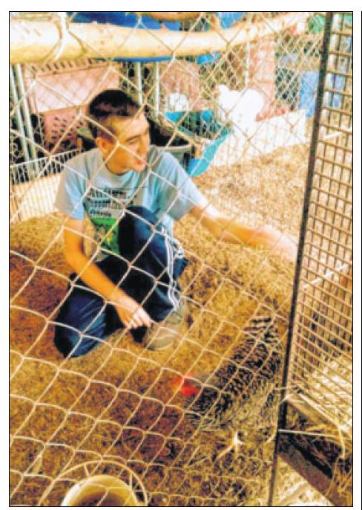

Sam Bernotaitis feeds the chickens at Elliott Stables in Germantown, where he also takes therapy sessions.

AUTISM SPEAKS SURVEY REVEALS HOUSING DESIRES

The Autism Speaks National Housing and Residential Supports Survey of 2012 reports that 35 percent of autistic adults will need 24-hour support and 58 percent will need support in walking safely outdoors. Of respondents who are on the autism spectrum, 37 percent want to live in their own home and 58 percent want their own home with a roommate. Of those who wanted a roommate 25 percent preferred to live with someone who had a disability. Only 22 percent want to live in their family home. Almost 30 percent choose a planned community as their top home type and almost 20 percent want to live in a rural or farm community.

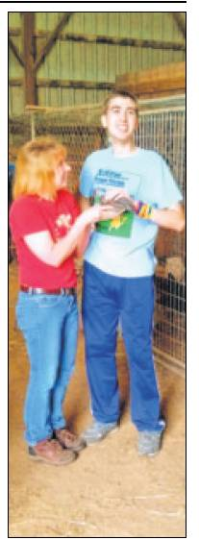

Sam Bernotaitis, right, with Gretta Miles, manager of Elliott Stables. Bernotaitis has been helped by his farm experiences and this has inspired his mother to create “Good Works Farm” a residential farm for autistic adults.

Children with autism grow up to become adults with autism. And according to recent statistics, approximately 3.5 million people with intellectual and developmental disabilities currently live with a family caregiver.

Nancy Bernotaitis’ son Sam was born in 1997 as a “blue baby,” and had problems from the start.

“Sam was late to talk and walk,” Bernotaitis said. “It became evident at about age 2 that he wasn’t doing the things my older two children did at the same age.”

It wasn’t until Sam was 4, however, that he was diagnosed with autism. Bernotaitis was relieved because she could finally get support and services.

“We began pursuing the usual interventions of speech, physical and occupational therapy for Sam,” Bernotaitis said. “In 2006 we started working with supplementation and diet and he made some great strides.”

Now 16, Sam is doing “quite well,” according to his mother, but she knows he will never be able to hold a job or live independently.

“He will always need one-on-one support,” she said.

Once Bernotaitis knew her son would need full-time care for life, she started researching options for him.

“I have always tried to be proactive,” she said. “I didn’t want my older children to have the responsibility for Sam so I looked into group homes, but I just didn’t feel those were a good fit for him. So I kept searching.”

Bernotaitis discovered a residential farm for adults with autism, the first of its kind in the United States, located in northern Ohio.

“I instantly fell in love after I took a tour,” she said. “It sounded amazing and exactly what I wanted for Sam.”

But the farm has a “lifespan” model and therefore would have no openings until a resident passed away.

“I knew Sam would never get in,” Bernotaitis said.

Undaunted, she kept searching and did find another farm near Middletown but it, too, had a long waiting list, even before the groundbreaking had begun.

“I was praying about it and at the same time feeling completely overwhelmed,” Bernotaitis said. “I just kept feeling the push in that direction.”

Then a Bible verse from Ephesians came to mind and Bernotaitis was reminded about how everyone was called to do “good works.”

In August of 2012, she began the process for the creation of “Good Works Farm,” which has a mission to provide an environment where adults with autism can learn, work, grow and become vital members of a community and where they are respected and treated with dignity.

“In February of 2014 we got our nonprofit approval from the IRS,” Bernotaitis said. “Then we hit the ground running with our board and committees.”

Today there are 30 people involved in the project, which has not yet broken ground and is still in the five-year planning stage.

“Our only stipulation is that the farm must be located somewhere in Ohio,” Bernotaitis said. “Almost 80 percent of the people involved have autistic children and the rest just have a passion for the cause.”

The group will host its first major fundraiser, “Gala for Good Works,” Aug. 9 at the Presidential Banquet Center in Kettering. With a need estimated at $5 to 6 million, Bernotaitis said this event will be the first of many.

“Once we are open, we will be a residential farm for anyone aged 18 and older with an autism spectrum diagnosis,” she said. “We will also offer day programs for adults with autism and summer camps for special needs children, as well as any children who want a fun farm experience.”

The Gala is a business casual event featuring heavy appetizers and a cash bar as well as live and silent auctions and a cover band. “We have an attendance goal of 200 and a fundraising goal of $10,000 for this event,” Bernotaitis said.

The next major fund-raiser to support “Good Works Farm” will be a Kentucky Derby themed party to be held at Elliott Stables in Germantown, where Sam goes for equine therapy.

“Sam has been going (to equine therapy) for two years,” Bernotaitis said. “He is now so excited to be there, which has been a 180-degree change for him. He understands he has to be careful around the horses and he knows some of the rules. He hasn’t ridden the horses yet, but it’s a goal. He loves his school and friends and is making progress.”

For more information about Good Works Farm and the Gala, visit www.goodworksfarm. org.

Contact this contributing writer at banspach@ymail.com.