Will Government Limit a Spectrum of Housing Options for Autism?
By Nancy Bernotaitis
As is typical of our government, a ruling meant to protect Americans with disabilities (Olmstead v. L.C. 1999) is being misconstrued to the detriment of this population. In Olmstead v. L.C., a ruling requires states to “eliminate unnecessary segregation of persons with disabilities and to ensure that persons with disabilities receive services in the most integrated setting appropriate for their needs.”
In 2009, President Obama issued a proclamation launching the “Year of Community Living” and directed his Administration to redouble enforcement efforts.
The U.S. Senate committee on Health, Education, Labor, & Pensions (HELP) lead by Senator Tom Harkin (D-IA) is charged with this enforcement.
In May of 2013, Jeff Rosen, Chairperson of the National Council on Disability (NCD), an independent federal agency charged with advising Congress and the executive branch on disability policy, wrote a letter to Shaun Donovan, Secretary of the U.S. Department of Housing and Urban Development (HUD), interpreted the ruling to mean that individuals with disabilities move from provider-owned housing into their own homes or scattered-site housing and apartments, and urged HUD to issue “guidance to recipients of HUD funds on meeting the obligations of Olmstead and the integration mandate of the ADA.” In his letter, Mr. Rosen seeks to define community living as “utilizing a definition that excludes gated communities, segregated farmsteads, clusters of group homes, settings that restrict personal choice and control, and other settings with the characteristics of an institution.”
The actual ruling, when construed correctly, is meant to keep individuals with disabilities out of 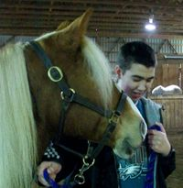nursing home facilities and institutional settings and placed in appropriate settings with appropriate supports. By creating that definition of community living, the NCD is reducing options for appropriate housing while the disability numbers are skyrocketing. There simply aren’t enough appropriate housing options or community supports to meet the needs.
The Agricultural Communities for Adults with Autism (ACAA) represents 35 existing or developing farmstead and community living options for adults with autism. In March of 2013, they wrote a response to Mr. Rosen’s letter to HUD recognizing that the NCD is an advisory, rather than regulatory, body and challenging the NCD’s knowledge of their living models. In their letter, they “strongly encourage HUD to reject the NCD’s request to issue rigid guidelines that limit (or eliminate) HUD program funding for agricultural or intentional communities and farmsteads for adults with autism and other developmental disabilities. Our closure would likely result in more of the very same institutional or congregate care placement the NCD claims to abhor.”
I, as the Executive Director of Good Works Farm, a farmstead community for adults with autism currently in development, also responded to Jeff Rosen:
Dear Mr. Rosen,
As the parent of a 15 year-old with autism, I am painfully aware of the challenges our children face as they enter adulthood, not the least of which is finding appropriate housing and employment. Your letter to HUD urging the elimination of farmstead communities shows your complete and utter lack of understanding of the needs of this population. Do you even have a child with autism? I seriously doubt it because we need more choices, not less!
Take my son, Sam, for instance. Sam goes to Equine therapy every Tuesday after school. At the barn, he is calm, relaxed, happy, a sharp contrast to the constant anxiety he lives with which causes him to tear off his own fingernails and toenails.
Why do you see a farmstead community as institutionalization? It's the least restrictive option I've come across. If my son lives into his adulthood with us, as 70% of autistic adults do according to research conducted by Autism Speaks, he will self-isolate, meaning, he will do what he does now with his down time, sit on the sofa with a movie and iPad. If placed in day programs, he would need transportation to-from these locations and transition is a huge struggle for Sam. His anxiety over transitions caused him to kick out three windshields on our vehicles last summer. The less he has to transition from environment to environment, the better!
I have worked for Goodwill/Easter Seals and have been in group homes and sheltered workshops. While they may be a good fit for some, they would definitely not be a good fit for my son. If there are 4 people in the residential home and 3 want to go on an outing but the 4th does not, nobody goes. There are few options for recreation on-site so they have to travel to participate in anything. It is very confining and constricting. Not to mention the increased risk of provider burn-out and abuse as a result of the isolation. And since nobody wants a special needs home in their community, these houses are often located in the most impoverished areas of the city. Not a place I would like my son to live. Do you want your child there?
Have you even been out to visit Bittersweet Farms or any of the other farmsteads? I doubt it, because if you did, you would see residents with the freedom to move around the property, visit friends in other houses, pursue their individuals interest, socialize, and have meaningful work ON-SITE. Does this mean they do not interact with the community? NO! On the contrary, they are often in town banking, shopping, engaging with the community, attending festivals, movies, bowling, and LIVING LIFE.
A farmstead is NOT an institutional setting, it is FREEDOM for individuals like Sam who need a balance between structure, safety, and freedom. A group home would not provide this balance. Interpreting the Olmstead act to include farmstead communities like Bittersweet is a mistake and one that will severely impact the autism community. Another 500,000 children with autism will be coming of age in the next 8-10 years. Do you really believe that limiting choices is the right way to handle the influx? Do you really think that one size fits all when it comes to individuals with autism? If so, that really shows your ignorance regarding this population. YOU are segregating and isolating them by not giving them a choice. If the farmstead model is wrong, why are so many families looking for this option for their child? WE know our children best. And I know that Sam would flourish in a farm community. Please reconsider your stance on the issue and educate yourself before making recommendations for a population you clearly do not respect or comprehend.
Sincerely,
Nancy Bernotaitis
Mr. Rosen’s response:
Dear Nancy -
Thank you for taking the time to write and describe what the farm residential community means for your son Sam and others. We at NCD have visited a variety of residential settings are always open to educating ourselves further about the experiences of people with disabilities and their families.
I wish the best for Sam and you.
-Jeff
A canned and empty response.
In July, 2013, Senator Harkin released a report entitled “Separate and Unequal: States Fail to Fulfill the Community Living Promise of the Americans with Disabilities Act”. This report shows that 14 years later “ADA’s promise of integration is not being met for many Americans with Disabilities.” It is estimated that a quarter of a million working-age Americans remain in nursing homes today and that number is growing. The report cites that home and community-based care is what people want and is more cost-effective. We don’t disagree. What we take issue with is the definition of “community-based care.” It is our belief that more choices, not less, is what was intended by Olmstead v. L.C. and those who are making the decisions to eliminate choice goes against what the American with Disabilities Act stands for.
Mark Olson from LTO Ventures, one of those intentional communities for adults with autism responded in this way:
Senator Harkin is a great advocate for the disabled, but in this report he is wrong. Wrong about what Olmstead means. Wrong about what many disabled people and their caregivers want. Olmstead is about choice. Harkin’s report is about eliminating choice – “…for virtually all people with disabilities, the most appropriate integrated setting is their own home.” This simply is not true for all persons with disabilities. The most appropriate integrated setting is the setting a person with a disability freely chooses from the broadest spectrum of options. Period. This is what Olmstead concluded, and this is what federal and state policy should support. A person with a disability who is eligible for LTSS should be able to use those funds wherever the person chooses. Justification for funding and quality of life and quality of care has nothing to do with the setting…it has everything to do with the civil right of the person to choose their setting and how the setting is supported and operated. Persons with disabilities can be just as isolated living alone in their own homes and victimized just as frequently (with no oversight or protections) as in any other setting. An individual apartment or home can have all the qualities of an “institution” as a badly-run state facility in Georgia. “Community” is what the disabled person decides for himself or herself, not what CMS or NCD or DoJ decide. Even worse, “scattered-site” housing is discrimination…pure and simple. Segregating disabled persons from each other with separation rules and denial of funding is cruel and un-American. Congressional hearings should be held to avoid the fast-tracking of Harkin’s recommendations, to give the broader population of disabled persons an opportunity to express their desires for choice, and to open the minds of federal and state agencies to achieve a fair outcome for all persons with disabilities.
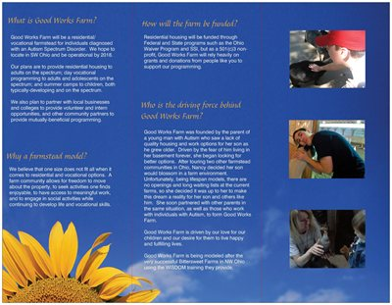
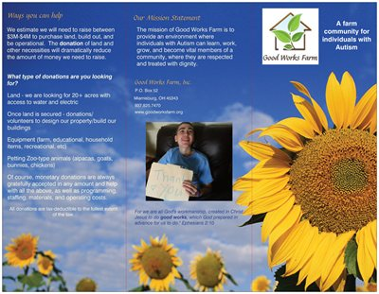
So it seems, while there is a contentious divide on the definition of community living and what it looks like when implemented, it seems we ALL want the same thing: safe, high-quality housing and lifespan services for individuals with disabilities. Mark Olson is right. More choices and the opportunity to choose is what Olmstead v. L.C. is about and what the HELP committee should be focused on. If Harkin’s recommendations are implemented as they stand, less individuals with disabilities will have an opportunity to live in the “most integrated setting appropriate for their needs”.
Nancy Bernotaitis is the parent of three children, her youngest, 15, diagnosed on the autism spectrum. Nancy has been involved in the autism community for over 13 years serving as president of the Autism Society of America-Dayton Chapter, Goodwill/Easter Seals Assistive Technology Specialist, and webinar moderator for Moms Fighting Autism. She is the Executive Director of Good Works Farm, Inc., a future farm community for adults with autism where she intends for her son and other with autism to live meaningful, happy, and fulfilling lives.
Posted by Age of Autism at July 31, 2013 at 5:45 AM in Current Affairs | Permalink | Comments (2)

