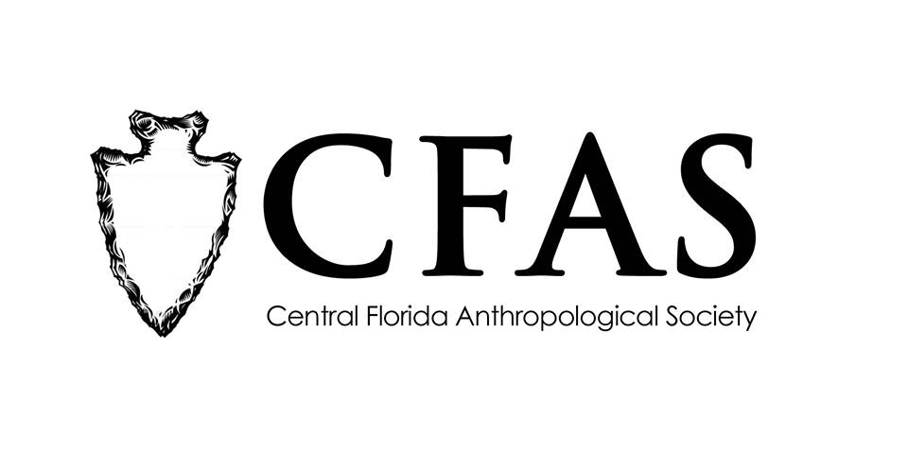

Central Florida Anthropological Society
General Meeting
April 16, 2018
Minutes

At approximately 7:00pm, Katherine Navarro called the meeting to order. Approximately 22 people were in attendance at the meeting.

Navarro began the meeting by welcoming everyone, both CFAS members and guests.
She then introduced the featured guest speaker of the evening, Dr. Edward Gonzalez-Tennant. He is a visiting professor at the University of Central Florida and spoke about the research project that led to the publication of his latest work with the University Presses of Florida, a book entitled "The Rosewood Massacre: An Archaeology and History of Intersectional Violence." Gonzalez-Tennant answered several questions about the site including on going field work, how relationships with private land owners make his work possible, and that the state recently approved a grant which will fund additional fieldwork in Rosewood. He also let everyone know that he arranged a special discount code with the UPF for anyone attending the meeting to receive a very generous discount. At the conclusion of his presentation, Navarro thanked everyone for coming.

CFAS officers Katherine Navarro, president, and Deborah Bauer, secretary, were in attendance.

The meeting was then adjourned at approximately 8:20pm.

Respectfully submitted on May 8, 2018,
Deborah Bauer
Secretary
Central Florida Anthropological Society

