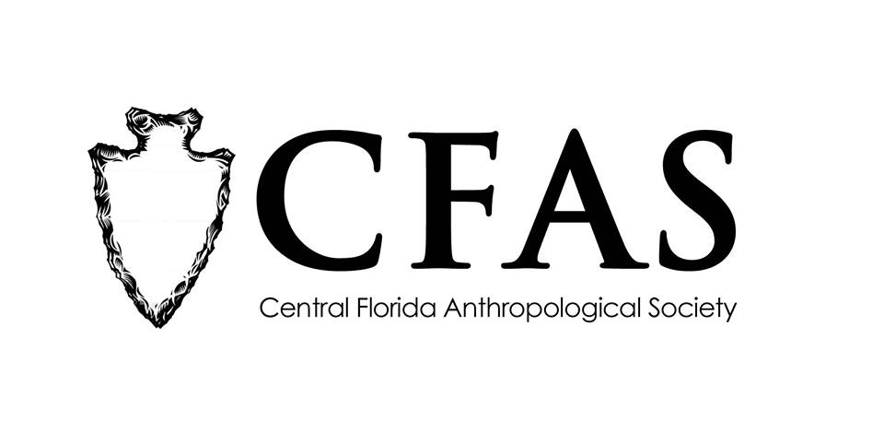

**Central Florida Anthropological Society**

**General Meeting**

**February 19, 2018**

**Minutes**

At approximately 7:02pm, Deborah Bauer called the meeting to order. Approximately 26 people were in attendance at the meeting.

Bauer began the meeting by welcoming everyone, both CFAS members and guests. She then welcomed everyone after the meeting break in January. The January meeting was cancelled because of the Dr. Martin Luther King Day, Jr. holiday.

Bauer then made several announcements. She reminded everyone that the Florida Anthropological Society was being held in St. Petersburg this year from May 7-9, 2018. CFAS is sponsoring an FAS registration scholarship for two CFAS students who get papers or poster presentations accepted for the 2018 meeting. Applications are due no later than April 1, 2018. Bauer also reminded everyone that March is Florida Archaeology Month and that more details about statewide planned events would be released via Facebook.

Bauer then introduced the featured guest speaker of the evening, Dr. Tosha Dupras, a professor from and chair of the Department of Anthropology at the University of Central Florida in Orlando. Dupras gave a presentation entitled “"The Mysterious Land of the Blow: Exploring the Bioarchaeology of Ancient Nubia on Sai Island, Sudan." Dupras answered several questions about the status of burials on Sai Island which included components that dated from pagan, Christian, and Islamic burial traditions. At the conclusion of Dupras’s presentation, Bauer thanked everyone for coming.

CFAS officers Katherine Navarro, president, and Deborah Bauer, secretary, were in attendance.

The meeting was then adjourned at approximately 8:10pm.

Respectfully submitted on March 19, 2018,

Deborah Bauer

Secretary

Central Florida Anthropological Society