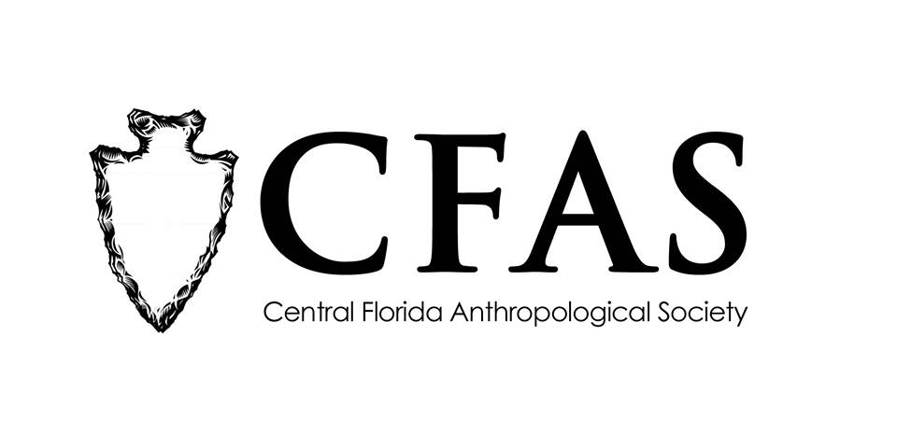

**Central Florida Anthropological Society**

**General Meeting**

**June 15, 2917**

**Minutes**

At approximately 7:00pm, Deborah Bauer called the meeting to order. Approximately 14 people were in attendance in the Multipurpose Room at the Winter Park Towers in Winter Park, Florida.

Bauer began the meeting by making several announcements. She reminded everyone that the night’s guest speaker would be the final presentation before CFAS’s annual summer recess. CFAS will not meet during the months of July and August. September’s speaker will be announced on the CFAS Facebook page. Bauer also reminded members to not send any correspondence to CFAS to the old PO Box address in Maitland. They are in the process of getting a new one in Orlando and the old address is no longer a valid one. They will be announcing the new mailing address for CFAS soon. Bauer also announced that she will be sending out membership renewal letters to current CFAS members over the summer break and thanked everyone who had already sent in their annual dues.

Bauer introduced Mr. Sean Norman of the Gulf Archaeology Research Institute (GARI). Norman gave a presentation entitled "The Tomoka Archaeology Project." A few questions were asked with an emphasis on the damage that was done to the Native American mounds at Tomoka State Park when Hurricane Matthew hit in October 2016.

At the conclusion of Norman’s presentation, Katherine Navarro thanked him for his informative presentation.

CFAS officers Katherine Navarro, president, Deborah Bauer, secretary, and Shari Arnold, membership chair, were in attendance.

The meeting was then adjourned at approximately 8:15pm.

Respectfully submitted on June 19, 2017,

Deborah Bauer

Secretary

Central Florida Anthropological Society