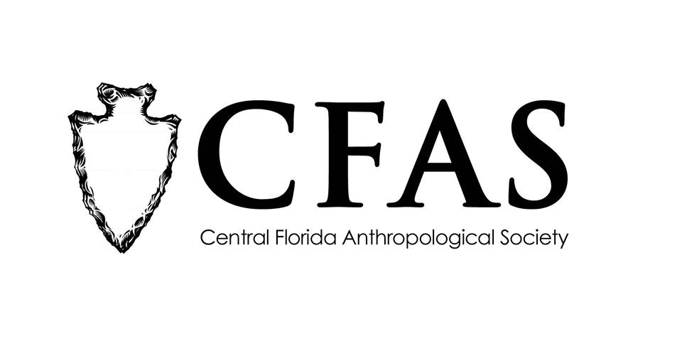

Central Florida Anthropological Society
General Meeting
December 18, 2017
Minutes

At approximately 7:01pm, Katherine Navarro called the meeting to order. Approximately 5 people were in attendance at the meeting.

Navarro began the meeting by welcoming everyone, both CFAS members and guests. She then reminded everyone there would be no meeting in January because of the Dr. Martin Luther King Day, Jr. holiday.

Navarro then turned the floor over to Vice President Caitlin Sawyer. Sawyer then introduced the featured guest speaker of the evening, Dr. John Starbuck, a professor from the University of Central Florida in Orlando. Starbuck gave a presentation entitled “Trisomy 21 and Gene-Dosage Imbalance: An Investigation of the Ameliorative Effects of EGCG on Animal Models and Human Faces Using 35 Imagery and Morphometric Approaches.” At the conclusion of Starbuck’s presentation, Navarro thanked everyone for coming.

CFAS officers Katherine Navarro, president, Caitlin Sawyer, vice president, and Deborah Bauer, secretary, were in attendance.

The meeting was then adjourned at approximately 7:45pm.

Respectfully submitted on January 15, 2018,
Deborah Bauer
Secretary
Central Florida Anthropological Society

