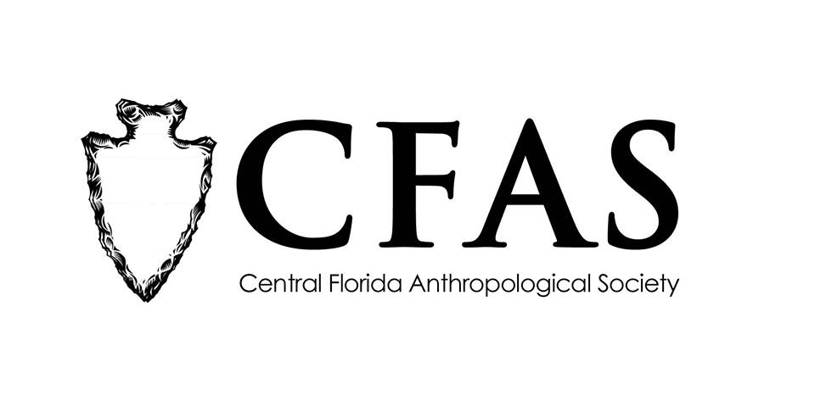

**Central Florida Anthropological Society**

**General Meeting**

**May 18, 2017**

**Minutes**

At approximately 6:57pm, Caitlyn Sawyer called the meeting to order. Approximately 16 people were in attendance in the Multipurpose Room at the Winter Park Towers in Winter Park, Florida.

Sawyer introduced  Dr. Gay Biery-Hamilton of Rollins College. Biery-Hamilton gave a presentation entitled "Swidden Horticulture." A few questions were asked with an emphasis on Dr. Biery-Hamilton’s opinions on how native peoples who live in Brazil are treated by the Brazilian government.

At the conclusion of Biery-Hamilton’s presentation, Katherine Navarro thanked her for her informative presentation. Navarro also reminded people that the June presentation would be the final one before the annual summer recess. She also encouraged members to complete the membership renewal applications and to return them to any of the officers on the board at their convenience.

CFAS officers Katherine Navarro, president, Caitlyn Sawyer, vice president, and Deborah Bauer, secretary were in attendance.

The meeting was then adjourned at approximately 7:50pm.

Respectfully submitted on June 14, 2017.

Deborah Bauer

Secretary

Central Florida Anthropological Society