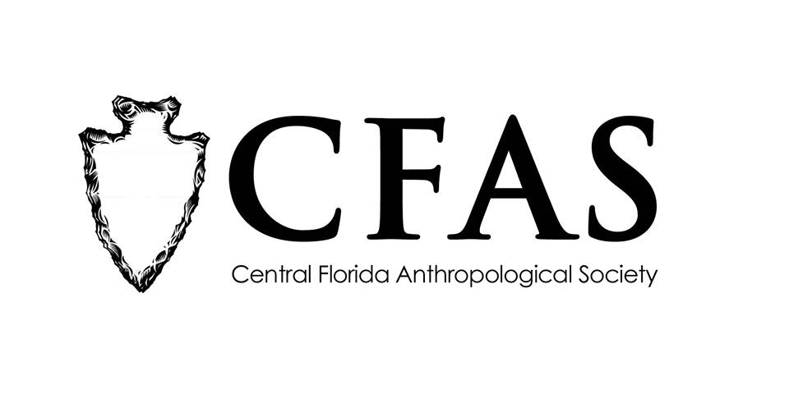

Central Florida Anthropological Society
General Meeting
May 21, 2018
Minutes

At approximately 7:01pm, Deborah Bauer called the meeting to order. Approximately 22 people were in attendance at the meeting with two guests from Archaeology in Central Florida Meetup group.

Bauer began the meeting by welcoming everyone, both CFAS members and guests.
She then made several announcements over the next ten minutes with a Powerpoint to illustrate the announcements details. She announced the CFAS had been contacted with a volunteer opportunity for June 16th in New Smyrna Beach, FL (Volusia County). In honor of commemorating the city’s 250th anniversary of its founding, three booths need volunteers to man Public Archaeology outreach displays. No experience is necessary. Two 4-hour shifts are available, one in the morning and one in the afternoon. Volunteers will be able to choose if they want to work at the 18th, 19th, or 20th century tables. Bauer then shared a recap of the annual meeting of the Florida Anthropological Society that was held in St. Petersburg from May 7-9, 2018. Dr. J. Michael Francis gave the keynote address about a new resource that is available to the public via the internet http://www.laflorida.org/. It launched in March 2018 and new content is constantly being added. The website is dedicated toward preserving and disseminating primary source documents about Florida’s colonial past. The 2019 meeting will be held in Crystal River, Florida. CFAS would like to see more of its members attend and present at FAS (undergrad and grad students). Last, Bauer announced CFAS’s June presentation speaker is TBA. It will be the last meeting of the 2017-2018 academic year.

Bauer then turned the floor over to Katherine Navarro. She then introduced the featured guest speaker of the evening, Mr. Nathan R. Lawes, a doctoral student in the Department of Anthropology at the University of Florida in Gainesville. Lawes gave a presentation entitled “The Belle Glade Monumental Landscape: Ontological Materializations of Monumental Proportions.” At the conclusion of Lawes’ presentation, Navarro thanked everyone for coming.

CFAS officers Katherine Navarro, president, and Deborah Bauer, secretary, were in attendance.

The meeting was then adjourned at approximately 8:20pm.

Respectfully submitted on June 18, 2018,
Deborah Bauer
Secretary
Central Florida Anthropological Society

