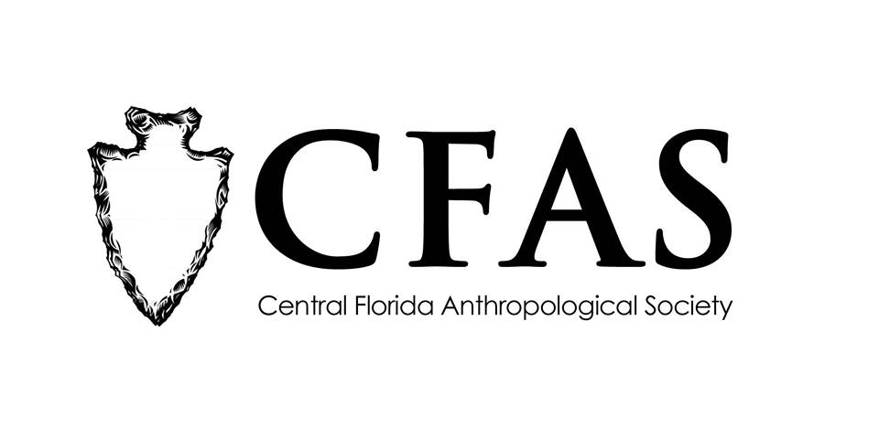

Central Florida Anthropological Society
General Meeting
November 20, 2017
Minutes

At approximately 7:03pm, Katherine Navarro called the meeting to order. Approximately 28 people were in attendance at the meeting.

Navarro began the meeting by welcoming everyone, both CFAS members and guests. She then turned the floor over to Deborah Bauer. Bauer made several announcements. She announced a cookie/dessert exchange would be held at the December 2017 meeting in lieu of the potlock dinner that had been hosted in past years. She promised more information about the cookie exchange would be forthcoming shortly. Bauer reminded people that updated/revised membership forms were available on the back table for new people who were considering joining CFAS for the first time or for people who are planning to renew their membership for the 2018 calendar year. Bauer also reminded everyone that CFAS is conducting a survey of membership interests. It is anonymous. Paper ballots can be filled out and completed during the meeting and then turned in at the end of the meeting to her. An online version is also available at the following URL: https://www.surveymonkey.com/r/7CZDWGP. Hard copies of the November 2017 meeting minutes were also available on the back table.

Bauer then introduced the featured guest speaker of the evening, Anthony Tricarico, a PhD student from the Anthropology Department at the University of South Florida in Tampa. Tricarico gave a presentation entitled “The Use of Soils as ‘Artifacts’ in Archaeological Research.” His presentation touched on his site research at several 18th century plantation sites in Antigua. Several people asked questions.

At the conclusion of Noche-Dowdy’s presentation, Navarro thanked everyone for coming.

CFAS officers Katherine Navarro, president, Caitlin Sawyer, vice president, and Deborah Bauer, secretary, were in attendance.

The meeting was then adjourned at approximately 7:55pm.

Respectfully submitted on December 18, 2017,
Deborah Bauer
Secretary
Central Florida Anthropological Society

