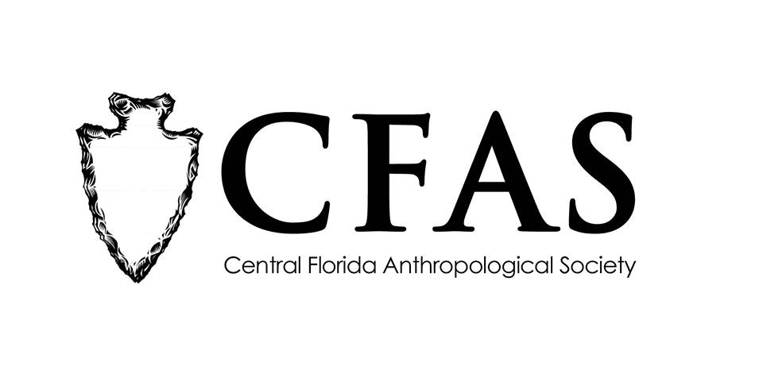

**Central Florida Anthropological Society**

**General Meeting**

**October 16, 2017**

**Minutes**

At approximately 7:05pm, Katherine Navarro called the meeting to order. Approximately 24 people were in attendance at the second meeting for the 2017-2018 academic year.

Navarro began the meeting by welcoming everyone, both CFAS members and guests. She then turned the floor over to Deborah Bauer. Bauer made several announcements. She indicated that updated/revised membership forms were available on the back table for new people who were considering joining CFAS for the first time or for people who are planning to renew their membership for the 2018 calendar year. She reminded everyone that anyone who renews between October and December 31st, 2017 will have their membership updated for one-calendar year as CFAS membership runs from January 1 until December 31st each year. She reminded everyone that CFAS’s website has a new URL: <http://www.cfasorlando.com/>. Bauer also announced that CFAS is conducting a survey of membership interests. It is anonymous. Paper ballots can be filled out and completed during the meeting and then turned in at the end of the meeting to her. An online version is also available at the following URL: <https://www.surveymonkey.com/r/7CZDWGP>. Hard copies of the September 2017 meeting minutes were also available on the back table.

Navarro then introduced the featured guest speaker of the evening Liotta Noche-Dowdy from the Anthropology Department at the University of South Florida in Tampa. Noche-Dowdy gave a presentation entitled “Summary Findings of the Investigation into the Deaths & Burials at the Arthur J. Dozier School for Boys.” Several people asked questions.

At the conclusion of Noche-Dowdy’s presentation, Navarro thanked everyone for coming.

CFAS officers Katherine Navarro, president and Deborah Bauer, secretary, were in attendance.

The meeting was then adjourned at approximately 8:17pm.

Respectfully submitted on November 20, 2017,

Deborah Bauer

Secretary

Central Florida Anthropological Society