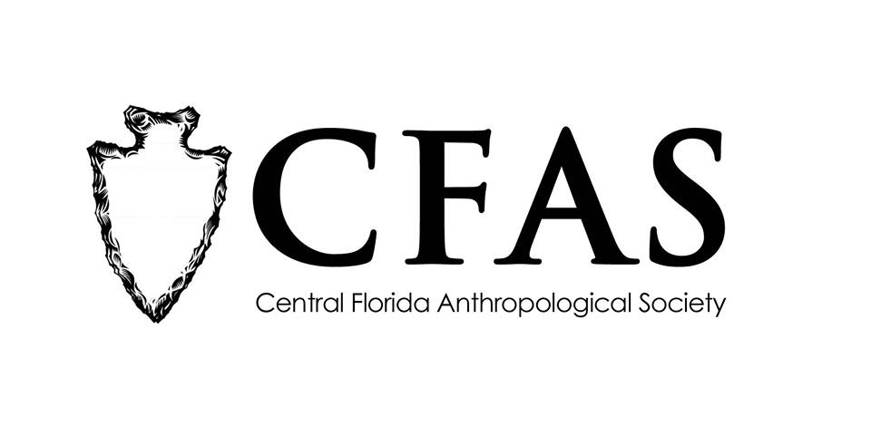

**Central Florida Anthropological Society**

**General Meeting**

**September 18, 2017**

**Minutes**

At approximately 7:00pm, Deborah Bauer called the meeting to order. Beth, an assistant reference librarian on staff at the Winter Park Library welcomed CFAS to our new meeting space in the Community Room on the first floor of the library (located at 460 E. New England Avenue, Winter Park, Florida 32789). Approximately 8 people were in attendance at the first meeting for the 2017-2018 academic year.

Bauer began the meeting by making several announcements. Bauer thanked everyone for finding the new meeting place. She also apologized for the absence of the other CFAS officers who had scheduling conflicts. Bauer then also reminded everyone of CFAS’s new mailing address ([Central FL Anthropological Society (CFAS), P.O. Box 530005, Orlando, FL 32853](https://www.facebook.com/groups/CentralFloridaAnthropologicalSociety/permalink/10155084277063822/)). She also reminded everyone to sign up for the CFAS newsletter if they had not done so already.

Bauer then made a presentation entitled “Families and the Colonization during the Age of the American Revolution."

At the conclusion of her presentation, Bauer thanked everyone for coming. She then encouraged everyone to remind people about the change in meeting location and that next month’s presentation would be on the Dozier School site.

CFAS officers Deborah Bauer, secretary, was in attendance.

The meeting was then adjourned at approximately 8:05pm.

Respectfully submitted on September 27, 2017,

Deborah Bauer

Secretary

Central Florida Anthropological Society