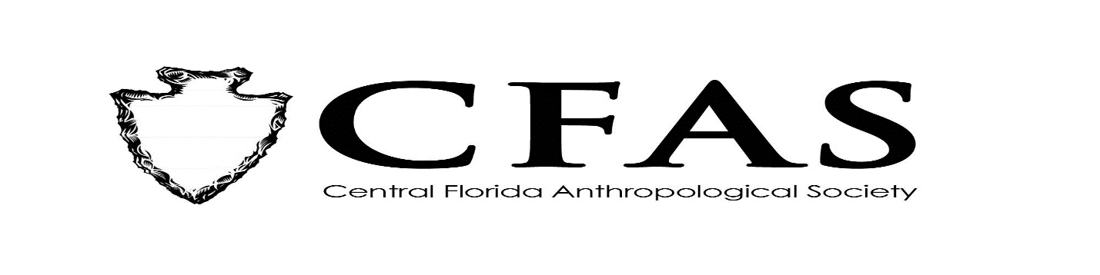
Agenda
General Meeting
February 17, 2020

- Welcome
- Meeting Convenes
- Officer Reports:
- President (Deborah L. Bauer)
- Vice President (Edward González-Tennant)
- Secretary (Susan Harrington)
- Media Relations Liaison (Richard J. Ott)
- Old Business: Election of 2020 Officer Slate
- New Business
- 2019-2020 Guest Lecture Series Speaker:
Ms. Tracy Lovingood – “Overturning the Turnbull Settlement of New Smyrna Beach: Artifact Analysis of the Old Stone Wharf “
- General Announcements:
-March 2020 Speaker: TBA
. Adjournment

