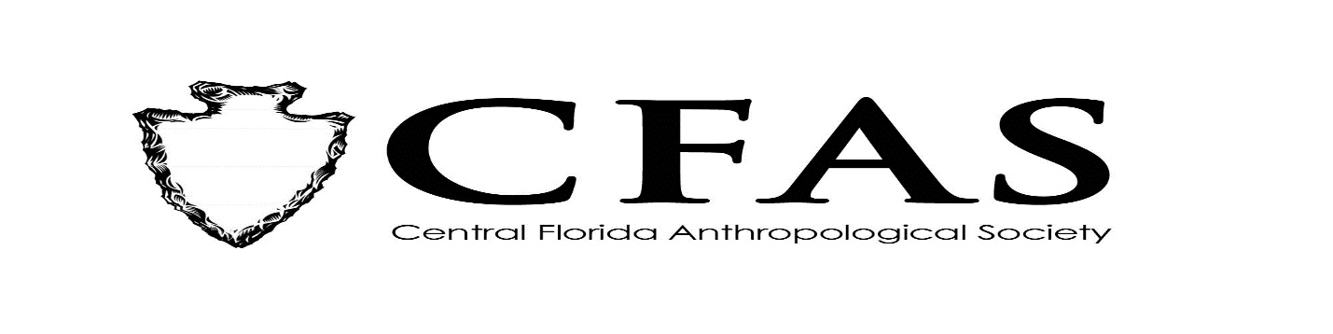

**Agenda**

**General Meeting**

**September 21, 2020**

1. Welcome
2. Meeting Convenes via Zoom
3. Officer Reports:
4. President (Deborah L. Bauer) – FAS Quarterly Board Report from August
5. Vice President (Edward González*-*Tennant)
6. Secretary (Susan Harrington)
7. Media Relations Liaison (Richard J. Ott)
8. Old Business
9. New Business
10. 2020-2021 Guest Lecture Series Speaker:

Ms. Brigitte Stephenson – “From the National Level to the Municipal Level, Women’s Suffrage”

1. General Announcements:

-October 2020 Speaker: Guest Speaker: Dr. Lee Newsom of Flagler College

Title: "Gourds, Mastodons, and Florida Indians: Insights into the Origins and Evolution of an

Indigenous Paleoethnobotany" VIA ZOOM – Advanced Registration is Required