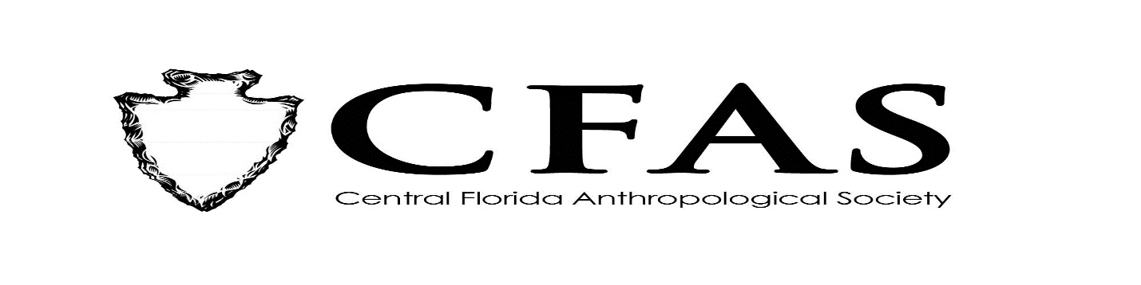
Agenda
General Meeting
October 19, 2020

- Welcome
- Meeting Convenes via Zoom
- Officer Reports:
- President (Deborah L. Bauer) – FAS Quarterly Board Report from August
- Vice President (Edward González-Tennant)
- Secretary (Susan Harrington)
- Media Relations Liaison (Richard J. Ott)
- Old Business
- New Business
- 2020-2021 Guest Lecture Series Speaker:
Dr. Lee Newsom – “Gourds, Mastodons, and Florida Indians: Insights into the Origins and
Evolution of an Indigenous Paleoethnobotany"”
- General Announcements:
-November 2020 Speaker: Guest Speaker: Ms. Becky O’Sullivan, Florida Public Archaeology
Network – West Central Office
Title: “Towards Zion: In Search of Tampa’s earliest African American Cemeteries” VIA ZOOM –
Advanced Registration is Required

